12/6/2019
Nicholas Evans
1704662
Project Initiation Document
ACDA5004

Contents

Introduction 2
Objectives 3
Scope 4
Constraints 4
Authority 5
Resources 6
Conclusion 7
References 8

Introduction

The Medical Bracelet is a product which was thought up and designed within the group based off a product which already exists but taken further. Unlike standard medical bands, this product is designed with a GPS tracker built in to help locate the user if lost or to be located by emergency services. On top of this, the bracelet will also house a chip which will hold all of the user’s information regarding any medication being taken, medical history and other important information which any medical professional will need to know.

Objectives

Having set goals to strive for is vital in any project. This enables the group involved to have clear time periods in which work is expected to be finished by. To help keep on top of these goals, a Gantt chart was designed to have each goal clearly displayed.

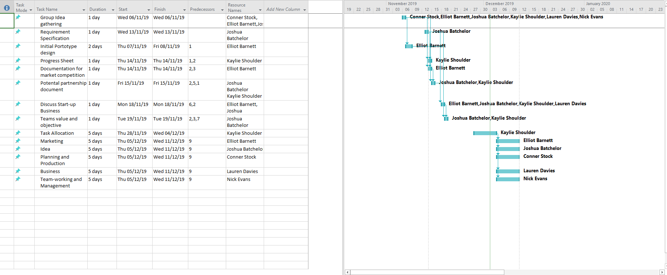
Figure 1 - Gantt Chart 1

The chart above displays which job needs to be done by, and by whom it has been assigned to. With a chart like this which clearly indicates how much progression is expected within a certain time period, everyone involved in the project can keep on top of not just their own work, but also keep track of how far along their co-workers are too.

Scope

The scope of the project is essentially what was mentioned in objectives but in far more detail and with a few extra key points. Listed they are [1]:
- Goals
- Deliverables
- Features
- Functions
- Tasks
- Deadlines
- Cost

Constraints

There are 3 threats to every group project that need to be taken into consideration. These threats are known by a few names but the most common one is the Iron Triangle, and for good reason. [2]
- Cost – This covers every financial aspect of the project, such as resources, bills and wages.
- Scope – As mentioned above, this represents the goals of the project.
- Time – This Represents the schedule and set time goals of the project.
This is where the project manager’s role is vital as it is the responsibility of the manager to keep track and maintain the progression of the project. The consequences of not keeping on top of this can be disastrous. If there is a problem which isn’t addressed, it can lead to major delays in production which will also cause a domino effect on everything else resulting in the serious threat of the project being cancelled and huge financial loss.

Authority

As stated earlier, the managers role is essential to the success or failure of any project work. To help keep track of everyone’s progression, the Gantt chart is used to help plan out the schedule for everyone’s work within a set time period. As indicated below, each member of the team is given a specific role to manage and be responsible for. This helps production run much smoother as the project can have multiple tasks worked on at a time and a specific member overlooking each task.

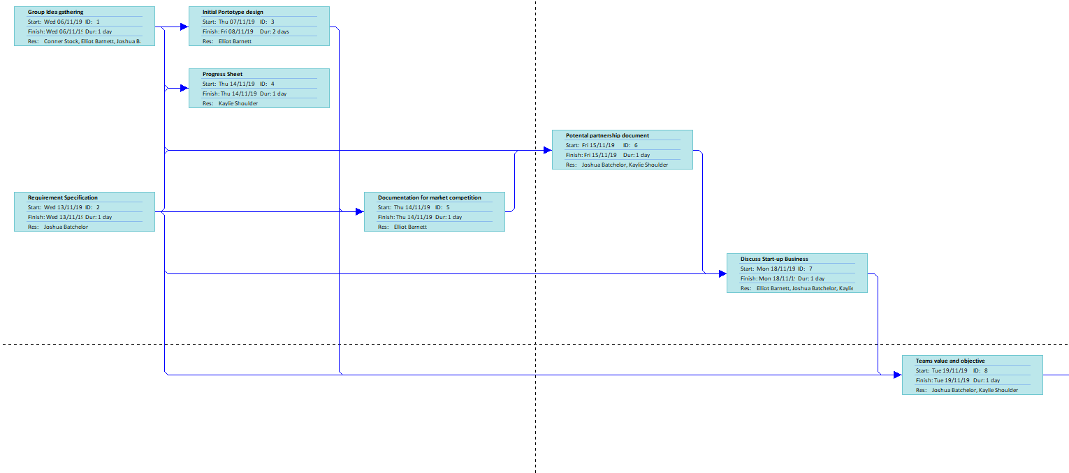
Figure 2 - Gantt Chart 2

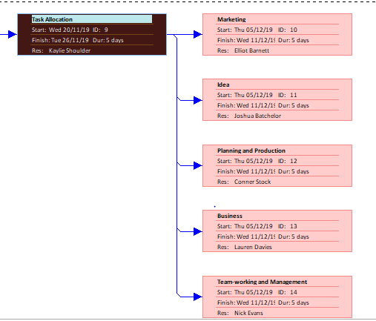
Figure 3 - Gantt Chart 3

Resources

Having people in the group skilled in different areas can greatly boost the production speed and quality. Having a team full of people which is only trained in web design and have them tasked with product manufacturing for example can lead to all sorts of issues. It is very important to keep in mind of the workforce skills set when delegating job roles to any group.
There are also the materials needed to manufacture the product itself to consider. For the medical band, it was decided that Fabric, silicone and rubber was to be used as the materials for the band itself, with a metal clasp to attach together around the wrist of the user. There was also insulation with the thoughts of protecting the chip inside.
The cost is another matter which is important to discuss. Everything has a cost from materials to all outgoings which need to be funded. There are backing websites such as Kickstarter.com [3] which enables 3rd parties interested in the product to voluntarily give money to the production of the product.

Conclusion

This project is still very early in development and there are a lot of problems that need addressing and ideas being finalized. So far, the majority of planning has been set across a time frame which will now be the key focus of the project whilst the group consults with each other on how best to move forward. Only with the group working as one unit with the project have any chance of success.

References

[1] | Heather, "totally.tech," 11 10 2018. [Online]. Available: https://totally.tech/quick-guides/how-to-define-the-scope-of-a-project/.
[2] | "pmtips.net," 29 01 2019. [Online]. Available: https://pmtips.net/article/defining-project-constraints.
[3] | "Kickstarter.com," [Online]. Available: https://www.kickstarter.com/?ref=nav. [Accessed 20 11 2019].

Figure 1 - Gantt Chart 1 2
Figure 2 - Gantt Chart 2 4
Figure 3 - Gantt Chart 3 4

