
April 4, 2022
Dinca Carmen Liliana 1919499
Lecturer: DR Richmond Lamptey

Customer Relationship Management Emerging Themes
BA Leadership and Management BMSW5103
Contents
Introduction: 2
A) The Customer Experience of Apple: 2
i. Apple customer touch point: 2
ii. Apple Customer Experience and Brand Experience: 3
iii. The CRM Policies of Apple Inc. And the impact on Customers: 3
B) Critical literature Review for Apple: 5
The five dimension of Service quality model: 5
Tangibility dimension: 5
Reliability dimension: 5
Responsiveness dimension: 5
Assurance dimension: 6
Empathy dimension: 6
Tangibility dimension: 6
Reliability dimension: 6
Responsiveness dimension: 6
Assurance dimension: 6
Empathy dimension: 6
The GAP model of service quality: 7
1. The gap between management perception and customer expectation: 7
2. The second gap: management perception and service quality specification: 7
3. The gap between service quality specification and service delivery: 7
4. The gap of service delivery and external communication: 7
References 9

Introduction:
Apple Inc. is an American Company and a very popular brand globally knowing from they most popular product, a smart phones called iPhone. In this report I will talk about customer service by analysing the customer service experience of Apple and do a critical evaluation of the benefits and the challenges to develop and maintain customer relationships.

The Customer Experience of Apple:
Apple Inc. is popular all over the world and is very known for the ability to ‘own the consumer’. In short, the Apple business model is designed to drive consumers into its ecosystem and then hold them there, which has been hugely successful to date and has allowed Apple to wield enormous power in the end-to-end supply chain. We demonstrate this through a detailed evaluation of Apple's physical and content supply chains and its retailing strategy.

Apple customer touch point:
The customers become loyal to the Apple product iPhone for reasons beyond the primary features and attributes all competitors offer such as Samsung. Touchpoints that address important but overlooked aspects consumers also care about it can become an importantly differentiating then other brands. Because Apple Inc. Master touchpoints is result in customers trading up to larger amounts per purchase occasion and additional purchases because every touchpoint plays a role in making the Apple brand positioning and overall perception. Apple touchpoints are very well done and some of the touchpoints they master are:
1) A Clean, Easy to Navigate Website
The Apple website is clean, well designed, easy to navigate, and easy to find and learn about new offers, set up appointments, and locate stores or delivery.
2) Packaging
There had been always something magical about opening a new Apple product. The packaging quality and design always look clean, direct and radiate. Also from iPhone 7 Apple re-design the iPhone box to become more eco friendly. According with Apple, they use a three-part strategy for the new iPhone box: (1) use paper more efficiently and, where possible, use recycled paper; (2) source virgin fiber responsibly; and (3) protect and create sustainable working forests. (Inc., 2017)
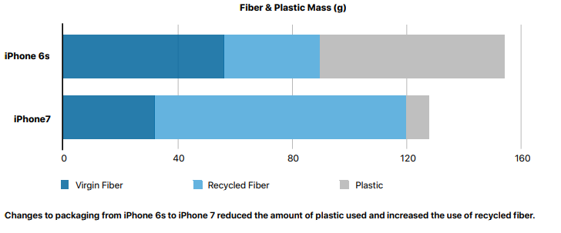

Apple Customer Experience and Brand Experience:
Earlier smartphones were unwieldy, tough to use and were usually focussed on out and out productivity. Oh and it also incentivized developers and users to buy into the Apple ecosystem – promising the developers a stable target audience, and the consumers the ability to carry their apps, purchases, music, notes, and so much more across several devices no matter where they are. Apple not only delivered a better customer experience, they changed the game on Mobile Customer Experience entirely, which allowed them to leapfrog veterans in the smartphone segment and create a user base that were willing to buy into the Apple ecosystem.
That’s because Apple Inc. doesn’t simply relegate its focus on Customer Experience to its products. Apple stores are designed to be the best possible Customer Experience anywhere(not just in retail). When opening the first Apple store, instead of improving on their competition’s services, Apple decided to benchmark itself against the masters of human interaction – the hospitality industry, which led to the creation of the Apple Genius Bar – knowledgeable, empathetic employees who could get virtually anyone using their devices in a jiffy.
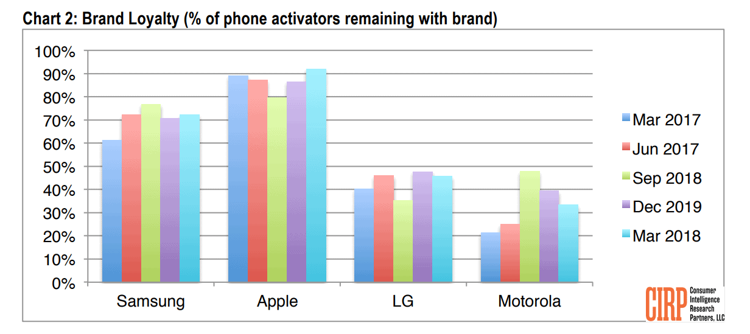

The CRM Policies of Apple Inc. And the impact on Customers:
The Apple company success also come from the business good strategy of CRM-customer relationship management, when they release the apple smartphones called iPhone they also bring with it something much innovated then other smartphone called Apple ID which is a unique profile that syncs with all Apple devices you own, making easier for the customer to transfer his data from his previous iPhone to the new purchased iPhone in just a second. This ID allows Apple to remember the customer purchases with the Apple Store, and provide personalised recommendations for music and films and share content and cloud storage with other members of the family, and monitoring the kids’ purchases. This help Apple and the customers by been an it’s a self-renewing, seemingly limitless data set that allow it to constantly tailor its services and re-engage customers with handpicked deals, discounts, and products and the targeted marketing is done effectively and also engenders a sense of loyalty and familiarity with Apple’s brand. Thru that Apple use CRM by:
Knowing customers:
The Apple’s mission stated by Jobs Apple Store statement is “Get closer than ever to your Customers. So close that you tell them what they need well before they realise it themselves” It’s an ambitious aspiration, but one that Apple follows through on. Apple’s consistently high NPS (Net Promoter Score) ratings indicate that it’s remarkably good at retaining its customers. Research recently reported that Apple’s operating system, iOS, had loyalty rates of around 89%.Also fuelling Apple’s commanding customer retention scores is its stellar technical support. Whenever you buy an Apple product, you have the option to schedule in a tailored, one-to-one session with a specialist – exploring your new device’s best features, and fine-tuning it to your tastes. Apple’s commitment to understanding the individual is no accident. It’s a carefully plotted out CRM strategy, and it’s paying stunning dividends.
Stores focussing on customer experience
Apple’s use of CRM in-store is a testament to its long-term mentality. An immediate sale is good, but an ongoing relationship with a customer is more profitable. By foregoing conventional sales tactics, Apple’s shops create value by encouraging browsers to love and appreciate the benefits of having an iPhone. Apple doesn’t stress or get mean on employees in their stores. There are plenty of employees in the store for the customers to insure that the customers don’t waits his own time to get information. The Apple criteria for hiring and also the training methods are different because Apple employees are collectively cooler, hipper, smarter, more patient, collaborative and more problem/solution oriented in order to satisfy all needs of the customer.

Brand well know by generations
Apple's brand is more than just the result of creating goods that look, feel, and function well. Its network of products – each of which works flawlessly with the others – fosters brand loyalty while rewarding customers for choosing Apple. Even better, Apple's branding has succeeded where many other large corporations have failed — by appealing to millennials. According to research, Apple is one of the brands that Generation Y (and Generation X, too!) feel the most emotionally attached to, and it's easy to see why. Apple (quite literally) talks to entire generations with simple, pared-down product designs, a commitment to sustainability, and a whimsical tone of voice.
Customers Loyalty:
Typically, Apple product users are examined in terms of their brand loyalty and the power that bestows on Apple; nevertheless, we isolate Apple's ability to govern its consumers as a distinguishing aspect of its business model. For example, Muiz and O'Guinn defined Macintosh computer owners' intense loyalty as "a specialised, non-geographically linked society built on a structured system of social ties among brand fans." Such communities are referred to as "subcultures of consumption" by Schouten and Mc Alexander because they share a devotion to a specific product class, brand, or consuming activity. A consuming subculture has "an identifiable, hierarchical social structure [based on status]; a unique ethos;... and unique vocabulary, rituals, and ways of symbolic expression that facilitate shared meanings in consumption."
Consumption items and activities Boorstin referred to such organisations as 'consumption communities,' a broader word than subcultures. He contended that, in consumption communities, Americans' sense of togetherness and commonality is increasingly focused on shared consumption patterns rather than everyday interaction. Having a dedicated customer base, however, did not necessarily help Apple expand and grow. Instead, it was Apple's ability to "possess the consumer" that enabled them to convert its devoted customer base into major income streams. (Tumbat 2005) (Schouten & McAlexander, 1995) (Boorstin 1973)( Muñiz and O’Guinn 2001)
https://www.sciencedirect.com/science/article/pii/S015599821300032X

Critical literature Review for Apple:
Further in order to understand better the Apple product, The iPhone and its quality I explain and apply the Service quality model and the GAP model of service quality to the product. Apple iPhone is a very popular gamma of smartphones produced by the Apple Company. For this section in order to apply the models the Apple iPhone product selected is the 2022 edition of the smartphone – the iPhone 13.

The five dimension of Service quality model:
The 5 service quality dimensions of Service quality model is used to measure the customer expectation regarding the product e versus how the product was actually delivered. By providing a customer experience that meets or his expectations regarding the quality of the product it can increases the customer loyalty and satisfaction and due to that the 5 dimensions of service quality model play an essential component of the overall customer experience, so at this point it’s vital to know how to measure the company or business service/ product quality. Measuring the 5 dimensions bring the benefits to help your company to have a better understanding of the customer expectations, perceptions, and areas for improvement, as well as track the company progress in increasing the product quality. Understanding that, The five service quality dimensions are: tangibility, reliability, responsiveness, assurance, and empathy. (Rodrigues, 2013) (Jos Lemmink, 1997)
Tangibility dimension:
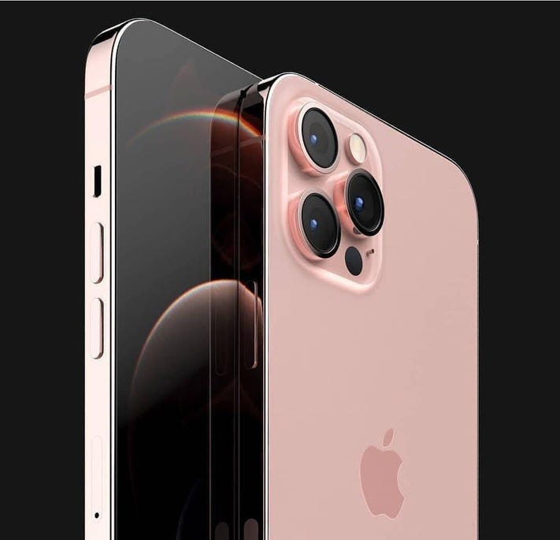
Is described as the physical appearance of facilities, equipment, and communication materials. Customers expect clean and professional facilities in stores, well-groomed and neat workers, and well-written and products. The product/ service appearance can show the organisation value the consumer comfort. Also the look of the product it does influence how the customers perceive your company, especially if your brand promises a premium or luxury experience.

Reliability dimension:
This dimension is approach the ability to provide the given product consistently and accurately and it's critical the company to do what it say the company going to do when the company say is going to do it if the company want to keep the customers happy. The customers want to be able to rely on the company to deliver a working product or an effective service, to obtain help when they need it, and to do it in a timely manner. So the customers want to know they can rely on the companies they buy from.

Responsiveness dimension:
This dimension is described as The willingness to assist clients and deliver prompt service is referred to as responsiveness. Responding to consumer inquiries and concerns as soon as possible is critical, especially in today's fast-paced society. Even if your clients are sluggish to respond, you must be responsive. Respond quickly to at least let customers know you're working on their request. Responsiveness shows your clients that you are listening to them and actively working to solve their problems.

Assurance dimension:
This dimension is the Employees' knowledge and civility, as well as their ability to express trust and confidence, constitute assurance. Customers want companies to be specialists in the services they provide. Customers can be reassured that they can trust you if you communicate that competence to them, whether through the display of credentials and industry certifications or through client testimonials. When clients have several options but are unsure who to trust when making a purchase, assurance is critical. Assume you own an online store, for example. In that instance, buyers are flooded with adverts from possibly untrustworthy online stores all day, so you must figure out how to differentiate yourself and acquire consumer trust.

Empathy dimension:
Empathy is the firm's caring, personalised attention to its clients. Customers want to feel like they're more than just a transaction; they want to form a relationship with your company. Even if you have the best product or service on the market, you may fall short of customer expectations. Empathy for clients entails ensuring that your organisation demonstrates its concern. Training personnel on how to deliver outstanding and empathic service, with regular smiles and interesting discussion, will help you exceed expectations.
(Edvardsson, 1998)
Now knowing about the five dimension of Service quality model, the next step to apply to the Apple product iPhone 13 :
Tangibility dimension:
The iPhone 13 is an tangible product, made to look luxury. In order to achieve the luxury appearance the iPhone 13 is made of Tungsten; Tin; Recyclable plastic; Gold ; ceramic; and mate glass. Also the iPhone design is shine and with emotional value as Apple try to renew the iPhone 4 design in order to satisfy the customers preference. (Apple Inc., 2021)

Reliability dimension:
The Apple iPhone reliability is was accurate as the smartphone iPhone 13 was relace in the time promise and with the new quality and performance was promised will be.

Responsiveness dimension:
For this Dimension Apple have for all products including the iPhone 13, 24/7 customer support. The customer support are always responding fast and solve the issue.

Assurance dimension:
In the Apple stores, the employees had been trained and very carefully employed to ensure that all the standards customers expects are accomplished. Also the Apple stores employee are trained in order to help a customer to find the exactly product they want faster then others stores.

Empathy dimension:
Apple had build a very strong relationship with the customers , and in order to satisfy them the iPhone 13 design was adopted the iPhone 4 design as per the customers wish, which bring to the customer not only the product, it also bring the customers nostalgia.
Apple Inc. had accomplish they quality product very well as it can result form the analysis below. But also Apple can measure those dimensions regularly over time in order to be up to date with the customer expectations, perceptions, and areas for improvement and also to track the progress of the increasing service quality by feedback, surveys, CES, and service quality questionnaires. (Apple Inc., 2021)

The GAP model of service quality:
This model is a professional framework for analysing customer satisfaction and identifying opportunities for improvement, having the same scope as 5 dimension quality service model. This approach, often known as the five gaps model, addresses some of the most prevalent communication difficulties that can lead to a divergence between consumers' service expectations and the service they actually receive. The five gaps are:

The gap between management perception and customer expectation:
The first gap measures the difference between what customers expect and what management thinks they expect. This can occur when management doesn't have enough information about their customers. For example, managers may think shoppers want a wider variety of brand-name items and self-checkout stations.

The second gap: management perception and service quality specification:
The second gap examines how accurately management specifies the level of quality they expect from their team. Addressing each of these can help you create parameters that are easy to understand and empower your team.

The gap between service quality specification and service delivery:
The third gap is about the difference that could exist between the service managers required the employees to provide and what type of service the customer actually receives. In this case sometimes the customers may receive lower-quality service than management anticipates if the team members are unable to meet expectations. Often, in this type of situation, the team may benefit from receiving additional training. Management may need to review their hiring practices to ensure candidates are both capable and willing to provide quality customer service.

The gap of service delivery and external communication:
The fourth gap is about the differences between the service a corporation claims to deliver and the service the clients really receive It assesses if the company accurately advertises and delivers facts about its services rather than exaggerating its claims. Advertisements and company statements have a tremendous impact on customer expectations, therefore managers must guarantee that the claims they make are truthful.

The gap between expected service and experienced service:
The fifth gap is covering the disparity between what customers expect and the level of service they perceive. This can emerge when a company's promises are truthful but misunderstood by the customer.
Now Appling it to the Apple company for the iPhone product iPhone 13 it show that The expectation promised from the Apple company to the customer was meet and the employees work well to meet all the expectation. Also Apple with the iPhone 13 had meet all the quality specification such as the product durability for drop impact and the resistance under water. And because the product had meet at all the expectation also helped in accomplishing the goal of the service delivery had regarding the quality requirements .The Customers receive 95% accuracy of the level of the services they expected. But they had been disappointed regarding the iPhone 13 by not doing the change they expected in the manufacturing of the smartphone display but Apple work on that and hope by the iPhone 14 that wish to be expected. Further Apple have to look on the customers feedback to make sure that there will not be any further disappointment. (Mauri, 2012) (Gremler, 2010)
Conclusion:
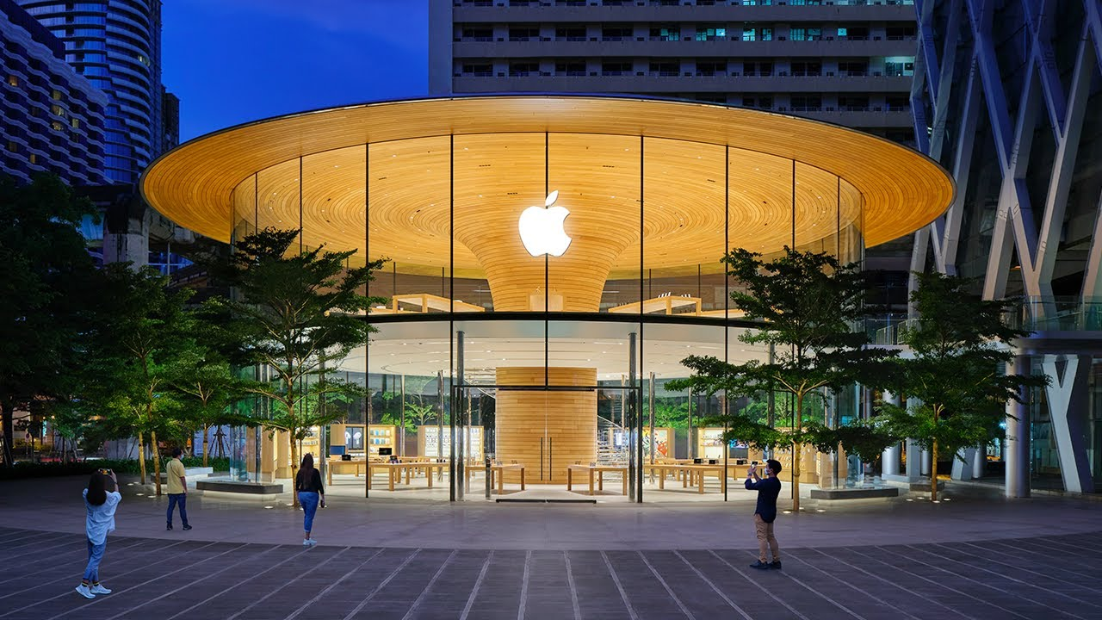
Due to the research and all the analysis done it conclude that Apple company have done right at almost all points: The company ensure that the customers have all the necessary high level support and the stores have everything is needed to attract them. Also the company know how to keep they customers loyalty and build a strong relations with the new ones too. So in the end Apple need to still keep an eye on what’s customers desire regarding they smartphones products further.

References
A.M. Muñiz, T.C. O’Guinn,Brand community,Journal of Consumer Research, 27 (4) (2001), pp. 412-433
Apple Inc., A., 2017. Apple Environment. [Online]
Available at: https://www.apple.com/environment/pdf/Packaging_and_Forestry_September_2017.pdf
[Accessed 17 03 2022].
Apple Inc., 2021. iPhone 13. Product Environmental Report, 1(1), p. 11.
Edvardsson, B., 1998. Managing Service Quality:. An International Journal, 8(2), pp. 142-149.
Gremler, D. D., 2010. Handbook of Service science. 1 ed. s.l.:Springer, Boston, MA.
Apple Inc., A., 2017. Apple Environment. [Online]
Available at: https://www.apple.com/environment/pdf/Packaging_and_Forestry_September_2017.pdf
[Accessed 17 03 2022].
Jos Lemmink, P. K., 1997. Managing Service Quality. 3 ed. Netherlands: SAGE Publications.
Mauri, A. G., 2012. A Review of Literature on the Gaps Model on Service Quality. International Business Research, 6(12), pp. 134-145.
Rodrigues, L. L. R., 2013. Service Quality Measurement: Issues and Perspectives. 1 ed. Hamburg: Anchor Academic Publishing.

