Business card
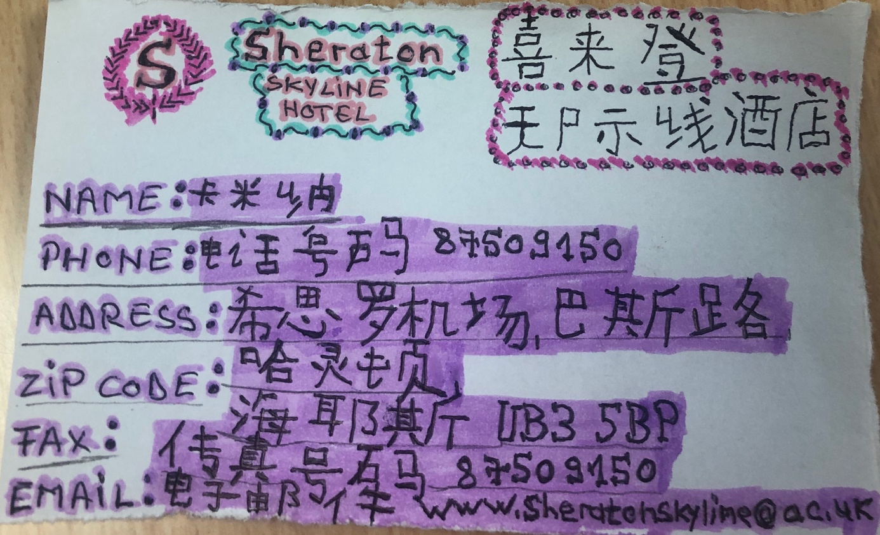

Carmina Lorena Cornea Lecturer: Jinping Li
1815046 Foreign Languages and
Cultural Awareness
Module code : M5X01923

17 December 2019

