Smart and Connected Devices Part 1
ACDA5005

0351709
Neil O’Mahoney
Cyber Networks and Security (Part-Time)
Contents
Abstract 3
Introduction 3
Research 4
Layered Approach 4
Perception Layer 4
Network Layer 4
Application Layer 5
Support Layer Threats 5
Methods of Combating Threats 5
Encryption 5
Firmware Updates 6
Default Settings 6
Data Privacy 7
Conclusion 8
References 9
Appendix A 11

Abstract
IoT (Internet of Things) are devices designed to make our lives easier or to help us with simple tasks which are connected to a network of some description.
Does Alexa listen to our every word? Where does the data go after it leaves us? This research report is designed to highlight where problems might occur and how best to mitigate against this.

Introduction
According to [1] Smart homes are ‘…Homes with integrated technology included in the design. This technology comes in the form of Internet of Things (IoT) devices, which are simply standard appliances with added internet-connectivity.’
Widely attributed to David Nichols, (a Computer Science graduate) and John Zsarnay (an electronics graduate) in 1982 at Carnegie Mellon University, Pennsylvania, USA who simply didn’t want to walk umpteen flights of stairs to be confronted with an empty drinks machine, the students designed a method of checking the status lights (and if it was empty or not) on the vending machine of their favourite fizzy beverage without ever leaving the office. ‘To pull data from the machine, Zsarnay installed a board that sensed the status of each of the indicator lights. A line from the board ran to a gateway for the department’s main computer, which was connected to the ARPANET ’ [2] A program was written to connect to this and check how many times it had been used and with it the first IoT device was born.
Oxford University defines Internet of Things as ‘A proposed development of the Internet in which everyday objects have network connectivity, allowing them to send and receive data.’ [3]
Although IoT is commonly associated with home or “Smart Home” devices, it has many industrial, medical and eco-friendly applications to name but a few. IoT in the home could be something as simple as a motion detection on a light system or as complicated as a respiratory monitoring system in a hospital, the principle remains the same; it is all designed around automation.
SMART (Self-monitoring Analysis and Reporting Technology) used to refer to ‘…When...an electronic device or system that can be connected to the internet and used interactively’ [4] however this has changed over the course of time for shopping and home consumer uses and now even includes smart labels in a seemingly [5] endless list of products and services now available. This is estimated to be work around ‘..These disruptive technologies are forecast to have a $6.2 trillion effect on the world economy by 2025.’ [4]

Research

Layered Approach
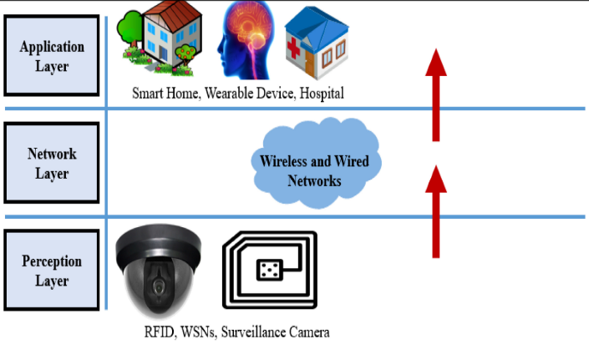
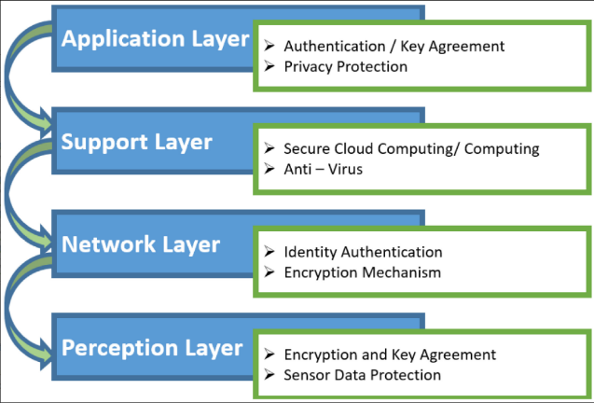
According to who you speak with there is a 3 or 4 layered approach for IoT models, ‘..Some researchers support the four-layer architecture. They think that, due to enhancement in IoT, the architecture of three layers cannot fulfil the requirements of applications.’ [6] The perception layer which includes sensors, network layer which includes IP addressing and wireless or wired media, application layer which includes the applications of which the IoT are programmed from. Depending on which model you read the fourth layer sits between the network and application, called the Support layer. The support layer confirms that data being sent is authentic and secondly it transmits information to the network layer from the application layer.

Figures of 3 & 4 layered models [6]

Perception Layer
This is the endpoint of the system, the devices that the user purchases and puts onto their network. They are susceptible to the following types of attacks:
Timing attacks – typically in slow computing devices, secretes are extracted according to how slowly they respond to different requests.
Replay Attacks - Stolen authenticated information being transmitted through the network by an attacker.
Node Capture - A device completely taken over by an attacker.
Fake Node - fake device installed on the network transmitting incorrect data.
Eavesdropping - real-time attack when data is transmitted between ‘Thing’ and user.

Network Layer
The network layer can be defined as the wired or wireless medium connected from the IoT device right up to the Application layer. ‘In a wireless network, the information is broadcast to the outside world. Hence it is susceptible to many vulnerabilities causing many attackers to interfere with the ongoing process.’ [7]
Denial of Service (DoS) Attack – an attempt to deny access to the network perhaps via using a jamming technique on wireless devices in order to prevent sensors in the perception layer linking with the server
Main-in-The-Middle (MiTM) - a hacker intercepts messages between the sensors and the application layer and could change the data in-between thereby compromising the CIA (Confidentiality, Integrity and Authentication) of the message being received.
Storage Attack - data stored in the cloud or on devices can be changed to incorrect details, this includes the replication of data.
Exploit Attack - a software-based attack taking advantage of vulnerabilities with the end goal of seizing control of the system and stealing information.

Application Layer
At the top layer is the Application layer. It may involve programs being ran, devices being linked in to name but a few. Authentication and security of such devices is key to preventing potential attackers from gaining access at such a critical level of the IoT model. ‘Special attention shall be given to identity authentication and application architecture because this layer is more vulnerable than other layers.’ [5]
Cross Site Scripting – allowing the hacker to change aspects of the script
Malicious Code Attack – an endless loop or something like a logic bomb where certain conditions are met to make the code go off.
Dealing with Mass Data – large amounts of data flowing around the network, if broken may require retransmissions causing more traffic on the NW.

Support Layer Threats
DoS (Denial of Service) Attack - large amounts of data overwhelm the network and consume vast resources. This ties up the processing time taken by the computer thus rendering genuine requests inaccessible or time out.
2. Malicious Insider Attack – Occurring from the inside of the network by authorised users an insider attack and would require active monitoring to detect such occurrences.
[8]

Methods of Combating Threats

Encryption
Encryption is a method of hiding the data that is being transmitted so that only the sending and receiving ends can view the material. ‘Information security can be categorized into three groups, including confidentiality, availability, and integrity’ [9] . This being the 3 pillars of IT security. Due to the fact that the system is unsupervised and that wireless compared to wired devices are more common ‘..Wireless connection media...listening stealthily is to a great degree basic.’ [10].
The inherent complexities of encryption technologies such as cyphers and limited bandwidth, processing power, capacity and cost that are associated with IoT devices, means that this is not conventionally available. Instead a Lightweight CA Cipher LCC is proposed, whereby the ‘…Encryption is done at the perception layer, where the sensor nodes are deployed and decryption is done at the network layer where gateway devices are installed.’ [6]
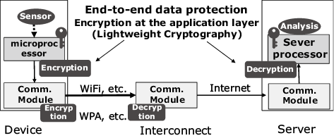
Fig. Example of lightweight cryptography applications. [11]

Firmware Updates
Delivering the latest updates to SMART devices in a home or car setting over a network costs the manufacturer. The cost involved with vehicles in the USA ‘…Per-service cost is roughly $100.’ [12] And in USA in 2015 ‘…Five million manufacturer recalls’ [12] were made. These updates were considered critical enough to the operation of the vehicle that had to take place a technology called Over-The-Air (OTA) updates being considered whereby it would use cell networks and radio masts to deliver updates to the devices. This of course could raise its own problems with vehicles or IoT devices for example only being driving during peak traffic times or switched on when used then turned off again, so the bandwidth and time for delivering these important updates diminishes also. ‘Some manufacturers provide USB sticks with software to the customers, but there are reports that this approach often fails due to reliance on human intervention.’ [12] It would be prudent therefore to use the alternative OTA approach instead.
An alternative to this could be checking the documentation of the device and allowing through the ports and IP’s through a firewall. This would be administratively complex to do initially, but after it is configured should leave the user with nothing to do.

Default Settings
Users have a responsibility to change the default user settings for each of the devices they have purchased. According to a report conducted by F-Secure Labs on behalf on a commercial buildings journal: “If they are properly isolated and maintained, they are safe. If they are just connected to company LAN and left with default passwords, they are very likely to be used as an attack vector,” [13]. Such measures as putting them into a separate VLAN/ firewall/ subnet/ Access control lists will all assist in the security of the devices and in doing so gives a layered approach that puts multiple barriers up against hackers.
One such popular device is the Nest (or Google Nest) brand of smart home products. Focusing on the Camera, this device connects to the home WI-FI and (if hard wired) then connects to an electricity cable as a power source. When successfully installed this will connect to an App on your smart phone device, tablet or PC.

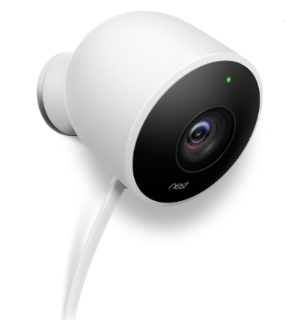
Image of Google Nest Camera NC2100GB (Outdoors).

This system can be modified to use Alexa also (the voice-controlled Google system) and can also send alerts or be shared with family members.
A potential hacker could gain access to the Google Nest system via a weak password or logon. Reports in the media recently noted that a user in Auburn Walsh, USA whose Nest Camera started speaking and telling them that nuclear missiles were on their way from North Korea. The news was of course a fake and a Google spokesperson said “Nest has reset all the accounts where customers reused passwords that were previously exposed through breaches on other websites and published publicly, ” [14]

Data Privacy

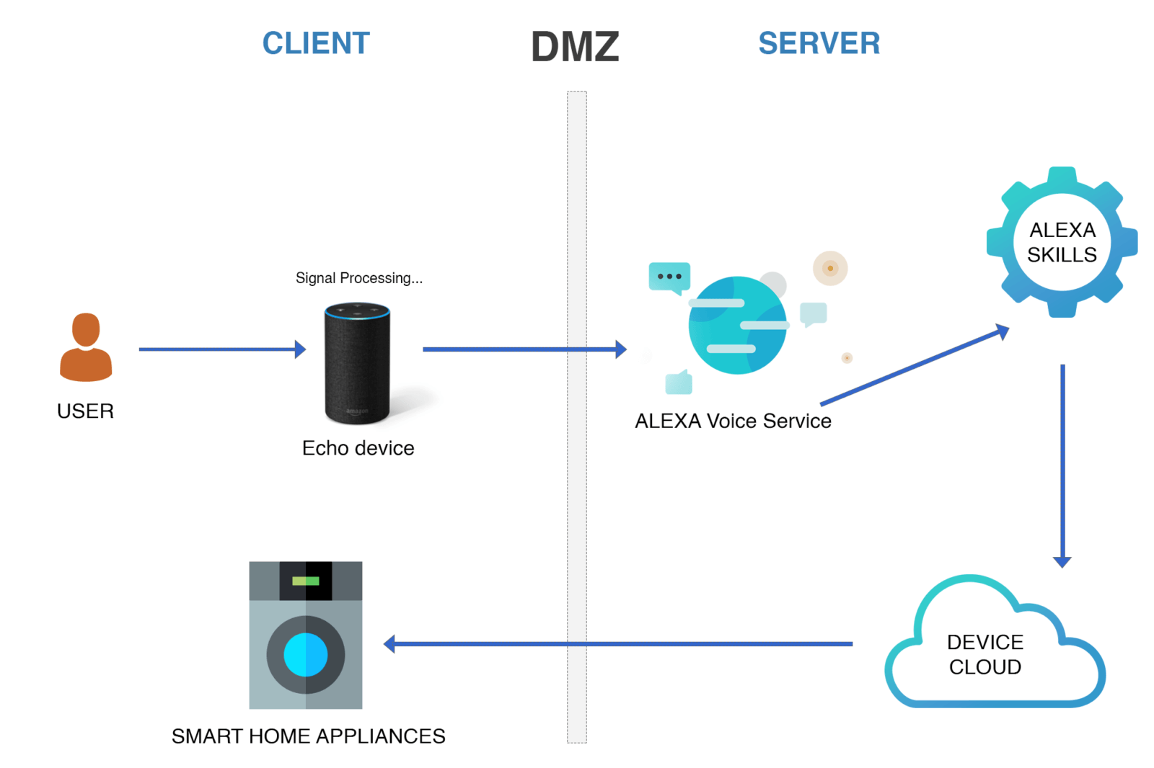
Figure How does Amazon Alexa Work? [15]
Devices such as Alexa, Echo Dot and Siri are entering our homes at an increasing rate ‘…Amazon accounts for 70% of the intelligent personal assistant market.’ [16]. Although a study was conducted in 2018 to the question ‘Alexa, are you listening to me?’ a study concerning network traffic over a 21 day period, remarks included that the ‘..Echo Dot did record and stream private conversations to AVS without utilizing the wake word.’ [16]. The study did include in its conclusion however that further questions should be raised about how voice training might reduce the private conversations streamed to Amazon. What happens to data after it is transmitted to the various corporations is often hidden in the small print of contracts users sign when installing the equipment into their homes. Amazon, allows users the opportunity to delete their data, however organisations outside of Europe are subject to whichever laws the data is transmitted to, in short, read the small print. An article detailing data privacy says that ‘Consumers should document the accounts they have opened, review the providers’ privacy policies, and review the information stored with or transmitted through these providers.’ [17] In short keeping records of who the data is shared with can help keep tabs may just be the tip of the iceberg.

Conclusion
Threats can come in all shapes and sizes and seemingly at every layer of the IoT model. From insider threat to outside forces, scripts to the very medium on which it is standing. Ideally a user would create a Demilitarised Zone (DMZ) between the internet and the home. This would give a base level of security to the home regardless of whatever default settings are on the devices. Access control lists, VLAN’s and port security on the network would give those devices which are at a high privilege level the power they need to make changes to the home devices. Fundamentally the WI-FI is an insecure medium but if encryption technologies are used this can further mitigate the threat. Of course, wired would be preferred this is also subject to specific attacks. Further on encryption, it is not a highly secure method, it is of course subject to the processing capabilities of which it is connected.
By keeping tabs on who and when the data a user is sharing, including reading the documentation thoroughly and removing the option to share data, the use can mitigate the potential loss of data as much as possible. By training their devices (Alexa specifically) to learn the user’s accent and voice this will reduce false transmissions.
Firmware updates are required through the life of the devices, sometimes they offer new features and sometimes they fix security flaws, they should still be delivered. In the case of vehicles this might be via OTA transmission however makes them vulnerable to attack or blocking. It would be better for the user to read and understand why the device needs to be updated and then delivering them via USB on a 6monthly cycle as necessary.
Dealing with upper layer security issues is certainly more complex. Keeping the devices updated and patching the latest software would be the key piece of advice to the average user, perhaps reviewing on a 6 month or yearly basis the manufacturer recommended firmware updates.

References

[1] | H. Covington, "Smart Homes: IoT Security and Ethical Concerns.," Regent University, 2015.
[2] | J. Teicher, "The little-known story of the first IoT device," 2018. [Online]. Available: https://www.ibm.com/blogs/industries/little-known-story-first-iot-device/. [Accessed 16 April 2020].
[3] | D.-R. Berte, "Defining the IoT," Santa Clara, 2018.
[4] | S. G. S. A. B. Pantea Foroudiam, "Investigating the effects of smart technology on customer dynamics and customer experience," Computers in Human Behavior, vol. 80, no. 1, pp. 271-282, 2018.
[5] | S. Li, T. Tryfonas and H. Li, "The Internet of Things: a security point of view," Internet Research, vol. 26, no. 2, p. 337, 2016.
[6] | M. Burhan, R. A. Rehman, B. Khan and K. Byung-Seo, "IoT Elements, Layered Architectures and Security Issues: A Comprehensive Survey," Scholarly Journals, vol. 18, no. 19, p. 1, 2018.
[7] | S. J. R. K. j. Garima Chopraa, "A survey on ultra-dense network and emerging technologies: Security challenges and possible solutions," Journal of Network and Computer Applications, vol. 95, no. 1, p. 55, 2017.
[8] | R. M. M. A. M. A. A. S. Fahad Azam, "INTERNET OF THINGS (IOT), SECURITY ISSUES AND ITS SOLUTIONS," Science Heritage Journal (GWS), vol. 1, no. 1, pp. 18-20, 2019.
[9] | J. Andreass, The Basics of Information Security, Lodon: Elsevier, 2014.
[10] | H. T. Alaa Q. Raheema, "LT10A LIGHTWEIGHT PROPOSED ENCRYPTION ALGORITHM FOR IOT," Iraqi Journal for Computers and Informatics, pp. 1-5, 01 June 2018.
[11] | Unknown, "Lightweight Cryptography Applicable to Various IoT Devices," NEC, Unknown Unknown Unknown. [Online]. Available: https://www.nec.com/en/global/techrep/journal/g17/n01/170114.html. [Accessed 23 June 2020].
[12] | S. D. V. G. E. H. Carlos E.Andrade, "Scheduling software updates for connected cars with limited availability," Applied Soft Computing, vol. 82, no. 1, p. 15, 2019.
[13] | J. Feilt, "Do Your IoT Devices Risk a Security Breach?," Buildings, vol. 111, no. 7, pp. 18-22, 2017.
[14] | C. Wolfe, "WEAK PASSWORDS BRING TROUBLE FOR GOOGLE NEST USERS," Security Distributing and Marketing (SDM), vol. 49, no. 3, p. 32, 2019.
[15] | D. Chhabra, "How does Amazon Alexa work?," qsstechnosoft, 4 June 2019. [Online]. Available: https://www.qsstechnosoft.com/how-does-amazon-alexa-works. [Accessed 03 July 2020].
[16] | M. Ford and W. Palmer, "Alexa, are you listening to me? An analysis of Alexa voice service network traffic," Personal and Ubiquitous Computing, vol. 23, no. 1, pp. 67-80, 2018.
[17] | M. Smith, "Protecting Privacy in an IoT-Connected World," Information Management, vol. 49, no. 6, pp. 36-39, 2016.
[18] | "www.squizzas.co.uk," 16 June 2020. [Online]. Available: https://www.squizzas.co.uk/products/nest-learning-thermostat-3rd-generation?variant=28797299097653&currency=GBP&utm_medium=product_sync&utm_source=google&utm_content=sag_organic&utm_campaign=sag_organic&gclid=CjwKCAjw26H3BRB2EiwAy32zhWfmciDxfVwn9c4FAF54FR.
[19] | S. Roy, U. Rawat and J. Karjee, "A Lightweight Cellular Automata Based Encryption Technique for IoT Applications," IEEE Access, vol. 7, no. 1, p. 3982, 2019.

Appendix A
Cisco Packet Tracer 7.2.2.0418
Overview of the system
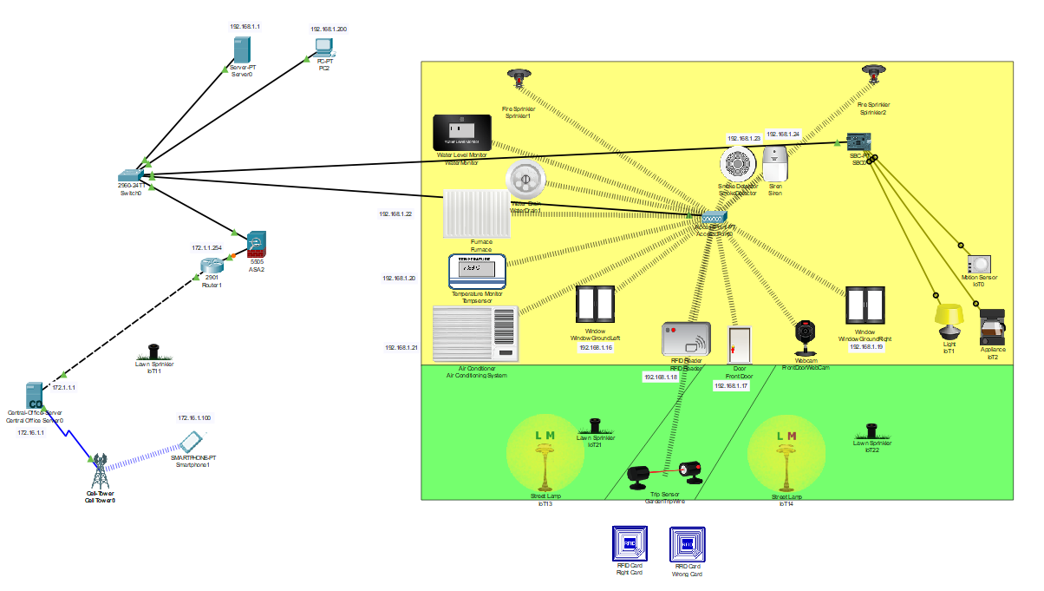
RFID Card Granting Access To Correct Card
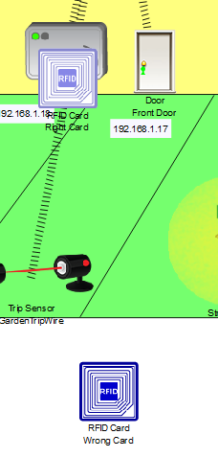

RFID Denying Access To Wrong Card
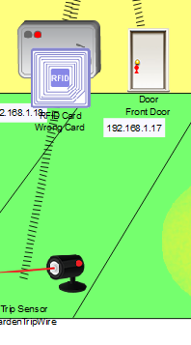
Motion Detector In Office In Off State
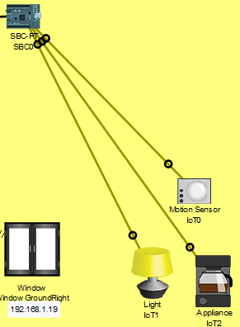

Motion Detector Activated (Light and Coffee Machine now on) PCB Programming
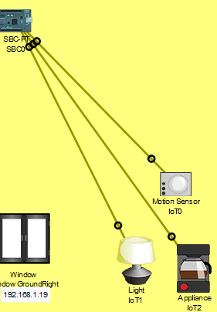
Smoke Alarm Detection System Dormant
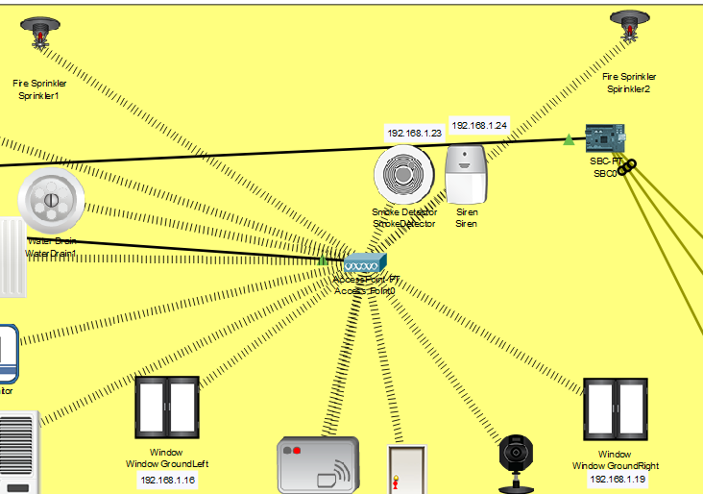

Smoke Alarm Detection System Activated (Carbon Dioxide Level Reached)
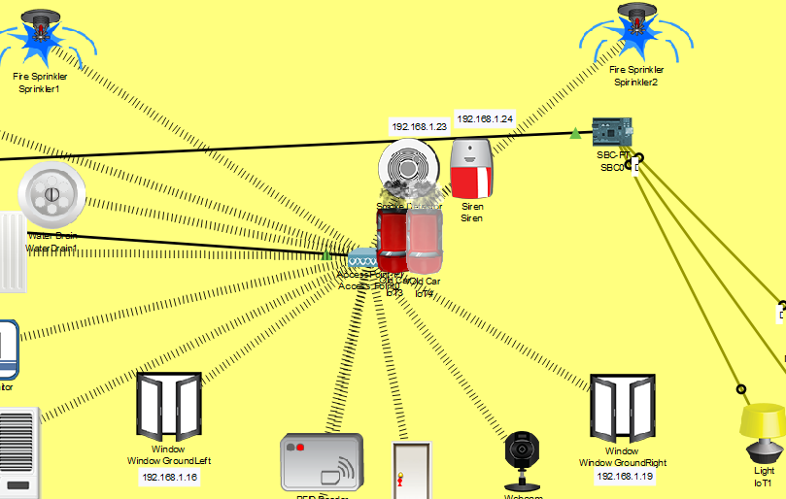
Too Much Water Bring Sprayed Into Area (Flooding Risk) Drains Activated Also
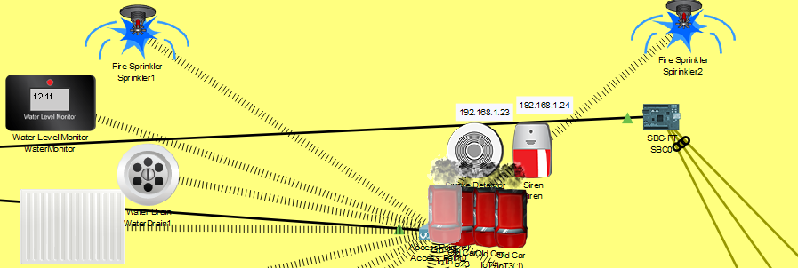

Constant Temperature Maintained (Between 12 And 15 Degrees)
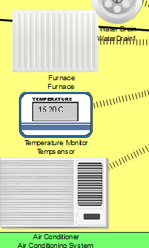

When Motion Detected Sends Email
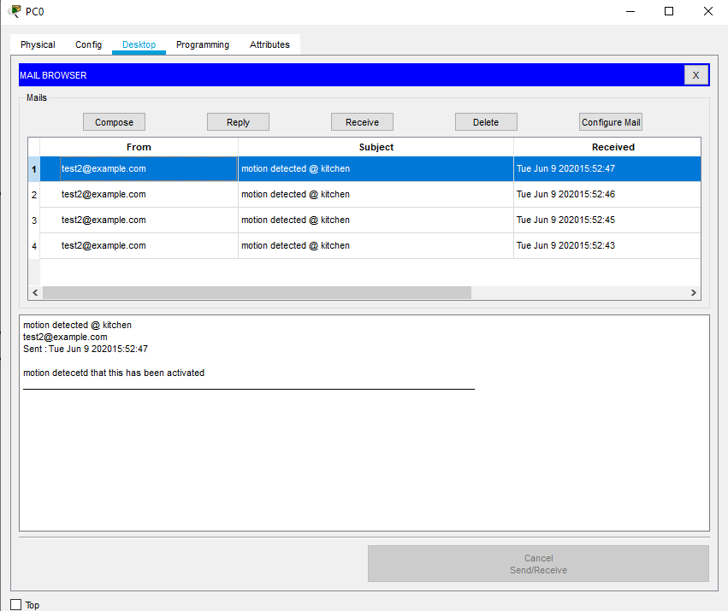

Logging Into Secure System For IoT Logic (password: admin username: admin) 192.168.1.1

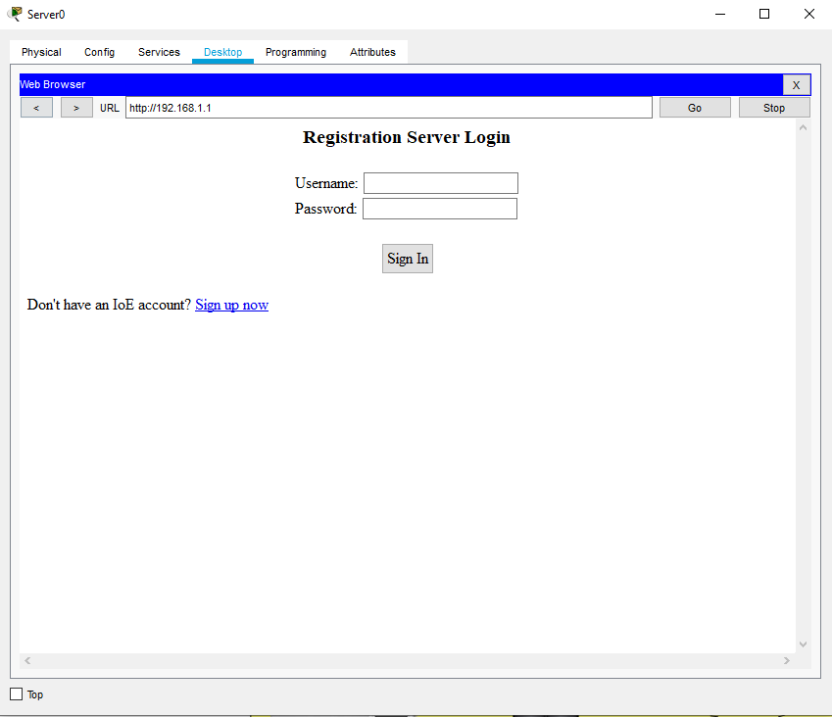
Motion Detection Programming (Sends email to test2@test.Com)


