INTRODUCTION TO WEB Concepts(ACCA4023)
Assignment: HTML & CSS Web development
Adam Smith (2317631)
Digital Degree Apprenticeship
Contents
Introduction 2
1. Requirements 2
2. Implementation 2
2.1 Validation 5
3. Evaluation 6
3.1 Self-evaluation 8
4. References 9
5. Appendices 9
5.1 Index page 9
5.2 Sales page 14
5.3 Used sales page 16
5.4 Service page 19
5.5 Clothing page 22
5.6 Parts page 25
5.7 CSS file 28

Introduction
This is a report based on a website created to meet the assignment set in ACCA4023. The report details the initial requirements and purpose of the website, the implementation of the website – including validation of the HTML and CSS code. Evaluation with research into website useability, accessibility and search engine optimisation, a self-evaluation of the website, references and then full HTML and CSS code.

Requirements
The website I have designed is based on a fictional motorcycle dealership named SWM, South Wales Motorcycles. The purpose of the website is to attract traffic from motorcyclists in the area looking to purchase a new or used motorcycle, obtain motorcycle parts or servicing, or purchase motorcycle clothing, to visit the dealership and purchase these items or services from SWM. The intended demographic has no set age, rather focusing on anyone who rides a motorcycle, catering to all types.

Implementation
Home page
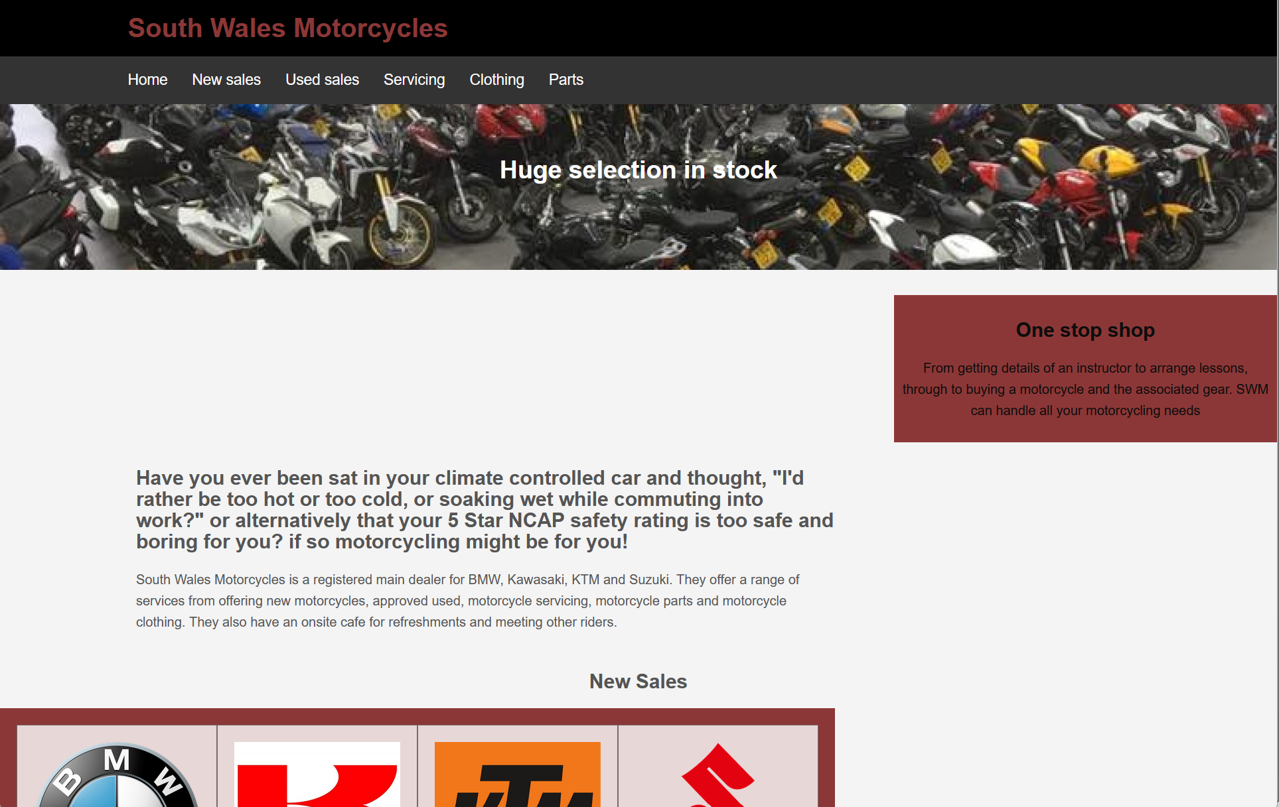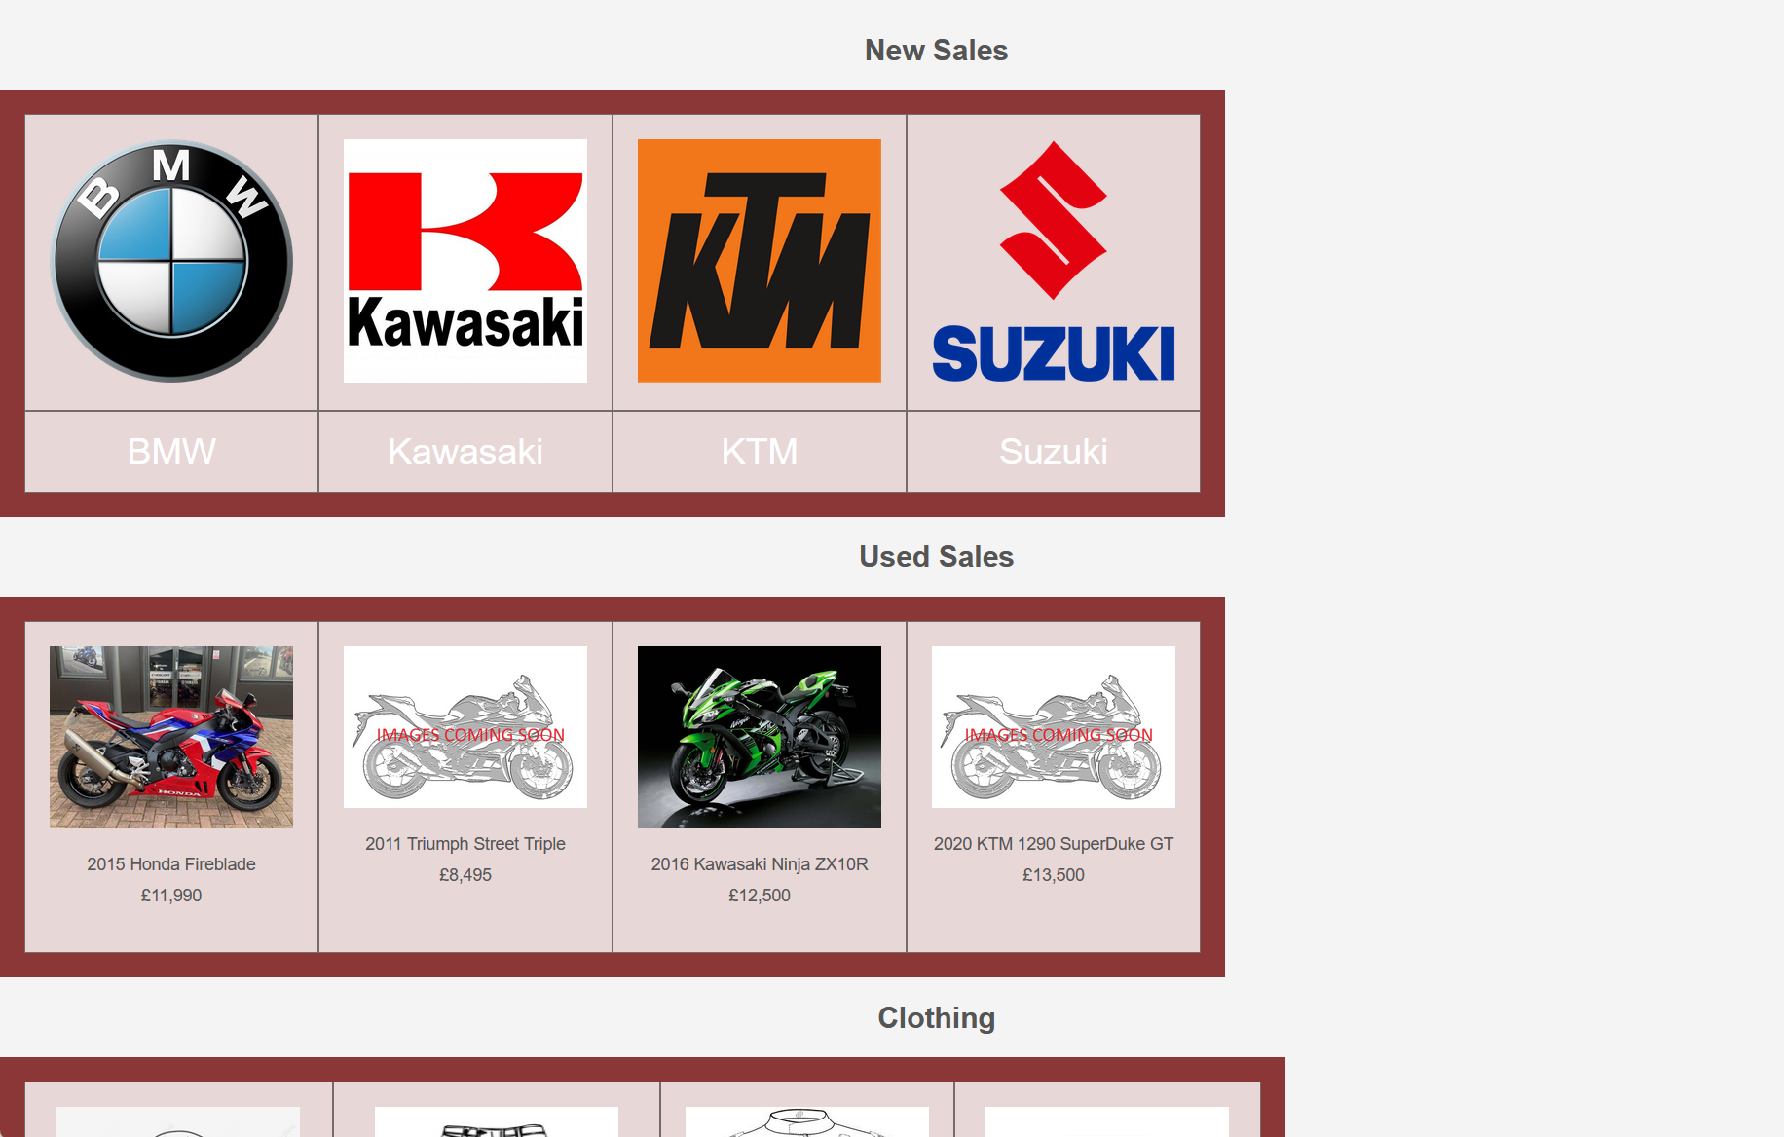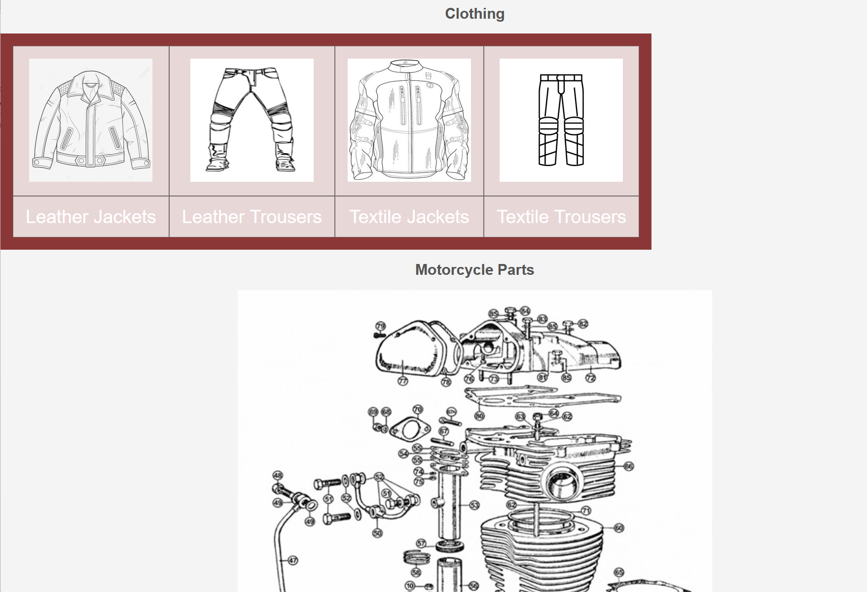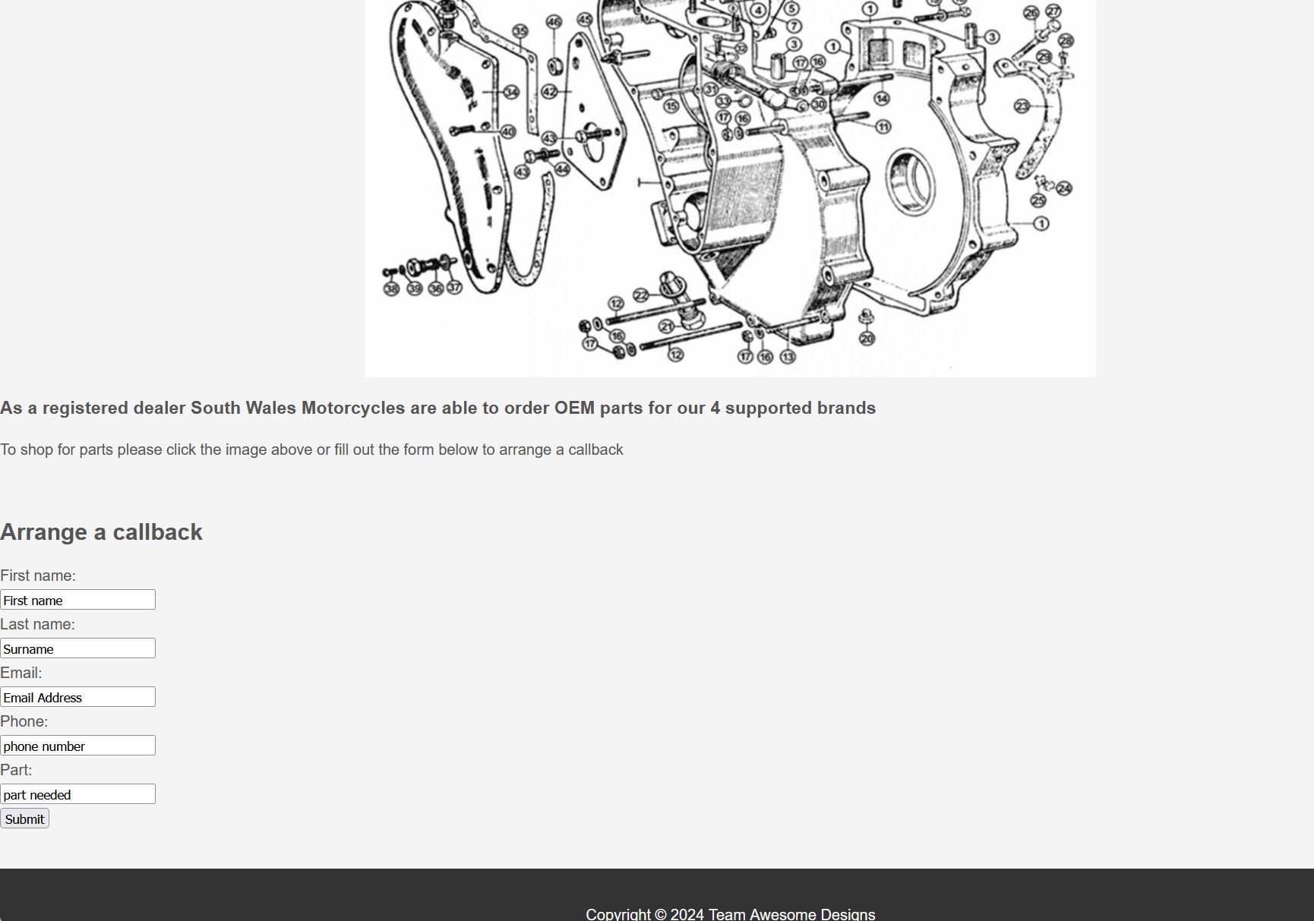
New sales page
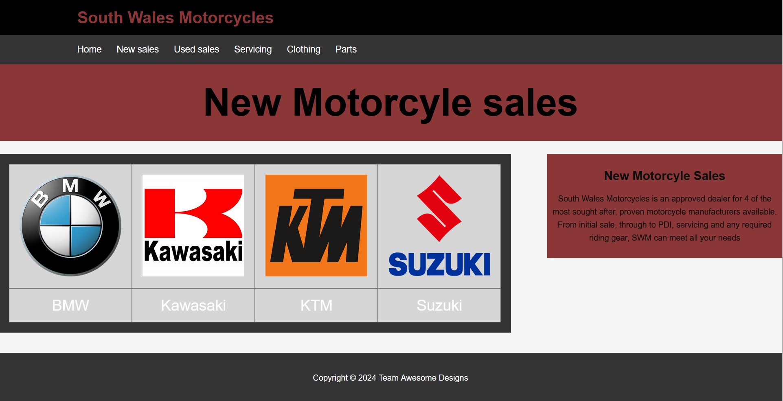

Used bike sales page
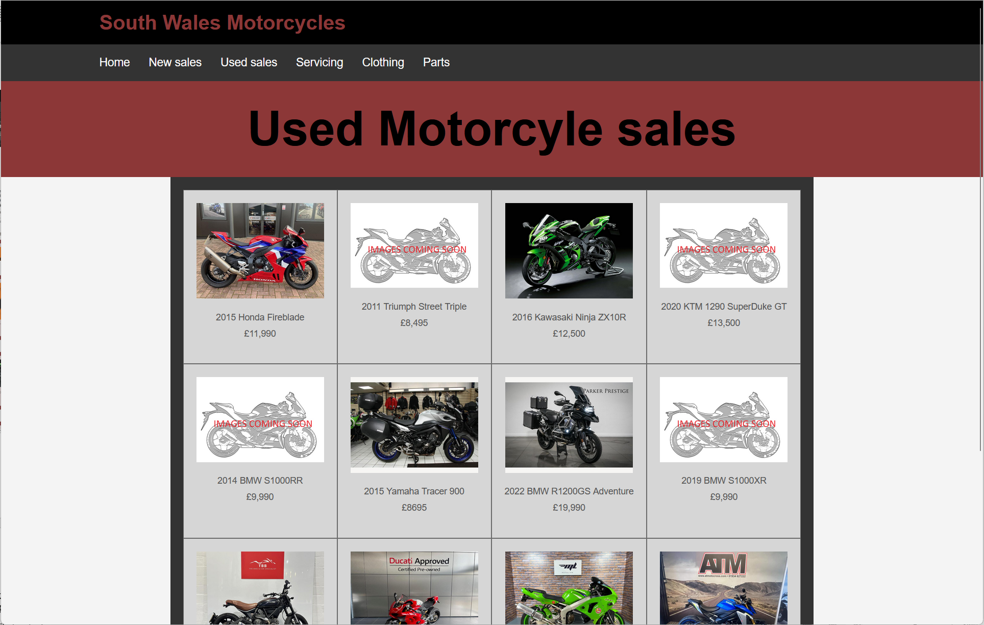
Servicing page
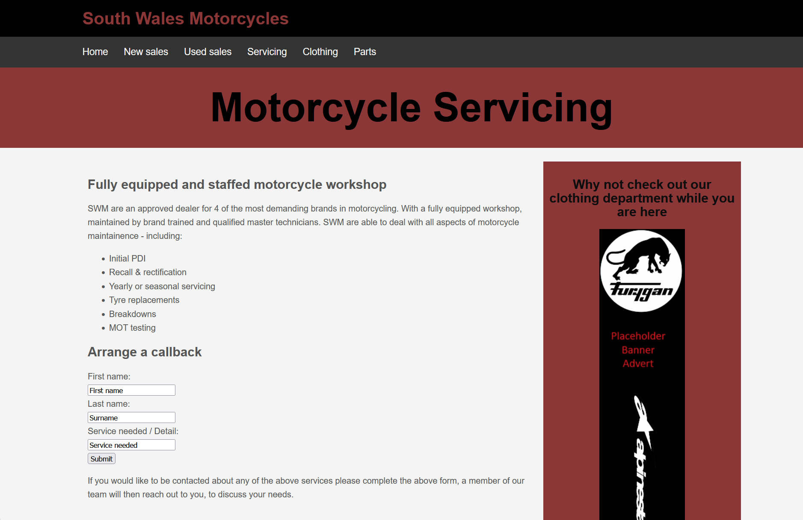
Motorcycle clothing page
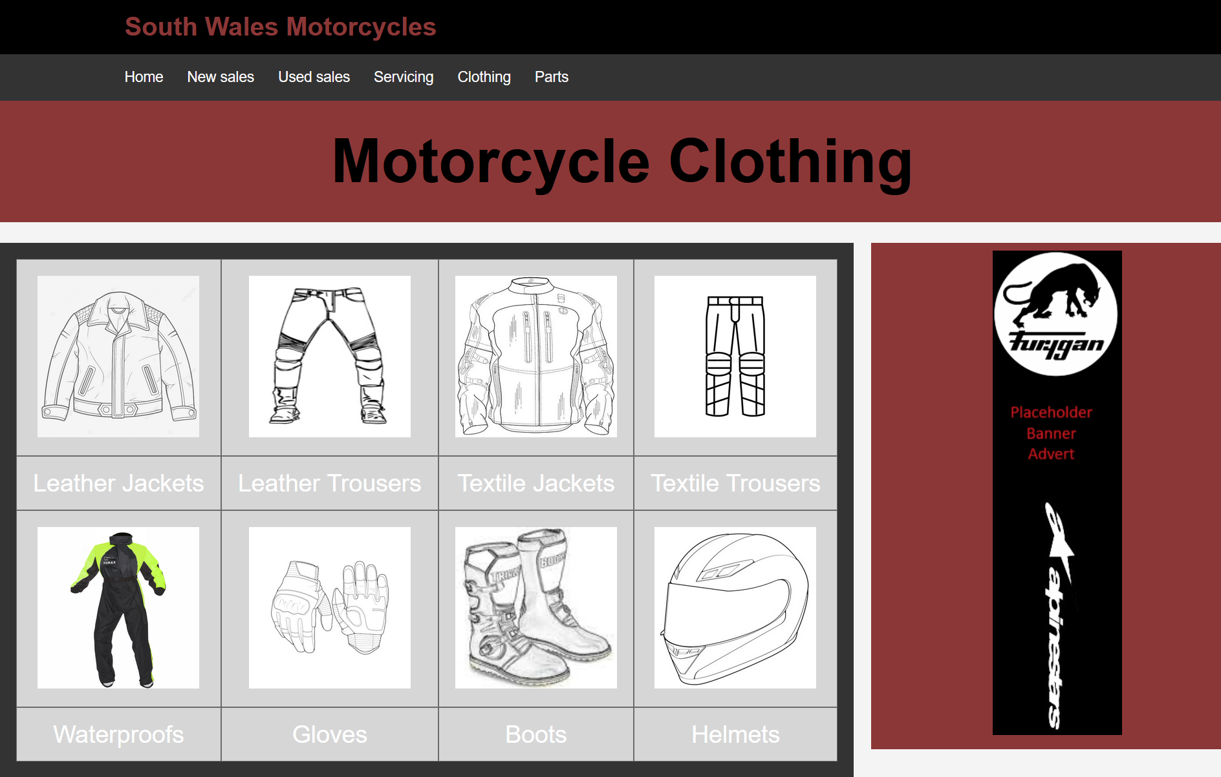
Motorcycle parts page
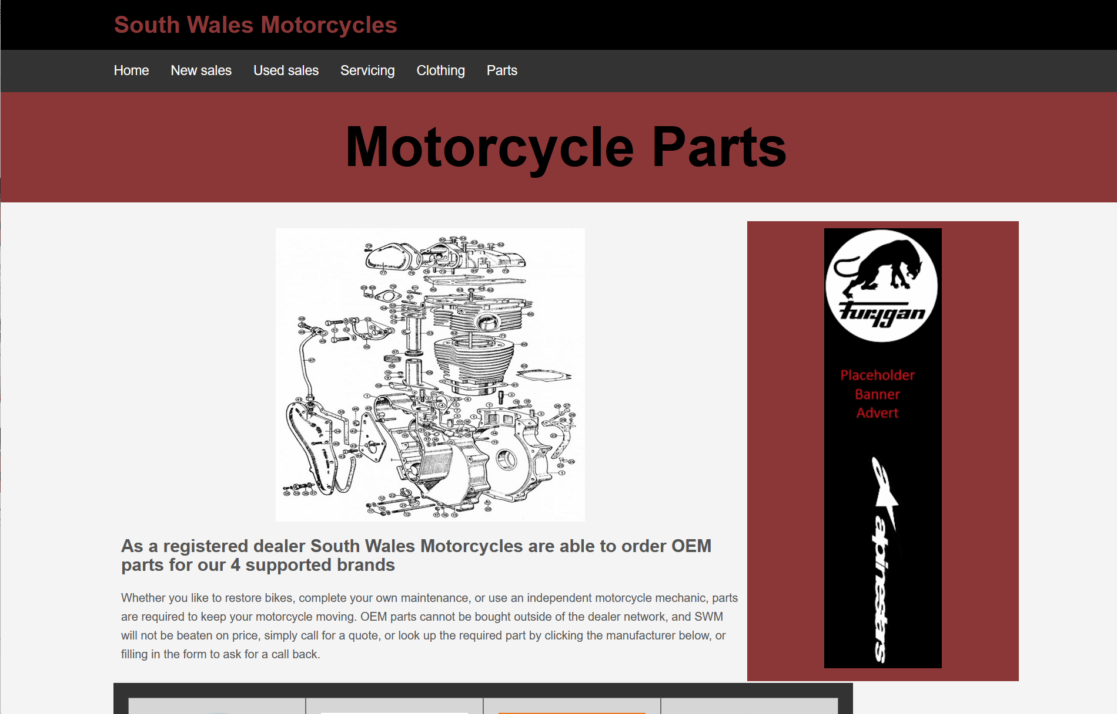

2.1 Validation
HTML
1. Warning: Consider adding a lang attribute to the html start tag to declare the language of this document.
From line 1, column 16; to line 2, column 6
TYPE html>↩<html>↩<head
For further guidance, consult Declaring the overall language of a page and Choosing language tags.
If the HTML checker has misidentified the language of this document, please file an issue report or send e-mail to report the problem.
2. Info: Trailing slash on void elements has no effect and interacts badly with unquoted attribute values.
From line 4, column 1; to line 4, column 24
l>↩<head>↩<meta charset="utf-8" />↩<titl
3. Warning: Consider using the h1 element as a top-level heading only (all h1 elements are treated as top-level headings by many screen readers and other tools).
From line 61, column 1; to line 61, column 4
sidebar">↩<h1> One s
4. Error: End tag for body seen, but there were unclosed elements.
From line 121, column 1; to line 121, column 7
/footer>↩↩</body>↩</htm
5. Error: Unclosed element div.
From line 57, column 1; to line 57, column 23
</aside>↩↩<div class="container">↩<sect
6. Error: The value of the for attribute of the label element must be the ID of a non-hidden form control.
From line 107, column 3; to line 107, column 21
e"><br>↩ <label for="Email"> Email

HTML Corrections
1 – Added a language attribute to the opening HTML tag at the start of the document.
2 – Removed the trailing slash (/) as it had no effect on document.
3- Changed from H1 to H2 for sidebar heading.
4 – Unable to correct this. Have checked the opening tag <body> is placed after </head>, have checked it only appears once in the document, and </body> is in the document and it is placed below or after </footer>
5 – Unable to correct this. The opening and closing tags are present. I suspect the cause is that I have misunderstood what can and cannot be placed in the container and so it is not recognising the closing tag.
6 – Unable to correct this. I suspect the issue is I have not identified a section of the form for it to work correctly, but the initial section of the form works without issue.

CSS
W3C CSS Validator results for TextArea (CSS level 3 + SVG)
Sorry! We found the following errors (4)
URI : TextArea
98 #showcase Parse Error object-fit
98 #showcase Parse Error cover
100 #showcase Value Error : background-position Too many values or values are not recognized : centre
130 Parse Error

CSS Corrections
1 – Corrected. This was caused by a semicolon(;) in place of a colon(:) in the instruction.
2 – Corrected. This is the same issue as above, both were corrected with the same change.
3 – Corrected. Removed this section, it has not changed the display of the website, code was to centre the image.
4- Corrected – This was caused by a missing closing bracket.

Evaluation
Website usability
As per the Nielson Norman Group (NNG), usability is “a quality attribute that assesses how easy user interfaces are to use. The word "usability" also refers to methods for improving ease-of-use during the design process” [1]. Usability is necessary for survival, if people find a website difficult to use or cannot achieve what they want, they will stop using the page and/or go elsewhere. Website usability can be defined using the following aspects A) ease of understanding the website – functions, layout content, B) Immediate ease of use, C) Speed which users can accomplish what they want, D) Ease of navigation, E) Control user has over what they are doing and where they are on the page [2]. Useability is addressed at all stages of web development from conception and initial design through to implementation and ongoing evolution. If a website scores poorly in the above 5 criteria, then its intended customers will find another supplier or website which scores higher. In the peer reviewed article ‘Website usability, consumer satisfaction and the intention to use a website: The moderating effect of perceived risk’ 4 hypothesis were put forward, 1. consumer satisfaction has a positive effect on consumer intention to use a website, 2. perceived website usability has a positive effect on consumer satisfaction, 3.perceived website usability has a positive effect on consumer satisfaction and If perceived risk increases, the relationship between perceived website usability and: (a) consumer satisfaction and (b) consumer intention to use the website will be strengthened. Testing was conducted and results confirmed points 1, 2 and 4a - consumer satisfaction has a positive effect on consumer intention to use a website and perceived website usability has a positive effect on consumer satisfaction and If perceived risk increases, the relationship between perceived website usability and consumer satisfaction will be strengthened.

Website accessibility
Web accessibility is a term that covers websites which have been designed and developed in a way which allows people with disabilities to access and use them [3]. Web accessible sites are designed to help intended audiences with a range of disabilities, from auditory, visual and speech to physical. Accessibility needs to be considered with web development, not only from a moral standard, but also to ensure you are compliant with any current standards such as ‘Public Sector Bodies (Websites and Mobile Applications) (No. 2) Accessibility Regulations 2018’ and keeping abreast of any future or intended standards being implemented, as well as a business requirement to make sure it’s services are available to all and avoid reputational damage and issues with discrimination. In the article ‘Local Government Website Accessibility—Evidence from Poland’ [4] website accessibility was reviewed for a range of local government websites. Websites were tested to ascertain their accessibility and each site was then graded with an aggregate accessibility rating and then ranked. The study found the websites scored 57% of the available points, indicating significant room for improvement. It reaches the conclusion that whilst an effort has been made to implement some elements to help, it does not go far enough, and people who manage content need to be both competent and trained.

Search Engine optimisation
Search engine optimisation (SEO) is the process of making webpages to rank higher than others in search engines [5]. When searching for products, services, or informational pages the majority of people using the internet will head to a search engine to find the required information or pages. Due to the multitude of available websites all competing for the same users, it is not a simple case of listing your website and it showing in a search engine. Search engines will show a huge number of results, ranking them on which is most relevant and placing these at the top of the list, or just below a top list of paid advertisements for relevant sites. Research shows that only 2-3% of users click beyond the first page of results returned by a search engine – as a result Search Engine Optimisation has become a service many site owners will seek out to ensure that their websites rank higher than others and are more likely to be returned in the first pages and lead to traffic to your website or domain. In the article ‘Investigating Search Engine Optimization Factors in Media Websites’[6] the authors cover the relationship between online journalism and search engine optimisation. The study conducted testing on a sample of Greek media websites. It concluded that the websites with the most traffic, also had the largest proportion of search engine optimisation. The review concluded that popular media websites in Greece with high traffic volumes employ basic search engine optimisation, but there is room for improvement. It goes onto conclude that search engine optimisation will always have a place in web strategy, so long as there are search engines.

3.1 Self-evaluation
Usefulness
The website I have created is basic in function and is utilitarian. There is considerable room for improvement with regards to layout and graphic style. It is currently simple and works well as a base. Page navigation is easy – each section is clearly defined and has its own purpose. The overall theme of the website is carried across all pages and the website itself is very easy to use.
Future improvements I would like to make would be the layout – centring images and text as well as the intersection of the header and the side bar, along with scaling of the page when using different devices and/or resizing the browser window. I also feel with time and practise I would be able to generate a more professional look to the page with better graphics and styling.

Search Engine Optimisation
I have taken inspiration from other websites, which are high performing and who’s display, and navigation method is tried and tested.
I had considered adding further detail to the webpages which would help it score and be optimised under ‘People also ask’, however, this would go against the simple bare-bones theme of the website, making it more clustered and score lower with accessibility.

Accessibility
I have assessed my website using the for principles of WCAG 2.1. and find it meets the requirements.
Perceivable – The website is very simple. It uses mainly text and few images. The colour and contrast mean that navigation and information are simple, to the point and well defined, if somewhat basic.
Operable – All operation on the site is either through clickable hyper-links, either text or image based with 2 separate forms asking for short, simple data as user would know or have, as that data pertains to them.
Understandable – The information contained within the webpage is very simple. There is no complex language and no jargon – all words are in common usage.
Robust – The content of the website is related to one topic, which is unlikely to change as technologies evolve. There is nothing present that can be interpreted in another or different fashion individually, and certainly given the whole overall theme of the website.
Using aXe: The Accessibility Engine developer tool I have scanned my website to assess accessibility. It has returned 3 accessibility errors and 1 compatibility error. All 3 accessibility errors are related to the same element of a form I have embedded at the bottom of the page. I have covered the element in the validation section and have attempted to rectify this but have not been able to. I would have like to have spent more time attempting to rectify the form element to resolve this.
Using www.contrastchecker.com I have dropped an image of the website into their online tool, and it has passed the 6 tests confirming the colour scheme and contrast is accessible.
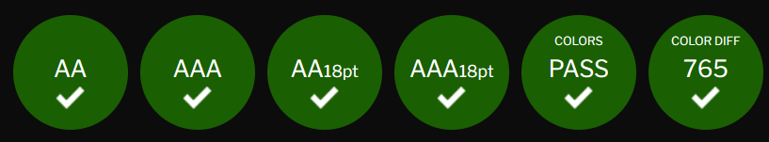

4. References
[1] Nielson Norman Group, (15.01.24), Useability 101 – Introduction to useability [Online]. Available: https://www.nngroup.com
[2] D Belanche, LV. Casalo´, M Guinalı´u, (2012) Website usability, consumer satisfaction and the intention to use a website: The moderating effect of perceived risk, Elsevier Ltd; Journal of retailing and consumer services, Vol.19 (1), p.124-132 Available: https://libkey.io/libraries/1422/articles/18787293/full-text-file?utm_source=api_311
[3] World Wide Web Consortium (W3.org) (15.01.24) Introduction to web accessibility [Online]. Available: www.w3.org/
[4] K Król, D Zdonek, (2020), Local Government Website Accessibility—Evidence from Poland, MDPI; Administrative sciences, 2020, Vol.10 (2), p.1-17, Available: https://libkey.io/libraries/1422/articles/378519902/full-text-file?utm_source=api_311
[5] Optimizely (15.01.24) Search Engine Optimization [Online]. Available: www.optimizely.com
[6] D Giomelakis & A Veglis (2016), Investigating Search Engine Optimization Factors in Media Websites, Digital Journalism, 4:3, 379-400 Available: https://libkey.io/libraries/1422/articles/59058633/full-text-file?utm_source=api_311

5. Appendices

5.1 Index page
<!DOCTYPE html>
<html lang="en">
<head>
<meta charset="utf-8">
<title>South Wales Motorcycles</title>
<link rel="stylesheet" type="text/css"
href="css.css">

<style>
.grid-container {
display: inline-grid;
grid-template-columns: auto auto auto auto;
background-color: #8C3737;
padding: 20px;
}
.grid-item {
background-color: rgba(255, 255, 255, 0.8);
border: 1px solid rgba(0, 0, 0, 0.5);
padding: 20px;
font-size: 30px;
text-align: center;
}
</style>

</head>
<body>
<header id="main-header">
<div class="container">
<h1>South Wales Motorcycles</h1>
</div>
</header>

<nav id="navbar">
<div class="container">
<ul>
<li><a href="#">Home</a></li>
<li><a href="sales.html">New sales</a></li>
<li><a href="used.html">Used sales</a></li>
<li><a href="service.html">Servicing</a></li>
<li><a href="clothing.html">Clothing</a></li>
<li><a href="parts.html">Parts</a></li>
</ul>
</div>
</nav>

<section id="showcase">
<div class="container">
<h1> Huge selection in stock</h1>
</div>
</section>

<aside id="sidebar">
<h2> One stop shop </h2>
<p>From getting details of an instructor to arrange lessons, through to buying a motorcycle and the associated gear. SWM can handle all your motorcycling needs </p>
</aside>

<div class="container">
<section id="main">
<h2>Have you ever been sat in your climate controlled car and thought, "I'd rather be too hot or too cold, or soaking wet while commuting into work?" or alternatively that your 5 Star NCAP safety rating is too safe and boring for you? if so motorcycling might be for you!</h2>
<p>South Wales Motorcycles is a registered main dealer for BMW, Kawasaki, KTM and Suzuki. They offer a range of services from offering new motorcycles, approved used, motorcycle servicing, motorcycle parts and motorcycle clothing. They also have an onsite cafe for refreshments and meeting other riders.
</p>
</div>

<h2><center>New Sales<center></h2>
<div class="grid-container">
<div class="grid-item"><img src="images/bmwlogo.png" Title="BMW" alt="BMW" width="200" height="200"></div>
<div class="grid-item"><img src="images/kawasakilogo.jpg" Title="Kawasaki" alt="Kawasaki" width="200" height="200"></div>
<div class="grid-item"><img src="images/KTM-LOGO.png" Title="KTM" alt="KTM" width="200" height="200"></div>
<div class="grid-item"><img src="images/suzuki-logo.png" Title="Suzuki" Alt="Suzuki" width="200" height="200"></div>
<div class="grid-item"><a href="#">BMW</a></div>
<div class="grid-item"><a href="#">Kawasaki</a></div>
<div class="grid-item"><a href="#">KTM</a></div>
<div class="grid-item"><a href="#">Suzuki</a></div>
</div>

<h2><center>Used Sales</center></h2>
<div class="grid-container">
<div class="grid-item"><img src="images/FIREBLADE.jpg" title="Honda Fireblade" width="200"><br><p style="font-size:14px; ">2015 Honda Fireblade<br>£11,990</p></div>
<div class="grid-item"><img src="images/placeholder.jpg" title="Triumph Street Triple" width="200"><br><p style="font-size:14px; ">2011 Triumph Street Triple<br>£8,495</p></div>
<div class="grid-item"><img src="images/zx10r.webp" title="Kawasaki Ninja ZX10R" width="200"><br><p style="font-size:14px; ">2016 Kawasaki Ninja ZX10R<br>£12,500</p></div>
<div class="grid-item"><img src="images/placeholder.jpg" title="KTM 1290 Superduke GT" width="200"><br><p style="font-size:14px; ">2020 KTM 1290 SuperDuke GT<br>£13,500</p></div>
</div>
<br>

<h2><center>Clothing</center></h2>
<div class="grid-container">
<div class="grid-item"><img src="images/leatherjacket.png" Title="Leather Jackets" alt="Leather Jackets" width="200" height="200"></div>
<div class="grid-item"><img src="images/leathertrouser.jpg" Title="Leather Trousers" alt="Leather Trousers" width="200" height="200"></div>
<div class="grid-item"><img src="images/textilejacket.jpg" Title="Textile Jackets" alt="Textile Jackets" width="200" height="200"></div>
<div class="grid-item"><img src="images/textiletrouser.webp" Title="Textile Trousers" Alt="Textile Trousers" width="200" height="200"></div>
<div class="grid-item"><a href="#">Leather Jackets</a></div>
<div class="grid-item"><a href="#">Leather Trousers</a></div>
<div class="grid-item"><a href="#">Textile Jackets</a></div>
<div class="grid-item"><a href="#">Textile Trousers</a></div>
</div>

<h2><center>Motorcycle Parts</center></h2>
<img src="images/parts.jpg" Title="Parts exploded diagram" alt="Parts Exploded diagram" Class="center">
<h3>As a registered dealer South Wales Motorcycles are able to order OEM parts for our 4 supported brands</h3>
<p> To shop for parts please click the image above or fill out the form below to arrange a callback</p>
<br>
<h2>Arrange a callback</h2>
<form action="/placeholder.php">
<label for="fname">First name:</label><br>
<input type="text" id="fname" name="fname" value="First name"><br>
<label for="lname">Last name:</label><br>
<input type="text" id="lname" name="lname" value="Surname"><br>
<label for="Email"> Email:</label><br>
<input type="text" id="email" name="email" value="Email Address"><br>
<label for="Phone"> Phone:</label><br>
<input type="text" id="phone" name="phone" value="phone number"><br>
<label for="Part"> Part:</label><br>
<input type="text" id="part" name="part" value="part needed"><br>
<input type="submit" value="Submit">
</form>
</section>
<footer id="main-footer">
<p> Copyright &copy; 2024 Team Awesome Designs</p>
</footer>
</body>
</html>

5.2 Sales page
<!DOCTYPE html>
<html>
<head>
<meta charset="utf-8" />
<title>SWM - South Wales Motorcycles, New Motorcycle Sales</title>
<link rel="stylesheet" type="text/css"
href="css.css">

<style>
.grid-container {
display: inline-grid;
grid-template-columns: auto auto auto auto;
background-color: #333;
padding: 20px;
}
.grid-item {
background-color: rgba(255, 255, 255, 0.8);
border: 1px solid rgba(0, 0, 0, 0.5);
padding: 20px;
font-size: 30px;
text-align: center;
}
</style>

</head>
<body>
<header id="main-header">
<div class="container">
<h1>South Wales Motorcycles</h1>
</div>
</header>

<nav id="navbar">
<div class="container">
<ul>
<li><a href="index.html">Home</a></li>
<li><a href="#">New sales</a></li>
<li><a href="used.html">Used sales</a></li>
<li><a href="service.html">Servicing</a></li>
<li><a href="clothing.html">Clothing</a></li>
<li><a href="parts.html">Parts</a></li>
</ul>
</div>
</nav>

<nav id="page-header">
<div class="container">
<h1>New Motorcyle sales</h1>
</div>
</nav>
<br>

<div class="grid-container">
<div class="grid-item"><img src="images/bmwlogo.png" Title="BMW" alt="BMW" width="200" height="200"></div>
<div class="grid-item"><img src="images/kawasakilogo.jpg" Title="Kawasaki" alt="Kawasaki" width="200" height="200"></div>
<div class="grid-item"><img src="images/KTM-LOGO.png" Title="KTM" alt="KTM" width="200" height="200"></div>
<div class="grid-item"><img src="images/suzuki-logo.png" Title="Suzuki" Alt="Suzuki" width="200" height="200"></div>
<div class="grid-item"><a href="#">BMW</a></div>
<div class="grid-item"><a href="#">Kawasaki</a></div>
<div class="grid-item"><a href="#">KTM</a></div>
<div class="grid-item"><a href="#">Suzuki</a></div>
</div>

<aside id="sidebar">
<h1> New Motorcyle Sales </h1>
<p>South Wales Motorcycles is an approved dealer for 4 of the most sought after, proven motorcycle manufacturers available. From initial sale, through to PDI, servicing and any required riding gear, SWM can meet all your needs</p>
</aside>
</div>

<footer id="main-footer">
<p> Copyright &copy; 2024 Team Awesome Designs</p>
</footer>

5.3 Used sales page
<!DOCTYPE html>
<html>
<head>
<meta charset="utf-8" />
<title>SWM - South Wales Motorcycles, Used motorcycle sales</title>
<link rel="stylesheet" type="text/css"
href="css.css">

<style>
.grid-container {
display: inline-grid;
grid-template-columns: auto auto auto auto;
background-color: #333;
padding: 20px;
}
.grid-item {
background-color: rgba(255, 255, 255, 0.8);
border: 1px solid rgba(0, 0, 0, 0.5);
padding: 20px;
font-size: 30px;
text-align: center;
}
</style>

</head>
<body>
<header id="main-header">
<div class="container">
<h1>South Wales Motorcycles</h1>
</div>
</header>

<nav id="navbar">
<div class="container">
<ul>
<li><a href="index.html">Home</a></li>
<li><a href="sales.html">New sales</a></li>
<li><a href="#">Used sales</a></li>
<li><a href="service.html">Servicing</a></li>
<li><a href="clothing.html">Clothing</a></li>
<li><a href="parts.html">Parts</a></li>
</ul>
</div>
</nav>

<nav id="page-header">
<div class="container">
<h1>Used Motorcyle sales</h1>
</div>
</nav>

<nav id="body-used">
<div class="grid-container">
<div class="grid-item"><img src="images/FIREBLADE.jpg" title="Honda Fireblade" width="200"><br><p style="font-size:14px; ">2015 Honda Fireblade<br>£11,990</p></div>
<div class="grid-item"><img src="images/placeholder.jpg" title="Triumph Street Triple" width="200"><br><p style="font-size:14px; ">2011 Triumph Street Triple<br>£8,495</p></div>
<div class="grid-item"><img src="images/zx10r.webp" title="Kawasaki Ninja ZX10R" width="200"><br><p style="font-size:14px; ">2016 Kawasaki Ninja ZX10R<br>£12,500</p></div>
<div class="grid-item"><img src="images/placeholder.jpg" title="KTM 1290 Superduke GT" width="200"><br><p style="font-size:14px; ">2020 KTM 1290 SuperDuke GT<br>£13,500</p></div>
<div class="grid-item"><img src="images/placeholder.jpg" title="Placeholder" width="200"><br><p style="font-size:14px; ">2014 BMW S1000RR<br>£9,990</div>
<div class="grid-item"><img src="images/tracer900.jpg" Title="Yamaha Tracer" width="200"><br><p style="font-size:14px; ">2015 Yamaha Tracer 900<br>£8695</div>
<div class="grid-item"><img src="images/1200gsa.jpg" Title="BMW R1200GSA" width="200"><br><p style="font-size:14px; ">2022 BMW R1200GS Adventure<br>£19,990</div>
<div class="grid-item"><img src="images/placeholder.jpg" Title="Placeholder" width="200"><br><p style="font-size:14px; ">2019 BMW S1000XR<br>£9,990</div>
<div class="grid-item"><img src="images/ducatiscrambler.jpg" Title="Ducati Scrambler" width="200"><br><p style="font-size:14px; ">2015 Ducati Scrambler 800<br>£6,500</div>
<div class="grid-item"><img src="images/panagale.jpg" Title="Ducati Panigale" width="200"><br><p style="font-size:14px; ">2019 Ducati Panigale V4R<br>£28,990</div>
<div class="grid-item"><img src="images/ZX6R.jpg" Title="Kawasaki Ninja ZX-6R" width="200"><br><p style="font-size:14px; ">1999 Kawasaki Ninja ZX-6R<br>£2,550</div>
<div class="grid-item"><img src="images/GSXS1000.jpg" Title="Suzuki " width="200"><br><p style="font-size:14px; ">2023 Suzuki GSX-S1000<br>£8,995</div>
<br>
<p1><br><a href="used2.html">Page 2></a></p1>
</div>
</nav>

<footer id="main-footer">
<p> Copyright &copy; 2024 Team Awesome Designs</p>
</footer>

5.4 Service page
<!DOCTYPE html>
<html>
<head>
<meta charset="utf-8" />
<title>SWM - South Wales Motorcycles, Servicing</title>
<link rel="stylesheet" type="text/css"
href="css.css">

<style>
.grid-container {
display: inline-grid;
grid-template-columns: auto auto auto auto;
background-color: #333;
padding: 20px;
}
.grid-item {
background-color: rgba(255, 255, 255, 0.8);
border: 1px solid rgba(0, 0, 0, 0.5);
padding: 20px;
font-size: 30px;
text-align: center;
}
</style>

</head>
<body>
<header id="main-header">
<div class="container">
<h1>South Wales Motorcycles</h1>
</div>
</header>

<nav id="navbar">
<div class="container">
<ul>
<li><a href="index.html">Home</a></li>
<li><a href="sales.html">New sales</a></li>
<li><a href="used.html">Used sales</a></li>
<li><a href="service.html">Servicing</a></li>
<li><a href="clothing.html">Clothing</a></li>
<li><a href="parts.html">Parts</a></li>
</ul>
</div>
</nav>

<nav id="page-header">
<div class="container">
<h1>Motorcycle Servicing</h1>
</div>
</nav>
<br>

<div class="container">
<section id="main">
<h1>Fully equipped and staffed motorcycle workshop</h1>
<p>SWM are an approved dealer for 4 of the most demanding brands in motorcycling. With a fully equipped workshop, maintained by brand trained and qualified master technicians. SWM are able to deal with all aspects of motorcycle maintainence - including: </p>
<ul>
<li>Initial PDI</li>
<li>Recall & rectification</li>
<li>Yearly or seasonal servicing</li>
<li>Tyre replacements</li>
<li>Breakdowns</li>
<li>MOT testing</li>
</ul>

<h1>Arrange a callback</h1>
<form action="/placeholder.php">
<label for="fname">First name:</label><br>
<input type="text" id="fname" name="fname" value="First name"><br>
<label for="lname">Last name:</label><br>
<input type="text" id="lname" name="lname" value="Surname"><br>
<label for="services"> Service needed / Detail:</label><br>
<input type="text" id="Services needed" name="services" value="Service needed"><br>
<input type="submit" value="Submit">
</form>

<p>If you would like to be contacted about any of the above services please complete the above form, a member of our team will then reach out to you, to discuss your needs.</p>
</section>

<aside id="sidebar">
<h1> Why not check out our clothing department while you are here </h1>
<img src="images/placeholder-banner.png" alt="placeholder banner advert" title="Placeholder banner advert" width="160" height="600"/>
</aside>
</div>

<footer id="main-footer">
<p> Copyright &copy; 2024 Team Awesome Designs</p>
</footer>

5.5 Clothing page
<!DOCTYPE html>
<html>
<head>
<meta charset="utf-8" />
<title>SWM - South Wales Motorcycles, Clothing</title>
<link rel="stylesheet" type="text/css"
href="css.css">

<style>
.grid-container {
display: inline-grid;
grid-template-columns: auto auto auto auto;
background-color: #333;
padding: 20px;
}
.grid-item {
background-color: rgba(255, 255, 255, 0.8);
border: 1px solid rgba(0, 0, 0, 0.5);
padding: 20px;
font-size: 30px;
text-align: center;
}
</style>

</head>
<body>
<header id="main-header">
<div class="container">
<h1>South Wales Motorcycles</h1>
</div>
</header>

<nav id="navbar">
<div class="container">
<ul>
<li><a href="index.html">Home</a></li>
<li><a href="sales.html">New sales</a></li>
<li><a href="used.html">Used sales</a></li>
<li><a href="service.html">Servicing</a></li>
<li><a href="clothing.html">Clothing</a></li>
<li><a href="parts.html">Parts</a></li>
</ul>
</div>
</nav>

<nav id="page-header">
<div class="container">
<h1>Motorcycle Clothing</h1>
</div>
</nav>
<br>

<div class="grid-container">
<div class="grid-item"><img src="images/leatherjacket.png" Title="Leather Jackets" alt="Leather Jackets" width="200" height="200"></div>
<div class="grid-item"><img src="images/leathertrouser.jpg" Title="Leather Trousers" alt="Leather Trousers" width="200" height="200"></div>
<div class="grid-item"><img src="images/textilejacket.jpg" Title="Textile Jackets" alt="Textile Jackets" width="200" height="200"></div>
<div class="grid-item"><img src="images/textiletrouser.webp" Title="Textile Trousers" Alt="Textile Trousers" width="200"height="200"></div>
<div class="grid-item"><a href="#">Leather Jackets</a></div>
<div class="grid-item"><a href="#">Leather Trousers</a></div>
<div class="grid-item"><a href="#">Textile Jackets</a></div>
<div class="grid-item"><a href="#">Textile Trousers</a></div>
<div class="grid-item"><img src="images/waterproof.jpg" Title="Waterproofs" alt="Waterproofs" width="200" height="200"></div>
<div class="grid-item"><img src="images/gloves.jpg" Title="Gloves" alt="Gloves" width="200" height="200"></div>
<div class="grid-item"><img src="images/boots.jpg" Title="Boots" alt="Boots" width="200" height="200"></div>
<div class="grid-item"><img src="images/helmet.jpg" Title="Helmets" Alt="Helmets" width="200"height="200"></div>
<div class="grid-item"><a href="#">Waterproofs</a></div>
<div class="grid-item"><a href="#">Gloves</a></div>
<div class="grid-item"><a href="#">Boots</a></div>
<div class="grid-item"><a href="#">Helmets</a></div>
</div>

<aside id="sidebar">
<img src="images/placeholder-banner.png" alt="placeholder banner advert" title="Placeholder banner advert" width="160" height="600"/>
</aside>
</div>

<footer id="main-footer">
<p> Copyright &copy; 2024 Team Awesome Designs</p>
</footer>

</body>
</html>

5.6 Parts page
<!DOCTYPE html>
<html>
<head>
<meta charset="utf-8" />
<title>SWM - South Wales Motorcycles, Motorcycle Parts</title>
<link rel="stylesheet" type="text/css"
href="css.css">

<style>
.grid-container {
display: inline-grid;
grid-template-columns: auto auto auto auto;
background-color: #333;
padding: 20px;
}
.grid-item {
background-color: rgba(255, 255, 255, 0.8);
border: 1px solid rgba(0, 0, 0, 0.5);
padding: 20px;
font-size: 30px;
text-align: center;
}
</style>

</head>
<body>
<header id="main-header">
<div class="container">
<h1>South Wales Motorcycles</h1>
</div>
</header>

<nav id="navbar">
<div class="container">
<ul>
<li><a href="index.html">Home</a></li>
<li><a href="Sales.html">New sales</a></li>
<li><a href="used.html">Used sales</a></li>
<li><a href="service.html">Servicing</a></li>
<li><a href="clothing.html">Clothing</a></li>
<li><a href="parts.html">Parts</a></li>
</ul>
</div>
</nav>

<nav id="page-header">
<div class="container">
<h1>Motorcycle Parts</h1>
</div>
</nav>
<br>

<div class="container">
<section id="main">
<img src="images/parts.jpg" Title="Parts exploded diagram" alt="Parts Exploded diagram" Class="center" height="400">
<h1>As a registered dealer South Wales Motorcycles are able to order OEM parts for our 4 supported brands</h1>
<p>Whether you like to restore bikes, complete your own maintenance, or use an independent motorcycle mechanic, parts are required to keep your motorcycle moving. OEM parts cannot be bought outside of the dealer network, and SWM will not be beaten on price, simply call for a quote, or look up the required part by clicking the manufacturer below, or filling in the form to ask for a call back.
</p>
</section>

<aside id="sidebar">
<img src="images/placeholder-banner.png" alt="placeholder banner advert" title="Placeholder banner advert" width="160" height="600"/>
</aside>

<div class="grid-container">
<div class="grid-item"><img src="images/bmwlogo.png" Title="BMW" alt="BMW" width="200" height="200"></div>
<div class="grid-item"><img src="images/kawasakilogo.jpg" Title="Kawasaki" alt="Kawasaki" width="200" height="200"></div>
<div class="grid-item"><img src="images/KTM-LOGO.png" Title="KTM" alt="KTM" width="200" height="200"></div>
<div class="grid-item"><img src="images/suzuki-logo.png" Title="Suzuki" Alt="Suzuki" width="200" height="200"></div>
<div class="grid-item"><a href="#">BMW</a></div>
<div class="grid-item"><a href="#">Kawasaki</a></div>
<div class="grid-item"><a href="#">KTM</a></div>
<div class="grid-item"><a href="#">Suzuki</a></div>
</div>

<h1>Arrange a callback</h1>
<form action="/placeholder.php">
<label for="fname">First name:</label><br>
<input type="text" id="fname" name="fname" value="First name"><br>
<label for="lname">Last name:</label><br>
<input type="text" id="lname" name="lname" value="Surname"><br>
<label for="Email"> Email:</label><br>
<input type="text" id="Email" name="Email" value="Email Address"><br>
<label for="Phone"> Phone:</label><br>
<input type="phone" id="phone" name="phone" value="phone number"><br>
<label for="Part"> Part:</label><br>
<input type="part" id="part" name="part" value="part needed"><br>
<input type="submit" value="Submit">
</form>
</div>

<footer id="main-footer">
<p> Copyright &copy; 2024 Team Awesome Designs</p>
</footer>

5.7 CSS file
body{
background-color:#f4f4f4;
color:#555;
font-family:Arial, Helvetica, san-serif;
font-size:16px;
line-height:1.6em;
margin:0;
}

.center {
display: block;
margin-left: auto;
margin-right: auto;
width: 50%;
}

.container{
width:80%;
margin:auto;
overflow:hidden;
}

#main-header{
background-color:black;
color:#8C3737;
}
/* Main banner - South Wales Motorcycles */

#page-header{
font-size: 50px;
text-align: center;
background-color:#8C3737;
color:black;
}
/*Text below the navigation bar */

#body-used{
text-align: center
}

#navbar{
background-color:#333;
color:#fff;
}

#navbar ul{
padding:0;
list-style:none;
}

#navbar li{
display:inline;
}

#navbar a{
font-size:18px;
padding-right:25px;
}

a{
color:white;
text-decoration: none;
}

a:hover{
color:brown;
}
/* nav bar hover colour */

#main-footer {
background:#333;
color:#fff;
text-align:center;
padding:20px;
margin-top:40px;
}

#main{
float:left;
width:70%;
padding:10px;
box-sizing: border-box;
}

#sidebar{
text-align: center;
float:right;
width:30%;
background:#8C3737;
color:#0d0d0d;
padding:10px;
box-sizing: border-box;
}

#showcase{
background-image:url("images/can000.jpg");
background-repeat: no-repeat;
object-fit: cover;
opacity:1.0;
min-height:200px;
margin-bottom:30px;
text-align:center;
}

#showcase h1{
color:#fff;
font-size:30px;
line-height:1.6em;
padding:30px;
}

@media(max-width:600px){
#main{
width:100%;
float:none;
}

#sidebar{
width:100%;
float:none;
}

#navbar li{
display:block;
}
}

