Digital Skills and Research Methods
Name of the student: Florina Petre
Student ID:2026992
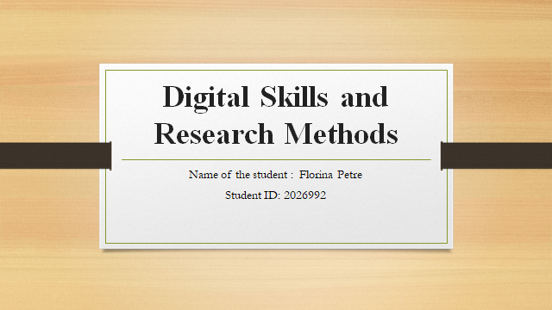
Table of Contents
Introduction 3
DIKW and CRAAP framework on primary data 4
DIKW and CRAAP framework on secondary data 5
Conclusion 9
References: 10

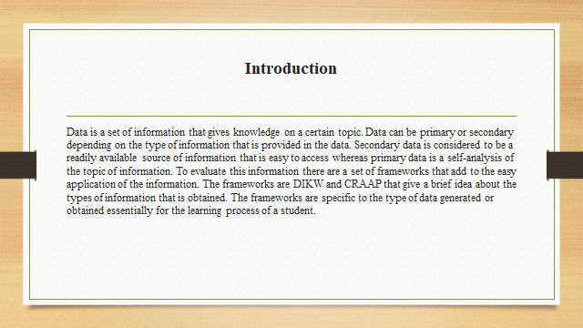

Introduction
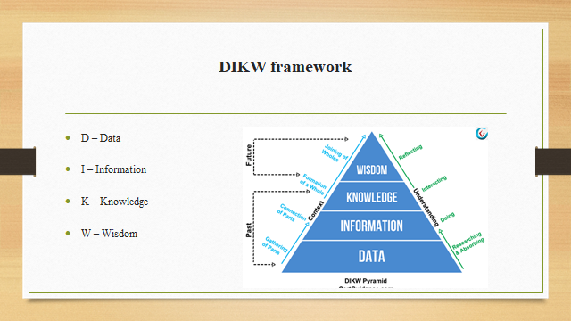
The DIKW framework is a method in which necessary decisions and actions are taken to transform data into information, knowledge, and wisdom. This is facilitated with the help of knowledge management which includes data extraction from different kinds of data. The DIKW framework is often depicted as a pyramidical hierarchy model where data is the base of information, knowledge, and wisdom.
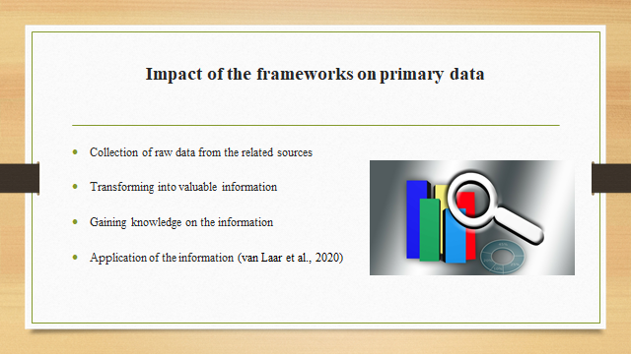
The CRAAP framework is the method of evaluating the worth of the information sources due to the existence of multiple sources that might not be of any use. This framework helps in reducing and eliminating the undesirable and unreliable information through the currency, relevance, authority, accuracy, and purpose factors of the CRAAP framework.
The primary data refers to the data that is collected from resources by an individual for analysis and the secondary data is the collection of data or information that is easily available for the analysis. The CRAAP framework provides various criteria for the evaluation of the sources of primary data where the information collected is evaluated according to the secondary data which is preexisting.
The criteria of currency give information about the timeliness of the data that has been collected. Relevance helps in determining the importance of the collected data according to the needs. Authority helps in identifying the source of information that represents the author and its related information. Accuracy helps in understanding the truthfulness of the collected data according to the primary data. The purpose is the need for the information that exists.

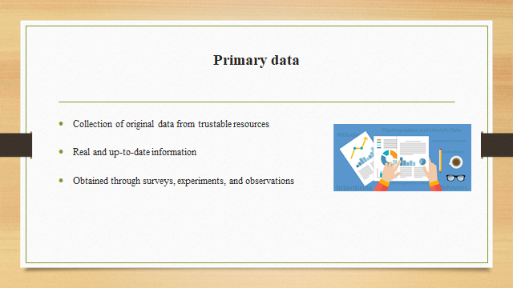

DIKW and CRAAP framework on primary data
The collection of the primary data can be eased with the help of the DIKW framework that helps in gathering, understanding, and storing the data and information. The DIKW framework helps in transforming the data into information, knowledge, and wisdom which can be related to the primary data that is collected by an individual (Hidayat and Suryono, 2020). The CRAAP method also contributes to the understanding of the type of data that has been collected and the reliability of the sources that it has been collected from.
The evaluation of the information includes gathering the data and information that further helps in the learning process. Grit result helps in analyzing the passion and perseverance that will help in the long-term achievement of the goals. High scores in the GRIT test give great achievements that can help in analyzing the intelligence of an individual. The primary data of the academic grit test result helps in the confirmation of the data that has been generated while the collection and gathering of information from various sources (Makhachashvili and Semenist, 2021). This was accelerated by the DIKW and the CRAAP frameworks that helped in the analysis process.

The primary data is collected in a raw and unorganized form that is of most importance when converted to a piece of information. The information is extracted from the raw data and then processed and organized to eliminate the errors and make it more convenient for specific purposes (Hecker et al., 2021). This organized information is understood deeply to use for the achievement of the goals. Finally, the whole knowledge of the information is turned into action that brings wisdom. This way the primary data is confirmed using the DIKW framework.
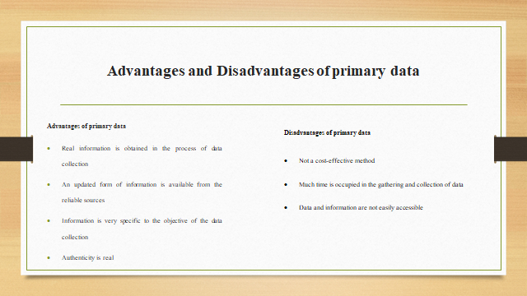
The primary data has the advantage of being real and up-to-date for the authenticity of the data that has been collected. The accuracy is perfect for the primary data as it is obtained from the sources and is specific to the objective of the data and information. There is direct access to the primary data to the subject of the research.

DIKW and CRAAP framework on secondary data
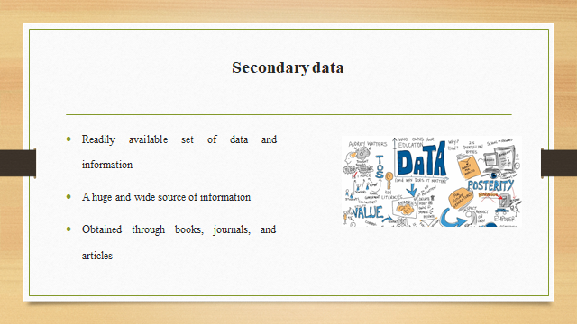
The secondary data is the preexisting data that can be analyzed through the CRAAP framework which determines the genuineness of the data and its sources. This involves a series of questions that helps in the estimation of the currency, relevance, authority, accuracy, and purpose. The availability of the information eases the process of evaluation of the information and the data. It also specifies the information collected in the primary data which is attained with the help of the secondary data (Margevica-Grinberga and Smitiņa, 2021). Hence, it is estimated that the secondary data is dependent on the evaluation of the primary data.
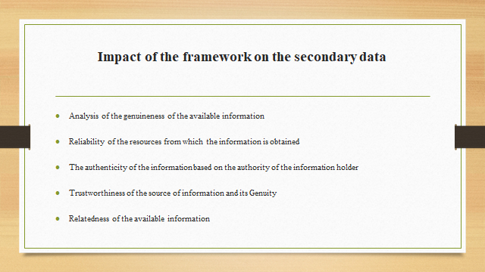
The secondary data when analyzed in the framework was found not to be specific according to the needs of the data information.
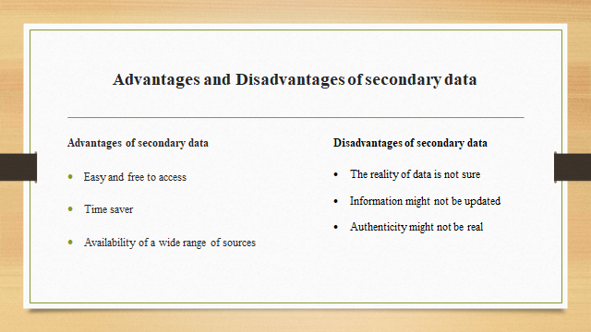
The quality of the data is also not trusted due to not knowing the Genuity of the source which has been collected from some other source. The data collected in the secondary data is about the ideas of the gatherer of the data. The timeliness of the data is unidentified which makes the secondary data not reliable (Černochová et al., 2020). For this, the
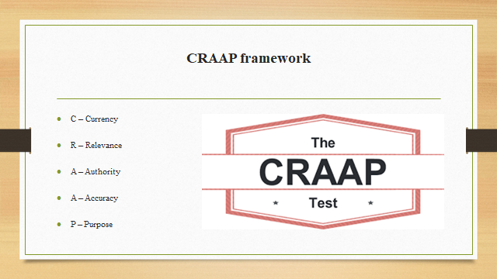
CRAAP framework is a convenient tool for the analysis of the source of information for the secondary data.
The CRAAP framework consists of the criteria of Currency, Relevance, Authority, Accuracy, and Purpose.
The Currency states the reliability and reality of the information that has been provided including the real-time of the information. The information is mainly updated and full of positive and relevant information.
Relevance relates to the authenticity of the information that has been provided. It consists of the reality of the sources if it is reliable or not relating to the originality of the information. A large number of available sources make it hard for the researchers to relate to the topic and get the necessary information (Nqgondi et al., 2021).
Authority is considered to be the trusting factor depending on the source of the information which is related to the author or authority holder of the information. Authority gives the idea of using the information to its full worth derived from a specific source.
Accuracy is the trustworthiness of the sources and the information about how accurate is the information that has been provided to the audience. It can also be clarified with information from other sources.
The purpose of the data or information is necessary to identify the need for the data and information in the research process (Perifanou et al., 2021). The information should be clear enough to identify the intentions of the author to relate it to the findings of the research.
The secondary data can further be divided into internal and external sources of data that have a varied source from which it is gathered. Quantitative data and qualitative data are the two types of data that are dependent on the research standard (Casno and Sloka, 2021). The decision-making process gets eased with the help of gathering the information through the secondary data along with its advantages and disadvantages. The DIKW framework is least applicable in the secondary data due to the preexistence of the secondary data where the gathering of raw data and turning it into information is not applicable.
Although there are certain drawbacks of the secondary data which have been solved with the help of the frameworks there are some advantages in the collection of the secondary data. It can be easily accessed with the help and evolution of advancements in technology. The information that is being gathered from the secondary data is either or very low cost or free to access. Huge time can be saved and managed in the process of the data or information collection in secondary data (Blažič and Blažič, 2020). The data can be collected by anyone that tends to use the information from a wide variety of sources. These advantages when compared to the primary data collection are a disadvantage to the gathering of data in the primary data where there is no easy access to the information or the data, huge amount of time is invested along with non-identification of the sources from which data can be derived.
Work of Angela Duckworth
Angela Duckworth became a research psychologist by noticing the smart and best student in her class. She conducted her research in understanding the achievement of self-control in the life of people. During her TED talk which she delivered in the year 2013 where she had explained the importance and significance of long-term goals for achieving success. Later she discovered the grit technique around the year 2019 which she was working on the whole time.
Her TED talk was considered to be a crucial element in the learning process where students tend to lose track of the other important factors. This has affected the learning process of the students which was also accepted by the believers of the grit process (Biletska et al., 2021). Grit helps in understanding the performance of an individual that is focused on the passion and perseverance of the individual towards the goal which is restricted through the distractions and obstacles significantly. Grit is the constant process of striving towards a goal that is seemingly difficult but can be achieved with the help of dedication.
Angela and her team dedicated themselves to the research of the grit theory where they developed the Grit scale where evaluation is done through questions that are set. The questions are based on the analysis of the questions based on the effort and interest factors related to it. The answering is done based on a scale from one to five. The evaluation of the grit scale helps in the calculation of the grit scores to determine to success rate. Thus, the Grit Scale and the Grit score helps to identify the students' worth in gaining knowledge along with the success rate.
Grit might not be the only characteristic to focus on depending on the success of a student. It is only a method for the development process of a student where the student tends to learn along with correcting the mistakes (Bergdahl et al., 2020). She also demonstrated the factors that had a major role in impacting the learning of the students. The site helps in the estimation of the classroom issues with the evaluation of the purpose, gratitude, and curiosity.
The research helped in creating the best ideas to be implemented for the success of the students and ideas to be implemented during failure to start with the lessons again. She was able to identify a common basis of human nature where students tend to shy away when making mistakes, confusion, and challenge. This nature needs to be handled by the teachers as said by Angela to help the students understand the context that is hard for them.
The teachers need to understand the part of the struggle of the students to solve their problems in the understanding of the context (Antonopoulou et al., 2021). The teachers that tend to start the implementation of grit in the classrooms are encouraged that helps in the development of the students through the learning process where the students are encouraged to correct their mistakes. Angela Duckworth had given an example of a teacher in her interview of Ed Surge where the teacher was able to promote reworks through the easy access to the test binder where the students got their work wrong.

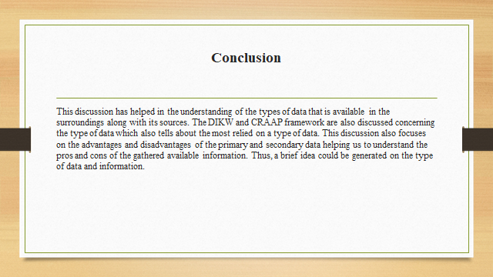

Conclusion
The above report has discussed the DIKW frameworks and the CRAAP frameworks which tell about the different theories through which the type of data and its source can be determined. The frameworks have given an insight into the aspects of the data and the information. The primary data and the secondary data can also be analyzed with these frameworks that have helped in the development of the knowledge of the data. The report also focuses on the effect of DIKW and CRAAP frameworks on the primary and secondary data. It could be analyzed that the DIKW framework was best for the analysis of the primary data and the CRAAP framework is a tool to analyze the secondary data.
There are certain advantages and disadvantages of the frameworks and the type of data that has been collected which helps in the determination of the decision-making process. This report also focuses on the research of Angela Duckworth who has developed the theory of Grit which helps in the analysis of the students. She developed strategies for the success of the students in the growth of the students. The Grit analysis was determined by the Grit scale and Grit score to identify the strength of the students that contributes to the success of the students. Duckworth was also able to encourage the teachers in implementing the Grit theory by helping the students to overcome their part of the struggle.

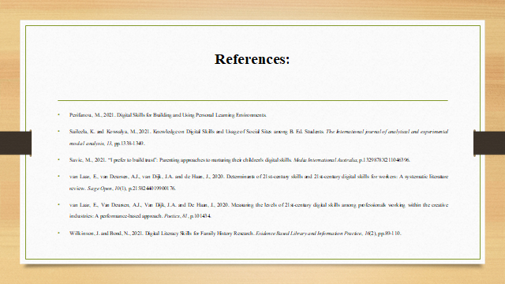

References:
Antonopoulou, H., Halkiopoulos, C., Barlou, O. and Beligiannis, G.N., 2021. Transformational leadership and digital skills in higher education institutes: during the COVID-19 pandemic. Emerging science journal, 5(1), pp.1-15.
Bergdahl, N., Nouri, J. and Fors, U., 2020. Disengagement, engagement and digital skills in technology-enhanced learning. Education and information technologies, 25(2), pp.957-983.
Biletska, I.O., Paladieva, A.F., Avchinnikova, H.D. and Kazak, Y.Y., 2021. The use of modern technologies by foreign language teachers: developing digital skills. Linguistics and Culture Review, 5(S2), pp.16-27.
Blažič, B.J. and Blažič, A.J., 2020. Overcoming the digital divide with a modern approach to learning digital skills for the elderly adults. Education and Information Technologies, 25(1), pp.259-279.
Casno, K. and Sloka, B., 2021. REDUCING SOCIAL STRATIFICATION VIA DIGITAL SKILLS IMPROVEMENT: THE CASE OF SOCIAL ENTERPRISES IN LATVIA.
Černochová, M., Voňková, H., Štípek, J. and Černá, P., 2020. How do learners perceive and evaluate their digital skills?. In Learning and Performance Assessment: Concepts, Methodologies, Tools, and Applications (pp. 1453-1464). IGI Global.
Hecker, I., Spaulding, S. and Kuehn, D., 2021. Digital Skills and Older Workers. Urban Institute, September, 14.
Hidayat, M.R. and Suryono, Y., 2020, February. Empowerment for adults through digital skills enters the era of industrial revolution 4.0. In Journal of Physics: Conference Series (Vol. 1469, No. 1, p. 012070). IOP Publishing.
Makhachashvili, R. and Semenist, I.V., 2021. Interoperable digital skills for foreign languages education in the COVID-19 paradigm. In 15th International Multi-Conference on Society, Cybernetics and Informatics (Vol. 1, pp. 39-44). International Institute of Informatics and Systemics.
Margevica-Grinberga, I. and Smitiņa, A., 2021. Self-assessment of the digital skills of career education specialists during the provision of remote services. World Journal on Educational Technology: Current Issues, 13(4), pp.1061-1072.
Nqgondi, T., Ngomane, I., Mauwa, H. and Williams, Z., 2021, May. An Overview of the Integration of Basic Research and Digital Skills in the High School Curriculum. In 2021 IST-Africa Conference (IST-Africa) (pp. 1-10). IEEE.
Perifanou, M., Tzafilkou, K. and Economides, A.A., 2021. The Role of Instagram, Facebook, and YouTube Frequency of Use in University Students’ Digital Skills Components. Education Sciences, 11(12), p.766.

