Joe Andrew Frohwein (2315545)
Introduction to web and database concepts
Developing an MS Access database for coastal tourism management

1 – The different users who might access the DBMS are:
- Tourists
- Their role is to use the CTMS to book packages
- Their responsibilities are:
- Enter correct and up to date personal information when booking
- Provide feedback for staff to use
- Local Businesses
- Their role is to update the CTMS with their current services, prices, packages, offers etc.
- Their responsibilities are to:
- Ensure information is kept up to date
- Keep coordination with Coastal Getaways

- Staff
- Their role is overseeing operations and managing the CTMS
- Their responsibilities are to:
- Keep information regarding prices and offers up to date for tourists
- Help tourists and local businesses with any queries or required assistance
- Monitor feedback and make improvements based off it

- Database administrators
- Their role is maintaining the CTMS database.
- Their responsibilities are to:
- Control End-user, Conceptual and Physical levels of database
- Control access, authorisation and security of the database
- Discuss and design overall structure and lay-out of database
- Maintain data integrity, consistency and redundancy, as well as data backups and security [1].

2 – The various departments within Coastal Getaways that might require access to the CTMS are:
- Administration / Management
- Needs access to whole system to oversee entire range of operations
- Needs access to whole system to provide support to each department
- Must monitor system and ensure application is running as designed and intended
- Must relay information to the system analysts, programmers and database administrators
- Marketing / Sales
- Needs access to sales records to tailor future marketing to most popular destinations
- Needs customer and sales records can help them to contact past users to offer them new deals
- Must update system so that sales representatives can access each other's sales information
- Customer services
- Needs access to customer and sales records to assist customers with their requirements
- Needs access to customer records to send follow-up emails after orders are placed
- Must update system with any changes made whilst serving a customer
- Accounts / Finance
- Needs access to sales records to extract financial information
- Needs access to customer records to keep track of payments/credit
- Needs access to managerial data to update progress to targets
- Must maintain database and update swiftly to maintain data integrity and accurate finances
3 – Entity Relationship Diagram for the Coastal Tourism Management System:
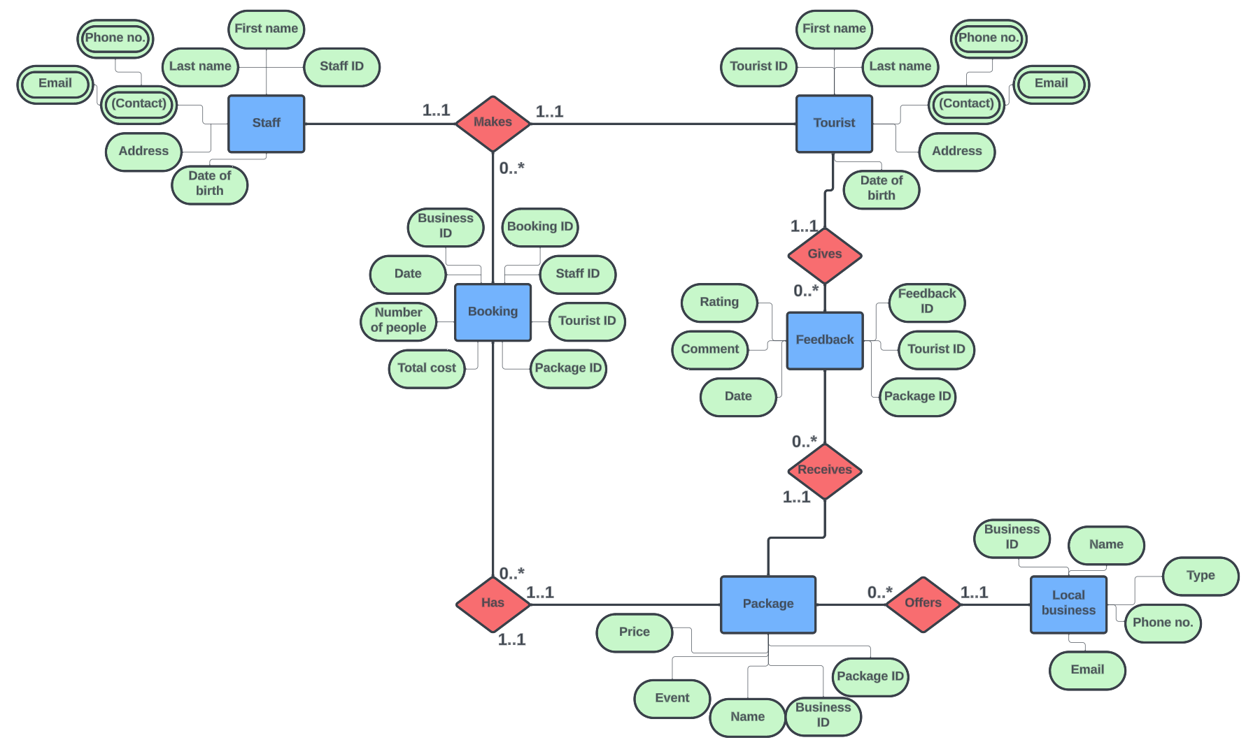
Entities and attributes:
Tourists are the customers and therefore are an entity. The Tourist table will have ‘Tourist ID’ as its primary key, as well as general information such as ‘First name’, ‘Last Name’, ‘Phone number’ etc.
Staff are the employees at Coastal Getaways. The Staff table will have ‘Staff ID’ as its primary key, as well as, similarly to Tourists, having general information such as ‘First name’, ‘Last Name’, ‘Phone number’ etc.
Packages are the experiences that can be booked as part of a Coastal Getaways package. The Package table will have ‘Package ID’ as its primary key, with additional information such as ‘Name’, ‘Type’ and ‘Price’, as well as ‘Business ID’ as a Foreign key to show which business offers the package.
Local Businesses are the companies in Wales that run the events and accommodation for the tourists. The Local Business table will have ‘Business ID’ as its primary key, with additional information such as ‘Name’, ‘Type’ etc.
Bookings are the records and details of what a tourist and staff member will book together. The Booking table will have ‘Booking ID’ as its primary key, with other primary keys present (Tourist ID, Staff ID, Package ID, Business ID) as foreign keys, as well as general booking information such as ‘Total Cost’, ‘Date’ and ‘Number of People’.
Relationships:
One Tourist and one Staff MAKES a booking together. However, one Tourist and one staff could make many bookings, hence the ‘0..*’ multiplicity.
One booking HAS one Package associated with it. However, there could be multiple bookings with the same Package.
One Local Business OFFERS Packages. However, one Local Business can offer multiple Packages.
One tourist GIVES Feedback, and one Package RECEIVES Feedback. However, each Tourist can give multiple reviews, and each Package can receive multiple reviews.

4 – Relational Database Schema:
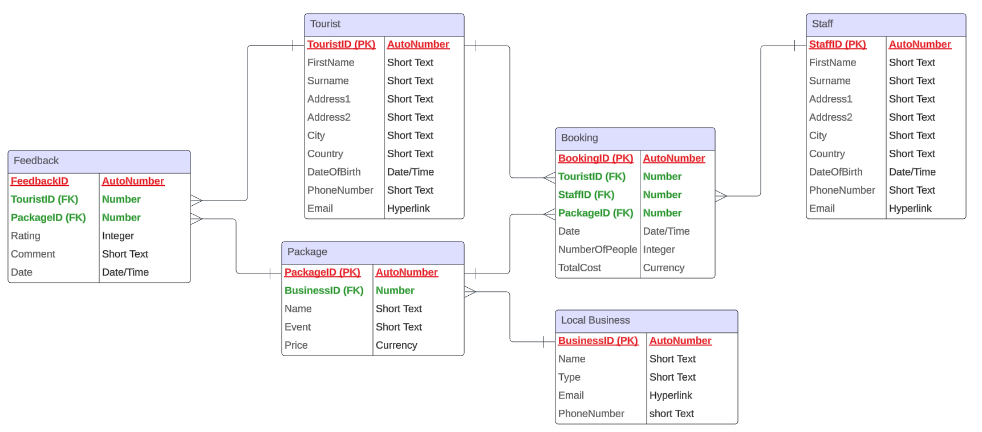
In the Relational Database Schema above, each table and field can be seen, also showing the Primary keys, which are coloured in red and labelled with ‘(PK)’, and the Foreign keys, which are coloured in green and labelled with ‘(FK)’.

5 – Application of Database Management System
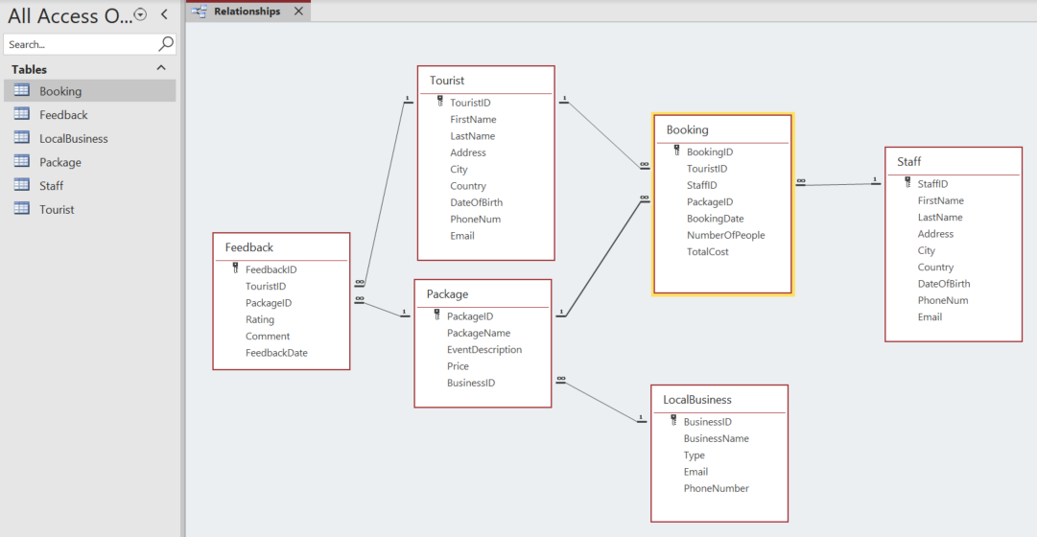
The above image shows the previous schema’s tables, entities and relationships created within a database in Microsoft Access. Below are some screenshots showing the tables in my database.
Booking table:
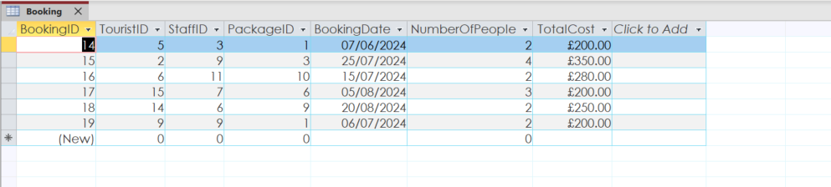
Feedback table:
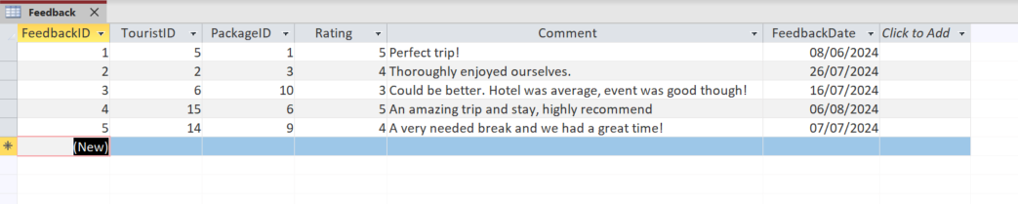
Local Business table:
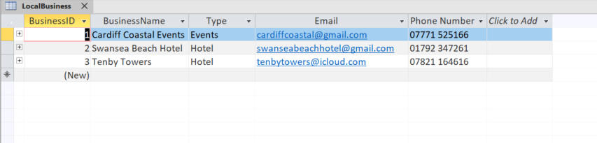
Package table:
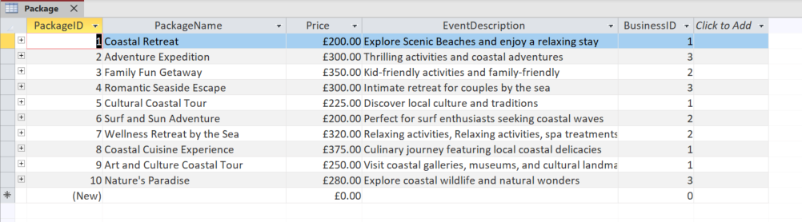
Staff table:
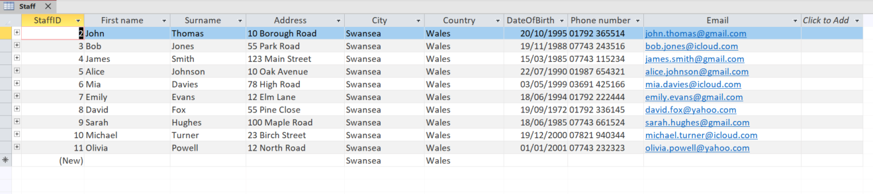
Tourist table:
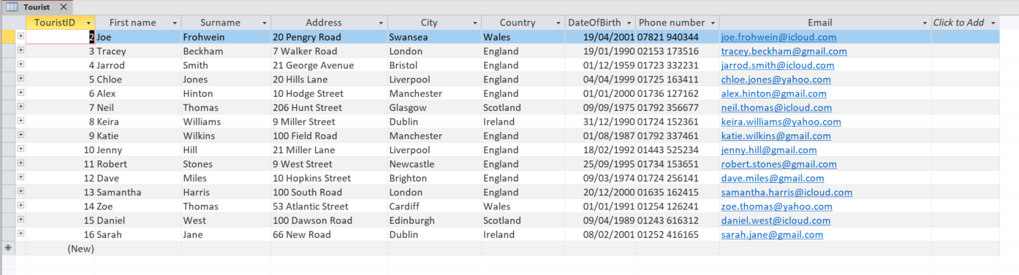

6 – Reports design
a) Revenue report
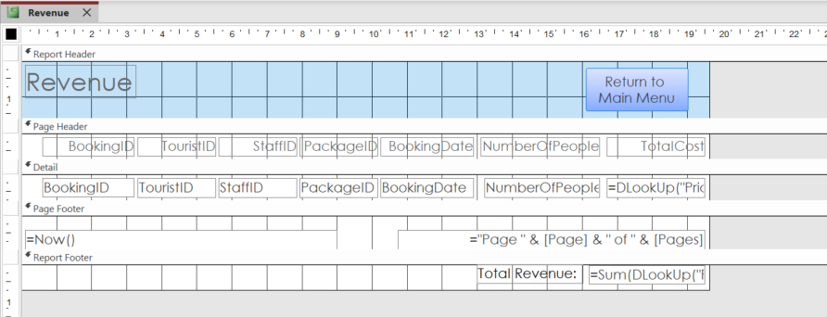
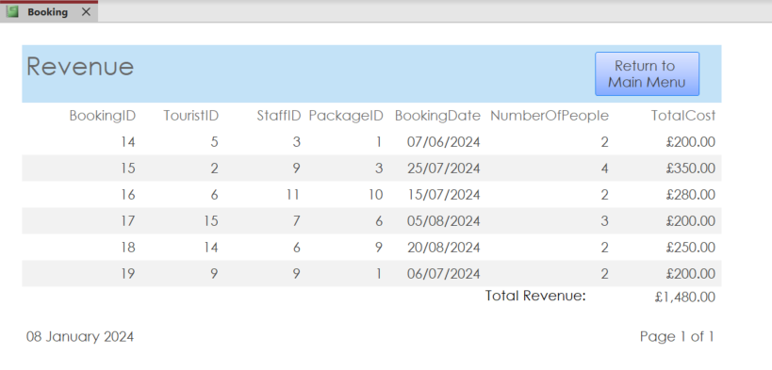
This report displays the information of each booking, including it’s TotalCost, and then sums together all of the TotalCost values to give a total Revenue value for Coastal Tourism, which can be seen in the footer.

b) Feedback report
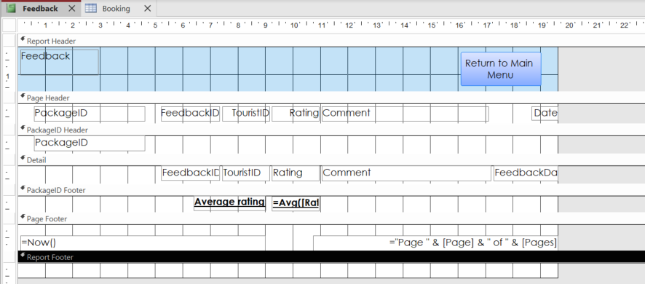
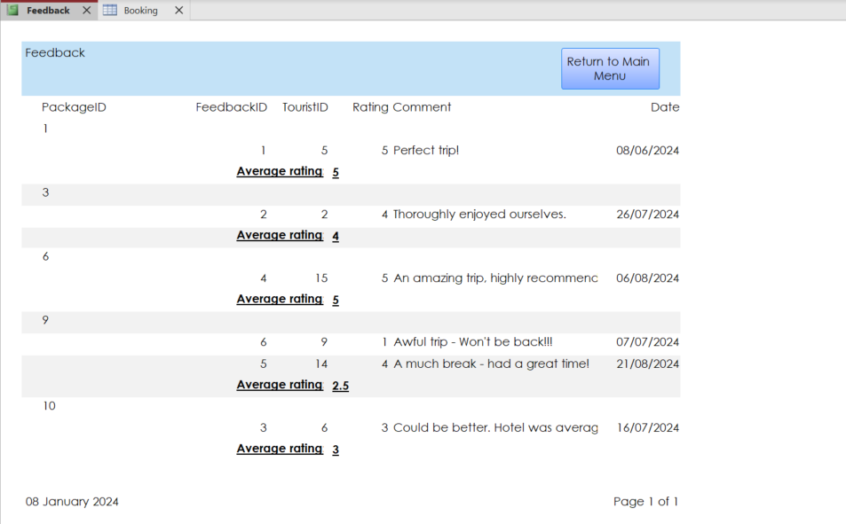
This report displays all feedback from the Tourists for the Staff to read and make improvements in. The data is grouped by PackageID for easy evaluation, and also gives an average rating of each Package below each group.

7 – Forms design
a) Reservation form for Tourists
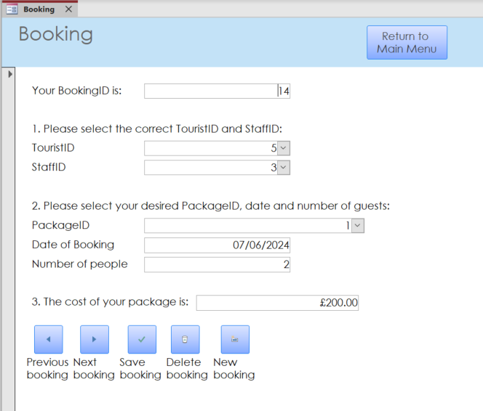
This form allows a Tourist to create a booking using a friendly interface. Using Comboboxes to select information.
There is validation on the form too. When selecting a date, the input is validated using ‘>=Now()’ to ensure that the entered date is either today or a later date. This prevents the user from creating a booking for a day which has already passed. Also, when entering a value for ‘Number of people’ the default value is 1 and the validation is ‘>0’ to ensure there is at least 1 guest on the booking.
The buttons below allow navigation and form operations to be performed.

b) Events form for Local Businesses
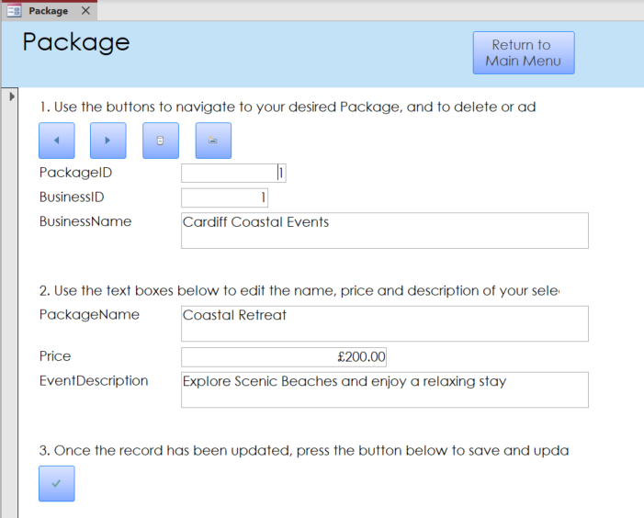
This form allows Local Businesses to access and update their packages’ information, using the buttons to navigate to the record and the textboxes to edit the data.

8 – User-friendly menu
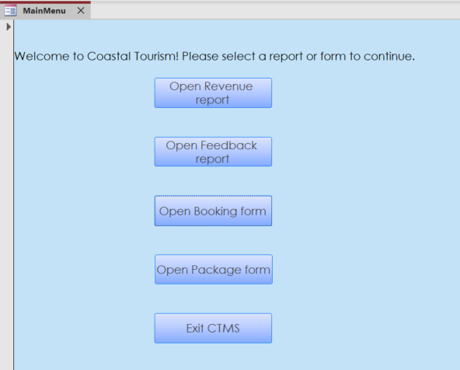
The above screenshot shows the main menu navigation form that I implemented so the user would have user-friendly buttons to navigate through the various forms and reports easily.
This menu displays immediately after opening the database. I did this using the setting which can be seen in the screenshot below.
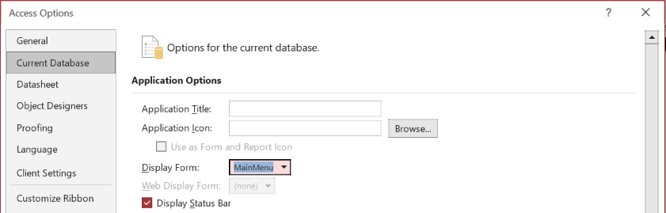

9 – A database can improve the efficiency and effectiveness of managing Coastal Getaways by:
- Increasing speed of retrieval
- A database can be used to quickly and accurately search for a specific customer record, or all bookings to a specific location, or availability for a specific date
- The ability to do this quickly can save time and, for example, customer services could serve a customer more efficiently than without a DBMS
- Improving data integrity and consistency
- Data integrity and consistency ensures data is accurate and reliable, and consistent.
- Coastal Getaways could have multiple branches/locations with lots of staff, so the ability to access data from a centralised location would ensure that each branch has complete, up-to-date information, which would improve the speed and efficiency of operations
- Improving data security and access control
- A DBMS improves security by implementing data encryption and access control
- By only allowing users the amount of access they require, it would prevent unauthorised users from accessing sensitive information (e.g., a customer would not need access to Coastal Getaways’ financial information) and would be very effective in protecting the company’s data
- Increasing scalability and flexibility
- This is the ability to withstand increasing amounts of data and users, which means the DBMS could be adapted and edited without losing its core purpose and uses
- The brief states “The coastal tourism sector has witnessed significant growth” which means they will require a DBMS which is scalable and flexible to allow easy upgrades.
- Reducing data redundancy and duplication
- A DBMS can be used to eliminate data redundancy and duplication by storing data in a structured way
- Coastal Getaways will benefit from this as, again they could have multiple branches with lots of staff, so this prevents duplication of data, which will also save them storage space hopefully helping their system to run at a higher speed and efficiency [2].

10 – A manual database is a collection of files stored in filing cabinets or a management system. The main drawbacks of this type of system, and the benefits of transitioning to a computerised system are:
- Physical space
- A large physical filing system would be required to store all Coastal Getaways’ data in. In addition, there would likely be a lot of data duplication between branches so this would make the physical storage even more wasteful and therefore less efficient
- This is unnecessary as transitioning to a DBMS would require no on-site space as it would all be stored on external storage or on the cloud, which would save space in Coastal Getaways’ office.
- Manual data entry and storage
- As data in a manual system is paper-based, data entry would have to be done manually. This could lead to human error during data-entry, as there would be no constraints, or during storage, as documents could be stored in incorrect files.
- This wouldn’t happen with a DBMS as data is all inputted and stored digitally, with plenty of checks and constraints to aid accurate data entry, and a well-defined layout ensuring data is stored correctly
- Time consuming
- A manual system is generally very time consuming. Finding the correct file in a cabinet, producing and printing any type of output/report, or inputting data into the system all take too much time
- Transitioning to a computerised system would cut down on all this wasted time as files are available to be accessed easily and quickly, reports can be produced much quicker, and data entry is accelerated due to a database’s speed of operations
- Lack of security
- A filing cabinet in an office could be left open/unlocked allowing any unauthorised staff to access its contents
- A computerised database would have different levels of access for specific staff, as well as encryption and authorisation to protect the sensitive data from the wrong users within Coastal Getaways
- Lack of remote access
- Paper-based documents are obviously not accessible remotely, which can cause lots of problems for Coastal Getaways, with staff who could need to access data while in another branch or working from home
- A DBMS would allow a user to remotely access whatever data they require from anywhere. [3]
The challenges of transitioning to a new computerised system are:
- Complexity of the new system
- The new system would be more complex and therefore require significant planning to design, as well as training for all staff to use it, which are both very time consuming and costly
- However, hopefully in the long run the improved speed and performance of operations on the new DBMS would address and earn back the lost time and make it a small loss for a much bigger, longer gain
- Downtime
- When transferring to the new system, there may be a time where the file-based system is redundant, but the computerised system is not up and running yet (due to the existing data being inputted), which would result in downtime for Coastal Getaways
- Again, the short downtime would be worth it for the greater speed and efficiency of the new system
- Cost
- A new DBMS can be quite expensive for a company to buy. It would obviously be more expensive than the pre-existing file-based system, alongside the above-mentioned time costs
- However these costs would hopefully become cost-effective in the long run, as the standards and performance throughout the business improve and more sales and business is brought in because of the improved organisation and efficiency from the DBMS.

References

[1] | M. Jain, "What are the Different Types of Database USers in DBMS?," Scaler Topics, 13 12 2022. [Online]. Available: https://www.scaler.com/topics/database-users-in-dbms/. [Accessed 29 10 2023].
[2] | "Advantages of Database Management Systems," GeeksForGeeks.org, 20 11 2019. [Online]. Available: https://www.geeksforgeeks.org/advantages-of-database-management-system/. [Accessed 30 10 2023].
[3] | "Advantages of DBMS over File systems," GeeksForGeeks.org, 31 10 2017. [Online]. Available: https://www.geeksforgeeks.org/advantages-of-dbms-over-file-system/. [Accessed 31 10 2023].

