University of Wales Trinity Saint David

Wales Institute of Science and Art


Engineering Technical Report

Workshop and Practice (ACHA4011)

Chloe Rees
2218480
November 2023
Table of Contents
Introduction 2
Chapter 1 3
Health and Safety with Risk Assessments 3
Chapter 2 4
Engineers Role in Society 4
Chapter 3 5
Problem Solving 5
Chapter 4 6
Team Structure 6
Chapter 5 7
Personal Development Plan 7
Conclusion 8
References 8
List of Tables 9
Table of Figures 9

Introduction

This report will be looking at different and important aspects of engineering such as health and safety, problem solving team structure and the role that engineers have in society. The aim of this paper is to evaluate different things that is essential in the life of an engineer. This will be carried out by researching various sources to gather information about the aspects started above.

Chapter 1

Health and Safety with Risk Assessments
An activity that engineers carry out daily is an engine build, this task requires a very strict health and safety rules.
The Health and Safety at Work Act 1974 saw the biggest change to the legislation, meaning that all employers must maintain duties of health and safety within the workplace. Along with the Work Act 1974, Control of Substances Hazardous to Health (COSHH) was introduced in 1988. Its primary goal is to lower occupational illness by laying out a straightforward framework for managing hazardous substances in the workplace. This was introduced to identify dangerous substances that hasn’t been recognised and to add another layer of safety around the workplace (Vaughan, 2020).
Health and Safety surrounding working on engines includes lifting heavy parts as regulations has limited this to a maximum weight of 25kg for men and 16kg for women. HSE has stated that when lifting e.g. an engine block or a crankshaft it is important to hold the heavy load in front and close to the body (Good Handling Technique, 2023)
PPE should be provided by employers under the Personal Protective Equipment at Work Regulations 1992. It’s important to wear appropriate PPE in the workplace because it protects workers from injury. Examples of PPE in the workplace include a hi-vis jacket, eye and ear protecting, safety hat and boots, boiler suits and gloves. When working on engines gloves and a boiler suit could be considered optional in certain workplaces, whereas safety boots are an essential as it involves working with heavy part that have a possibility to drop something (Kendall, 2023).

There are many risks that could cause injury when working on an engine. Table 3 shows multiple different risks that could occur during this task, tables 1 and 2 show what is the likelihood and severity of that risk happening.

Risk Matrix | Insignificant | Minor | Moderate | Major | Severe
Almost Certain | 5 | 7 | 8 | 9 | 10
Likely | 5 | 6 | 7 | 8 | 9
Possible | 3 | 5 | 6 | 7 | 8
Unlikely | 2 | 3 | 5 | 5 | 7
Rare | 1 | 2 | 3 | 4 | 5
Table 1- Risk Matrix
Risk | Risk Level
1-4 | Low Risk
5-7 | Medium Risk
8-10 | High Risk
Table 2- Risk Level
Risk | Injury | Mitigation | Risk Assessment Level
Getting fingers stuck on rotating parts when dismantling or rebuilding the engine | Cuts and bruises | Avoid moving parts | 6
A tool falling and causing injury | Cuts, bruises, or broken bones | Have a good grip on tools | 7
The engine stand moving and hitting someone | Bruises | Have someone supporting the stand | 5
Hitting hand with mallet/hammer | Bruises, broken/fractured bones | Hit hammer slowly | 6
Tripping/falling over the engine stand | Cuts and bruises | Look where walking | 5
Lifting heavy parts | Back pain due to incorrect posture | Avoid lifting or use correct posture | 5
Assembly errors | Mechanical issues | Create a list of what has been done already | 7
Table 3- Risk Assessment

Chapter 2

Engineers Role in Society
Engineers have an extremely significant role in society, such as looking at new technology, manufacturing structural buildings or looking at software and data. All engineers are expected to uphold a strict code of conduct that is expected to be followed. Global warming has become a bigger issue and companies must now find way to become more sustainable as the government has made new targets for the future.

One organisation that declares a code of conduct for engineers is Formula 1. Formula 1 has one of the strictest code of conducts that all parties involved must follow. As the government makes targets to become a greener planet F1 must follow as it produces high amounts of emissions. About 256,000 tonnes of CO2 are produced annually by F1, with the logistics of transporting the race setups around the globe 23 times a year accounting for 73% of these emissions (Singliarova, 2023). The Formula One code of conduct states plans that it has in place for the future that engineers must attempt to achieve. A main target for F1 is to reach a net zero carbon footprint by 2030 (Code of Conduct, 2023). In order to accomplish this the engineers must find a way to use 100% sustainable fuels by 2026, which should reduce CO2 emission by 85-96%. F1 has also adapted a new season calendar in order to have races in the same continent closer as this would lower its carbon footprint (Barretto, 2022).

Another organisation the produces a code of conduct for engineers is Ford. The manufacturer has already unveiled the Mustang Mach-E in 2021 and has more plans for electric vehicles in the future. Ford already has plans in order to become more sustainable and environment friendly as they state to “conserve energy, minimize emissions and waste, use sustainable water strategies, use recycled and renewable material, and follow Ford procedures designed to safeguard the environment along the lifecycle of our products” (Human Rights and the Environment, 2023). In order to tackle these goals engineers at Ford must find a way to be carbon neutrality by 2050 and use 100% carbon free electricity by 2035 (Integrated Sustainability and Financial Report 2023, 2023).

Chapter 3

Problem Solving
Engineers will encounter many situations that requires them to think outside the box. When developing a new vehicle or product engineers will most likely be faced with an issue either found during the development, on the market or a supplier issue in the production process. (Jones, 2003) States “The problem needs to be worked out by the individual using skills and strategies that can solve their problem”. In order to become a good engineer, it is crucial to have the skills and think of different strategies to overcome a problem.

When looking at issues found in the development process of a car, there are many things that will not work such as a part has failed or doesn’t fit when building the car. By understanding the problem, it can lead to solving the issue much easier. Problem solving techniques that can be used is to define the problem by diagnosing what the issue is and examining the root cause of the issue. To follow up the issue it is best to look at an alternative part by engineers discussing what is the best option and to test the part and complete a data analysis. Having a key date of when this issue will be resolved will give engineers enough time to plan the alternative option and look at more research that can help fix the problem (What is Problem Solving , 2022).
Once a vehicle enters the market to the public there is a chance that something would have failed. To solve this problem quickly manufactures will simply recall the car from the public, this could be due to design-related defect or a manufacturing defect (Ni, John & Huang, Xiaowen, 2018). A customer analysis is the best way for manufactures to understanding the problem and to figure out what is the next step of the solution. Software engineers can create a remote update for consumers.
During the production process of a vehicle the supplier might have an issue and cause the production to slow down or stop all together. Suppliers could have an issue with sourcing the product, therefore engineers will need to look for other alternatives of the part. Manufactures should also have a back up supplier and a supplier from a stable reign in the world. If supplier is having shipping issues, it is also best to look at another shipping methods beforehand (Freiman, 2022).

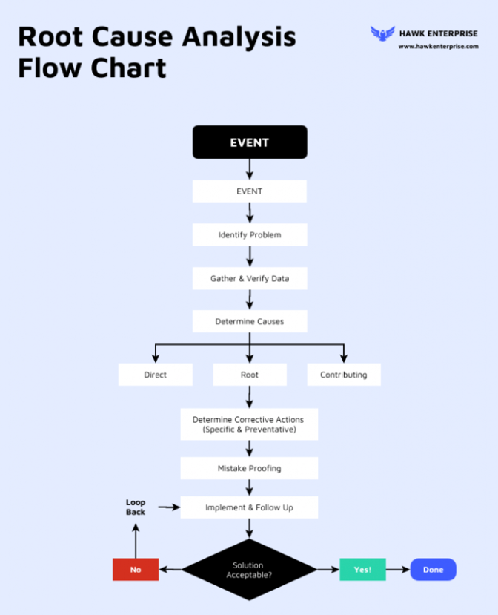

Figure 1- Flow Diagram (Ramuthi, 2023).

Chapter 4

Team Structure
Communication is key when working in a team, as engineers they would need to tell others about important data, how to change a broken part on a car or how to put a desk together. When taking on the Duke of Edinburgh Award it was my first insight of how important team working was. I have had previously worked in a team when doing group work in Welsh baccalaureate lessons in school, however the team bond was strong, and communication was not there. When participating in DofE there was not a time when there was complete silence, as I was quite confident with coordinates and map skills, I volunteered to read the map which is one of the important roles as I could easily lead my team to get lost around the Gower. It was crucial for me to deliver the correct information of the direction we were going to my teammates as we could easily take the wrong path. The terrain under our foot was sometimes very bumpy and rocky, so as a team we would always help and communicate with each other to find the best route to tackle the obstacle that was ahead. At some points myself and others were starting to become more exhausted due to heat and the heavy load we were carrying, therefore at this point communication did start to become weaker. As a team we all worked together to set up the tent as there was many parts, we had to make sure were correct. I started to lay everything out so we could see what parts we were working with. Others in my group were working together and having to communicate when the poles might have gotten stuck. Everyone was telling each other what they were doing as there would not be any confusion and to make sure everyone was doing something to help. As the tent was quite heavy, we had split all the part amongst the group, so it was extremely important to communicate and say what parts everyone had with them. In the morning when taking the tent down I had made a note on my phone stating all the parts that everyone was carrying as this would help us when we gave it back to the school.
By doing DofE it really helped me understand the importance of working in a team and communicating because I know that without everyone communicating everything would have been harder to complete. I also improved my problem-solving skills as I had to think of ways to cook the food and making my way through muddy and rocky areas around the Gower. Without realising at the time these skills that I had used would be extremely beneficial for me in the future as being an engineer these skills are the most important and are used every day.

Chapter 5

Personal Development Plan
Name- Chloe Rees
Degree- BEng Motorsport Engineering
Pervious Qualifications- A*-D GCSE and A-D A-levels
Previous Experience- NA
Long Term Goals (5 to 10 years)
Have a Job in the Motorsport industry.

Short Term Goals (0 to 5 years)
Graduate UWTSD with a 1st Class degree in Motorsport engineering.
Go travelling around South America.
Expand my geography knowledge.
Goal | Objective | Resources Required | Measurement | Target Date
Graduate UWTSD | To get a pass mark | Effort and Commitment | End degree mark | 2026
Travelling | To travel around South America | Money and Time | Countries visited | 2027
A job in motorsport | To get a job | Commitment and Time | Work for a motorsport team | 2028
Expand my geography knowledge | Look at different course about different subjects | Commitment and Time | How much I have learnt | 2026

Conclusion
Overall, this technical report shows the importance of an engineer’s life and how they have to be spot on with the data collected and communicated, how important it is to have a strong team structure that includes having reliable and trustworthy team members. Also, how engineers have to think outside the box to solve issues on vehicles or a buildings structure. Without thinking engineers are needed in today’s society as mostly everything has a role where an engineer is required.

References
Barretto, L. (2022, September 28). Net Zero Carbon: How Formula 1 is going to meet this ambitious target by 2030. Retrieved from amp.formula1.com: https://amp.formula1.com/en/latest/article.net-zero-carbon-how-formula-1-is-going-to-meet-this-ambitious-target-by-2030.5QsK9NpYbz7pXp7423I3iJ.html
Code of Conduct. (2023, November). Retrieved from Formula 1: https://www.formula1.com/content/dam/fom-website/manual/Misc/f1_code_of_conduct/F1_Code_of_Conduct_7_November_2023.pdf
Freiman, A. (2022). Has Your Business Been Hit Hard? 8 Tips on How to Solve Supply Chain Problems. Retrieved from Patriot: https://www.patriotsoftware.com/blog/accounting/how-to-solve-supply-chain-problems/
Good Handling Technique. (2023). Retrieved from hse.gov: https://www.hse.gov.uk/msd/manual-handling/good-handling-technique.htm#:~:text=Keep%20the%20load%20close%20to,Adopt%20a%20stable%20position.
Human Rights and the Environment. (2023). Retrieved from coporate.ford.com: https://corporate.ford.com/operations/governance-and-policies/code-of-conduct/en/index.html#/lessons/Oft9MNoz6oPlrNUNcBOlvg94yn2umdrr
Integrated Sustainability and Financial Report 2023. (2023). Retrieved from coporate.ford.com: https://corporate.ford.com/content/dam/corporate/us/en-us/documents/reports/2023-integrated-sustainability-and-financial-report.pdf
Jones, C. (2003). Problem solving--what is it? Cheryl Jones reminds us of the underlying principles of problem solving and why they play an important role in our work with students as we learn mathematics together in a 'community of thinkers'. The Australian Association of Mathematics Teachers, Inc.
Kendall, P. (2023, January). PPE: A Complete Guide to Legislation and Equipment. Retrieved from uk.rs-online.com: https://uk.rs-online.com/web/content/discovery/ideas-and-advice/ppe-guide#
Ni, John & Huang, Xiaowen. (2018). Discovery-to-Recall in the Automotive Industry: A Problem-Solving Perspective on Investigation of Quality Failures. Wheat Ridge: John Wiley & Sons, Inc.
Ramuthi, D. (2023, August 10). Retrieved from Venngage: https://venngage.com/blog/problem-solving-flowcharts/
Singliarova, P. (2023, January 17). Sustainability and F1: Strive to Survive? Retrieved from impakter.com: https://impakter.com/sustainability-and-f1-strive-to-survive/#:~:text=The%20report%20stated%20that%20F1,1%2C%202%2C%20and%203.
Vaughan, V. (2020, January). What Does COSHH Stand For? Retrieved from Manutan: https://www.manutan.co.uk/blog/coshh/what-does-coshh-stand-for/#
What is Problem Solving . (2022). Retrieved from asq.org: https://asq.org/quality-resources/problem-solving#Process

List of Tables
Table 1- Risk Matrix 4
Table 2- Risk Level 4
Table 3- Risk Assessment 4

Table of Figures
Figure 1- Flow Diagram (Ramuthi, 2023). 5

Word count = 1880

