Awe and wonder- science, mathematics and the outdoors.

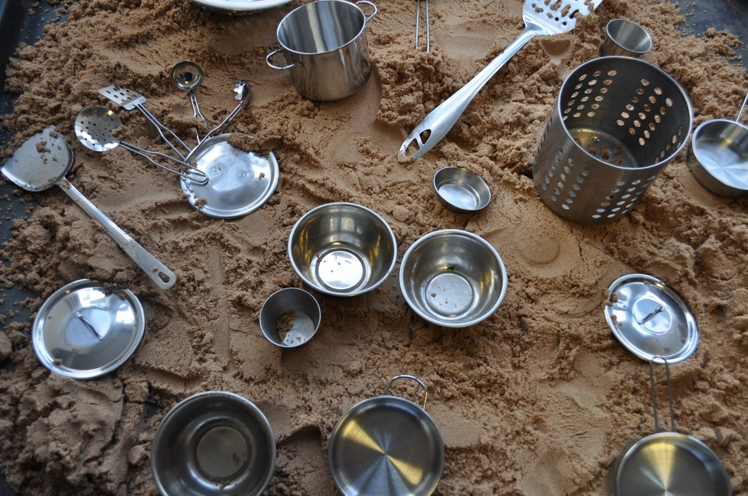
Task 1:
Image 1- Pinterest, No Date

Task 2:
These outdoor play activity’s that I am about to discuss, represent the importance of using sciences and Mathematic in the outdoors. They also display how the New Curriculum for Wales support practitioner into guiding them to teach children how to use core subjects in the outdoors and how it can support their holistic development.
Firstly, we need to ensure that we have done a risk assessment of the outdoor area that we are using for our outdoor play activities to ensure that they are no harmful risk that could put the children in any danger. Also, we need to ensure that the area is enclosed so that the children can not escape from the area, to ensure that this is done successfully as a school we need to have enough practitioners to be able to observe the children throughout these activities to ensure that they are safe and to support the children in anyway possible.
Each practitioner had small groups of children, in my group there were 8 children, and every child was 5 years old.
The children are preparing to outdoors, they start by putting their overalls, wellies, and coats on, the children found the outdoor equipment in a small room by the classroom. A practitioner observed the children while they were putting their outdoors equipment on.

Activity 1:
One of the children asked, “Miss, do you think that all the pots and pans will be filled up with water because of the rain?” I said to the children, “Shall we go outside and have a look?” The children were very enthusiastic about going outdoors in the rain.
The children lined up single file, waiting to go outside into the yard. The children ran to the sand area where all the pots and pans were lying face down. I heard one of the children say to another child, “Should we turn the pots and pans upwards to see if the rain will fill the pots up with water?”
The children watched carefully and observed the rain rushing into the pots. Suddenly, the children listened to the sounds that the water was making. One of the children noticed and said, “Look! Everyone can hear the different noises that the water is making.” When the child said this, I asked them all as a group why they thought that the water was making different noises each time it fell into the pots and pans. The children all looked at each other and paid close attention to why this was happening.
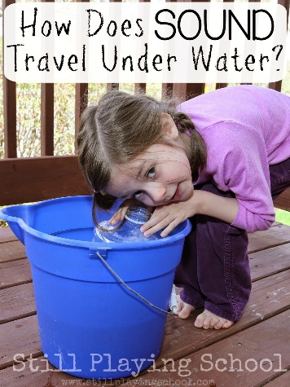
After this, I then explained to the children that these noises are known as sound waves, which mean that the sound of water vibrates and travels through the air to your ears. All the children looked so interested; one of the children asked if they could do more research on sound waves when they went back to class. I noted that the children were interested in this, and that I was able to use more of the outdoor area to teach science and mathematics.
Image 2- Artofit, 2024

Activity 2:
The children then turned towards me and asked, “Miss, can we get a timer so that we can see how long it takes each pot and pan to fill up?” I pulled a stopwatch out of my coat and gave it to the children; the children then proceeded to try and work out how the stopwatch worked. The whole group worked as a team, and then suddenly one of the children understood how the stopwatch worked.
I then asked the children, “What is the stopwatch showing you?” One of the children answered back and said, “It is showing us numbers, and the digits are going up.” The children watched the stopwatch and counted aloud, starting with “1, 2, 3, 4, 5, 6…” The children stopped counting, as they struggled to count above 20.
When I realised that the children were struggling with the next number, I knelt to their height and asked the children what the first number was. The children then replied by saying “two.” Next, I asked the children what the second number was, and they replied by saying “one.”
Suddenly, one of the children said, “Miss, is it 21?” After this, I praised the child and said, “Well done!” After we finished outside, I said to the children, “When we go back to class, we can learn our numbers from 20 to 60, so that it can help us read the stopwatch.” One of the children turned around and said, “Miss, we also have to look at minutes and seconds.” Another child asked this child, “Why?” The child responded and said, “This helps us read how long it took for the rain to fill up the pots and pans.”
The children found another interesting area to play with while they waited. An hour later, the children returned to this activity to see if they could see any progress. One of the children shouted excitedly to the other children, “Look! The pots and pans are all full of water. Shall we look at the stopwatch?” The children ran over to the stopwatch. They said, “Look, Miss, it has taken a whole hour for all the pots and pans to fill up.”
One of the children realised that one of the pots had a hole in it. They asked the group, “Why is there no water in the pot that has a hole in it?” One of the children said, “It’s because the water cannot stay in the pot if there’s a hole in it; all the water will fall out.”

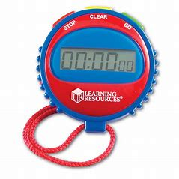
Image 3- Primary ICT, No Date.

Activity 3:
After the second activity, the children decided to try something else. I saw all the children gathered around the kitchen utensils. As I observed, I noticed that the children were drawing around the pots and pans. The children then just stared at what they had drawn on the sand.
To engage with them, I asked the children a question: “What have you drawn on the sand?” One of the children replied and said, “We have drawn a circle.”
After this, I asked the children, “What is a circle?” All the children looked at the circle and discussed what they thought a circle was. One of the children jumped up from the ground and said, “Miss, a circle is a type of shape.” I praised that child with positive words.
Then, I asked the children what other shapes they could think of. One of the children picked up a kitchen utensil and started drawing a shape.
As I observed the children carefully, I asked them, “How many sides does that shape have?” The children started counting the sides of the shape. They counted aloud together while tracing the kitchen utensil on the sand. Together, the children counted, saying, “One, two, three and four.” Then, the children looked up at me and said, “Miss, look! There are four sides to this shape.”
Then, I asked the children what type of shape they had drawn on the sand. When I said this, one of the children pointed to our classroom window and noticed that the shape they had drawn resembled the window. The child also noticed that the window had four sides as well. I praised the child for recognising this similarity.
I then noticed that the children were still drawing a square. I asked the children, “What is the name of this shape?” One of the children said, “Miss, this shape is called a square, as on television I watched a programme that teaches us all about different shapes.”
While the children were still drawing on the sand, I decided to set them a challenge to see if they could draw a triangle. I asked the children, “Are you able to think of different items that look like a triangle?” One of the children began to draw a triangle. Then I asked this child, “What type of items look like a triangle?”
All the children began thinking, and one of them shouted, “Miss, a pizza slice has three sides, which means it is a triangle shape!”

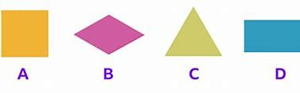

Image 4- BBC, 2021.
Task 3 – Risk Assessment:
RISK BENEFIT ASSESSMENT

Location / Activity: | Outdoor area of the school | Date: | 15/03/25
Assessor: | Miss Beca Mair Havard Hiscocks | Review date: | 25/03/25

Experience exploring outdoor space in photograph | How will young people BENEFIT from this activity? | Hazards and associated risks | Who is at risk? | PRECAUTIONS in place to reduce the risk of injury | Overall risk after precautions  RATING: L/M/H
Walking on uneven surface of sand | Will help children become aware of their balance.  Allows children to become aware of their own body.  Children become aware of different surfaces | Children may lose their balance due to uneven surfaces on the school yard. This may lead to a child falling over which can lead to the person cutting themselves, bruising or even breaking something. | Children and adults | Make children aware of then uneven surfaces when they go outside.  Make children aware that the weather conditions can impact how slippery and uneven the surfaces may be outside.  Tell children to walk slowly around the area to ensure that they are aware of the surroundings. | Medium
The weather outside. | Making children aware of vocabulary that a practitioner may use to describe the weather.  These vocabulary may be cold, wet, windy, sunny, raining and storm.  Children should become aware of the risk of these different weather conditions.  Practitioners should allow children to learn about the weather, such as showing children the weather app. | If the weather is cold and there is also a lot of rain, children may become cold and some children may be sensitive if their clothes become wet.  Sun exposer may also cause children to burn or even worse children may have a sun stroke.  Having a storm can also lead to branches and tree falling on the floor. This can obstruct the children from the activity. | Children and Adults | Practitioners should monitor the weather through the Met office website, so that they can plan the activity on a suitable day. | Medium

Experience exploring outdoor space in photograph | How will young people BENEFIT from this activity? | Hazards and associated risks | Who is at risk? | PRECAUTIONS in place to reduce the risk of injury | Overall risk after precautions  RATING: L/M/H
Children playing with sand and water | Children can use their senses such as touch, smell, hearing, and sight.  Children can use hand eye coordination to mix water and sand together.  Using utensils, such as kitchen utensils to make patterns in the sand can help children motor skills.  This support children multisensory experiences, sand is known as a form of multisensory which can support children development. | Having too many children in the sand area may lead to children having a turn.  Sand getting caught in an adult or child eye.  This could lead to being in pain and worst scenario could lead to someone going to hospital.  Unhygienic water could also interfere which a child who may be sensitive to these types of textures.  Sand getting into the child’s footwear may also be a sensory overload for the child. | Children and adults | Making children aware of the risk of sand getting caught in their eye.  Ensuring children are not putting their eyes to close to the sand when they are playing.  Children should also be made aware that throwing sand can also lead to sand getting in their eye.  Making children aware that when mixing water and sand it may be unhygienic and that throwing dirty water may get into someone eye.  Having enough staff to ensure that they can observe children through these risks. | Medium
Sharing and taking in turns throughout the activity’s | Children will learn that sharing with their peers is important while playing.  Sharing can also allow children to help each other when their peers are struggling.  It can support children to build on  team working skills which is a part of the new curriculum for Wales.  It can also children to learn listening skills and to listen to one other when playing. | Children with additional learning needs, may find it difficult to share.  Children with additional needs may become attached to an item that they have found.  Children may become physical with one another and start hurting each other.  Also, children may start using violent words towards each other. | Children and Adults | Having a lesson in class before going out about the importance of sharing with each other and the use of kind hands.  Practitioner may find a different technique to use with children with additional learning needs.  Using a video or cards that can show the importance of sharing. Also, given the child with additional learning needs space during these difficult times.  Practitioner should ensure that each area does not have too many children and that groups are kept small. | Low

Task 4: Academic writing
Task 4: Academic Writing

In this task, I will be evaluating three key aspects: the role of an adult during outdoor play, how practitioners should encourage and support Mathematics and Science in the outdoors, and linking these approaches to the New Curriculum in Wales. Lastly, I will be linking this approach to theories that support these three approaches.
According to Maynard (2013), all foundation phases in Wales advocate a play-based learning approach for children, and outdoor play also falls into this category. Adults have a role to play in ensuring that children receive these opportunities. The second source suggests that creating a rich environment for children during outdoor play can allow them to develop skills such as social skills, physical development, and emotional well-being (Care Learning, 2024). Vygotsky believes that a practitioner being responsive during child-centred activities is vital, as this ensures that the child feels like the practitioner is listening to their interests (Huang, 2021).
One of the most important considerations of this study is that practitioners should allow children to take risks, as risk-taking allows children to overcome fears. Practitioners should ensure that the environment allows children to overcome these challenges (Waters, 2019). Huang (2021) also emphasises how Vygotsky believes that social interaction plays a key role during play. If practitioners create a positive and inclusive environment during play, children can learn to their best potential, which will support their development.
On the other hand, it is significant that child-led activities and practitioner-led activities have an even balance. Practitioners should ensure that they create opportunities for child-led outdoor activities (Maynard, 2013). Following this, First Discoverers (No Date) states that practitioners need to ensure that children receive the same opportunities when they play indoors as they do during outdoor play. Waters (2019) agrees with First Discoverers (No Date), as they believe that practitioners should understand the importance of a pedagogical approach, meaning the child’s best interests are at the centre of a child’s learning and a practitioner’s planning.
Vygotsky's theory emphasises the importance of a child-centred approach and child-led learning. He emphasises how this plays a crucial role in children learning about the world around them (Huang, 2021). Following this, Vygotsky believes that if child-led learning is done through play, it can allow children to explore and help develop their problem-solving skills (Huang, 2021).
Bruner (1961) also believes that children learn through play-based activities and from their peers. He believes that practitioners should allow children to develop answers through play rather than being told the answers by practitioners (Evans, 2024). To emphasise this, Bruner (1961) states that when children learn through child-led play and activities, the knowledge they gain from those activities is more likely to last longer in their brains. This is because children will learn key skills such as problem-solving and critical thinking (Febrianti, 2021).
This is to say that Bruner (1961) also believes in the importance of Science and Mathematics in children's learning. He believes that if these core subjects are not used through a child-centred learning approach, children may not be able to develop that key knowledge (Febrianti, 2021). It is a well-known fact that the best way to teach children Mathematics is through creativity. This can make children’s learning meaningful, allowing them to learn life skills such as problem-solving and, most importantly, making connections between Mathematics and other subjects (Tucker, 2014). In approaching outdoor play, Froebel's theory (1836) believes that children benefit from outdoor play. Schools have now offered more opportunities for outdoor learning, such as forest schools (Tucker, 2014).
The Early Years Careers (No Date) also agrees with Froebel's theory (1836) that any subject, such as Mathematics and Science, can be taught outdoors. This means that the subject will be a fun and refreshing way for children to learn, creating opportunities for them to enjoy learning through play-based activities and gain knowledge (The Early Years Careers, No Date). Another factor is that children can learn to develop teamwork skills and curiosity, which allows them to develop a sense of independence (The Early Years Careers, No Date).
Glackin (2016) states that using Mathematics and Science in the outdoors allows practitioners to use a pedagogical approach during learning, meeting children's individual needs and targets. Using Science and Mathematics in outdoor play-based activities can allow practitioners to gain knowledge of what the child is interested in. Children are likely to discover problems that need solving (Mazzocco, 2021). For example, if a child enjoys exploring the outdoors, this concept allows them to consider things that can support their early Mathematics development, such as shape, speed, and counting.
One of the important considerations of this study is that practitioners need to ensure that the outdoor environment allows children to gain knowledge of Science and Mathematics (Mazzocco, 2021). This source believes that incorporating natural objects into Mathematics and Science, such as leaves, water, and stones, allows children to see that these subjects are used in these areas and are all around us (Mazzocco, 2021). Play and learning outdoors are positive ways to support children's development and well-being. It can also support practitioners by providing a base for their approach, offering advice and support on how to support children's learning both currently and in the future (Robertson, 2017).
Robertson (2017) states that the best way for practitioners to use Mathematics or Science in the outdoors is to step back and observe the children. This means allowing the child to do the activity independently. Following this, practitioners could take a photo of the children during the activity and then ask them afterward what they were thinking and doing during outdoor play (Robertson, 2017). Another important consideration of this study is that using Science in the outdoors allows children to learn about the world around them, such as how things grow, how different objects make different sounds, and the weather. It means allowing children to have hands-on experiences and explore natural resources (Campbell, 2021).
Also, using core subjects such as Science in the outdoors reaches a child's ability to build a sense of curiosity, as it is a child's natural instinct to do so when they are young (Campbell, 2021). Waite (2011) also states that using Mathematics and Science as outdoor learning subjects naturally encounter each other, making outdoor learning less isolated than core subjects.
On the other hand, play-based learning should not be isolated, as it is part of the Early Years provision for children and supports their holistic development (Waite, 2011). To expand on this, Waite (2011) believes that during transitions, using outdoor learning for core subjects such as Science and Mathematics can help children have a better transition. Children will learn these core subjects by having hands-on experiences and solving problems, which will help them in everyday life and in the future. Using Science in the outdoors can help with multi-sensory learning, allowing children to develop their senses, making learning more memorable. This is because it can allow children to develop their imaginative skills and creativity (Learning through Landscape, No Date). Another factor is that children can understand the different types of weather they experience. Allowing children to be outside is important for their well-being, and they can develop first-hand experiences, such as what they need to wear in certain weather conditions and why (Learning through Landscape, No Date). Another factor is that Nicholson's theory (1972) believes that when practitioners provide appropriate outdoor areas and loose parts for children to play with, children will be able to build objects such as water and living animals. This will satisfy the child's curiosity and support their intervention and discovery (Play Scotland, No Date).
Dietze (2017) states the importance of loose parts in the outdoors for children in the early years and how it allows them to develop curiosity. According to Dietze (2017), using loose parts for outdoor learning in subjects such as Science and Mathematics provides children with open-ended questions and allows them to develop their play experiences, supporting their ideas and goals. Nicholson's theory (1972) emphasises that using loose parts with children allows practitioners to support children's behaviour, curriculum development, and environmental education (Play Scotland, No Date). Practitioners should also remember that when children are playing outdoors, it should not be dominated by the practitioners, as this will not allow children to develop their sense of curiosity, new ideas, and goals (Dietze, 2017).
The affordance theory (1979) by Gibson states that children do not need traditional toys to develop through play. He believes that the natural resources around children all have value and meaning, which will be different for each child's individual needs and learning (Play Scotland, No Date). It is generally considered today that children need and should be able to access loose parts, as this gives them many opportunities to develop skills in Science and Mathematics. Children will develop skills that may be useful in their everyday life, such as real-life problems both inside and outside of school. Children can also learn to value the world they live in and understand how things are created through natural resources (Creative Star Learning, 2024).
The New Curriculum for Wales (2022) supports practitioners by guiding them in delivering opportunities that enable children to learn Science and Mathematics in the outdoors. It also emphasises the use of a pedagogical approach during a child's learning. According to the Welsh Government (2023) website, they are ensuring that in order for children to have the best possible start in life, practitioners must ensure that play supports children's development and well-being. One of the most important considerations of this study is that the Welsh Government also agrees that play-led learning plays a significant role in children learning Science and Mathematics in the early years (Welsh Government, 2019). It is a well-known fact that when children learn to use skills such as collaborative work or independent work with other children, it will support them in the future and teach them at an early stage of their life (Welsh Government, 2019). Another factor is that the New Curriculum emphasises the importance of how children thrive in an inclusive environment both outdoors and indoors (Welsh Government, 2023).
Conclusion
To conclude, from all the information that this paper has examined, we can tell that outdoor play provides a great opportunity for children to learn Science and Mathematics through loose parts. Not only this, but theory supports the importance of this by stating that it allows children to develop curiosity. The New Curriculum for Wales also emphasises the importance of child-led learning for children's holistic development and how practitioners need to ensure that children are exposed to the correct resources, which allow them to develop these opportunities. Lastly, we know that a pedagogical approach is important during a child's earliest years.

References:
Artofit (No Date) Underwater sound experiment for kids. Available at: Underwater sound experiment for kids – Artofit (Accessed: 15 March 2025).
BBC Bitesize (No Date) Shapes with 4 sides. Available at: Shapes with 4 sides - KS1 Maths - Year 1 - Learning with BBC Bitesize (Accessed: 15 March 2025).
Campbell, C. Jobling, W. and Jobling, M. W. (2012) Science in Early Childhood. Sydney: Cambridge University Press.
Care Learning (2024) 3.1. Outline ways that adults support children in play and leisure activities. Available at: 3.1. Outline ways that adults support children in play and leisure activities – Care Learning (Accessed: 15 March 2025).
Creative Star Learning (2024) Simon Nicholson and The Theory of Loose Parts – 1 Million Thanks. Available at: Simon Nicholson and The Theory of Loose Parts – 1 Million Thanks | Creative STAR Learning | I'm a teacher, get me OUTSIDE here! (Accessed: 21 March).
Early Years Careers (No Date) The Importance Of Taking Maths Outdoors. Available at: The Importance Of Taking Maths Outdoors - Early Years Careers (Accessed: 18 March 2025).
Early Years Carers (No Date) 10 activities for under 2’s. Available at: 10 Activities For Under 2's - Early Years Careers (Accessed: 15 March 2025).
First discovery (No Date) Playworker: The Adult Role in Outdoor Play and Learning. Available at: Playworker: The Adult Role in Outdoor Play and Learning (Accessed: 15 March 2025).
Flannigan, C. and Dietze, B. (2017) Children, Outdoor Play, and Loose Parts. 42 (March) 18103. Available at: Children, Outdoor Play, and Loose Parts | Journal of Childhood Studies
Huang, Ch. Y (2021) Comparison and Contrast of Piaget and Vygotsky’s Theories. 381 (May) , pp. 2352-5398. Available at: Comparison and Contrast of Piaget and Vygotsky’s Theories | Atlantis Press.
Maynard, Trisha (2014) Exploring outdoor play in the early years. New York: Open University press.
Mazzocco, M. Olson, R. and Ridge, W. Sh. (2021) Taking Math Outdoors: A Natural Learning Environment. Available at: Taking Math Outdoors: A Natural Learning Environment - DREME (Accessed: 19 March 2025).
Mcleod, S (2024) Cognitive Development. Available at: Jerome Bruner Theory of Cognitive Development & Constructivism (Accessed: 16 March 2025).
Melissa Glackin. (2019) Professional Development in Education 45:3, pages 372-389. Available at: ‘It’s more than a prop’: Professional development session strategies as sources of teachers’ self-efficacy and motivation to teach outside the classroom.
Play Scotland (No Date) 1-Loose-Parts-Play. Available at: 1-Loose-Parts-Play.pdf (Accessed: 18 March 2025).
Primary ICT (No Date) Simple Stopwatch (Set of 6) - by Learning Resources. Available at: Simple Stopwatch (Set of 6) - by Learning Resources LER0809 | Primary ICT (Accessed: 15 March 2025).
Purwaningrum , P.J and Febrianti , N. D. (2021) Jerome Bruner's Theory of Learning to Improve Basic School Students' Understanding of Numbers by Learning in Stage. 5 (February) article 2579-5260. Available at: Mathematics Education Journal
References
Robertson (2017) Messy Maths: A playful, outdoor approach for early years. Crown House Publishing.
Tucker, K. (2014) Mathematics through play in the early years. London: SAGE Publications
Waite, Sue (2025) Children Learning Outside the Classroom : From Birth to Eleven. London: SAGE Publications.
Waters, J. (2019) Young Children’s Outdoor Play-Based Learning. United Kingdom: University of Wales Trinity Saint David.
Welsh Government (2019) Mathematics and Numeracy: Introduction. Available at: Mathematics and Numeracy: Introduction - Hwb (Accessed: 21 March).
Welsh Government (2023) Early childhood play, learning and care in Wales. Available at: Early childhood play, learning and care in Wales - Hwb (Accessed: 22 March).

TTa

