Something is Missing, and Not Just The D.

The village of Kingston upon Trifle is exactly what you might think of if someone were to tell you to imagine a stereotypical rural, English village. Rows of stone cottages, each with a small but immaculately kept lawn in the front. The village green with its small lake has several benches on the circumference where the locals might meet to pass the time or say ‘hello.’ The centre point of the village is of course the church. A gothic pile that has been the focal point of village life in many respects, since the fifteenth century. Its spire rises high into the air and is a means by which newcomers or visitors can locate the village from a way off, quietly nestling in the valley. It has a pub, a village store which for once hasn’t been taken over by a chainstore operation, possibly because it’s actually in the same house as the the pub. (That’s not a typing error by the way, it is actually a public house in the true sense.) Or possibly because it will never be a viable proposition for a corporate outfit.

There is a war memorial, commemorating the young boys from the village who fought in The Great War in a square vehicular turning point where across the small carriageway an ancient public telephone box leans against a waist-high stone wall, it’s sagging frame making it look as if it’s slightly tipsy. Perhaps from some melancholy in its own remembrance of the fallen as it has spent it’s entire existence gazing blankly at the the memorial. There was even until recently a blue police box too, but that has been taken away because it was apparently inciting fans of a certain well known science fiction television series to visit the village to take selfies with it. While on the subject of the police, although there is no police station as such there is a house which is kept by the police service, from where a community officer is able to perform their professional obligations from home for the majority of the time, only leaving to perform regular patrols to ensure the peace is being kept. Peace. That is absolutely the colloquy. A peaceful village, in a peaceful area, in a peaceful valley. The perfect place, yet there is something missing. There is no life, no one lives in the quaint cottages, no one visits the post office, the shop or the pub. Furthermore only the ghosts of parishioners long in the grave haunt the church. The sabbath sees no matins, no holy communion, no evensong. No voices of the faithful ring out across across the green, It is in all respects…

Photo Captions



King Arthur suspected in road rage incident

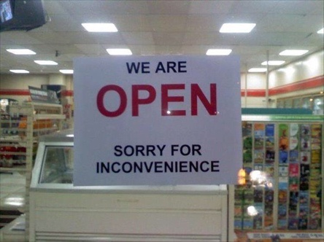

1822 coffee shop gets new signage



Highways Agency to introduce literacy test as part of selection process for road painters



The irony is the biggest thing here



“Big guy, red suit, white beard. Have you seen him?”

Storytelling in Advertising

Maxell Audio and Video Tapes
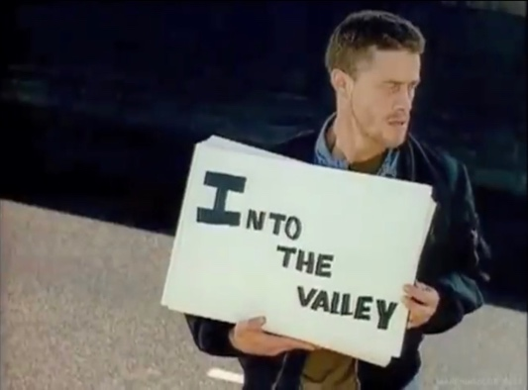

https://youtu.be/Gl-R5jF-1ns

This is a TV advert from the early 1980s, unfortunately I couldn’t find the exact year but when we received this project it was the first thing that came into my mind as I remembered it clearly. The fact that it is still clear in my mind after almost forty years must state to its success on a psychological level, the question is how and why does it work so well? The story told by the advert is basically a man listening to music that has been recorded presumably onto a tape cassette, although that is never actually alluded to in the commercial. Neither is there an obvious sales pitch of any kind, it is simply a recounting of an experience. The man featured in the commercial is a fan of the band The Skids and is listening to their song Into The Valley. Using a series of cue cards he shows the lyrics to the viewer as the song is played, almost all of the lyrics are wrong. It makes a very strong use of humour as he mishears the words to the song, with examples such as, ‘This disease is catching, from victory to stone’ being shown on the cue cards as, “His disease is cat skin, my picture is Hugh’s toe.” It is worth noting here that I think that there may be an underlying narrative in the advert. The Skids were a punk rock band and known to be quite extreme however like many punk bands they were well educated, accomplished musicians. The lyrics to Into The Valley relate a fairly intellectual narrative and looking back with a more experienced and analytical mind than I had forty years ago, it could be argued that his misinterpretation of the lyrics is as much down to the fact that punk is a genre which is aimed at the ‘the lowest common denominator’ of society and that he doesn’t have the intelligence to interpret the lyrics correctly. The punchline of the advert is the man holding a card which reads “At least I think that’s what he says, but I need to hear it on a Maxell.”

I’m sure, if I know my own mind, that the reason I remember this advert is for its comedic value, it certainly made the teenage me laugh uncontrollably. But the storytelling, especially if my speculation that it was devised to appeal on two levels is a wok of genius, if somewhat insulting to fans of punk rock!

R Whites Lemonade (1973)


https://youtu.be/hro4AdTYiTA

Another old TV advert that still sticks in my mind is for R Whites lemonade. I still clearly remember not only the advert but the lyrics to the song, and they still pop back into my head from time to time. Not a bad achievement considering I was four years old when the advert was aired. In contrast to the Maxell advert, which doesn’t explicitly dell the product until the closing seconds, in this advert the product is clearly front and centre right from the start and the promotion is constant and relentless, but it is nevertheless a catchy song! The story is that of a man who wakes in the middle of the night feeling thirsty, he creeps downstairs so as not to wake anybody else and makes his way into the kitchen to get a drink from the fridge. All this time the song which is central to the advert is building in intensity, and by the time he has poured his drink it’s a full blown rock ‘n’ roll number with him doing an impersonation of Elvis Presley while using the bottle of lemonade as a microphone. He makes so much noise singing that he wakes his wife who then also comes downstairs for a drink. Side note of a continuity or at least logic error here as she’s already holding a glass, presumably she had one on her bedside table. A very simple theme but used to great effect and driven entirely by the strength of the music.

Travel Blog

Have you ever fancied a Caribbean vacation? How about visiting a small island where you can experience two countries? Or do you have a hankering to visit a place that’s never spelled the same way twice? If any of these prospects appeal to your adventure appetite, I’ve got just the place for you. Welcome to Sint Maarten, or St. martin. Take your pick.

St. Maarten sits on the heart of he Netherlands Antilles, a group of islands in the eastern Caribbean Sea where the weather is warm but never too hot, the sea is enough waves to make for a fun swim but never gets rough enough to be dangerous, the people are friendly and the cuisine is served with a multi-cultural flavour. It is an island of two sides, quite literally. The Dutch side of st. Maarten with its capital city of Phillipsburg occupies the east the island while only an hour or so drive away on the west you’ll find the French colony of St. Martin. You can travel between the two sides of the island by taxi for around US$40, or if you want a real local flavour you can take the bus for only US$2 in each direction.

The Dutch side of the island seems to be much more at ease with its identity and the official currency being the Eastern Caribbean Dollar, although as with all the Caribbean islands, the US dollar is accepted at a standardised exchange rate of US$1 to EC$2. Whereas on the french side the currency is the Euro, although prices in both currencies are usually the same, which makes the Dutch side cheaper as if something costs US$20 in Phillipsburg, you’ll find the same thing costs €20 on the French side. The French culinary influence is very noticeable on this side of the island too, and the sea tends to be a lot more calm as this coast is on the Caribbean Sea whereas the coast on the Dutch side faces the Atlantic.

All in all though this is the perfect place to holiday and with a choice of styles while you’re here, it provides more choices than most other single destination vacations.

Forum comments

Please note: As I no longer have access to the Moodle page for the module, I cannot retrieve my comments from the forum to include with the submission.

