Ishrat Rehman (2118374)

BMSW4001
Academic and Employability Skills
Tutor - Johnathan Wyatt
Report -
What is the most effective way to motivate staff?

Contents Page

Page 1. Contents page
Page 2. Introduction
Page 3. Introduction continued, Pay
Page 4. Pay continued
Page 5. Pay Continued, Recognition and Awards
Page 6. Additional Holidays, Good Working Conditions
Page 7. Good Working Conditions continued, Conclusion

Introduction
When it comes to motivating staff there is no question that it can be a difficult task for business owners to get right. Burton (2012) suggests that there is a lack of understanding amongst employers on how to motivate staff effectively. A monetary and a non-monetary rewards system, which is managed effectively can have an impact on motivation in the workplace. According to the CMI (2021) when managers communicate well, they then also motivate their employees to communicate effectively. This helps employees to innovate rapidly, through sharing knowledge, achievements, and mistakes, they learn to collaborate rather than to be competitive. Employees place a high importance on the ability to communicate effectively. Managers who fail to effectively communicate, demotivate employees. Inept managers often withhold information and refuse to share it with employees, this is a calculated move that is used to keep them uniformed. They often provide inadequate feedback that has been requested from employees and refuse to take onboard other perspectives therefore, having little interest in listening to employees’ opinions or promoting vigorous debates to uncover optimum answers. CMI (2021) also suggests that they are unconcerned about developing excellent communication among team members. Incompetent managers are incommunicado and favour the seclusion of their office rather than meeting with individuals of their company. They refuse to physically discuss issues with employees, and often send emails, keeping face to face communication to a minimum. Unskilled managers fail to prepare effectively for presentations, this can have a detrimental effect as they choose to address the attendees with spur of the moment commentary, this can often lead to not having the audiences needs met by failing to provide appropriate, clear, and concise information. They’re vague with their information and fail to check if any of the information they’ve relayed has been understood. Inadequate training provided to managers can be costly in the long run of the company. Herzberg (1959) created a motivational model for job satisfaction and discovered through analysis that job-related elements may be classified into two categories: hygiene factors and motivation factors. Hygiene aspects cannot produce contentment, but they can alter discontent into contentment or provide short-term motivation, but motivational factors have a long-term influence by increasing positive sentiments about one's profession and converting dissatisfaction into satisfaction.
According to Benson (2003) in order to motivate employees effectively they must feel secure, needed and appreciated, this can be through applying Maslow’s hierarchy of needs.
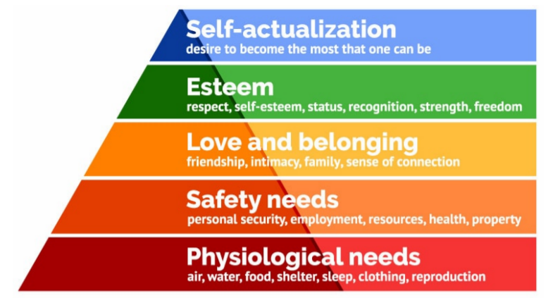
Figure 1.1 Maslow Hierarchy of Needs. Image from - https://canadacollege.edu/dreamers/docs/Maslows-Hierarchy-of-Needs.pdf
As the picture above shows there are five steps to ‘self-actualisation’. Each human has basic needs and requirements. As part of ‘safety needs’ employment is one of the necessities that is required. Another step is ‘esteem’, self-esteem, status, and recognition form partially of this. Companies can assist workers achieve their ultimate goal of 'self-actualisation' by using incentive schemes and having a rewards system in place.
Reward systems are common within companies. According to Armstrong and Brown (2019) reward is a complex field, guidelines provide decision-making criteria and, as a result, offer the structure for operating a reward system. They are distinctive from guiding principles, which generally convey a more generic concept, and incentive strategies, which reveal objectives on how the reward system should be built but do not explain how it will be run in detail. However, it said that there are three drivers of any reward management system, as illustrated in Figure 2.1: (1) internal issues to consider of fairness and relativities, supported by employment assessment methods and grading systems; (2) external considerations of real economy pay levels, to enable the company to attract and retain, supported by internal pay levels and ranges; and (3) performance-related factors linked to guaranteeing stable employment.
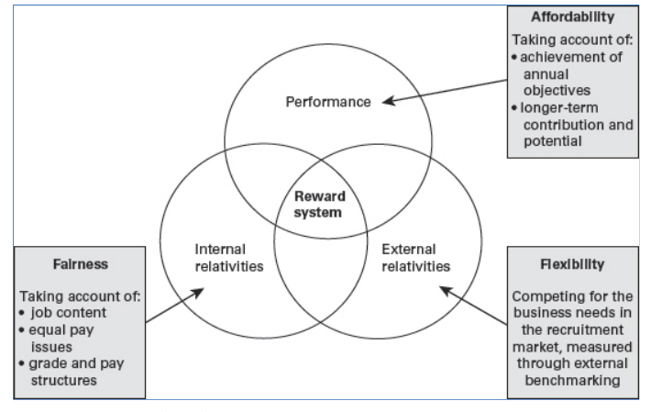
Figure 1.1 Pay management: three key drivers SOURCE Brown, D (2018) Fairness, Flexibility and Affordability: What are the lessons from pay and reward approaches and trends in the UK? Institute for Employment Studies, February, http://www.employment-studies.co.uk/resource/fairness-flexibility-and-affordability
With that said, there a several types of rewards.
Pay
Pay is used to compensate employees for their contribution to the workplace. Money is used in every aspect of life; it is a source of purchasing daily commodities and can be used as a step to power. Humans need money to survive, this therefore triggers their motivation. The UK adopts a national minimum wage which increases yearly. Currently the hourly rate for an adult over the age of 23yrs old is £8.91 which will rise 6.6% to £9.50 from April 2022 (https://www.gov.uk/government/publications/minimum-wage-rates-for-2022). Professional fields of employment have pay grade boundaries set within each organisation, these are based on previous experience and education, with increases made accordingly. Monetary rewards can have a great influence on motivation, performance related pay has been introduced to influence productivity in many sectors. Through goal setting, it can operate as an incentive to boost employee performance and efficiency, as employees desire to attain the highest pay rise. It can increase workplace motivation, attentiveness, and morale. When employee and the organisation are essentially on the same page, it leads to an increase in productivity and a stronger work ethic. As stated by Hasnain and Pierskalla (2012), performance related pay - PRP is a compensation system in which an employee's ultimate income is an outcome of a form of evaluated performance, where how performance is assessed, who assesses it, and how it is tied to their salary all vary significantly and are crucial components of the scheme's design. Sign on bonuses and retention bonuses can also have a positive effect on motivation. According to Law (2016) a sign-on bonus is a one-time payment made to entice a potential employee to accept an offer of employment. Its goal is to make the overall pay package more appealing and can lead to the acceptance of employment.
Recognition and Awards
Recognition and awards can have effect on employee’s motivation in the workplace. In the opinion of Philips et al (2017) verbal acknowledgement in front of the team, entries in a company newsletter, or postings on a departmental or company bulletin board are all options of recognising employees’ contribution. All these strategies can be used to clearly articulate achievements and recognised traits or attitudes of outstanding employees. Employees at all levels of the hierarchy should recognised publicly by the management team, which can affirm their confidence levels in the employee and can act as a motivator. Furthermore, a program that recognises and rewards employees for their contribution can have a great effect on motivation. Being recognised by peers and management boosts morale. Ashraf, Bandiera and Lee (2014) suggest symbolic recognition such as employee of the month is also valued by employees and can influence their motivation. Employers can also show appreciation for employees by giving the praise and letting them know how well they are doing. Acknowledging them and identifying top achievers whilst highlighting their exceptional efforts, accomplishments, and value to the organisation can be a driver for motivation and cause a ripple effect within the company. Some companies award long term employees with special recognition awards. These can be non-monetary such a company watch, an employee appreciation day or even a parking spot. According to Fisher (2015), having a strategic awards and recognition program can boost morale and increase productivity. Non-monetary awards and recognition has a means of recognising individual employees for special praise or commendation. As stated by Cohen (2006) non-monetary awards demonstrate to your employees that you acknowledge their successes and value their time and effort. Respect, recognition, and admiration are all regarded as rewards, and are what most employees yearn for.

Additional Holidays
Additional holidays are often a source of motivation within a company. A study by the Office for National Statistics - ONS (2019) revealed that in the UK there are 6.2million couple families that have dependent children, of this 73.2% had both parents in employment. According to the gov.uk website, guidelines on maternity and paternity paid time off suggest that the latter only has a maximum of 2 weeks of paid paternity leave. However, paid maternity leave is 39 weeks. Many new parents use the time of leave to bond with their newborn child. A request for longer paternity leave is made regularly. Providing extra paid time off is a great incentive for companies who want to retain their best employees. Employers in the United Kingdom invest over £42.0 billion on training each year, with an estimated cost of £1,530 per employee, however according to Guthrie, Simpson and Adams (2018) bringing in a new employee and training them can cost up to £3000, this money could instead be used to retain employees whose contributions are invaluable. The UK has a diverse society, with many different faiths being practised. According to Park et al (2018) a British Social Attitudes (BSA) poll was conducted, 52% of the UK people claimed they did not identify as belonging to any religious denomination, 38% defined themselves as Christian, and 9% people affiliated with other faiths. Smaller faiths have petitioned for their religious holidays to be acknowledged and have this as paid time off. As reported by the Equality and Human Rights commission (2010), companies are not legally obliged to give additional holidays to employees to celebrate and faith-based occasions. However, in order to keep their finest workers, they may do so; this not only strengthens relationships between employer and employee, but also inspires them to perform to the best of their abilities. To promote equality amongst the staff who may not have a faith, employers can offer an additional holiday which can be used when they choose to. However, neither is financially sustainable. Employees who are able to take frequent vacations may feel more respected and motivated at work, allowing them the opportunity to perform more efficiently. Taking sabbaticals means that employees are far less vulnerable to mistakes and are less likely to experience stress since they have frequent opportunities to recuperate.

Good Working Conditions
One of the numerous obstacles that a company has is motivating its workers in order to adapt with the ever-changing and complex world, achieve success, and remain competitive. According to Raziq and Maulabakhsh (2015) to boost company's productivity, efficacy, output, and job dedication, companies must meet the demands of its employees by providing ideal working conditions. The hse.gov.uk states that the Health and Safety at Work Act 1974 is a vital element of workplace regulation in the United Kingdom. Each organisation should have a health and safety policy in place and all employees should be familiar with the regulations. It guarantees that all companies maintain a safe working environment and care for their workers' health, regardless of where they work. According to Unison, employees and visitors have the right to a safe and healthy work environment that is adequate. This affirms that an employer must consider the health and safety of things space, cleanliness, sanitation stations, lighting, and ventilation, as well as sufficient drinking water, toilet, bathing, and changing facilities. Companies can also provide their employees with ergonomic chairs, a quiet room which can be used as a reflection, relaxation, or prayer room. Many firms fail to recognise the value of a positive working environment for employee job satisfaction, and as a result, employees confront several challenges at work. According to Aiken, Clarke, and Sloane (2002) such firms are inherently inadequate, and as a result, they are unable to introduce innovative ideas into the industry in order to outperform their competitors. In order for organisations to flourish and succeed, employers must consider paying the living wage of their employees’ residence. Employees require adequate working conditions that allows them to work freely and without constraints that may impede them from functioning to their full ability in order to satisfy organisational requirements.

Conclusion
In conclusion to the above, as Burton (2012) suggests employers find it challenging to motivate employees. Herzberg (1959) suggested employees are more likely to be unhappy if hygienic variables, such as working environment, supervision quality and level, interpersonal interactions, job security, and remuneration are lacking. With that being said, employees require both monetary and non-monetary rewards to ensure the success and survival of a company. When employees are motivated, companies reap financial reward. Good working conditions should be the focal point of companies when looking to motivate the workforce. This is closely followed by pay as a motivator, organisations paying the living wage and bonuses can produce loyal and engaged employees. However, one size does not fit all. Relationships with motivation are individual. Evidently, in this period of personalisation, almost everything can be tailored to our preferences. Monetary and non-monetary rewards systems are still predicated on presumptions; and these should be tailored to individual needs.

References

- Aiken, L.H., Clarke, S.P., Sloane, D.M. and International Hospital Outcomes Research Consortium, (2002). ‘Hospital staffing, organization, and quality of care: cross-national findings’. International Journal for quality in Health care, 14(1), pp.5-14.
- Armstrong, M. and Brown, D. (2019) ‘Armstrong’s handbook of reward management practice improving performance through reward’. 6th edn. London: Kogan Page.

- Ashraf, N., Bandiera, O. and Lee, S.S. (2014) ‘Awards unbundled: Evidence from a natural field experiment’ Journal of Economic Behaviour & Organisation, 100, pp.44–63.

- Benson, S.G. and Dundis, S.P. (2003) ‘Understanding and motivating health care employees: integrating Maslow’s hierarchy of needs, training and technology’, Journal of Nursing Management, 11(5), pp. 315–320.

- Burton, K. (2012) ‘A study of motivation: How to get your employees moving’, Management, 3(2), pp.232-234.

- Cohen, S. (2006) ‘Compliment your staff with nonmonetary rewards’ Nursing Management 37(12), pp 10-14.

- Equalityhumanrights.com. (2010). ‘Religion or belief: time off work’ Equality and Human Rights Commission. [online] Available at: https://www.equalityhumanrights.com/en/advice-and-guidance/religion-or-belief-time-work

- Fisher, J.G., (2015). Strategic reward and recognition: Improving employee performance through non-monetary incentives. London: Kogan Page Publishers.

- Guthrie, A., Simpson.,E, Adams, S,. (2018) ‘U.K. L&D Report: 2018 Benchmark your workplace learning strategy’. [online] Available at: https://www.findcourses.co.uk/inspiration/read-uk-ld-report-2018-13589?utm_source=independent&utm_medium=article&utm_campaign=read-report

- Hasnain, Z. and Pierskalla Henryk, N., (2012). ‘Performance-related pay in the public sector: a review of theory and evidence’, World Bank Policy Research Working Paper, pp 2-9.

- Herzberg, F., (2008). One more time: How do you motivate employees?. Harvard Business Review Press.

- Hse.gov.uk. 2022. Health and Safety at Work etc Act 1974 – legislation explained. [online] Available at: https://www.hse.gov.uk/legislation/hswa.htm (Accessed 19 March 2022).

- Law, C.C.H., (2016). ‘Using bonus and awards for motivating project employees’. Human Resource Management International Digest, 24(7), pp. 4-7.

- Maslow Hierarchy of Needs. Image from - https://canadacollege.edu/dreamers/docs/Maslows-Hierarchy-of-Needs.pdf

- Murray, K. (2021) ‘Eight ways managers kill conversations – and motivation’, CMI, pp. 1-4
- Nickerson, N. (2012) ‘Herzberg’s motivation two-factor theory’ Available at: https://www.simplypsychology.org/herzbergs-two-factor-theory.html (Accessed 24 March 2022).

- Office of National Statistics, ‘Families and the labour market, UK - Office for National Statistics’. (2022). Families and the labour market, UK - Office for National Statistics. [online] Available at: https://www.ons.gov.uk/employmentandlabourmarket/peopleinwork/employmentandemployeetypes/articles/familiesandthelabourmarketengland/2019#:~:text=In%202019%2C%20there%20were%20around,had%20both%20parents%20in%20employment. [Accessed: 16 March 2022].

- Park, A. et al., (eds.) (2013), British Social Attitudes: the 30th Report, London: NatCen Social Research, [online] Available at: www.bsa-30.natcen.ac.uk (Accessed: 14 March 2022)

- Phillips, H. et al., (2017) 'Commentary: Exploring Novel Approaches to Staff Rewards and Recognition', Hospital Pharmacy, 52(11), pp 729-731.

- Raziq, A. Maulabakhsh, R. (2015) ‘Impact of Working Environment on Job Satisfaction’, Procedia Economics and Finance. Vol 23, pp 717-725,

- Sanderson, B., Rt, T., Kwasi, H. and Mp, K. (2021). National living wage and national minimum wage rates for 2022. [online] Available at: https://assets.publishing.service.gov.uk/government/uploads/system/uploads/attachment_data/file/1028629/NMW-NLW_recommendations_for_2022.pdf. (Accessed: 22 March 2022)

- Unison ‘Working Environment’, Available at: https://www.unison.org.uk/get-help/knowledge/health-and-safety/working-environment/ (Accessed: 12 March 2022)

