Critically analysing the health and well-being of Ms. P

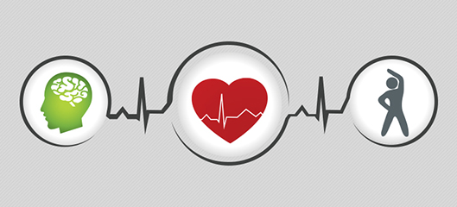

(UB.2018)

Contents Page
Introduction……………………………………………………………………………..3
Basic Information……………………………………………………………………….4
Medical………………………………………………………………………………….5
Habits/Lifestyle …………………………………………………………………………7
Conclusion and Recommendations ……………………………………………………...8
Reference Page…………………………………………………………………………..9
Appendix…………………………………………………………………………………11
Consent Form…………………………………………………………………………….14

Introduction
In this report a woman in her twenties known as Ms. P will be analysed on a questionnaire she answered. This report will analyse her basic information, her medical health and her habits and lifestyle. The questionnaire she answered had some open questions that she could expand on and other questions that where closed so she only had to answer yes or no to the question, the type of data received from the questions was qualitive as all the information was all about one person, however there were some quantitive aspects to the questionnaire as all that was given was to the point data nothing to do with Ms. P’s emotions on the topic. Ms. P also signed a consent form so that nothing about what is written will be share with anyone who is not supposed to see it without permission of Ms. P. the report will also discuss recommendations of what Ms. P can do to better her life through either a different diet or by trying different forms of exercise.

Basic Information
Ms. P is a female in her mid-twenties, she is 5ft and 4” tall and weighs 10st and 3lbs, however her average weight is likely to be around 10st as a women’s weight changes throughout the month because of water weight and because of her periods. As the increase of hormones during menstrual cycle will cause her to eat more. (Hildebrandt, 2014)
Using the National Health Service’s (NHS) body mass index (BMI) calculator to calculate Ms. P’s body mass resulted in a BMI of 24.4, which is in the healthy weight range for someone her age, height and weight. However, she is on the higher end of the scale, this means that she will have to keep an eye on her weight and to be careful to not increase her calorie intake or to decrease how active she is throughout the week. (NHS,2018)
To calculate her energy requirements, the method used will be the Schofield Equation and Physical Activity Levels (PAL). For Ms. P her basal metabolic rate is 1,448 calories and with her activity level also calculated in with PAL being in the light active range her daily calorie intake should be 1883kcals. She has admitted that she does not reach her daily intake of calories often but that her activity levels are not very high so she has found a balance but should be careful as any increase in her calorie intake with her low levels of activity could mean that she could gain weight, pushing her from her place in the healthy weight margin into the overweight section.

Medical
Ms. P does not have any medication over the counter or prescribed by her doctor that could affect her health, the only medication she receives from a prescription is hydrocortisone creams that she uses to treat her eczema as she is an adult she would have no side effects from the cream and only uses them to her eczema as told by her doctor.(NHS, 2018). She also only uses paracetamol sparingly as treatment for her headaches so there will be no side effects there if she follows the instructions on the medicine’s dosages. To her knowledge she has never had her blood sugar levels checked, so during her next General Practitioner (Gp) appointment she should ask to have her sugar levels checked as it is always good to have an idea of what her levels are like as diseases like diabetes can sometimes develop suddenly.
Ms. P’s blood pressure is on the lower end of the average blood pressure levels for a woman in her twenties her blood pressure is 112/78. Blood pressure is a measurement of the pressure in your arteries during the active and resting phases of each heartbeat. The systolic pressure is the amount of pressure the heart generates during the process of bumping blood through the arteries of the heart to the rest of the blood circulatory system of the body, for Ms. P her systolic pressure is 112mmHg. The diastolic pressure is the pressure of the blood reading found during the resting phase of a heartbeat, the reading ins from the amount of blood found in the arteries between beats of the heart. (mayo clinic. 2018). Ms. P’s blood pressure levels could be on the lower end of normal because she may not have drunk enough water that day, she had her blood pressure taken, as dehydration can lower the pressure in the blood by lowering the volume of the blood. (Heart. 2016)
Ms. P has never been on a diet in her life and has never been told to go on a diet by other like family or her Gp, as she says that her weight has mostly been in the healthy scale most of her life, other than the time period where she was underweight by a few pounds as a child as she had just had a minor growth spurt at the age of 12, and after that her weight has been fine through her teenage years. It is normal for children and teenagers to lose and gain weight as they grow as they lose weight during a growth spurt as the body uses up more of the nutrients in growing then storing as fat for later energy use, then once the growth spurt is over the body will rapidly restore its energy sources that was used during the growth spurt. (Gavin, 2018)
On the other hand, she has admitted that the major issues she had with her diet is that she thinks she eats too many carbohydrates, she skips meals when busy and that she eats snacks when she is bored. These issues can be quite serious if not addressed properly, with the snacking if she stays to having fruit or vegetables or other healthy snacks when snacking she should be fine as it is recommended that she should eat up to five pieces of fruit and veg a day by the Government in 2003. (GOV. 2016)
Skipping meals can be bad for her health if she has not taken in the amount of calories that she should take in as this can lead to dizziness, faintness or light-headedness, headache, irritability, easily agitated, lack of concentration and nausea, but if during the rest of the day she has managed to take in enough nutrients then she should be fine when it comes to her health. (Myfooddiary. 2018).
If Ms. P believes that she is eating too many carbohydrates in her meals but does not want to change her diet too much, she could cut down on carbohydrates by eating less processed carbohydrates like bread, pasta, cake, sugar and switch to more natural carbohydrates in foods like sweet potatoes, squashes, rice, fruits, and whole grains. (Harvard. 2018)

Habits/Lifestyle
Ms. P has quite a healthy lifestyle in that she does not smoke or regularly drinks alcohol which is amazing for her health as smoking can severely damage the body by causing fatal diseases such as pneumonia, emphysema and lung cancer. Smoking causes 84% of deaths from lung cancer and 83% of deaths from chronic obstructive pulmonary disease (COPD). (NHS. 2018). The long-term health issues that can be caused by alcohol are high blood pressure, pancreatitis, liver disease, strokes, and cancer of the liver, mouth, breast, bowel or head and neck. As Ms. P only drinks on special occasions like weddings, birthdays or holidays like Christmas and only on or two drinks at that she should be safe from any health issues that are a result of alcohol misuse. (NHS. 2018)
Ms. P does find herself dealing with stress, she find that most of her stress comes from school work and large social events and that stress kills her appetite which can lead to more stress as she gets tired and emotional from not eating enough to fuel her throughout the day, she also has Irritable Bowel Syndrome (IBS) is the name used by doctors to describe a collection of symptoms relating to a disturbance in the body’s bowels, these symptoms are bloating, abdominal pain, diarrhoea and constipation. (Theibsnetwork. 2018), which is triggered by stress.
Young adults are meant to have sleep between seven to nine hours a night, Ms. P only sleeps on average around four to seven hours a night as she finds herself with too much energy to settle down and sleep. (NSF. 2015). Lack of sleep can affect a person’s ability to think clearly, to form clear memories, to preform at their best and to react quickly. It also affects the person’s mood by making them emotional or short tempered as they are too tired to have as much patience as they normally do, lack of sleep can also increase a person’s anxiety. Lack of sleep also affects a person’s immune system so if they find themselves ill after a few sleepless nights it is because their immune system was not at its best because of the lack of sleep they have had. (NIH.2016)

Conclusion and Recommendations
Ms. P health and well-being is over all very good as she is somewhat conscious of what her health is like with only having concerns about her diet and her activity levels and her lifestyle choices of not smoking or drinking alcohol heavily will only benefit her in the future as she will not have to deal with the severe health issues that come from smoking or alcohol misuse such as cancer to whole different body systems like the lungs, heart, liver and bowel. However, there is also room for improvement to her life, with her diet she could begin to eat less processed foods like white bread and pasta and switch to the wholemeal versions, she could lessen the amount of sugar she eats by cutting out sweets and pop from her diet and eat fruits instead to solve her craving for something sweet. For exercise, she could start a sport such as yoga this will help her stay flexible and a way to release stress. She could also start to take daily half hour walks because as long as she does some type of exercise that will have her heart pumping afterwards is what she is looking for, nevertheless she will have to keep an eye on her calorie intake because if she does too much exercise but does not take into account her diet she could end up losing too much weight and become underweight.
Ms. P’s weight at this time is fine it is within her healthy weight boundaries and her diet is not as bad as it could be, but she could improve her health by only changing small things about her lifestyle as she is in good health and could carry on like this for a while but it is easier to change habits at a younger age then to try and change them later when it is needed.

Reference Page

Batty, D. (2003) Q&A: five-a-day campaign [online] Available at https://www.theguardian.com/society/2003/jan/20/medicineandhealth.publichealth1 (Accessed 30-11-18)
Disabled World. (2018) What Does Blood Pressure Refer To? [online] Available at https://www.disabled-world.com/calculators-charts/bloodpressurechart.php (Accessed 17-12018)
Gavin, M. (2018) Your Child's Weight [online] Available at https://kidshealth.org/en/parents/childs-weight.html# (Accessed 17-12-18)
GOV. (2016) Government 5 A Day logo [online] Available at https://www.gov.uk/government/publications/government-5-a-day-logo(Accessed 10-1-19)
Harvard. (2018) Carbohydrates [online] Available at https://www.hsph.harvard.edu/nutritionsource/carbohydrates/(Accessed 29-11-18)
Heart. (2016) Low Blood Pressure - When Blood Pressure Is Too Low [online] Available at http://www.heart.org/en/health-topics/high-blood-pressure/the-facts-about-high-blood-pressure/low-blood-pressure-when-blood-pressure-is-too-low (Accessed 12-12-18)
Hildebrandt, B, et al. (2014) The effects of ovarian hormones and emotional eating on changes in weight preoccupation across the menstrual cycle. International Journal of Eating Disorders.
IBS Network. (2018) WHAT IS IBS? [online] Available at https://www.theibsnetwork.org/ (Accessed 8-1-19)
My Food Diary. (2018) Calorie counting made easy. [online] Available at https://www.myfooddiary.com/resources/ask_the_expert/hunger_signals.asp (Accessed 9-1-19)
National Sleep Foundation. (2015) NATIONAL SLEEP FOUNDATION RECOMMENDS NEW SLEEP TIMES [online] Available at https://www.sleepfoundation.org/press-release/national-sleep-foundation-recommends-new-sleep-times (Accessed 5-1-19)
NHS. (2017) Diet, lifestyle and medicines [online] Available at https://www.nhs.uk/conditions/irritable-bowel-syndrome-ibs/diet-lifestyle-and-medicines/(Accessed 19-12-18)
NHS. (2017) Hydrocortisone skin creams. [online] Available at https://www.nhs.uk/medicines/hydrocortisone-skin-cream/ (Accessed 12-12-18)
NHS. (2018) BMI healthy weight calculator. [online] Available at https://www.nhs.uk/live-well/healthy-weight/bmi-calculator/ (Accessed 19-11-19)
NHS. (2018) Risks [online] Available at https://www.nhs.uk/conditions/alcohol-misuse/risks/ (Accessed 29-12-18)
NHS.(2018) How smoking affects your body [online] Available at https://www.nhs.uk/smokefree/why-quit/smoking-health-problems (Accessed 28-12-18)
The University of Buckingham. (2018) Centre for Health and Relationships [online] Available at https://www.buckingham.ac.uk/research/chr (Accessed 29-12-18)
US Department of Health and Human Services. (2016) How is the body affected by sleep deprivation? [online] Available at https://www.nichd.nih.gov/health/topics/sleep/conditioninfo/sleep-deprivation (Accessed 9-12-18)

Appendix
Health and Well-Being Questionnaire
Basic Information
- Gender? Male/Female
- Age?
- – 18 19 – 30 31 – 60 61+
- Height?
5ft 4”
- Weight?
10st 3lbs
Medical
- Are you on any prescription medication? Yes/No
If yes, what kind?
Moisturisers and hydrocortisone creams
- a) Do you take over the counter medication? Yes/No
b) If yes, what kind and why?
Normally paracetamol for headaches.
c) How often do you take over the counter medication?
Not often only when I have a bad headache
- When did you last visit the GP?
3 months ago
- Have you ever had your blood sugar levels checked?
Not to my knowledge
- Do you have any disabilities? Yes/No
If yes, list them
Hypermobility
Dyslexia
ADHD
- Do you have any illnesses? Yes/No
If yes, List them
Eczema
- Do you have any allergies?
No, however I had an allergy to eggs as a child.
- What is your blood pressure?
112/78
- Have you ever been on a diet? Yes/No
- Are currently following a specialised diet? (example low-sodium or low fat)
Yes No
If yes, what type of diet?
- Why did you choose this diet?
- Was the diet prescribed by a doctor/dietician?
- How long have you been on the diet?
- What do you consider to be the major issues in your diet and eating plan? (e.g work, eating late at night, snacking on high-fat foods, skipping meals, or a lack of variety)
I think the main problem of my diet is the high amount of carbohydrates that I eat, and I also skip meals if I am too busy. I also tend to eat snacks when I am bored like chocolates, crisps or fruit.

- How many cups of water/fluid do you drink per day? (1 cup = 225ml)
1-2 3-6 7-10 11-15
- Any additional medical information not covered above:
Has anyone in your immediate family been diagnosed with the following?
Heart disease Age of diagnosis
High cholesterol Age of diagnosis
High blood pressure Age of diagnosis 30’s
Cancer Age of diagnosis 50’s
Diabetes Age of diagnosis
Osteoporosis Age of diagnosis
Habits/lifestyle
- Do you smoke?
Yes No
If yes, how many cigarettes do you smoke a day?
0-1 2-5 6-10 11-16 17-20 21+

- If No, have you:
never ever smoked given up smoking in the last year not smoked for more than 1 year
- How is your appetite affected by stress?
Increased Not affected Decreased
- Do you drink alcohol?
Yes No
If yes, How much? (1 unit = ½ glass of wine, ½ pint of cider, 1 shot of spirits, ½ pint of beer, 250ml alcopop)
0-1 2-3 4-5 6+
How often do you drink alcohol?
Daily weekly monthly yearly special occasions
- Do you drink caffeinated beverages?
Yes No
How many cups a day?
Up to 4 cups more than 4 cups
- Do you take any vitamin, mineral, or herbal supplements?
Yes No
Please list type and amount per day:
- Do you currently participate in any structured physical activity?
Yes No
If so what
- Have you experienced any injuries that may limit your physical activity?
Yes No
If yes, briefly describe your limitations?
- Do you find yourself stressed?
Yes
- What causes you to feel stressed?
School work and big social events.
- Have you been diagnosed with a stress-based illness?
Yes no
If yes, what kind?
Irritable Bowel Syndrome.
- How many hours of sleep do you have a day?
1-3 4-7 8+
- Any additional information you want to provide:
- I am not a very active person and only do maybe 2-3 hours of walking a day.
- I very often don’t eat breakfast but graze through the day instead. I also don’t overeat as I will stop eating the moment, I feel full, so I don’t have large portions of food in one meal. I don’t think I often reach my recommended daily calorie intake either.
- I was underweight for a while when I was 12 because I had just had a growth spurt, but I regained the weight I lost relatively fast as my appetite has increased at the same time so I was eating more during that time then I normally eat.
- I also don’t sleep as much as I’m supposed too as I find it hard to fall asleep most of the time, because I just can’t settle down.

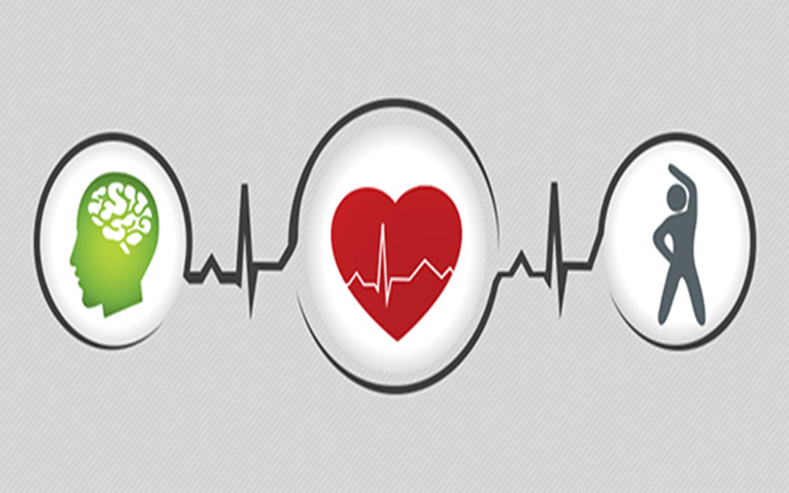

Consent Form

I have been asked to participate in a questionnaire conducted by a level 5 student from the university of South Wales Trinity St David which has been devised as part of a module Physiology of the Body Including Nutrition I am free to contact the module lead with any question or concerns I have regarding this questionnaire by contacting felicity.page@uwtsd.ac.uk or (01792) 481255

INTRODUCTION: Below is a description of the research procedures and an explanation of my rights as a research participant. In accordance with the policies of Davidson College, I have been asked to read this information carefully. If I agree to participate, I will sign in the space provided to indicate that I have read and understood the information furnished on this consent form. I am entitled to and will receive a signed copy of this form.

PURPOSE: The purpose of this assignment and the questionnaire is for students of the university to assess the normal and abnormal physiology, health and nutritional status of a chosen individual. Students are required to assess the current health and fitness of a chosen individual. Collected date will be reported on a health and fitness questionnaire designed by the student. The data will be analysed and evaluated and recommendations made, in line with current health recommendations. The evaluation will focus on the physical, intellectual, emotional and spiritual needs of the individual. Recommendations will be made on how the chosen individual can improve their overall health and wellbeing. The student will also discuss current Government, public health and NHS strategies put in place to overcome any health damaging behaviours identified for example high blood pressure, obesity. The student working in agreement with yourself will be expected to perform a variety of health assessment tests; these tests must be within their skill ability and proved to be valid and reliable assessment tools. The test results will be collated, analyzed, and recorded on a data collection form of your own design. In line with the data protection act 1998 it is compulsory that, all reported data will be anonymized and non- identifiable. The collected data will be analyzed and compared to norms for the undertaken test. In the report, please note that students can only work within the scope of their ability and are not a replacement for medical advice or treatment.

POTENTIAL RISKS AND DISCOMFORTS: Should your assessment reveal readings out of the normal range, you will be advised to consult your general practitioner. If you have any questions or queries please contact the course lead.

BENEFITS: A benefit to me of participating in this study is that you will have access to the student’s assignments and recommendation within which will help to identify ways that you can improve your health and well-being. However these are only a guide are a not a substitute for medical advice.

RIGHT TO REFUSE OR WITHDRAW: I understand that my participation is voluntary. I may refuse to participate or discontinue my participation at any time; there will be no penalty for doing so. Some details of this project may not be made known to me until my session is completed. I realize at the completion of the session that I have the option of withholding the responses I have provided from subsequent analysis. .

DURATION AND LOCATION OF STUDY: If I agree to participate in this study, my participation will last for approximately 30 minutes and will take place at my home

PROCEDURES: During this study, I will be asked to respond to a health questionnaire, which will be designed to design my current levels of health and well-being.

CONFIDENTIALITY: I understand the data collected in this study will be kept confidential unless law requires disclosure. : reported data will be anonymized and non- identifiable.

OFFER TO ANSWER QUESTIONS: If I have any questions about this questionnaire and subsequent assignment in the first instance please contact felicity.page@uwtsd.ac.uk or (01792) 481255

*I CERTIFY THAT I AM AT LEAST 18 YEARS OLD AND I AGREE TO PARTICIPATE IN THIS RESEARCH PROJECT.
Rhianna Phillips 20-12-18

PARTICIPANT'S SIGNATURE DATE

PERSON OBTAINING CONSENT:
I have allowed the individual named above the time to read this consent form and have answered any questions that have been asked. I will provide the participant with a copy of this consent form.
Rhianna Phillips 20-12-18

RESEARCHER'S SIGNATURE DATE

