
Terrorism in the UK is a topic of debate, on a level of National security basis, involving the security and safety of the citizens living in the United Kingdom.
The country has been subjected to a lot of terrorist attacks in the past, all has developed into topics about immigration, asylum seeking, terrorist organisations like ISIS, these have been social and political problems that have sparked mixed feelings from the people living in the United Kingdom.
Threats to the UK’s national security have created many situations where a breach of security, have created debates between the people.
Is the impact of terrorism, and the fear of terrorism still present? It’s important then to find out on whether the British government is doing its best to protect the lives of the people living in this country, and if the plans to tackle terrorism is or isn’t making any effect, and on whether the citizens living in the UK can trust the government for protection.

Pedro Soares 2105050
Impact of Terrorism in the UK
Is the fear of terrorism still present?

Acknowledgments

I would like to say thanks for my amazing partner Rowan Larcher who dedicated herself into supporting me through this hard journey, it wouldn’t be possible to complete my academic studies without her.
I would like also to thank my best friends back home in the European Union notably Maik Goossens and Jasper Witkamp, who have supported me in many ways.
I also would like to thank my other close friends in the UK, especially those who stayed with me the last 3-4 years of university Thomas Sinclair, Luke Thomas and Patrick Dalea and Daniel Hurford who helped me a lot.
I have also to thank my friend Rachel Curtis who sadly lost her life during Level 5, she always encouraged me to continue the degree.
Lastly, I would like also to express gratitude to one of our lecturers Mike Durke for the good support and help he gave me through this dissertation.
I would like also to thank Kelly Andrews for teaching her good Policing experience in her modules, and finally to thank Jane Davies to have accepted me into this course, as she was the lecturer who interviewed me before starting Level 4.

Declarations
This work has not previously been accepted in any University for any degree nor currently being submitted for any degree except for the Professional Policing degree at the University of Wales Saint David Trinity.
Signed: Pedro Soares Date: 06/05/2025

Statement 1

I declare that this dissertation is credited of my own, all references and all researches were conducted with my effort and choice over the topic.

Signed: Pedro Soares Date: 06/05/2025

Statement 2
I give my consent for this dissertation to be available for everyone, for research, referencing and guide over the chosen topic, and to be deposited in the University’s digital storage.
Signed: Pedro Soares Date: 06/05/2025

Declaration from the Supervisor

I ……………… hereby confirm that this work is the result of this student only
Signed:

Table of Contents
Chapter 1 - Introduction 4
Key Objectives for the literature review 5
Chapter 2 - Literature Review 6
Objective 1: A brief history of terrorism in the UK 6
Objective 2: The war on terrorism 7
Objective 3: The role of the media 9
Objective 4: Rehabilitation of terrorists 9
Chapter 3 - Research Methods 11
Research Strategy 11
Data Collection 11
Data Analysis 12
Chapter 4 - Findings 13
Survey Questions – Demography 13
Terrorism related questions: Answers 16
Chapter 5 – Conclusion 32
Reference List 33
Appendix 40
Raw Data: Survey link and results 40

Chapter 1 - Introduction
Terrorism in the UK has a very complex history, members of the public have high concerns for terrorist activities. What role do the media, the British Government and social services play in this? According to the British Government website, we can see that the terrorism level in the UK is substantial, the Joint Terrorism Analysis Centre (JTAC) explains that the supplied information helps establish protective security measures and advice (MI5, 2025), although the terrorism level in the UK is substantial, Northern Ireland and England are the two countries in the UK where the terrorism level can rapidly change, in the previous year of 2024 Northern Ireland saw a change of level, with it the significance it has for the communities, police officers and staff, have successfully prevented attacks from the NEW IRA who disregard the idea of keeping the communities out of risk and the safety of officers (PSN, 2024).
The Troubles may have ended with the “Good Friday Agreement”, but the IRA has remained a threat to the UK, only in the last year of 2024 has the level been lowered. Although Northern Ireland is still ground area for terrorist plans as of 2019 forward, as operations were being conducted from the New IRA terrorist attacks from this organisation were still active, although it has been decreasing since 2018 (British Government, 2020).
The media has an impact in how they deliver the news to the public, and the fear of indifference, Liao (2023) tells us that people are exposed to the media significantly and that it shapes their beliefs, opinions and actions, impacting their understanding of the related issue. Researches have shown that someone’s perceptions can be influenced by being exposed to certain subjects.
Immigration is also a key factor that plays a role in the public when it comes to British society, it has been a topic since before and after Brexit has happened, the public opinion about it is very mixed, the Migration Observatory (2025) said that there is existing evidence that shows the public is divided in this topic, but that the level of opposition differentiates depended to whether they ask respondents if it’s a good or a bad thing. In April 2023 it was reviewed that 32% of respondents thought immigration was very bad, while 52% thought that just their numbers should be reduced.
The UK also has relied a lot with the support coming from the E.U, both still remain partners against terrorism, and some of the agencies established there notably the Interpol, works with the UK to prevent terrorism, both have established the UK/Interpol International Agreement 2023, this agreement even specifies that immunities and privileges defined in it shall be granted if the ICPO – Interpol requests to perform its duty in the hosted country (British Government, 2023).

Key Objectives for the literature review
- Brief History of terrorism in UK how it started, to understand why it is relevant in our present day, analyse the failures and successes the British government has put in place for the protection of the public.

- The war on terrorism, which has that led to terrorist attacks in the UK and made the UK a target country for terrorist organisations such as ISIS.

- The role of the mainstream media in influencing the public’s perception of terrorism while playing a role in British life.

- Can we rehabilitate terrorists? Whether the British Government’s critical decisions about this are right, and if the help of social services resources to help the rehabilitation of ex-convicts.

The literature review will give a good insight of the Impact of terrorism in the UK, following the research methods used to conduct a survey which will be displayed in the findings, finishing then with a summarised conclusion of all that was discussed with the findings being an essential detail to reach that conclusion.

Chapter 2 - Literature Review

Objective 1: A brief history of terrorism in the UK
The United Kingdom has a history of “radical movements”, the tensions started between the Catholic community and the Protestant community after Henry VIII break from the Roman Catholic Church (Royal Museums Greenwich, 2025).
The first known act of rebellion before the word “terrorism” existed, started with Guy Fawkes attempt to blow up the Westminster Parliament. He was a devout Catholic who sought to kill King James I and the parliament of that time, to instate a more Catholic friendly monarch, this part of history is very popular across the country, people nowadays celebrate it with fireworks on the 5th of November every year (Historical Royal Palaces, 2025)
In the UK, there are historical facts leading to modern events compared to what happened in the previous centuries, but what happened in the 20th century and 21st century became part of the UK’s present memory when it comes to terrorism, the conflict in Northern Ireland has left a great impact in British society, these were matters of Irish national identity and pride over territorial dispute whether Northern Ireland should join the Republic of Ireland or remain within the UK, Irish Catholicism sentiment and British Protestantism, led to a conflict and to terrorist attacks, while both sides made serious accusations. The conflict in Northern Ireland can be traced before 1919 when Ireland gained independence from Britain, although to better understand the “impact of terrorism” in British society, the 30-year conflict that lasted from the late 1960’s until the late 90’s is the main focus of discussion, Wallenfeldt (2025) says Northern Ireland remained under British rule, with a Protestant majority and a small minority of Catholics, this Catholic minority suffered discrimination.
The tensions in the country started developing when groups of armed militants were created, most famous being the Provisional IRA a pro Republican and pro-Irish organisation, and the pro-British UVF (Ulster Volunteer Force).
One of the most notorious attacks by the Provisional IRA was an attempt on Margaret Thatcher’s life, it happened at the Brighton Hotel on the 12 October 1984, where an IRA bomb was planted under a bath in a room above where Thatcher was staying, the bomb was intended to kill the prime minister and government officials, this was the most audacious attack on a British Government since Guy Fawkes’s gunpowder plot (The National Archives, 2014).
The UVF’s most notorious attack is the Loughinisland massacre took place on the 18th of June 1994 in the village of Loughinisland county in the Northern Ireland, it developed when members of the Ulster Volunteer Force armed with assault rifles entered in a pub during a football game and fired at the customers, killing six civilians and wounding others, the pub was targeted purely because of its Catholic crowd (McGovern, 2017).
As the division from both communities escalated, the IRA’s bombing campaign also proceeded, only ending officially with the Good Friday Agreement on the 10th April 1998 (British Government, 1998).
British methods of counter-terrorism were conducted through espionage and military operations, the MI5 only had a supporting role against the Provisional IRA and against all other terrorist threats to mainland Britain, including Protestant Loyalist paramilitaries. MI5 had the lead intelligence role, and that wasn’t acknowledged until 1972 (MI5, 2025).
The British government failure to maintain the peace during the troubles was due to the “Operation Banner” between 1969 and 2007, where it failed to protect civilians as the British military was responsible for 301 deaths, this has led to an investigation breaching the article 2 of the European Convention of Human rights (House of Commons Library, 2022).

Objective 2: The war on terrorism
The war on terrorism began 19 years ago, but how has the UK been involved in this? Were the 9/11 attacks provoked? How was UK affected by this?
To understand this, Reed (2020) explains that the 9/11 were driven by Islamic extremism, fuelled by multiple factors, that extremism turned into anti-American sentiment due to U.S support for Israel and repressive secular Arab regimes this document states that the supply of weapons gave activists the means to inflict harm and wage psychological warfare in western populations. The main character that led the planning of the 9/11 attacks was Osama Bin Laden, he declared war on the United States, believing that the presence of US Troops stationed in Saudi Arabia during the Gulf war in 1990 to 1991 was a violation of the Islamic sacred spaces near Mecca and Medina.
The 9/11 attacks happened when two commercial planes were hijacked by members of the terrorist group Al Qaeda, hitting the two towers at the World Trade Centre in New York, this situation shocked the whole world including the UK where British citizens were working in the towers, it was revealed in the media that 67 British citizens died that day (The Northern Echo, 2021).
After the 9/11 attacks, Britain was a major in the 2003 Iraq War, since then there has been links between resistant’s to western intervention groups like Al Qaeda and ISIS inflicting terror attacks in Britain, with ISIS becoming known in British history as the most popular group, there is also many examples involving terrorist situations in the UK, the most known ones being the case of the 7/7 Central London bombings in 2005, where a series of suicidal bombings resulted in the killing of 52 people and injured other 770 people (British Transport Police, 2025).
The 2017 Westminster attacks where Khalid Masood a 52-year-old British born citizen drove a vehicle through Westminster bridge killing three people and injuring several others, the individual was shot on the scene by armed police present in the Parliament area (British Government 2018). The Manchester Arena bombing also in 2017 during Ariana Grande’s concert, where a suicidal bomber Samel Abedi 22 also a British born citizen, killed several people and also injured many others in the process, while it isn’t clear if ISIS was involved in this, it is reported that Abedi knew some British extremists who had ties with ISIS fighters present in Libya, his younger brother Hashem who was also involved and was convicted for terrorism offences due to encouraging his brother (Combating Terrorism Center, 2020)
The London Bridge attacks in the same year where extremists drove a van into pedestrians and then stabbing people around the pubs in the area, the Counter Terrorist Police lawfully killed the suspects on the spot, thus saving the lives of innocent people (Counter Terrorism Policing, 2019). These incidents caused fear and safety concerns in the UK.
Such examples sadly also resulted in hate evolving, with the British Muslim community being targeted with Islamophobia, although the British Government has tackled this issue by issuing laws against hate speech providing the means to fight anti-Muslim hatred, with incidents of anti-Muslim hate crime recording high in England and Wales condemning religiously motivated hate a crime (British Government, 2025).
Since the start of the Syrian Civil war in 2012, ISIS has been a threat for the UK, the British government proclaimed ISIS a global terrorist group that poses a great threat to the world because of its violent behaviour and ideology and network of terrorist fighters, stating also that the UK is at the forefront of a global coalition against ISIS (British Government 2023), ISIS is infamous throughout the world for displaying videos of beheadings, some of the victims were British citizens, these videos shows ISIS’s intentions towards psychological warfare in creating fear, a case reported in the media says that in 2014 a British citizen called Allan Henning was killed and ISIS released the video of the beheading, former UK Prime Minister David Cameron condemned this act as “barbaric and repulsive” (NBC news, 2014).
To honour Henning who came to the help of those in need, the Salford City Council awarded him with the “Freedom of the City of Salford” on the Friday 28th of April 2023, and a memorial was opened in 2016 (Salford City Council, 2023).
Muslim communities in the UK expressed their concerns about ISIS’, and the opinion of Muslims has been very relevant and important, as ISIS seeks out to recruit Muslim members of the public, radicalising individuals, the BBC (2014) reported that Muslim leading Shia and Sunni clerics shared their feelings about ISIS, describing it as “evil” and asking people to not “get mixed up. In the year of 2017, thousands of Muslims in London marched in peace against terrorism, condemning terrorism and ISIS (Metro News, 2017).
In the UK there are also organisations that seek out to eliminate these misconceptions of associating Islam with terrorism, to educate and help people Faith Associates (2025) focus their work with all members of faith communities, working with agencies, businesses, education and with the local councils, going as far as nationally (Faith Associates, 2025).
The British government implemented actions to prevent Terrorism involving more than 20 agencies and since 2017 more than 200 recommendations were created in response to possible terrorist attacks, Counter Terrorism Operations Centre was also established (British Government, 2022).

Objective 3: The role of the media
The media plays a role in informing the public about terrorist cases in the UK, but it also helped creating a public feeling of awareness and perception. UNESCO (2017) said that many of the violent attacks that is seen today are partially conceived by media coverage in mind, that targets directly both victims and millions of shaken people exposed by the news reports.
The criticism of media is very predominant by writers, Jetter (2017) said it has been suggested that terrorist organisations seek out media attention to amplify their message and create fear, once a terrorist organisation gains the media’s attention, the organisation seeks out to take advantage of it to reinforce their actions.
Many members of the public feel intimidated by the behaviour of the media as news can cause psychological fear coinciding with terrorist goals of causing panic amongst civilians, the Global Coalition against Daesh (2025) says that the mass media is a powerful tool of communication but controversial when reporting terrorism, they can be culpable to the negative impacts of terrorism when reporting news to the public.
Another source also claims a very negative view of the media, saying that even though terrorism is defined as a form of practice motivated by negative aspects such as violence, it employs a wide range of platforms, the so- called traditional news media such as newspapers and television (Royal United Services Institute, 2020).
The relationship between the media and terrorism is very difficult, but according to Carnegie Council (2016) both have a mutual beneficial relationship as the need for terrorists to take advantage of the news to promote their ideologies, while mass media produces dramatic news drawing public interest

Objective 4: Rehabilitation of terrorists
This subtopic of whether terrorists can be rehabilitated is a debatable subject as public opinion on this issue is mixed and government policies often vary. In the United Kingdom individuals convicted for terrorism offences serve prison sentences. However, the question remains on whether jail constitutes a good response.
According to the British Government (2022), offenders convicted of serious terrorist offences committed in the early 2000’s are eligible for release but authorities must first assess these individuals to assess if any terrorist behaviour is still present to determine an adequate intervention, on the other hand recent offenders face longer periods in prison, without the possibility of early release reflecting a concern for radicalisation in prison. To provide more debatable material about this, the Prison Reform Trust (2023) said that foreign nationals account up to 12% of the prison population in England and Wales totalling 10.148 individuals in prison, half of those foreign nationals coming from Albania, Poland, Jamaica, Lithuania, Portugal, Pakistan and Somalia.
The most viral case is that of Shamina Begum, a British citizen that joined ISIS as a bride when she was 15 consequently losing her British citizenship, since then she has remained in Syria since 2015, currently being detained in a camp in Syria run by the Syrian Democratic Forces, her appeals to return back to the UK have been declined by the Home Office a decision that highlights tension between national security concerns and possible rehabilitation, even though she did stated she was a “dumb kid and would love to come back to the UK and help rehabilitate others, if she was allowed to return (Yahoo Finance, 2021).
Institutions claim that rehabilitation can be effective at stopping ex-terrorists from re-offending, the British Government (2022) said that dangerous and influential terrorists will be separated from less dangerous terrorists to limit the spread of extremist ideologies. This can be considered an effective decision since terrorists need influential leadership to be led in, without it, it can create more favourable conditions for rehabilitation.
Policing powers were introduced to support the rehabilitation of terrorists by supervising the level of terrorism, the Police can apply for court warrants to search the premises of the released offenders, to assess ongoing risk levels helping detect early signs of re-radicalisation (British Government, 2022).
Counter Terrorism strategies in the UK, promotes the development rehabilitation courses, involving the participation of ex- terrorists who share their personal stories that can then stop from radicalising (The Jakarta Post, 2022).
Programs that help the rehabilitation of terrorists like the “Prevent” strategy were introduced by the respective authorities, according to the British government (2024) the prevent’s main goal is to promote rehabilitation and the disengagement of those involved with terrorism, working with education, health departments and the local authorities such as prisons and probation to detect early signs of radicalisation.

Chapter 3 - Research Methods
The University of Southampton (2025) says that a methodology outlines the research methods employed in the dissertation, it considers relevant points made and the challenges faced when conducting the research, it gives the foundation for the results and discussion. The whole objective of this Methodology is meant to gather more information and opinions of other people through a survey, this survey is related to the individual’s opinion about the Impact of Terrorism in the UK, asking a few questions that wouldn’t take no longer than ten minutes to complete.
The option of answering anonymously this survey respects anyone’s data protection as under the Data Protection Act 2018 its stated that personal information is meant to be used fairly lawfully and transparently, used for a purpose accurate and kept no longer than is necessary with the appropriated security (British Government, 2018).

Research Strategy
One of the best ways to find answers for this dissertation is to create an online survey that could be accessible to anyone, it is also easier and faster to engage with people and get answers, for example Smart Survey (2025) says that online surveys are a great when it comes to engaging with the targeted audience by increasing response rates, conducting market researches with low cost and getting quick results for an easy analysis. Research strategies like questioning people about important topics helps us understand personal points of view and enhance the key points about the literature review, many of these opinions from the public can be very mutual and others very different, but why is it important for this study? Well to understand the impact of terrorism in the UK and the effect it has on people, to get to the crucial point of understanding on whether if the fear of terrorism is still present in the public, quantitative methods must be used, Survey Planet (2020), says that it is the best method available, as we are asking questions to people to gain their feedback about the related topics. The use of the internet is a great form to reach out to people, great and faster results limiting the complications of finding people to answer questions due to everyone’s lifestyle. It is faster, on average about two thirds shorter than any other research methods. Online surveys are being taken automatically, and there is no need to wait for paper questionnaires to come back or someone to do a phone interview to achieve their findings (SurveyLegend, 2021).

Data Collection
Data collection can be highlighted with mixed research methods used for that exact Data Collection, we have to take in consideration that if we want higher results and accurate results we have to use a certain type of methodology that gives us more information when using online resources, George (2021) said that mixing methods of research can help gain a more complete picture than a standalone quantitative or qualitative study, as it integrates both and benefits the methodology.
The people’s own words is crucial to know how they feel about the topic, so in terms of qualitative methods in this survey, when asking a person’s opinion it is qualitative data, it comes with the fact on how much effort a person wants to put in the answer, of course depending on the relevancy and how interesting the question may be for the individual, Verhohef (1997) confirms this, by explaining that the quantitative research is very well suited to establish relationships, test hypotheses and to determine people’s opinions, behaviours and practices of a large population, while qualitative research is about developing those hypotheses and theories such as decision making or communication.

Data Analysis
For both Data analysis it was discussed above that using online resources to make this survey possible is a faster and efficient way to get the responses needed for further study,
Both qualitative and quantitative methods of research help us preparing enough data to reach the study goals, which again is to get to know exactly how the public feels about terrorism in the UK, the survey software used for this is the Microsoft Forms which gives us that chance to combine our methods of research together and analyse data collection, the University of Oxford (2025) says that Microsoft forms is an easy way to set up and to use, there is a variety of question types and its forms can be completed by external or anonymous users, another feature is that the combined data can be stored into another software like OneDrive.

Chapter 4 - Findings
Twenty-six individuals made possible to evaluate why Terrorism is such a relevant topic of discussion and of large relevance to this day, to describe all the data evaluation and checking its analysis, it’s necessary to go into context of how we analysed that data.
Analysis can be defined by applying statistical or numerical techniques to discover different interpretations that in turn is meant to also discover different patterns (Datacamp, 2023). The interpretation of different analysis and different ways of having data comes also from coding, but what does coding mean? When researching the context and the meaning of coding we find several references on the internet, but coding is assigning a meaning to the data collected to simplify and to identify patterns (Hurst, 2023).
The questions asked are made entirely of the individual’s point of view, by turning it into a variety of qualitative and quantitative information, but since both share differences, how can the qualitative information received be understood? Differences are outlined showing that the individual has chosen to elaborate through words, while in another question the individual simply had to make a click on an answer, with this there is a good description of an analytical answer in the survey because analytical writing share the same purpose and they are connected, the University of Sydney (2022) said that it includes descriptive writing, but it requires us to re organise the facts and information into categories.
With descriptive writing the meaning it’s itself on the words, described and facts provided, for example to make relevance to a case of terrorism that the media broadcasted in 2017 about the case of the Manchester Arena attack, De Simone (2020) highlighted that at 22:00 on the 22nd of May 2017, in a large crowd of people after the Ariana Grande concert, an attacker emerged from the stairway and crossed the concourse where he detonated his device, 22 were killed, children, teenagers and parents, this type of descriptive information tells us the details and facts of the incident, this is a way to present descriptive writing.
During the survey when participants showed to have emotion coding in the qualitative questions, to understand the meaning of emotion coding and how is this related to the participant’s answers, Saldaña (2016) said that emotion coding means that it’s an analytical process of qualitative data to identify and classify emotional expressions, from interviewing individuals to a group focus, tagging keywords and non-verbal cues into specific emotions, making that raw information into knowledge.

Survey Questions – Demography
For a survey analysis purposes, the first questions to be asked are of demographic nature, to know the ethical background of the survey and create a good sense of equality, the demographic information can help us understand the audience according to their characteristics, like the age, their level of income, education and their geographic location, all in which will help the researcher identify the trends and patterns in people (SurveyMonkey, 2025).
Twenty-six people have received the survey link and they all agreed to participate as seen in the graphic below:
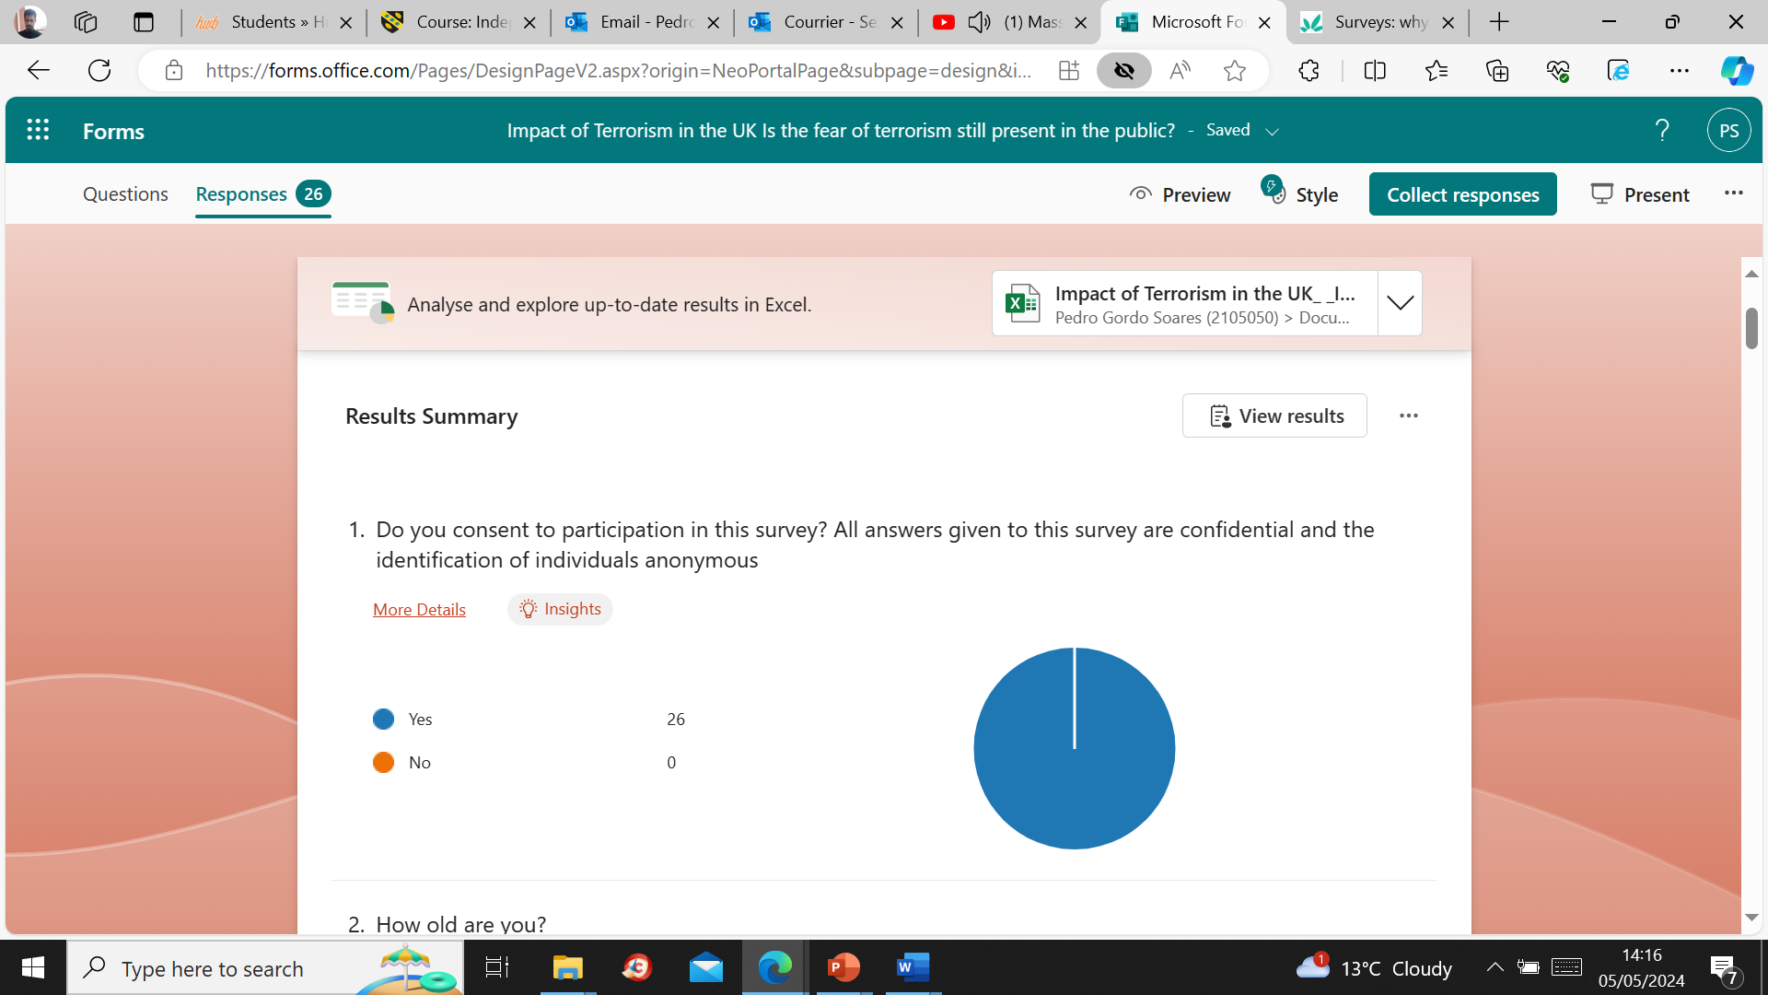

To understand why our demographic questions, have patterns on a personal level, the Countryside and Community Research institute (2019) says that when we conduct surveys, we collect a lot of personal information, respondents could feel questions like age, gender, ethnicity or occupation is personal and not relevant to the topic of the survey, these types of questions may seem intrusive but the good reason why it’s asked it’s because it allows us to check if the respondents are similar and if they represent a wider population, this makes us understand by diversifying our survey and our data analysis, if we conducting a survey where everyone is the same gender, same age and ethnicity, that would not represent a sense of wider population, therefore a survey like this wouldn’t work, for a much diverse population we must include welcome anyone despite their demography
This can start with the age of the individuals, below in the graphic:
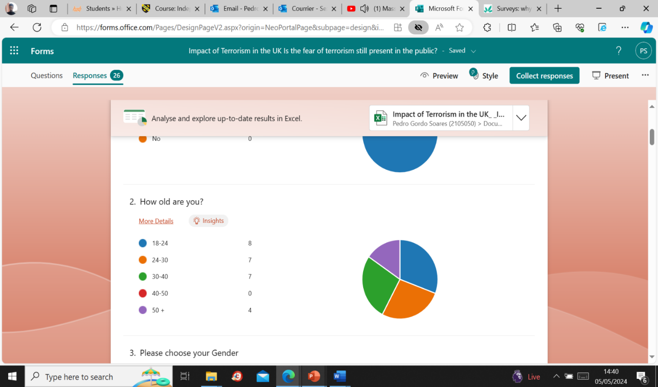

There is a fair amount group of age that is mixed, although 18 to 24 years old comprises the majority reaching, a number of 8 people, the people aged from 24 to 30 and 30 to 40 have is not far behind with a total of 7 people, it doesn’t fall much behind, another thing, is that we can also see a group of people aged of 50 plus, who answered this survey, although they comprise a lesser number, they add a good representation to the survey, sadly we have no answer from people aged 40 to 50.
A good point for reference, is why it is crucial to have different age groups answering the survey, this tells us that these differences correspond to the experiences of life between different age groups and that tastes and behaviours can be useful to include the age question on a survey, people born around a similar time, within a particular generation, share some similar characteristics in their way of thinking (Smart Survey, 2024).
This type of question helps us knowing if there is a possibility to bring a balance to the survey, by precisely proving that with diversity is essential for the survey, but why is it important asking this on a survey? Well, (Bhat 2024) said that for a good survey design, accomplishing the survey in accuracy and inclusiveness, the survey makes the participant feel that their opinion is well valued as any other participant.
Gender, in the graphic we can then observe that there is a balance in answers, so starting by the red percentage, where one participant chose to not identify itself, the answer to this question doesn’t affect the survey but it shows how one feels about its privacy, providing options helps keeping the person’s value and integrity in the survey, we can understand this by reviewing what Kang (2023) said, poor anonymity and confidentiality strategies not only create harm to the participants but also impacts the overall criticism of the research outcome, respecting anonymity and confidentiality is key for a credible research.
The numbers between male and female answering the question only changes by one person, meaning that there are more females, numbering thirteen answering our survey and twelve males, but that again still brings inclusiveness to this survey as the difference isn’t large, so it is expected to have fair answers from both sides.

No answer in the graphic was obtained from anyone who identifies as “other”.
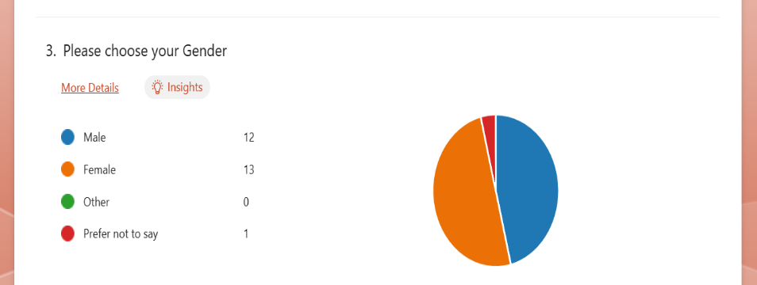

The final demographic question is about one’s national and ethnical background and nationality. The survey’s question graphics shows us primarily also what nationality do the participants belong to, if they are British nationals, double nationality or non-UK nationals. We can see eighteen people are British Citizens, seven aren’t British, and only one has a double nationality meaning the individual is either both British and a national from another country or someone who does not have British citizenship at all but possesses a double nationality and lives in the United Kingdom.
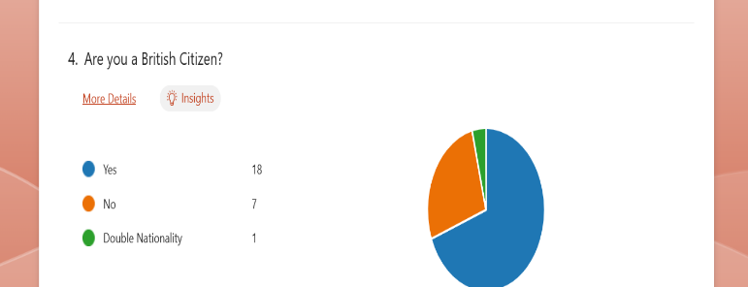

The ethnicity of the twenty-six participants in the graphic shows us a solid majority of twenty-two people who identify as white and four others who self-identify from another ethnical background.

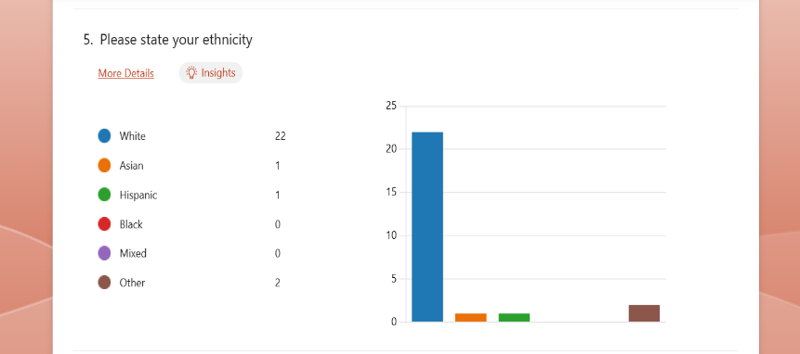

Terrorism related questions: Answers

- The people’s opinion related to the British government’s strategy to tackle terrorism.
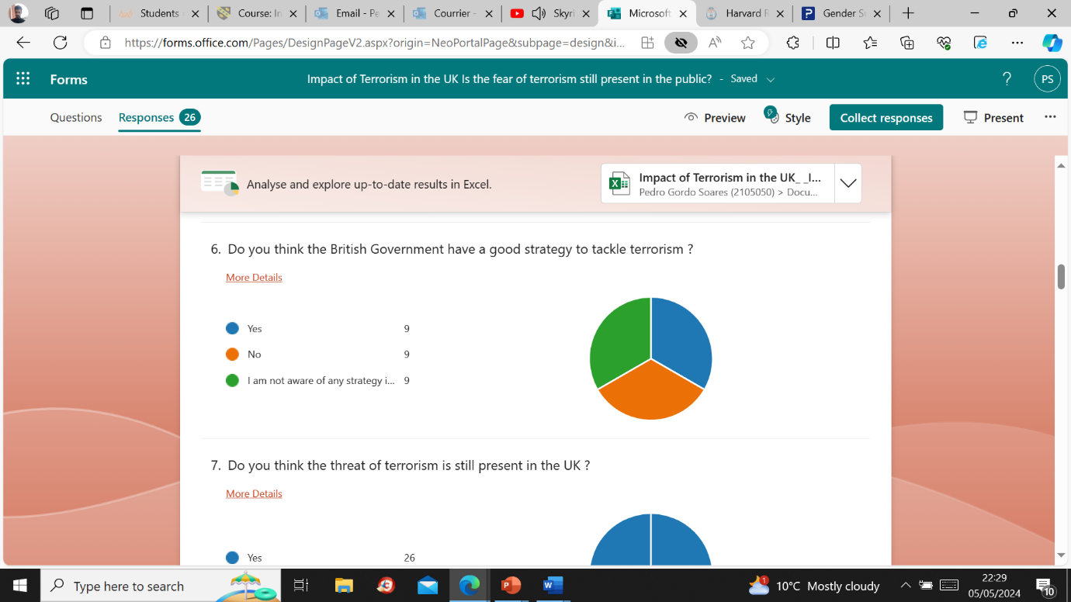

Result:
Yes: Nine people answered this and are aware of the strategy that the British government have in place to tackle terrorism, they think it’s a good strategy.
The newly updated strategy from 2023, can be found on the official British Government website, the British Government (2023) explains a summary of it, saying the aim of CONTEST is the UK’s counter-terrorism strategy to reduce risk from terrorism to the UK and citizens interest overseas, allowing people to live their lives freely with confidence.
No: Nine people don’t think the British government has a good strategy, or that this strategy isn’t working at tackling terrorism.
I am not aware of any strategy in place: Nine people do not know about any anti-terrorism strategy in place by the British government.
Each answer comprises a third of the total, and this amounts to an equal division of answers, as by observing the graphic we can see all of the answers amount to the same number.

- The question asks If participants think that Terrorism is still present in the UK. With about 3.395 deaths related to terrorism since 1970, the conflicts in Northern Ireland, account for the highest number of incidents (Neighbourhood watch, 2022).
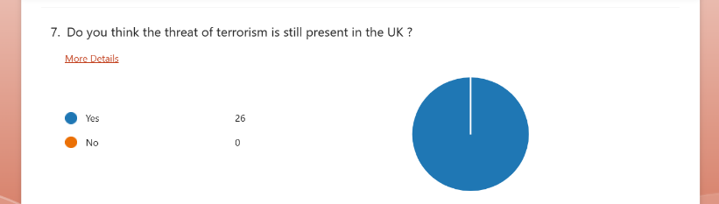

Result: This question achieved its goal, with the twenty-six answers comprising a percentage of 100%, the knowledge people have in knowing that the terrorism threat is still present in the UK, this is very relevant to the fact that the people are aware of the “Substantial” terrorism threat level in England Wales Scotland and Northern Ireland (MI5, 2024). This also answers the subtopic question of this dissertation by expressing that these individuals do think that the fear of terrorism is still present in their minds and in British society.

- Asking the participants where would a terrorist attack would most likely happen.

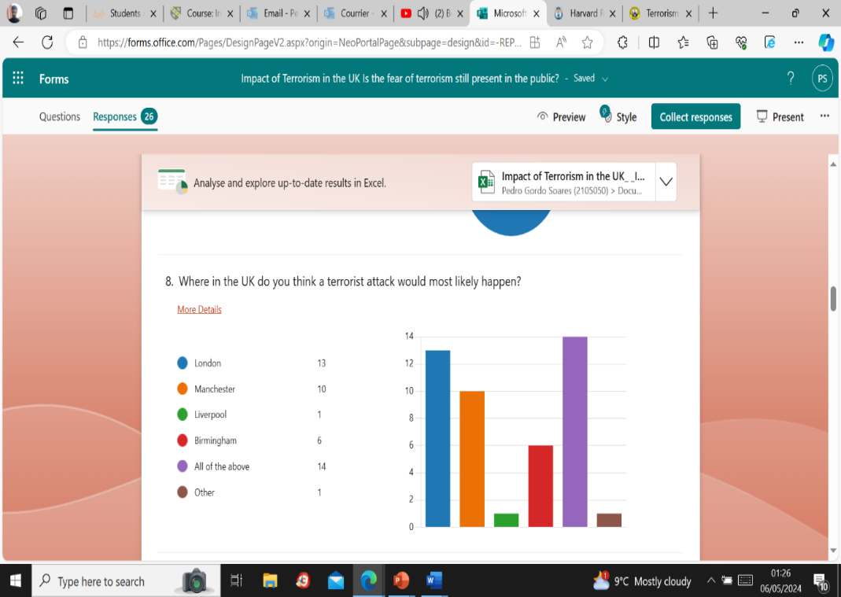
Result: This question is based on the point of view of the individual, in this question thirteen people chose London as the main possibility for an attack, Manchester ten people, Liverpool one, Birmingham six, and fourteen people chose the all of the above option. Responders can select the option that in their view fits best, with multiple answers being allowed SurveyMonkey (2024) said something positive about this, saying that multiple choice questions are flexible and accurate, well-structured data is easy to analyse.

- This shows us how both question nine and eight relate to each other due to the location of the terrorist incidents, asking which terrorist attack had a more impact, in question eight, thirteen people chose London as the main target for an attack compared to the ten people who chose Manchester, but in the graphic below we can see that the Manchester Arena Bombing in 2017 amounts to twelve responses, showing us that the impact of this terrorist incident in 2017 has caused more fear in the public compared to any other displayed in the graphic, even if fourteen people chose the all of the above option.
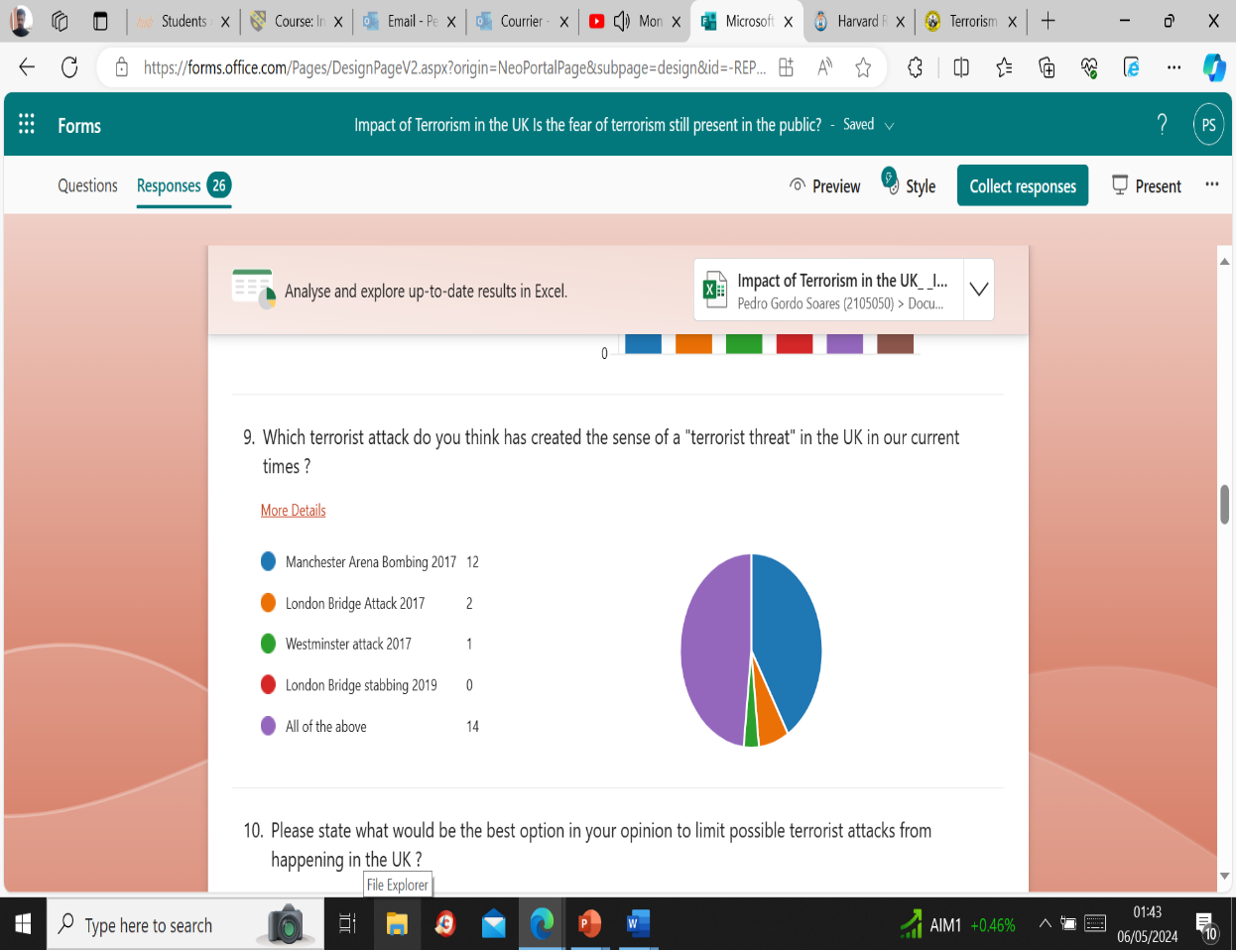

Result of both questions: Question number eight and number nine are very crucial for the validation to of the title and sub titles of this dissertation a majority of people in both graphics think the “All of the above” with 14 answers (48%) is the correct answer, creating a notion that in all the major cities in the UK there is a feeling that a terrorist attack might happen and that all of the terrorist attacks that happened in these locations are relevant, but responders do think that the Manchester Arena Bombing 2017 had a huge impact.

- This question of qualitative data aims to know what the participants think about what would be the best option in their opinion to limit terrorist attacks, as an optional answer, this gives the flexibility to people express whether they wish to answer or not, out of twenty-six people, sixteen people answered.
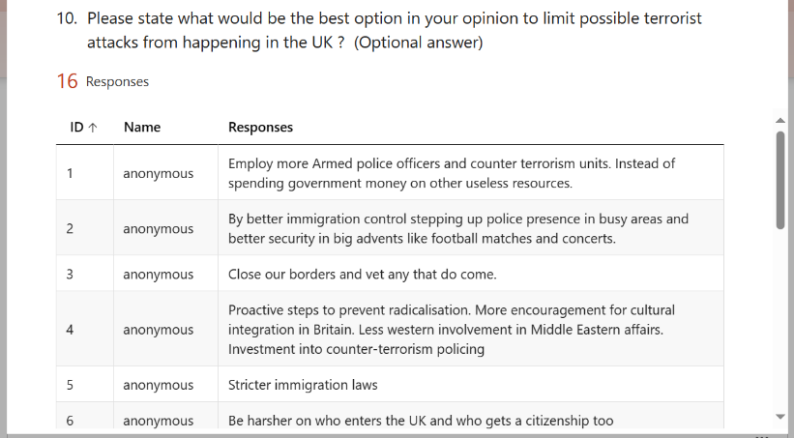
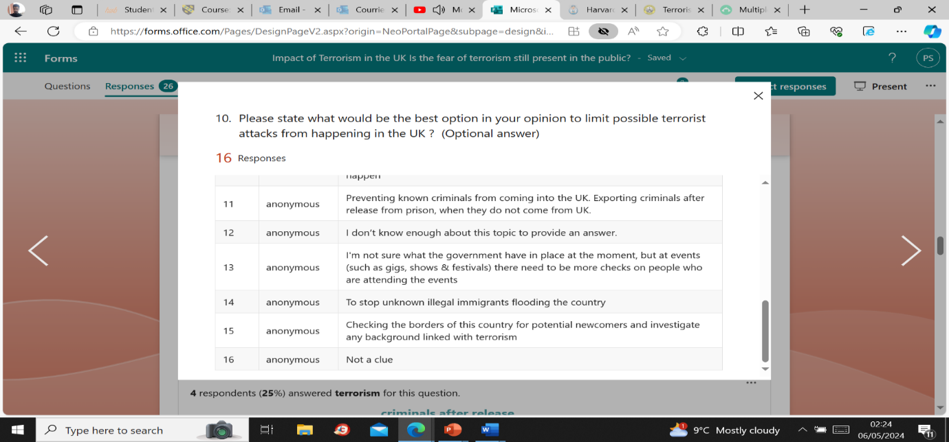
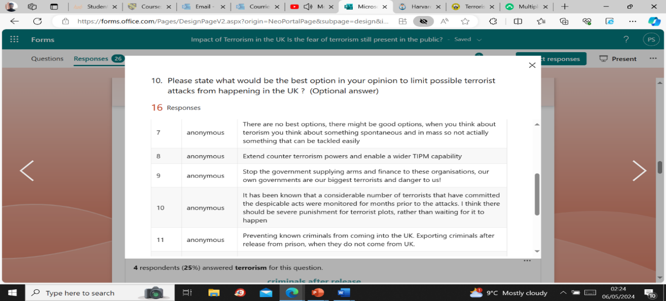

Result: The answers are of similar opinions, in general people ask for the government to employ more armed police officers trained in counter terrorism, better immigration control, vetting, steps to prevent radicalisation such as cultural integration, strict and harsher immigration laws to whoever enters in the UK and to who gets citizenship, number seven the answer says that “there are no best options”, it’s not something that can be tackled easily” while number nine says “severe punishment for terrorist plots and export criminals after release from prison”.

- Believing in the rehabilitation of terrorists, this question relates to one of the key points in the literature review, the cases like the one of Shamina Begum is a primary example, again Shamina who found herself in a detention camp and her citizenship revoked applied multiple times for the right to asylum but got refused (Dalton, 2024) thus Begum’s rehabilitation was also denied when she was refused back in the UK. Now, the complexity of the question on whether we believe in the rehabilitation of terrorists or not, relies in the programs available to rehabilitate them, Mullins (2010) said that while there are some positive effects of in different programs, it is also acknowledged that rehabilitative efforts with terrorists are still new but that there is a great deal in learning.

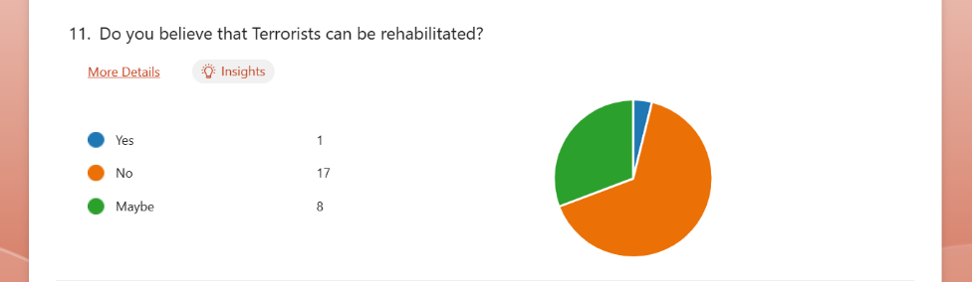
Result: On the graphic we see choice the people’s opinion about the rehabilitation of terrorists, contrary to what Mullins wrote in 2010, 14 years after and the UK a target for terrorist attacks, the survey responder’s opinions are in between a spectrum of perhaps and negative. In the answers we can see:

Yes: Only one person out of twenty-six believes they can be rehabilitated comprising of 4% in the graphic.
No: A majority of people don’t believe terrorists can be rehabilitated, accounting for 65%.
Maybe: People believe that the rehabilitation system may help terrorists to rehabilitated, this comprises of 31% of the rest of the answers basically half of the 26 participants believe there may be a possibility in the rehabilitation of terrorists.

- The impact of the media on reporting the news related to terrorism, in this question people were asked on whether they’d think the media plays a positive or negative role or even both in reporting the news?

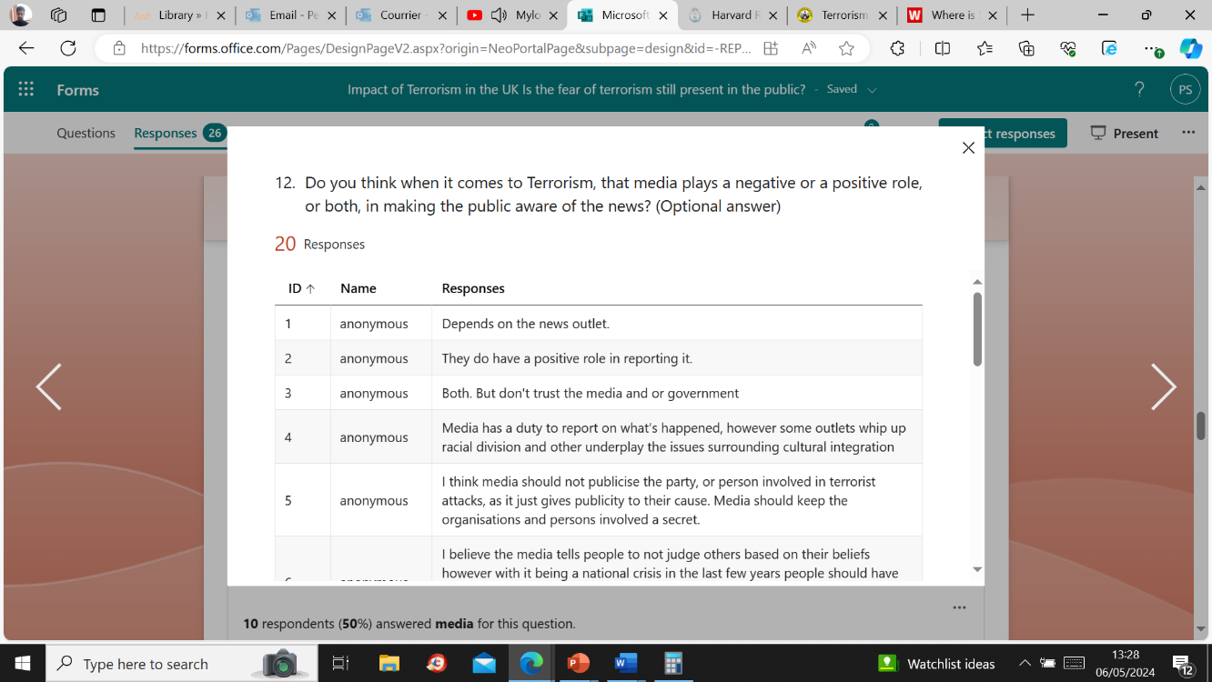

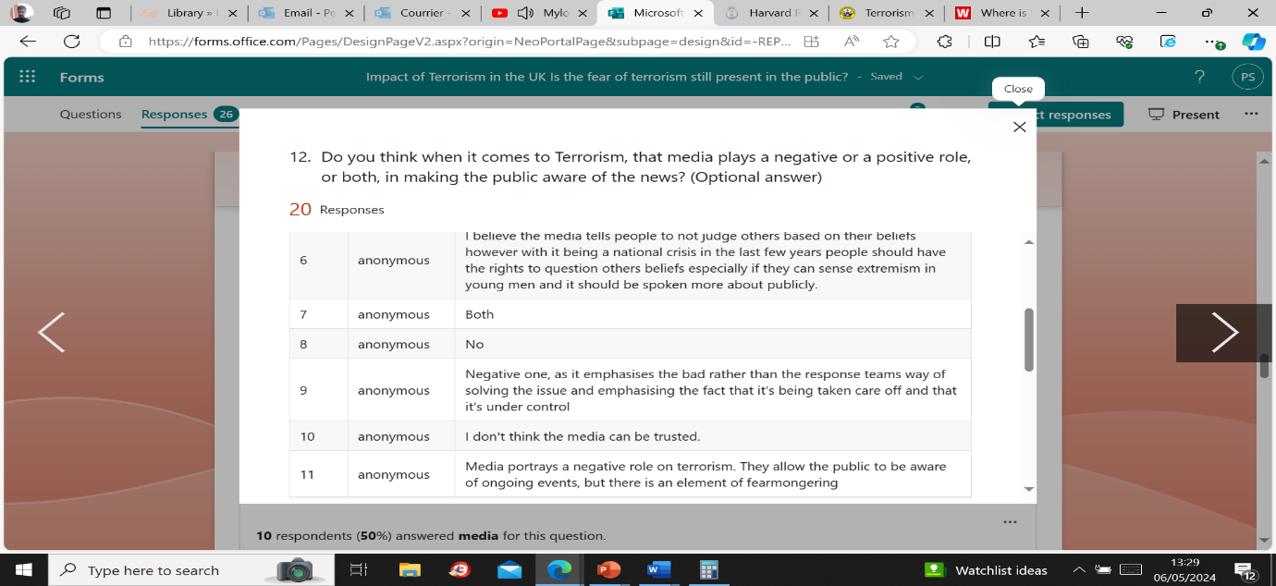

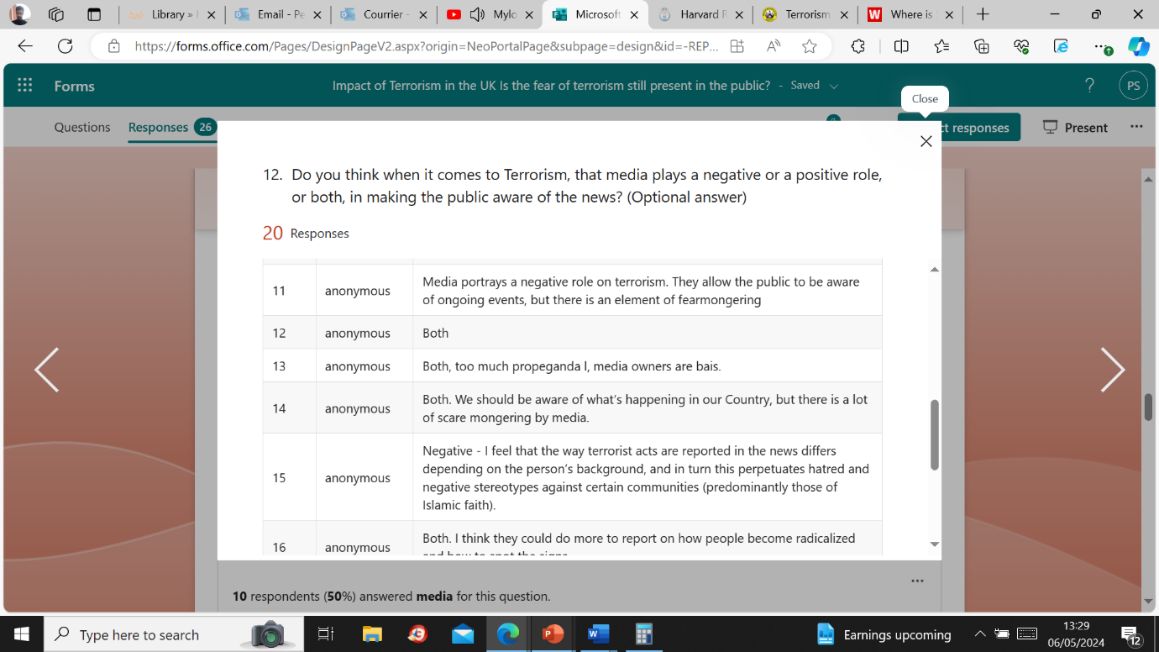

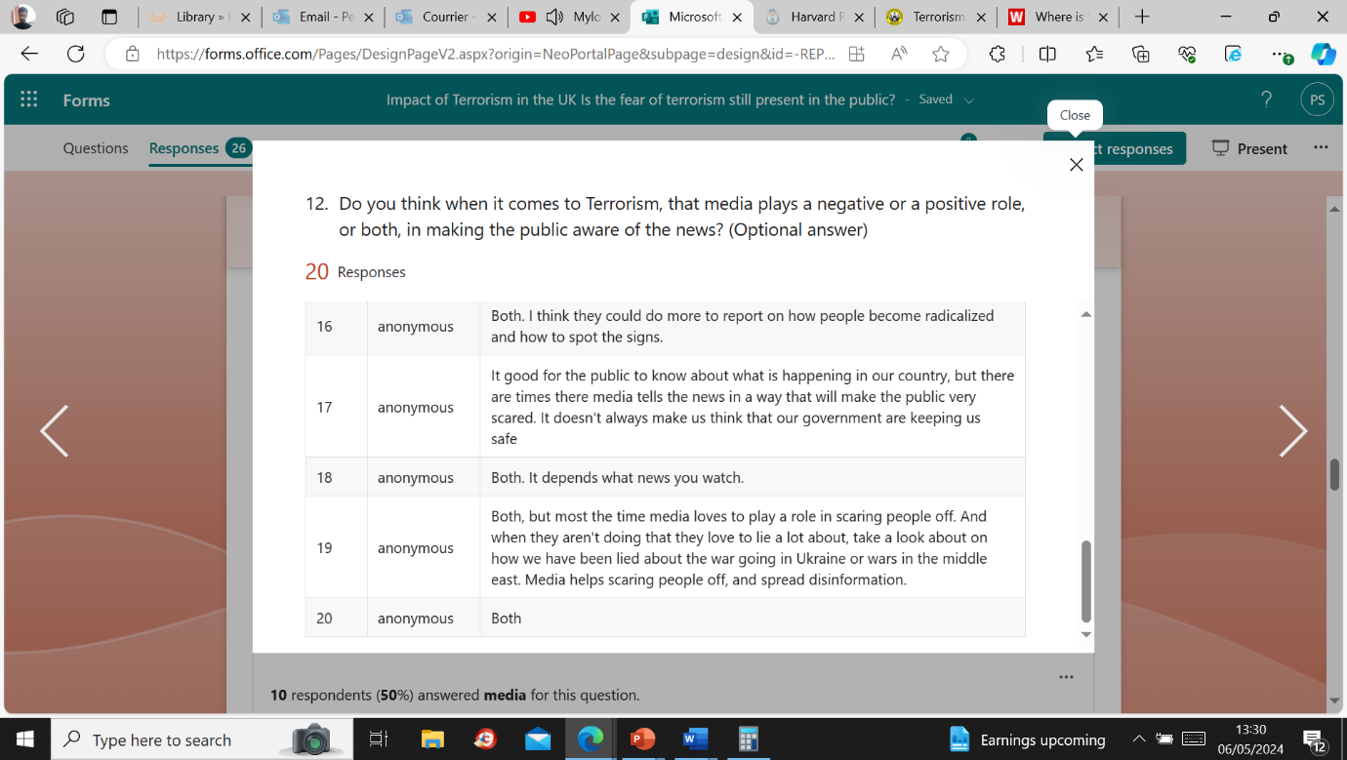

Result: The answers that were given are of qualitative data, in question twelve we can see that twenty out of twenty-six people developed their opinions focusing on the question and keeping it to the topic, the majority of people who answered believe that the media have a both positive and negative role in making the public aware of the news with some people in answer 3, 10, 11 and 15 expressing a negative opinion about it.
The person answering in the answer 2 says that the “media does have a positive role in reporting cases of terrorism”, but how does the media reach out to us in our present day lives?
Since the last decade or more, the internet is the most prominent platform source of spreading information, Kenyon (2021) said that the role of the internet was becoming very prominent in the radicalisation of convicted extremists in England and Wales, between 2005 and 2017, there was an increase in the number of extremist offenders that were affected by online radicalisation, this included those who were already radicalised online and those who they were radicalising through a combination of online and offline influences.

- This asks the participants if they think it’s possible to stop someone from becoming radicalised, bearing in mind the UK parliament has expressed also their views on this in 2020, former Justice secretary, Michael Gove was commissioned a review, and this review found that Islamic extremism in prisons was growing (UK Parliament, 2020), meaning, there was a large number of radicals serving time in prison back then, also becoming more radicalised thus questioning if the rehabilitation of terrorists was actually working.
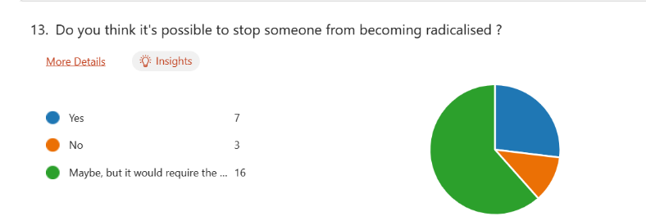

Result: The quantitative data shows us a more present opinion showing
Yes, seven people believe it’s possible from stopping someone becoming radicalised (27%). No, three people don’t think it’s possible (12%).
Maybe, but it would require the required social services to intervene: Sixteen people are not sure but with the proper help from social services they believe it’s possible (62%)
With the changes in governmental structure and years gone by, and now people’s opinions expressed in 2024, the participant’s opinion on stopping someone from becoming radicalised differ slightly from the parliament’s review of radicalisation in 2020

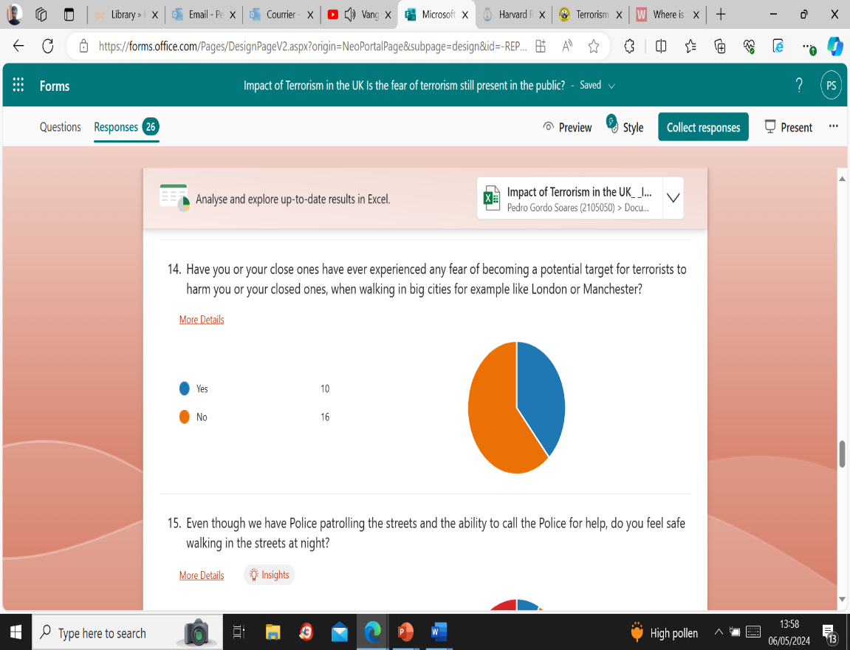
- Asking if the participants ever experienced any concerns of becoming a target for terrorists in major cities like London and Manchester.

Result: In this answer ten participants expressed that them or their close ones have experienced to be potential targets for terrorists making up to 38% of the answers and those who chose “No” making 68% saying that they haven’t experienced it.

- On the next question, eleven people say they don’t feel safe walking in the streets at night making 42%, an interesting point, because it’s an answer that can combine with the seven people who said that only in daylight, they feel safe making 27%, with the two participants who said “Yes”, and the six participants that said they feel safe both at night and day making a combined percentage of 31%.
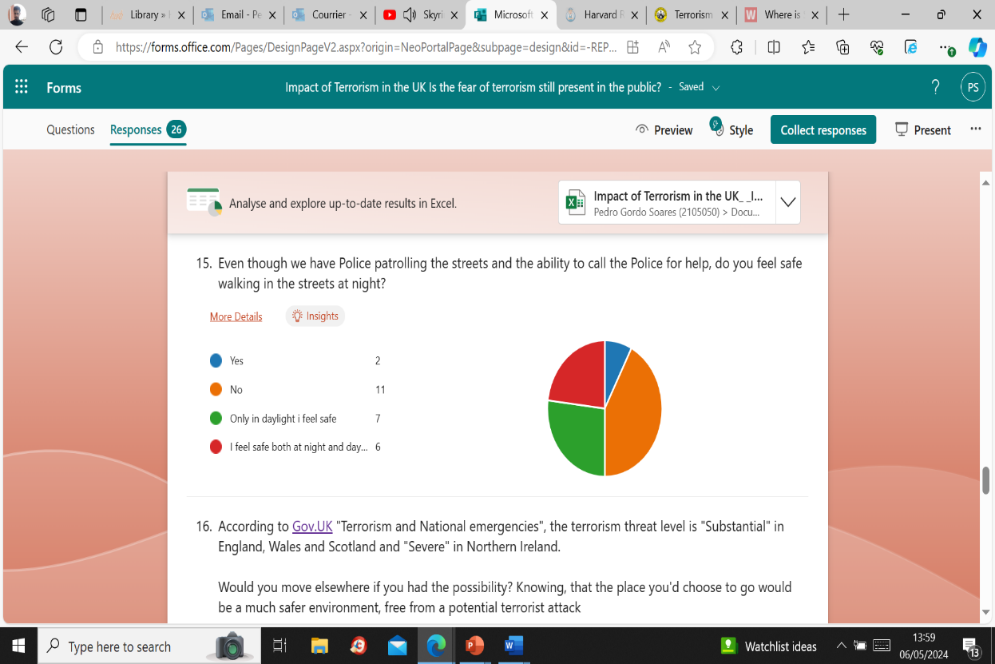
Result: This shows us that these two questions link to each other when discussing safety on the streets, walking for example in cities like London Manchester or Birmingham, where terrorist attacks have challenged public safety. But how does terrorism and public safety relate to terrorism? Fregonese (2024) said an estimated 80 % of terrorist attacks in the UK are being perpetrated by bladed or other types of blunt weapons, the use of explosives is decreasing, less lethal weapons compared to explosives are being used by perpetrators targeting everyday public spaces.

- This is about the participants perspective of life, participants were asked if they’d move elsewhere, if they had the possibility of choosing a place with a much safer environment, safe from any possible terrorist attack.
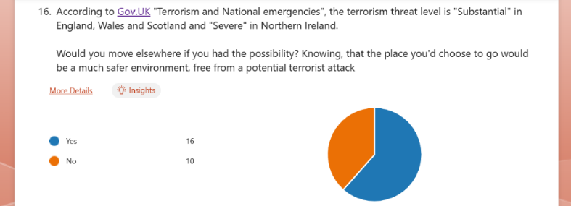

Result: On option “Yes” sixteen people said they’d go somewhere else if it means they would live in a much safer environment (62%), while people who chose option “No” ten people rather remain in their homes and would stay even if the threat of terrorism is a possibility (38%). If terrorism is a safety concern, this can be one of the reasons for the people in the survey to desire living in a much safer environment, this choice of living elsewhere can or may be associated with the rise of crime in England and Wales, the Office for National Statistics (2024) showed an increase of 10% of crime incidents in 2024 in comparison to June 2023, and since COVID-19, robbery has been estimated in 139,000 incidents compared to 60.000 incidents whilst until June 2023, furthermore it tells us that violence levels rose up to around 562,000 incidents compared to 376,000 in the year prior to 2024.
On the other hand, there is also people who feel they want to stay in the UK despite safety issues, this could be particularly associated with the lifestyle they have in the UK, a sense of pride and identity, Ipsos (2022) said that 6 in 10 would rather be a citizen of Britain than any other country in the world, that the NHS, British history and the Royal family makes them proud of being British, this research shows that 60% of British people agree while 13% do not.
- This is an optional answer, and seventeen people out of twenty-six opted with the choice of answering the question, the question asks the people’s opinion about civilians fleeing places affected by terrorist organisations like ISIS or Al Qaeda,
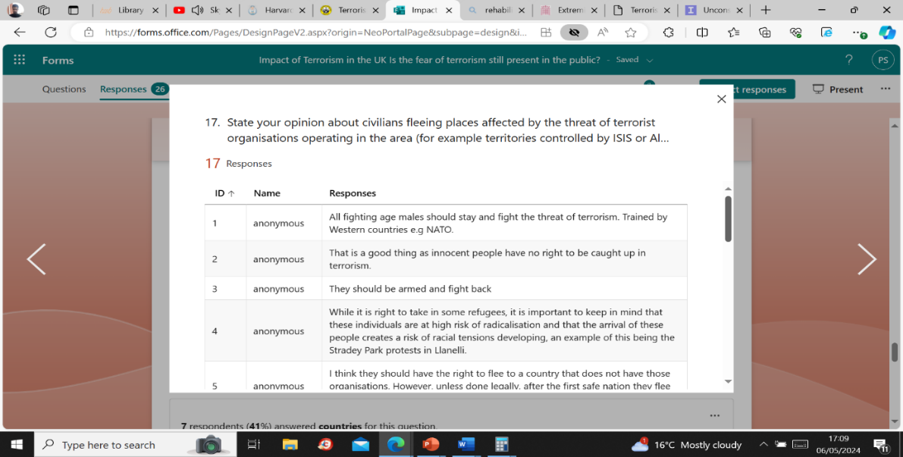

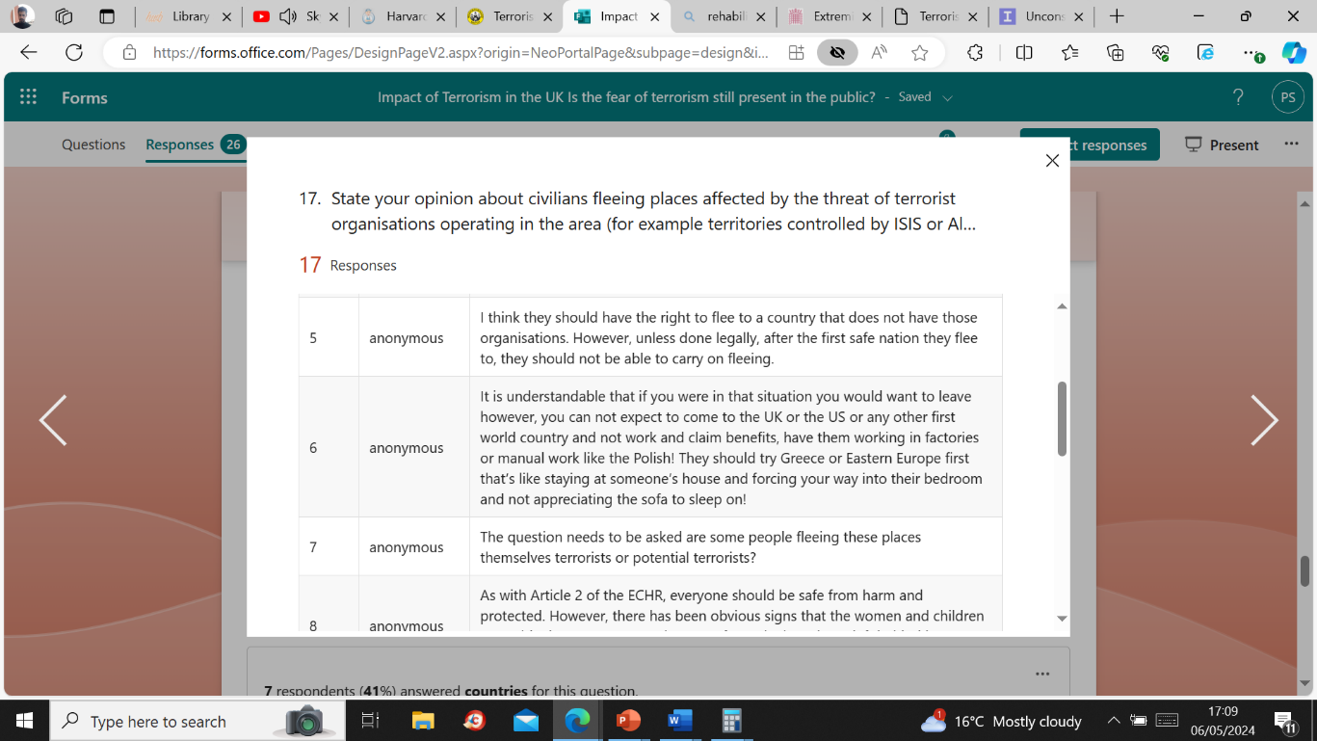

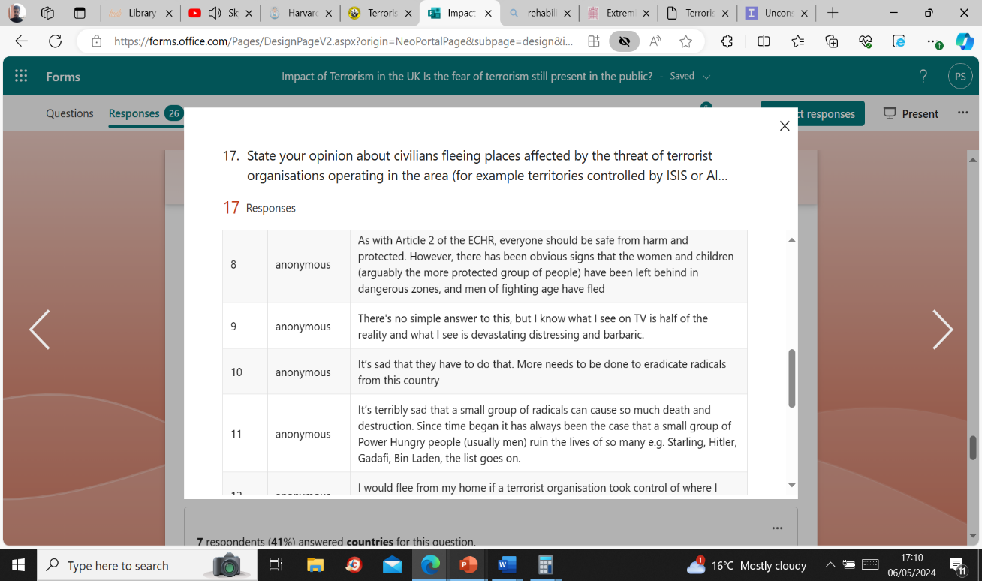

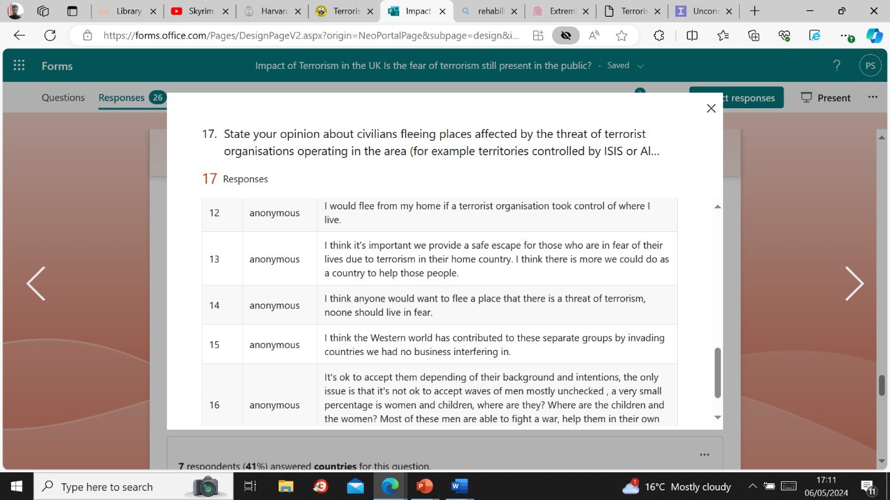

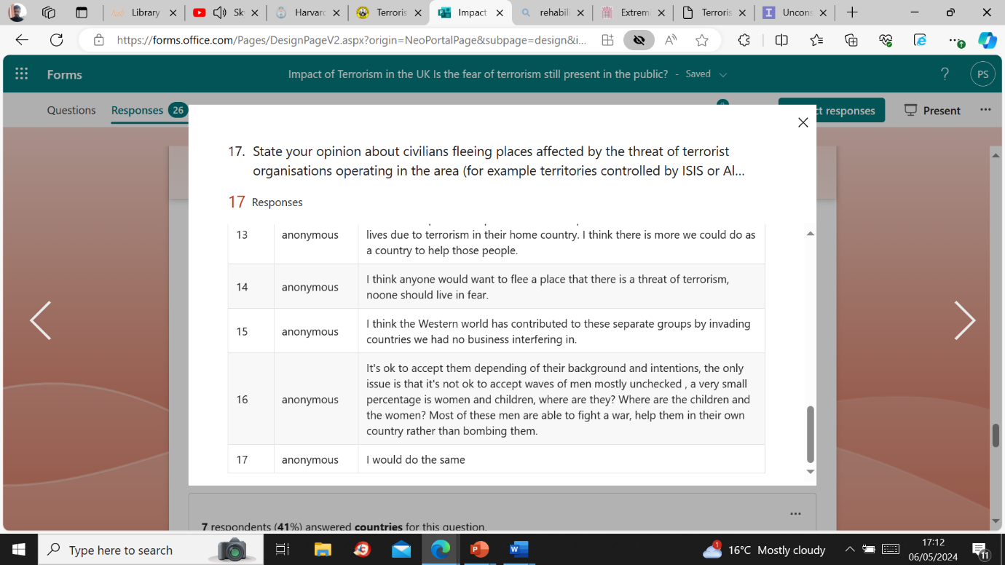

Result: With a mix of results there is no right or wrong about the individual’s opinions, but since the last decade we have seen a rise of asylum seekers and migrants fleeing war zones, mostly from the Middle east and Africa, although the said the number of asylum seekers coming to the UK is overestimated by the British public, that people seeking asylum comprised of only 7% of the UK’s migration numbers (British Red Cross, 2023), some statistics from the Refugee Council (2022) also talk about being a refugee is a matter of fleeing persecution because of ethnicity religion or even nationality, or a member of a specific social and ethnic group, but in term of statistics 72% of the refugees go live in a neighbouring country, by the end of 2021 around 89.3 million of people were displaced from their homes, and of these 27.1 million became refugees, also when it comes to the past conflict in Syria about over 6.8 million people have fled the war with the neighbouring country Turkey a (secular Muslim country) being the biggest host of refugees providing safety for 3.7 million Syrian refugees at the end of 2022, while the UK has resettled 20,319 refugees from Syria, with the UK itself being part of the country who has received 1% of the 27.1 million refugees.
While asylum seeking may be estimated of 7%, the UK immigration levels rose as of 2023, Migration Watch UK (2023) says when it comes to immigration that the levels continue to rise as over 600,000 per year and the high immigration has worsened the UK’s housing crisis.
These statistics could not be completed without further information about the deportations and removals or voluntary departures from the UK, as this comes in relation with the topic of immigration and asylum seeking, returns from the UK remained low compared to past levels but returned to pre pandemic levels in 2023 around 41% of those applying for asylum seeking status between 2010 and 2020 were refused and removed from the UK by 2022, then in the year ending 30th of September 2023, 16% of all the people deported from the UK were foreign national offenders, with 53% of those offenders being EU citizens, but 1.3% of people arriving by boat across the channel between the years of 2018 to 2023 were returned back from the UK (The Migration Observatory, 2024)
- This crucial question helps us understand with clear the public’s opinion when it comes to trusting the government with a strategy to protect the citizens from the threat of terrorism, on whether believe or not the British Government is doing enough to prevent a terrorist attack from happening.
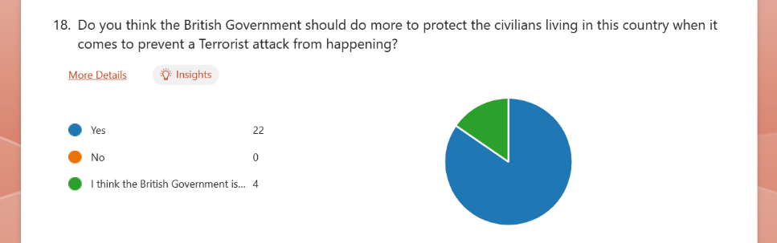
All the twenty-six participants engaged with the question and gave their opinion based on the choices available

Result: The answers show that clearly a majority comprising of twenty-two people (85%) chose option “Yes” and agree that the British Government should be doing more to protect the people living in the United Kingdom, No individuals in the survey choose the “No” option, but four people (16%) comprising a small minority out of all the participants in this survey, said “They think the British Government is doing enough”, which is a slightly positive remark towards the government’s performance towards the strategies in place for the prevention of terrorism.
The British Government, indeed has in place strategies to prevent a terrorist attack from happening, to further strength this point the British Government (2023) shows another review of the “CONTEST strategy” saying it’s aimed at preventing people from becoming or supporting terrorists, to pursue in stopping terrorism from happening in the UK and overseas, to protect the people against any terrorist attacks and to prepare by minimising any impact of an attack, the British Government explains how they do it, by transforming counter terrorism into a communications effort, maintain investment in threat assessment capabilities, strengthening the international counter terrorism partnerships, building engagement with the tech department, maintain data for investigation and eliminate any terrorist activities, invest in the identification of future threats, and finally by strengthening the UK’s bordering.

- An opinion about the social behaviour of radicalised individuals, this question asks the participants to make a choice about what is causing the radicalisation of individuals in the UK. It can come across as a bias opinion depending on what are the views of the individual about religion or social services. The Imperial college (2024) said that unconscious bias triggers our brain into automatically make a quick judgement by assessing a person’s background and their personal experiences, resulting in cultural stereotypes and all the context related to it.
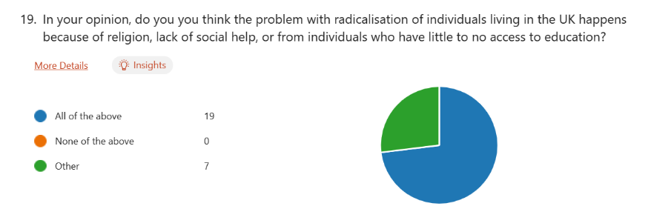

Results Nineteen participants (73 %) believe that religion, lack of social help and the limited access to education is what is contributing to radicalisation. Seven people (27%) out of the twenty-six selected “Other” causes but none chose the “none of the above option” which suggests all respondents believe in the issues regarding the radicalisation of individuals.
Radicalisation is a very broad subject, the Leeds City Council (2024) said it’s crucial to recognise the contributing factors towards the radicalisation of individuals, including the misuse of drugs, child sexual exploitation, gangs and alcohol abuse, but other factors include as well the need for belonging, isolation, mental health struggles, injustice, online radicalisation or desire for status, bullying can also be a factor for the radicalisation of individuals. However the UK parliament (2017) argued back then that the presence of these risk factors do not make radicalisation inevitable or predictable, the majority of people at risk often choose to not engage in extremism, due to strong factors like a strong family support self-confidence and purpose, close friendships that could be at risk by involvement of terrorist activities or open mindedness, the UK parliament also mentions that terrorists often make use of the social media to radicalise and recruit.

- The final question is in synchronisation with the previous question asking the participants to now state their opinion, whether they chose the “none of the above option” or “other” , this is also an optional answer, individuals are now free to express their opinion or just complete the survey without needing to say anything, although this question was aimed at those who either answered those two options in question nineteen, it was possible to convince the individuals to respond and develop an opinion, thus obtaining nine responses and enriching the subject, bearing in mind that in the previous question, seven people chose the “other” option, while nineteen who chose “all of the above” two of those nineteen people, chose to engage with the question, which confirms the interest of some of the responders about the subject of radicalisation of individuals in the UK.
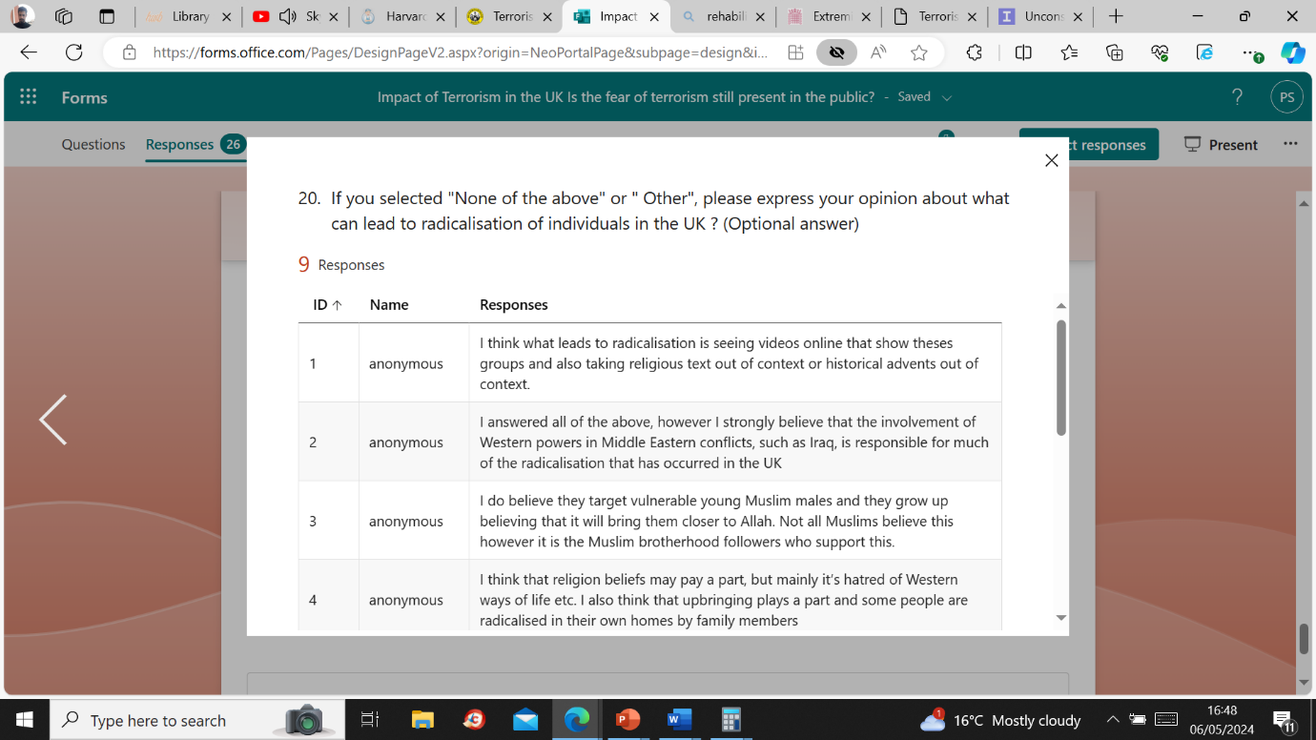
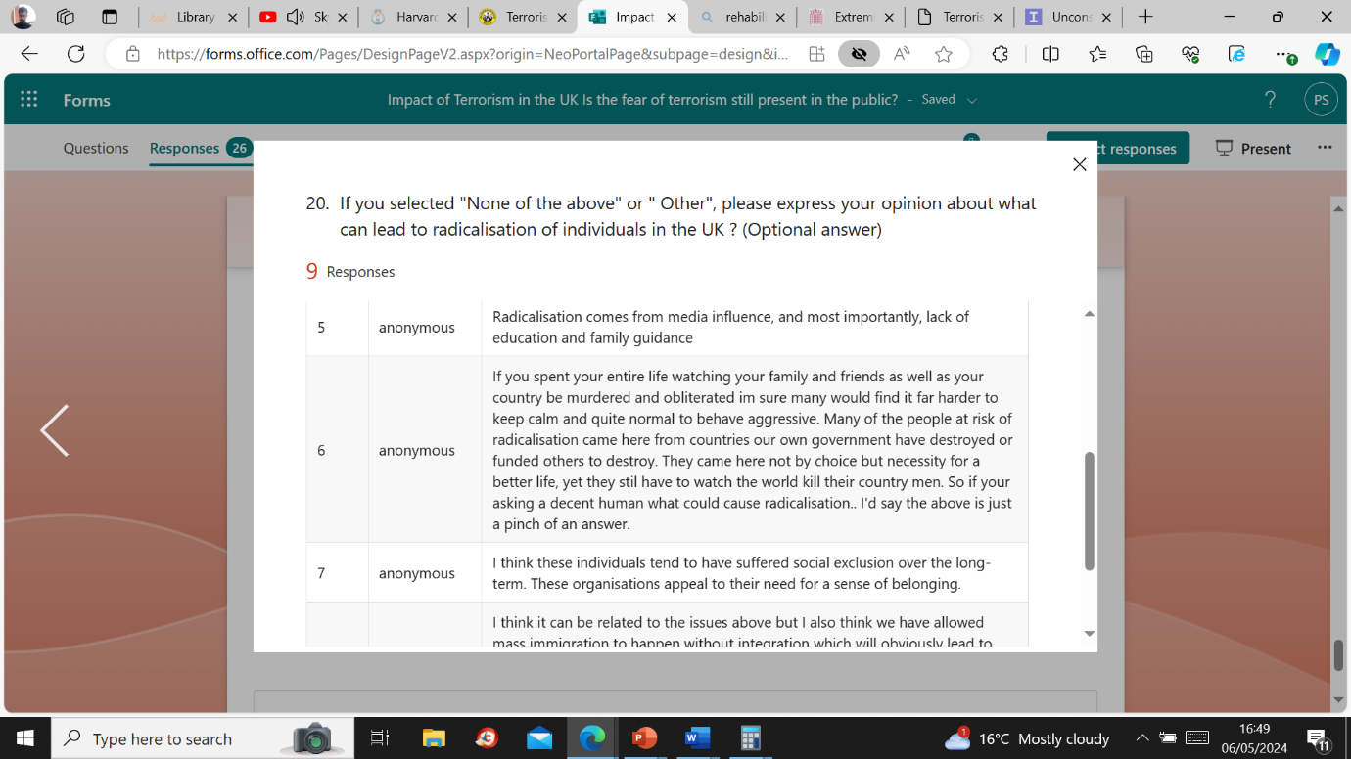

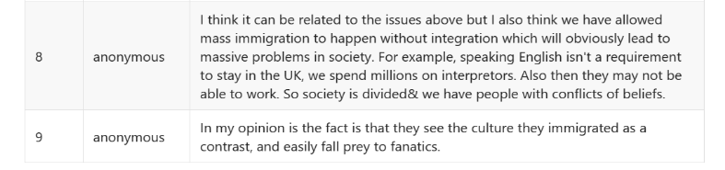

Result: Many responses are linked to earlier results in question nineteen, people realised that there are cultural contrasts with immigration, social exclusion, but in question six someone blamed the British government for the displacement of people, leading to radicals entering in the UK, it was said religion was a factor in radicalisation or anti-western sentiment. One person said they believed that young Muslims are vulnerable to extremism grooming, that while not all are like this, the participant believes the Muslim brotherhood is responsible for it, the British Government (2015) made an investigation about the group and explained that it was founded in Egypt in the 1950’s and it’s established in the UK, some of its members had ties with Hamas, while only some members of the group held those views, it was said the Muslim brotherhood aimed at Islamising the individual not the state, and did not supported terrorism against the UK, by condemning terrorism.

Chapter 5 – Conclusion
The Impact of terrorism in the UK, shows very mixed results, with ongoing concerns among the public towards the media and immigration.
This research found that the Muslim community has been unjustly demonised by the actions of extremists, despite a long history of terrorism in the UK from all types of groups, ideologies and faiths.
These are individuals do not represent the Muslim community in general, former prime minister Cameron (2015) said “the root of the problem” was Islamic extremism and often this violence results in harm to Muslims who do not agree with this worldview, the Muslim Council of Britain (2016) expressed its concerns about the threat of terrorism to Muslims, emphasising that the best way to tackle the issue is to show that British Muslims are part of British life, there are concerns that singling out Muslims could contribute to extremism, with Muslims having to pass subjective counter-extremism tests further reinforcing terrorist behaviour. The Council also encourages the reporting of any terrorist activity.
Islamophobic behaviour has worsened, especially towards Muslim women who faced verbal and physical abuse, the Muslim Women’s Network UK (2017) reported an increase in islamophobia, particularly negative political comments and the media stereotyping of Muslims fuelled that behaviour. Anti-Muslim hatred has become socially acceptable with young people showing hostility towards Muslims making great relevance to today’s situations where the rise of hate crime and anti-Muslim extremism is on the rise.
The results highlight that Terrorism in the UK with its history, public opinions, and safety concerns, involves all sorts of organisations like ISIS and Al Qaeda. However, terrorists and terrorism originate from various countries, ethnicities and religions with none of them having a political ideology to unite them (CPS, 2022).

Reference List
British Government (1998). “The Belfast Agreement”. Last Updated: 10 April 1998. Available at: The Belfast Agreement - GOV.UK (www.gov.uk) – (Accessed the 04/12/2023)
British Government. (2023) “UK action to combat Daesh”. Last Updated: Unknown date. Available at: UK action to combat Daesh - GOV.UK (www.gov.uk) – (Accessed 06/12/2023)
British Government. (2022a). “Review of government counter-terror strategy to tackle threats”. Last updated: 30th of October 2022. Available at: Review of government counter-terror strategy to tackle threats - GOV.UK (www.gov.uk) – (Accessed 06/12/2023)
British Government. (2022b). “New drive to tackle terrorism in prisons”. Last Updated: 27th of April 2022. Available at: New drive to tackle terrorism in prisons - GOV.UK (www.gov.uk) – (Accessed 15/12/2023)
British Government (2022c). “Management of Terrorist offenders: Police, Crime, Sentencing and Courts Act 2022 factsheet”. “Police Powers 2.1”. Last Updated: 20th of August 2022. Available at: Management of terrorist offenders: Police, Crime, Sentencing and Courts Act 2022 factsheet - GOV.UK (www.gov.uk) – (Accessed 16/12/2023)
British Government (2020). “Northern Ireland related Terrorism”. Last Updated: 2020. Available at : ES1015527_CCS207_CCS0920226370-001_Northern Ireland-related terrorism.pdf – (Accessed 31/03/2025)
British Government. (2018) “Data Protection. The Data Protection Act 2018”. Last Updated: 2018. Available at Data protection: The Data Protection Act - GOV.UK (www.gov.uk) – (Accessed 05/04/2024)
British Government (2023a). “CONTEST: The United Kingdom’s Strategy for Countering Terrorism 2023”. “Execute Summary, 1. The aim of CONTEST”. Last Updated: July 2023. Available: Microsoft Word - English Standard_CONTEST 2023 (publishing.service.gov.uk) / Counter-terrorism strategy (CONTEST) 2023 - GOV.UK (www.gov.uk) – (Accessed 05/05/2024)
British Government (2023b). “CONTEST: The United Kingdom’s strategy to prevent terrorism 2023”. Last Updated: July 2023. Available at: Counter-terrorism_strategy__CONTEST__2023_Leaflet.pdf – (Accessed 09/04/2025)
British Government (2023c). “International treaty UK/Interpol: Agreement in the privileges and immunities of INTERPOL on the territory of the UK”. “Article 1 Purpose of the Agreement”. Last Updated: March 2023. Available at: CP 820 – Agreement between the Government of the United Kingdom of Great Britain and Northern Ireland and the International Criminal Police Organization - INTERPOL on the Privileges and Immunities of INTERPOL on the Territory of the United Kingdom of Great Britain and Northern Ireland – (Accessed 09/03/2025)
British Government (2018). The Westminter Bridge Terrorist Attack. “Executive Summary” page2. Last Updated: February 2018. Available at: THE WESTMINSTER BRIDGE TERRORIST ATTACK – (Accessed 10/03/2025)
British Government (2025). “Government Launches working group of Anti-Muslim Hatred/Islamophobia definition”. Last Updated: 28th of February 2025. Available at : Government launches working group on Anti-Muslim Hatred/Islamophobia definition - GOV.UK – (Accessed 24/03/2025)
British Government (2024). “Prevent duty guidance: for England and Wales. The Prevent duty”, pp13, pp14. Last Updated: 6th of March 2024. Available at: Prevent duty guidance: for England and Wales (accessible) - GOV.UK – (Accessed 25/03/2025)
British Government (2015). “Muslim Brotherhood Review: Main Findings”. Last Updated: 17th of December 2015. Available at: 53163 Muslim Brotherhood Review - Main Findings.pdf – (Accessed 09/04/2025)
British Transport Police (2025) “London bombings of 2005”. Available at: London bombings of 2005 | British Transport Police – (Accessed 10/03/2025)
British Red Cross (2023). “Number of asylum seekers coming to the UK overestimated by British public”. Last Updated: 18th of October 2023. Available at: UK asylum seeker numbers overestimated by the British public – (Accessed 08/04/2025)
BBC News (2014) UK “Imams condemn ISIS in online video”. Last Updated: 11th of July 2014. Available at: UK imams condemn Isis in online video - BBC News – (Accessed 07/12/2023)
Bhat (2024). “Gender Survey Questions for Questionnaires. “Importance of gender survey questions in a questionnaire”. QuestionsPro. Last Updated: 2024. Available at: Gender Survey Questions For Questionnaires | QuestionPro – (Accessed 05/05/2024)
Cameron (2015). “Roots of the problem”, pp1-5. British Government. Last Updated: 20th of July 2015. Available at: Extremism: PM speech - GOV.UK – (Accessed 09/04/2025)
Carnegie Council. (2016) “The Symbiotic Relationship between Western Media and Terrorism”. Last Updated: 24th of May 2016. Available at: The Symbiotic Relationship between Western Media and Terrorism | Carnegie Council for Ethics in International Affairs – (Accessed 09/12/2023)
Combating Terrorism Center (2020). “The 2017 Manchester Bombing and the British Libyan Jihadi Nexus”. “Abstract”. Last Updated: May 2020. Available at: The 2017 Manchester Bombing and the British-Libyan Jihadi Nexus - Combating Terrorism Center at West Point – (Accessed 10/03/2025)
Counter Terrorism Policing. (2019). “London Bridge Inquest – Statement.” Counter Terrorism Police UK. Last Updated: 16th of July 2019. Available at: London Bridge Inquest - Statement | Counter Terrorism Policing – (Accessed 24/03/2025)
CCRI (2019) “Surveys: Why do we… ask so many personal questions?” CCRI UK Last Updated: 25th of November 2019. Available at: Surveys: why do we… ask so many personal questions? - Countryside and Community Research Institute (ccri.ac.uk) – (Accessed 05/05/2024)
CPS (2022). “Terrorism; Terrorist Organisations”. Last Updated: 2022. Available at: Terrorism | The Crown Prosecution Service – (Accessed 14/04/2025)
Datacamp (2023) “What is Data Analysis? An Expert Guide with Examples”. Datacamp. Step 4: Data Analysis. Last Updated: July2023. Available at: What is Data Analysis? An Expert Guide With Examples | DataCamp – (Accessed 10/04/2024)
De Simone (2020). “The road to the Manchester Arena Bombing”, p.1. BBC News. Last Updated: 17th of March 2020. Available at: The road to the Manchester Arena bombing - BBC News – (Accessed 11/04/2024)
Dalton (2024). “Where is Shamina Begum now? Ex-ISIS member’s husband and family updated after citizenship row”. Last Updated: Updated: 23rd of February 2024. Available at: Where is Shamima Begum now? Ex-ISIS member's husband and family update after citizenship row - Wales Online – (Accessed 06/05/2024)
Faith Associates. (2025). “About us/Our mission”. Last Updated: Unknown. Available at: About Us - Faith Associates – (Accessed 07/12/2023)
Fregonese (2024). “Collective perceptions of security threats: an evidence-based political debate is needed”. University of Birmingham. Last Updated: 15th of March 2024. Available at: Dr Sara Fregonese - School of Geography, Earth and Environmental Sciences - University of Birmingham – (Accessed 07/04/2025)
Global Coalition Against Daesh (2025). “What is the relationship between terrorism and mass media?”. Last Updated: 2025. Available at: What is the relationship between terrorism and mass media? RUSI Fellow Jessica White explores their interactions in her recent literature review - The Global Coalition Against Daesh – (Accessed 25/03/2025)
George (2021). “Mixed Methods Research / Definition, Guide&Examples. p.1 “Mixed methods research”. Scribbr. Last Updated: 22nd of June 2023. Available at: Mixed Methods Research | Definition, Guide & Examples (scribbr.com) – (Accessed 09/04/2024)
Historical Royal Palaces (2025). “Guy Fawkes and the Gunpowder Plot”. Historical Royal Palaces. Last Updated: 2025. Available at: Guy Fawkes and the Gunpowder Plot | Tower of London | Historic Royal Palaces – (Accessed 10/03/2025)
Hurst (2023). “Chapter 18. Data Analysis and coding”. Oregon State University. Last Updated: 2023. Available at: Chapter 18. Data Analysis and Coding – Introduction to Qualitative Research Methods (oregonstate.education) – (Accessed 10/04/2024)
Imperial College London (2025). “Unconscious Bias. What is unconscious bias?” Imperial AC UK. Last Updated: 2024. Available at: Unconscious bias | Administration and support services | Imperial College London – (Accessed 06/05/2024)
Ipsos (2022). “6 in 10 would rather be a citizen of Britain than any other country in the world, the NHS our history and the Royal family are most likely to make them proud to be British”. Last Updated: 24th of April 2022. Available at: 6 in 10 would rather be a citizen of Britain than any other country in the world – the NHS, our history and the Royal Family are most likely to make them proud to be British | Ipsos – (Accessed 08/04/2025)
Jetter (2017). “The effect of media attention on terrorism by Jetter 2017”. Science Direct. Last Updated: September 2017.Available at: The effect of media attention on terrorism - ScienceDirect – (Accessed 09/12/2023)
Kang (2023). “The Importance of Anonymity and Confidentiality for Conducting Survey Research”. Research Gate net. Last Updated: March 2023. Available at: (PDF) The Importance of Anonymity and Confidentiality for Conducting Survey Research – (Accessed 27/03/2025)
Kenyon et al (2021). “Exploring the role of the internet in radicalisation and offending of convicted extremists”. British Government. Last Updated: 2021. Available at: Exploring the role of the Internet in radicalisation and offending of convicted extremists. (Accessed 07/04/2025)
Leeds City Council (2024). “One minute guide: Radicalisation and preventing extremism. Last Updated: August 2024. Available at: One minute guide: Radicalisation and preventing extremism | Leeds.gov.uk – (Accessed 09/04/2025)
Liao (2023). “Exploring the Influence of Public Perception of Mass Media Usage and Attitudes towards Mass Media News on Altruism”. “2.3 Media Exposure and Public’s Perceptions about Mass Media News/Message”. pp. 8-9. PMC NCBI. Last Updated: 26th of July 2023. Available at: Exploring the Influence of Public Perception of Mass Media Usage and Attitudes towards Mass Media News on Altruistic Behavior - PMC / Exploring the Influence of Public Perception of Mass Media Usage and Attitudes towards Mass Media News on Altruistic Behavior – (Accessed 09/03/2025)
Metro News (2017). Thousands of Muslims protest against ISIS and terrorism in London. Metro News. Last Updated: 2nd October 2017. Available at: Thousands of Muslims protest in London against terrorism and ISIS | Metro News – (Accessed 07/12/2023)
MI5. (2025). Introduction to The Cold War: The later cold war. Last Updated: Unknown date. Available at: The Cold War | MI5 - The Security Service. – (Accessed the 04/12/2023)
MI5 (2025). Terrorism threat levels. “Current national threat level”. Last Updated: 2024. Available at: Threat Levels | MI5 - The Security Service – (Accessed 06/05/2024)
MI5 (2025). “JTAC’s Role”. Last Updated: Unknown date. Available at: Joint Terrorism Analysis Centre | MI5 - The Security Service – (Accessed 09/03/2025)
Migration Watch UK (2023). “Record net migration and the rising demand for housing. Migration Watch UK. Last Updated: 8th of June 2023. Available at: MW514 : Record net migration and the rising demand for housing | Migration Watch UK – (Accessed 08/04/2025)
McGovern (2017). “See no evil: collusion in Northern Ireland”. Sage Journals. Last Updated: 12th of January 2017. Available at: ‘See no evil’: collusion in Northern Ireland - Mark McGovern, 2017 (uwtsd.ac.uk) – (Accessed the 04/12/2023)
Mullins (2010). “Rehabilitation of Islamist Terrorists: Lessons from criminology”. Last Updated: 2nd of December 2010. Available at: Rehabilitation of Islamist terrorists: Lessons from criminology: Dynamics of Asymmetric Conflict: Vol 3 , No 3 - Get Access – (Accessed 31/03/2025)
Muslim Council of Britain (2016). “The Threat of Terrorism: How should British Muslims respond? – A progress report”. Last Updated: 20th of October 2016. Available at: The Threat of Terrorism: How Should British Muslims Respond? – A Progress Report | Muslim Council of Britain / Muslims Against Terrorism | Muslim Council of Britain – (Accessed 09/04/2025)
Muslim Women’s Network UK (2017). “Muslim Women’s Network UK for the All party parliamentary group inquiry into tackling terrorism”; “Executive Summary”. Last Updated: July 2017. Available at: Microsoft Word - MWN submission for tackling terrorism.doc –(Accessed 09/04/2025)
NBC News. (2014) “ISIS Releases Video Showing Beheading of Alan Henning”. Last Updated: 3rd of October 2014. Available at: ISIS Releases Video Showing Beheading of Alan Henning (nbcnews.com) – (Accessed 07/12/2023)
Neighbourhood Watch (2022). “Terrorism Presentation, power point slide 2”. Last Updated: 2022. Available at: Terrorism-Presentation-2022.pptx (live.com) – (Accessed 05/05/2024)
Office for National Statistics (2024). “Crime in England and Wales: year ending June 2024”. Last Updated: 24th of October 2024. Available at: Crime in England and Wales - Office for National Statistics – (Accessed 08/04/2024)
PSN (2024). “Chief Constable statement on the threat level being reduced from severe to substantial by MI5”. Police Service of Northern Ireland. Last Updated: 6th of March 2024. Available at: Chief Constable statement on the threat level being reduced from severe to substantial by MI5 | PSNI – (Accessed 09/03/2025)
Prison Reform Trust (2023). “Prison: the facts. Foreigner nationals in prison”, p.8. Last Updated: 2023. Available at: prison_the_facts_2023.pdf – (Accessed 25/03/2025)
Reed (2020). “9/11: causes and lingering consequences”. Ohio State University. Last Updated: 14th of August 2020. Available: The Causes and Consequences of 9/11 – (Accessed 31/03/2025)
Refugee Council (2022). “The Truth about Asylum”. Last updated: 2025. Available at: The truth about asylum - Refugee Council – (Accessed 08/04/2025)
Royal United Services Institute. (2020). “Terrorism and the Mass Media by Jessica White”. Last Updated: 12th of May 2020. Available at: The effect of media attention on terrorism - ScienceDirect – (Accessed 09/12/2023)
Royal Museums Greenwich (2025). “Why did Henry VIII break with Rome?”. Last Updated: 2025. Available at: Why did Henry VIII break with Rome? | Royal Museums Greenwich – (Accessed 31/03/2025)
Salford City Council (2023). “Alan Henning has been honoured with Freedom of the City of Salford”. Last Updated: 28th of April 2023. Available at: Alan Henning has been honoured with Freedom of the City of Salford•Salford City Council – (Accessed 07/12/2023)
Saldaña. (2016). “The Basics of Emotion Coding in Qualitative Research”, p.1. Delvetool. Last Updated: 2016. Available at: Emotion Coding in Qualitative Research — Delve (delvetool.com)
Smart Survey (2024). “Age Groups for Surveys”. Last Updated: 2024. Available at: Age Groups for Surveys - SmartSurvey – (Accessed 05/05/2024)
Survey planet. (2020) “Why are surveys a good research method and when to use them? “When is survey research the best method available”. Last Updated: 12th of March 2020. Available at: Why are surveys a good research method? | SurveyPlanet – (Accessed 05/04/2024)
Survey Legend. (2021). “4 Advantages of online Surveys (and 4 disadvantages)”. 1 – Faster Last Updated: 26th of May 2021. Available at: 14 Advantages of Online Surveys (and 4 Disadvantages) (surveylegend.com) – (Accessed 05/04/2024)
SurveyMonkey (2024). “Multiple choice questions: Everything you need to know”. Last Updated: 2024. Available at: Multiple choice survey questions: Everything you need to know | SurveyMonkey – (Accessed 06/05/2024)
SurveyMonkey (2025). “Demographic survey question guide”. Tips, examples and best practices. SurveyMonkey. Last Updated: 2025. Available at: Demographic Survey Question Guide | SurveyMonkey – (Accessed 27/03/2025)
SmartSurvey (2025). “10 Advantages of Online Surveys”. SmartSurvey UK. Last Updated: 2025. Available at: 10 Advantages of Online Surveys - SmartSurvey – (Accessed 25/03/2025)
The National Archives. (2014). “The Brighton Bomb”. Last Updated on the 13th of October 2014. Available at: The Brighton bomb - The National Archives blog – (Accessed 04/12/2023)
The Jakarta Post. (2022) “A Better way: How rehabilitated terrorists are helping counter extremism”. Last Update: 13th of January 2022. Available at: A better way: How rehabilitated terrorists are helping counter extremism - Community - The Jakarta Post – (Accessed 16/12/2023t
The Migration Observatory (2025). “UK Public Opinion toward immigration: Overall attitudes and level of concern. Public opinion on migration in the United Kingdom is divided”. The Migration Observatory at the University of Oxford. Last Updated: 24th of January 2025. Available at: UK Public Opinion toward Immigration: Overall Attitudes and Level of Concern - Migration Observatory - The Migration Observatory – (Accessed 09/03/2025)
The Migration Observatory (2024). “Deportation, removal and voluntary departure from the UK”. Last Updated: 14th of February 2024. Available at: Deportation, removal, and voluntary departure from the UK - Migration Observatory - The Migration Observatory – (Accessed 08/04/2025)
The University of Sydney. (2022). “Types of academic writing”. Subtopic: “Analytical”. Sydney.edu.au. Last Updated the 26th of October 2022. Available at: Types of academic writing - The University of Sydney
UK Parliament. (2022). “Investigation of Former Armed Forces Personnel Who Served in Northern Ireland”. House of Commons Library. Last Updated: 18th of May 2022. Available at: Investigation of Former Armed Forces Personnel Who Served in Northern Ireland - House of Commons Library (parliament.uk) – (Accessed 06/12/2023)
UK Parliament (2020) “Extremism in prisons: Are UK deradicalisation programmes working?” House of Lords Library. Last Updated: 11th of June 2020. Available at: Extremism in prisons: Are UK deradicalisation programmes working? - House of Lords Library (parliament.uk) – (Accessed 06/05/2024)
UK Parliament (2017). “Radicalisation: the counter narrative and identifying the tipping point”. Last Updated: December 2017. Available at: Cm 9555, Radicalisation: the counter-narrative and identifying the tipping point – (Accessed 09/04/2025)
UNESCO (2017). “Terrorism and the Media”. “Foreword”, pp2. UnesDoc. Last Updated: 2017. Available at: Terrorism and the media: a handbook for journalists - UNESCO Digital Library – (Accessed 25/03/2025)
University of Southampton (2025). “Writing the Dissertation - Guides for Success. Overview of writing the methodology”. Library Southampton University UK. Last Updated: 3rd of March 2025. Available at: Methodology - Writing the Dissertation - Guides for Success - LibGuides@Southampton at University of Southampton Library – (Accessed 25/03/2025)
University of Oxford (2025). “Microsoft Forms. Why use Forms?”. University of Oxford UK. Last Updated: 2025. Available at: Microsoft Forms | IT Help – (Accessed 25/03/2025)
Verhohef et al (1997). “Broadening horizons: Integrating quantitative and qualitative research”, pp.9. PMC NCBI. Last Updated: 8th of March 1997. Available at: Broadening horizons: Integrating quantitative and qualitative research - PMC – (Accessed 25/03/2025)
Wallenfeldt (2025). “The Troubles Northern Ireland history”. Britannica. Last Updated: 18th of March 2025. Available at: The Troubles | Summary, Causes, & Facts | Britannica – (Accessed 31/03/2025)
Yahoo Finance. (2021). “Shamina Begum says “I was a dumb kid and pleads for UK return”. Yahoo Finance. Last Updated: 15th of June 2021. Available at: Shamima Begum says ‘I was a dumb kid’ and pleads for UK return (yahoo.com) – (Accessed 15/12/2023)

Appendix

Raw Data: Survey link and results

The results of the survey can be seen found in this link to view the results one must have a Microsoft Forms account:
https://forms.office.com/Pages/DesignPageV2.aspx?origin=NeoPortalPage&subpage=design&id=-REPTm4EBUWcuNshUjEeISY5EALIWDxBsueeDmZTwlVUREdaTFZXN1c2MEQxNDFEOVFZMFlORDlJOC4u&analysis=true

