LEVEL 4 ASSESSMENT SPECIFICATION
Student name: | Mohammad Tanvir | Student ID number: | 2211271
Programme: | Cert. International Hotel Management
Module: | Marketing Essentials
Module code: | BMIH4005 | Contribution to Overall Module Assessment (%): | 100%
Lecturer: | Chris Wilkin, Ruth Taylor-Davies, Sabastian Joseph, Gayathri Mudiyanselage | Internal Verifier: | Deborah Lloyd
Assignment Title: | Individual Presentation (50%) & Supporting Marketing Plan (50%) | Word count (or equivalent): | 1,500
Submission deadline: | Presentation w/c 05/12/22  Marketing Plan & Presentation slide submission: Friday 9th December 2022 23:55  Draft deadline: Friday 2nd December | Return date of provisional marks & written feedback: | Friday 6th January 2023  23:55

Marketing plan written for Travelodge
Student Name: Mohammad Tanvir Ahmed
Student ID Number: 2211271
Module Title: Marketing Essentials (BMIH4005)
Lecturer’s Name: Ruth Taylor
Words Count: 1180

Introduction
The report proposes a marketing plan for Travelodge to attract new customers in the current scenario. Therefore, both macro and micro environment have been analyzed with the help of Situation Analysis (5C’s), formed a marketing strategy and implementing it with the assistance of Marketing Mix (4P’s), to generate more sales and revenue for Travelodge. Attracting new generation of travellers through digital marketing while creating value and engagement with the existing customers. A Gantt chart of the marketing activities have been provided and a sound recommendation have been made to execute the plan in a better way for Travelodge.
Situation Analysis
Company
Travelodge was established in 1985 as the first value hotel, then opened their first hotel at Barton (Travelodge, 2022). Now, they are the largest independent hotel brand with more than 40,000 guest bedrooms and 500 hotels across the UK, Ireland and Spain (Travelodge, 2022).
SWOT(Micro)
Travelodge is well equipped to mitigate the current challenges with its diversified networks, strong brand value and customer mix. The expansion plan to open new hotels can be viable, considering the attractive deals they offer to loyal customers and affordable pricing to potential ones.
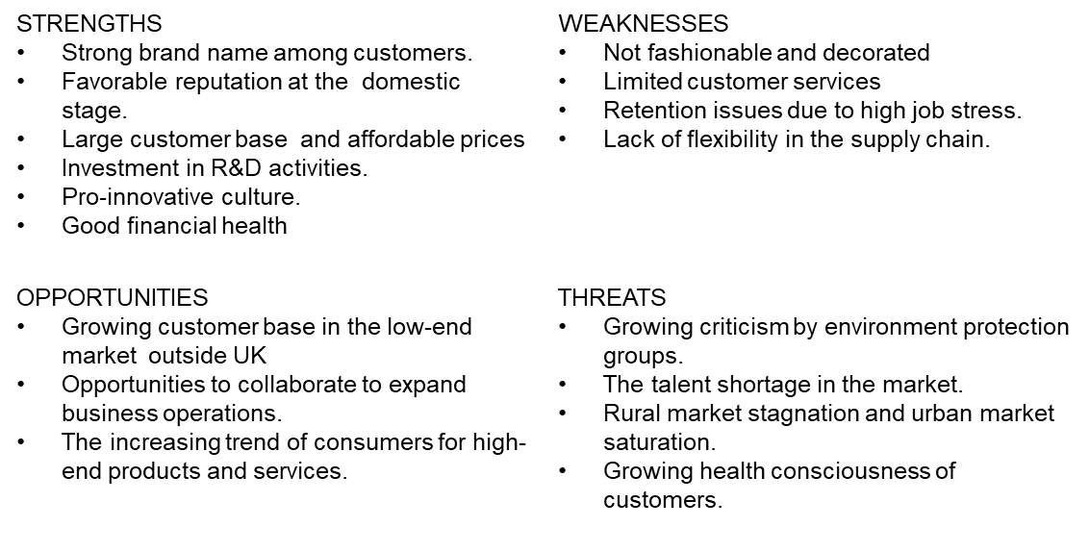
Customers
Through effective market segmentation Travelodge have been able to enhance pricing and optimization, effectively plan marketing and operational budgets, gain better insights and understanding of the customer needs and perform better financially (Kapoor and Kapoor, 2021). The targeted customer segment of Travelodge is aged between 20-65, focused on budget travelling, premium economy and concern about environment and segmented according to the level of income. Therefore, 80 per cent of the hotels are located in major cities, towns, near airports and conference centres to provide reasonably good services at affordable price (Travelodge, 2021). Moreover, they are working closely to enrich the travel experience of business travellers while offering strong bargaining power, variety of alternatives and low switching costs.
Competitors
The competitive rivalry remains high, limited growth opportunity and product differentiation remains low. Therefore, Travelodge is offering new features of personalized booking, advanced administration, improved payment terms, more discounts and develop new service lines to be more attractive to customers and limiting the rivalry (Travelodge, 2021).
Porter’s Five Forces Model | Industry Rivalry remains high
Porter’s Five Forces Model | Bargaining power of buyers remain high due to the low switching costs and variety of alternatives
Porter’s Five Forces Model | Bargaining power of supplier remains moderate due to low switching costs and availability of alternatives
Porter’s Five Forces Model | Threat of new entrants is moderate
Porter’s Five Forces Model | Threat from substitutes remain low

Collaborators
Travelodge has been able to enhance product development and develop new service lines, evaluating different value chain factors to improve supply chain efficiency and increase control through collaboration. Moreover, Travelodge’s collaboration with educational institutions to develop efficient business operations, better training facilities, improved management skills, communication skills and leadership skills for colleagues to deliver excellent customer service while working under pressure have an excellent opportunity for expertise development (Travelodge, 2021).
PESTEL(Macro)
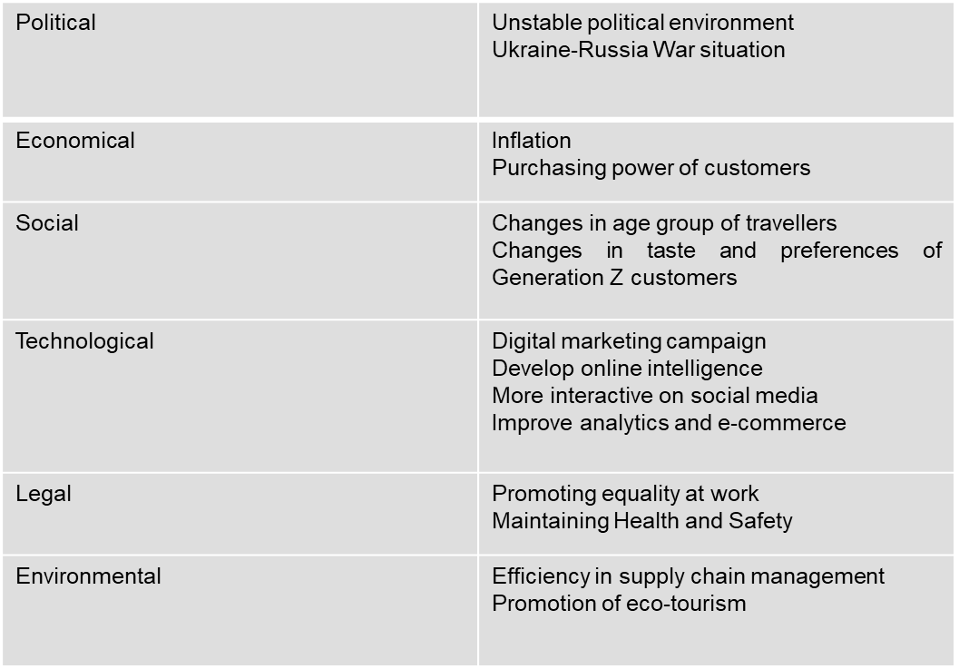
Objectives
The marketing objectives of Travelodge is to increase profitability and market share through SMART goals. As they are focused to increase the sales through new service lines to be more attractive to existing and potential customers (Armstrong et al., 2018). It will be measured by the increase in direct bookings by 10 per cent. The goal will be achievable by using CRM and email marketing, increase spending on digital marketing, upgrading hotel management software, optimizing hotel’s booking engine and improve parity rate with OTAs. Aligning the goals with the overall objective to minimize costs and improve profitability. Thus, setting the goal to be achieved over the next six months period

Strategy
Travelodge is focusing on increasing its market share and enhance brand image by providing quality services at affordable prices. Therefore, they have adopted low pricing strategy of Bowman’s strategy clock for luxury quality services to customers to attract more potential customers. While locating at the heart of major city centres, towns, vital roadside stops and seaside locations (Travelodge, 2022). Therefore, adopting cost leadership strategy to be more cost-effective and efficient has been effective to create positive image, increase brand value and gain higher profitability. Thus, they plan to expand the global presence through new personalized booking process, advance administration, improved payment terms and offering more discounts (Travelodge, 2022).
The Marketing Mix
Travelodge promises to deliver low-cost choice to everyone for business travel and leisure at an affordable price (Travelodge, 2021). The management has been able to establish strong brand image and good reputation over the decades of operations.
PRODUCT  Accommodation and related services  Standard services and suitable for short stay  SuperRoom with premium economy services | PRICE  Committed to provide best services at affordable prices  Offers competitive promotional programs including special offers, discounts and special deals
PROMOTION  Use different marketing methods to attract more customers and effective promotional channels  More presence in social media  Focus on effective Digital Marketing  Special offers, discount and promotional activities | PLACE  Located in major cities, towns, airports and conference centres.

USP
Travelodge’s unique selling proposition is to offer the low-cost choice for travel and leisure. Moreover, they are offering the SuperRoom feature to enhance the experience of the stay. The improved consistency of improved room facilities offers premium economy option for customers. The added value at an amazing price will be able to create strong brand image for the company.
Effective use of Digital Marketing
With the change in age groups in the targeted customers and expansion of digital marketing, Travelodge is using different digital channels to maximize awareness among potential customers. Therefore, the goal is to be more creative to increase awareness of the brand and its direct bookings. Optimizing the campaign performance with the launch of YouTube campaign using True Views, use of Google Analytics for audience list mining to focus on targeting ideas and optimizing the targets throughout the digital campaign. For evaluating the results, they need to track increase in view rate, improve ad recall, email marketing, social media marketing and be more creative to help the conversion engaging and relevant.
Conclusion
Investment in Research and Development of product and services is necessary to adapt to the changing tastes and preferences of the customers. Though budget travellers demand limited options of services. Travelodge need to carefully on Public Relations, aggressively promote their brand through various marketing channels and make their footprint stronger in the digital market. They are still in a strong position to attract more customers and be more competitive in the market. However, upgrading the Aspire program and training the employees to offer exceptional customer service can make the difference.

References
Armstrong, M. and Taylor, S. (2020) Armstrong’s handbook of human resource management practice. 15th edition. London, United Kingdom; Kogan Page.
Armstrong, M., Kotler, P., Harker, M. J., and Brennan, R. (2018) Marketing: an introduction. London: Pearson UK.
Bowie, D., Buttle, F., Brookes, M. and Mariussen, A., (2017) Hospitality Marketing. 3rd ed, Routledge, London.
Chaffey, D and Ellis- Chadwick, F. (2019) Digital Marketing. 7th ed, Pearsons, London.
Clow, K & Baack, D (2013), Integrated Advertising, Promotion and Marketing Communications. 6th ed, Pearson, London
Ghauri, P.N., (2014) International Marketing, 4th ed, McGraw Hill, London.
Housden M (2008), Marketing Research & Information, Butterworth Heinemann, Oxford.
IBISWorld, (2022) Hotels in the UK-Market Research Report, Available at: https://www.ibisworld.com/united-kingdom/market-research-reports/hotels-industry/, [Accessed: 28 November 2022].
Jobber, D. and Ellis-Chadwick, F (2020) Principles and practice of marketing. 9th ed. London:
Johnson, G.R., (2021) UK hotel statistics, Finder UK, Available at: https://www.finder.com/uk/hotel-statistics, [Accessed: 18 November 2022].
Kapoor, R. and Kapoor, K. (2021) The transition from traditional to digital marketing: a study of the evolution of e-marketing in the Indian hotel industry, World Hospitality and Tourism Themes, 13(w2), pp. 199-213.
Kotler, P., Armstrong, G., Harris, L. and He, H., (2020). Principles of marketing. 8th European ed, London: Pearson Education Limited.
Kotler, P., Setaiwan, I. and Kartajaya, H., (2017). Marketing 4.0 Moving from Traditional to Digital, 1st ed, Wiley. New York.
Ryan, D., (2012) Understanding Digital marketing: Marketing Strategies for Engaging the Digital Generation. Kogan Page, London.
Smith, P.R. & Zook, Z.E., (2020) Marketing Communications. 7th ed, Kogan Page, London.
Torrington, D, Hall, L, Atkinson, C, and Taylor, S. (2020) Human Resource Management PDF eBook, Pearson Education, Limited, Harlow. Available from: ProQuest eBook Central.
Travelodge, (2021) How we’re responding to the hospitality staffing crisis, Travelodge, Available at: https://www.travelodge.co.uk/blog/news/responding-hospitality-staffing-crisis/, [Accessed: 19 November 2022].
Travelodge, (2022) The good bits, Travelodge, Available at: https://www.travelodge.co.uk/careers/what-we-offer.aspx, [Accessed: 21 November 2022].
Travelodge, (2022) Travelodge delivers record financial results and continued out-performance, Travelodge, Available at: https://www.travelodge.co.uk/blog/news/travelodge-delivers-record-financial-results-and-continued-out-performance/, [Accessed: 21 November 2022].


