ASSIGNMENT 1 – FAILURE ANALYSIS
Mechanisms of Material Failure (ACEA7010) – Kyle Cummings (1700852)

University of Wales Trinity St David: School of Engineering
MSc Motorcycle Engineering

Abstract
The following report introduces the principals of failure analysis including root cause failure analysis as well as connecting methodologies from various different types of testing. The work then continues by presenting a brief history of the telescopic front fork suspension system of a motorcycle, including the evolution of the system’s design and material usage. Following this, the production process of an inner tube from the telescopic front fork suspension system of a motorcycle is presented with a failure analysis of the same component analysed as part of the main body of the report. The report then concludes by discussing the overall findings from the failure analysis work, including the future recommendations based on the findings in order to stop the failures from potentially reoccurring.

List of Figures & Tables

Fig.1 – Original Front Fork System & Inverted Front Fork System - (Anthony, 2015) 5
Fig.2 – Yamaha Front Fork Outer Tubes - (YAMAHA Motor Co., n.d.) 6
Fig.3 – Carbon Fibre Outer Tubes Used on 2020 MotoGP-Spec Ducati Desmosedici - (MotoGP, 2020) 7
Fig.4 – Production Line Diagram of a Fork Inner Tube - (Dey et.al, 2013) 8
Fig.5 – Failure of Fork Inner Tube - (Dey et.al, 2013) 10
Fig.6 – Dye Penetrant Inspection Test Procedure - (Dye Penetrant Inspection, n.d.) 11
Fig.7 – Graph Showing Change in Material Hardness Across Material Sample - (Dey et.al, 2013) 12

Table 1 – Aluminium Alloys Chemical Composition - (Japanese Industrial Standards Data – Aluminum alloy castings, 2010) 6
Table 2 – Chemical Analysis of Tube Results - (Dey et.al, 2013) 12
Table 3 – Results of UTM Tests - (Dey et.al, 2013) 13
Table 4 – Weight % of Sample Results - (Dey et.al, 2013) 14
Table 5 – ASTM E-45 A. Analysis Results - (Dey et.al, 2013) 14

Table of Contents

Preface 1
i Abstract 1
ii List of Figures & Tables 2
1. Introduction 4
1.1 Introduction to Failure Analysis 4
1.2 History & Development of Telescopic Front Fork Outer Tube 5
2. Fork Tube Production Process 8
3. Fork Tube Analysis & Procedures 10
3.1 Visual Inspection 10
3.2 Chemical Analysis 11
3.3 Physical Property Testing 12
3.4 Microstructural Examination 13
4. Discussion & Conclusion 15
5. Bibliography 22

- Introduction
  - Introduction to Failure Analysis
Material failure analysis of components is an integral part of the testing segment in design process of a component, during these tests the component is pushed to its limits until it reaches a point known as failure. This point is defined as any change to the material’s structure for example a change to the size or shape or a change in the material properties of the component, this change then renders the component unable to complete its desired function (Lefaivre, 2005). These failures on components can be caused by faults that stem from four key areas – design, manufacturing, environmental and material; material failures are often caused by defects within the material itself or contamination via foreign particles. Design and manufacturing failures can often be linked as design failures can come from the design being slightly altered to better suit the manufacturing process, this small change then has the power to alter how the material responds to certain high loads and stresses. Environmental issues can also cause failures via the build-up of rust on the component, hence causing degradation of the material (Lefaivre, 2005).

One extremely catastrophic and well-known environmental failure was during the launch of the Challenger Space Shuttle in January 1986, the shuttle exploded only a few seconds after launch killing all seven astronauts aboard the space craft. This incredible disaster was actually caused by a relatively small component, the O-rings within the rocket booster expanded due to their exposure to low temperatures and did not seal correctly due to the rubber becoming stiff – this caused a fuel leak and hence the explosion (Tate, 2016). This information was eventually found in the aftermath of the accident, further proving the need for failure analysis to predict these issues before these catastrophes occurred. Over the years various techniques within failure analysis have been used to analyse different material, structures, and components; such methodology includes fatigue or fracture testing, non-destructive testing, and surface analysis. Root cause failure analysis (RCFA) is a specific type of failure analysis that has been used to determine the specific underlying cause of a larger failure and help control it in the future. This type of analysis is a problem-solving methodology and is largely successful when there is a depth of information and data regarding the failure, some tools used in RCFA include Fishbone Diagrams, Fault Tree Analysis and Tree Diagrams (Hussin, Ahmed and Muhammad, 2016).
  - History & Development of Telescopic Front Fork Suspension
The telescopic front fork on a motorcycle is the suspension system responsible for controlling the rider’s feeling with the front end of the motorcycle. The telescopic front fork was originally developed to provide better suspension on motorcycles to the standard fork systems seen on bicycles, with BMW being the first company to develop a production motorcycle with telescopic front forks in 1935 (Gardiner, 2019). These forks however were not the same as today’s preferred model, the original system was similar to that shown on the left of figure 1 whereas the currently preferred system is the inverted system shown on the right-hand side. The inverted system was introduced to lower the unsprung mass (comprising of the wheel, tyre, and lower part of the suspension system) and hence giving a better feeling for the rider (RevZilla, 2014). This is due to the fact that the stiffer and stronger outer tube is attached to the triple clamp near the handlebars and not the wheel as opposed to the inner tube, this causes less deflection on the fork system as the outer tube’s stiffer structure can withstand the larger forces better (Kraus Motor Co, u.d.). The strength of the entire outer tube structure is greatly important as it must also be able to withstand the forces applied under braking and so this is something manufacturers must consider during the design process.
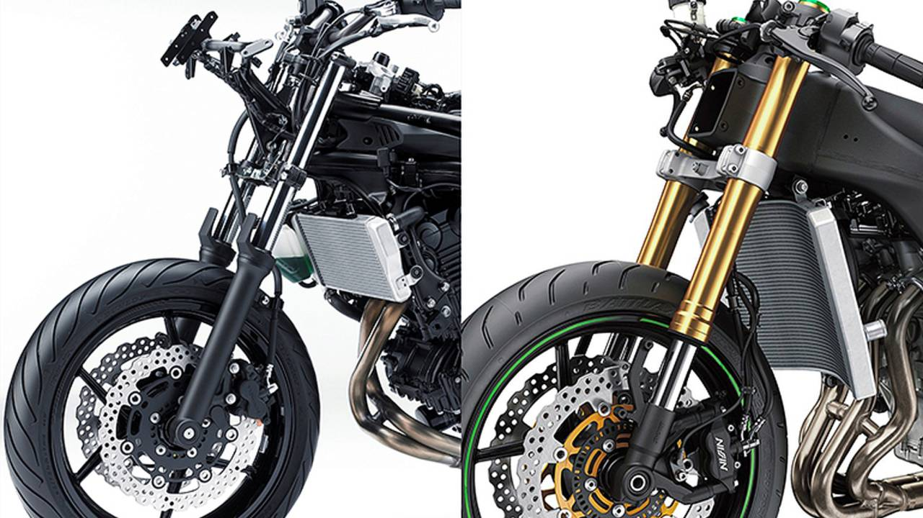

Fig.1 – Original Front Fork System (Left), Inverted Front Fork (Right)

This choice of inverted or standard forks is instrumental in the development of the outer tube as different machines may require different outer tubes with different properties to provide the best possible performance. The most commonly used material to manufacture front fork outer tubes are either steel or aluminium alloy, for example Yamaha use an alloy known as AC2B to produce the outer tubes via a casting method as shown in figure 2 (YAMAHA Motor Co., n.d.). The rough chemical composition of alloy AC2B is shown in table 1. The inner tube of the front fork is very similar to the outer tube in terms of metallic materials chosen such as stainless steel, however the role of the inner tube is vastly different to that of the outer tube. Due to the inner tube’s purpose being to house the inner technology of the suspension system it is more simplistic than the sliding outer tube and therefore does not require as detailed manufacturing processes but must remain strong enough to protect the suspension internals.
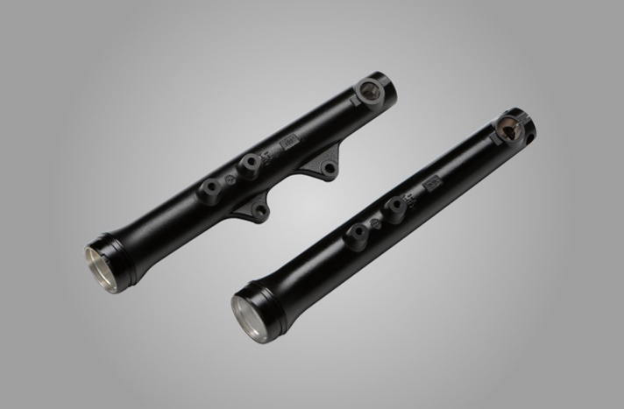

Fig.2 – Yamaha Front Fork Outer Tubes
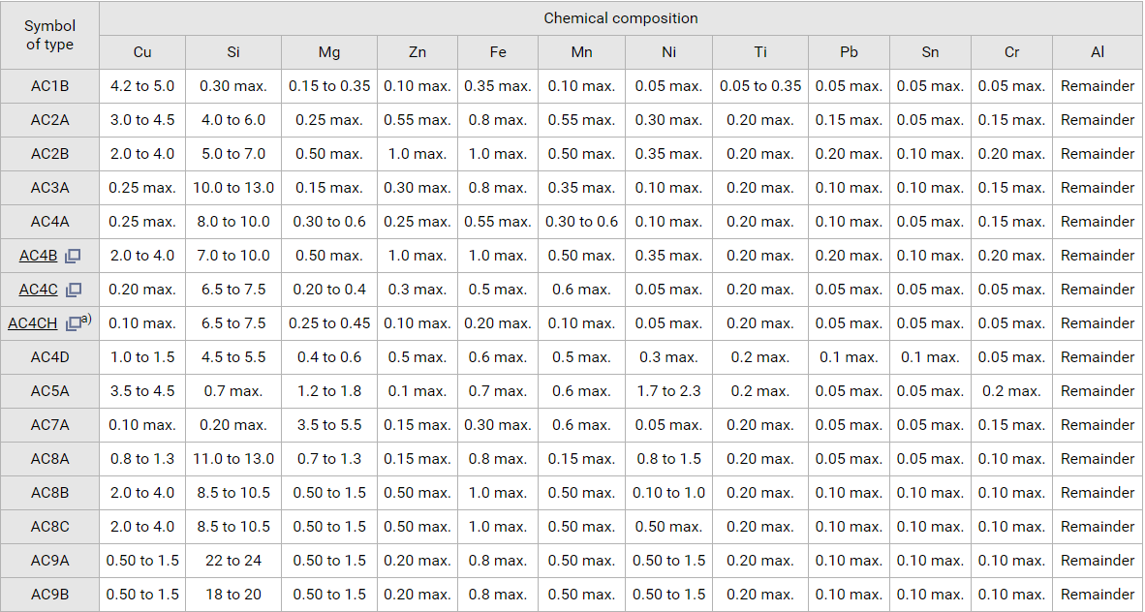
Table 1 – Aluminium Alloys Chemical Composition
Over more recent years, suspension manufacturers such as Ohlins have moved away from traditional aluminium alloys for their racing products as the demands of motorcycle manufacturers and race teams become greater. Within the racing paddocks various engineers were looking to save weight in any way possible, this led to the introduction of Carbon composite outer tubes. Ohlins engineer Thomas Alatalo stated this new design resulted in around a 10% weight loss compared to the standard aluminium alloy (Guidotti, 2017), this weight loss was achieved while also keeping the exact stiffness values seen in the aluminium tubes. Ohlins MotoGP technician Craig Cummings also explained that the advantage of using carbon outer tubes was that individual sections can be altered throughout the tube due to the changeable layering and weave types of the carbon material (Cummings, 2021). This structural alteration is used to allow the tube itself to withstand the different forces applied on various sections, this was as opposed to the aluminium alloy’s single stiffness value that was then altered via mechanical techniques such as tapering. Since this evolution in the racing world various companies have decided to produce their own attempts at the composite outer tube, such as CeraCarbon, proving that this change in material structure could be a revolution in the production of telescopic fork outer tubes.
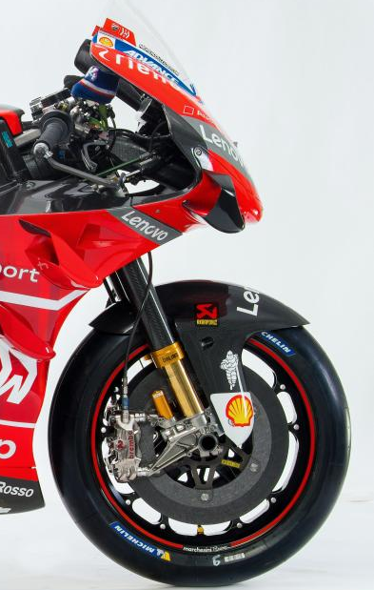

Fig.3 – Carbon Fibre Outer Tubes Used on 2020 MotoGP-Spec Ducati Desmosedici
- Fork Tube Production Process
The production and manufacturing process of a fork inner tube is extremely detailed so to achieve the required safety and performance factors identified during the design process. Firstly, the chosen material coil is loaded on the locked side of a double mandrel un-coiler (DMU), the pinch roll flattener is then used to straighten the ends of the coil and they are levelled ready for welding. The coil ends are then MIG welded together and the strips are accumulated vertically on a large radius in a continuous coil accumulator (CCA). The coil is then pickled (submerged in acid solution) in order to remove any impurities on the material surface, the pickled slit coils are then fed into the stamping unit with the continuous strip fed into a tube mill in order to create the desired tube shape strip. High-frequency induction welding then takes place in order to properly form the tube by connecting the strip ends together using high heat and pressures within a machine operating at a speed of 80 m/min. The newly formed tube then passes through a roller hearth furnace at a temperature of around 880 Celsius in order to be normalised, before surface treatments are carried out on the tube via cold drawing. The cold drawing process reduces the size of the originally formed tube and gives it a better-rounded shape and can increase the tensile strength, perfect for the purpose of a fork inner tube (Customer Benefits of Cold Drawn Steel Bar, n.d.). The newly sized tubes are then put inside the roller hearth furnace again at a lower temperature of around 600 Celsius in order to temper them, increasing the hardness of the structure (Tempering, 2019).
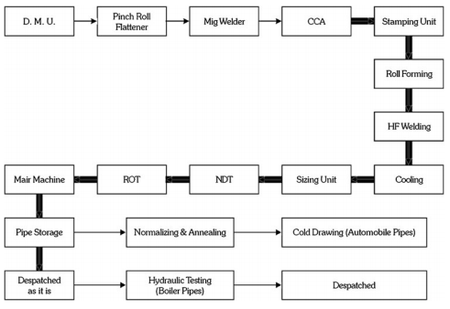

Fig.4 – Production Line Diagram of a Fork Inner Tube
The tubes have now been manufactured, however are not ready for public use as they must be quality checked. Non-Destructive Testing (NDT) methodology is to be carried out first in order to check for any potential surface defects in the material that may have been missed during the manufacturing process, such as cracks in the welds. A Run-Out Table (ROT) procedure is then undertaken which involves the tube being sent through a conveyor system to check for various issues that were not resolved via the manufacturing treatments. The conveyor system firstly allows the tube to be analysed by programmed sensors to check it matches the allowed parameters and tolerances. The final step for the tube is being placed into a pneumatic air pressure chamber (via the conveyor) in order to clean up trimmed sections of the tube. Once the tube has passed all of these tests it is then safe and ready to be used within the public domain. One of these tubes that suffered a failure while in public use was collected and analysed as seen in section 3.

- Fork Tube Analysis & Procedures
Following the production of the fork tube discussed in section 2.1, various failures have been recorded early in the part’s life cycle - at around 2000-3000 kilometres of distance covered by the motorcycle. Due to these uncharacteristic failures, detailed failure analysis was undertaken on the component to understand the cause of these issues by Dey et.al in 2013 – the failure subjected to the analysis is shown in figure 5. The failure in this case is a crack of around 1cm in length close to the weld. It’s likely that this may have been caused by an impact on the suspension system such as a stone hitting the weld and destabilising the structure, it may be due to a design issue within the suspension system as a whole causing the tube to flex or twist more than it should while under higher stresses, or it may be an issue with the welding procedure causing instability within the tubes.
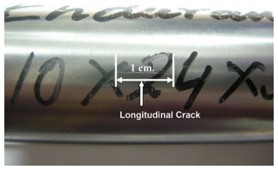

Fig.5 – Failure of Fork Inner Tube

  - Visual Inspection
The crack is very thin and difficult to detect and so was detected in more detail as part of the first form of analysis – visual inspection, this task was completed using a form of NDT known as a dye penetration inspection (DPI) test. A DPI test involves covering a component in low surface tension fluid which is then used to penetrate breaks in a surface. Once the liquid is given time to penetrate the surface break, the break is covered with a developer and a white or ultraviolet light is used to highlight the flaw that originally may have been easily missed by the human eye. A notable issue with this method of NDT is that cleaning of the component beforehand is of upmost importance as any contaminant could obstruct a defect’s detection for example any remnants of oil that may have leaked from inside the suspension system (Dye Penetrant Inspection, n.d.).
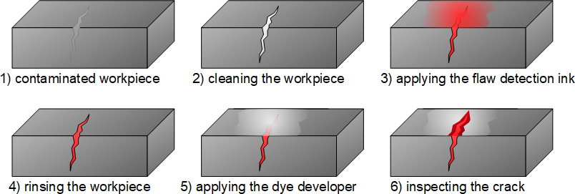

Fig.6 – Dye Penetrant Inspection Test Procedure

  - Chemical Analysis
The next step in the failure analysis of the inner tube is a chemical analysis to understand if the chemical balance of the material had been changed in some way, which may have caused the crack due to a properties change from the originally produced component. This analysis was conducted using an x-ray fluorescence (XRF) spectroscopy method for all materials bar carbon and sulphur, which were analysed using a combustion infrared technique. The XRF method involves the tube material sample being irradiated using high energy x-rays, once an x-ray with enough energy hits the metal atom it can overcome the binding energy of the atom’s electron and dislodge the electron from the atomic structure. The atom then regains its stability by replacing the dislodged electron an electron from a higher shell, this electron used in the replacement emits a fluorescent x-ray which is used to determine the element within the material sample with different elements producing slightly different x-ray energies (What is XRF and How Does it Work?, 2020).

The infrared combustion technique procedure can be seen in figure 7, it works by turning the carbon and sulphur content of the material sample into a gaseous state, which are then detected using infrared technology to determine the concentrations of both carbon and sulphur from the sample by detecting gases such as carbon dioxide and sulphur dioxide (Oxley, 2012). Both tests yielded the below results shown in table 2, where it is clear to see that the material sample taken from the failed tube structure complies with the data from the original material used, however has a very low sulphur count and phosphorus count compared to the maximum in the chosen material’s guidelines.
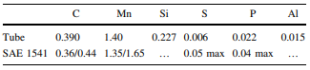

Table 2 – Chemical Analysis of Tube Results

  - Physical Property Testing
Following the chemical analysis, the authors of the study conducted further work on the physical structure of the used tube material sample, comparing it with another identical tube from the same batch that did not suffer a failure. The failed tube sample underwent testing via a universal testing machine (UTM), in which the machine measures various parameters such as the ultimate tensile strength (UTS) and elongation. The results of the tests are displayed in table 3 and show that the failed sample still complies with the expected results obtained using the standard sample, with values for yield strength, UTS and elongation all achieving above the minimum expected values. The micro-hardness testing that took place also shows in figure 7 that a relatively uniform hardness is seen across different areas of the sample as expected. All of this information combined essentially dismisses the cause of the failure being from the original material itself as another item in the batch has similar properties and there is no drastic change.

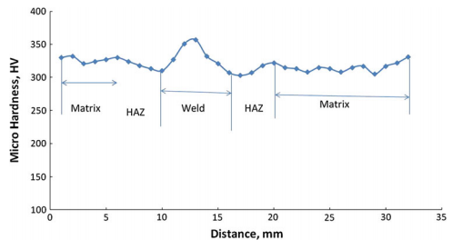

Fig.7 – Graph Showing Change in Micro Hardness Across Material Sample
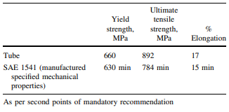

Table 3 – Results of UTM Tests

  - Microstructural Examination
Further study was conducted on the failure within the fork tube component by analysing the structure of the material at the failure point under powerful microscopes, this was done in order to show the details of such a small crack in a bid to further understand the cause. The authors found the crack to be in a J-shape and was a depth of around 0.5mm, the J-shape crack is known to be typically associated with ‘hook’ cracking. Hook cracks tend to occur where there are non-metallic inclusions at the edges of the metal strip used in the welding process, described in section 2, incorporating the non-metallic substance into the weld causes discontinuities and hence the weakening of the structure (ROSEN - Hook Cracks, n.d.). This discovery then led to an investigation as to what had specifically caused this hook crack.

In order to further understand the crack within the component the authors conducted energy dispersive x-ray spectroscopy (EDS) analysis in conjunction with scanning electron microscopy (SEM). EDS analysis involves detecting x-rays emitted from the sample in a similar way as discussed in the XRF analysis in section 3.2, in this case the material is bombarded with a beam of incident electrons generated using a thermal emission source from within the SEM system (Scanning Electron Microscopy, n.d.). The SEM system The x-ray in EDS is emitted in the same way as in XRF due to the change in electron shells, where the specific energy of the x-ray relates to the specific element detected by the method (Energy Dispersive X-Ray Spectroscopy, n.d.). The EDS analysis found inclusions in the sample of manganese sulphide, as seen in table 4. This information confirms the theory from the authors regarding the cause of the hook crack being from a fault within the weld, as the found manganese sulphide is likely the non-metallic impurity causing the weld’s discontinuity.

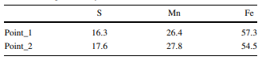

Table 4 – Weight % of Sample Results

In order to further confirm this theory, the authors conducted another form of analysis methodology known as ASTM E-45 A, which is used to check the cleanliness and purity of the steel. Two of the ASTM E-45 microscopical methods (A&D) are able to determine four different types of non-metallic inclusions found in steel, type A can detect sulphides with types B-D used to detect alumina, silicate, and globular oxides respectively. An issue with this method however is that it is destructive, but it does reveal the extremely small non-metallic inclusions needed for this context and so makes it a good choice of test by the authors (Meriguet, 1992). The results for the test are shown in table 5 for the four different types of non-metallic inclusion, the results prove that the sulphide is present as in the EDS analysis and is the likely cause of the failure.

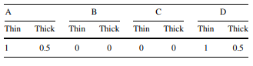

Table 5 – ASTM E-45 A. Analysis Results

- Discussion & Conclusion

Throughout the report, the works completed by Dey et.al have been discussed as they undertook various failure analysis methodology in connection with a crack on a front fork inner tube. The failure was initially discovered before further details of the crack were uncovered using a DPI test. Chemical analysis of the material via XRF methodology revealed that the tube’s current material matched with one from the same batch, this data connected with the physical property tests in order to confirm the initial tube material was not the cause of the issue.

The final section of testing conducted, microstructural examination, showed that the crack was hook-shaped and turned at an angle at one end as well as being a depth of 0.5mm. This type of crack links to non-metallic impurities included at the ends of the metal strip during the welding process, a theory backed up during EDS analysis and ASTM E-45 analysis as traces of manganese sulphide were found within the tube’s structure. The crack’s turned end is as a result of the impurity upsetting the metal’s structure as the crack will turn towards whichever end the upset is largest, in this case this was the outside surface edge of the tube. It is also confirmed that the cause of the issue was not due to surface oxidation via heat treatments as the crack was further into the plate thickness (Dey et.al, 2013). The material’s relatively high carbon and manganese values within the chemical analysis also back up the theory that the weld is the cause of the crack due to the high manganese and sulphur ratio, which is associated hook cracks. This is likely due to the fact that the sulphur is rejected during the welding at temperatures below 1500 Celsius, allowing for intergranular weaknesses within the weld (Dey et.al, 2013).

In conclusion, it is certain that all evidence from the analyses undertaken by the authors points to the manganese sulphide impurity as being the cause of the crack. In order to rectify this, it is recommended that extra cleaning practices are undertaken, such as further pickling, before the welding process is conducted in order to ensure there are no impurities remaining on the metal. Once the tube has been formed via the weld it would then be important to conduct some NDT-style tests in order not to damage the tube. It is of paramount importance to ensure the tube is safe enough for public use, as undetected failures such as these can have catastrophic human consequences.
- Bibliography

Analytical Answers. n.d. Motorcycle Suspension Failure Analysis. [online] Available at: <https://analyticalanswersinc.com/case-studies/failure-analysis-of-a-motorcycle-suspension/> [Accessed 9 January 2021].
Anthony, G., 2015. Standard & Inverted Front Fork Systems. [image] Available at: <https://www.rideapart.com/news/247982/the-basics-modern-motorcycle-suspension/> [Accessed 9 January 2021].
Beeler, J., 2017. Ducati's Secret Weapon: Carbon Fiber Öhlins Fork Tubes. [online] Asphalt & Rubber. Available at: <https://www.asphaltandrubber.com/motogp/ducatis-secret-weaponcarbon-fiber-ohlins-fork-tubes/> [Accessed 9 January 2021].
Bell, T. and Esch, K., 2016. The Challenger Disaster: A Case Of Subjective Engineering. [online] IEEE Spectrum: Technology, Engineering, and Science News. Available at: <https://spectrum.ieee.org/tech-history/heroic-failures/the-space-shuttle-a-case-of-subjective-engineering> [Accessed 9 January 2021].
Bodycote. 2019. Tempering. [online] Available at: <https://www.bodycote.com/services/heat-treatment/hardening-and-tempering/tempering/#:~:text=The%20maximum%20hardness%20of%20a,ratio)%20to%20a%20specified%20application.> [Accessed 5 January 2021].
Bryant, J., Grant, A. and Walsh, Z., 2018. Motorcycle Rear Suspension. [online] Worcester Polytechnic Institute. Available at: <https://web.wpi.edu/Pubs/E-project/Available/E-project-042618-114047/unrestricted/BRYANT_GRANT_WALSH_MQP_Motorcycle_Rear_Suspension.pdf> [Accessed 9 January 2021].
Croccolo, D., De Agostinis, M. and Vincenzi, N., 2011. An analytical approach to the structural design and optimization of motorbike forks. Proceedings of the Institution of Mechanical Engineers, Part D: Journal of Automobile Engineering, [online] 226(2), pp.158-168. Available at: <https://journals.sagepub.com/doi/pdf/10.1177/0954407011416178> [Accessed 9 January 2021].
Cummings, C., 2021. Front Fork Evolution Discussion.
Das, S., Lal, J., Dey, A., Mukhopadhyay, G. and Bhattacharya, S., 2018. Surface Defect in Telescopic Front Fork: A Metallurgical Analysis. Journal of Steel Structures & Construction, [online] 04(02). Available at: <https://www.hilarispublisher.com/open-access/surface-defect-in-telescopic-front-fork-a-metallurgical-analysis-2472-0437-1000143.pdf> [Accessed 9 January 2021].
Dey, A., Dhara, S., Bhttacharyya, T. and Bhattacharyya, S., 2013. Cracking of Telescopic Front Fork Tube During Field Operation. Journal of Failure Analysis and Prevention, [online] 13(3), pp.292-297. Available at: <https://www.researchgate.net/publication/257714274_Cracking_of_Telescopic_Front_Fork_Tube_During_Field_Operation> [Accessed 9 January 2021].
Gardiner, M., 2019. Why Are There No Alternatives To The Telescopic Fork Front Suspension? - Revzilla. [online] Revzilla.com. Available at: <https://www.revzilla.com/common-tread/why-are-there-no-alternatives-to-the-telescopic-fork-front-suspension> [Accessed 31 December 2020].
Guidotti, M., 2017. Ohlins Motogp Carbon Forks: Worth Ten Seconds Over Race Distance…. [online] Bikesport News. Available at: <https://www.bikesportnews.com/news/news-detail/ohlins-motogp-carbon-forks-worth-ten-seconds-over-race-distance> [Accessed 2 January 2021].
Hussin, H., Ahmed, U. and Muhammad, M., 2016. Critical Success Factors of Root Cause Failure Analysis. Indian Journal of Science and Technology, [online] 9(48). Available at: <https://www.researchgate.net/publication/313407767_Critical_Success_Factors_of_Root_Cause_Failure_Analysis> [Accessed 31 December 2020].
Kraus Motor Co. u.d. Why An Inverted Front Fork Suspension Is Superior To A Conventional (Tube & Slider) Front Suspension. [online] Available at: <https://www.krausmotorco.com/pages/why-inverted-front-suspension> [Accessed 2 January 2021].
Lefaivre, J., 2005. Failure Analysis In Material Science. [online] Uky.edu. Available at: <http://www.uky.edu/~tzhai0/index_files/fail_analysis.htm#:~:text=Scientists%20and%20Materials%20Engineers%20use,satisfactorily%20perform%20its%20intended%20function.> [Accessed 31 December 2020].
Mahajan, Y., Likhite, A. and Peshwe, D., 2014. FAILURE OF FRONT SHOCK ABSORBER OF A MOTORCYCLE. International Journal of Advanced Research in Engineering and Technology, [online] 5(5), pp.141-148. Available at: <http://www.iaeme.com/MasterAdmin/UploadFolder/IJARET_05_05_016/IJARET_05_05_016.pdf> [Accessed 9 January 2021].
Mee-inc.com. n.d. Energy Dispersive X-Ray Spectroscopy. [online] Available at: <https://www.mee-inc.com/hamm/energy-dispersive-x-ray-spectroscopyeds/> [Accessed 8 January 2021].
Mee-inc.com. n.d. Scanning Electron Microscopy. [online] Available at: <https://www.mee-inc.com/hamm/scanning-electron-microscopy-sem/> [Accessed 8 January 2021].
Meriguet, P., 1992. The Assessment Of Non-Metallic Inclusions In Steels And Nickel Alloys For Ultra High Vacuum Applications. [online] Abingdon: JET Joint Undertaking. Available at: <http://cds.cern.ch/record/238642/files/JET-R%2092-01_001.pdf> [Accessed 8 January 2021].
MotoGP, 2020. Ducati Motogp Bike 2020. [image] Available at: <https://www.motogp.com/en/gallery/2020/01/23/ducati-bike-evolution-2003-2020/281755> [Accessed 9 January 2021].
Oxley, E., 2012. Advancing Carbon And Sulfur Assessment: Combustion Analysis With Minimal Furnace Maintenance. [online] Billerica: Bruker Elemental. Available at: <https://www.bergeng.com/mm5/downloads/bruker/G4-ICARUS-HF-Advancing-CS-Assessment.pdf> [Accessed 5 January 2021].
Precisionkidd.com. n.d. Customer Benefits Of Cold Drawn Steel Bar, Hot Rolled Bar/Rod. [online] Available at: <https://www.precisionkidd.com/customer_benefits.htm> [Accessed 5 January 2021].
Revzilla.com. 2014. Why Is This Fork Upside Down? - Revzilla. [online] Available at: <https://www.revzilla.com/common-tread/why-things-are-inverted-forks> [Accessed 2 January 2021].
Rosen-group.com. n.d. ROSEN - Hook Cracks. [online] Available at: <https://www.rosen-group.com/global/solutions/services/pipeline-cracks#hookcracks> [Accessed 7 January 2021].
Spalding, N., 2019. Motogp Technology. Kent, UK: Phoebus Apollo Ltd.
Tate, K., 2016. The Space Shuttle Challenger Disaster: What Happened? (Infographic). [online] Space.com. Available at: <https://www.space.com/31732-space-shuttle-challenger-disaster-explained-infographic.html> [Accessed 31 December 2020].
ThermoFisher Scientific. 2020. What Is XRF And How Does It Work?. [online] Available at: <https://www.thermofisher.com/blog/ask-a-scientist/what-is-xrf-x-ray-fluorescence-and-how-does-it-work/> [Accessed 5 January 2021].
Wermac.org. n.d. Dye Penetrant Inspection. [online] Available at: <http://www.wermac.org/others/ndt_dyepenetrant.html> [Accessed 5 January 2021].
YAMAHA MOTOR CO., LTD. 2010. Japanese Industrial Standards Data – Aluminum Alloy Castings. [online] Available at: <https://global.yamaha-motor.com/business/cf/data/jis/> [Accessed 5 January 2021].
YAMAHA MOTOR CO., LTD. n.d. Outer Fork Tubes. [online] Available at: <https://global.yamaha-motor.com/business/cf/example/casting/ex004/> [Accessed 5 January 2021].

