Answers FCC
- An element crystallizes in a face centred cubic lattice and has a density of 1.45 g cm⁻³. The edge of its unit cell is 4.52 x 10⁻⁸cm.

a) How many atoms are in each unit cell? 4

b) What is the volume of a unit cell? (4.52 x 10⁻⁸cm)³ =9.23 x 10⁻²³

c) What is the mass of a unit cell? Mass = d x v = 1.45 g cm⁻³x 9.23 x 10⁻²³ = 1.338 x 10⁻²²g

d) Calculate the approximate atomic mass of the element. 1.338 x 10⁻²²g / 4 = 3.346 x 10⁻²³g

2. Which one of the following statements about unit cells and packing in solids is incorrect?

a) In unit cells of solid crystals, every face of the cell must have an opposite face which is equal and parallel to it. True

b) The faces of unit cells must meet 90 degree. False

c) The coordination number of atoms in a close packed metal is 12. True

d) The packing efficiency in fcc structures is higher than in bcc structures. True

e) The packing efficiency in fcc and hcp structures is the same. True

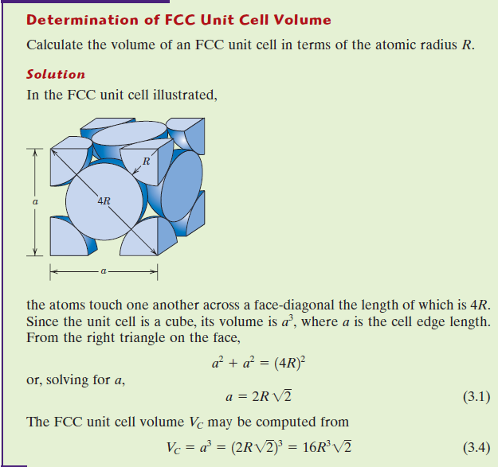

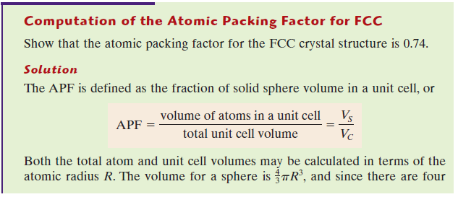
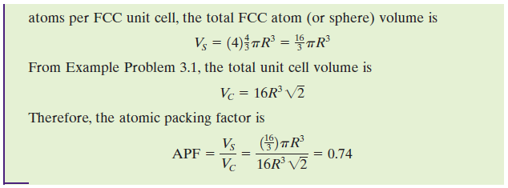

Body centred cubic worksheet answers
Problem #1: The edge length of the unit cell of Ta, is 330.6 pm; the unit cell is body-centred cubic. Tantalum has a density of 16.69 g/cm³.
(a) calculate the mass of a tantalum atom.
(b) Calculate the atomic weight of tantalum in g/mol.
Solution:
1) Convert pm to cm:
330.6 pm x 1 cm/10¹⁰ pm = 330.6 x 10¯¹⁰ cm = 3.306 x 10¯⁸ cm
2) Calculate the volume of the unit cell:
(3.306 x 10¯⁸ cm)³ = 3.6133 x 10¯²³ cm³
3) Calculate mass of the 2 tantalum atoms in the body-centred cubic unit cell:
16.69 g/cm³ times 3.6133 x 10¯²³ cm³ = 6.0307 x 10¯²² g
4) The mass of one atom of Ta:
6.0307 x 10¯²² g / 2 = 3.015 x 10¯²² g
5) The atomic weight of Ta in g/mol:
3.015 x 10¯²² g times 6.022 x 10²³ mol¯¹ = 181.6 g/mol

