

Module: Project Control & Contract Administration

Module Code: ACBA5006

Student: Jack Keenan

Student number: 1908062

Table of Contents
1. Introduction 3
2. What is a procurement route? 3
3. Tendering and procurement processes used in the UK construction industry 4
• 3.1 Traditional procurement 4
• 3.2 Design and build 4
• 3.3 Management contracting 4
• 3.4 Partnering procurement 4
4. Advantages and disadvantages procurement strategies 4
4.1 Benefits for main contractor 4
4.2 Benefits for design team 5
4.3 Benefits for the client 5
5. Factors that influence the choice of tender process. 6
• 5.1 Project characteristics 6
• 5.2 Client characteristics 6
• 5.3 External factors 6
• 5.4 Covid 19 pandemic 6
6. What is lowest cost tendering? 8
6.1 Risks with lowest cost tendering 8
6.2 Obstacles that would affect industry from moving away from lowest cost tendering. 9
6.3 Obstacles 9
7. An alternative approach to lowest cost tendering? 10
7.2 Partnering 10
8. Conclusion 11
Bibliography 12

Introduction

In this assignment I will be exploring the factors that affect the choice of tendering and the procurement methods used in the UK construction industry. I will be explaining how factors in the industry are having a massive influence on the methods being used and why many clients are choosing lowest cost tendering. I will be showing why lowest cost tendering has become so popular in the in industry but also the negative affect it is having and why we are desperate for change to improve construction in the IK.

What is a procurement route?

Firstly, we need to understand what procurement is. The word “procurement” is a broad term and is used across a few different industries not just construction. Procurement means to obtain or gain something, it can be involved in several different activities like negotiating, sourcing, and acquiring goods. Procurement is used in the construction industry to agree upon something or to secure something. The aim of the process in construction is to deliver a good quality building that is on time and within the budget agreed.

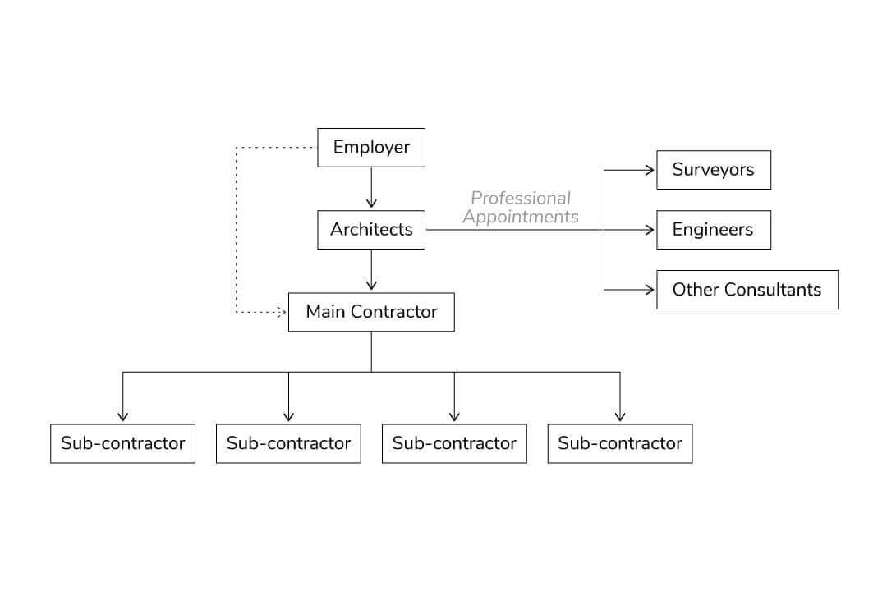
(Scott, 2020)

Above is a breakdown of who is involved in the process and shows the hierarchy of how the procurement is broken down and decided on. Normally if the client doesn’t have a construction background a qualified person for example a quantity surveyor would be able to guide to the client by looking through the projects information to determine the best tender process. The procurement route chosen for the project is very important to make sure the project is successful.

Tendering and procurement processes used in the UK construction industry

The UK construction industry has several types of procurement strategies that are used. Each procurement has a different approach to a project, Offering different risks and benefits for a job. The below are some of the following methods used in the UK:

- 3.1 Traditional procurement – This procurement is a single stage process. A client appoints a design team which then designs the project in detail. Once a design is complete a contractor is then appointed agreeing upon a lump-sum contract.

- 3.2 Design and build - This procurement route is a very popular choice in the construction industry. This method is where the contractor undertakes the design and construction of the full project. Taking away a lot of responsibility from the client.

- 3.3 Management contracting - This procurement route is when multiple different contractors carry out the works on a project. The contractors are contracted to work for the client, but the client then employs a construction manager to manage the all the parties involved with the project,

- 3.4 Partnering procurement - This procurement route is probably the fairest type of procurement method as it tries to achieve the best value for all the parties involved on a single project. It is not as contractual as other methods used and gives breathing space for contractors and buyers to work together and achieve the best outcome.

Advantages and disadvantages procurement strategies

Each procurement route has a wide range of advantages and disadvantages. When a client is trying to appoint a contractor for a project it can be a very stressful and time-consuming task but if the procurement route is done correctly, it can have a lot of benefits for all the personnel involved.

4.1 Benefits for main contractor

The benefits for a main contractor with a well-run procurement route can involve contractors to make sure they are on top of updated technologies and construction methods being used. This will then keep client’s interest in there and help make them more successful when winning work.

4.2 Benefits for design team

The benefits for the design team with a well organise procurement can include the client appointing them first before going to a main contractor. If this happens the design team can then suggest a contractor, they have a good working relationship with. By doing this it can save money, help improve the time needed on a project and improve the overall quality.

4.3 Benefits for the client

The benefits for the client with a well produce procurement route can include the allowance to assess the contractor before they are appointed. Meaning the client can make sure that the contractor is competent and experienced. It can also create a lot of competition between contractors, giving the client more quality tenders to choose from.

The above procurement routes are used within the construction industry to help with the tendering process, some are a lot more popular than other options as they provide different advantages and disadvantages. It is very important that the correct procurement method is chosen to make sure the project is a success and to keep all the parties involved happy.

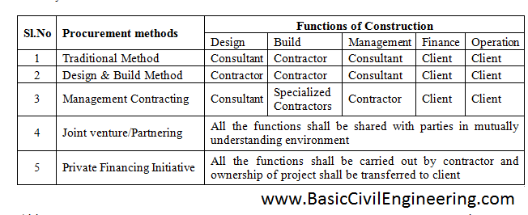
(Gowrinath , 2016)

Factors that influence the choice of tender process.

There are many factors that occur in the industry that can affect the choice of the tender process chosen by a client or contractor. The factors can come from both external and internal problems but external seems to produce more issues. The risks involved with a project have a massive influence on the choice of the procurement a contractor would prefer to use on a project. These problems that influence the procurement can include the following:

- 5.1 Project characteristics – These can involve complexity, size, site location and any unique risks that will have an influence on the cost of the project.

- 5.2 Client characteristics – This will involve a clients experience and knowledge around the project. Some clients will have a lot more knowledge in construction than others.

- 5.3 External factors – These can range anywhere from political issues to economic issues.

- 5.4 Covid 19 pandemic – Over the last two years this has had a massive impact on the industry, increases material costs and impacting on labour shortages.

When a company starts looking at tendering for a project, they will consider the issues and risks that would come with the project. Most construction companies would evaluate the pre and post risks of the project in an internal meeting. The meeting would involve the company deciding if they would like to continue with the tender and produce a price, if the company is happy to proceed with the tender the main contractor and client would have to agree on a procurement route they feel is fit for the project.

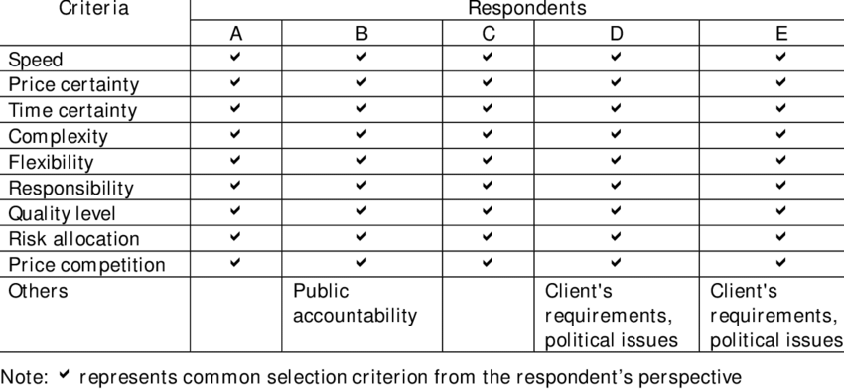

(Luu, 2002)

Again, this demonstrates how important the procurement is because this will most likely determine the quality, speed, and meet the requirements the client desires. Most construction projects come with a lot of risks, and it is very hard to eliminate all of them, but an organised procurement process can help prevent many challenges that a project can throw at a contractor. Therefore, it is very important to agree upon the correct procurement to help deviate some of the issues that occur on a project. In my opinion because there can be so many dangerous factors that can be involved with a project this influencing companies to choose the easy option and use the “lowest cost tendering”. By choosing lowest cost tendering this is then producing a lot of problems for all the parties involved and having a huge impact on the project quality.

What is lowest cost tendering?

Firstly, we need to discuss what lowest cost tendering is. Lowest cost tendering is clients and contractors just simply choosing the cheapest price for a project. This way of tendering is very dangerous and could backfire massively on the client. it is causing a very hostile environment in the industry as it is having a domino effect on all companies and trades squeezing them to lowest costs possible.

6.1 Risks with lowest cost tendering

Because lowest cost tendering involves choosing the lowest price, contractors miss out a lot of factors that offer an excellent tender and construction deal. When a tender is sent it is important that the client goes through each tender with care. Although some contractors might be more expensive than others, they can offer a lot of benefits. These benefits can include the following:

- Firstly, a contractor could have included for more in their price taking the responsibility away from the client and the contractor undertaken the works themselves. For example, a contractor can price for supply and fit of the fire protection on site. This would take a lot of responsibility from the client as the contractor has stated they have included for this in their price.

- Secondly, the company might have a better track record and more experience than others. A lot of contractors can make many mistakes on site resulting in a lot of extra costs and missing site programme targets. It is very important for a client to choose the correct tender as a more experienced company will be able to stay within the budget required.

- Lastly, A company could be offering a better system of work. For example, if the project is timber frame. One contractor could be offering a cheaper, more traditional way of timber frame and one company could be offering a more expensive alternative but a more advanced way or building timber frame like a modular system. The modular system would have a quicker speed of build and allow the client to progress quicker on site.

The above benefits show how dangerous lowest cost tendering is. It is eliminating build quality, collaborative options, and damaging companies’ profits and over heads. Lowest cost isn’t always the best option, a lot of contractors can offer many benefits for a project. They can include for things like fire protection, engineering details and modular systems. A great example of how dangerous lowest cost tendering is Grenfell tower. Therefore, reading through all your tenders and not just looking for the lowest cost is very important to make sure that the company is competent and will produce a safe project and meet the standard building requirements needed.

(Price, n.d.)

6.2 Obstacles that would affect industry from moving away from lowest cost tendering.

For the industry to alter and adapt from using lowest cost tendering will most likely be very challenging and a long process. For it to begin it would involve a contractor to improve their processes and methods of construction to persuade clients to accept their tenders. The process of moving away from lowest cost tendering wouldn’t be a simply as there are obstacles in the industry that might prevent it from happening. These obstacles can include the following:

6.3 Obstacles

The main obstacle that is preventing industry from moving away from lowest cost tendering is budget. Clients are not likely to start increasing their budgets for a project as they have yearly targets on over heads and want to make as much profit as possible, therefore they are choosing lowest cost tendering as it is the cheapest option. This is then forcing contractors and suppliers to cut their costs massively creating very complex situation. Another obstacle that would prevent the change is clients and contractors not communicating with each other. Because clients are not communicating with contractors this is impacting their experience in construction. With lack of experience means clients are choosing the lowest price as they will not understand what has been priced for in the tender they are given. Other contractors might be more expensive, but they will be offering a better package over all for the project. This obstacle leads on to the final obstacle that I believe is stopping the industry from moving away from lowest cost, which is the lack of training and mistakes made in the tendering process. A lack of training in the industry is causing for contractors to tender wrong and produce incorrect prices for the client. A contractor could be offering a low cost without realising they have made a massive mistake, missing out an important element from their overall price. I believe that if training improves in the construction industry it will help us adapt from lowest cost tendering as contractors will be producing more accurate quotations and could potentially increase tendering costs as an overall.

(Redactive Media Group, 2021)

(RICS, 2015)

An alternative approach to lowest cost tendering?

I believe the best options we have currently got in the industry to counter lowest cost tendering is partnering procurement and better collaborative options when it comes to tendering but I also believe as the industry develops into the future that new processes will occur and help improve the tendering environment.

7.2 Partnering

In my opinion I believe this procurement method will help the industry massively in moving away from lowest cost tendering because it urges all parties to work together. As stated in the perfect storm article “better collaboration will improve outcomes” The importance for companies and clients to start forming alliances in the early stages of the procurement is massive for the future of construction. Clients should be able to look past the costs and understand that “collaborative forms of procurement” will eliminate mistakes that are repeated constantly. If these mistakes are eliminated it will then produce better profits for all the parties involved and a collaborative approach would improve the clients understanding of a project, helping improve their knowledge in construction. The strategy of alliance isn’t new to the industry, it has just been abandoned. The “1998 Egan report” is a great example of this method works and how it can benefit a project. Partnering would help prevent repeated mistakes that occur in the industry, with flexibility between contractors this would resolve issues like complex design details and environmental problems This form of procurement would involve getting rid of “reactive management”, it would involve all parties sharing the risks and building trustworthy relationships between each other, learning from each other’s mistakes and produce new better methods for the future .This method has already produced some amazing results in the industry, showing just how beneficial it can be. Hallam university announced a new campus plan in June 2020, they appointed a “three partner supply” to help deliver the project. This new procurement method was seen as “ground-breaking” for its time and was pushed massively to help introduce a new method of procurement to the UK construction industry. The tender process was designed to produce a £220m investment over a 5-year period and the focus was for all parties involved to collaborate with each other but also work efficiently and produce an amazing outcome.

(Redactive Media Group, 2021)

Conclusion

To conclude on the information, I have shown in my assignment, I believe that the industry is desperate to move away from lowest cost due to the high risks involved with it. The move would help improve the quality of our building's and allow companies to produce new, futuristic, and more eco-friendly designs. With smarter spending and better management, it should encourage contractors to use better processes to eliminate lowest cost tendering. There are already projects showing how a collaborative approach to procurement is producing higher standards in construction by using software’s like BIM to help with collaboration. BIM is now a massive push in the industry for companies to start using to help form alliances in the UK construction industry. By producing 3D models and more accurate designs it will improve the tender process. By contractors working together it can allow the tendering eco system to be a lot more positive and help companies in the industry improve their overheads and profit by having a lot more flexibility.



(chapmantaylor, 2020)

Bibliography
chapmantaylor. (2020, January 6). Retrieved from www.chapmantaylor.com: https://www.chapmantaylor.com/insights/why-bim-matters
Gowrinath . (2016, October 5). basic civil engineering. Retrieved from basiccivilengineering.com: http://basiccivilengineering.com/2016/10/procurement-methods-construction-industry.html
Luu, C. D. (2002, January). researchgate. Retrieved from www.researchgate.net: https://www.researchgate.net/figure/Criteria-used-for-procurement-selection_tbl2_252557068
Price, R. (n.d.). ellisfox. Retrieved from ellisfox.co.uk: https://ellisfox.co.uk/lowest-cost-tendering-the-industry-should-know-better/
Redactive Media Group. (2021, January). The Building Engineer.
RICS. (2015, January 1). rics. Retrieved from www.rics.org: https://www.rics.org/globalassets/rics-website/media/upholding-professional-standards/sector-standards/construction/black-book/tendering-strategies-1st-edition-rics.pdf
Scott, B. (2020, December 16). urbanistarchitecture. Retrieved from urbanistarchitecture.co.uk: https://urbanistarchitecture.co.uk/traditional-vs-design-and-build/

