Jon Walton (2028159)
2028159@student.uwtsd.ac.uk
Abstract
This report follows the work carried out by Group 1 – AWE France for the OME level 4 group project. The report looks at all of the work contributed by each member and how the interlinking of each area of specialization helped to increase the quality of each members work. These efforts culminated in a power point presentation that was presented to the course lecturers. This presentation showed the highlights of each discipline covered by the team ending in a video of the simulation of the fireworks display. Feedback was given to the group, which although extremely positive still identified areas for improvement. The group project was understood to be an invaluable tool in better understanding group dynamics in an OME environment.
Word count: 4972
Graduation fireworks display
OME level 4 group project

Contents
1. Introduction 2
1.1. What was achieved and how? 3
1.2. The team 3
1.3. Presentation 3
2. Project management 4
3. Systems thinking 4
3.1. Using systems to help design a firework display. 4
3.2. Determining Requirements 4
3.3. Functional Requirements 5
3.4. The importance of customer requirements 6
3.5. QFD 1 Functional importance 8
3.6. Function means analysis. 9
3.7. QFD 2 Critical design features 9
3.8. Functional FMEA 10
3.9. How systems influenced the group 10
4. Simulation design 11
4.1. The theme 11
4.2. Electronic firing module 11
4.3. The plan 11
4.4. FWsim 11
5. Procurement 12
6. Test and evaluation, conducting display and disposal. 12
6.1. Environmental considerations 12
6.2. Test and evaluation 12
6.3. Display 13
6.4. Firing equipment 13
6.5. Setup/safety 13
6.6. Firing 13
6.7. Disposal 13
7. Safety 14
7.1. The why, the how and the what 14
7.2. Storage 14
7.3. Location 14
7.4. Logistics 15
7.5. Performance 16
8. Weather and shell calc 16
8.1. Weather on the day 16
8.2. Parameters and findings 17
8.3. The most dangerous scenario 17
8.4. Mitigations 18
9. The presentation 18
10. Conclusion 19

Figure 1 - The list of requirements captured. 5
Figure 2 - A use case for the fireworks display. 6
Figure 3 - An organised list of Functional requirements. 6
Figure 4 - A populated Pairwise comparison tool. 7
Figure 5 - A graph showing the relative importance values that were the output of the Pairwise comparison tool. 7
Figure 6 - A populated QFD 1 graph. 8
Figure 7 - A graph showing functional importance, the output of QFD 1. 8
Figure 8 - A Function means analysis. 9
Figure 9 - A populated QFD 2 graphs. 9
Figure 10 - A graph showing the output of QFD 2, identifying the critical design features. 10
Figure 11 - Examples of the highest risk areas found in the FMEA. 10
Figure 12 - Examples of the highest risk areas found in the FMEA. 10
Figure 13 - Firing point set up diagram. 13
Figure 14 - a picture showing the approximate locations of the audience and the firing points. 14
Figure 15 - An annotated picture showing safety distances from the IQ campus. 15
Figure 16 - A bird's-eye-view of the final configuration of the firing points and the storage container. 16
Figure 17 - The output of a simulation showing fallout during a 32km/h gust. 17
Figure 18 - The output of a simulation showing fallout during average windspeeds of 14km/h. 18
Figure 19 - Feedback generated for the Systems Engineer. 19

Introduction
The OME level 4 HNC has taken place over the span of approximately 30 months. This 2-and-a-half-year period has culminated in a group project focused on the delivery of a fireworks display on university grounds. Students were split into teams and given a set of instructions to guide them in their efforts. This report will focus on the group identified as ‘Group 1 – AWE France’ of which three members work for AWE and three more work for QinetiQ. The task description is as follows:
- You will be part of a small design team which will engage in the solving of the design task below.
- The team should agree on defined roles for the individuals in the team so as to be able to demonstrate the individual contribution for marking purposes.
- The display theme needs to represent OME, the university and education.
- They are to be fired from the quayside near the IQ building (Plans provided).
- The audience will be located in and around the IQ campus. (Safety trace to be calculated)
- A duration of at least 30 seconds is required (excluding any time to effect) though up to two minutes is desirable.
- The materials budget for the fireworks display is £2000 per minute of display or a max of £10000.
- The display shall not break any legal limitations/regulations.
- ‘Fall-Out’ (airborne display debris) shall be assessed and any associated safety issues addressed.
- Logistics and safety plans will be required.
- Environmental effects are to be considered and documented (disposal, site contamination, air pollution, etc.)
- The team should consider the design of the desired effect, any synchronisation to music, critical to safety and critical to function elements. The task should not be limited to the display alone but include transportation. set up, initiation and display and the clean-up and disposal action after the performance.

What was achieved and how?
As per the second bullet point in the task description, the group assigned themselves individual roles and specialisations allowing for focused attention on specific areas. Despite the group splitting off to carry out their own tasks, ideas could and would still be shared, some of which greatly influenced other areas of the project.

The team
- Project manager – Callum Eaton
- Systems engineer – Jon Walton
- Design and simulation engineer – Scott Copperthwaite
- OME specialist – Charlie Jones
- Safety engineer – Joseph Lyons
- Metrology simulation engineer – Shaun Malone

Presentation
As part of the group project, the students were to present all the work that was carried out to the lecturers so feedback could be given. This meant collating an overall synopsis of each section and the findings from each student in such a way as to have roughly 7 minutes of presenting time and enough detail to provide confidence to the lectures that the theoretical fireworks display could in fact be carried out safely and to a high degree of quality. The feedback generated from the presentation would identify mistakes, aspects of preparing for and managing a display that were missed and any overall improvements that could be made to further improve the quality of the carried out.
This report will detail the work carried out, in the same order that the presentation was carried out with to ensure continuity is maintained. Although the report does focus on the group's efforts, yet more focus will be brought to the author’s work as the systems engineer. In the same vein, the feedback from the lecturers for the group will be glossed over and more focus will be given to the work carried out by the systems engineer.

Project management
The project manager has various responsibilities to ensure that all tasks are completed in a timely manner. This is done by making priority calls and setting targets for the team. The PM is a conduit for information exchange and is responsible for bringing stakeholders together as and when required whilst organising meetings between team members to ensure that information is shared as frequently as possible. This frequent information exchange is the key to a functional team and was integral to the success of the systems thinking approach applied by the Systems engineer.
The PM was able to identify several factors that were key to measuring the success of the project. These critical success factors where; to ensure that the project stayed within budget, all deadlines were met, employees and stakeholders were satisfied, and high-quality standards were achieved throughout the life cycle of the project.

Systems thinking

Using systems to help design a firework display.
Systems engineering is often used to help design a product, but it is possible to use systems thinking to increase the chances of success when designing a fireworks display. Despite not being a product, a fireworks display is a system made up of subsystems that when brought together produce an output. Systems thinking, at its core is a method of problem solving, and the earlier in a design process that problems can be solved, the faster and less costly a design process can be made, whilst ensuring high levels of safety are maintained [1] [2].
Systems thinking will aid hugely here in determining what are the most important stakeholders, requirements, functions, and failure modes. Some of the principal tools that were used were QFD 1 and 2 to determine key functionality and critical design features. This will drive where money is spent and what areas need to be focused on.

Determining Requirements
Gathering the list of requirements was simple as most were set by the customer, the University, in the task description but the came together to review these requirements and made sure to add a couple more points to either make sure they were not missed, or to emphasise a requirements importance. Namely safety and legal regulations, both of which affect how the team were to design the fireworks display greatly.

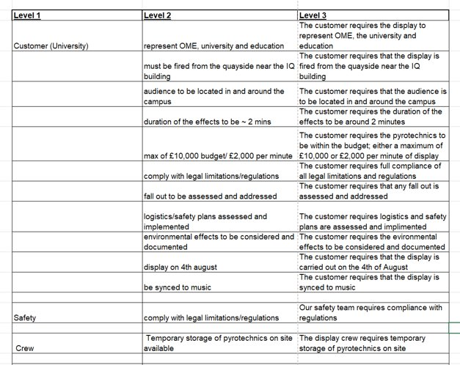
Figure 1 - The list of requirements captured.

Functional Requirements
To derive the functional requirements associated with the fireworks display, a tool known as a use case was implemented. The use case was written to include the everything that needed to happen prior to the event itself and all the post firing conditions. This helped to structure a basic flow of what would need to happen for the team to successfully display something. From this flow, functional requirements were easier to determine, and they were organised into groups to help to identify any gaps.
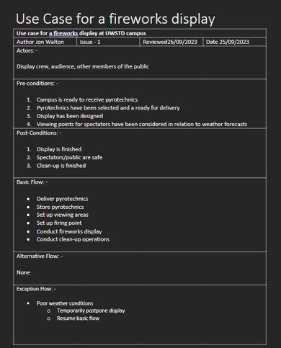
Figure 2 - A use case for the fireworks display.
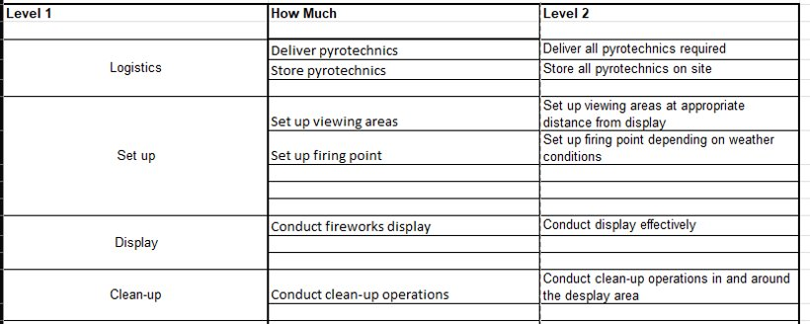
Figure 3 - An organised list of Functional requirements.

The importance of customer requirements
To determine the relative importance of the requirements that were gathered, a meeting was arranged by the Project Manager and chaired by the Systems Engineer. Using the Pairwise comparison tool, each requirement was weighted against all the rest. This took some time but by bringing the team together and approaching each comparison from a slightly distinct perspective, a much more accurate assessment of which requirements were the most important was made, which was integral for the next systems tool.
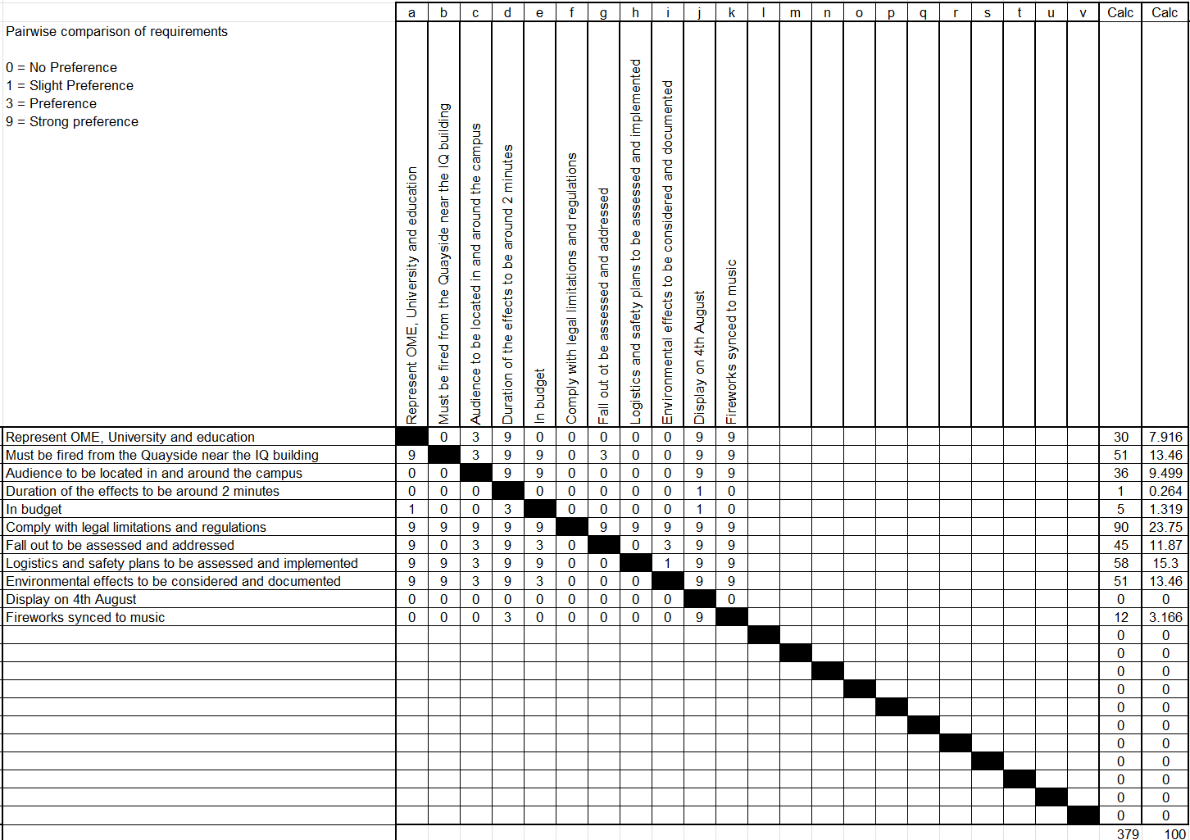
Figure 4 - A populated Pairwise comparison tool.
As can be seen more clearly in Figure 5, this is how the requirements weighed up against each other. The most important by a large margin is complying with legal limitation and regulations. The main reasoning behind this high weighting is that the safety of the public and of those working with the pyrotechnics is a priority, and the laws and regulations put in place by the government and the HSE are there to protect the populace. In the same vein, logistics and safety plans being implemented is the next highest followed swiftly by considerations being made towards the environmental effects that could take place.
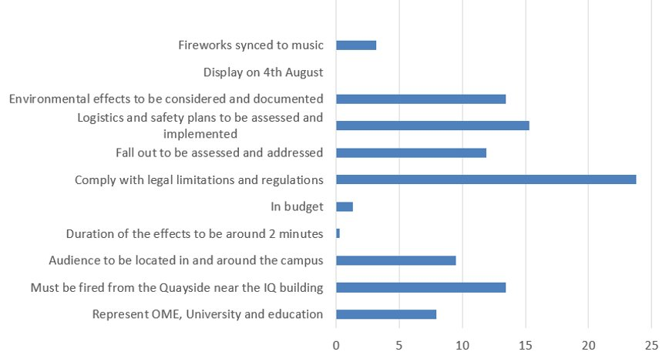
Figure 5 - A graph showing the relative importance values that were the output of the Pairwise comparison tool.
There were limitations placed on the team by the customer as to where the firing point must be as well as the location of bystanders, this placed them high in terms of importance as most of the simulations would have to be done with these locations in mind. As can be seen in Figure 5 there are three things on the list that rate very low down, the display date, the budget, and the duration of the effects. It is important to point out that these requirements are not unimportant, but the safety and physical restrictions placed on the team, just rate that much higher.

QFD 1 Functional importance
Once the requirement importance had been determined, these numbers could be entered into the house of quality, better known as QFD 1 or Quality Function Deployment. This allowed for the comparison of the non-functional requirements against the functional requirements, thus allowing the team to have a better understanding of what the critical functions of the display are by highlighting the relationships and corelations between them.
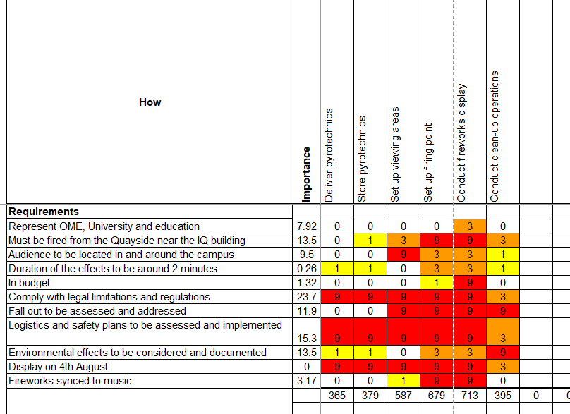
Figure 6 - A populated QFD 1 graph.
As can be seen in Figure 7, this resulted in the conducting of the fireworks display as the most important function. This was the expected outcome as without a display, there is no requirement for anything else to happen completely negating the point of this exercise. There is an abundance of regulations and constraints placed on the team regarding the hosting of the display, which is why the firing point and viewing areas are rated so highly here, there are aspects of both that cannot be altered.
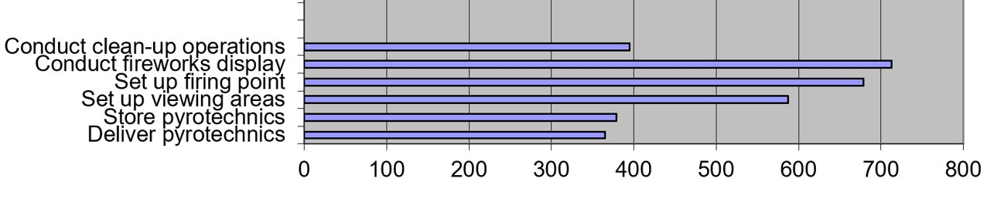
Figure 7 - A graph showing functional importance, the output of QFD 1.
The least critical function was the delivery of pyrotechnics. Much like the requirements weightings, this does not mean that the logistics of firework delivery is unimportant, there are just other aspects of the display that have a more direct impact on the success of the evening. Unlike most of the other functions, the delivery of pyrotechnics would be carried out by a third party, making it difficult for the display team to influence or control their actions.

Function means analysis.
Figure 8 shows a function means analysis that was carried out by the team. The team came together once again to suggest different ideas as potential solutions to help ensure that the functions of the fireworks display could be carried out. In other words, by what means can the team ensure that the display, and the subsystems required for it, take place. The boxes highlighted in yellow are the options deemed to be the most appropriate.
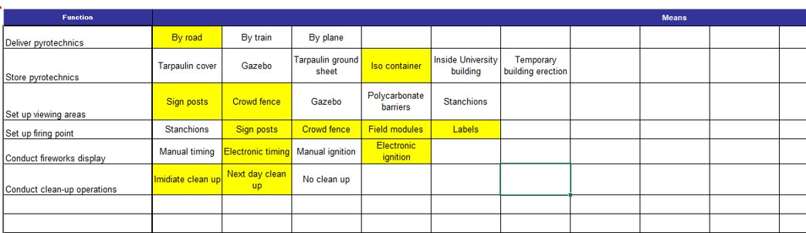
Figure 8 - A Function means analysis.

QFD 2 Critical design features
To determine which of the proposed features were the most important or had the most impact on the display, QFD 2 was the next systems engineering tool to be used. This tool compares the relationships between system functionality and the chosen solutions proposed in the function means analysis. This helps to identify the critical features of the display.
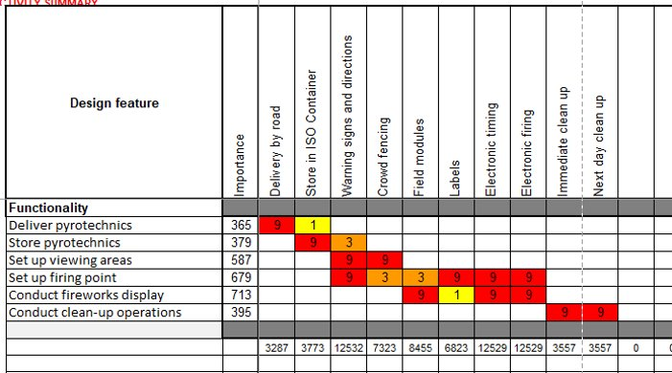
Figure 9 - A populated QFD 2 graphs.
As can be seen in Figure 10, high importance was given to the ability to correctly time and fire the display, ensuring that a good show can be put on for the crowd. Appropriate signage in tandem with crowd fencing keeps people safe and where they need to be; more specifically the audience need to be kept to the designated viewing areas, and nowhere near the firing point.
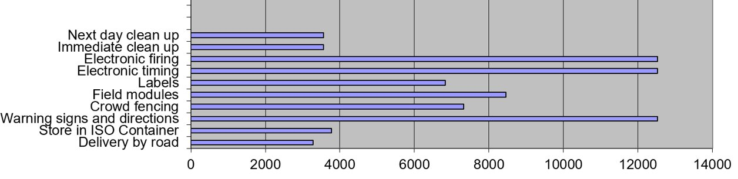
Figure 10 - A graph showing the output of QFD 2, identifying the critical design features.

Functional FMEA
The Functional FMEA is very much the culmination of the work carried out by the systems engineer by this point. Identifying critical functions and critical features has generated enough information to identify failure modes and their severity. Within the FMEA, Severity, likelihood of occurrence and likelihood of identification of the failure are the three factors that are used to gauge overall risk levels. The values assigned to these areas are pulled together to create a risk priority number or RPN which makes the identification of high-risk areas extremely easy. Any value over one hundred was deemed to be of highest risk and the most effort needed to go into solving these issues. Any value below one hundred and above 50 were the next highest in terms of priority, with the remaining failure modes either solved by solutions that solved other areas, or of very low risk. By examining the areas of highest risk, planning and simulation are by far the most critical areas of focus; the more effort that is applied to these areas, the more prepared the display team will be for the display day. This was emphasised by poor planning and changing weather conditions being the most common causes of failure. This means safety and legal restrictions needed to be well understood, and in-depth simulation of the fireworks display in expected weather conditions needed to be areas where the most time and resources are spent.
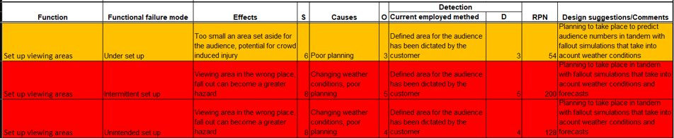
Figure 11 - Examples of the highest risk areas found in the FMEA.
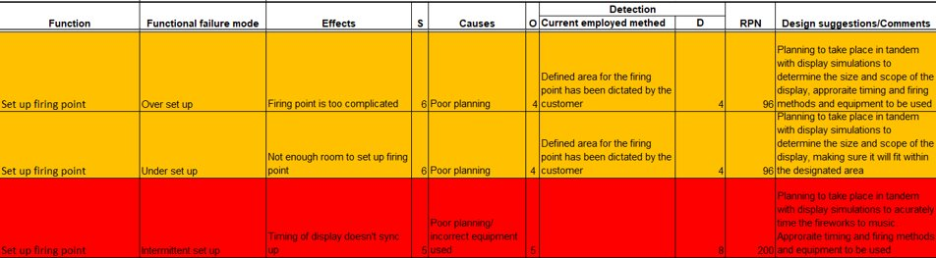
Figure 12 - Examples of the highest risk areas found in the FMEA.

How systems influenced the group
Systems thinking was an invaluable tool set that provided a great deal of information to the group. Critical functions were identified, and these were: Conducting the fireworks display, Set up the firing point, and Setup of the viewing areas. These are the top three most crucial functions that are integral to the success of the fireworks display and they need to be done correctly with high levels of quality achieved. Critical Features were identified namely: Electronic timing, electronic firing, and Warning signs and directions. These three features will have the greatest impact on the success of the display on the day, ensuring that the display is as good as it can be whilst ensuring the safety of those present. Through the use of the FMEA, the areas of greatest risk were identified. It emphasises the requirement to plan effectively, ensure that all display staff have a good understanding of the rules and regulations surrounding fireworks and to carry out detailed simulations, to further ensure the safety of the public and quality of the display.
With all of the information generated from the use of systems thinking, detailed limits and boundaries set by the requirements were passed on to the other team’s members to help focus and drive their work.

Simulation design
The Simulation and Design engineer had three main areas of focus. Firstly, to establish and ensure that a theme is represented throughout the display, secondly, the ignition and timing method must be electronic and as such an appropriate solution must be selected. Lastly the fireworks display must be synchronised to a chosen song.

The theme
As per the requirements set on the group, the fireworks display must be themed to be a representation of the time spent at the University of Wales Trinity Saint David in Swansea and the OME course that the group members have been attending.
The overall message that the group decided on was to acknowledge the improvement of both the university and the students attending the course, showing a first year that was poorly timed and underwhelming, with a second year that is vastly improved over the first.

Electronic firing module
Prior to any planning or simulation, it was understood that there was a requirement for an electronic firing module as was proposed by the Function means analysis and underpinned by the Functional Failure Modes and Effects Analysis. A COBRA firing module was chosen due to a large number of channels so less modules would have to be purchased and used. This gave the Design and Simulation engineer the ability to plan around three areas with a total of seven firing points.

The plan
The song ‘Sweet Caroline’ by Neil Diamond was chosen as it is a crowd favourite and that it would be a good song to match fireworks to. The idea was to have a record scratch after a poorly timed first half and then the second half of the display would be much better timed, and the music replayed at a better quality. The highlight of the music that was chosen to be used as a crescendo occurs slightly over a minute into the song, meaning the show would last just over 2 minutes.

FWsim
FWsim is a free to use program that allowed for a detailed plan of the display to be created and allowed for the planning of timings, angle of projection, firing position and module address [3]. Many hours of simulation culminated in a plan with the following characteristics:
- 332 individual firework shots
- 14 cobra modules
- NEQ estimated at 116.24Kg

Procurement
Procurement began shortly after the first draft of the firework simulation. Fireworks were chosen from listings provided by Kimbolton and MLE [4] [5]. The purchasing of existing fireworks was chosen over custom making the fireworks in house to avoid time and money spent on the development and manufacture of fireworks by the group. This did however mean that fireworks could not be perfectly match to the simulation. As a result, procurement and simulation teams worked closely together to find a best fit solution and compromise were appropriate.
Here is a list of the procurement totals.
- Display time: 2m 30s
- Number of fireworks purchased: 16 cases, 681 units.
- Number of fireworks to be used: 332 units.
- Unused fireworks remaining: 349 units.
- Total materials cost: £2,296.85 (£2,500 budget for £1000 per minute)
- Materials cost for used units: £953.30.
- Total NEQ: 116.27kg (close to estimate from design)
- HCC 1.3G Total: 99.42kg
- HCC 1.4G Total: 16.85kg

Test and evaluation, conducting display and disposal.

Environmental considerations
Noise is a staple of many fireworks., and as such is something that is likely to affect the environment in the local area. Limits of 120dB at the observation points are imposed. However, so long as the operating instructions are followed, damage to human health will not occur.
Air pollution caused by large displays have the potential to be very harmful. Particulate made up of heavy metals and other toxins can cause damage to humans and other animals. Fortunately, the outside is a well-ventilated area and as such, this pollution should quickly disperse.
Litter and debris are guaranteed during a fireworks display. Shell casings and other detritus from spent fireworks will be spread across a wide area, and not all are biodegradable.

Test and evaluation
The testing of all chosen fireworks should be conducted in similar weather conditions that have occurred in previous years and the expected conditions forecast for the event. This will allow for fallout to be analysed, paying special attention to the direction and distance travelled. These finding will then be compared to further simulations carried out on shell calc. Acoustic testing will also be carried out to ensure the 120dB limit is not exceeded in the viewing areas wind direction will affect noise patterns greatly. Testing all of the fireworks is essential for the underpinning of the timing script, to ensure that the fireworks are initiated correctly and that synchronisation with the music track can be achieved. These tests can be done without any fireworks being set off, allowing for many dry runs and time to dial in the timings.

Display
Fielding of the display will be carried up by qualified professionals to ensure they understand the importance of carrying out risk assessments and the requirements set upon them by health and safety legislation. The operators must understand how the fireworks are to be set up, used, and cleared up. The operators will be competent in the use of the Cobra firing system and its software so that a script can be written and timed to music.

Firing equipment
There are several pieces of electronic equipment that will need to be used for the display. All fireworks will be connected to Cobra 18M firing modules. A Cobra 18R2 will be used to control the display and to monitor signal strengths, ignitor connectivity and battery levels. A Cobra Audio box will be used to transmit audio to the chosen sound system and is used to synchronise the music to the display. Finally, ignitors will be used to initiate any fireworks used and connect them all to the relevant modules.

Setup/safety
Safety is a crucial part of the fireworks display. The operators will be familiar with the manufacturer's instructions several days prior to the fireworks display. Tooling and materials will be mustered prior to the fireworks display. All fireworks will have clearly defined set up areas. Set up will occur during daylight hours. No fireworks will be left unattended during or after setting up. Appropriate PPE will be worn by the operators. This will include flame retardant outer clothing, ear defenders, hard hats, and safety boots.

Firing
Figure 13 shows the setup of the firing points and the locations of the Cobra modules. The rectangles are the seven firing points, with the Cobra modules being denoted by the diamonds. The Cobra modules are placed behind the firing points. With eighteen channels each, there will be enough Cobras spread between the firing points to cover all of the fireworks. Ignitors and predetermined lengths of bell wire will be used to connect the fireworks to the modules to allow for accurate timing. A timing script will be applied to the system, igniting the fireworks automatically.
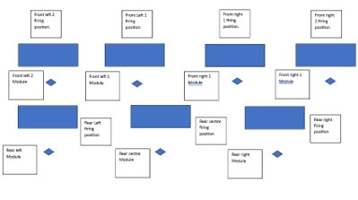
Figure 13 - Firing point set up diagram.

Disposal
The management of waste produced by the fireworks is exceptionally important. All fireworks that fail to go off must be left for 30 minutes before being submerged in water for 48 hours (or as per the manufacturer's instructions) to break down the pyrotechnics to render them functionally inert. These fireworks will then be stored inside an ISO storage container. As for fireworks that did go off, on the same evening of the display, a walk of the area will be conducted using torches to collect litter and debris in the area. This will then be bagged and disposed of by the local authorities. A second clean up walk will be carried out the next day in day light hours to ensure that nothing was missed.

Safety

The why, the how and the what
Safety affects everything in the workplace and the Health and Safety at work act 1974 dictates this [6]. Employers must “ensure, so far as reasonably practicable, the health of his employees” [7]. Employees must “…take reasonable care for the health and safety of himself and of other persons who may be affected by his acts or omissions at work” [7].
The Health and Safety executive has legislation that governs both explosives, the Explosive Regulations 2014, and fireworks, the Fireworks Regulations 2004 [8] [9]. Fireworks that have a Category F rating on them must be CE compliant. The F category that is assigned to fireworks provides information on the safety distances associated with them. F2 has a safety distance of 8-15m, F3 requires that the safety distance be set to at least 25m and F4 rated fireworks are meant only for professional use.

Storage
HSE.Gov states “If you wish to use the fireworks for a commercial display or for some other work activity, you can keep up to 100kg of hazard type 3 fireworks for up to 5 consecutive days without the need for a license, provided they are kept in their place of intended use” [10]. This allows the display team to safety store explosives on site without the need for an explosive licence up to 5 days prior to the date of the actual display.

Location
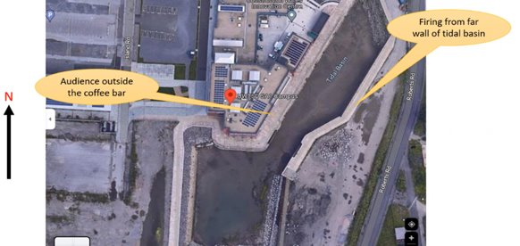
Figure 14 - a picture showing the approximate locations of the audience and the firing points.

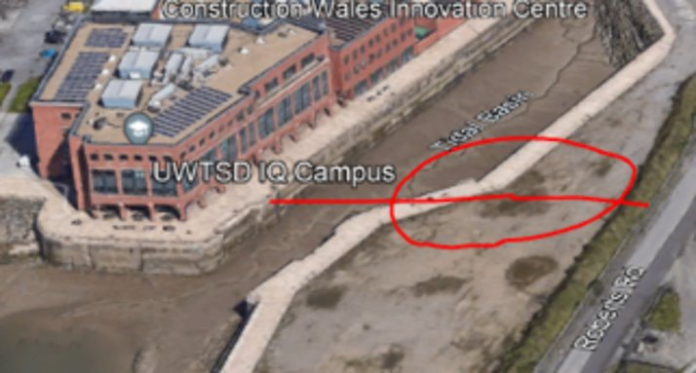
Figure 15 - An annotated picture showing safety distances from the IQ campus.
Figure 15 shows a series of important distance with regards to the positioning of the firing point. There is a 25m safety area delineated by red circle. This is just under 51m to nearest edge of the viewing area and just over 31m to Roberts Road.

Logistics
Logistics covers not only the delivery of fireworks, but also how the team plans to store them and in what location. To begin with, Fireworks will be ordered to arrive no more than 5 days in advance. Upon arrival, a rented 20ft ISO container will be used to securely house the fireworks keeping them dry. The ISO container will be situated away from the firing area and viewing area. Class E separation distance of 64m (950-1000kg HT3 Tabel 10 ER2014 [8]) For a display with an NEQ of 116.25kg a 34m Class E distance can be used as seen as the blue circle in Figure 16. The storage area will be contraband controlled keeping any potential sources of ignition or incompatibility away. The storage area will be accessible to emergency services in the event of an incident.
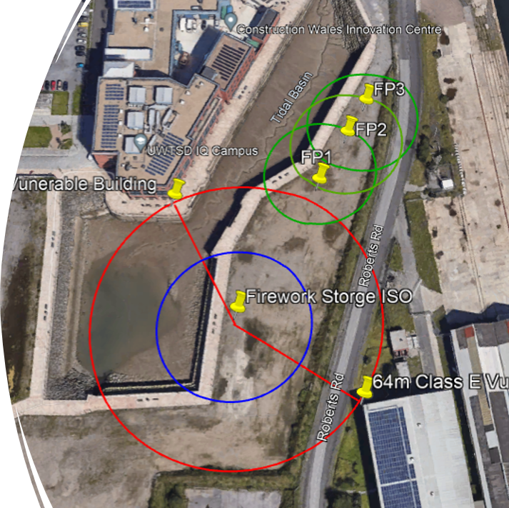
Figure 16 - A bird's-eye-view of the final configuration of the firing points and the storage container.

Performance
Prior to the event, several tasks must be completed. A Risk Assessment will be required for the display. Swansea council and the emergency services need to be informed that a display is due to take place and where it will be taking place. A first aid station needs to be located and accessible on site. Marshals need to be employed to provide directions and guidance to the audience as well as being an added layer of security.

Weather and shell calc

Weather on the day
The proposed display date was the 4th of August 2023. This was a requirement set by the University. The Metrology Simulation Engineer gathered weather data for 1800 on the 4th of August and 0000 on the 5th of August. For the earlier time the weather is overcast with cloud cover at approximately 450m. There is a low chance of rain and wind speeds of up to 32km/h in a north westerly direction. The weather at 0000 is to be thunderstorms with cloud cover at 300m. Rain is likely and wind speeds will be up to 25km/h in a westerly direction. For the day of the display, sun set is due to be just before 2100. Due to the significantly worse weather conditions at midnight, the display would have to take place as early as possible once the sun sets. The lack of weather data for 2100 means some guess work must take place, with the conditions assumed to be somewhere between the conditions at 1800 and 0000.

Parameters and findings
The Metrology Simulation Engineer ran simulations to consider the best and worst-case scenarios. The findings of these simulations influenced specifics of the locations of the firing point and the viewing areas. During initial tests it became apparent that fallout from the shells and bombettes in forecast wind conditions would be potentially dangerous. The fallout had potential to travel distances in excess of 300m inland directly in the audience. It was noted that low cloud cover meant that some fireworks would detonate beyond the cloud ceiling. To address these concerns, comets became the preferred firework of choice in many instances.

The most dangerous scenario
Figure 17 and Figure 18 show simulations carried out in the worst-case scenario. It was noted that the display was in fact the most dangerous during the average wind speeds and the fall out would land in the carpark, and the gusts would push fall out into the tidal basin beyond the University grounds.
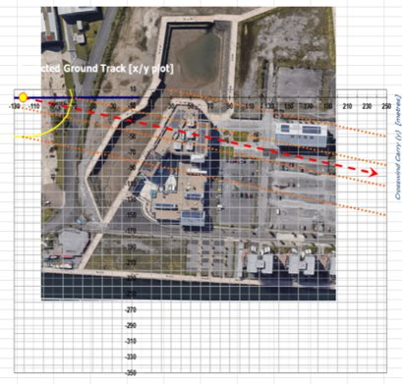
Figure 17 - The output of a simulation showing fallout during a 32km/h gust.
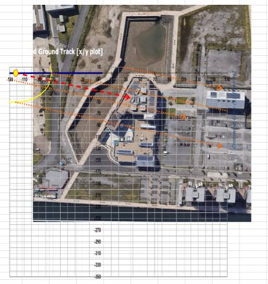
Figure 18 - The output of a simulation showing fallout during average windspeeds of 14km/h.

Mitigations
Several proposals were made by the Metrology Simulation Engineer. Changing the date to a day with better weather was considered however greater costs would be incurred due to rearrangement so this was dismissed an option, favouring other methods of mitigation. The display must be conducted well before midnight before weather conditions become too bad preferably immediately after sun set when wind is North Westerly. Due to the wind conditions, it is safer to fire pyrotechnics straight up rather than firing away from audience. Vertical firing angles should contain fallout to tidal basins and the car park. Comets have been identified as being of minimal risk and the most appropriate for a display during conditions with low cloud cover. However, it is noted that later into the night and especially by midnight, the cloud cover will be so low that it would still adversely affect the display. Surrounding areas such as the car park, should be clear of spectators. The display team must be constantly monitoring the weather in case of sudden changes in wind speed or direction. All personnel must be prepared to call a stop to the display if dangerous conditions come about. Finally, the doors of the university IQ building should be open to allow swift clearance of the viewing area to hard cover if required.

The presentation
Overall, feedback on the day of the presentation was exceptionally good, however there was, as there always is, room to improve. It was noted that, although great work was done by the systems engineer, it was very top level leaving much to be desired on the subsystem level. Failure Modes and Effects Analysis could have been carried out on a more granular level to determine potential fault paths associated with individual types of fireworks. An example that was given was that it is possible to mount some types of fireworks upside down, and as a result it was important to have display staff who are adequately trained in the use of fireworks to ensure small mistake that could compromise safety or quality would not occur. A Process failure modes and effects analysis could also be carried out to look more closely at the inner workings of how to set up and perform a display. This would help hugely in the development of a full operating process which would more effectively guide and control the work carried out on the night of a display.
Another area of concern was that in QFD1 (Figure 6) there are many ‘9s’ which suggests that some requirements might benefit from decomposition. This means that some requirements are too general. For example, “logistics and safety plans to be assessed and implemented” covers a huge spectrum, and as a result heavily influences all of the functional requirements. It would perhaps be better to split this into multiple sections that focus on specific areas such as transport arrangements, storage arrangements and risk assessments. This would provide more clarity and allow for a deeper understanding of all the facets associated with a fireworks display.

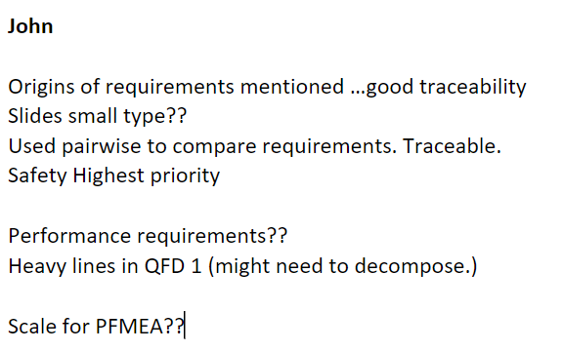
Figure 19 - Feedback generated for the Systems Engineer.

Conclusion
This group project was an effective tool to better understand working as a team in an OME environment. A great deal of work went into every aspect of the project, each team member linking in with the rest to ensure that information is freely shared and thus ensuring overall success. The role carried out by the Systems engineer was integral to the success of the group project. Despite there being little in the way of a physical output that the end user would see such as the design of the display itself, the pre work carried out allowed for prioritisation of work as well as the identification of key elements that may have otherwise been missed. Design and planning were made easier as a direct result of the value of systems thinking as well as limiting the need to go back to the requirements to repeat work that had not been effectively managed. It was noted during the feedback after the group presentation that the volume and quality of the work submitted by the team was beyond what is usually delivered by professional display companies. As humbling as this high praise was, however, improvements can always be made, and there was much more that systems thinking could offer to enhance the quality of a fireworks display.

References

[1] | P. Checkland, N. Jayaratna, S. Challender and S. Holwell, “Systems Thinking, Systems Practice [Review of Systems Thinking, Systems Practice],” Systems Research and Behavioral Science, vol. 17, no. S1, pp. 77-81, 2000.
[2] | N. G. Leveson, Engineering a Safer World: Systems Thinking Applied to Safety, Cambridge: The MIT Press, 2012.
[3] | “FWsim,” FWsim, [Online]. Available: https://www.fwsim.com/. [Accessed 17 November 2023].
[4] | Kimbolton Fireworks, “Trade Sales,” Kimbolton Fireworks, [Online]. Available: https://www.kimboltonfireworks.co.uk/trade-sales/. [Accessed 17 November 2023].
[5] | MLE Pyrotechnics, “Fireworks,” MLE Pyrotechnics, [Online]. Available: https://www.mlepyrotechnics.co.uk/services/fireworks/. [Accessed 17 November 2023].
[6] | HSE, “Health and Safety at Work Act 1974,” [Online]. Available: https://www.hse.gov.uk/legislation/hswa.htm. [Accessed 17 November 2023].
[7] | “Health and Safety at Work etc. Act 1974,” [Online]. Available: https://www.legislation.gov.uk/ukpga/1974/37/contents. [Accessed 17 November 2023].
[8] | “The Explosives Regulations 2014,” [Online]. Available: https://www.legislation.gov.uk/uksi/2014/1638/contents. [Accessed 17 November 2023].
[9] | “The Fireworks Regulations 2004,” [Online]. Available: https://www.legislation.gov.uk/uksi/2004/1836/contents/made. [Accessed 17 November 2023].
[10] | HSE, “Storing explosives,” [Online]. Available: https://www.hse.gov.uk/explosives/licensing/storage/index.htm. [Accessed 17 November 2023].

