3/24/2025
University of Wales Trinity Saint David
London campus
E-Portfolio Link: https://2544935.wixsite.com/creative-showcase
Module Name: Learning In the Digital Era
Module Code: ACCA 4025

Student Name: Artur Dujs
Student ID: 2544935
Group: 1

Lecturer’s Name: Koushik Modak

LDE Assignment 1
E-Portfolio
Table of Contents
Introduction 2
Main Body 2
Task 1: Essential Academic and Employment Skills for the future career Path 2
Task 1 (a): Report on Essential Academic and Employment Skills 2
Task 1 (b): Evaluation of Task 1 (a) based on Similarity report 4
Task 2: Collaborative Mind Map and Individual Poster 4
Mind Map (Collaborative) 4
Poster (Individual) 4
Task 3: Virtual Collaboration and RefWorks 6
Task 3a: Unit 3 Topic Summary – Forming a team 6
3b Use of RefWorks 6
Adding add-in ReWorks to Microsoft World 9
Task 4: E-Portfolio Creation and Evaluation 10
Task 4 (a): E-Portfolio Creation 10
Conclusion 11
References: 11

Introduction
This is Assignment 1 for Learning in Digital Era where I am going to write about skills in digital Era. Creating Mind Map, E-Portfolio, E-Poster. Ussing EIII Referencing and RefWorks tool.

Main Body

Task 1: Essential Academic and Employment Skills for the future career Path

Task 1 (a): Report on Essential Academic and Employment Skills

By reading “The Guide to Learning and Study Skills” by Sue Drew and Rosie BinghmamI have learned about those skills both applicable in studying and employment. [1]
For my carrier path I Have chosen Cyber Security Engineer. I know Action Planning will be very important and good Time Management too. Good Solving Problems skills will be attractive too.
Grow of Cyber Security Threats resulted in need to create Action Plan in case of such events occur [7] [8]. Private users and even more businesses need to have plan how to react, resolve and issues after cyber security event. Trying to solve the problems when attack is happening is very difficult and almost impossible since usually, we deal with new problems. Not having action plan in place in advance is a shortcut for disaster and issues can become more severe than being prepared and fallowing steps prepared for such situation. Action Planning needs to predict most scenario that might happen. Example of Action Plan in case of infecting one or few computers in a business would be disconnecting affected machines from network not allowing attack to spread to other computers. Restoring those machines and moving workload from those computers to temporary machines or creating extra shift and use existing machines to do the work. Next step would be to resolve issues with affected machines.
Solving Problems skills are getting more important in current cyber security environment.[9] Students are being encouraged to solve problems in real world situations to be prepared for real threats not just the academic examples created for learning purposes. Knowledge gained in real life events is valuable for future properness. Some of the attacks can still be not fully solved making them open problems with many possible outcomes. Ability to solve new open problems only can be gained by solving real world problems where outcomes can be verified.
Time management
Any cyber security event is always time based. [10] We usually know when it happened and when it was resolved. It is very important to manage such event in timely manner. The faster we can solve any issue the faster we can go back to business as usual. The shorter break in normal business operation the loses to business should be lower. Another example for old phrase “time is money”. In many cases we can calculate quite precisely based on past how much money is being lost per minute by business. Depending on operation size it can be quite substantial. Correct time management is needed when solving problems during cyber security attacks. Spending too much time on one issue might be not efficient. For example, might be faster to replace affected machine then trying to fix all the issues occurred.
There are several more skills that can be useful in Cyber Security but will describe them here in details. Some of them are: Doing Projects, Finding, Using and Analysing Information and Evidence, Making Notes, Presenting Your Work, Discussions, working in a Group or Team, Dealing with Other People. valuable.
Valuable work of Laura Garcia-Pérez “Skills for a Working Future: How to Bring about Professional Success from the Educational Setting”Formatting...focusing on essential skills enabling access to job positions in coming years. [5]
Another publication of Naimatullah Shah; Safia Bano; Ummi Naiemah Saraih; Nadia A. Abdelmegeed Abdelwahed and Bahadur Ali Soomro “Leading towards the students’ career development and career intentions through using multidimensional soft skills in the digital age” focusing on soft skills. [6]

Task 1 (b): Evaluation of Task 1 (a) based on Similarity report

Task 2: Collaborative Mind Map and Individual Poster

Mind Map (Collaborative)
Mind Map Link: https://mm.tt/map/4030978062?t=dXSY9k9FIy
Mind Map Image:
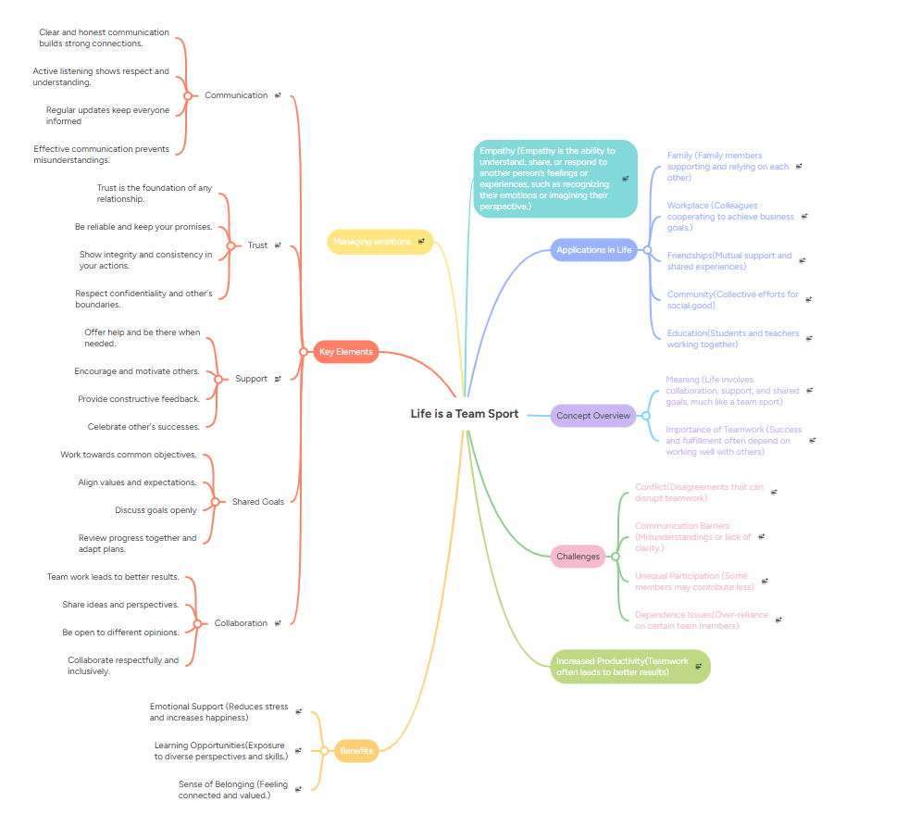
Screenshot: Mind Map created with mindmaister.com.

Poster (Individual)
Poster Link: https://canva.link/aeb0ubp9xaeknej
Poster Image:
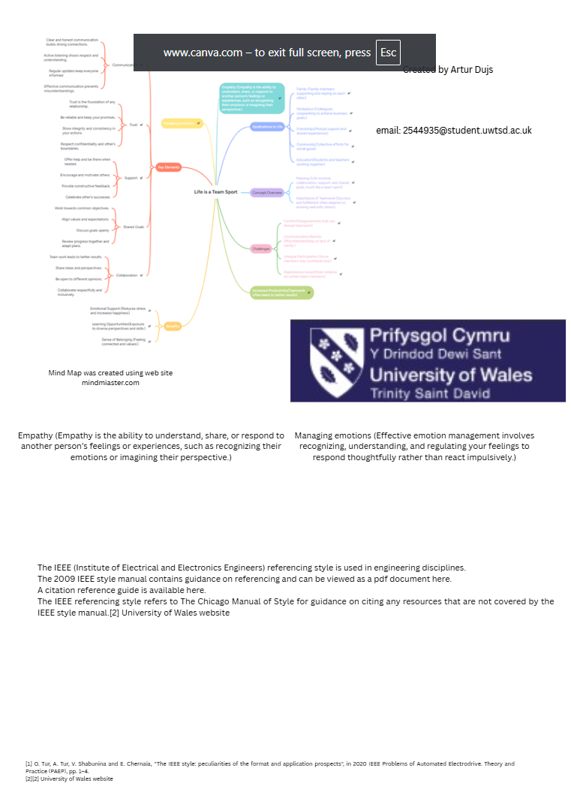
Poster Image: Created with www.canva.com.

Task 3: Virtual Collaboration and RefWorks

Task 3a: Unit 3 Topic Summary – Forming a team
Group activities require the formation of the team whose members can have ties different to each other depending on the task. Team forming is critical and essential process and can be time consuming. It is important to select team members based on skills needed to accomplish goal. Success of the team is not guaranteed. [11] The are several methods of selecting a team. One is named Know – what + Know – how + Know – who. Know what refers to knowledge what task need to be performed in organisation to execute task efficiently. Know – how involves skills and techniques required to perform tasks efficiently. Know – who – is about knowing who can execute tasks within organisation. Who would be accountable for specific tasks.
Those 3 elements work together to create a comprehensive knowledge management framework that supports organisation processes and goals. [12]
Another approach is utilization of fuzzy optimisation in team creation process. A fuzzy optimisation approach translates human traits and project requirements into quantifiable mathematical models. Fuzzification translates linguistic variables into mathematical membership function. Example could be skill lavers rated as poor, average, excellent. Fuzzy optimization considers objective function and restrains. Goals could be opposing like maximising team skills and minimizing overall cost of the team. Some of the restrains could be deadlines or team size limits. Defuzzification converts mathematical outcomes into lists of ideal candidates or team configurations. Key benefits of Fuzzy optimisation are capture of human factors, handling of ambiguity and balancing of opposite goals. [13]

3b Use of RefWorks
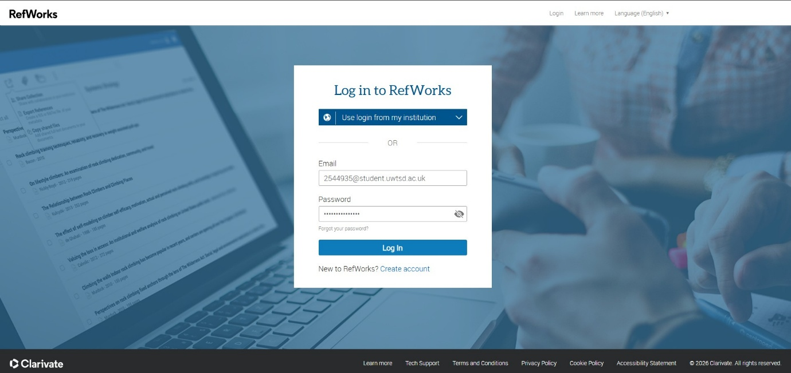
Creating and logging into ReWorks account at www.reworks.com

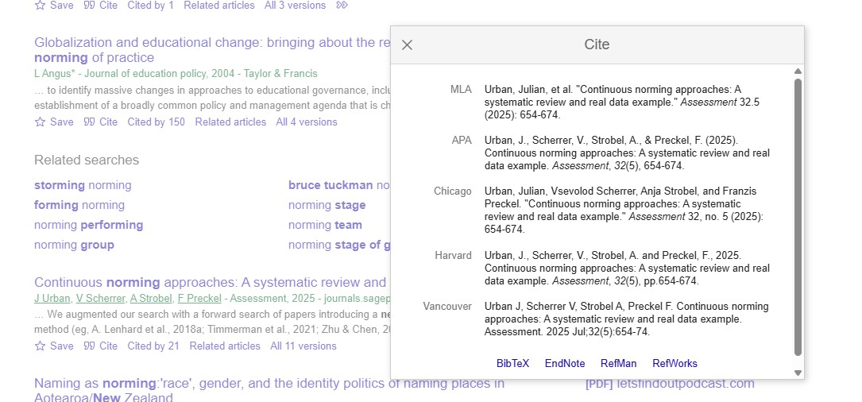
Imprting references to ReWorks related to topic The New Norming
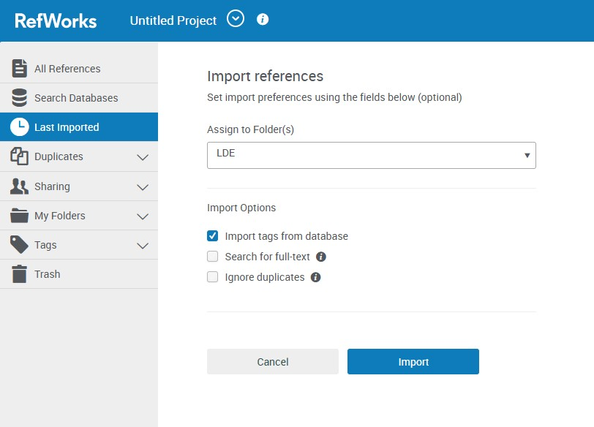
Importing references into folder at ReWorks for easier organisation.

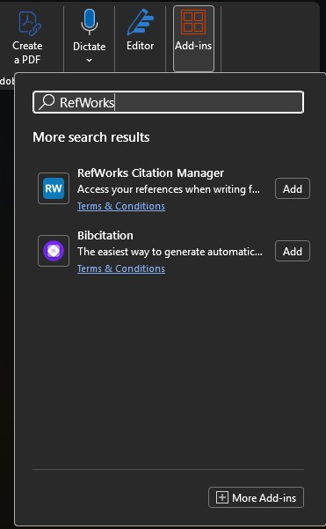

Adding add-in ReWorks to Microsoft World
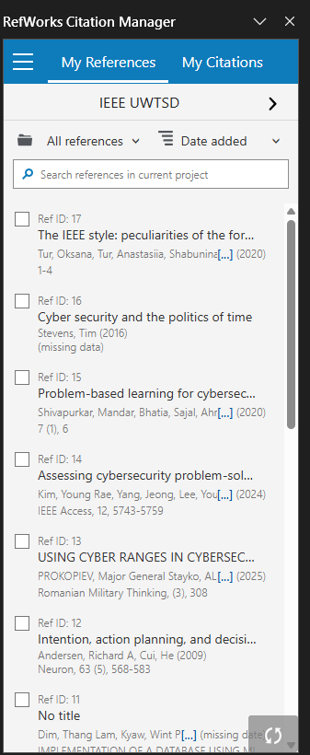
Importing references directly inside Microsoft Word from RefWorks account.

Task 4: E-Portfolio Creation and Evaluation

Task 4 (a): E-Portfolio Creation
I have created simple E-Portfolio using www.wix.com

https://2544935.wixsite.com/creative-showcase
Task 4 (b): Illustrative Review of E-Portfolio tool Selection
I have used www.wix.com because even free version allowed me to create it easily and fast. Wix is example of WYSIWYG (What You See Is What You Get) website builder, allowing users to visually design websites without need coding knowledge. I have created simple e-portfolio and the whole process was intuitive. Wix builder is available through website with easy access. There are several added services available for quick domain and server purchase enabling quick website deployment.

Conclusion
There is a vast array of digital tools that can aid us in learning process. The digital era has fundamentally transformed learning from a static, location-bound activity into a dynamic, lifelong journey. Learning now is more accessible and can be started at later age. By leveraging tools like artificial intelligence, virtual reality, and global online platforms, education has become more personalized, accessible, and collaborative than ever before. However, this shift also demands new skills, requiring learners to develop critical digital literacy and self-regulation skills to navigate information. Amount of information can be overwhelming and vary in quality. Ultimately, the future of education lies not in replacing human connection with technology, but in merging the two to increase creativity, adaptability, and inclusive growth for all.

References:

[1] | S. Drew and S. Bingham, The Guide to Learning and Study Skills, Farnham: Gower Publishing Limited, 2010.  [2] J. Urban, V. Scherrer, A. Strobel and F. Preckel, "Continuous norming approaches: A systematic review and real data example," vol. 32, no. 5, pp.654–674, 2025,  [3] G. Ligon and E. Mangino, "A Call for a New National Norming Methodology." 1991,  [4] A. Lenhard, W. Lenhard, S. Suggate and R. Segerer, "A continuous solution to the norming problem," vol. 25, no. 1, pp.112–125, 2018,  [5] L. García-Pérez, M. García-Garnica and E. M. Olmedo-Moreno, "Skills for a working future: How to bring about professional success from the educational setting," vol. 11, no. 1, pp.27, 2021,  [6] N. Shah, S. Bano, U. N. Saraih, N. A. A. Abdelwahed and B. A. Soomro, "Leading towards the students’ career development and career intentions through using multidimensional soft skills in the digital age," vol. 65, no. 6-7, pp.848–870, 2023,  [7] R. A. Andersen and H. Cui, "Intention, action planning, and decision making in parietal-frontal circuits," vol. 63, no. 5, pp.568–583, 2009,  [8] M. G. S. PROKOPIEV, V. ALEKSANDROVA, E. PAVLOVA and V. VASILEVA, "USING CYBER RANGES IN CYBERSECURITY TRAINING AS AN ACTION PLAN IN THE FACE OF HYBRID THREATS." no. 3, pp.308, 2025,  [9] M. Shivapurkar, S. Bhatia and I. Ahmed, "Problem-based learning for cybersecurity education", in Journal of The Colloquium for Information Systems Security Education, pp. 6.  [10] T. Stevens, Cyber security and the politics of time, Cambridge University Press, 2016.  [11] G. Stavrou, P. Adamidis, J. Papathanasiou and K. Tarabanis, "Team formation: A systematic literature review," 2023,  [12] H. Wi, S. Oh, J. Mun and M. Jung, "A team formation model based on knowledge and collaboration," Expert Syst.Appl., vol. 36, no. 5, pp.9121–9134, 2009,  [13] A. Baykasoglu, T. Dereli and S. Das, "Project team selection using fuzzy optimization approach," vol. 38, no. 2, pp.155–185, 2007,

