Coursework Title
Module Name: Computer Architecture and Operating Systems
Module Code: ACCA4022
Student Name: Sandu Doncila
Student ID: 2509918
Lecturer Name: Md Shantanu Islam

Submission date: 26/03/2026

Contents
Introduction 4
Key functions of general Operating Systems 4
Task Management: 4
Application/Program Management: 4
File/Directory Management: 5
Device Management: 5
Security Management: 6
Use of Windows OS CLI commands 7
Example 1: 7
Example 2: 7
Example 3: 8
Example 4: 8
Example 5: 8
Example 6: 9
Example 7: 9
Example 8: 10
Example 9: 10
Example 10: 11
Use of Linux OS CLI commands 11
Example 1: 11
Example 2: 12
Example 3: 12
Example 4: 13
Example 5: 13
Example 6: 14
Example 7: 14
Example 8: 15
Example 9: 15
Example 10: 16
Use of Windows OS scripts 16
Example 1: 16
Example 2: 17
Use of Linux OS scripts 18
Example 1: 18
Example 2: 19
Conclusion 20
References 20
Appendices 21

Introduction
This report gives basic information about Microsoft Windows and Linux command-line interfaces (CLI). It explains some simple commands used in both systems in a step-by-step way. It also includes examples of Windows scripts and Linux scripts, such as “nano” for adding two numbers and a “loop” script for repeating tasks. This assignment shows my basic IT skills and understanding.

Key functions of general Operating Systems
Microsoft Windows, first released on November 20, 1985, is an early graphical operating system developed by Microsoft. Its origins trace back to 1981 with a project called “Interface Manager.” The system introduced graphical boxes to represent programs, known as “windows,” which inspired the operating system’s name and identity

Task Management:
Microsoft Windows Task Manager is a built-in utility used to monitor and manage system performance and running applications. It provides real-time data on CPU, memory, disk, and network usage. Users can open it using Ctrl + Shift + Esc or by typing taskmgr.exe in the Run dialog. The Processes tab shows active applications and background tasks, while the Performance tab displays system activity through graphs. Additionally, the Startup tab allows users to control programs that run at boot. Task Manager helps identify unresponsive programs, troubleshoot issues, and optimize system performance efficiently.

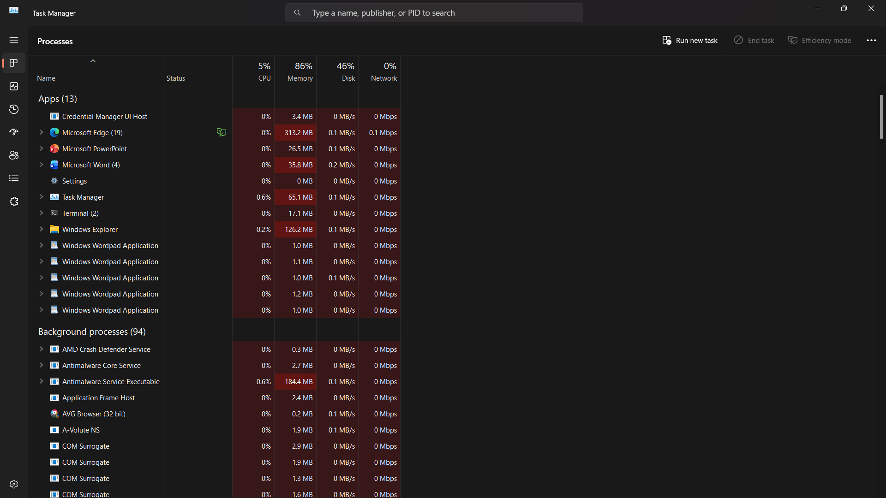

Application/Program Management:
Program management in Microsoft Windows involves installing, updating, removing, and monitoring software to maintain system performance and security. Users can manage applications through the Settings app, while Task Manager helps monitor CPU, memory, and running processes. Command-line tools like Windows Package Manager simplify software installation and updates. Startup management allows control over apps that run at boot, improving performance. Additionally, Microsoft PC Manager helps clean storage and optimize system efficiency.

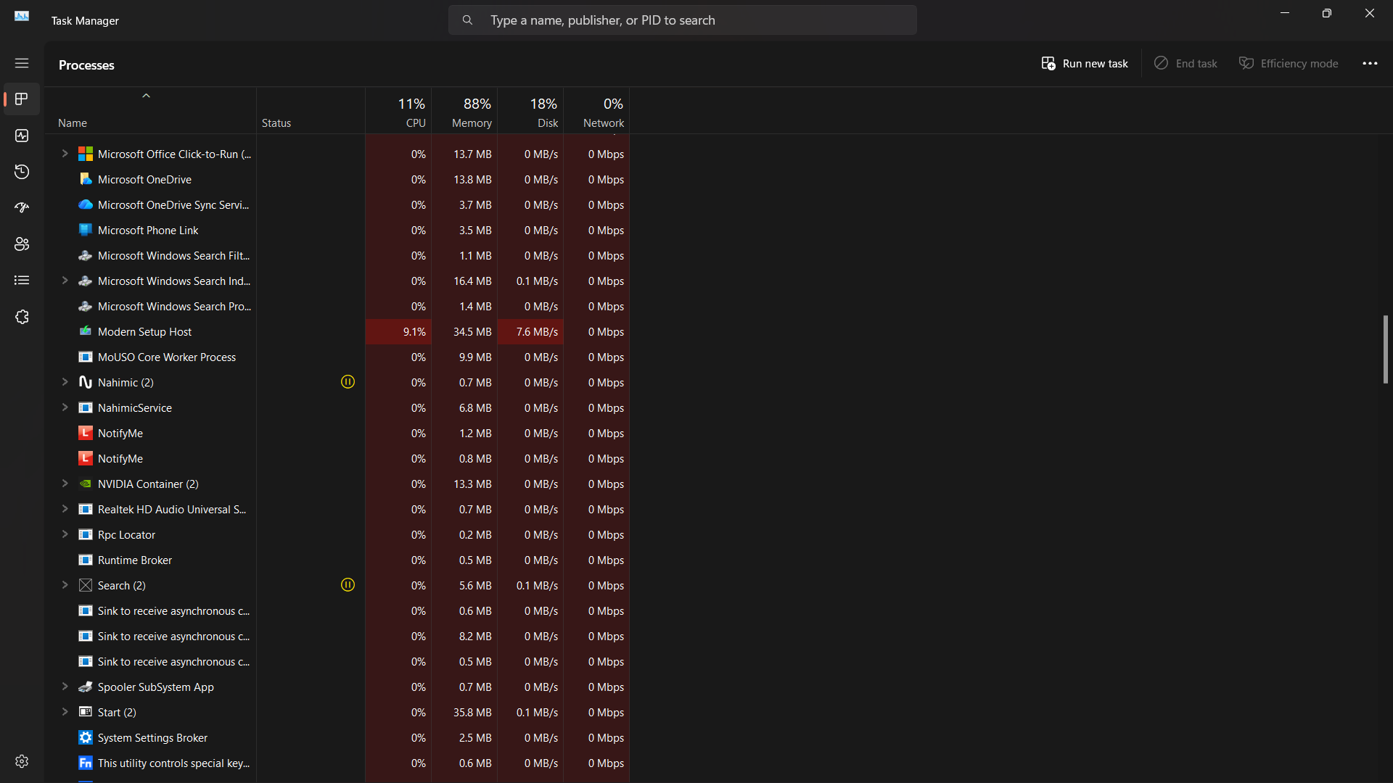

File/Directory Management:
Directory management in Microsoft Windows refers to the organisation and storage of files and folders on devices such as hard drives and SSDs. It follows a hierarchical, tree-like structure where a root directory contains folders and subfolders. This structure allows users to organise data logically, making files easier to locate and manage. Effective directory management improves file retrieval speed, enhances system efficiency, and supports smooth operation of applications. It also simplifies data access for both users and programs, reducing clutter and confusion while promoting better productivity and system performance.
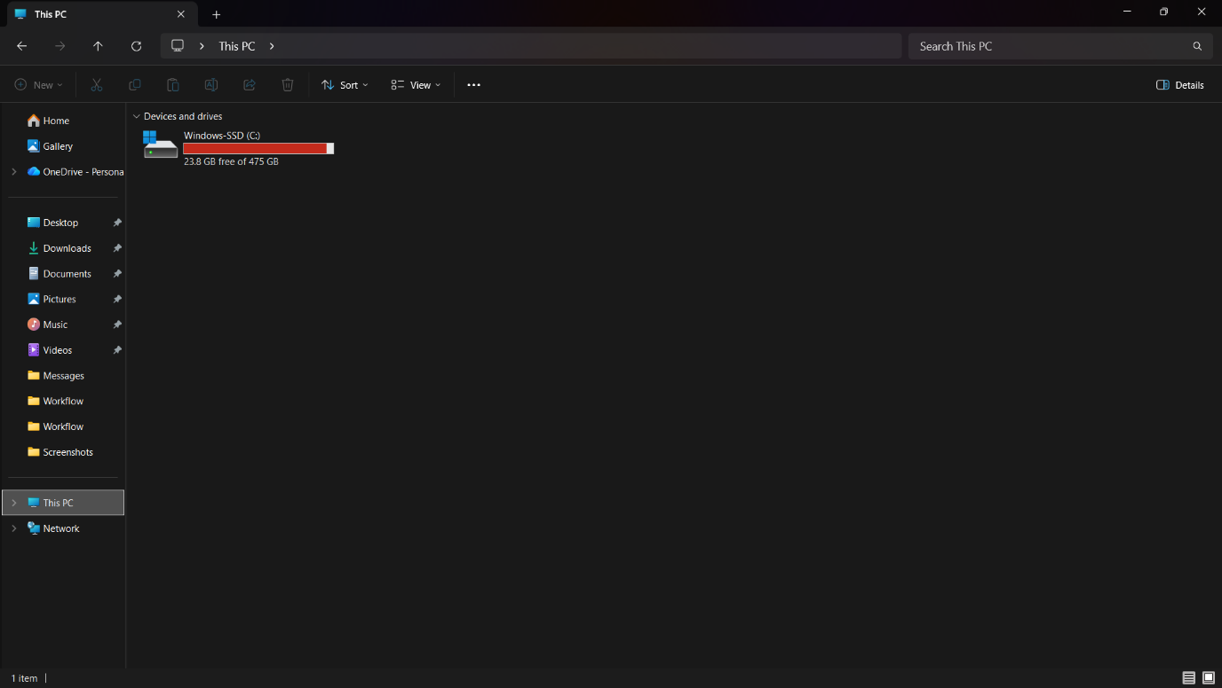

Device Management:
Device management in Microsoft Windows refers to how the system controls and interacts with hardware components such as the mouse, keyboard, printer, and graphics card. It enables communication between the operating system, applications, and physical devices through drivers. Users can manage hardware using tools like Device Manager to install, update, enable, or disable drivers. The system also allocates resources to ensure devices function efficiently without conflicts. Effective device management improves performance, maintains system stability, and reduces the risk of hardware errors or security issues during everyday computer use.
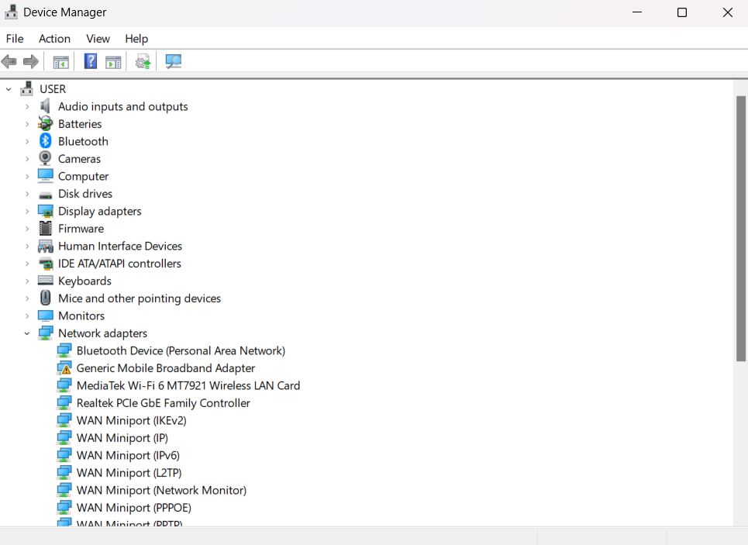

Security Management:
Security management in Microsoft Windows protects computers, data, and system resources from viruses, malware, and unauthorized access. It supports multiple user accounts with customizable access levels, controlling who can view or modify files. Users can authenticate using passwords, PINs, or biometric methods like fingerprints. Real-time protection is provided by Microsoft Defender Antivirus, while regular system updates address vulnerabilities. Tools like BitLocker encrypt drives to secure data on lost or stolen devices. Effective security management ensures data safety, prevents breaches, and maintains system stability and proper operation.
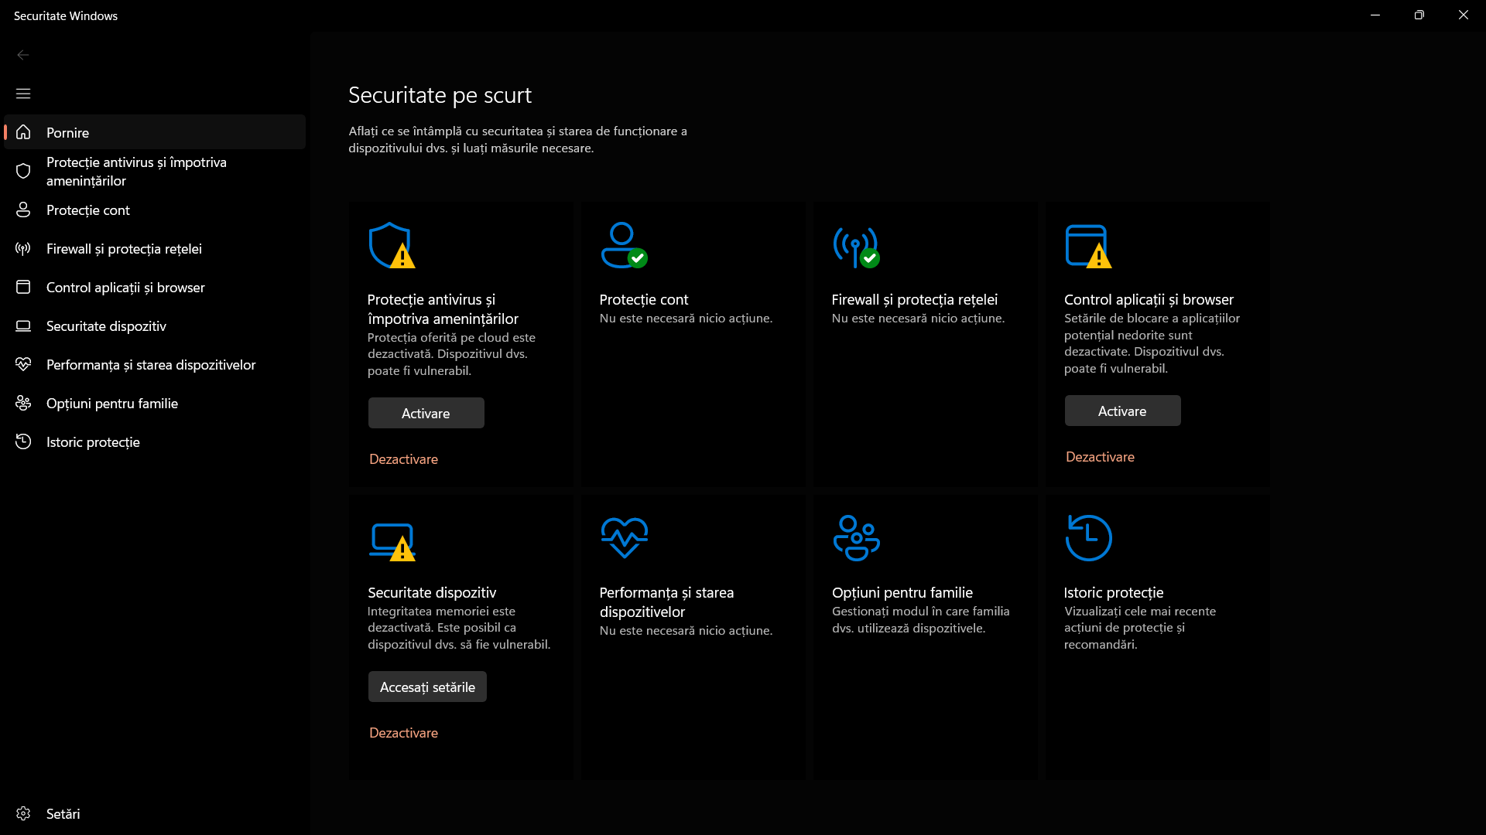

Use of Windows OS CLI commands
The Windows command-line interface (CLI) enables users to operate the system using text-based commands rather than a graphical interface. The primary CLI tool, Command Prompt, allows users to manage files, control running processes, automate repetitive tasks, and configure system settings. It provides a powerful way to perform administrative and troubleshooting tasks efficiently.

Example 1:
The dir command in Windows lists all files and folders within the current directory. It provides details such as file names, sizes, and the last modified date. Using this command allows users to quickly view the contents of a directory. In the example below, the dir command was used to display the folder structure.

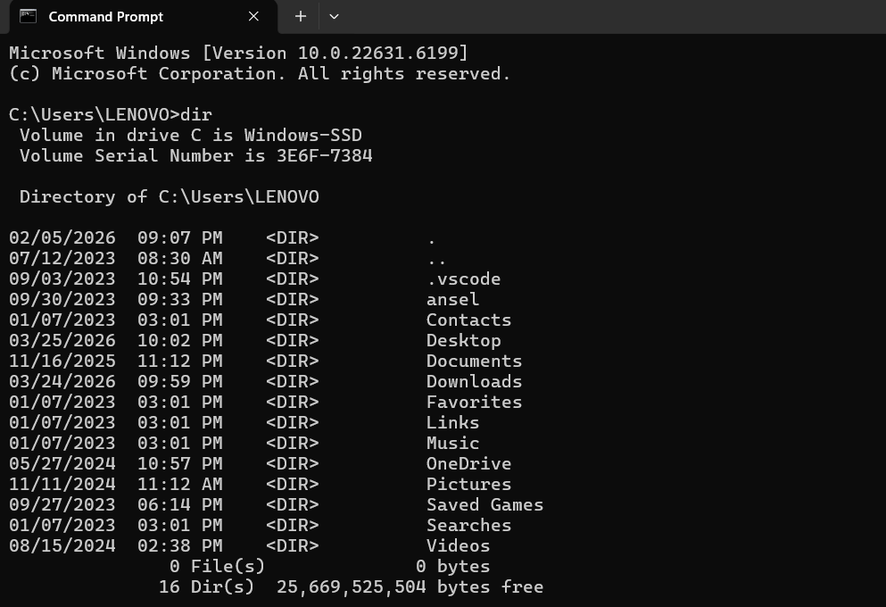

Example 2:
The cd command in Windows is used to navigate between directories. It allows users to move into a specific folder or return to a previous one using ... In the example below, the command was used to move from the "LENOVO" folder into the "Downloads", making directory navigation simple and efficient.
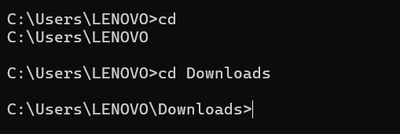

Example 3:
In Windows Command Prompt, typing .. allows users to move up one directory level. This shortcut simplifies navigation, letting users quickly return to a parent folder without retyping the full path. In the example below, the command was used to go back from the "Documents" folder to the "Users" folder, streamlining directory movement.
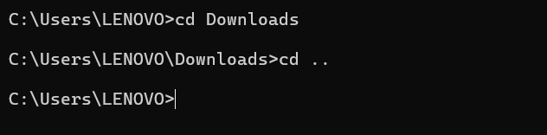

Example 4:
The mkdir command in Windows is used to create new directories. It can also create multiple folders at once with a single command. In the example below, the mkdir command was used to create a folder named “890,” providing a quick and efficient way to organize files through the command-line interface.
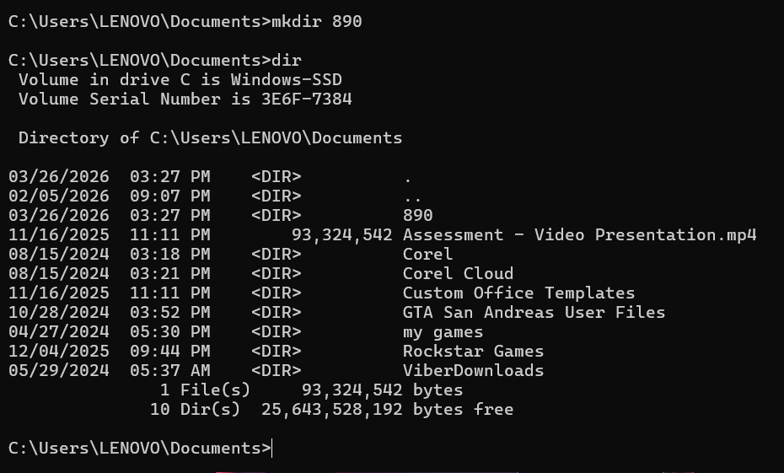

Example 5:
The command mkdir "qwe rty" lets you create a folder with spaces in its name. Using double quotation marks ensures that the entire name is treated as a single folder. Without the quotes, the space would split the command, causing an error. This allows more flexible folder naming in Windows CLI.
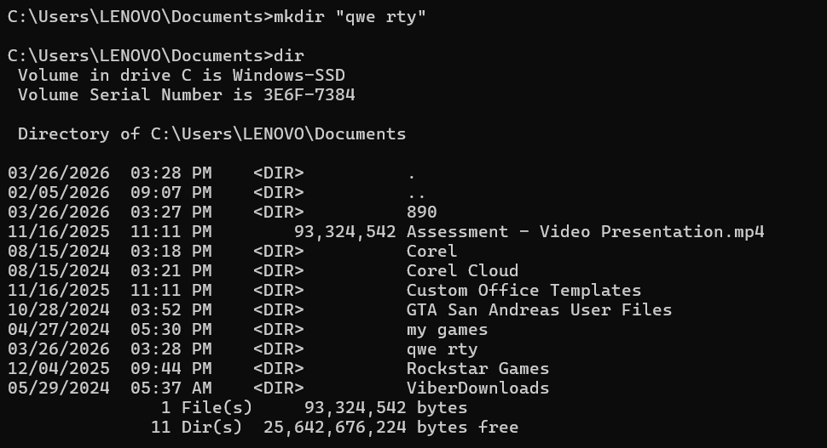

Example 6:
The rmdir command in Windows is used to delete folders from the system. It can remove single or multiple directories at once. In the example below, the command was used to delete several folders, including the previously created folder with a space in its name, “qwe rty,” efficiently clearing unwanted directories.
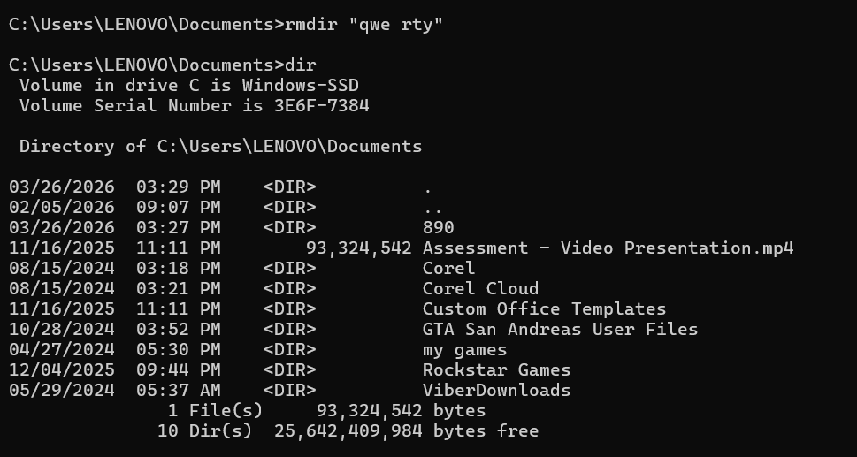

Example 7:
The echo command in Windows is used to display messages or text on the screen. It can also be used to write content into files. In the example below, the echo command was used to create a file named new.txt containing the text “this is the text,” demonstrating a simple way to generate files with content via the command line.
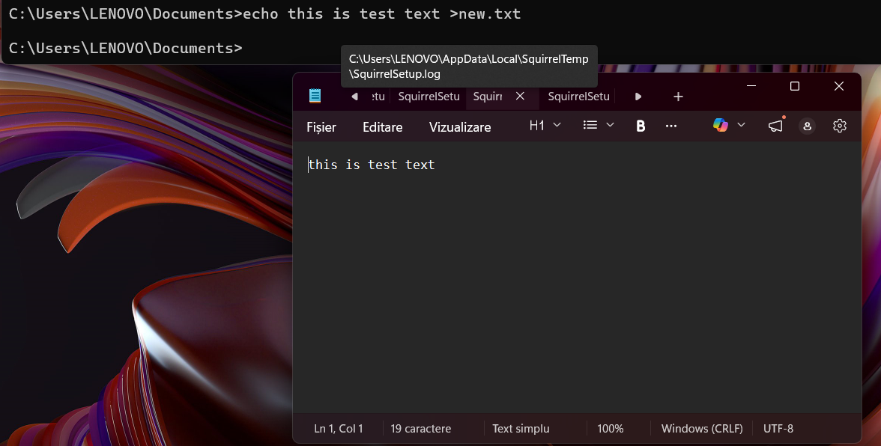

Example 8:
The tasklist command in Windows displays all currently running processes on the system. It provides details such as process names, Process IDs (PID), memory usage, and other relevant information. In the example below, the tasklist command was used to view all active processes on the laptop, helping monitor system activity and resource usage.
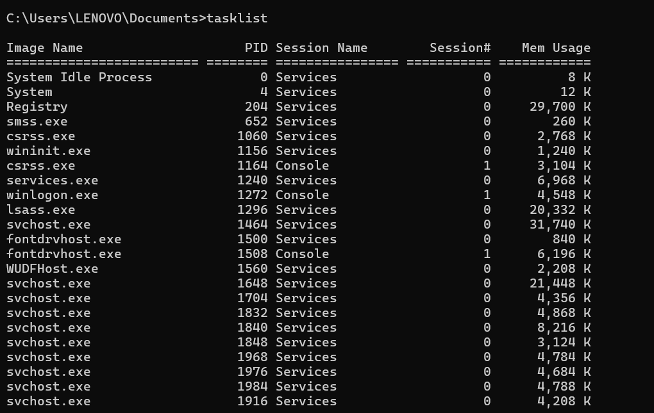

Example 9:
The systeminfo command in Windows displays detailed information about the computer, including hardware specifications, operating system version, and installed updates. It is useful for checking system configurations and planning updates or troubleshooting. In the example below, the command was used to view the specifications of the laptop, providing a comprehensive overview of the system.
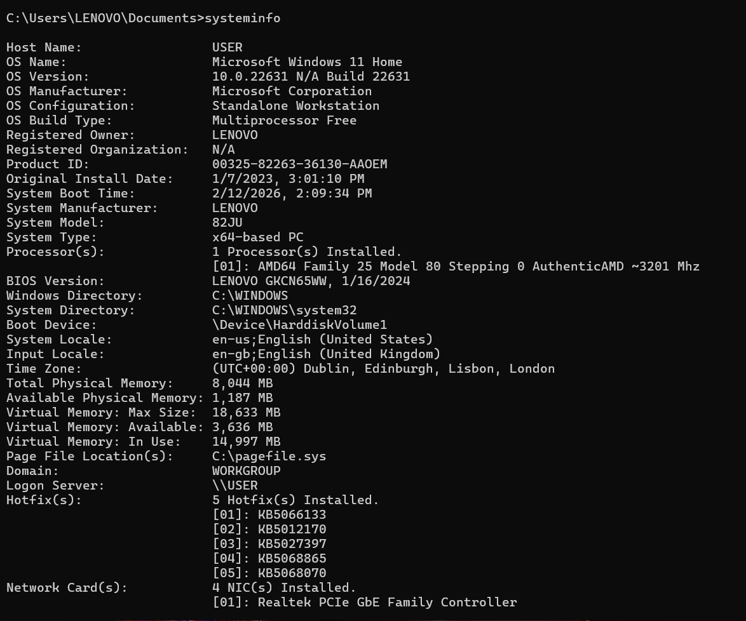

Example 10:
The ipconfig command in Windows displays and manages the IP configuration of a computer’s network adapters. It is commonly used to check network settings, troubleshoot connectivity issues, and verify network integrity. In the example below, the command was used to view the laptop’s current network configuration, helping monitor and manage network connections effectively.
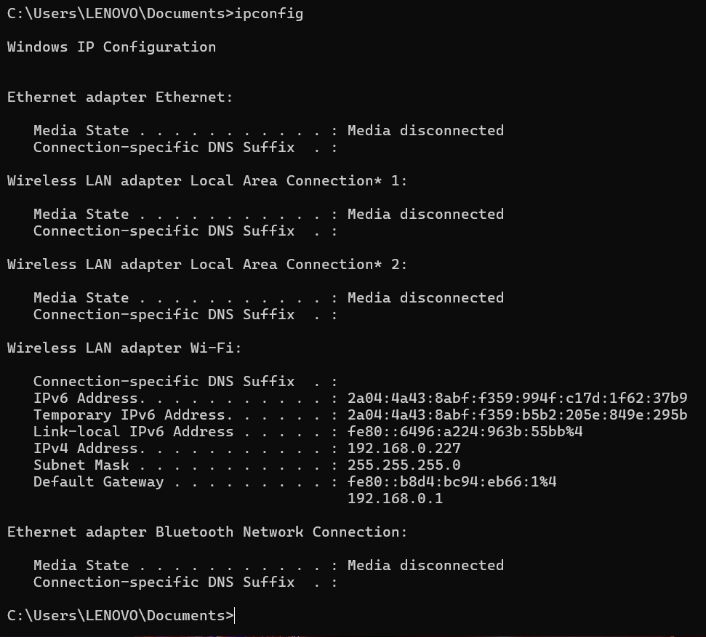

Use of Linux OS CLI commands
Linux CLI lets users control the system by typing commands. It helps manage files, run programs, check system status, and automate tasks using simple scripts like Bash. It is widely used because it is fast and flexible.

Example 1:
The ls command in Linux is used to list all files and folders within the current directory. It provides a quick way to view directory contents, and additional options can show details like permissions, sizes, and modification dates. In the example below, the ls command was used to display all files and folders in the current directory.

Example 2:
The ls -1 command in Linux lists the contents of a directory with one file or folder per line, making it easier to read long lists. In the example below, this command was used to display all files and folders in the directory clearly and in an organized manner.
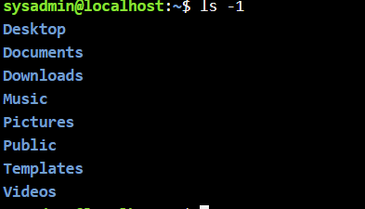

Example 3:
The cd command in Linux, similar to Windows, is used to navigate between directories. It allows users to move into specific folders or return to previous ones. In the example below, the cd command was used to navigate into the “Desktop” directory, demonstrating simple and efficient directory navigation in the Linux CLI.

Example 4:
The mkdir command in Linux is used to create a new directory. By typing a space after the command followed by the desired folder name, users can quickly generate folders. In the example below, the mkdir command was used to create a directory named “new,” demonstrating a simple way to organize files in the Linux CLI.
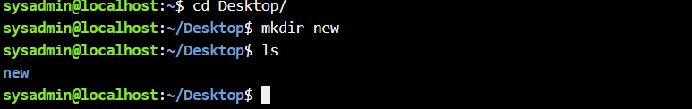

Example 5:
The rmdir command in Linux is used to remove or delete empty directories. It allows users to clean up unwanted folders from the system efficiently. In the example below, the rmdir command was used to delete the folder that was created earlier, demonstrating basic directory management in the Linux CLI.
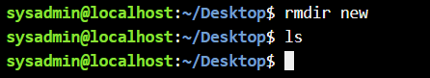

Example 6:
The touch command in Linux is used to create a new, empty file quickly. In the example below, the command was used to create a file named “new1.” After creating the file, the directory was checked to confirm that the new file had been successfully added, demonstrating basic file creation in the Linux CLI.
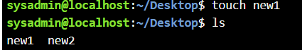

Example 7:
The echo command in Linux is used to display text on the command line and to write text into files. In the example below, the command was used to add the text “this is test” into a .txt file, demonstrating a simple way to create or modify file content directly from the CLI.

Example 8:
The cat command in Linux is used to create, view, and display the contents of files. In the example below, the command was used to display the text stored inside the file “new.txt,” allowing the user to quickly read its contents directly from the command line.

Example 9:
The ifconfig command in Linux is used to view and configure network interfaces. It provides information such as IP addresses, network masks, and interface status. In the example below, the command was used to display the network interface details of the laptop, helping monitor and manage network connections through the CLI.
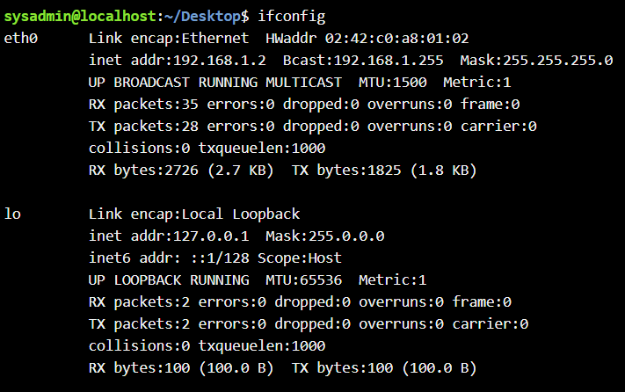

Example 10:
The command rm is used to remove not a folder but a file from the directory, in the picture below I used it to delete the file which is called new1. And later used the command ls to show that the file was successfully deleted.
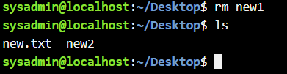

Use of Windows OS scripts
Batch scripting is a method of automating tasks in Windows Command Prompt using .bat files. It executes a sequence of commands to manage files, run programs, or perform system maintenance. Common applications include backups, software installations, and task scheduling, making repetitive tasks more efficient and error-free.

Example 1:
The example shows a simple Windows batch script that calculates the sum of two numbers provided by the user. The script begins with @echo off, which hides command execution details to make the output cleaner. The commands set /p num1=Enter the first number: and set /p num2=Enter the second number: prompt the user to input values, storing them in the variables num1 and num2 respectively. The arithmetic operation is performed with set /a sum=num1+num2, where /a instructs the system to treat the inputs as numbers and compute their sum. The result is stored in the variable sum. The command echo The sum is %sum% displays the result to the user, with %sum% retrieving the stored value. Finally, pause keeps the command prompt window open, allowing the user to see the output before the script exits. This demonstrates basic input, calculation, and output in batch scripting.
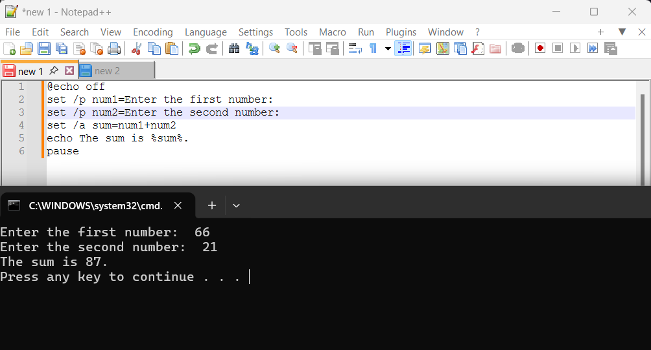

Example 2:
The example shows a Windows batch script that calculates the area of a rectangle based on user input. It begins with @echo off, which hides the commands in the command prompt to make the output cleaner. The command set /p length=Enter the length of the rectangle: prompts the user to enter the rectangle’s length and stores it in the variable length. Similarly, set /p width=Enter the width of the rectangle: requests the width and stores it in width. The arithmetic calculation is performed using set /a area=length*width, where /a allows the system to treat the inputs as numbers and multiply them, storing the result in area. The command echo The area of the rectangle is %area%. displays the calculated area to the user, with %area% retrieving the stored value. Finally, pause keeps the command prompt window open. In this example, entering 87 and 660 produced an area of 57420.
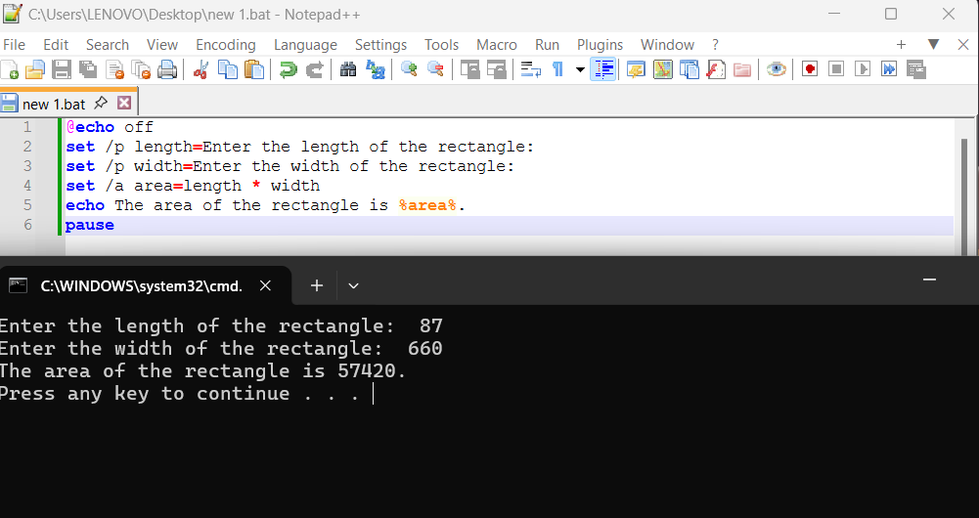

Use of Linux OS scripts
BASH scripting in Linux is a powerful tool used for automating tasks such as file management, system monitoring, and software administration. By combining commands, variables, and scripts, users can streamline repetitive tasks and improve overall efficiency. BASH is essential for system administration and server management, enabling automation of file handling, software installations, backups, and other routine operations, which reduces errors and saves time. Its flexibility makes it a critical skill for Linux users and administrators working in professional and development environments.

Example 1:
This example shows a simple Bash script created in the Linux CLI using the text editor nano. The script’s purpose is to take two numbers as input and display their sum. It begins by using echo to prompt the user to enter the first and second numbers. The read command stores these inputs in the variables num1 and num2. The script then calculates the sum using arithmetic expansion: total=$((num1+num2)), storing the result in the variable total. Finally, echo "The sum is $total" displays the result in the terminal. In the example, the script was executed with ./script.sh, and entering num1=9689 and num2=45678 produced the sum=55367. This demonstrates a basic yet fundamental Bash script for performing arithmetic operations in Linux.
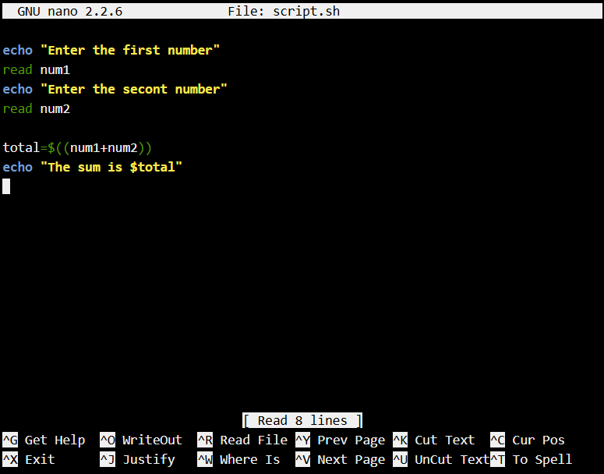
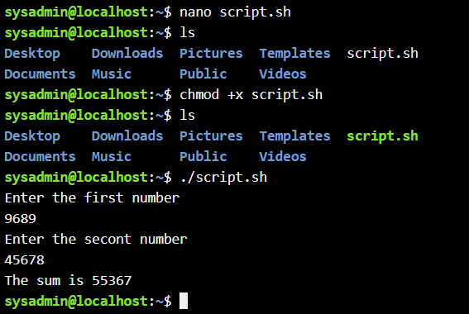

Example 2:
The second Linux CLI script demonstrates a loop to repeat a task multiple times using a for loop. The command for ((i=1; i<=10; i=i+1)) initializes the variable i at 1, continues the loop while i is less than or equal to 10, and increments i by 1 after each iteration. Inside the loop, the command echo "$i" displays the current value of i on a new line. Before running the script, chmod +x loop.sh is used to give it executable permissions. The script is executed with ./loop.sh, and as intended, it prints numbers from 1 to 10 sequentially, demonstrating how loops can automate repetitive tasks in Bash scripting.

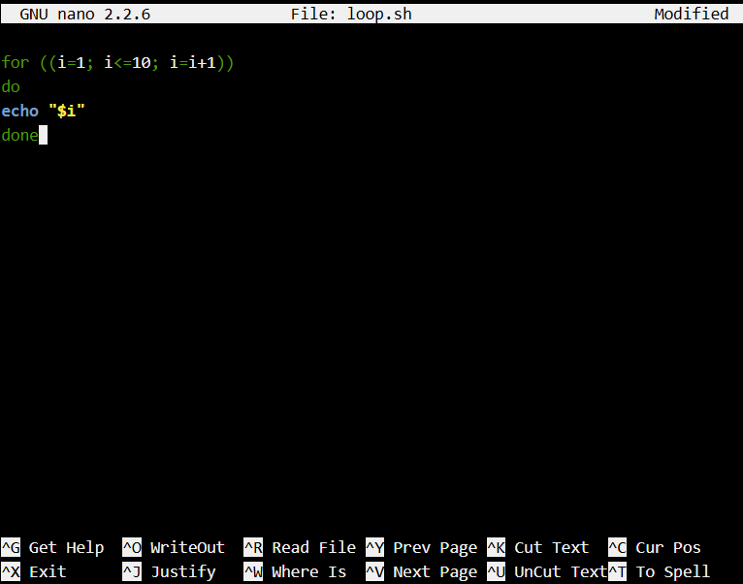
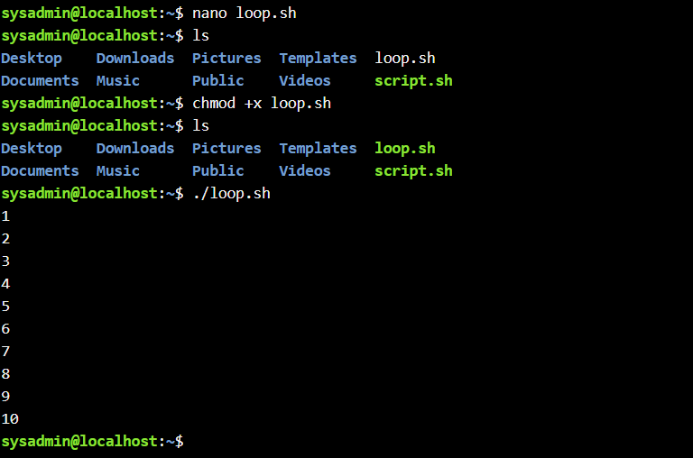

Conclusion
In conclusion, these tasks showed me what is the fundamental command-line and scripting skills in both Windows and Linux. Using commands, batch scripts, and Bash scripts, we learned to manage files, perform calculations, navigate directories, automate repetitive tasks, and monitor system activity. These exercises build a strong foundation in practical IT and system administration.

References
[1] Microsoft, “Windows Task Manager,” Microsoft Docs. [Online]. Available: https://learn.microsoft.com/
[2] Microsoft, “A brief history of Windows,” Microsoft Docs. [Online]. Available: https://learn.microsoft.com/
[3] Microsoft, “Windows Package Manager overview,” Microsoft Learn. [Online]. Available: Windows Package Manager
[4] Microsoft, “File systems in Windows,” Microsoft Learn. [Online]. Available: https://learn.microsoft.com/
[5] Microsoft, “Device Manager in Windows,” Microsoft Learn. [Online]. Available: https://learn.microsoft.com/
[6] A. Silberschatz, P. B. Galvin, and G. Gagne, Operating System Concepts, 10th ed. Wiley, 2018.
[7] Microsoft, “Create a batch file,” Microsoft Learn. [Online]. Available: https://learn.microsoft.com/en-us/windows-server/administration/windows-commands/batch-files
[8] C. Negus and D. Bresnahan, Linux Bible, 10th ed., Hoboken, NJ, USA: Wiley, 2019.
[9] GNU Project, “Bash Reference Manual,” GNU, 2024.

Appendices
Online Course name:

Figure 34: Certificate of completion

