Connor Daniel
Gower College Swansea

Digital Signal and processing

Table of Contents
Task 1 2
Task 2 2
a) Read the provided TMPRS .wav file. 2
b) Determine the frequencies of the tones. 3
c) Design a filter to remove the cause of the unpleasant sound. 4
d) Retaining clean version of tone contain only two frequencies. 5
e) Provide a new version of the uncorrupted TMPRS. 6
Task 3 7
Task A 7
Task B 8
Task 4 10
a) Compute the impulse response of the low pass function: 10
b) Compute the output low pass filter 11
c) Compute the impulse response of the high pass function 14
d) Compute the output high pass filter 15

Task 1
Time division multiple access (TDMA) is a digital modulation technique that is used in most 2G cellular systems. It allows multiple people to use the same frequency splitting each cellular channel in to different time slots. This means a single frequency can simultaneously support multiple data channels. (Awati, 2021)

Wideband Code Division Multiple Access (WCDMA) is a 3G type of cellular technology. It uses a wider frequency band, provides a higher date rate and better capacity than the previous 2G cellular technology. There are two modes of WCDMA which are:
- Frequency Division Duplex (FDD) this mode separates the users by using codes and frequencies. FDD uses one frequency for the uplink and another for the downlink.
- Time Division Duplex (TDD) this mode separates the users by the use of codes, frequencies and time. The same frequency is used for both the uplink and the downlink. (Rouse, 2012)

Due to the increase of demand of increased capacity of in mobile networks cellular technology has had to improve from previous 2G and 3G versions. Therefore we now have 5G which works in the same way as 3G however its uses higher radio frequencies which are less clustered, this means it can carry a higher capacity at a quicker rate. 5G is also able to split the physical network in to several virtual networks which can deliver the best network suited to whatever the user capacity demand is. For example, a user watching a video would use a smaller data capacity compared to a business running a large program. 5G does have interference issues when it needs to send data over a large distance, this is being overcome by using antennae to boost signals. (TWI, n.d.)

The process of frequency reuse involves using the same radio frequency on transmitter sites that are separated by an adequate distance that causes the least amount of interference. This has a significant increase on capacity as it allows users to operate on the same frequency. (Harte, n.d.)

Task 2

Read the provided TMPRS .wav file.
clear
clc

%step 1

newfilename = 'filtered.wav'; %uncorrupted filtereed wave file
d = 4.0; %waiting time in s

[s,fs]=audioread('wav_Connor.wav'); %original wave from rabya
fs %display
t = (0:length(s)-1)/fs; %s in the number of samples, fs is the sample frequency

figure(1)
plot(t,s,'b')
xlabel('Time(s)')
ylabel('Signal Value(v)')
title('Corrupted signal')

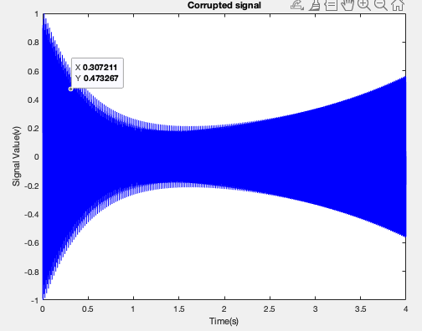

Determine the frequencies of the tones.
figure(2)
n = 5000; %plot a part of the corrupted signal
plot(t(1:n),s(1:n))
xlabel('Time(s)')
ylabel('s[n]')

%step two

%This process is due changed the sound from the time domain to the
%frequency domain, allowing me to filter the sounds I dont want

sound(s, fs); %generate sound

pause(d + 0.5); %waiting for sound end

FF = fft(s); % fouriers

L=length(s);
ff2=abs(FF/L);
ff1= ff2(1:L/2+1);
k= fs*(0:(L/2))/L; %sampling frequency multiplied by

figure(3)
%plot (K,ff1)
plot(k(1:15000),ff1(1:15000), 'r')
grid
xlabel('Frequency (F)')
ylabel('Magnitude')
title ('FFT of the signal')
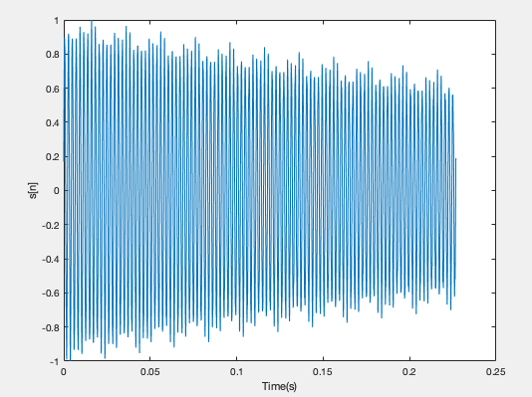

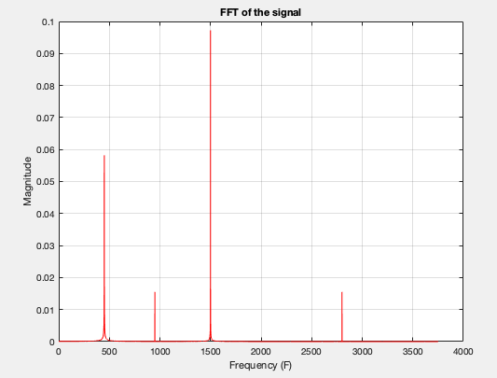

Design a filter to remove the cause of the unpleasant sound.

%step 3

%eliminate the first frequency from the signal f1 (first spike on freq
%graph

LCF1 = 300/(fs/2); % low cutoff frequency , xxx is the low value for filter
HCF1 = 600/(fs/2); %high cutoff frequency , yyy is the high value of the filter
fiord1 = 500; % order of FIR bandstop filter. (The high the order the smoother the filter
filtercoeff1 =fir1(fiord1, [LCF1, HCF1], 'stop');% returns the filter coefficients in length ORD1+1 vector filtercoeffl

voice1= filter(filtercoeff1,1,s); % generate a new voice after removing f1
sound(voice1,fs);%this will display new filtered sound

%step 4
pause(d+0.5);
%eliminate the third frequency from the signal f3 (third spike on freq
%graph

LCF2 = 1300/(fs/2); % low cutoff frequency , zzz is the low value for filter
HCF2 = 1700/(fs/2); %high cutoff frequency , vvv is the high value of the filter
fiord2 = 500; % order of FIR bandstop filter. (The high the order the smoother the filter
filtercoeff2 =fir1(fiord2, [LCF2, HCF2], 'stop');% returns the filter coefficients in length ORD1+1 vector filtcoeffl

voice2= filter(filtercoeff2,1,voice1); % generate a new voice after removing f3
sound(voice2,fs);% this will display new filtered sound

Retaining clean version of tone contain only two frequencies.

figure(4)%final uncorrupted time domain sound
plot(t(1000:length(t)-1), voice2 (1000:length(t)-1), 'r')

grid
xlabel('Time (s)')
ylabel('signal value (v)')
title('A Plot of the new voice')

figure(5)% final uncorrupted frequency domain sound

pause(d+0.5);%waiting for sound end

L1= length(voice2);
magnitude1 =abs(fft(voice2));
k2= fs*((0:(L1-1))/L);
plot(k2(1:15000), magnitude1(1:15000), 'r')
grid
xlabel('frequency(Hz)')
ylabel('magnitude')
title ('FFT of the newVoice')
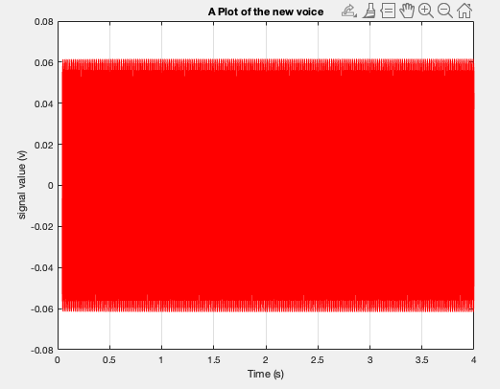

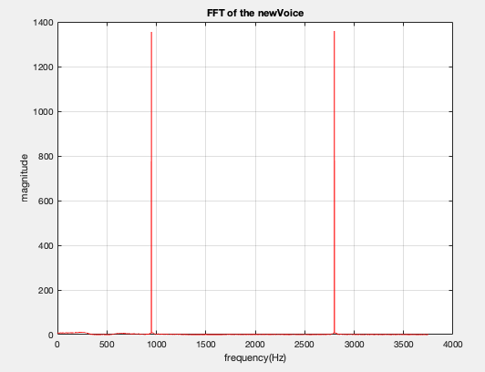

Provide a new version of the uncorrupted TMPRS.
%Save wav file to disk

audiowrite(newfilename, voice2, fs);

Task 3

Task A
%generate the input signal
R = 101;
noise = 2.0*(rand(R,1)-0.5);
n = 0:R-1;
Sa = 3*n.*(0.9.^n);
Sx = Sa + noise';

%Implementation of the moving average filter
M = input('Desired length of filter 1 = ');
num = ones(1,M); %Variable M (lowpass filter)
y1 = filter(num,1,Sx)/M;

M1 = input('Desired length of filter 2 = ');
num = ones(1,M1); %Variable M (lowpass filter)
y2 = filter(num,1,Sx)/M1;

M2 = input('Desired length of filter 3 = ');
num = ones(1,M2); %Variable M (lowpass filter)
y3 = filter(num,1,Sx)/M2;

%plotting Sx
subplot(2,2,1);
plot(n,Sx);
xlabel('time index');
ylabel('amplitude');
title('Sx');

%plotting M
subplot(2,2,2);
plot(n,y1);
xlabel('time index');
ylabel('amplitude');
title('y1');

%plotting Sx
subplot(2,2,3);
plot(n,y2);
xlabel('time index');
ylabel('amplitude');
title('y2');

%plotting Sx
subplot(2,2,4);
plot(n,y3);
xlabel('time index');
ylabel('amplitude');
title('y3');
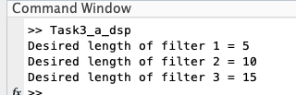

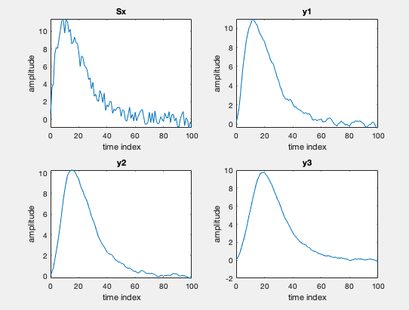
As you can see the higher the length of the filter the smoother the outcome.

Task B
%simulation for an M-point moving average filter

%generate the input signal
n = 0:100;
Sa = cos(2*pi*0.05*n);
Sb = cos(2*pi*0.47*n);
Sx = Sa + Sb;

%Implementation of the moving average filter
M = input('Desired length of the filter = ');

%y=filter(num,1,x);
num = ones(1,M); %Variable M (lowpass filter)
lowpass = filter(num,1,Sx)/M;

hp = (-1).^(0:M-1); %Variable M (High pass filter)
highpass = filter(hp,1,Sx)/M;

%plotting Sa
subplot(3,2,1);
plot(n,Sa);
xlabel('time index');
ylabel('amplitude');
title('Sa');

%plotting Sb
subplot(3,2,2);
plot(n,Sb);
xlabel('time index');
ylabel('amplitude');
title('Sb');

%plotting Sx
subplot(3,2,3);
plot(n,Sx);
xlabel('time index');
ylabel('amplitude');
title('Sx');

%plotting lowpass
subplot(3,2,4);
plot(n,lowpass);
xlabel('time index');
ylabel('amplitude');
title('lowpass');

%plotting highpass
subplot(3,2,5);
plot(n,highpass);
xlabel('time index');
ylabel('amplitude');
title('highpass');
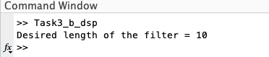

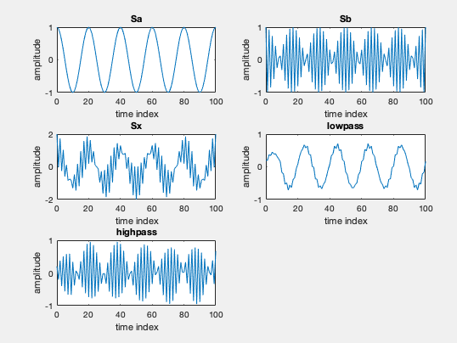

Task 4
Low frequency signal given by:
x=[-0.001 -0.0045 -0.01 -0.0042 0.002 0.005 0.006 0.007 0.004 -0.001 -0.005 -0.009 -0.01 -0.001 0.005 0.004 -0.001 0.005 0.004 -0.002 0.007 0.008 -0.004 -0.005 -0.012 -0.007 -0.005 -0.001];

Compute the impulse response of the low pass function:
y[n] = 3.6y[n–1]+5.0y[n–2]–3.2y[n–3]+.82y[n–4] +.013x[n]–.032x[n–1]+.044x[n–2]–.033x[n–3] +.013x[n–4]

%program impulse response
%Compute the impulse response of the following function
%y[n] = 3.6y[n-1] + 5y[n-2] - 3.2y[n-3] + 0.82y[n-4]
% +0.13x[n] - 0.32[n-1] +0.044x[n-2] - 0.033x[n-3] +0.13x[n-4]

clf;
N = 7;
num = [0.013 -0.32 0.044 -0.033 0.013];
den = [1 -3.6 -5 3.2 -0.82];
h = impz(num,den,N);

%Plot the impulse response
hold on
stem(h,'r');
h
xlabel('Time impulse');
ylabel('Amplitude');
title('Impulse response');
grid;

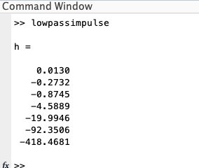

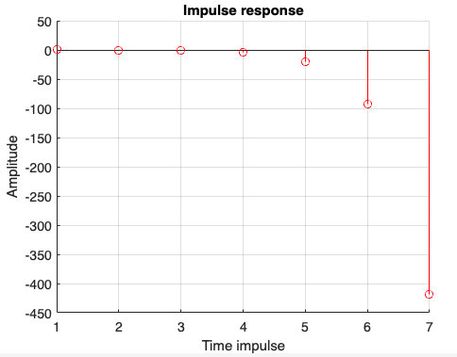

Compute the output low pass filter

%Compute low pass filter
h = [0.013 -0.273 -0.874 -4.5889 -19.994 -92.3506 -418.4681];
x1 = [-0.001 -0.0045 -0.01 -0.0042 0.002 0.005 0.006 0.007 0.004 -0.001 -0.005 -0.009 -0.01 -0.001 0.005 0.004];
x2 = [-0.001 0.005 0.004 -0.002 0.007 0.008 -0.004 -0.005 -0.012 -0.007 -0.005 -0.001];
x = [x1 x2];
y1 = conv(x,h);

%Plot the impulse response
figure(1)
stem(x,'b');
xlabel('Time index n');
ylabel('x[n]');

figure(2)
stem(y1,'g');
y1
xlabel('Time index x');
ylabel('y[n]');
title('lowpass output');
grid;

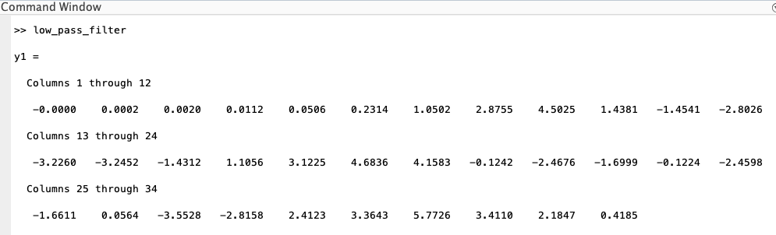

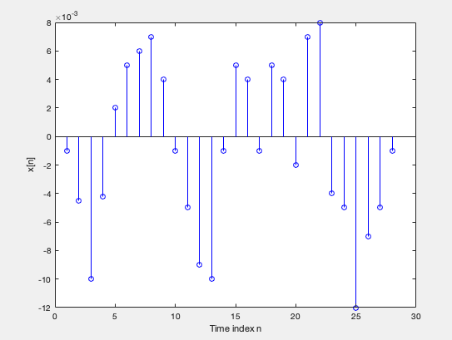

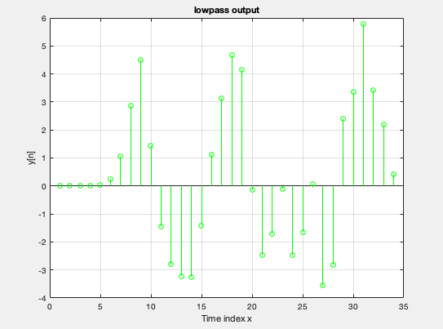

Compute the impulse response of the high pass function
y[n] = 2.7y[n–1]–3.3y[n–2]+2.0y[n–3]–.57y[n–4] +.35x[n]–1.3x[n-1]+2.0x[n–2]–1.3x[n–3] +.35x[n–4]

%Compute impulse response of the high pass filter
%Compute the impulse response of the following funtion
%y[n] = 2.7y[n-1] .......

clf;
N = 7;
num = [0.35 -1.3 2 -1.3 0.35];
den = [1 -2.7 3.3 -2 0.057];
h = impz(num,den,N);

%Plot the impulse resonse
hold on
stem(h,'r');
h
xlabel('Time index n');
ylabel('Amplitude');
title('Impulse response');
grid;

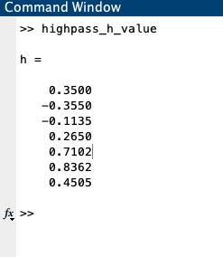

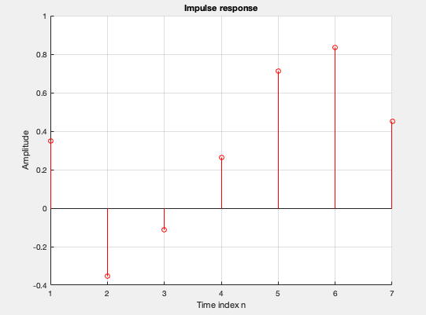

Compute the output high pass filter

%Compute high pass filter

clf;
h = [0.35 -0.0355 -0.1135 0.265 0.7102 0.8362 0.4505];
x1 = [-0.001 -0.0045 -0.01 -0.0042 0.002 0.005 0.006 0.007 0.004 -0.001 -0.005 -0.009 -0.01 -0.001 0.005 0.004];
x2 = [-0.001 0.005 0.004 -0.002 0.007 0.008 -0.004 -0.005 -0.012 -0.007 -0.005 -0.001];
x = [x1 x2];
y1 = conv(x,h);

%Plot the impulse response
figure(1)
stem(x,'r');
xlabel('Time index n');
ylabel('x[n]');

figure(2)
stem(y1,'g');
y1
xlabel('Time index n');
ylabel('y[n]');
title('high pass output');
grid;

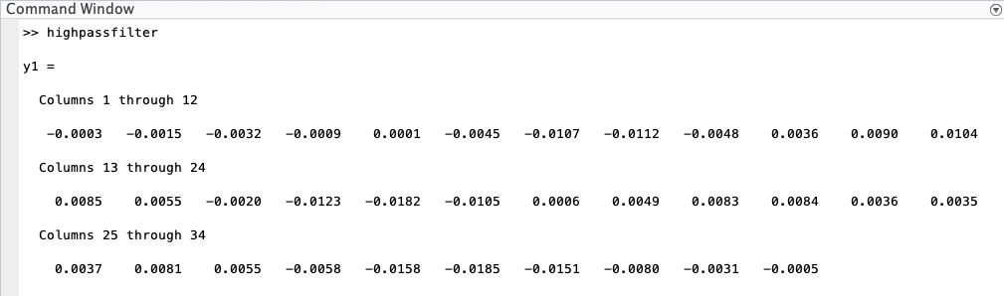

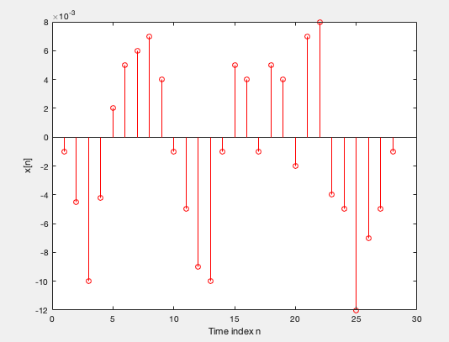

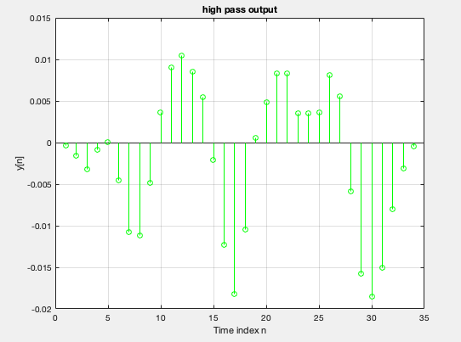

References
Awati, R. (2021, June). Time Division Multiple Access (TDMA). Retrieved from TechTarget: https://www.techtarget.com/searchnetworking/definition/TDMA#:~:text=Time%20Division%20Multiple%20Access%20(TDMA)%20is%20a%20digital%20modulation%20technique,division%20multiple%20access%20(FDMA).
Harte, L. (n.d.). Introduction to Code Division Multiple Access (CDMA): Network, Services, Technologies, and Operation. Retrieved from GlobalSpec: https://www.globalspec.com/reference/66041/203279/frequency-reuse
Rouse, M. (2012, October 21). Wideband Code Division Multiple Access. Retrieved from Techopedia: https://www.techopedia.com/definition/24282/wideband-code-division-multiple-access-wcdma
TWI. (n.d.). WHAT IS 5G TECHNOLOGY AND HOW DOES IT WORK? Retrieved from TWI: https://www.twi-global.com/technical-knowledge/faqs/what-is-5g#HowDoes5GWork

