PHYSICAL THEATRE A DEVISING PROJECT

My understanding of Physical Theatre is that the body through movement is implying and alluring to communicate the narrative, character and meaning of the work, with and without text and that the concepts can be suggestive leaving the audience to experience and emotionally respond.

This is my account of the process of devising a six-week Physical Theatre project, and creating with Niamh Provan the work titled 'ARCHETYPICAL.'
Primarily I have engaged in a physical fitness regime within studio time and I also have maintained this at home. This is an essential discipline within the realms of theatre making, giving the body the potential to expand its repertoire of movement and allows for a more dynamic approach to techniques.
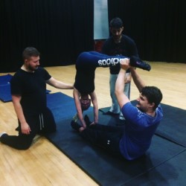
This regime led to the ability to perform headstands and handstands within the performance and to have the dexterity to perform other tasks in this piece. And then comes movement and its quality.
The body is the vehicle and communicator that we wish to convey, through performance, and it does not lie. This is what is chiefly read by an audience.
An indispensable part of my training was the technique of Authentic Movement. An exercise we undertook was that of the Mover and the Witness.
The Mover begins with eyes closed "in order to facilitate a deeper listenin g to (the) kinaesthetic reality" (Adler 20). The task of the Mover is to receptively follo w the pathway of sensory / kinaesthetic impulses. These sometimes lead to large expansive moveme nts but, just as often, they may be so subtle as to be externally invisible. Conscious awaren ess (the inner Witness) acknowledges and tracks the experience without attempting to lead into any predetermined direction (Brook's "flowing static"). The person in the midst of this "flow experience" is "both keenly aware of his or her actions and oblivious to that aw areness itself" (Dreyfuss 66). (Kol Tai, J. 1994)

I found whilst participating in this exercise for the first time that I blocked my impulses and was concerned that this urge was a mental concoction. This exercise led into an improv exercise with eyes closed responding to our urges. This was a key moment in connecting to my body and its inner life, it was rich with shape and emotional content. This developed into an improv with eyes open, where I was less aware of myself, and then with text, where I lost total contact with these sensations and it became theatrical, playing to an audience and the text actually initiated the movement. I found that each step took me further away from connecting to myself and that this exercise has been a valuable lesson in understanding the presence of being, required in performing physical theatre. Throughout my exploration and rehearsals this has been a guiding principle. I have found it challenging to embody this connection of integrity in physical movement and I believe it is an advanced state of practice and performance. This is my aim as a performer and it is what slipped in the final performance.

Similarly, Jacques Lecoq uses the method of Neutral Mask in his training, and it is my understanding that behind the mask you become aware and primal within your own physical movement and also of the spatial aspect around you. It is an honest connection to oneself and fundamental to physical expression as a performer.

‘Essentially, the neutral mask opens up the actor to the space around him. It puts him in a state of discovery, of openness, of freedom to receive. It allows him to watch, to hear, to feel, to touch elementary things with the freshness of beginnings. You take on the neutral mask as you might take on a character, with the difference that here there is no character, only a neutral generic being.’ (Jacques Lecoq. 2002)
This practice generates availability and provides the stability of quality performance.

The content and context of ‘Archetypical’ has sprung from physical theatre training (Thania Acaron) in the studio using exercises in Laban notation (the language referring to movement shape) and using Action Drives (Laban. 2011) to produce phrases of movement and to promote intention and variation of voice and movement quality, this influenced our movement work and character development. We also used abstraction techniques to deconstruct our concepts, and used improv and devising. As well as researching key practices; Meyerhold, Jacque Lecoq and Commedia dell Arte.

At the beginning of this project I was reading a book by Sarah Pascoe, titled Animal. This is her account of the female body and its function and history in society. Initially this book gave me the inspiration to work on the topic of women and develop work reflecting on body image and how women are objectified. This in turn presented the idea of four archetypes of women, The Witch, The Whore, The Martyr and The Saint. This became the substantial weight that held our piece together. We developed this using thought showers and the use of abstraction in our work. Whilst investigating the qualities of these four archetypes, the theme of duality arose as we perceived each archetype to have positive and negative aspects. We began to use this as our lens and filter for this work. This in turn led to using the lens also of the contemporary representation of characters and the nature of how women are objectified in modern society, and to use the filter of farcical exaggeration.

Thought shower 1

Thought shower 2

Thought shower 3

Thought shower 4

Finding a topic and style of theatrical performance has been key to the investment of this process. I am drawn to the grotesque as a performer and the use of physicality in an abstract manner.
I consider ‘Archetypical’ to be a physical comedy in part, it pertains to the absurd and the surreal. The development of this work has established itself around the concepts of feminism.

Here is an overview of the core scenes and its process into final manifestation;

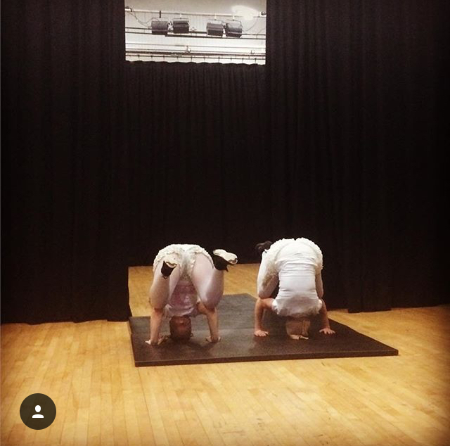

1. (Moody,J.)
Opening scene;
The physical aspect initiates with a duo performing headstands in large frilly knickers and a conversation addressing the need to cross your legs in public, and to present yourself in a ladylike manner. This has been an ongoing issue throughout history, the control of women’s behaviour in society.
We desired to communicate the headstand as it was a newly acquired skill and the shape was interesting for an audience to behold and it drew your attention to the crotch. This reflects back to the Whore archetype of being sexualised, even as you sit. Originally, we used a gibberish sound gesture to communicate with each other inspired by working with ‘The Viewpoints Book,’ which introduced us to vocal viewpoints of pitch, dynamic, tempo, acceleration/deceleration, timbre and silence. We used the exercises in chapter 9, Starting to speak, to develop our sound quality. Although the gibberish sound gestures we created did not read and this was edited to speech. Throughout this work I have been challenged, in securing the texture and pitch variation of voice and character, and embodying this consistently.
This scene proceeded into an even more absurd scene of stripping wax strips covered in hair from our body in the style of jazzy strippers. I feel this opening scene juxtaposes qualities of behaviour, and from there it moves onto a more serious, yet still comical note with a neutral retelling of the song lyrics Bitch by Meredith Brooks. I believe this scene to be burlesque comedy. This is embracing our lens of duality and farcical.
‘Burlesque is a random combination of radically different elements in the same act’
‘There’s a joyful exuberance in pulling elements out of their traditional context and mixing them all together-just for the fun of it. On one level, its alarmingly meaningless but on the other, these hybrid combinations pose awkward and disturbing questions.’ (John Wright. 2006)

Core scene 2. ‘Open House’ and 4. ‘The Auction’, are similar in concept.

2. (Moody,J.)
The Whore archetype that we thought showered, brought to mind words like property, ownership and sale. This became a strong element of both these scenes. Through the exploration of improvisation and using Niamh’s body to represent a house and its various rooms, we used the techniques of abstraction and free association that we were familiarised with in the workshops, to create a house sale. The objective of these scenes was to represent how women’s bodies are objectified and that through marriage and in many cultures a woman is owned by the father, and husband. This work created strong physical images and through development of improvised text exaggerated these concepts and used parody. In distorting this concept, we became very aware that it is a thin line not to actually become the perpetuators of sexualisation yourself.

‘In parody, your job is to make us think and laugh-at the same time. Meaning is never very far away in parody, but it falls apart as soon as we lose sight of what we are really saying’ (John Wright.2006)

This scene ends with myself approaching the audience informing them that they can own this property. I have tried to deliver the Open House scene with parody and then implement the stark contrast of the reality of what this scene truly represents.
In the final showing of this scene I feel I came across too heavy and the laughter could not free itself from the audience although they did see the humour. In the future, this will need a quality of lightness. The character I performed was edited from a male Harlequin (commedia deli arte) type character with free flow and taking up a large kinesphere, to a female character with smaller kinesphere and the trajectory, adopted the effort quality of Glide. (Laban. 2008) This changed in order to use the male voice quality in the Tent scene to allow for an opposing quality to the female tent models voice.
My part in the Auction was to have my body parts sold individually. The phrase of movement was slowed to the pace of a moving circular display, using the use of moving image shapes to convey the catalogue of artefacts on sale. This was a very sustained and bound movement (Laban. 2008) and contributed a strong visual moving image to the retold improvised text.
https://youtu.be/AResg7qJhuw
Exploration of The Whole Truth
[gallery ids="37,41" type="rectangular"]

3. (Moody, J.)
The Whole Truth
We endeavoured to make the scenes seamless with transitions and not conclude but roll the journey of the audience into the bizarre smoothly. The transition into Core scene 3 ‘Tent’, was a physical deconstruction of the word Hole that again came from the Whore archetype thought shower, representing and resembling the vagina. This was called the Whole Truth and we used abstraction and deconstruction techniques, to create alluring images of birthing and the passage of childhood.
This transitioned into using the physical gesture of body shaping around myself and audience members as a symbolic movement of our individual body shapes. This could be considered as pantomime according to Jacques Lecoq.

‘In pantomime, gestures replace words.’
’It requires an ability to draw objects and images in space, to come up with symbolic attitudes’ (Jacques Lecoq 2002).
‘My understanding is that all movement must be drawn from intention and attitude.

[gallery ids="40,42" type="rectangular"]
4.(Moody, J.)
Core scene 3 ‘The Tent; Shapeless’
This scene had its inception from the Saint archetype with the mood initially being shapeless from the garments they may wear. We spent a long time developing improvisations for this scene, and it was a strong lesson in working with a partner to be playful and accepting of the words offered. This scene was set in the context of a fashion show and an interview with the model. Again, the aim was to provoke a reaction by showing the need for women to protect themselves from others objectifying their bodies. This was delivered as an advancement for mankind. My host character used angular shapes in a predominantly vertical plane. (Laban.2008) Again, this movement quality was slightly lost through lack of connection in the performance.
https://youtu.be/LLs1PMEQ31E

Explorations of Prayer.

Core scene 5
‘Prayer.’
This scene manifested through the archetypes of Saint and Martyr. The process of abstraction in the quality of movement conjured a phrase of movement that was self flagellating. The use of tights over our heads lent to this. We used text that was in a contemporary context, that of praying to hashtags and we practiced the use of voice rhythm and timbre to match that of a chant. Throughout this project, sequence movement has been a struggle due to my working memory and processing skills. I feel that in a professional environment this could hinder me, as Niamh had great patience in repeating the structure and holding the space. In respect to this I will need to heighten my awareness of body rhythm.

Core scene 6.
‘The Inquisition.’
Final scene.
The Witch archetype, inspired the use of The National Theatres teachings of the Witch, from Commedia dell arte; this inspired our witch character carving the space in large kinesphere.

https://www.youtube.com/watch?v=h_0TAXWt8hY&list=PLFB7C0BBCDCE9B8A9

(National Theatre.2011)
The connection to the inquisition which was initiated from the thought shower, instigated the lyrics from the song Burning times by Christy Moore.

‘There were those who came to power, through domination
They were bonded by their worship of a dead man on a cross
They sought to control the common people
By demanding an allegiance to the church of Rome
And the Pope he commanded an inquisition
It was a war against the women whose power was their fear
In this holocaust in this age of evil
Nine million European women died
And the tale is told of those who by the hundreds
Holding hands together chose their deaths in the sea
Whilst chanting the names of the Mother Goddess a refusal of betrayal
Women were dying to be free’ (Christy Moore.2005)

This lead to the idea of a trial. We brought female audience members forward creating a gender division and a trial was held. Again, the questioning was through the contemporary lens, asking questions such as are you on your moon cycle? In response to questioning I used the Seven Levels of Tension from Jacques Lecoq teachings that we exercised in the studio by responding on the scale of curious, suspense, passionate and tragic, up until the point where I was drowned. This was represented by a handstand and the Burning Times text spoken upside down. Here I feel I captured the voice timbre intended and this captured the sober element of the intention of the whole piece.

Throughout the process I found I can naturally sink into my default movements. I felt very disappointed after the performance, as the day before in dress rehearsal I reached a place of connection and presence and it is to this that I will endeavour to realise, and to own my work and sell it to an audience. It was the difference between being a sharp knife that cut through reality and created a world in that moment, to being a mundane butter knife, where the room and my mind appeared simultaneously, losing the clarity of presence.
Although I was not always economical with my body movements and voice texture and solid with my characters, giving these aspects the space and rhythm I’d built upon, the state of presence as a performer will be my continuing practice of improvement. I believe that from a place of neutrality, breath and observation of myself my performance quality will improve.
The significance of where I feel I have failed has led to the recognition of principles that will continue my advancement.
I believe that ‘Archetypical’ is a strong piece of theatre and it has even more potential with further refinement of physicality and presence.

Reference
Adrian, B. (2008) Actor training the Laban Way. New York: Allworth Press.
Bogart, A. and Landau, T. (2005) The Viewpoints Book. New York: Theatre Communications Group, Inc. p112
Brooks, M. (1997) Bitch, Blurring the Edges: Capitol.
Kol Tai, J. (1994) Authentic movement the embodied experience of text, Canadian Theatre Review. (78) p22

Lecoq, J. (2002) The Moving Body. Revised Edition. London: Methuen. p38
Lecoq, J. (2002) The Moving Body. Revised Edition. London: Methuen. p107
Moody, J. (2017) Photo 1
Moody, J. (2017) Photo 2.
Moody, J. (2017) Photo 3
Moody, J. (2017) Photo 4
Moore C. (2005) Burning Times. Sony.
National Theatre. (2011) Youtube Video available from: Video:https://youtu.be/h_0TAXWt8hY
Pascoe, S. (2016) Animal. The Autobiography of a Female Body. London: Faber and Faber Limited.

Wright, J. (2006) Why is that so funny. London: Nick Hern Books Limited. p288
Wright, J. (2006) Why is that so funny. London: Nick Hern Books Limited. p253

