BA Business Management

UNIVERSITY OF WALES: TRINITY SAINT DAVID

MARKETING FUNDAMENTALS

Analysis and Evaluation
LCBB4004

Module Coordinator/Lecturer: Tushara Balendran

Student Name: VALENTINA SIMONA DUROIU
Student ID: 2021942

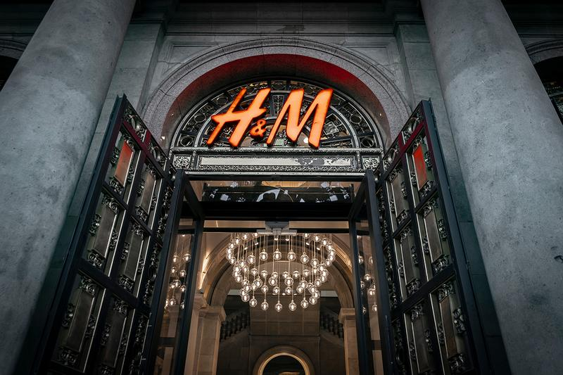

Introduction
Marketing concept signifies the data and information which helps to understand the needs, wants and demands of the customer from the market. It defines the way with, which the marketer can meet the expectation of the customers. The first part of this report is about the concept of market and the advantages as well as disadvantages, which in turn create a value of the product on the customers. Then the next part is about the strategies which are used and are explained based on the Ansoff matrix. And in the last part the impact and the influence of the stakeholders within the market and the activities of it. The strategies of the market help to increase and enhance the communicative bond among the stakeholders and the company.
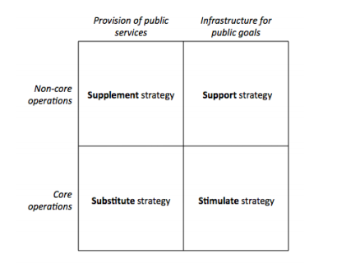
Stakeholder Matrix
(Source: Research-api, 2021)


(Sources: indulgexpress.com)

Concept of marketing–The main concept of the market implies the area and fields which are based on the data and information of the entire market. This data and information of the market highlight the areas or point-based upon which the products are manufactured by the company in order to meet the needs wants and demand of the customer from the markets (Illes, 2020). On the other hand, the marketer always tries to launch or promote the product based on the customer's wish, this influences in a positive way on the percentage of the entire sales of the company. The more the company will launch the product considering the needs, wants and demands of the consumer, the more will the rate of sales or the rate of profit of that specific company.
Moreover, in each and every aspect the companies follow these points or structure before manufacturing any product or before selling any product, in every aspect. For instance, the company first go through market research based on which the needs, wants and demands are highlight form the data and information. After analysing those data and information the marketer concludes the main point, which is implemented during the time of any manufacturization of any product or launching of any product. As a result, after implementing those points into production, the company finally meets or mitigate the expectations of the customers. However, the companies not only mitigate the criteria of the customer's expectation but also, implement new strategies during the process of production with which more numbers of customers are attracted toward the product and will be more incline to buy that specific product. As a result, the profit percentage, as well as the value of that specific company, will be increased and enhanced.
The advantages which are experienced by the customers after the marketing concept are enlisted below –
Due to the marketing concept, the consumers can explain their criteria's and preferences more significantly and more clearly to the marketer or manufacturer. As a result, this enhances the procedures of consumers and the rate of consumptions is also increased (Attaset al., 2017). Hence, the quality, as well as the quantity of the products which are consumed by the customers, are its best, because die to the marketing concept the choices of the customers are exercised. The strategies which were used to implement in order to mitigate the expected are way better than that of before.
Branding –It a process or a way which is used to create positive as well as strong imminent about the company which are retailing and manufacturing the products on the basis of the needs, want and demands of the consumers. The methods which are implemented for the branding strategies play a major role in making the company which are mainly involved in retailing. In this case, the company H&M is considered (Beyer, Bierling and Öjerbrant., 2018). With the help of branding or with the pattern and procedure the brand value of this company had been increased. On the other hand, the company H&M uses variant styles and pattern which impacts positively on the entire brand, as a result, this company has implanted a perspective on the consumer's mind. The things or the products manufactured by this company will be always good in quality as well as good in quantity. Hence, this company has created a specific name for its brands depending upon which the percentage of sales or the profit varies. Another role played with the help of branding is that with the help of a good brands name a company can grab a huge place within the global market and can also increase its intensity and networking channel amongst the other countries.

Ansoff Matrix –
Utilising the tool Ansoff matrix with the help of which the strategies of marketing are analysed and are evaluated -
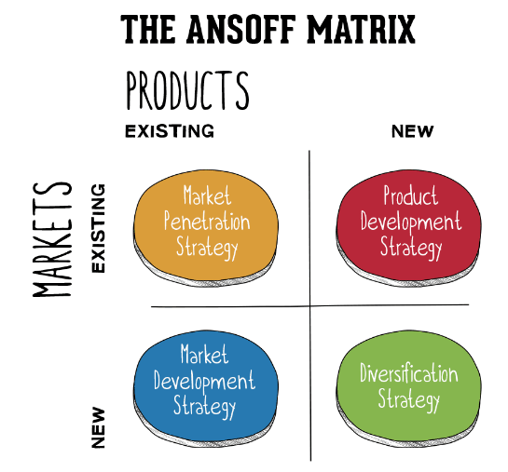

Ansoff Matrix
(Source:Yadav, 2021)
The Ansoff Matrix model is segregated into four different components, which are enlisted below:
Penetration with the market – The market penetration or the penetration of the market is mainly the strategies which are used by the company during the time of promotion or launching a product that is already existing, in the market which is also existing (Mensah and Osman., 2018). Moreover, the implementation of new strategies or ways opted by a company in order to re-launch the old product in a new appealing style or way in the old or pre-existing market (Eliasson., 2018). In most cases, the company H&M opted for offers that seem to be more productive as most of the consumers are more incline towards the offers provided by the company.



(Source: perfectsourcing.net)

Development of the market–The development of the market signifies the ways or the strategies which are used by the company H&M in order to promote the pre-existing product in the new market (Lee, Jung and Ha-Brookshire., 2020). Like for instance, the company which are mostly inclined towards retails always tries to increase their channel and networkability amongst the other countries in order to increase the percentage of sales. The market development strategy facilitates the organisation to gain new customers. In this context, it is noteworthy that it also helps in enhancing the growth of the company and also increases its revenue. Appropriate implementation of the market development strategies also helps the firm to enhance its competitive advantage. On the other hand, the customer gains new kind of products and services from the firm due to their market development strategy.
Development of the product –The development of the product implies the situation of the product development in order to launch them in the new market so that the sales of the company can be increased. In order to launch a new product in the pre-existing market this company uses new strategies to develop the product like, for instance, new colours, new style, new patterns, these are the most useful ways which are used by the company in order to launch a new product in the existing market. Moreover, in order to launch a new product in a new appealing way, new ideas are implemented.
Diversification– This term Diversification signifies the ways which are used or are implemented by this company so that it can launch a new product in a new market, considering the marketing policies are goals (Van Bruggen, Nikolic and Kwakkel, 2019). With the help of this goal, the company can target to launch and to promote a new product in different fields or purposes and can also manufacture depending on that goal. As a result, this company can also increase its rate in the profit percentage and can also enhance its sale in marketing. Diversification helps the customers to get access to new products, by which they can cater their needs in a better manner.
From the aforementioned-analysis it is observed that there are few specific strategies used or opted by the company H&M, the first and foremost methods are that this company analyse the geographical location of the areas where it will be launching its new outlet in order to grow the business market. Therefore, it can be stated that as H&M is hugely involving its products and services for the customers, the company can look forward to consider the diversification strategy. At first, this company does not remain constant about the cost or the expenditure which are spent by this company in order to grow or to enhance the growth of the business. On the other hand, this company not only remains concerned about the outlet of their company but also tries to implement new way in order to increase the growth of the company this company includes new ways or new methods in order to increase the sales of the company. Like for instance, in the places where this company has not increased its network or does not have any outlets, there they launch or promotes its business on the basis of the online sites.



(Source: www.hol-mannequins.com)

Stakeholder Engagement and its impact on the marketing activities
The stakeholders are the parties or the members who are attached or are collaborated with the main company, or it has a primary interest in the entire company. The primary members of the company are the investors, employees, customers or the consumers and suppliers of the company (Chyhrynet al., 2020). The main types of stakeholders are – customers, vendors or suppliers, governors, investors, employees. These are some of the stakeholders who are immensely affected by the profit and by the loss of the company.



(Source: fashionart.partriciareports.nl)

Internal stakeholders–The internal stakeholders are those stakeholders who are directly connected with the company like for instance, the ownership, the employees and the investors of the company. The connectivity of the network of these stakeholders is directly connected with the company (Derakhshan, Turner and Mancini, 2019). In this case, the internal stakeholders of this company are the employees working within the company, the suppliers of this company, the financial communities who provide the back-support for the company.
External Stakeholders – The external stakeholders are those who’s network or the connectivity is not directly linked with the company (Boaz et al., 2018). On the other hand, they are not directly affected due to the profit or loss of the company or using any action or outcome of the company. Here, in this case, the external stakeholders of this company are the NGOs, the policy providers and IGOs.
The ways that are opted by the companies in order to maintain an effective way of communication are enlisted below –
Scheduling meeting in between the stakeholder and the company – Scheduling meeting in between the stakeholder and companies are one of the most methods opted by the company in order to maintain a smooth and positive bond of relationship in between the company and with the client. With the help of the schedules meeting the messages or the information can be conveyed to a large number of people within a few periods (Salti, 2017). Hence, this method or the way are mostly opted by the company. With the help of these methods miscommunication or communication, the gap can be removed or avoided by the stakeholders and company as a result, the goals and objectives remain in the target and conflict are removed amongst them.
Meeting on a virtual basis– In order to save time and to minimize the area of time-consuming, now people mostly had become more inclined towards the advanced technology where the task is done and completed within time-effective manner (Boaz et al., 2018). As a result, the meeting is nowadays conducted via the online platform or on the basis of the virtual platform so that time could be saved and the completion of the work can be more effective and efficient manner.
Scheduling a call on a conference basis–The meeting based on the conference calls are one of the most effective and efficient ways of removing or avoiding any kind of misconception or misinterpretation among the stakeholder and company (Yu, Rothenberg and Moore, 2020). Conference calls are one of the easiest way and common way to avoid any kinds of problem and emergencies. During the time of any emergency or obstacles which are faced by the stakeholders, they opt for the conference call meeting.
Meeting over lunches– This is one of the informal ways of meeting perform or followed by the stakeholder and the members of the companies (Valenti, 2020). In some cases, it has been seen that sometimes the informal ways of communication reflect more innovative and more efficient and effective ideas amongst the people.

Reports on a project basis – The reports are mainly based on the performance which is targeted or are set out for the different stakeholders of the company in order to complete them in time or order accomplish the task in more definite ways or types (Shen, Choi and Chow, 2017). The report also reflects the budgets of the work or the entire expenditure for the entire project work (Gustafsson, Lager and Wengblad, 2020). Based on the report or the logbook, the working structure and the procedure of the work can opt and efficiency, as well as the effectiveness of the entire work, can also be analysed.
The impact of the stakeholders can be in both ways like for instance the influence and impact can be negative as well as positive by both internal and external stakeholders. The impact of the internal stakeholders is they provide financial back support to the marketing team in order to promote and launch the product and goods of that specific company like for instance, in this case for the company like H&M the company needs a lot of capital resources for the promotion and the financial back support for the company (Rangarajan, Gelb and Vandaveer., 2017). During the time of launch or promotional program, a huge amount of resources are implant and many famous or popular faces are hired, so that people can be more oriented or inclined towards this brand. As a result, the involvement or the impact of the internal stakeholder is huge.
On the other hand, the impact of the external stakeholders can be negative (Kasapi and Cela, 2017). For instance, the external stakeholders do not allow or vote for the decision those were taken by them, and hence the entire working procedure of the company are impacted and are affected negatively. In some other studies the decisions of the external stakeholders do not meet the expectations of the companies’ policies as a result; this creates a conflict between the two parties (Gielens, and Steenkamp, 2019). Moreover, the external stakeholders or the parties of the stakeholders are mostly governmental bodies. The decisions taken or considered by them reflect or impact in a major way as result; their decision plays an important role and major role in the marketing activities of the company. Depending on the marketing policies and procedures the company's profit increases as well as decreases. The more the advertisement or the promotional background is implementing or attractive the more will be the rate of profit for a specific company (Swaminathanet al., 2020).As nowadays people are more inclined towards the virtual world, hence the advertisement or promotion must meet such kinds of criteria and should also grab the attention of the people or consumers.

Conclusion
From the above report, the different aspect of the stakeholders and the areas which are more implementing and reflective for the promotion, for the enhanced growth of the business, and increase the network of connectivity in order to grow its business in the global market are analysed and are evaluated. On the other hand, the role of the market, branding is concluded as well as the impact of them into the entire marketing policies are also signified, and the ways they are affecting the market of the specific company and helping to grow its business are also included.


(Source: becomegorgeous.com)

Recommendation
Evolution of product and services: The strategies which are opted for the growth and the implementing of the business within the market should be more evolved as nowadays people or the consumers are much more advance than the previous times. As a result, the ways which are opted should be more customer-oriented because this will create a positive impact and will help the company to grow its business.


(Source: becomegorgeous.com)

References
Attas, K., Bojanowicz, W., Gao, S.L. and Niesen, L., 2017. Communication Through CSR: Is It Sustainable?–The Case of H&M. LBMG Corporate Brand Management and Reputation-Masters Case Series.
Beyer, J., Bierling, K. and Öjerbrant, F., 2018. Case H&M-(Un) coolest Monkey in the Jungle-When Ads Turn Against Their Creators. LBMG Corporate Brand Management and Reputation-Masters Case Series.
Boaz, A., Hanney, S., Borst, R., O’Shea, A. and Kok, M., 2018. How to engage stakeholders in research: design principles to support improvement. Health Research Policy and Systems, 16(1), pp.1-9.
Bruijl, G.H.T., 2018. The relevance of Porter's five forces in today's innovative and changing business environment. Available at SSRN 3192207.
Chyhryn, O.Y., BilanYuriiValentynovych, Y.V. and Kwilinski, A., 2020. Stakeholders of green competitiveness: Innovative approaches for creating communicative system.
Derakhshan, R., Turner, R. and Mancini, M., 2019. Project governance and stakeholders: a literature review. International Journal of Project Management, 37(1), pp.98-116.
Eliasson, J., 2018. The H&M Group: Enabling the Future: An anthropological discourse analysis of The H&M Group Sustainability Report 2016.
Gielens, K. and Steenkamp, J.B.E., 2019. Branding in the era of digital (dis) intermediation. International Journal of Research in Marketing, 36(3), pp.367-384.
Gustafsson, J., Lager, J. and Wengblad, L., 2020. Internal Employer Branding-A One Way Street or a Highway of Opportunities?.
Hope, A., 2018. Sustainable business model design: A review of tools for developing responsible business models. Sustainable Business Models, pp.377-394.
Illes, J., 2020. Corporate Citizenship and H&M: A case study of business participation in society.
Jarek, K. and Mazurek, G., 2019. MARKETING AND ARTIFICIAL INTELLIGENCE. Central European Business Review, 8(2).
Jiang, S., 2020. A Comparative Analysis of Chinese and British Consumers’ Consumption Behaviours and Attitudes Toward Fast-Fashion Brand as Zara and H&M. Asian Journal of Social Science Studies, 5(2), p.17.
Karayev, R.A., 2020. The advantages of cognitive approach for enterprise management in modern conditions. Бизнес-информатика, 14(2 (eng)).
Karunakaran, M.S. and Raveendran, P.T., 2018. CUSTOMER ENGAGEMENT-THE CO CREATION OFVALUE IN THE MARKETING PROCESS.
Kasapi, I. and Cela, A., 2017. Destination branding: A review of the city branding literature. Mediterranean Journal of Social Sciences, 8(4), p.129.
Lee, S., Jung, S. and Ha-Brookshire, J.E., 2020, December. A Framework of Perceived Corporate Social Responsibility Gaps between Internal and External Stakeholders: A Stakeholder Theory Approach. In International Textile and Apparel Association Annual Conference Proceedings (Vol. 77, No. 1).Iowa State University Digital Press.
Liu, R., 2017. A reappraisal of marketing definition and theory. J. East. Eur. Cent. Asian Res, p.49.
Mensah, F. and Osman, T., 2018.Communicating through social media to regain stakeholders trust during crises: A case study about H&M.
Nguyen, D., 2018. Social media marketing strategy-Case study H&M Hennes&Mauritz.
Rangarajan, D., Gelb, B.D. and Vandaveer, A., 2017. Strategic personal branding—And how it pays off. Business Horizons, 60(5), pp.657-666.
Salti, R., 2017. Ethical Fashion Branding: Multiple Case Studies of Mission Statements and Fashion Films.
Shen, B., Choi, T.M. and Chow, P.S., 2017. Brand loyalties in designer luxury and fast fashion co-branding alliances. Journal of Business Research, 81, pp.173-180.
Stindt, D., QuariguasiFrotaNeto, J., Nuss, C., Dirr, M., Jakowczyk, M., Gibson, A. and Tuma, A., 2017. On the attractiveness of product recovery: The forces that shape reverse markets. Journal of Industrial Ecology, 21(4), pp.980-994.
Su, Y.Z., 2020. The Internationalization Strategies of Fast Fashion Clothing Retailer Brands: A Cases Study of ZARA, H&M, UNIQLO, and Gap.
Swaminathan, V., Sorescu, A., Steenkamp, J.B.E., O’Guinn, T.C.G. and Schmitt, B., 2020.Branding in a hyperconnected world: Refocusing theories and rethinking boundaries. Journal of Marketing, 84(2), pp.24-46.
Tsutskiridze, M. and Mammadov, A., Case study report H&M brand reputation.
Valenti, N., 2020. Co-branding: ilcasoBalmain per H&M.
Van Bruggen, A., Nikolic, I. and Kwakkel, J., 2019. Modeling with stakeholders for transformative change. Sustainability, 11(3), p.825.
Verdenhofa, O., Afanas' jev, M.V., Panchuk, A., Kotelnykova, I. and Chumak, G., 2018. The conceptual bases of introduction of foresight marketing into business management. Problems and perspectives in management, (16, Iss. 3), pp.163-173.
Yu, Y., Rothenberg, L. and Moore, M., 2020. Exploring young consumer's decision‐making for luxury co-branding combinations. International Journal of Retail & Distribution Management.

