Module: Principles of Human Resource Management
Assignment Title: CW1
Presentation Notes File

Slide 1: Title
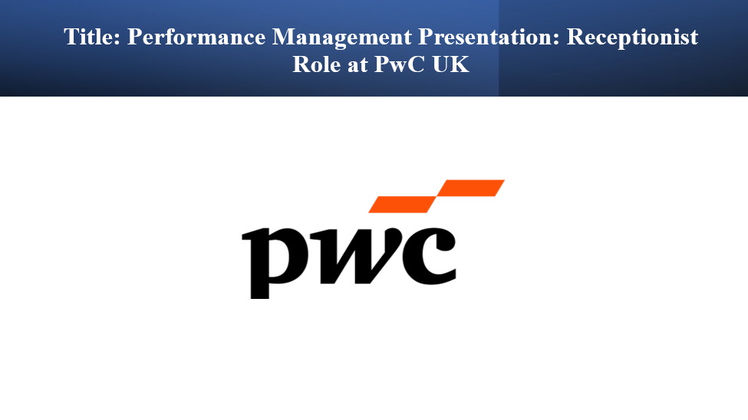
Performance Management Presentation: Receptionist Role at PwC UK
This presentation discusses the performance management of a receptionist job at PwC UK, one of the most successful professional services firms in the world that employs approximately 22,000 employees in 20 offices (PwC, 2021). This presentation will provide an overview of the performance rating system, main receptionist duties, and effective performance management practices that are in tandem with the modern HRM principles.
Slide 2: Introduction
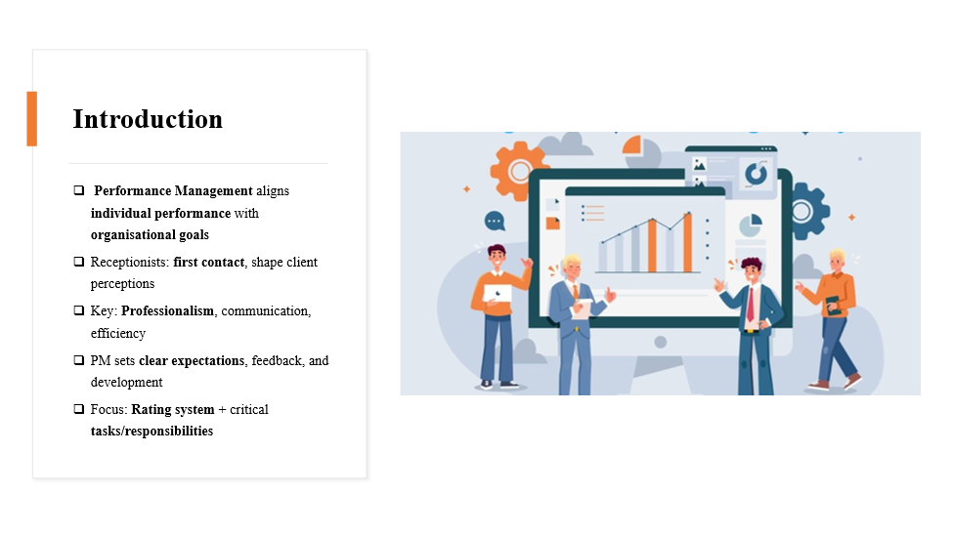
Performance management is one of the functional human resource areas that is all-inclusive, linking the individual input to the organisational objectives and also promoting employee development. The receptionists play a significant role since they are the first contact and they influence the perception of the clients by being professional, communicative and efficient. The quality of their performance directly affects the quality of service and organisational reputation. The performance management that works out the efficient performance management sets clear expectations and provides constructive feedback, and promotes continuous development. This presentation is devoted to the performance management rating system of the receptionist job and the definition of the most important tasks and responsibilities that are supposed to guarantee operational excellence and sustained adherence to the organisational standards.
Slide 3: Performance Rating System Overview
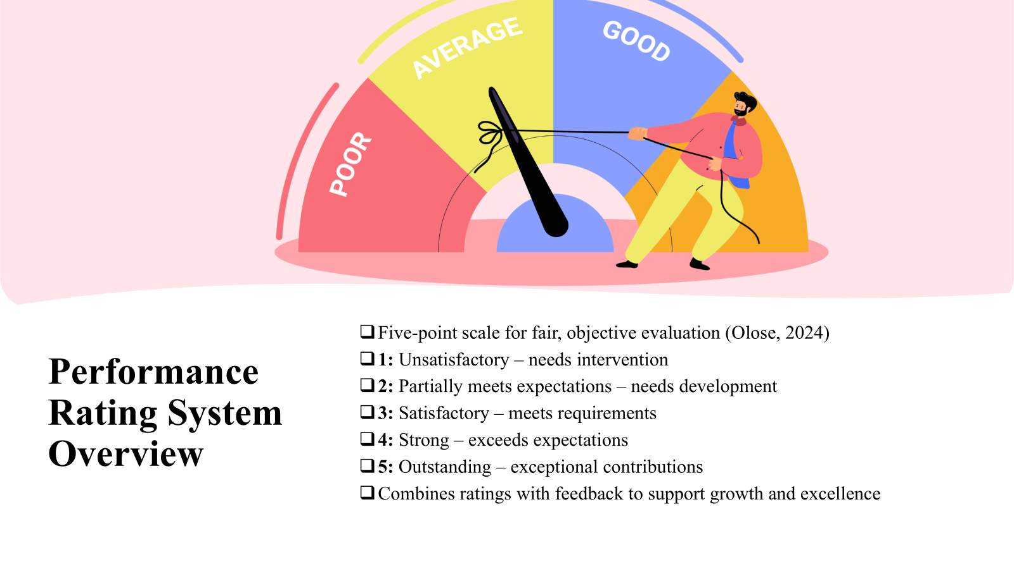
PwC has a performance rating system that is based on a five-point scale to make sure that employee performance is fairly, objectively, and distinguishably evaluated (Olose, 2024). The rating of 1 means unsatisfactory and needs to be intervened, whereas the rating of 2 means that the performance is satisfactory but needs to be developed. The score of 3 means that performance is satisfactory, and all the core requirements are met. The 4 rating means that a performance is stronger than expected, and the 5 rating means that the performance is outstanding and contains exceptional contributions. This system promotes quantitative evaluation as well as qualitative feedback, which helps to affirm the investment of PwC in the perpetual professional development, performance excellence and employee development through explicit, orderly, and practical performance appraisals.
Slide 4: Key Performance Areas for Evaluation
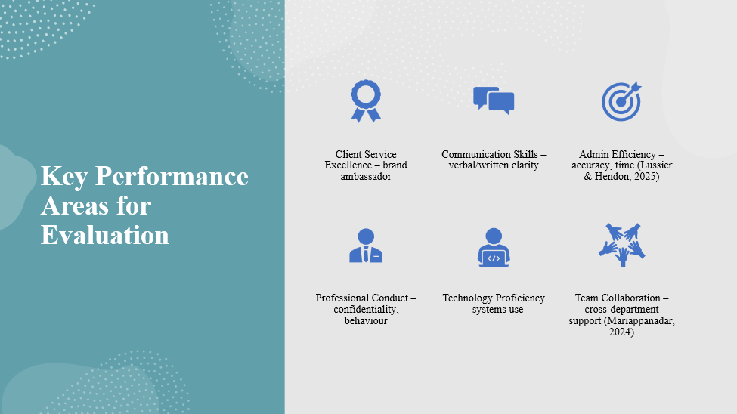
Client Service Excellence displays the level of interaction with the clients and stakeholders, where the receptionists are brand ambassadors. Communication Skills are a measure of verbal and written communication. Administrative efficiency evaluates organisational abilities, time management and precision (Lussier and Hendon, 2025). Professional Conduct looks at compliance with the standards of PwC, such as confidentiality and behaviour in the workplace. Technology Proficiency is used to assess the ability to work with reception management systems. Team Collaboration is a measure of the capacity to collaborate in various departments (Mariappanadar, 2024). This is a multidimensional strategy that guarantees performance assessment.
Slide 5: Detailed Rating Criteria - Client Service Excellence
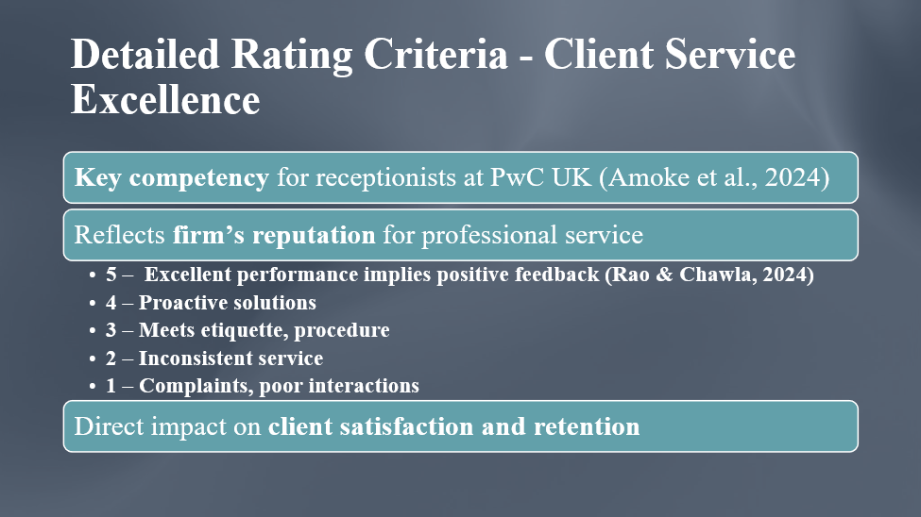
One of the most important competency areas of a receptionist in PwC UK is Client Service Excellence because the firm has a reputation for providing excellent professional services (Amoke et al., 2024). Excellent performance implies being able to predict the needs of clients and receive positive feedback on a regular basis (Rao and Chawla, 2024). Going beyond expectations means being proactive and finding solutions. Delivering on expectations implies good etiquette and observing procedures. Needs improvement displays inconsistent service or dependency on supervision, whereas unsatisfactory features include bad interactions or complaints. This has a direct effect on client retention.
Slide 6: Detailed Rating Criteria - Communication Skills
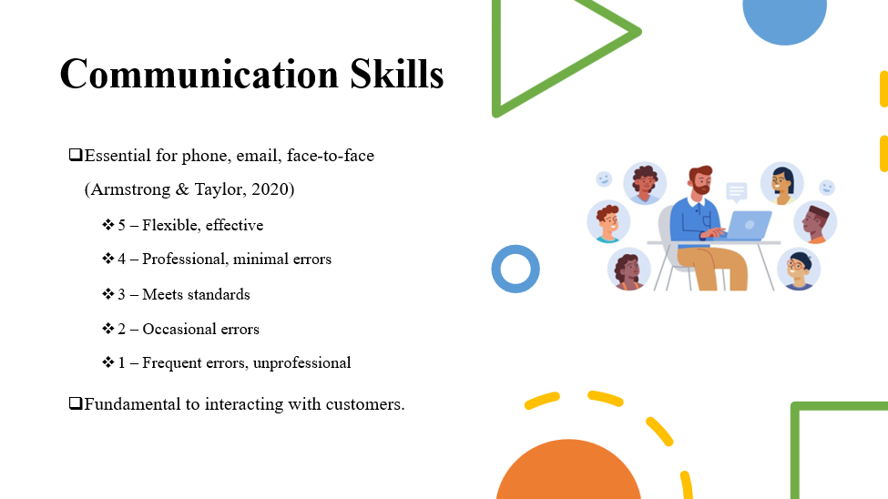
The receptionists rely on communication, which includes phone, email, and face-to-face communication. According to Armstrong and Taylor (2020), Outstanding refers to effective, flexible communication. Exceeding expectations is professional with minimal mistakes. Meeting expectations is correct and adhering to regulations. Performance needs improvement displays some occasional errors and unsatisfactory performance involving common mistakes or unprofessionalism. Effective communication is fundamental to interacting with customers.
Slide 7: Detailed Rating Criteria - Administrative Efficiency
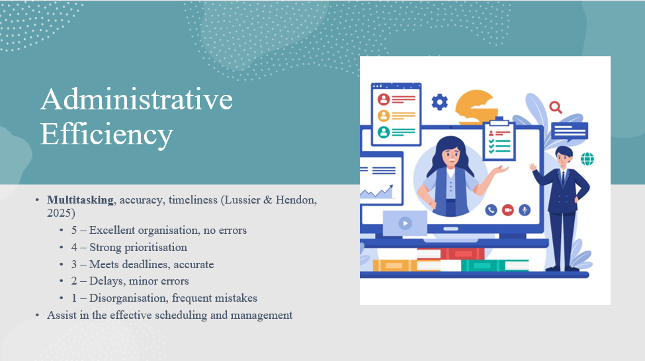
It is an assessment of multitasking, accuracy and smooth operation. Excellent performance reflects excellent organisation and no mistakes. Spending more is effective prioritisation. Meeting expectations is a sign of correct and punctual work. Delays or errors could be considered as needing improvement and unsatisfactory as disorganisation (Lussier and Hendon, 2025). The administrative power will assist in the effective scheduling and management of partners and visitors.
Slide 8: Professional Conduct, Technology & Team Collaboration
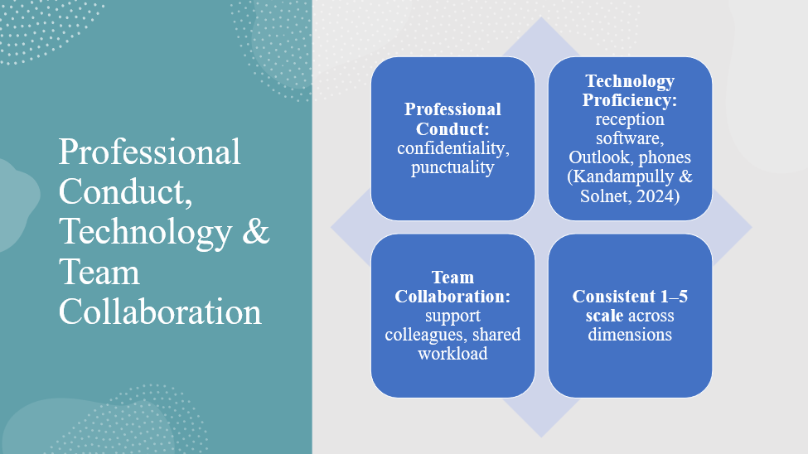
Professional Conduct involves observing high levels of confidentiality with sensitive information, appearing in a manner that is professional in line with the standards of PwC and being punctual. Since PwC UK deals with confidential issues, the most important thing is discretion. Technology Proficiency is based on the ability to work with the visitor management system, Microsoft Outlook, telephone systems, and software specific to the firm (Kandampully and Solnet, 2024). With the growing dependence of professional services on technology, digital literacy is becoming necessary. Team Collaboration evaluates the teamwork skills, capacity to support in times of high demand, and the ability to contribute towards a good culture at the workplace. All the criteria are measured on the same 1-5 scale, which means that there is consistency among the performance dimensions.
Slide 9: Key Receptionist Roles at PwC UK
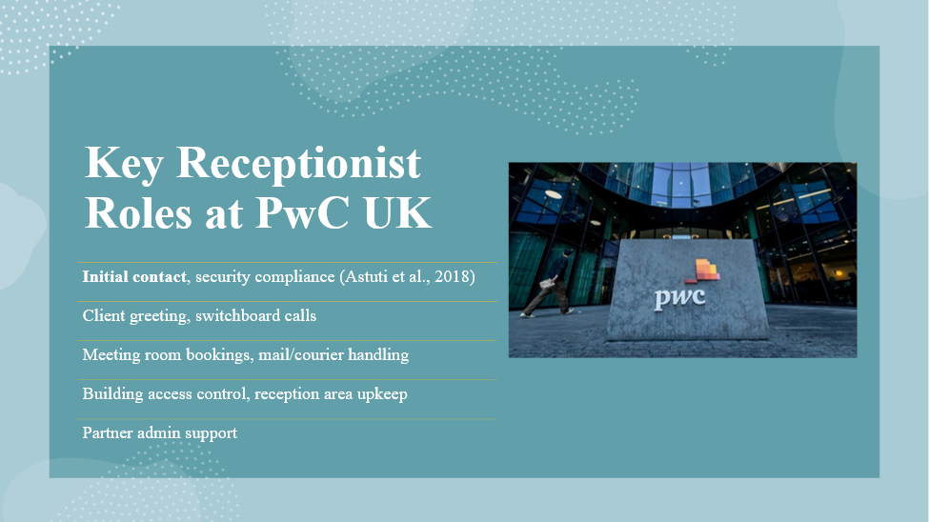
The receptionist is charged with a lot more than visitor reception. They are the initial contact, and first impressions and security measures are adhered to. They take care of the reception, welcome the clients warmly, and make them feel special. They deal with a large number of calls on the telephone switchboard. They reserve and set up meeting rooms, sort and dispatch mails and courier deliveries and assist in the administration of partners. They also manage access to buildings in order to ensure security and always maintain the reception area as clean and professional (Astuti et al., 2018).
Slide 10: Strategic Importance of the Receptionist Role
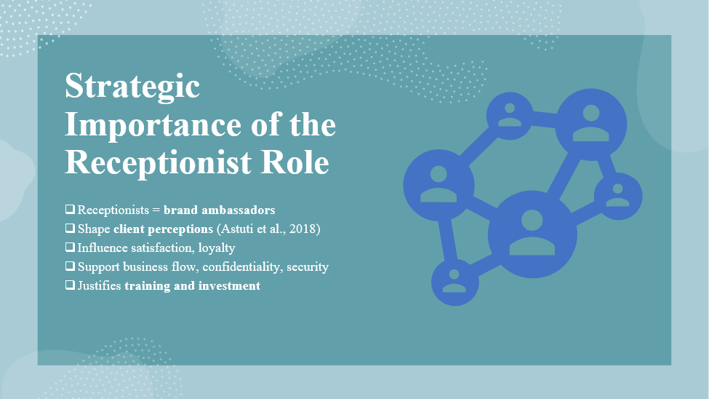
The receptionist is a very important position, although it is often regarded as a support role. Receptionists are embodiments of the values of PwC, and they form the initial impressions that form perceptions of the clients. Astuti et al.'s (2018) research indicates that front-line employees are highly influential on customer satisfaction. The receptionists contribute to the retention of clients by providing superior services, facilitating a seamless operation of the business by coordinating the activities, as well as contributing to the aspects of security and confidentiality. The acknowledgement of this fact will guarantee their appropriate support and training.
Slide 11: Performance Expectations - Daily Operations
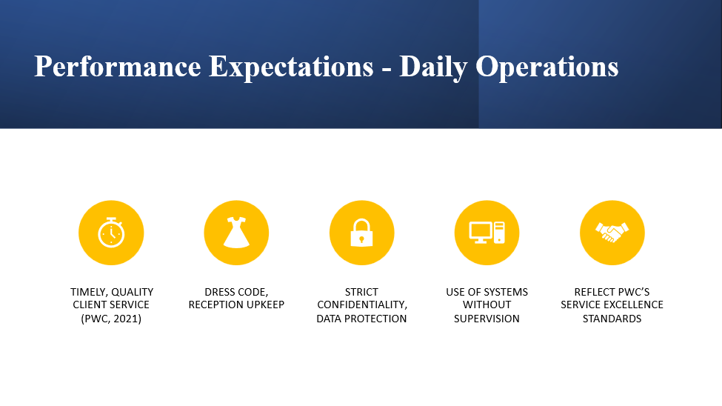
PwC UK receptionists are supposed to offer timely and quality services to clients and visitors so that they feel welcomed (PwC, 2021). This involves observing the dress code of PwC and keeping reception areas clean and orderly. The paramount importance of strict confidentiality and data protection is one of the expressions of the quality and client trust of PwC. The receptionists are also supposed to work with reception systems without supervision, which is a sign of expertise and trustworthiness in the job. These criteria are part of the larger excellence commitment of PwC and are part of its service offerings that are outstanding to its clients.
Slide 12: Best Practices in Performance Management
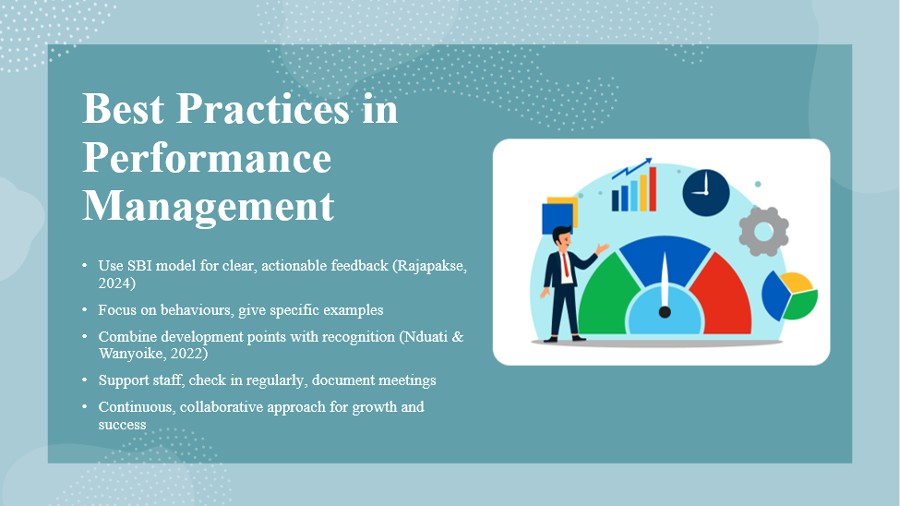
To achieve the objective of providing effective feedback, this is through the use of the SBI (Situation-Behaviour-Impact) model (Rajapakse, 2024). This is by giving concrete feedback through certain examples and focusing on behaviours to avoid defensiveness. Nduati and Wanyoike (2022) state that feedback on areas of improvement and recognition of achievements together enhance the receptiveness of employees. To establish a developmental culture, it is essential to present feedback as a chance to grow, praise accomplishments, support employees, make frequent check-ins, and record the meetings. These tactics are the current concepts of the HRM parameters whereby performance management is a continuous, participative process which develops employees and adds to the total organisational performance.
Slide 13: Performance Management Benefits
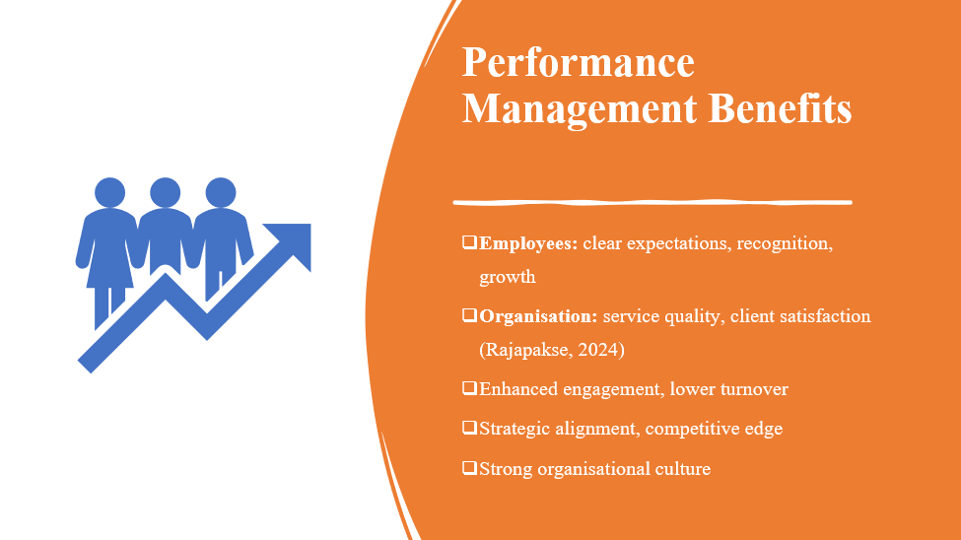
Performance management is helpful to both the employees and the organisations. The employees receive good expectations, recognition, and development opportunities. In the case of PwC UK, it enhances the quality of services and customer satisfaction by providing quality and trustworthy services. According to Rajapakse (2024), good employee engagement has been associated with better results. When the contributions are recognised, reduced turnover is achieved. Performance management aligns individual targets to strategic purposes, which gives the organisation a competitive edge by delivering better services and a good organisational culture.
Slide 14: Challenges and Solutions in Performance Management
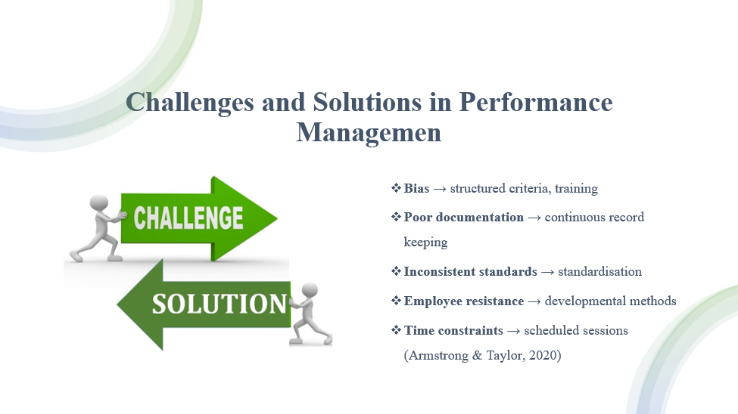
The performance management is challenged with problems which need to be solved. The unconscious bias is minimised with the help of structured criteria and training of managers. Documentation deficiency is dealt with by keeping records of performance on a continual basis. Unchecked standards are solved through the standardisation of processes throughout an organisation. Developmental methods reduce the resistance of employees. Time management is done through time scheduling, which is setting aside time and protecting it. These solutions are supported by Armstrong and Taylor (2020) in order to be more effective.
Slide 15: Conclusion
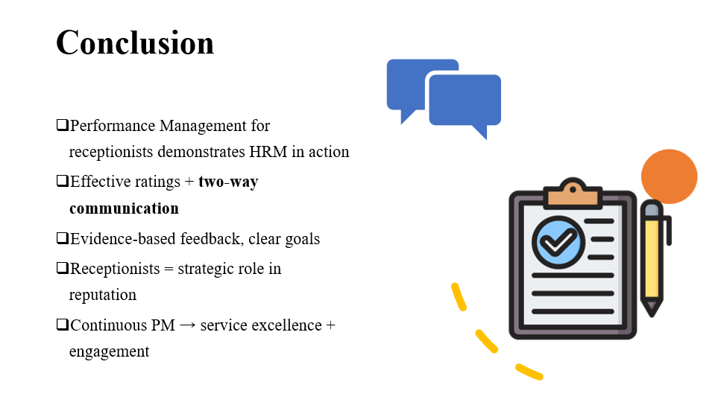
The performance management presented in this presentation was based on the example of a receptionist at PwC UK, and the HRM principles were put into practice. Management should include effective ratings, two-way communication, evidence-based feedback and joint goal setting. Receptionists are the initial contact with the client, which makes it a strategic aspect of reputation. With constant and supportive performance management, there will be service excellence, employee development, engagement and accomplishment of organisational goals, as each role will be recognised as contributing to the success of the organisation.

References
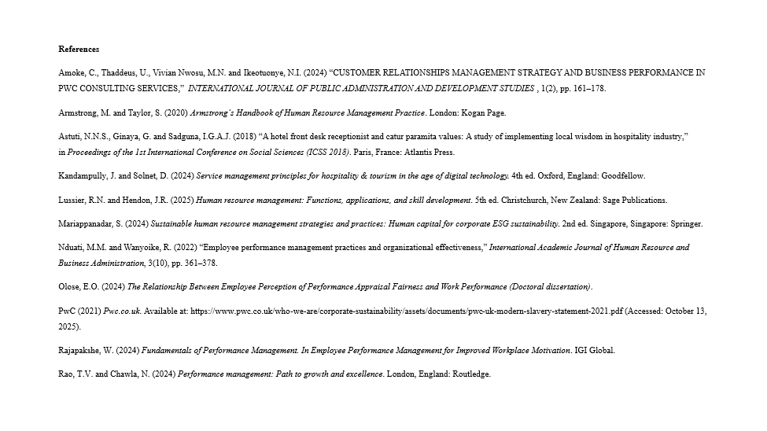
Amoke, C., Thaddeus, U., Vivian Nwosu, M.N. and Ikeotuonye, N.I. (2024) “CUSTOMER RELATIONSHIPS MANAGEMENT STRATEGY AND BUSINESS PERFORMANCE IN PWC CONSULTING SERVICES,” INTERNATIONAL JOURNAL OF PUBLIC ADMINISTRATION AND DEVELOPMENT STUDIES, 1(2), pp. 161–178.
Armstrong, M. and Taylor, S. (2020) Armstrong’s Handbook of Human Resource Management Practice. London: Kogan Page.
Astuti, N.N.S., Ginaya, G. and Sadguna, I.G.A.J. (2018) “A hotel front desk receptionist and catur paramita values: A study of implementing local wisdom in hospitality industry,” in Proceedings of the 1st International Conference on Social Sciences (ICSS 2018). Paris, France: Atlantis Press.
Kandampully, J. and Solnet, D. (2024) Service management principles for hospitality & tourism in the age of digital technology. 4th ed. Oxford, England: Goodfellow.
Lussier, R.N. and Hendon, J.R. (2025) Human resource management: Functions, applications, and skill development. 5th ed. Christchurch, New Zealand: Sage Publications.
Mariappanadar, S. (2024) Sustainable human resource management strategies and practices: Human capital for corporate ESG sustainability. 2nd ed. Singapore, Singapore: Springer.
Nduati, M.M. and Wanyoike, R. (2022) “Employee performance management practices and organizational effectiveness,” International Academic Journal of Human Resource and Business Administration, 3(10), pp. 361–378.
Olose, E.O. (2024) The Relationship Between Employee Perception of Performance Appraisal Fairness and Work Performance (Doctoral dissertation).
PwC (2021) Pwc.co.uk. Available at: https://www.pwc.co.uk/who-we-are/corporate-sustainability/assets/documents/pwc-uk-modern-slavery-statement-2021.pdf (Accessed: October 13, 2025).
Rajapakshe, W. (2024) Fundamentals of Performance Management. In Employee Performance Management for Improved Workplace Motivation. IGI Global.
Rao, T.V. and Chawla, N. (2024) Performance management: Path to growth and excellence. London, England: Routledge.

