

Programme: Master of Business Administration
Module Name: Marketing Management
Module code: LCMB7024
Module Lecturer: Taonga Kaonga Sobere-Snithers
“Title: Oak Living Eco Collection”
Student Name:Darshil Mukeshkumar Dodiya
Student ID: 2522995

Table of Contents
Element 1 poster: Sustainable brand extension: Oak Living Eco Collection 3
Element 2: Segmentation, Targeting, Differentiation and Positioning (STDP) analysis 4
Segmentation 4
Geographic Segmentation 4
Psychographic Segmentation 4
Behavioural Segmentation 5
Targeting Strategy 5
Differentiation Strategy 5
Positioning Strategy 6
Element 3: Marketing Mix (4Ps) for the Oak Living Eco Collection 6
Product 7
Price 7
Place 8
Promotion 9
Element 4: Reflection 10
Reference List 12

Element 1 poster: Sustainable brand extension: Oak Living Eco Collection
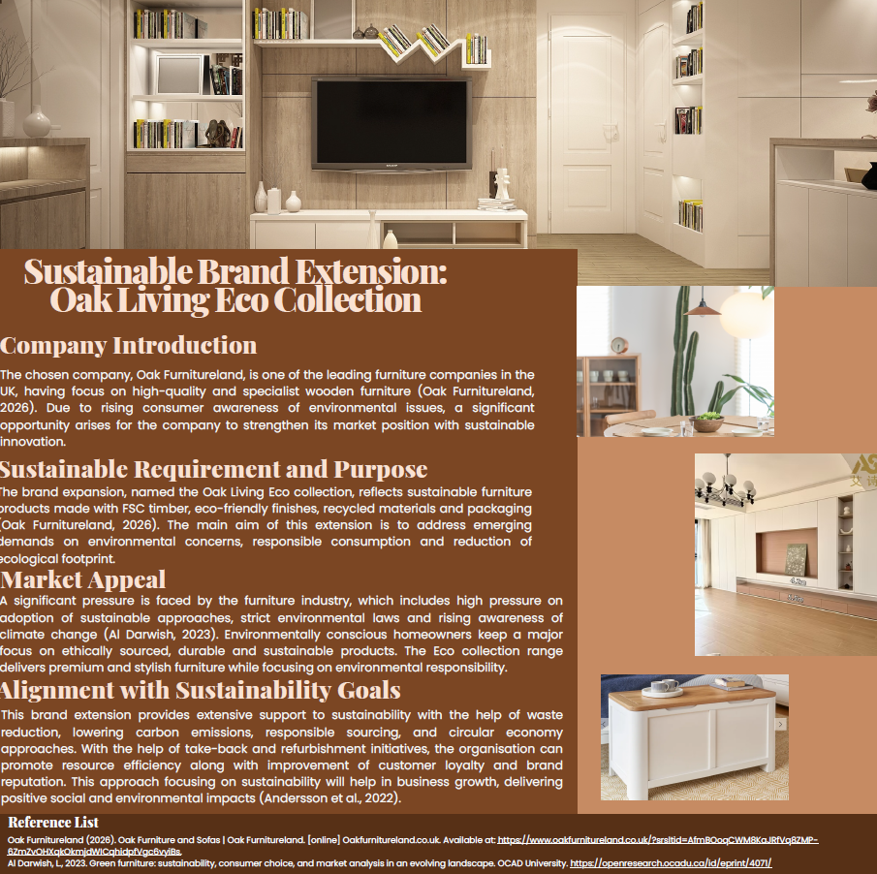

Element 2: Segmentation, Targeting, Differentiation and Positioning (STDP) analysis
The chosen sustainable brand extension has the main aim towards strengthening the competitive positioning of Oak Furnitureland through dealing with the rising demand for environmentally responsible items. According to Arnett, (2024), efficient marketing approaches are connected with the identification of appropriate market segments and the selection of targeted customers, whose demands can be satisfied compared to the competitors. Hence, an effective STDP analyst is crucial to gain higher sustainable brand expansion.

Segmentation
The word market segmentation can be defined as dividing larger markets into different customer groups based on their characteristics and needs.

Geographic Segmentation
The brand expansion consists of suburban and urban consumers present across cities like Bristol, Leeds, London, Manchester and Birmingham, where there is higher demand for sustainable home solutions and environmental awareness. Considering future expansion, various environmentally conscious markets like Germany, Sweden and the Netherlands deliver significant opportunities due to their strong purchasing power and sustainability culture.
Demographic Segmentation
The main target consumers include individuals aged between 25 and 45 years. This group of individuals consist of newly married couples, young professionals, homeowners and young families having medium to high levels of disposable income. All these consumers have a demand towards investing in premium quality furniture to gain sustainability and long-term value. Moreover, increased education levels also deliver better contribution towards environmental awareness in dealing with ethical consumption and sustainability issues (Al-Nuaimi and Al-Ghamdi, 2022).

Psychographic Segmentation
Psychographic segmentation is based on consumers' lifestyles, attitudes and values. The Eco Collection is for those consumers who are environmentally conscious and look for sustainable products and ethical business practices. These people prefer durability, quality and responsible sourcing. Furthermore, minimalist and contemporary home designs are bound to appeal to modern homeowners towards the stylish design furniture of the brand.

Behavioural Segmentation
The target market is customers who want sustainability, durability and a better quality product. They will pay more for products that reflect their lifestyle and values in terms of being environmentally friendly (Plakantonaki et al., 2023). Home improvement, first home and new furniture purchases are all purchase occasions. Also, these consumers often undertake in-depth online research prior to making a purchase, and are more loyal to brands when their sustainability pledges are genuine.

Targeting Strategy
Oak Furnitureland will take an approach of target in middle income and upper-middle income consumers aged between 25–45 who are eco-conscious. This segment is a fast-growing consumer segment that is increasingly considering sustainability in their buying decisions (Trzcielinski and Pawlowski, 2024). The main target is the stylish and eco-friendly furniture market for young professionals and families in urban areas who are looking for high-quality, long-lasting furniture. These consumers are digitally engaged and value sustainability, even if it means paying a little more for products that support sustainability. Oak Furnitureland can leverage the increasing trend of ‘ethical consumption' in this segment, while simultaneously establishing long-term customer relationships.

Differentiation Strategy
In the fiercely competitive furniture industry, differentiation is key. Oak Living Eco Collection will stand out from the others, with a focus on sustainability, product quality and initiatives in the circular economy. The Eco Collection will feature FSC-certified wood, recycled materials and environmentally friendly finishes, which are not the main concerns of most furniture stores (Sosa, 2023). It will also launch recyclable packaging and carbon-neutral delivery services to decrease the environmental impact. In addition, a furniture take-back and refurbishment programme will help to implement the principles of the circular economy by prolonging product lifecycles and minimising waste. The sustainability efforts offer a competitive edge and build customer trust and credibility. This differentiation is in line with the expectations of today's consumer, and in support of long-term business sustainability.

Positioning Strategy
This can be stated as the development of a distinctive image across the minds of consumers relative to competitors (Pituşcan and Ioncu, 2024). The position of Oak Living Eco Collection will be based on a premium range of furniture which incorporates elegant design, environmental responsibility and durability.
The positioning statement for the brand extension is:
"For environmentally conscious homeowners seeking stylish and long-lasting furniture, Oak Living Eco Collection provides premium sustainable furniture crafted from responsibly sourced materials, offering superior quality while contributing to a greener future."
This will establish a communication situation that sets out functional benefits, like durability and quality, and emotional benefits linked with environmental stewardship and responsible consumption. Moreover, the Eco collection helps in strengthening the market position of the organisation and providing extensive support towards sustainable business development.

Element 3: Marketing Mix (4Ps) for the Oak Living Eco Collection
The term marketing mix can be stated as a fundamental framework which helps organisations in developing effective strategies for providing value to customers and achieving various business objectives (Abedian et al., 2022). The proposed Oak Living Eco Collection will keep a major focus on place, product, price and promotion strategies which will support sustainability aims and enhance competitive positioning of the company. Effective integration of elements of the marketing mix is crucial for the development of a coherent value proposition which will meet the needs and demands of consumers along with keeping alignment with organisational goals.

Product
The heart of the Oak Living Eco Collection is the product strategy. The brand extension will be a range of sustainably produced furniture such as dining tables, wardrobes, sofas, beds and storage. The products will be manufactured from FSC-certified timber, recycled materials, recyclable packaging and environmentally friendly finishes. The collection will feature designs that are durable and of high quality, with a focus on longevity and sustainability to promote the use of the product for as long as possible
Sustainability-wise, the product approach is also in line with the principles of the circular economy, which aim to minimise waste and prolong product life. Customers will be encouraged to take furniture back to be refurbished or recycled with Oak Furnitureland's furniture take-back and refurbishment programme. The project will advance environmental stewardship and generate support for customers.
Moreover, transparency will be introduced to product differentiation in the sourcing and manufacturing processes. QR codes on products will give consumers details on their carbon footprint, certifications and sustainability (Hasan, 2026). This is timely because consumers are more concerned with ethical consumption and corporate responsibility, and that’s what this transparency brings. The Eco Collection is a blend of high quality, sustainability and innovation that meets functional and emotional consumer needs and enhances brand credibility.

Price
The pricing of the Eco Collection will be value-based. Ethical sourcing, environmentally friendly materials, and responsible manufacturing processes often come at a premium, thus contributing to the overall higher costs associated with sustainable furniture production. As a result, the furniture products will be slightly more expensive compared to conventional furniture alternatives.
On the other hand, Oak Furnitureland is not just going to be a low-cost competitor; it will highlight the long-term value of sustainable and durable furniture. Value pricing is based on the willingness of customers to pay a higher price for products that fit their environmental values and provide a higher quality (Yang et al, 2024). Some studies suggest that environmentally conscious consumers are willing to pay a reasonable premium for green products if the sustainability aspect is clearly delivered.
A variety of payment models and seasonal promotions will be made available in order to increase the affordability and promotion of adoption. Furthermore, incentives and loyalty schemes associated with the furniture take-back scheme can help further promote sustainable consumers' behaviour. The price position increases profit and reinforces the premium and eco-friendly image of the brand extension. Most importantly, premium pricing is only effective if consumers feel that they are doing something good by buying a premium product (Sun and Yoon, 2022). Therefore, it will be crucial to have clear communication about environmental performance and product quality to keep alignment with the premium price and customer trust

Place
Place focuses on making the Eco Collection easily available to the target group and reducing its environmental impact. Oak Furnitureland will employ an omnichannel distribution model that involves both online and offline channels. In the United Kingdom, current showrooms will remain vital to the product experience for consumers, as they will be able to test the quality of a product before buying. Stores can have sustainability sections for the Eco Collection and to explain the environmental benefits. Demonstrations, sustainability information displays and consultations also enhance the physical stores, supporting customer engagement.
Online channels will equally have a major role to play, as digital is a key factor in the target audience, who are often looking at research before they buy (Abu Seman and Segar, 2023). All of this will be detailed on the company's website and include sustainability credentials, customer reviews, and virtual room visualisation tools. The e-commerce feature will allow customers to buy conveniently and learn about the sustainability information.
Distribution operations will be optimised from a sustainability perspective by implementing efficient logistics planning, carbon-neutral means of transport and consolidated deliveries (Tetteh et al., 2025). The overall sustainability strategy will be further enhanced by the use of recyclable packaging and environmentally responsible supply chain approaches. By integrating both digital and physical outlets, this approach helps achieve a wide reach and meets the needs of the market while also advancing customer convenience and environmental goals.

Promotion
Promotion must play a key role in communicating the value proposition of the Oak Living Eco Collection and raising awareness among environmentally conscious consumers. The marketing will emphasise the sustainability benefits and the design, quality and durability of the products.
The main method of communication will be digital marketing. Target audiences will be reached through social media, content marketing, influencer marketing and search engine optimisation (SEO). Storytelling for sustainability can illustrate the potential benefits of responsible sourcing, ethical production, and circular economy efforts in protecting the environment (Kazakova and Lee, 2022). This kind of material enables fostering emotional ties with customers and enhances brand authenticity. Public relations activities will provide support to promotional efforts with the help of environmental campaigns, sustainability reports and alignment with environmental organisations. All this will improve stakeholders' confidence and corporate reputation. Moreover, case studies and customer testimonials reflect sustainable lifestyle choices.
Information about sustainability certifications, product lifecycles and environmental benefits will be available on in-store promotional materials. Interactive displays and QR codes can further enhance customer engagement. Value will be the main focus of promotional messages, rather than just the price, and will be established through quality, long life, and environmental responsibility.
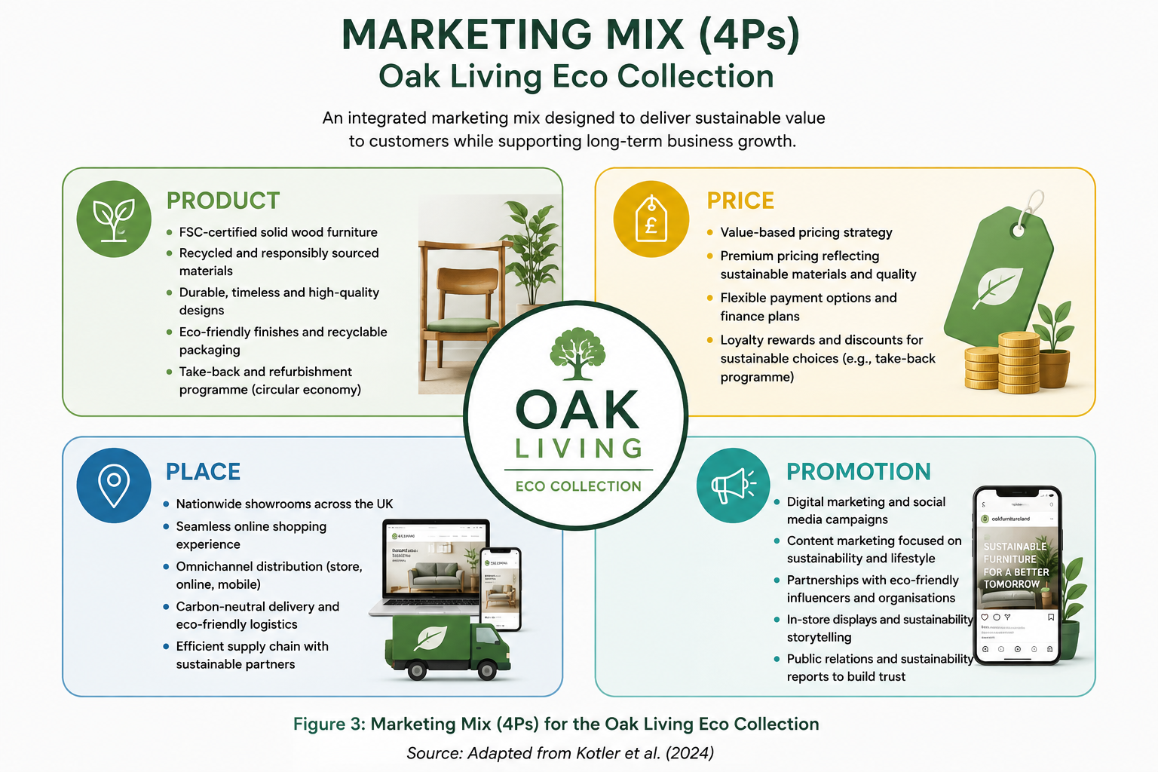
Figure 1: Marketing Mix 4Ps
(Source: Self-made)

Element 4: Reflection
I enhanced my understanding of sustainability and strategic marketing through the development of the sustainable brand extension approach for Oak Furnitureland. In this project, I gained various practical experiences while applying different marketing approaches or theories, such as STDP and the marketing mix. This helped me learn the importance of business growth objectives with social and environmental responsibilities.
The most important was the increasing significance of sustainability for consumers' behaviour and buying choices (Weniger et al., 2023). Studying the concepts and trends in sustainable furniture gave me an awareness and understanding of how sustainability concepts and trends can provide an organisation with a competitive advantage in meeting evolving customer expectations. Furthermore, I gained enhanced analytical and critical thinking abilities and skills as I analyzed market opportunities, considered target groups and created marketing plans tailored to specific market groups and based on academic literature.
I got better at communicating and giving a presentation when I made a poster presentation. I found out the way to summarise a lot of information in an appealing, concise and visually interesting format and make sure that the key messages were conveyed. Additionally, by giving the presentation, I gained confidence in presenting professional ideas and answering questions that might arise during the presentation (Theobald, 2026). Based on professional and personal perspectives, this task helped me enhance my knowledge on strategic-descision making, problem solving and research abilities. All these sets of skills are crucial for marketing roles and future management. Moreover, I also found that I can enhance my presentation skills and data analysis by gathering more experience on marketing tools and opportunities in public speaking.

Reference List
Abedian, M., Amindoust, A., Maddahi, R. and Jouzdani, J., 2022. A game theory approach to selecting marketing-mix strategies. Journal of Advances in Management Research, 19(1), pp.139-158. https://www.emerald.com/jamr/article/19/1/139/211517
Abu Seman, N.A. and Segar, V., 2023. The impact of digital marketing channels on consumer buying decision. Journal of International Business, Economics and Entrepreneurship (JIBE), 8(1), pp.42-53.https://ir.uitm.edu.my/id/eprint/84182/
Al Darwish, L., 2023. Green furniture: sustainability, consumer choice, and market analysis in an evolving landscape. OCAD University. https://openresearch.ocadu.ca/id/eprint/4071/
Al-Nuaimi, S.R. and Al-Ghamdi, S.G., 2022. Sustainable consumption and education for sustainability in higher education. Sustainability, 14(12), p.7255. https://www.mdpi.com/2071-1050/14/12/7255
Andersson, S., Svensson, G., Molina‐Castillo, F.J., Otero‐Neira, C., Lindgren, J., Karlsson, N.P. and Laurell, H., 2022. Sustainable development—Direct and indirect effects between economic, social, and environmental dimensions in business practices. Corporate Social Responsibility and Environmental Management, 29(5), pp.1158-1172. https://onlinelibrary.wiley.com/doi/abs/10.1002/csr.2261
Arnett, D.B., 2024. Market segmentation strategy, target markets, and competitors: a resource-advantage theory perspective. Journal of Marketing Management, 40(13-14), pp.1269-1285. https://www.tandfonline.com/doi/abs/10.1080/0267257X.2024.2391367
Hasan, M., 2026. QR-based durable labeling for digital product passports in fashion industry (Doctoral dissertation, Kauno technologijos universitetas.). https://epubl.ktu.edu/object/elaba:269083756/
Kazakova, E. and Lee, J., 2022. Sustainable manufacturing for a circular economy. Sustainability, 14(24), p.17010. https://www.mdpi.com/2071-1050/14/24/17010
Oak Furnitureland (2026). Oak Furniture and Sofas | Oak Furnitureland. [online] Oakfurnitureland.co.uk. Available at: https://www.oakfurnitureland.co.uk/?srsltid=AfmBOoqCWM8KaJRfVq8ZMP-6ZmZvOHXqkOkmjdWICqhidpfVgc6vyiBs.
Pituşcan, F. and Ioncu, O., 2024. Product Positioning Strategies in the Market as a Marketing Tool. Economy Transdisciplinarity Cognition, 27(2), pp.158-168. https://search.proquest.com/openview/2dcc0ff0542ab5dfca3b9b34519708f2/1?pq-origsite=gscholar&cbl=266695
Plakantonaki, S., Kiskira, K., Zacharopoulos, N., Chronis, I., Coelho, F., Togiani, A., Kalkanis, K. and Priniotakis, G., 2023. A review of sustainability standards and ecolabeling in the textile industry. Sustainability, 15(15), p.11589. https://onlinelibrary.wiley.com/doi/abs/10.1111/ajes.12459
Sosa, T., 2023. How does personality influence the willingness to pay for sustainable wood-based products in Italy?. https://unitesi.unive.it/handle/20.500.14247/6648
Sun, Z.Q. and Yoon, S.J., 2022. What makes people pay premium price for eco-friendly products? The effects of ethical consumption consciousness, CSR, and product quality. Sustainability, 14(23), p.15513. https://www.mdpi.com/2071-1050/14/23/15513
Tetteh, F.K., Owusu Kwateng, K. and Mensah, J., 2025. Enhancing carbon neutral supply chain performance: can green logistics and pressure from supply chain stakeholders make any differences?. Sustainability Accounting, Management and Policy Journal, 16(2), pp.521-551. https://www.emerald.com/sampj/article/16/2/521/1243211 ]
Theobald, T., 2026. How to Develop Your Presentation Skills: Inspire and Inform with Clarity and Confidence. Kogan Page Publishers. https://books.google.com/books?hl=en&lr=&id=NtigEQAAQBAJ&oi=fnd&pg=PP1&dq=+by+giving+the+presentation,+I+gained+confidence+in+presenting+professional+ideas+and+answering+questions+that+might+arise+during+the+presentation&ots=R6WqLvehBU&sig=YBweUWfN3wROOnGkf-gOzusjSmI
Trzcielinski, S. and Pawlowski, G., 2024, September. Simulation of Discovering Market Opportunities Using AI Methods. In European Conference on Knowledge Management (pp. 1108-1117). Academic Conferences International Limited. https://search.proquest.com/openview/e3ace9562289d8cd2dfc46cb62e16fa1/1?pq-origsite=gscholar&cbl=1796412
Weniger, A., Del Rosario, P., Backes, J.G. and Traverso, M., 2023. Consumer behavior and sustainability in the construction industry—relevance of sustainability-related criteria in purchasing decision. Buildings, 13(3), p.638. https://www.mdpi.com/2075-5309/13/3/638?utm_source=releaseissue&utm_medium=email&utm_campaign=releaseissue_buildings&utm_term=titlelink214&recipient=salnapitt.3@gmail.com&subject=Buildings%2C%20Volume%2013%2C%20Issue%203%20%28March%202023%29%20Table%20of%20Contents&campaign=ReleaseIssue
Yang, J., Reza, M.N.H., Al Mamun, A., Masud, M.M. and Rahman, M.R.C.A., 2024. Predicting guest satisfaction and willingness to pay premium prices for green hotels. Humanities and Social Sciences Communications, 11(1), pp.1-13. https://www.nature.com/articles/s41599-024-04024-y

