Digital Skills and Research Methods
Student Name:Crina-Alina Dolea
Student Number:1813665
Module Leader:Joy Botu
Module No:BMSK4003
Assessment Title:

Contents
1.0 Introduction: 3
2.0 Evaluation of Effectiveness of Modern Technologies in the Workplace: 4
2.1 Usefulness of Cloud Storage: 4
2.1.1 Scalability: 4
2.1.2 Cost Savings: 4
2.1.3 Flexibility 4
2.1.4 Security Concerns and Data Recovery: 5
2.2 Contributions of Virtual Learning Environment (VLE): 5
2.3 Effectiveness of Social Media Tools: 6
2.3.1 Social Media for Marketing: Facebook 6
2.3.2 Social Media for Communication: 9
2.3.3 Social Media for Information Gathering: 9
3.0 Social and Professional Networks to create Professional Online Presence to Improve Employability: 11
3.1 Creation of Professional Online Presence: 11
3.2 Facebook, Twitter, and LinkedIn Accounts: 11
4.0 Conclusion: 12
5.0 References: 13

1.0 Introduction:
The report developed can be divided into two segments, that is, the effectiveness of social media for marketing, information gathering, and communication and the contribution of social and professional network for ensuring the professional online presence to boost the employability. The social media for marketing comprises the identification of the target market, management of the marketing mix, and promotion of customer and brand engagement. The communication through social media focused on social media that can be used to communicate and the added convenience from using the social media platform for communication purpose. As the companies require all the related and relevant information for rational and optimal decision-making, they need to gather and manage the information first, which constituted the last segment of the first topic. The second topic provided insights about how the social and professional network stimulates the professional online presence and how it improves the employability.

2.0 Evaluation of Effectiveness of Modern Technologies in the Workplace:
The companies rely on technologies to invite efficiency in their operations and the first adopter of sophisticated technology is rewarded with the competitive edge in the marketplace. Other than bringing efficiency, the technological infrastructure often saves costs, accelerate the R&D, evade human-related problems, etc.

2.1 Usefulness of Cloud Storage:
The companies can either develop their data management infrastructure or the can avail the same services from a cloud storage service providers like Google, Microsoft, Amazon, etc. for subscription fees without installing the data management tools inside the organisation.

2.1.1 Scalability:
The scalability of the business may require scaling up or down the business operations, which will need new resources or replacing some of the old resources. Either possibility will require the firms to commit a reasonable amount of funds, which may adversely affect the growth plans of the company (Yuhuan, 2017). However, if the company relies on cloud storage, they need not bother about such changes; the service provider will deliver the services of the new technology, perhaps for an additional payment.

2.1.2 Cost Savings:
As mentioned already, the company need not commit investible funds to procure IT equipment to establish in-house data management infrastructure as the company can get the services under the arrangement of SaaS (Software as a Service), IaaS (Infrastructure as a Service) or PaaS (Platform as a Service) in exchange for subscription fees. The company can save costs like opportunity costs, interest expense (if financed with debt), and maintenance costs by resorting to cloud storage services.

2.1.3 Flexibility
The flexibility offered by the cloud storage also increased its usage and importance in different activities within and outside the workplace because it allows the users or staffs to amass data on and get access to cloud storage on different devices other than the devices at the workplace from anywhere.

2.1.4 Security Concerns and Data Recovery:
It is difficult for SMEs to develop an IT infrastructure and protect it from cybercrime due to a shortage of funds, the limitation, which they can avoid by subscribing to the cloud storage services, the security system of which is too stern to breach (Sarngadharan and Minimol, 2016). In addition, data loss has become a great concern for business and permanent loss of data may even question the sustainability of the businesses. If the companies resort to cloud services, they can get a guarantee to recover data up to a certain date.

2.2 Contributions of Virtual Learning Environment (VLE):
The success or failure of the business heavily depends on the efficacy with which management carries out its operations that comes from the expertise and experience of the organisation’s employees. The skilled and experienced personnel of the firm increases the likelihood that the company will pinpoint the value-additive operations (Campling, 2015) and remove the non-value-additive activities to bring efficiency in the operations of the firm.
The virtual learning environment can be referred as a distance learning platform encompassing study materials, tests, assessments and feedback, homework, etc. that provides the employee the flexibility to learn further (Teare, 2018). The companies can even integrate the VLE with their ERP or LMS systems and tie the benefit and bonus plans of the employees with the enrollment and achievement of certificates on different courses that shows the career path and facilitates the talent management of the company.
The VLE updates and increases the knowledge of the employees regarding different fields of the business, for example, supply-chain risk management, data analytics, machine learning, etc. The affordability of the VLE has increased its appeal to the organisations as the online course providers charge less than the amount the company would have to pay if they arranged something in their workplaces.

2.3 Effectiveness of Social Media Tools:
The online social media sites are becoming an important platform for companies to place their advertisements, communicate with customers, employees and other parties, and gather and disseminate information.

2.3.1 Social Media for Marketing: Facebook
Every component of the marketing mix is affected by the burgeoning presence of the customers on social media. Hence, companies rely on standardised and customised social media tools to market their products.
2.3.1.1 Identifying Target Customers:
The first step in formulating marketing strategy is to identify the target customer segment clearly. The company can use the Facebook platform and can survey through their Facebook pages that will allow the company to find their target customers on social media using social intelligence. In addition, the company relies on push marketing, that is, the company can use the plat to discover customers for its products.
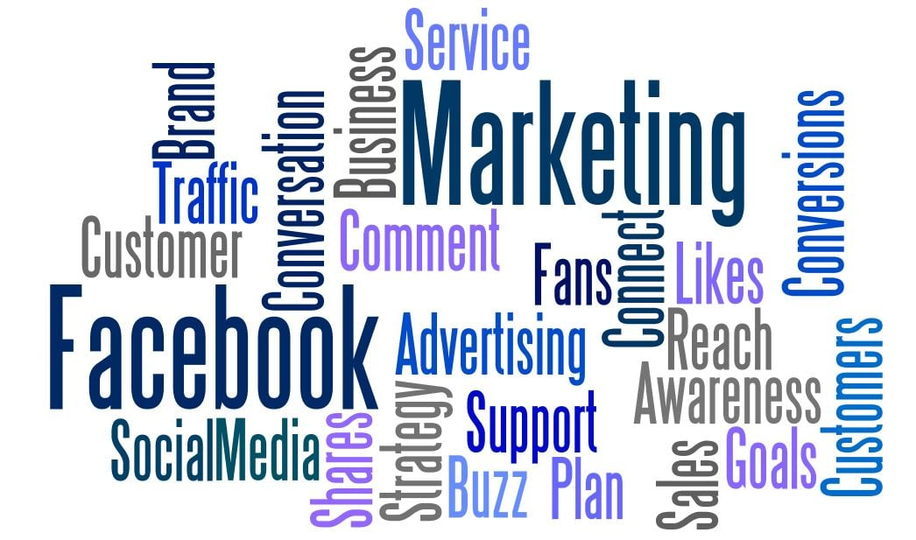
Figure 1: Ways for finding target customer using Facebook, Source: (Agency, 2019)
2.3.1.2 Managing the Marketing Mix: 4Ps
The company can rely Facebook Analytic s, to gather the data of consumers from social media sites and examine them to design their products and services that will attract them. The analysis on the customer will also provide insights about the price the customers may be willing to pay and the mode of delivery system they may prefer, even the social media like Facebook can be used to take orders online for home delivery (Pant, 2016). Finally, the companies undertake promotional strategies to introduce customers with the benefits of the products and services and stimulate them to make a purchase.

Figure 2: Social media marketing through Facebook platform, Source: (Periyakoil, 2017)
The company first should determine the type of Facebook ads e.g. photo ad, video, carousal, slide show, collection, instant experience, lead, dynamic, messenger, etc. ads the company wants to post for developing advertising or promotional contents. The companies can the formulate their advertisement strategies and contents according to the needs and requirements of the type of ads to be used, message to be delivered etc. and then can post them in the social media sites like Facebook, WhatsApp, etc. based on the customer segments
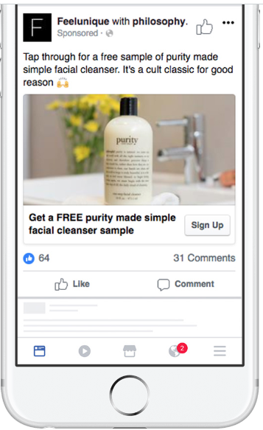.
Figure 3: Lead ads for attracting customers, Source: (Ashley and Tuten, 2018)
2.3.1.3 Customer Engagement with Brands:
Consumer-generated contents and customer engagement are two popular concepts in marketing contents, which proved benediction for a marketer (Moliner, Monferrer-Tirado, and Estrada-Guillén, 2018). The companies find it convenient to engage customer using the Facebook page or Facebook group to facilitate the engagement of customers and promote a sense of belongingness to a community. The customer engagement culminates in customer satisfaction and customer retention, which increased its appeal to marketers.

2.3.2 Social Media for Communication:
Social media can also be used to communicate with the employees, existing customers, potential customers, the public, and other stakeholders. The customers can present any of their complaints regarding the products and services via Facebook pages, messenger chat box of the company, etc. so that the company can provide solutions promptly to pacify the agitated customer who might otherwise be lost. The companies can also conduct surveys using google forms or creating a poll in the Facebook pages to collect the responses of the customer pertaining to certain issues.
The employees who are away from the workplaces can be communicated via Facebook messenger and WhatsApp messenger, which allow efficient communication with technically no cost. In addition, the cross-functional teams scattered in different geographic locations can communicate with each other via the social media sites like Facebook Messenger, WhatsApp, etc. to share important information on a timely basis. The companies can contact with other constituencies like suppliers, distributors, public, vulnerable community, government agencies, etc. using Facebook as well, which increased its appeal to companies.

2.3.3 Social Media for Information Gathering:
Businesses generate and collect data from diverse sources to consider the 360-degree view of an issue to arrive at an appropriate decision. Whether the company needs to analyse the preferences of the customers to develop the advertising strategies, the company wants to innovate a new product or introduce new services, it needs to examine a large set of data (Etzel, Walker and Stanton, 2017), which is known as big data analytic s to incorporate all related factors in the decision-making process.
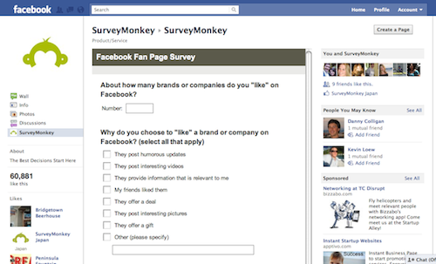
Figure 4: Facebook Platform for information gathering, Source: (Khan, 2018)
The social media tools like Facebook analytics (a paid service) offer an excellent bundle of services to gather the data plucking out the unnecessary data to include the data in the databank. This social media tool enable the companies to collect data related to customer behaviour and preferences from their posts, engagement with different Facebook groups and pages. The companies can either accumulate the data on their database or cloud storage to use them in the future to analyse the trends to become the early adopter to gain a competitive advantage.

3.0 Social and Professional Networks to create Professional Online Presence to Improve Employability:

3.1 Creation of Professional Online Presence:
The social and professional interactions result in the creation of networks that promotes cooperation, information sharing, and trust among each other. As the businesses need to collaborate with different parties to create the value for customers (Czinkota, Ronkainen and Sutton-Brady, 2018), which is apparent from their supply and value chain, the companies prefer employees with better networking skills to skim off the benefits of their existing and potential networks.
The surge in the popularity of social media and other online communication tools, it has become important for professionals to maintain their online presence to communicate with different parties. The existing social and professional network promotes professional online presence because online communication and interaction are more convenient, flexible, and cost-effective than offline communication.
The professionals may have knowledge regarding some specific aspects of the business and may lack specialised knowledge regarding legal issues, risk management, financial management, etc. which may require the professionals to resort to other professionals who have specialised knowledge pertaining to those areas. Hence, networking with professionals from diverse background helps to gather insights about the aspects the professional may have insufficient knowledge. The networking can also be used to avail compatible employment opportunities. Thus the knowledge and information sharing can ameliorate the employability of the professionals.

3.2 Facebook, Twitter, and LinkedIn Accounts:
Serial Number | Social and Professional Media | Id of or Link to Accounts
1 | LinkedIn | https://www.linkedin.com.in/Alina
2 | Twitter | https://www.twitter.com/CrinaAlina
3 | Facebook | https://www.facebook.com/Crina.Alina

4.0 Conclusion:
The undertaking of this report analysed the contribution of social media tools for different purposes that is, marketing, teamwork, communication, information gathering, etc. The social media tools used can be tailored to the individual needs of the companies to cater to their specific objectives. Social media marketing has become a hot topic for the marketer, which drives them towards taking steps to improve the marketing ingredients to develop a better marketing mix every time to outperform the competitor and achieve the aims and objectives of the company. The analysis also divulged that the way the social media tools facilitate communication with different stakeholders of the company as well as the way companies use social media tools to garner important information. Lastly, the report described how the networks both the social and professional one can stimulate the online presence of the professionals to improve their employability.

5.0 References:
Agency, M. (2019). Social Media | Digital Advertising Agency | Miller Ad Agency. [online] Milleradagency.com. Available at: https://www.milleradagency.com/Digital-Marketing/Social-Media [Accessed 4 Apr. 2019].
Ashley, C. and Tuten, T. (2018). Creative Strategies in Social Media Marketing: An Exploratory Study of Branded Social Content and Consumer Engagement. Psychology & Marketing, 32(1), pp.15-27.
Campling, J. (2015). Management. Milton, Qld.: John Wiley & Sons Australia.
Czinkota, M., Ronkainen, I. and Sutton-Brady, C. (2018). International Marketing. Melbourne: Cengage.
Etzel, M., Walker, B. and Stanton, W. (2017). Marketing. New York: McGraw-Hill.
Khan, R. (2018). Review: Social Media: Tools for User-Generated Content Social Drivers, Volume 1: State of the Art. Media International Australia, 134(1), pp.155-156.
Moliner, M., Monferrer-Tirado, D. and Estrada-Guillén, M. (2018). Consequences of customer engagement and customer self-brand connection. Journal of Services Marketing, 32(4), pp.387-399.
Pant, H. (2016). Advertising and media. Jaipur, India: ABD Publishers.
Periyakoil, P. (2017). Using Social Media Tools To Build an Active and Effective Social Media Presence about Palliative Care. Journal of Palliative Medicine, 16(6), pp.599-600.
Sarngadharan, M. and Minimol, M. (2016). Management Information System. New Delhi: Himalaya Pub. House.
Teare, R. (2018). Implementing virtual support for workplace learning. Journal of Workplace Learning, 10(2), pp.122-137.
Yuhuan, Q. (2017). Cloud Storage Technology. Big Data and Cloud Innovation, 1(1).

