Liliana Calin .
ID Number- -1818714.

EFFECTIVE TEAM WORKING AND COMMUNICATION

Table of Contents
INTRODUCTION 3
MODELS OF COMMUNICATION 4
BERLO MODEL 4
SCHRAMM MODEL 6
SHANNON AND WEAVER MODEL 6
COMMUNICATION SKILLS 8
CONCLUSION 12
REFERENCES 13
APPENDIX 14

INTRODUCTION
Communication is the ability of an individual to transfer or communicate information effectively, accurately, and correctly. Effective communication is required to achieve success in the workplace. Communication is the simplest way of transferring information and understanding what others say. This report focuses on various models and skills of effective communication along with poor communication at the workplace and ways to improve communication to achieve success (Turaga, 2016).

MODELS OF COMMUNICATION
Various models of communication which can be used at the workplace to achieve success by transferring right and accurate information are:

BERLO MODEL
This model is given by David Berlo and the model focuses on the four components that are sender, message, channel, and receiver to describe the process of communication and each component is affected by many factors that can lead to poor communication(Juneja, 2020). Components are as follows:
Sender
The sender is information source, message and person who originated the message. The sender deliver the information to the receiver and the sender needs to have effective communication skills to send the right information. The attitude of the sender toward self and reviver can affect the message. Knowledge about the subject of communication help in effective communication. Social system and culture also affect the message because a person something which is accepted in other culturemight be offensive in culture of other (Talukdar, 2017).
Message
The message is the information that the sender wants to communicate to the receiver. Message can be affected by content, elements like nonverbal things, treatment in which message is conveyed, structure, and codes that are language, text, etc. all these can create an impact on the message. For example unstructured messages with ineffective codes which employees unable to understand cerate difficulty in understanding the message of top authority effectively at my workplace. This can be improved when top authority send the message by arranging the information properly and using effective codes (Juneja, 2020).
Channel
This is the medium of transferring the information such as telephone, email, internet, etc. and communication flow through five sense of human being and it can affect the channel effectiveness. Such as in the case of Maria and Pedro due to a lack of effective listening Pedro misunderstood what Maria said to him and he comes back home without buying chicken (Talukdar, 2017).
Receiver
The person who gets the information or message sent through the communication process is known as receiver. Communication skills, attitude, knowledge, social system, and culture of the receiver also affect the message and that is this model believes that thinking patterns and other factors of receiver and sender must be the same because differences create poor communication. For example, in the workplace difference in the language of consumer and consumer representative of the company leads to poor communication because the consumer representative unable to understand what the consumer is saying and consumer problems and on the other hand consumer also did not get the information of representative (Juneja, 2020).
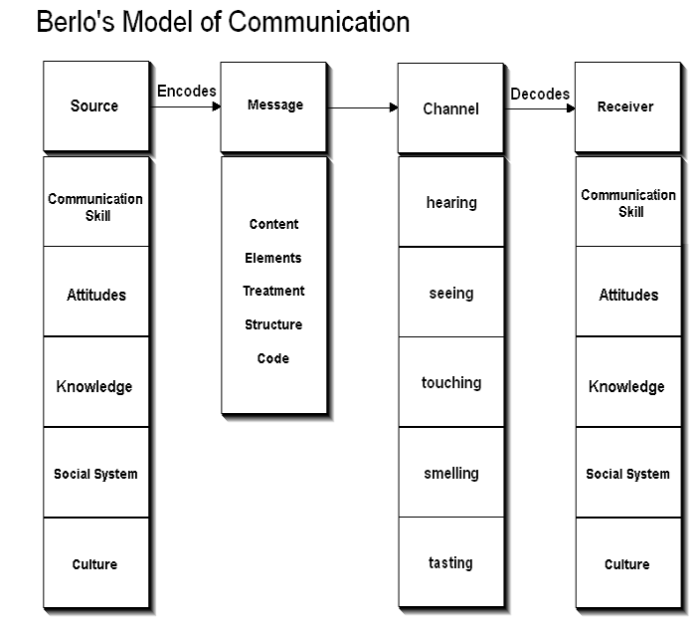
Figure: Berlo’s model
Source: (Talukdar, 2017)

SCHRAMM MODEL
This model of communications given by Wilber Schramm in 1954 and this model says that information when not putted into careful words and conveyed to others than such information is of no use.
Encoding plays significant role in communication because it initiates the communication process where the encoder converts the thoughts into message or content. It is the primary responsibility of the receiver to understand what the sender wants to convey. Unless and until the second party or receiver decodes or able to understand the information of the sender the message is actually of no use. Thus encoding and decoding of the message is a very significant factor for effective communication without which information cannot flow between the sender and receiver (Juneja, 2020).
This model emphasizes encoding and decoding as two essential processes of communication and communication are incomplete until the sender receives feedback from the recipient.
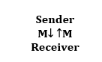
M- Stands for message
Schramm believes that knowledge, cultural background, and experience of individuals also plays a significant role in effective communication because individuals from diverse background, culture and religious interpret the message differently. This model concludes that when the sender sends the information it must be interpret by receiver in the desired form and send feedback to the sender (Juneja, 2020).
For example, when my supervisor said to the servant that as I am suffering from sore throat please bring something hot for me to drink and the servant brings the glass of lukewarm water because the servant did not interpret the message correctly. This poor communication occurs because of different background of both of them and this can be resolved if the supervisor sends him the message in the language which servant able to understand.

SHANNON AND WEAVER MODEL
This model includes the following components:
Information source (sender): sender is the person who covert the thoughts into information and chose a channel to transfer the information (Kubota, 2019).
Encoder: sender encodes the message using a technological channel or machines to convert the message into binary or single data (Drew, 2020).
Decoder (Receiver): receiver receives the message and decodes the message using a decoder machine to convert the single or binary data into a message which the receiver able to translate.
Destination: receiver or place is the destination of the message where the sender sends the information and the receiver provides feedback according to the message.
Noise: noise is the disturbance like people, sound, environment, etc. which does not let the message get to the recipients as what is sent by the sender (Kubota, 2019).
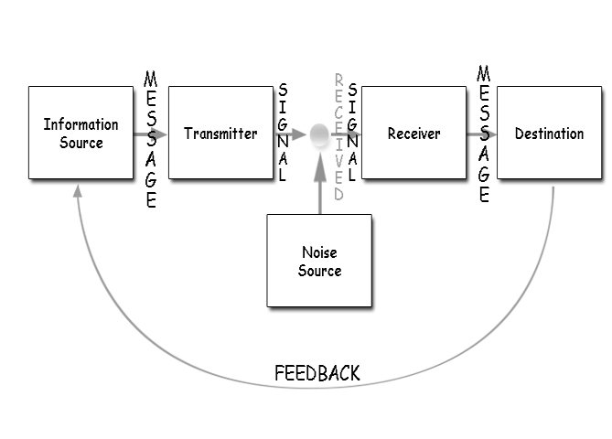
Figure: Shannon and Weaver model
Source:(Drew, 2020)
For example, in case of Maria and Pedro, Maria encodes the message and transfer the message to Pedro using telephone mode and Pedro decode the message in wrongly because he works at the building site where a lot of noise created difficulty in listening correctly and thus poor communication arises. Maria can prevent the wrong transmission of by message either by texting a message to Pedro or by asking the question to him that he understand what she said or not. Maria can also wait for the answer of Pedro that he understand the message correctly or Pedro also can provide feedback.

COMMUNICATION SKILLS
Communication skills help in effective communication as this enables to transfer the right information and understand the information of others correctly. Verbal and non-verbal are skills that can be used for effective communication.
VERBAL COMMUNICATION
These skills involve the use of words that is oral and spoken to share information with other people. It can include both written and spoken communication but mainly use spoken communication. Effective Verbal communication skills depend on the selection of work, how words are used and how words are reinforced with non—verbal communication that is facial expression, etc. all these affect the transmission of right and accurate information from one person to another (Doyle, 2018).
For example, at my workplace superior called us for a meeting and communicated verbally about what staff needs to do for the day. Superior speaks very fast and using technical words to us and staff members unable to understand what superior said. Superior leaves the room after completing but most of the staff members confused as they did not get to ask questions and clarification which could be risky because they need to complete the task in a day. In such a way it leads to poor communication. This can be avoided by the superior by making use of the right words that staff can understand easily, superior should speak patiently, and after completing the information superior should ask if anyone had a doubt, confusion, and query and should welcome the feedback of employees for effective communication (Doyle, 2018).
NON-VERBAL COMMUNICATION
Non-verbal communication skills include the use of gestures, postures, tone, body language, and signs. These non-verbal signs give additional information and clues over and above verbal communication. These skills are important to support the message, help in conveying the feelings, express the current condition, and indicate the desired action. An individual can understand the Non-verbal communication of the speaker by paying attention, picking up the non-verbal cues (Doyle, 2018).
For example, if someone speaks quietly with crossed arms or slouched shoulders it may a cue that person is feeling anxious or nervous and responded can respond empathically by smiling and holding open body language.
LISTENING SKILLS
Effective listening skills are required to accurately receive and interpret the message communicated in the communication process. Listening is very significant and many employers provide training for listening to their employees for enhancing consumer satisfaction (Khanna, 2020).
- Active listening: this is skills of listening that can be acquired with practice as it involves paying attention and not doing other things when someone is speaking. It involves listening with all senses. Active listening involves signs like posture, smile, eye contact, and others which shows that the individual is paying attention. Active listening is important because it helps in building connections with others, building trust, help in identifying and resolving conflicts (Khanna, 2020).
- Empathetic listening: this is the skill of being attentive and responsive to the input of others during the conversation as it involves trying to put oneself in the speaker's shoes. It supports and encourages the speaker rather than providing critics or advice. A good empathetic listener has the qualities of being present, trustworthiness, non-judgment, and responsiveness (Karunathilake and Witharana, 2020).
Effective listening is required to make communication effective such as in the case of Maria and Pedro if Pedro listens to the message of Maria actively than it can create effective communication. For example, at my workplace when the manager provided information every employee listens to the message effectively so that employees can understand the message effetely and ask questions if anyone has a query to provide a better and effective result (Karunathilake and Witharana, 2020).

POOR COMMUNICATION AT WORKPLACE
Effective communication at the workplace is important to achieve success whereas poor communication leads to the risk of failure. Poor communication can be arises at the workplace due to the wrong transmission of information, the use of ineffective words, lack of clear objectives, and cultural diversity at the workplace which cause wrong interpretation of information. Ineffective communication can disturb the working of employees as a result they feel frustrated which leads to a reduction in their productivity and performance. When poor communication occurs it is important to find out the causes of ineffective communication in order to resolve it.Poor communication at the workplace reduces the motivation of the employees which reduced employees’ potential to perform effectively. In such a way poor communication at the workplace can affect the profitability and success of organisations (Stich, 2020).
For example, leaders and employees at the workplace who refuse to communicate directly with the co-worker and make use of mail to communicate can leads to problems. In an organisation failure in listening to the co-worker can create a problem of miscommunication.
WAYS TO IMPROVE COMMUNICATION
- Communication is improved by learning basic verbal and non-verbal communication skills and avoiding rely on visual aids (Hall, 2016).
- By encouraging feedback from the receivers, managers, peers, and other members’ sender can improve their communication skills.
- The sender should communicate the message in the language as per the cultural background of the audience by using easily understandable works so that audience interprets the message right.
- Communication is improved by enhancing listening skills and developing questioning skills so that the speaker understands the opinions of others and responds accurately (Hall, 2016).

CONCLUSION
This report provided knowledge of effective communication to transfer the right information and interpreting the message of others correctly. The different model of communication such as Berlo's, Schramm, and Shannon Weaver communication models which shows the process of communication along with the examples of poor communication. Communication skills such as verbal, non-verbal, and listening is presented in this report which shows that these skills are significant for an effective communication process. Poor communication at the workplace and ways to improve communication are presented in this report.

REFERENCES
Doyle, A. (2018). Communication Skills for workplace success. The Balance Careers, last modified November, 4.
Drew, C. (2020). Shannon weaver model of communication. (online)available at; https://helpfulprofessor.com/shannon-weaver-model/. Last accessed on; 24th October 2020.
Hall, A. (2016). Exploring the workplace communication preferences of millennials. Journal of Organizational Culture, Communications and Conflict, 20, p.35.
Juneja, P. (2020). Berlo’s model of communication. (online)available at; https://www.managementstudyguide.com/berlo-model-of-communication.htm. Last accessed on; 23rd October 2020.
Juneja, P. (2020). Schramm’s model of communication. (online)available at; https://www.managementstudyguide.com/schramm-model-of-communication.htm. last accessed on; 25th October 2020.
Karunathilake, I. and Witharana, C. (2020). Take-Home: Communication Skills Can Be Taught. In Effective Medical Communication (pp. 257-266). Springer, Singapore.
Khanna, P. (2020). Techniques and Strategies to Develop Active Listening Skills: The Amour for Effective Communication across business organizations. The Achievers Journal: Journal of English Language, Literature and Culture, 6(3), pp.50-60.
Kubota, M. (2019). What is “Communication”?―Beyond the Shannon & Weaver’s Model―. International Journal, 13(1), pp.54-65.
Stich, J.F. (2020). A review of workplace stress in the virtual office. Intelligent Buildings International, pp.1-13.
Talukdar, H. (2017). The Different Models of Communication-Their Differences, Lacks and Integrity, and their Association to Real Life Communication. Asian Journal of Research in Social Sciences and Humanities, 7(8), pp.36-50.
Turaga, R. (2016). Organizational models of effective communication. IUP Journal of Soft Skills, 10(2), p.56.

APPENDIX


