

Module Name: Learning In The Digital Era
Module Code: BMBM4008
Assignment Name: Reflective VLOG
Student Name: Evelyn Jeannette Ramirez de Martinez
Student Number: 2520056
Lecturer: Ffion Cumberpatch
Deadline: 08th December 2025
Wordcount: 651
Video Link: Grabando-20251129_174006.mp4

My academic skills have increased over this course. At the beginning, I had only a basic understanding of researching, Harvard referencing, and using digital tools. I often didn´t know how to begin a task and felt frustrated, but the learning in the Digital Era module guided me. I learned how to analyse and evaluate resources using the CRAAP test (University of Wales Trinity Saint David, 2025), structure essays and presentations, make my writing clearer, and use different software confidently. They are important for professional life because clear communication, accurate research, and digital confidence are essential in workplaces where reliable information is expected.
A new ability I learned is how to reference using the Harvard style (Ellis, 2025, slides 2-40). In the past, before studying this module, I did not realise the importance, because I did not use to reference properly; now I understand that it helps me to prevent plagiarism. I give credit to someone else's idea, and support my arguments by quoting, paraphrasing, and summarising; using the correct citation in text and the reference list at the end of my work (Ellis, 2025, slides 10-12). When I started this course, referencing was confusing, but my confidence increased by practising. This ability is important in university and in jobs where getting the correct information matters.
Additionally, I learned that using the CRAAP test helped me to know if the source is trustworthy by checking if it is updated, relevant, to know who the author is, if I can verify the information, and the purpose of writing the text (University of Wales Trinity Saint David, 2025). I used to select the first information that I found on Google, but now I know what information I have to choose. This has made my work more reliable and taught me that research is not just about finding information, but about finding the right one. For example, when I was doing my first essay, I found many articles that didn’t meet the criteria because they weren’t updated, so I chose the updated ones, where I could check the author, relevance and the other criteria. This is important in my university work and especially in accounting, where the decisions I make need to be based on trustworthy information to avoid mistakes.
Although I have not used AI very much because I am concerned about academic dishonesty, it has supported me by explaining difficult words, giving me simple terms and examples. AI is useful for learning, but it is not accurate, so it is necessary to understand the importance of critical thinking and doing my own work, so I can really learn and develop by myself. I learned to use AI by checking the information it gives.
To find enough information for my assignments was one of my first difficulties. So, I started feeling desperate, but my lecturer explained how to use keywords in the university resources, such as the online library and Primo Research Assistant. This taught me that research requires patience and strategy, and I finished my assignments, which is a success for me.
Another obstacle was doing my first presentation because I was scared of speaking in public. After reflecting on my experience using Kolb’s Learning Theory, I realise that I don’t need to memorise everything (University of Wales Trinity Saint David, 2025). I will develop my presentation abilities by dedicating time to practice, as a result, it will help me to engage the audience, having visual contact and not reading from my notes. I feel more confident creating slides and preparing for speaking tasks (University of Wales Trinity Saint David, 2025).
One personal goal for the future is to apply all I have learned and the skills I have gained throughout my university journey to my professional life. I want to keep improving my academic, digital, and communication skills, as they will support my success and help me to become a confident professional.

REFERENCES
Ellis, L. (2025) 'UWTSD's Intro to Harvard Referencing' [Presentation slides]. BMBM4008 Learning in the Digital Era. Available at: https://moodle.uwtsd.ac.uk/course/section.php?id=182301 (Accessed: 01 December 2025).
University of Wales Trinity Saint David. (2025) 'Building your Student Toolkit', BMBM4008: Learning in the Digital Era. Available at: https://moodle.uwtsd.ac.uk/course/section.php?id=182299 (Accessed: 01 December 2025).

APPENDIX
I have created a Microsoft Excel book which helps me with the CRAAP Test.
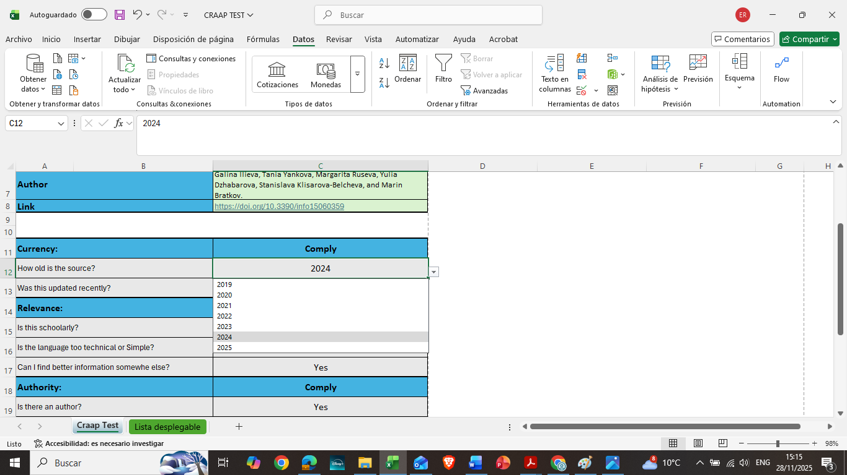

I read every single source, highlighting the most important information.
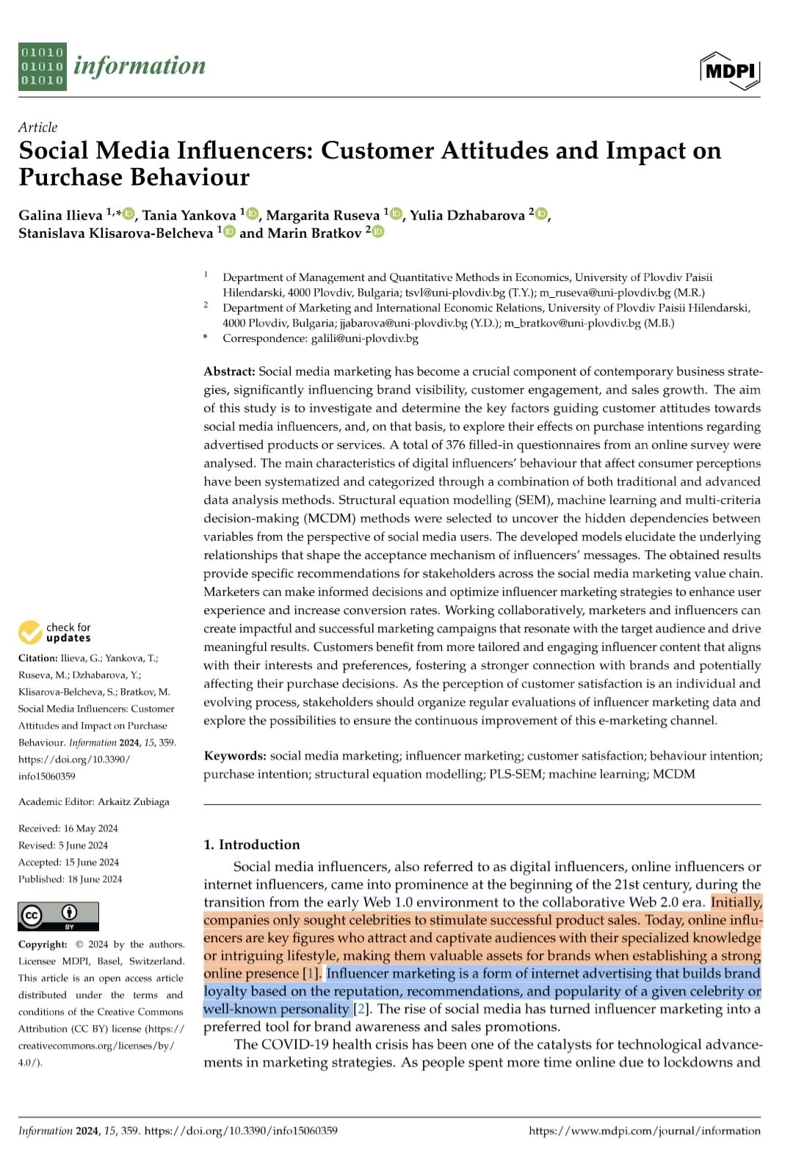
Then in my notes, I synthesise, paraphrase or summarise the information.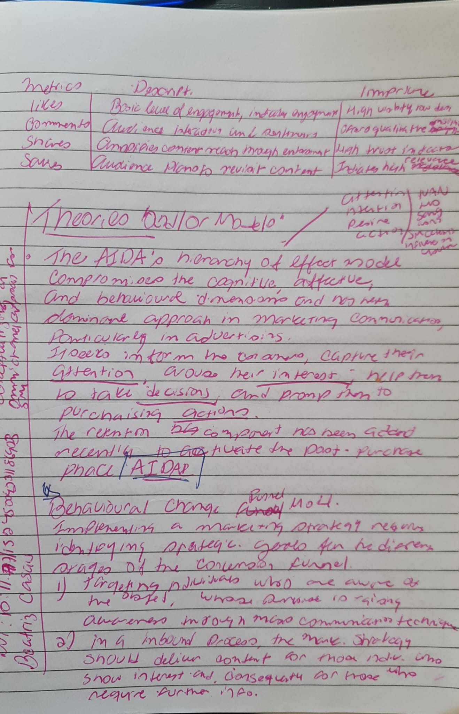

With my presentations and all my writings, I made a plan. It was a useful guide for my writing. 

