Academic Writing Report (Semester 2 2019/20)

Visualisation methods for big data

Introduction

The term “Big Data” is often overlooked by the lay person to be a term that is self-explanatory in its definition, however the concept itself is far broader than what can be explained in one single defining term. Roughly speaking, it is a field of information that comprises of many individual data sets which cannot be dealt with as one cohesive data set through traditional means within data-processing software. If visualisation is done incorrectly, those reading into the data will be overwhelmed in statistics and will waste a metaphorical information ‘gold-mine’. This “gold-mine” metaphor that I used to portray the strength and worth of information is also reinforced by Atul Butte the Biomedical and Biotechnology entrepreneur who said, “Hiding within the mounds of data is knowledge that could change the life of a patient, or change the world” [1] . This report will hopefully give the reader a precise and informative understanding on how these initially complex “Big Data” sets can be visualised to allow those who collect the information to identify correlation and make use of it.

What are the basic components of “Big Data” and what can data visualisation do to “Big Data”?

To understand the information that I will convey throughout this report, the brief explanation of the term “Big Data” given in the preceding introduction must be expanded upon. Throughout my research I came across several references to the “the 3 V’s” [2] they stand for “Volume”, “Variety” and “Velocity” which all help explain what qualities attribute to a large dataset that is not yet visualised. In the many individual datasets there are an increased amount of untraceable links of correlation. With the help of data visualisation methods, the 4th V known as “value” can then begin to take shape. The term “value” in context to Big Data is the information that is pieced together during the process of data analysis and can be translated to real world value. The value itself is buried within the trends that can be identified by the individuals who understand these patterns (data miners and data analysts).

Generic example:

For instance, if a conceptualised shopping company collected data on their customers. Through the process of collecting of data, after the initial volume, variety and velocity of values are distinguished and then visualised, the value of the trends within the numbers can be used by the company to identify trends in their customer’s actions. This holds real value for the person who has collected the information (the company) as they can then translate this data “value” into financial gain which would benefit this conceptualised company e.g send them suggested items that other’s in their social demographic purchase.

1.2 How do you turn many individual datasets in one ‘Big Data visualisation’?

In the process of data collection, the information/values are stored in to columns and rows within databases which are given context to create a metric. Data Analysts (individuals who work to identify trends in datasets) must resort to various increasingly advanced methods which present the information in more abstract forms than that of a basic pie chart or a bar chart to visualise this immense field of information. Depending on the data sets and the types of correlation in the data, those individuals who are visualising the Big Data are deciding what type of graph they will use. In the next chapter I will explain how the following factors affect the choice of data visualisation methods; geographical data, the volume of the data value sets and whether the specific data is subject to time. These are all factors that Data Analysts will need to consider during the process between collection of data and then how they will eventually convert this into a form of visualisation.

Methods of Data Visualisation

2.1.0 Two-Dimensional (2D) area graphs

The next three types of visualisation is what is considered “geospatial” [3]. This is when a graph conveys information that is a metric of geography.

Suitable for:

This method of visualisation can be extremely useful to those analysing data for large-scale geographical data such as depicting democratic election results, or representing a plethora of results from a population survey.

2.1.1 Area Cartogram

This is popular form to represent statistical variants within a population of a location. The example I’ve given is this map below of the U.S which increases in size and colour to express where both metrics of mountaineers and accidents combine in co-ordination to when the event occurred geographically.

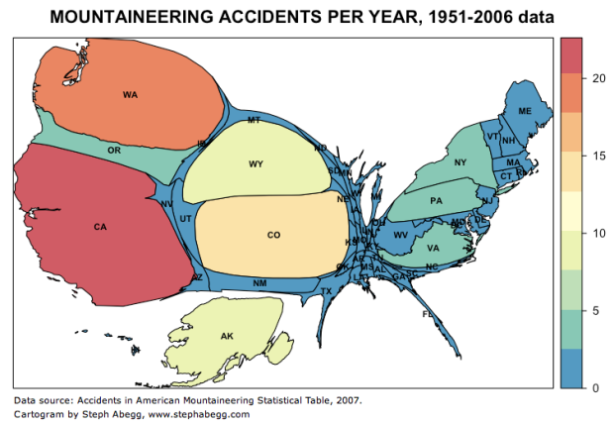[4]

2.1.2 Choropleth

The Choropleth visualisation is also used wide-spread to represent statistical variants within a population through geographical location, however to qualify as a Choropleth the graph must represent a geographical location that is showing changes in data by shading transitions or a change in the colours depending on their values. Here we can see the difference in age of a population throughout a country.

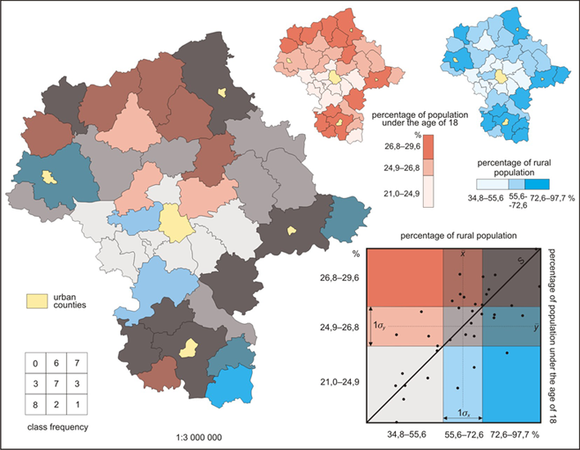[5]

2.1.3 Dot Distribution Map

This type of graph represents data through the use of dots on a location, this is a map that represents the population of the U.S. The variables increase in the dense sections of the map especially in major city areas such as Washington, New York and Los Angeles. This type of representation is simpler when compared to the previous two.

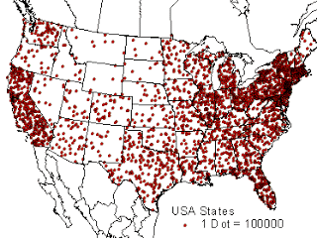[6]

2.2.0 Multidimensional Data Visualisations

The next three types of data visualisation are where a data analyst takes a dataset that conveys information that only requires values from only two correlating metrics. These values are not used to depict complex data which compares more than one data type, unlike the other types of visualisation. As these methods are the most popular for less complex data sets to be visualised there will be less detail in this section to save over explanation on a simple topic.

Suitable For:

This method of data visualisation is used to depict information that only requires two metrics to represent the data values. They are suitable to represent basic X and Y values that work with a dependant and independent variable relationship.

2.2.1 Pie Chart

Pie charts cluster results in data, into segments of a circle to represent different percentages of a total dataset.

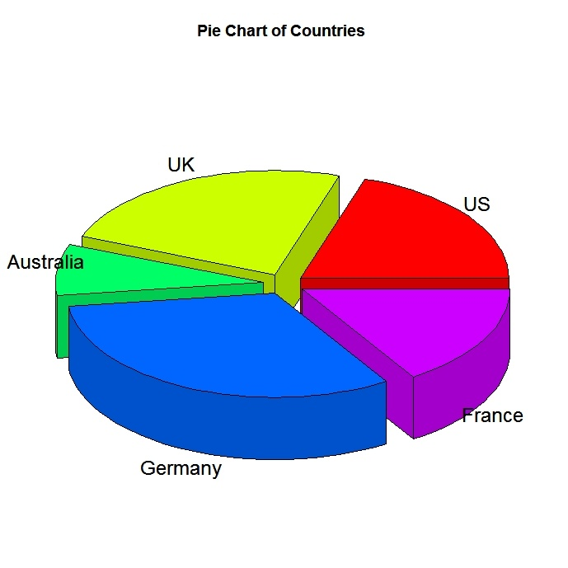[7]

2.2.2 Histogram

A histogram represents the data in blocks, this is particularly popular to measure frequencies of events over a period of time, however they aren’t dependant on time, just an X and Y axis.

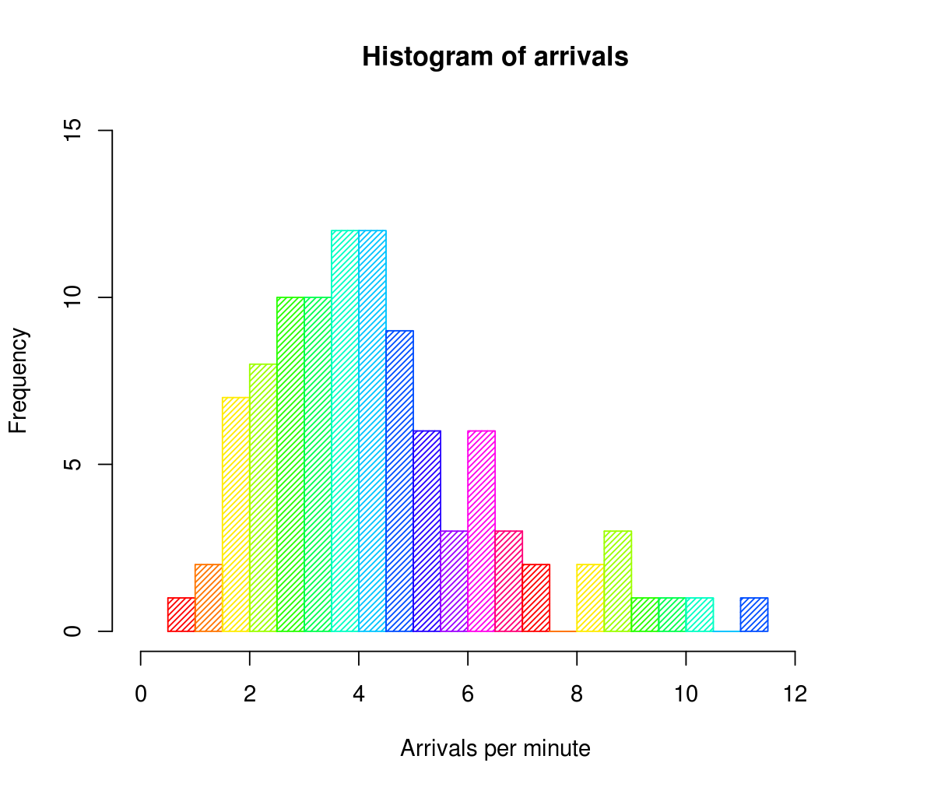
[8]

2.2.3 Scatter Plot

A scatter plot graph is mostly used to visualise both a dependant and independent variable to show trends that can usually follow a curve or gradient that can be spotted with little to no real insight into the data. From a glance at the example we can see that as height increases in the subjects so does their weight.

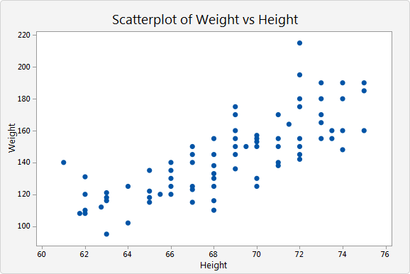[9]

2.3.0 Hierarchical data visualisation

Hierarchical methods of data visualisation links more directly to my explanations that I depicted throughout the introduction phase of the report. This type of data visualisation allows multiple datasets to be visualised in once instance instead of focusing on one particular dataset. These visualisations are connected through their relationships and correlation between variables.

Suitable For:

The following visualisations are particularly reliable for depicting the way datasets correlate. Not to be confused with an entity relationship model, this visualisation focuses on variable inside of datasets and not the information itself.

2.3.1 Dendrogram

Dendrograms are a form of statistical trees. They convey how various datasets can cascade between one another. As you can see from this example the various branches filter down into specific values that correlate to results from a different dataset. We can see the relationship between the Y axis data set and the X axis dataset.
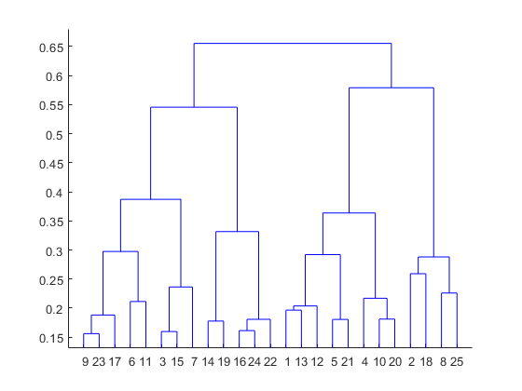[10]

2.3.2 Sunburst Chart

Sunburst charts are essentially more detailed pie charts. They follow a hierarchal visualisation that filters down into sub categories that relate to the preceding data set variable. In this example the correlation is geographical between the variables of continents, countries and cities.

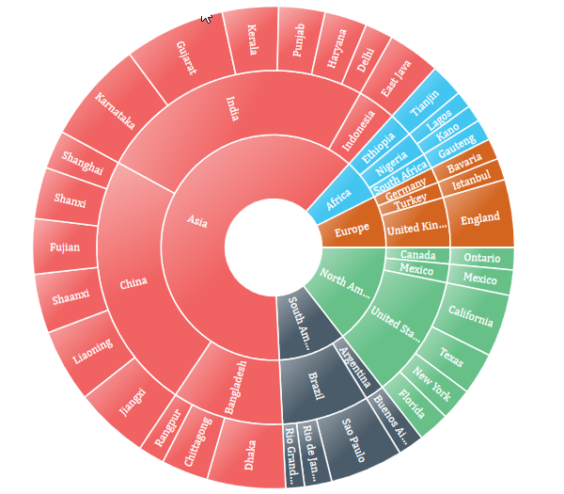 [11]

3.2.1 Other Methods:

In terms of conveying information there are endless forms of visualisation that are constantly being pioneered since as a species we are delving and discovering more information at a rate that is exponential. I have merely touched upon the first few meters of what I previously noted a metaphorical “Data Gold-Mine”. Network Data Models such as alluvial diagrams, node-linked diagrams and matrix’ have not been mentioned which convey comparisons between datasets as well as Temporal visualisation which are confined to time limits and how a metric will vary over a time period.

3.2.2 Conclusion

Throughout this report I hope that the main concept is evident of how important it is for people to be able to successfully take “Big Data” and visualise it. As Chris Lynch is cited to say “Big data is at the foundation of all the megatrends that are happening today” [12]. His point in context to mine reinforces the point that it is of pivotal importance that through visualisation, as a civilisation we can harness the power of statistics. I also must re-iterate the importance understanding of how the process of visualisation takes place. By identifying useful correlations, datasets can be gathered and displayed through means such as Hierarchical data visualisation.

References:

[1] https://med.stanford.edu/news/all-news/2012/07/stanford-medicine-magazine-examines-sciences-deluge-of-big-data.html

[2] https://itsvit.com/blog/big-data-visualization-principles/

[3] https://www.jisc.ac.uk/geospatial-data#

[4] https://edgeneration.wordpress.com/2016/08/27/using-cartograms-to-engage-students-with-maps/

[5] https://viscomvibz.wordpress.com/2012/03/17/the-pros-cons-of-choropleth-maps-blot-maps-patch-maps/

[6] http://wheredamapat.blogspot.com/2012/11/dot-distribution-map.html

[7] http://ww2.coastal.edu/kingw/statistics/R-tutorials/graphically.html

[8] https://en.wikipedia.org/wiki/File:Histogram_of_arrivals_per_minute.svg

[9] https://support.minitab.com/en-us/minitab-express/1/help-and-how-to/graphs/scatterplot/create-the-graph/choose-a-scatterplot/

[10] https://www.mathworks.com/help/stats/dendrogram.html

[11] https://www.syncfusion.com/products/wpf/sfsunburstchart

[12] Chris Lynch – Vertica Systems

Research material used but not quoted

https://study.com/academy/lesson/multidimensional-data-visualization-methods-examples.html

https://towardsdatascience.com/big-data-information-visualization-techniques-f29150dea190

