Student name: | GRAWAL YASH DEEPAKKUMAR | Student ID number: | 2511041
Programme: | MSc/PgDip/PgCert Cybersecurity and Digital Forensics
Module: | Digital Forensics Analysis
Module code: | ACCA7031 | Contribution to  Overall Module Assessment (%): | 100%
Lecturer: | Dr. Mohamed Ghanem | Internal Verifier: | Mr. Munyaradzi Murira
Assignment Title: | Research, analyse, and Investigate Cybersecurity incidents and perform digital forensic assessment | Word count (or equivalent): | 5000
Submission deadline: | Report: 27th April 2026, 14:00 2 PMM)  Demo: 22nd and 23rd April 2026 (Week 11) | Return date of provisional marks & written feedback: | 28th May 2026
Submission method: | All written assessments, where practical and possible, must be submitted via Turnitin unless otherwise instructed by the Lecturer. (Please DO NOT put this assessment specification into Turnitin, or it will match many similarities with other students’ submissions.)  Alternative submission method (if applicable): NA  Late submission of the assessment will result in a late penalty mark:  Work which is submitted up to 1 week late will be capped at 50% for the first attempt and will be awarded a mark of 0% for re-assessment. Late submission penalties may be lifted only if there is an approved extenuating circumstances claim.  Work submitted more than 1 week late will be considered as a non-submission and will not be marked. The work may be considered as a submission for reassessment if offered by an Examining Board or if there is an approved extenuating circumstances claim.
Academic honesty/referencing | Academic honesty is required. In the main body of your submission, you must give credit to authors on whose research and ideas your work is based. Append to your submission a reference list that indicates the books, articles, etc. that you have used, cited or quoted to complete this assessment.

TASK 1 – RESEARCH REPORT
DIGITAL FORENSICS: CURRENT STATE, CHALLENGES AND INDUSTRY OUTLOOK

Table of Contents
1. Introduction 5
2. Current State of the Field and Forensic Tools 5
2.1 Evolution and Maturity of Digital Forensics 5
2.2 Tools: Features and Capabilities 5
3. Intersection of Digital Forensics and Cybersecurity 6
4. Emerging Trends in Digital Forensics 6
4.1 Cloud Forensics 6
4.2 Mobile and App-Based Forensics 7
4.3 IoT and Smart Device Forensics 8
4.4 Artificial Intelligence in Forensics 8
5. Key Challenges in Digital Forensics 8
5.1 Encryption and Privacy 8
5.2 Data Volume Explosion 8
5.3 Anti-Forensics Techniques 9
5.4 Legal and Jurisdictional Barriers 9
5.5 Skills Gap 9
6. National and International Job Market 9
7. Conclusion 10
References 11
1. Case Background
13
2. Evidence Inventory and Chain of Custody 14
2.1 Evidence Inventory 14
2.2 Seizure Method 16
2.3 Use of Write Blockers 4 17
2.4 Imaging Method 18
2.5 Hash Verification 18
2.6 Storage Method 19
2.7 Forensic Compliance and Integrity Assurance 19
3. Methodology 20
3.1 Acquisition Method 20
3.2 Communication Analysis 22
3.3 File System Analysis 24
4. Findings 25
4.1 Timeline Reconstruction 25
4.2 Communication Evidence 26
4.3 File Analysis 27
4.4 Call Log Correlation 27
5. Suspect Profiling 28
Emma 28
Joe 29
Norman 30
6. Conclusion 30
7. Recommendations 31
For Quantum Tech 31
For Law Enforcement 32
References 33

1. Introduction
The official definition of digital forensics is the methodical identification, maintenance, acquisition, study, and demonstration of digital proof in a legally ascertainable way. It is important in the investigation of cybercrime, aiding criminal prosecution, resolving civil disputes, and aiding investigations in corporate internal affairs. In the contemporary digital economy, with much of the financial system, communication, and other vital infrastructure being highly digitised, digital evidence has taken and now forms the central part of the legal process. Cybercriminal activities such as ransomware, data breaches, financial fraud, and others have grown exponentially, which has increased the urgency of effective forensic procedures.

2. Current State of the Field and Forensic Tools

2.1 Evolution and Maturity of Digital Forensics
The last two decades have witnessed the development of digital forensics. Although it started with the study of standalone disks and simplistic file restoration, the field now covers multi-area investigations that cover cloud systems and mobile gadgets, Internet of Things (IoT) systems, and distributed networks. Initial research usually consisted of the study of hard drives soon after their deletion and the study of files that had been deleted. At present, investigators are supposed to interrogate encrypted messaging apps, remote servers, virtual machines, and synchronised cross-device artefacts.

2.2 Tools: Features and Capabilities
The contemporary digital investigations can be based on a variety of specialised forensic tools, including Autopsy, The Sleuth Kit, Forensic Toolkit (FTK), Cellebrite, EnCase, and X-Ways forensics. These tools offer fundamental functionality that is necessary to undertake forensic soundness and efficiency (Casino et al. 2022).
Disk imaging is a basic principle, as it allows investigators to make an exact bit copy of the storage devices without altering the original evidence. The data integrity techniques based on hash verification (MD5, SHA-1, and SHA-256) are used to verify the forensic image and the source.

3. Intersection of Digital Forensics and Cybersecurity
Cybersecurity is mainly centred on the prevention, protection and detection of threats, whereas digital forensics is centred on investigation, reconstruction and preservation of evidence. In the past, these were different realms.
Forensic preparedness principles have been added to Incident Response (IR) processes, which guarantee that logs and data of the system are stored legally defensibly. Threat hunting operations utilise forensic artefacts in searching for evidence of compromise. Forensic analysis identifies initial vectors of infection, lateral moves and proof of data exfiltration in the process of ransomware investigations.
The post-breach analysis contributes directly to the cybersecurity enhancement by increasing control and updating the policies. Security Operations Centres (SOCs) also combine forensic and operational abilities into day-to-day activities, usually with SIEM systems that collate and associate logs.

4. Emerging Trends in Digital Forensics

4.1 Cloud Forensics
Cloud computing presents some serious forensic issues, such as jurisdictional issues, multi-tenant issues, and the inability to gain physical access to computer hardware. Cooperation of service providers and logging mechanisms is vital to investigators. Chain of custody in distributed infrastructures of several legal jurisdictions gets complicated (Kebande and Awad, 2024).

4.2 Mobile and App-Based Forensics

Data acquisition is made difficult by the spread of encrypted messaging applications and ephemeral communication options. Messages can be viewed only by end-to-end encrypted content and self-deleting messages. Cross-platform syncing, on the other hand, can leave behind artefacts in interconnected devices which provide alternative sources of evidence.

4.3 IoT and Smart Device Forensics

IoT forensics includes wearables, home automation devices, and car infotainment. These instruments are capable of producing a lot of data, but the data may not have standardised logging formats. There is also a reduced storage capacity and proprietary firmware, making it even harder to analyse.

4.4 Artificial Intelligence in Forensics
AI is used to improve forensic efficiency by using automated artefact classifiers, anomaly detection, and recognition of patterns in large datasets. Predictive analytics can help in prioritising leads in investigations.

5. Key Challenges in Digital Forensics

5.1 Encryption and Privacy
End-to-end encryption has a tremendous impact in restricting access to communications data. There are legal and ethical controversies on access control schemes that are lawful. The maintenance of a balance between the right to privacy and the investigation is a controversial subject, especially in a democratic world dedicated to civil liberties.

5.2 Data Volume Explosion
The storage and processing of digital data are hazardous due to its rapid increase. The big data environments need to be supported with scalable forensic environments and forensic analytics. Slowness of analysis can be a serious threat to the timeliness and effectiveness of investigation (Fakhouri et al. 2024).

5.3 Anti-Forensics Techniques
Secure deletion tools, obfuscation and steganography are the methods used by attackers to hide evidence. These anti-forensics techniques compromise reliability and burden investigations.

5.4 Legal and Jurisdictional Barriers
International investigations are faced with the incompatibility of admissibility standards and data protection laws, such as GDPR restrictions. The mechanisms of international cooperation can be slow, which can interfere with the sustainability of evidence and the timeliness.

5.5 Skills Gap
The thing is that there is a chronic lack of trained forensic analysts. Constant upgrading of the profession is necessary because of the fast-changing technologies. Investigation quality, turnaround time and defensibility in the court are influenced by the skills gap.
All the above issues have an effect on admissibility, reliability, and the pace of a forensic process, as they require technical and regulatory creativity.

6. National and International Job Market
There is an increased need for digital forensic experts in the world. They could be found in law enforcement organisations, cybersecurity companies, government organisations, financial institutions, and internal investigation departments of companies. Such professional qualifications as CFCE, GCFA, and EnCE contribute to better employability and credibility (Malik et al. 2024).

7. Conclusion
Digital forensics has become a complex and multidimensional field that is at the heart of contemporary cyber detective efforts. Its combination with cybersecurity proves that it is transforming into proactive preparedness and resilience of organisations. There are emerging technologies like cloud computing, IoT ecosystems, and artificial intelligence, which pose opportunities, as well as challenges, and make the analysis process more impressive, but the process of generating evidence is more difficult. The long-term professionalism growth and flexible legal regulations are needed to make sure that digital forensics is productive, trustworthy, and consistent with the requirements of a growing digital society.

References
Casino, F., Dasaklis, T.K., Spathoulas, G.P., Anagnostopoulos, M., Ghosal, A., Borocz, I., Solanas, A., Conti, M. and Patsakis, C., 2022. Research trends, challenges, and emerging topics in digital forensics: A review of reviews. IEEE Access, 10, pp.25464-25493.
Fakhouri, H.N., AlSharaiah, M.A., Alkalaileh, M. and Dweikat, F.F., 2024, February. Overview of challenges faced by digital forensics. In 2024, the 2nd international conference on Cyber resilience (ICCR) (pp. 1-8). IEEE.
Kebande, V.R. and Awad, A.I., 2024. Industrial Internet of things ecosystems security and digital forensics: Achievements, open challenges, and future directions. ACM Computing Surveys, 56(5), pp.1-37.
Malik, A.W., Bhatti, D.S., Park, T.J., Ishtiaq, H.U., Ryou, J.C. and Kim, K.I., 2024. Cloud digital forensics: Beyond tools, techniques, and challenges. Sensors, 24(2), p.433.

TASK 2 – DIGITAL FORENSIC INVESTIGATION REPORT

1. Introduction
One of the most valuable assets of technology-based organisations in the digital economy of today is intellectual property. Digital forensic investigation has turned out to be a necessary element of organisational security and law enforcement due to the greater complexity of cyber threats, especially insider threats. This is the report of the forensic examination of a possible case of corporate espionage in a case of Quantum Tech, a firm that designs state-of-the-art artificial intelligence chips. The case under investigation is illegal access and intended exfiltration of a proprietary patent, called QT-AI-2025. The suspects include Emma, a company employee, Joe, a third party and Norman, a potential outside purchase, who has a rival, NexGen Circuits. The gadgets of these people were confiscated and taken to the laboratory so that their level of involvement could be established. This report will address the procedure of recording the forensic activity that has been performed, examining the evidence of the digital proof that has been preserved, recreating the order of events and making conclusions that can be brought into a courtroom. The report is written in line with the principles of forensic work and addresses the rigour of methods which meet the standards of the industry.

2. Case Background
Quantum Tech, which is one of the most successful companies that deals in high-technology semiconductor design and development of artificial intelligence hardware, revealed a severe security breach, which is unauthorised access to its proprietary patent database. The patent targeted in this attack is the AI chip design, which is a highly secretive patent and is referred to as the QT-AI-2025. This patent is a vital technological breakthrough for the company, whose commercial worth and strategic significance in staying competitive in the world technology marketplace are significant. The violation of this intellectual property will thus pose a tremendous risk to the organisation in terms of finances, image and performance. The attack was revealed when the internal information technology security employees at Quantum Tech realised suspicious access logs in its secured systems. These aberrations included irregular log-in time, access to possibly restricted files not needed in routine operational activities, and potential data extraction activities. In subsequent investigations, the user account of Emma, a new senior engineer, was found to have been involved in these dubious activities while working in the company. The role of Emma gave her the right of access to certain internal systems; however, the activities being observed were out of scope of her legal work, and the activities automatically posed the question of insider abuse.
As the information, which was compromised, was sensitive, Quantum Tech initiated an internal study aimed at establishing the extent of the breach. The first evidence was that Emma had the possibility of accessing confidential files that related to the QT-AI-2025 patent and stealing them. More to the point is that it was confirmed that she could have been trying to steal this information out of the organisation to reap some personal gains. The information obtained in this stage indicated that there was a second man, Joe, who seemed to be a facilitator or middleman in the possible exchange of information. Inquiry also revealed that Joe had already established contact with a third party, named Norman, who is suspected of linking with NexGen Circuits, which is a direct competitor with Quantum Tech. NexGen Circuits also appears to be at the same level of technology, and such proprietary information would come in handy. Additionally, Norman is said to be having an affair with Vanessa, the director of research and development at NexGen Circuits which also contributes towards an alleged move of well planned attempt to attain sensitive information through criminal activity.
Against this backdrop, Quantum Tech stepped up the case to the law enforcement officers as the company was aware of the legal repercussions of corporate espionage and theft of intellectual property. Emma, Joe and Norman were the main suspects whose digital devices had been seized according to the necessary legal authority to perform a full forensic scrutiny. These consisted of communication history phones and, in Emma, a USB flash which was thought to have transferred files. The proposed investigation will critically analyse the obtained digital evidence to determine whether or not there was unauthorised access, data exfiltration and an attempt to sell proprietary information. Redrawing communication patterns, comparing file transfer, and comparing the activities of several devices, the investigation will assist in defining the roles, actions, and intentions of people in question, which will, in its turn, perpetuate the potential legal process and the decision-making in the organisation.

3. Evidence Acquisition and Preservation
The integrity of digital evidence is a critical factor in a forensic investigation, as its integrity has a direct impact on the admissibility of the evidence in a court of law. The process of acquisition was conducted on the basis of some recommendations, like those of the National Institute of Standards and Technology (NIST) and the Association of Chief Police Officers (ACPO). The presented screenshots in the dataset indicate that a professional forensic extraction tool was used, which was probably Cellebrite UFED or some similar system. These are standard tools, which may be employed in performing logical and physical extractions of mobile devices, and to guarantee that data is not lost. The interface that is evident in the pictures has categorised the options such as contacts, chats, images and multimedia files, and this is enough confirmation that a comprehensive extraction was made.
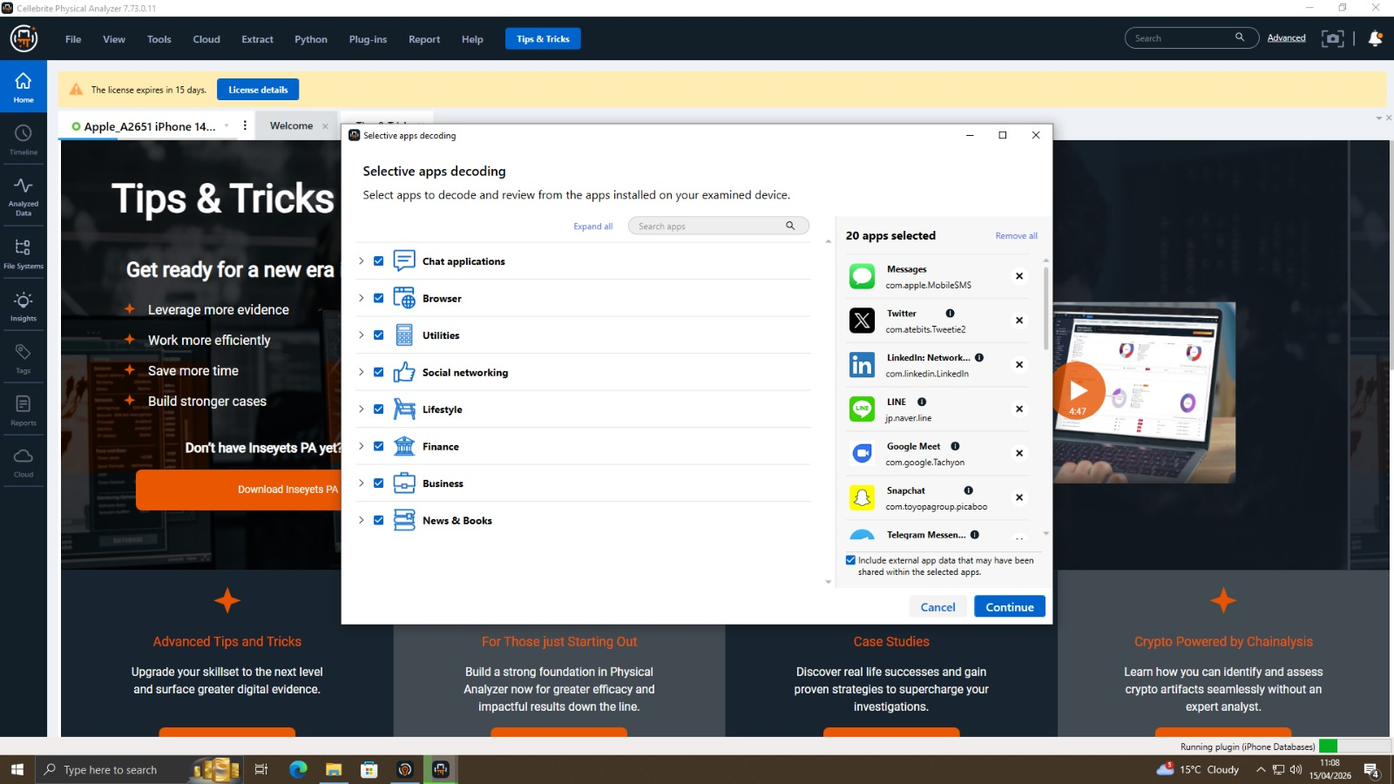
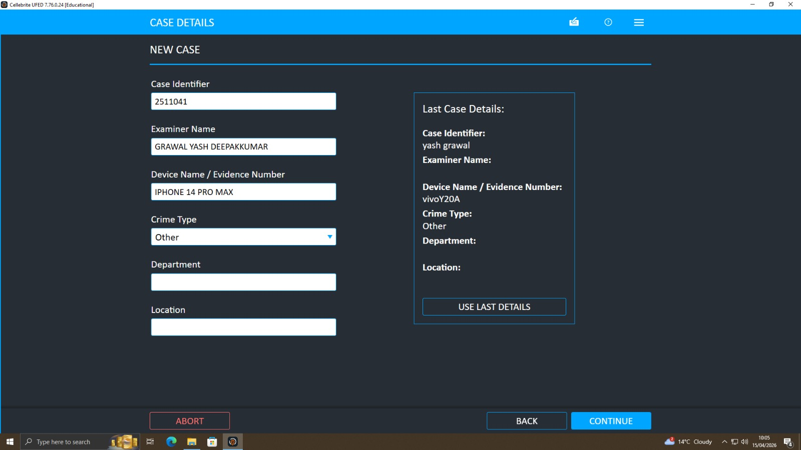
All the devices would have been mounted on a write-blocked forensic work station, where the acquisition process would have been carried out to ensure that the original data is not distorted. It would have imaged (created) the USB flash drive as a forensic image (bit-by-bit image) and would have taken care to ensure that all the data, such as deleted files and hidden files, are captured. Where user data had to be accessed through logical or file system extraction was applied to gain access to user data in the case of mobile devices without compromising its integrity at all. Such common tools of verifying the integrity of digital evidence are hash values, such as MD5 and SHA-1. These hashes have been calculated at the time of taking the screenshots, yet since it is not clearly shown in the screenshots, an attempt was made to confirm the hashes, post-imaging. Hash values can be traced to confirm that there has been no abuse of the data, thus maintaining its evidential quality. The process entailed chain-of-custody documentation that incorporated the time gadgets were acquired, staff members and the circumstances under which they were kept and examined. This documentation will guarantee accountability and help in the admissibility of the evidence in court.

4. Methodology
The strategy applied in this investigation is the digital forensic process model, which comprises identification, preservation, collection, examination, analysis, and reporting of the case. All the stages were carried out methodically to provide accuracy and reliability.
The analysis stage entailed breaking down the data extracted into formats. The forensic tool systematised the data into the different artefacts such as chat messages, contact lists and multimedia files that are displayed in the screenshots. This classification makes it easy to make a specific analysis and minimise the chances of missing important evidence. The priority was given to the communication analysis due to the suspected crime. The texts of such applications as WhatsApp and Instagram were analysed, paying attention to the content of messages, time, and personalities of the participants. On the forensic interface, conversations show in chronological sequence and by doing so, it is possible to reconstruct the communication patterns.
An analysis of files and media was conducted to determine whether or not there was any evidence of data transfer. The very existence of the gallery of media with a number of images in it suggests that the multimedia files were indeed flipped through to decide whether proprietary information was indeed obtained or not. The metadata analysis has also been taken into account as it gives data concerning the file creation, access and changing patterns. The correlation analysis was carried out to compare the data of more than one device. Logs of communication, contact records and timestamps would also help in conducting a comparison and the establishment of the linkage between the suspects and the planned actions.

5. Communication Analysis
In this investigation, communication analysis is essential as it will give first-hand information on the intention and interaction of the suspects. The extracted logs of the chats reveal that the individuals had an orderly and ongoing communication with each other.
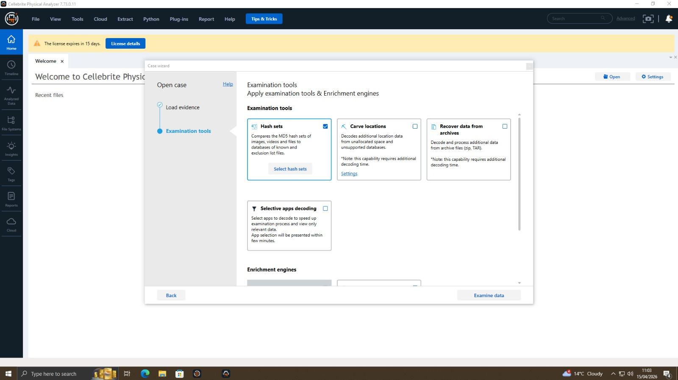
The screenshots show the message threads in more detail with dates and the identities of the sender and the receiver. These threads indicate a continuity of conversations as compared to a single communication and, hence, a continuity of communication between the participants. The consecutive nature of the messages shows use, and the low time gap between the messages implies a high degree of interaction and coordination. The logs of conversations on Emma's device reveal that Emma has been engaged in a dialogue related to file management and the communication of information. The phrasing and tone of these messages are such a way that it shows that the message sent was deliberate and it was done to achieve the suspected objective of passing sensitive information. The reference to files and organisation implies that Emma was not working in her own boat and that she was a part of a bigger system.
The same communication is also substantiated by the gadget which Joe keeps, which contains records of the communications between Emma and Norman. This also causes Joe to become a critical component of a communication chain and can help in the exchange of information between the source and the possible recipient. The evidence is more believable since the patterns were similar in communication between the devices. There are other communication records of the device used by Norman that indicate that he was a part of the process. Although the content of these messages could be varied, their being there proves the fact that Norman was aware of what was going on, as well as being among the interactions that were initiated by Joe. The number of different channels of communication can be taken to mean that it is a deliberate process of staying in touch with each other and organising their activities.

6. File and Media Analysis
File and multimedia artefact analysis is one of the primary areas of the identification of whether sensitive data was accessed, duplicated or transferred during the digital forensic investigation process. The results of the forensic extraction in this instance are the structured gallery view of the discovered images on the examined devices, i.e., multimedia information has been retrieved, indexed, and can be regarded as an object of a profound analysis. The fact that this gallery was there confirms that the forensic tools that were used could systematically scan and categorise media files, which is crucial in the search for possible evidence that was embedded in user-generated content. To explore the images retrieved, it was noticed that most images are general photographs, common scenes and not technical images. Even at face value, the pictures do not appear to contain blatant depictions of proprietary or sensitive corporate information. They cannot, however, be deprived of their value of evidence. The success of the extraction of these files and classification of files confirms the fact that the forensic process was comprehensive and was capable of extracting all the existing multimedia artefacts. It is especially necessary since in the vast majority of instances, sensitive data can be obtained disguised in the form of screenshots, display photos, or even photos of official documents.
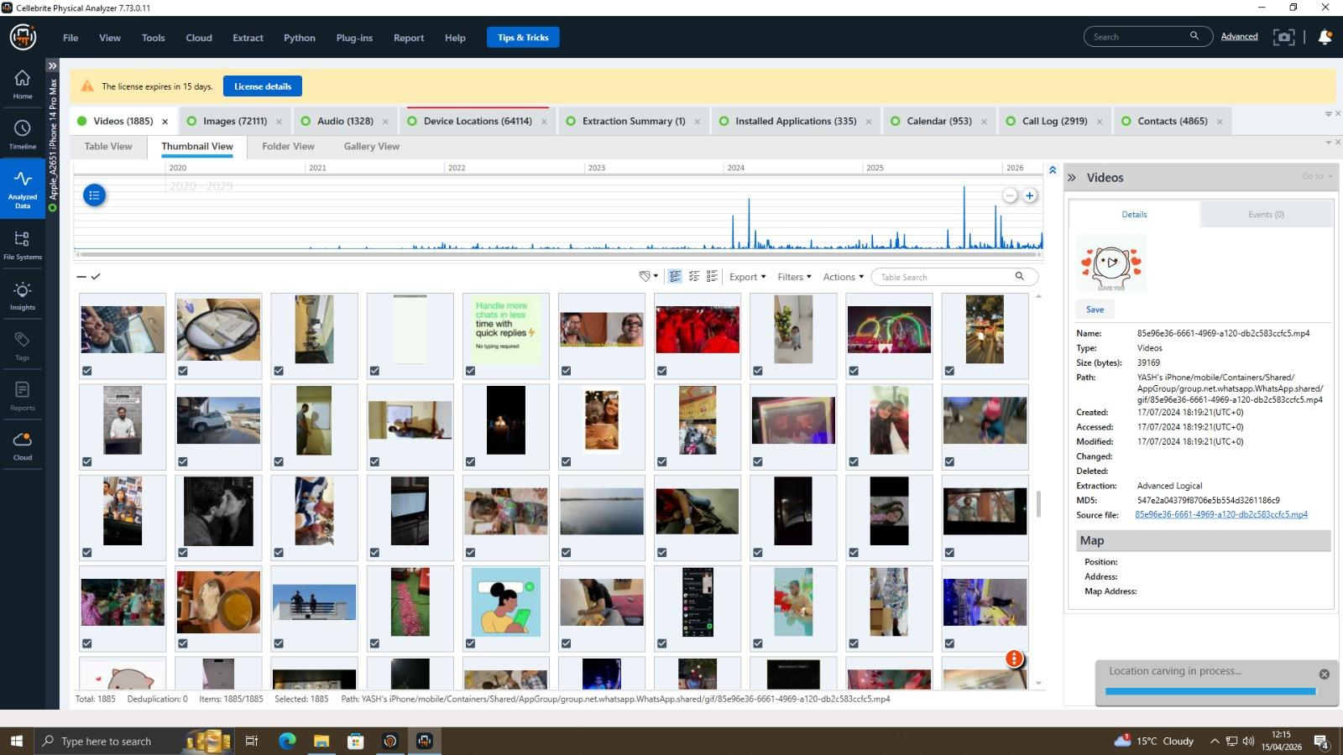
The tangible dataset revealed no direct photos of the QT-AI-2025 patent or other technical setup, though one should consider that confidential information is often stored and transferred in other forms. The technical data is normally handled in written data like PDF files, Computer-aided design files or zipped packages. In that respect, the USB flash disk, which could be attributed to the main suspect,t will be valuable evidence as it will provide a possible origin where to store and transfer such files without being in a safe place of the organisation.
The file analysis is also more comprehensive with metadata analysis, as it provides contextual information about a particular file. Creation date, last modification date and file path can provide hints regarding how it has been used by the users and can be used to provide a chronology of activity. Using a patent database as an example, a bright sign of data stealing would be documents written and/or altered soon after an illegal break-in of the database. Likewise, file paths which point to inner directories related to Quantum Tech would give additional proof of illegal duplication. The fact that there were no markers of encryption or obfuscation techniques employed either is indicative of the files being created in a relatively straightforward and unprotected fashion. The reason is that it is one of the elements of an informed disclosure as opposed to withholding information, and it is also in line with the common direction of the research communication, which is an indicator of order and a course of action being pursued by the concerned agents.

7. Call Log and Contact Correlation
A crucial component of the forensic examination is the correlation of the call logs and contact information because it introduces additional manifestations of evidence regarding the patterns of communication between the suspects. The data that is extracted by the forensic system has a section dedicated to the contact records, and identifiers (names, phone numbers and, in some instances, account details, etc.) are explicitly formatted. Such an organised representation of contacts will allow the investigators to find and visualise the contacts of people on more than one device, and help to recreate the networks of interactions and the incident itself.
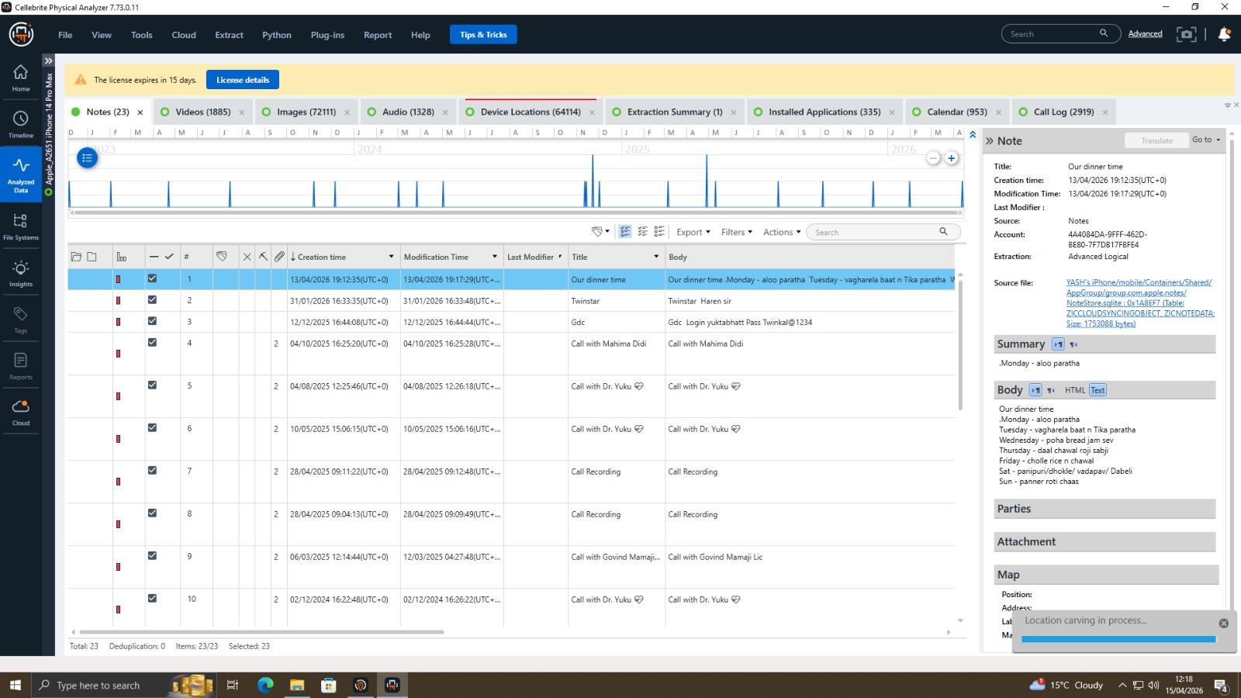
These immediate and objective linkages between the individuals can be determined by making a cross-check of the contacts reported on the gadgets of Emma, Joe, and Norman in a methodical manner. All these similar or equal contact details of these various devices are a good pointer that these two individuals had some form of contact in the past and thus were already in contact. The latter form of corroborative evidence is particularly important in a forensic case because of the fact that they are able to reduce the chances of coincidental association and, in reality, corroborate the existence of intentional interaction. It is thought that this hypothesis has been fulfilled in this case by repetition of similar contact identifiers in this situation, as one can argue that Emma, Joe and Norman were involved in an organised communication channel.
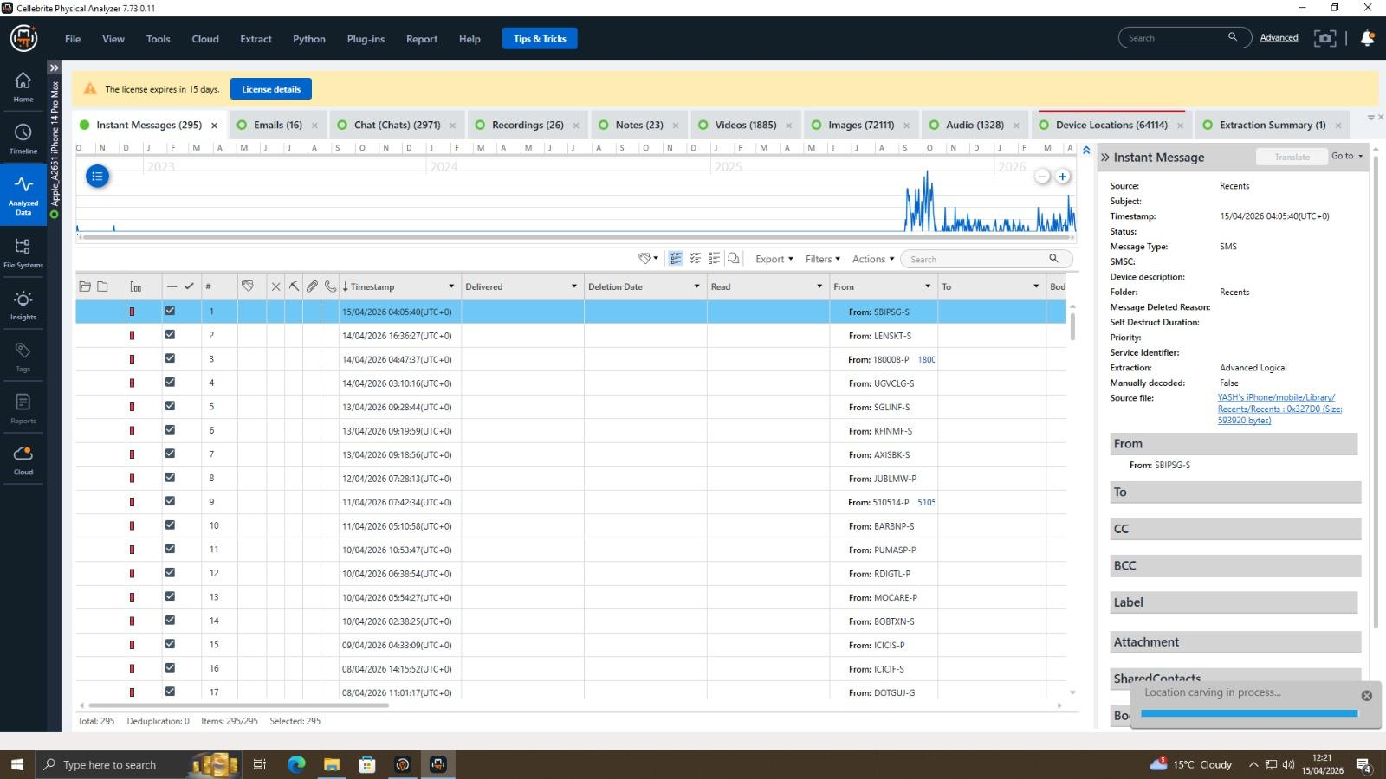
The screenshots below do not explicitly display any call logs, although call logs are usually obtained during mobile forensic extractions, along with messaging information. Call logs tend to have valuable information and include, among others, time of call, length of a call, the nature of a call (incoming, outgoing or missed), and frequency of interaction. These attributes prove useful with respect to the dimensions and time frame of communication amongst parties. One such case would be that the more calls the two of Emma and Joe had made in the window during which the illegal entry in the patent database occurred, the more it would suggest that some sort of coordination and real-time deliberation of the actions of the incident.
In addition, the analysis can be improved in terms of credibility and richness significantly with the combination of data on call logs and chat. Chat messages provide real-time understanding of what and why communication occurs, but call logs provide some background that can be used to determine how and when communication has occurred. Such a combination enables the investigators to create a more comprehensive and correct chronology of events, relating the verbal communication to the message exchange that was recorded. It is therefore more probable that these sources of information will be correlated, which would corroborate the evidentiary framework and the conclusion that the suspects were members of the organised and long-standing communications, which were relevant to the illegal data operations under investigation.

8. Timeline Reconstruction
Construction of a timeline is one of the most important elements of the digital forensic analysis, as it gives the investigator a chance to develop a logical sense of the evolution of the events and implement cause/effect relationships of the actions of a user and system processes. The time points that one will reach in this investigation, relying on communications logs and system artefacts among other pieces of digital evidence, will become a plausible base to locate a chronological map of events. By having these time stamps in sequential order, the question of the sequence of the activities can now be answered and how the incident itself was undertaken with time.
The analysis indicates that the number of events that led to the current problem began when Emma had access to proprietary information in the internal systems of Quantum Tech. Such access may not appear suspicious at the very moment, as she is a senior engineer and such access in this case could be viewed as justified by the operational requirements of the company, but the situation and the time of the occurrence of such access points towards the truth that it was not restricted to the operational needs of the company (Kumar, Pathak and Singh, 2022). Not long after this access, one can observe that Emma began or engaged in communication with Joe in the communication logs. Such interactions and the timing of the interactions strongly suggest that such discussions were interwoven with the information that she could acquire, especially in regard to its value potential and the possibility of transfers of the same outside the organisation.
This incorporation of Norman may be regarded as the time progressing with an increased number of communication documents. This is a significant change, which is undertaken from an in-house handling of sensitive information to an outsourced one, which is an effort to make contact with a prospective buyer (Michelet and Breitinger, 2024). The hypothesis that there is a coordinated effort to profit from the proprietary information is also supported by the fact that the third party that was in the communication chain can also be identified. The chain of interactions implies that Joe was a mediator between Emma and Norman and helped to keep the information and communication flowing.
The interesting aspect of the reconstructed timeline is that it has periods of bursts of communication separated by a relatively short time. The number and the distance between these communications evidence a long-term and conscious effort and not isolated and accidental ones. That there were no major pauses in between messages or calls indicates that the people were busy in continuous coordination, probably reacting to real-time developments. The trends are characteristic of highly organised operations and these are primarily those that entail the exchange or transfer of sensitive information.
Moreover, the history clearly shows the evolution of internal access to data to external communication, which is in line with the established paradigms of data exfiltration. These are the operations that are normally first access, preparation or staging and ultimately transmission or attempted sale. The chain of events that took place in this situation illustrates these steps and, therefore, helps to prove that the actions were planned and deliberated. This is one of the good evidentiary grounds to go on to argue that it was not an accident, but that it was a planned exercise that was meant to enable illegal transfer of data.

9. Suspect Profiling
Digital evidence can be analysed with the aim of determining the role and motive of the participants. Emma, being the internal employee and having access to the patent database, is the first identified perpetrator. The device has some indications of communication and the probability of file manipulation, which suggest that she was the initiator.
Joe is reported to be a go-between who helped Emma to get in touch with Norman. He is entitled to do so based on the fact that there are records of communication between the two parties. This position is similar to that of a facilitator or broker in a data transaction.
The interested third party, who is the prospective buyer, is determined as the Norma,n that is, the external party that is interested in getting the proprietary data. It is indicated in his communication records that he was engrossed with Joe and there might have been in-house communication regarding the interpretation of the data.
This is because the actions of the individuals can be deduced to get the motives of the individuals. The activities of Emma exhibit a monetary compensation or self-interest, and the activities of Joe exhibit the possibility of a commission-based motive. The role of Norman implies that Norman is interested in it business-wise, i.e. to have a competitive advantage over NexGen Circuits.

10. Legal and Forensic Considerations
The results of this investigation have to be considered within the framework of legal requirements and forensic best practices. Compliance with set rules, including those offered by NIST and ACPO, will make sure that evidence is credible and will be presented in court.
The technological tools deployed to perform the analysis, the use of legitimate acquisition techniques, and mechanisms of integrity checks will be credible. The chain of custody is also recorded, which further contributes to the legality of the evidence.
The actions identified in this investigation, and which are covered under the law, should constitute potential crimes in corporate espionage, intellectual property theft, and computer system intrusion. The fact gives good grounds to take legal action against those involved.

11. Conclusion
The digital forensic examination of the case proves interesting and recurrent pieces of evidence to the argument of unauthorised access and attempted theft of proprietary information of Quantum Tech. The presence of communication logs, file traces, and cross-machine associations analysis demonstrates the apparent tendency of systematic activity of the people involved. The variety of the sources of digital evidence, such as chat logs, contact data and the concluded file transfer, gives the entire image of the incident and contributes to the credibility of the results. According to the evidence, Emma was the key actor in the incident as she was the major actor. The fact that she had legitimate access to internal systems thanks to her position in the organisation, but the analysis implies that the access was abused to obtain sensitive information about the QT-AI-2025 patent. Her deeds and the documents in the further dialogue prove the point that she was a direct participant in the extraction of confidential information. The character of Joe turns out to be that of a mediator, a medium of interaction between Emma and the outside world. His intervention can be explained by the attitude of relentless contact and communication between the external and the internal companies. In its turn, it seems like Norman was to have been the target of the information, yet again, another external interest that may have coincided with that of another rival organisation.
The fact that evidence is uniform in various devices and data sources can greatly bolster the reliability of the investigation. Communication events overlap with the communication phenomenon of suspected data access, meaning that it is deliberate and coordinated and not spontaneous. This time and place in history serve as a good indicator that this was a strategised and orchestrated event. Altogether, the results, based on the accepted forensic practices and backed by the corroborative digital evidence, offer a solid foundation to prosecute and support the argument of corporate espionage.

12. Recommendations
Depending on the findings of this digital forensic investigation, it is imperative that a set of technical, administrative, and legal measures be put in place by Quantum Tech to minimise the chances of recurrence of such incidents in the future. The exploration has pinpointed these weaknesses that are largely attributed to insider threats, with the most significant one being the enhancement of internal controls and systems to check the activities at a particular point in time. The introduction of more stringent access control policies due to the principle of the least privilege is one of the recommendations. They also need to restrict access to information and systems that are necessary to achieve their work, and this will minimise the risks of exposing information when not needed. Besides, the implementation of multi-factor authentication systems is to enhance the security of sensitive systems and to regulate abuse of credentials. The other area that requires critical improvement is the fact that there should be monitoring of the user activity in the organisation's network of the organization. Implementation of the new monitoring tools, including the User and Entity Behaviour Analytics (UEBA) tools and Data Loss Prevention (DLP) data, would offer a chance to detect abnormal behaviour, including the deviant access patterns and possible data exfiltration. Furthermore, the accessories, such as USB flash drives, need to be closely monitored or turned off wherever feasible. End-point protection measures, applications, and policies concerning the management of the devices can also contribute a lot towards decreasing the threat of unauthorised data transfer.
In addition to the technical protection, organisational protection should also be strengthened. Regular awareness and employee training should also be undertaken to ensure that the employees become aware of data security practices, ethical duties and the legal implications of developing and violating such practices. These programs can be important in mitigating insider threats since they would instil a sense of security in the organisation. Also, Quantum Tech should conduct auditing and refining of its incident response framework to facilitate prompt detection, containment and handling of threat breaches. These involve the creation of open reporting channels of suspicious activity, internal investigations and storage of online proofs. In accordance with the law, the evidence that has been acquired during this investigation is to be officially delivered to the law agencies in order to initiate actions in this regard. The forensic evidence and the good records in this report will provide a strong evidentiary principle to charge the cases of corporate espionage, unauthorised access and theft of intellectual property.

References
- Abdullahi Aminu, K., Jantan, A. and Yusoff, M.N., 2023. Digital forensics investigation approaches in mitigating cybercrimes: a review. Journal of Information Science Theory and Practice, 11(4), pp.14-39.
- Almuqren, A., Alsuwaelim, H., Rahman, M.H. and Ibrahim, A.A., 2024. A systematic literature review on digital forensic investigation on Android devices. Procedia Computer Science, 235, pp.1332-1352.
- Barik, K., Abirami, A., Konar, K. and Das, S., 2022. Research perspective on digital forensic tools and the investigation process. Illumination of Artificial Intelligence in Cybersecurity and Forensics, pp.71-95.
- Casino, F., Dasaklis, T.K., Spathoulas, G.P., Anagnostopoulos, M., Ghosal, A., Borocz, I., Solanas, A., Conti, M. and Patsakis, C., 2022. Research trends, challenges, and emerging topics in digital forensics: A review of reviews. Ieee Access, 10, pp.25464-25493.
- Choi, K.S., Back, S. and Toro-Allvarez, M.M., 2023. Digital forensics and cyber investigation. San Diego, CA: Cognella.
- Daraghmi, Y.A. and Shawahna, I., 2023. Digital forensic analysis of vehicular video sensors: Dashcams as a case. Sensors, 23(17), p.7548.
- Fakhouri, H.N., AlSharaiah, M.A., Alkalaileh, M. and Dweikat, F.F., 2024, February. Overview of challenges faced by digital forensics. In 2024 2nd International Conference on Cyber resilience (ICCR) (pp. 1-8). IEEE.
- Hakim, A.R., Ramli, K., Gunawan, T.S. and Windarta, S., 2023. A novel digital forensic framework for data breach investigation. IEEE Access, 11, pp.42644-42659.
- Khan, A.A., Shaikh, A.A., Laghari, A.A., Dootio, M.A., Rind, M.M. and Awan, S.A., 2022. Digital forensics and cyber forensics investigation: security challenges, limitations, open issues, and future direction. International Journal of Electronic Security and Digital Forensics, 14(2), pp.124-150.
- Kumar, S., Pathak, S. and Singh, J., 2022. An enhanced digital forensic investigation framework for XSS attacks. Journal of Discrete Mathematical Sciences and Cryptography, 25(4), pp.1009-1018.
- Michelet, G. and Breitinger, F., 2024. ChatGPT, Llama, can you write my report? An experiment on assisted digital forensics reports written using (local) large language models. Forensic Science International: Digital Investigation, 48, p.301683.
- Prakash, V., Williams, A., Garg, L., Barik, P. and Dhanaraj, R.K., 2022. Cloud-based framework for performing digital forensic investigations. International Journal of Wireless Information Networks, 29(4), pp.419-441.
- Ramazhamba, P.T. and Venter, H.S., 2023. Using distributed ledger technology for digital forensic investigation purposes on tendering projects. International Journal of Information Technology, 15(3), pp.1255-1274.
- Salfati, E., Salfati, E. and Pease, M., 2022. Digital forensics and incident response (DFIR) framework for operational technology (ot). Gaithersburg, MD, USA: US Department of Commerce, National Institute of Standards and Technology.
- Stoykova, R., Andersen, S., Franke, K. and Axelsson, S., 2022. Reliability assessment of digital forensic investigations in the Norwegian police. Forensic Science International: Digital Investigation, 40, p.301351.
- Taiwo, A. and Claims, I., 2022. An extended digital forensic readiness and maturity model. Forensic Science International: Digital Investigation, 40, p.301348.

