BMSK4002
Assessment 01
Effective Team Working & Communication
Student Name: Ali Miah
Student ID: 1709388

Table of Contents

Introduction 03
Process of communication 03
Conflicts & Communication 04
Communication & Importance 05
Different Models of Communication in Sara’s Workplace 06
Teamwork & its importance 08
Interpersonal communication 09
Analysis & Findings 10
Improvements in Communication Skill & Performance 10
Conclusion 11
Reference 12

Introduction
Communication is the most important part of human life, so the importance of workplace communication is obvious in any kinds of organization. Communication means a conversation between two or more person, it can be oral or written or any form (Johnson, 2000). For workplace communication written is the most used form that most of the people follows. It helps to remove the conspiracy in terms of future purposes & help to provide the authenticity of the organization. to show the importance of workplace communication, I am going to discuss my friend named Sara. Who is currently working for Workstation, which is mainly customer service agent based organization? She has to do lots of things in terms or communicating with different clients, doing the best thing that customer is asking for, manage or motivate other people to give the best for the organization and marketing as well. She expressed her feelings for the organization by informing different part that she does for communicating with different people inside or outside of the organization. In this report, I am going to describe communication with the experience that my friend described to me.

Process of communication
There is a different process of communication that described by my friend Sara. She had experienced both oral & written communication format while working. While working, she had to communicate with different types of people. For different types of business workings or proposal, she always followed the written format because it helps to maintain or remove any kinds of conflicts that can be arises in future. There are different types of written & oral communication that organization follows for several purposes.
Letter: This format is the most common type of written communication that different organization follows. Sara used the letter for different business purposes that included proposals, resolving various issues that arise while doing business, purchasing information or considering issues. The letter includes proper word format that makes any big issues in a brief & proper utilization. By reading the efficient letter it makes a sound solution with the respect that’s why Sara used to communicate through a letter.
Report: Making a research on different issues Sara used to make a report in financial tasks or making statements of different works. The report usually finds out the overall situation of the organization that can be used in various forms, by analyzing or researching of certain issues an overall report is made that is really important as unique data.
Memos: For purchasing different materials or equipment’s, Sara used to prepare memos which is a part of communication. Memos are prepared for financial uses that helps to make positive communication in the workplace. There are different types of memos are used in the workplace for its various purposes & helps to maintain the financial part of the organization.
Informal communication: Sara used to communicate in the organization in verbal or oral as well. that helps to make the situation easy & flexible as well. There is various method that Sara used to communicate informally in the organization like:
- Eyes
- Face to face
- Proximity
- Posture
- Gesture
All these methods are controlled by body movements with other people, by moving the body Sara used to communicate with the people that helped her to share her expression in a different situation. Face to face communication helps to make the situation more easy than other communication. But it's not as accurate as written communication, as face to face communication just allows to share the opinion or resolving issues but in future, it doesn’t have any proof copy or something that can be used as well.

Conflicts & Communication
Sara shared with me that there are some conflicts that arise due to communication. When people communicate with other people but some mis understating occurs that causes conflicts or some people intentionally make conflict in the organization. There are some major conflicts she found while working these are:
Personal problems: Sara shared that she had some own problem while working or communicating. She had a lot of anger that leads her to make trouble to work with other people. While managing other people she faced some difficulties to work or making motivated other people. In terms of focusing on something, she felt trouble because all the people in the workplace are some same. There are different types of people that mad her trouble to work or communicate.
Problems in the organization: There are some organizational problems that Sara faced while working as well. Some people in the organization was not cooperative that made her in trouble to manage or make them supportive to work. The overall environment was not friendly that made her trouble to motivate or manage them for doing some work.
She faced difficulties because the way of communication inside, it wasn’t supportive at all because of different form or style that her company was following. It made her in trouble as there was huge communication gap in the organization. Sometimes she faced system failure as well, as she had to communicate different people in outside to support them by giving different types of information. Due to system failure, it made her trouble to get proper information from the organization.
The passing of the information was the biggest issue in her organization, she faced trouble for passing information to one from another. All the information comes from the higher management, there were some people in the organization that made her trouble to get the perfect information due to its misjudgment from other people.

Communication & Importance
It's obvious that communication plays a vital role in the organization, without proper communication it’s not possible to work properly internally or externally in the workplace (Bell, 2005). Sara shared her opinion & feelings on communication that she faced while working. The organization Sara worked for they mainly give customer feedback on different issues that’s why she used to have various communication with clients or the people inside the organization. there needs to make proper confidentiality for different purposes of the communication that can’t be shared with outside people of the organization. in terms of maintaining the communication in the proper way, written communication is very important for it different uses. Here are few points that Sara shared with me about the importance of the organization:
- Communication makes the overall situation easy that makes proper bonding in the workplace.
- Proper communication makes the overall work easier because it makes the team bonding strong among different people in the workplace.
- Makes all the people inside the organization more fruitful for doing different works.
- Sara used to perform properly following the overall aims & objectives of the organization.
- Communication helps to motivate other people by showing the overall impact of different parameters.
- For maintaining the proper relationship with various people in the workplace effective communication acts as the most important part.
- Effective communication makes the environment fruitful that leads to cut down several costs of the organization.

Different Models of Communication in Sara’s Workplace
Sara faced different model or theories of communication, all these theories are basically related to communication. From the very beginning to communicate different types of people made some theories of communication. All these theories are getting an upgrade in the next stage made the overall communication easier than the previous one. Here are some models of communication that Sara shared with me:
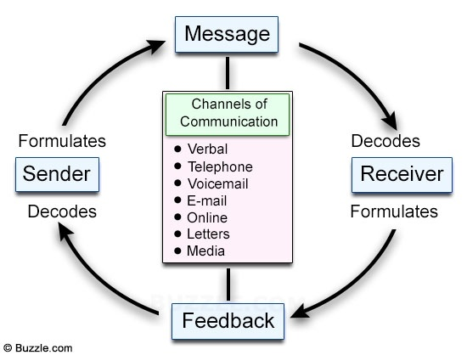
Figure: Linear Model
Linear Model: This model is the most common and updated model of communication. It shows that send will send a message to the receiver where it will pass from a different channel of communication. This channel will find out which message will be converted from the sender, it can be verbal, telecommunication, voice mail, email, online chatting, letters or memos (Cottrell, 2011). In Sara’s organization, this model is basically used because it has all the information of the communication.
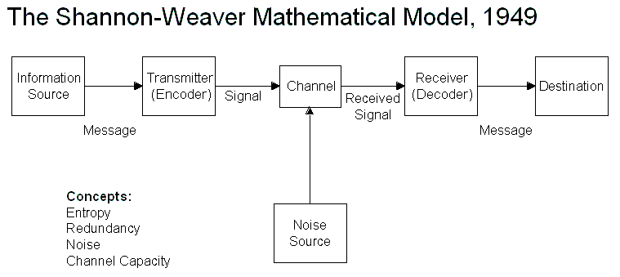
Figure: The Shannon-Weaver model
Model of Shannon-Weaver: This model was established in 1949, previously this model was the most famous one to follow or transform into communication. This model has shown that there will be information that is the main source that will transmit through encoding in a channel that will transmit through the receiver then it will go to the destination of the receiver.
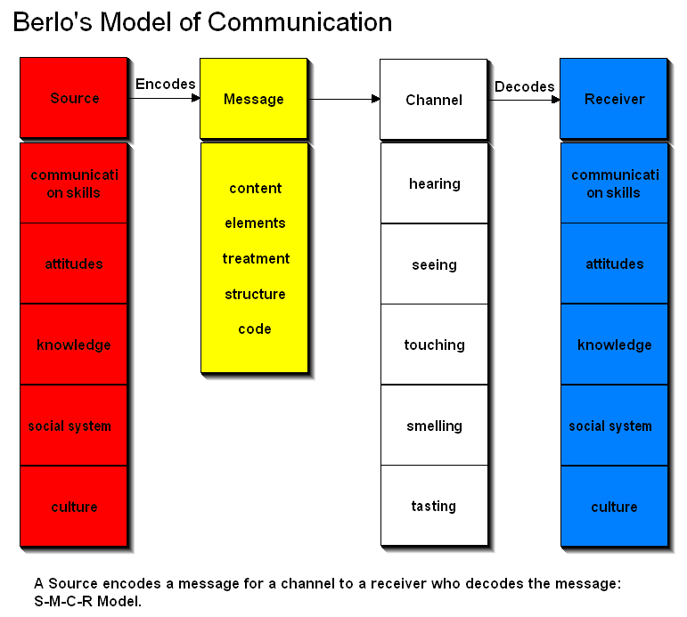
Figure: Berlo’s Model
Berlo’s Model: In this model, Berol’s made a huge information that related to overall communication of the people. There is an encoding of the message that will go through a channel it can be hearing, seeing the touching, smelling or testing. Then it will transmit to the receiver of the communication, through proper communication skill, attitudes, knowledge, social system & culture of the people. Sara experience this communication model while working because it has overall sender, receiver & the factor that is related to the sender that sends the communication then the receiver that will receive from the sender.

Teamwork & its importance
Teamwork is important in any workplace, it helps to make the overall work easier. For proper team working it’s obvious of proper communication (Morgan, 2016). Sara made a team working in her organization, all the team member made the team spirit that focuses on different methods or strategies that are related to findings of the business goals & objectives. Here is some importance of team working that Sara shared with me as she felt these while working:
- Teamworking made the overall work easier than the single task, for reaching the goal if all the team member works properly automatically get the success.
- Communication helps to make the coordination with all the people of the team, proper communication makes all the work easy.
- For attending in different meeting teamworking makes the work easier.
- Dividing the work among the team members helps to make the work finish before the lead time.
- It enhances the overall respects among the other seniors of the organization.
- Teamworking increases the group discussions among all the group members.
For communicating in a proper way there are some factors that are related to the team workings. Sara expressed some information showing the parts that are related to the effective team working proper team working. These factors that Sara get from different communication models.
Source: A Proper source of information is important that comes from the sender of the communication. To make the overall team working authentic source makes the work easier. To do this there need credibility, attractiveness & expertise of the source. Credibility finds out whether the information is proper or not, for assigning on different tasks credibility is important. Attractiveness finds out the source of the work that is assigned to different team members. For expertise on the work, the manager needs to get the overall experience of the work in the team that makes the work easier.
Encoding: After getting the information from the source the communication is encoded into work media. Encoding mainly convert the message with different codes for a structure that helps to the receiver for getting the proper information. All the team members need to encode their messages in their ways that are related to the group working.
Channel: Channel is related to the transforming the message in a way that makes the information in the proper way (Maund, 2017). Channel can be over the verbal communication, telecommunication, letters, emails, voice conference or video conference or any other methods. Channel mainly organize the information for passing it to the team members for working inefficient way.
Feedback from the receiver: Proper feedback is important from the receiver, it helps to maintain the works properly. In terms of getting the feedback, all the team members work to make the best possible works from the source that sender sends to team members. Feedback can be positive or negative & it can be verbal or written.

Interpersonal communication
Sara shared her opinion on developing her inter personal communication skill as well. These skills help her to communicate properly through expressing her body movements. Here are some interpersonal skills that she gathered:
Body language: Communicating through moving or expressing through body movements is a part of interpersonal communication (Hoechsmann, 2012). Body language helped Sara to perform or communicate with her subordinate people in the organization.
Active listening: Its important to hear the speaker properly for performing better in any work. Sara used to listen properly what are other people are saying to her. This skill helps her to share different things that she got from her superior or expressing them in an efficient way.
Context awareness: It important to inform other people be aware what the person is getting or doing, context awareness helps to do certain activities that made aware of other people. Sara used to make the influence of her working by making proper awareness of the work.
Personal Presentation: For performing properly it’s important to make proper presentation what the person is trying to do or sharing. It helps to influence other people for preparing the best or sharing information of certain things.

Analysis & Findings
After finding the overall information that Sara shared with me it can be easily seen that effective communication is important for any kinds of communication. Without communication it's not possible to handle other people inside or outside of the organization. Here is some finding from her overall working:
- Communication makes the work easier to perform better in the workplace.
- Without effective communication it's not possible to work or manage other people.
- Communication helps to get the feedback that allows getting the make any further improvements.
- Verbal communication is the most important communication in any kinds of organization that make the authenticity of the information.
- To handle the certain situation there, need some informal communication as well.
- There are different types of communication models that make the communication easier.

Improvements in Communication Skill & Performance
After having overall information on different information or models, I have found out some necessary improvements that are related to increasing the communication skill & performance in the workplace. Here are some improvements for increasing the skill:
- Remove certain words that can hurt other people for proper communication.
- Make the overall situation calm, quiet & confident while presenting or communicating with other people.
- For motivating the need to use proper communication skill or words that will help to get the best output easier.
- Proper feedback helps to enhance the overall performance or resolving any problems.
- For making the teamwork effectively it should be proper communication or effective capability to work better.

Conclusion
To finalize the report on overall analysis on communication, it can be easily seen that without proper communication it’s not possible to make the proper team working in the organization. Different methods are needed to gather for performing better regarding the effective way of communicating. Sara shared overall experience on her feelings regarding different parts of communication that helped her a lot to perform better. Finally, it can be seen that without proper & effective communication it’s not possible to get success without effecting communication & its uses.

Reference
Blanchard, K.H., Hersey, P. and Johnson, D.E. (2000) Management of organizational behavior: Leading human resources. 8th edn. United Kingdom: Prentice Hall
Bell, J. (2005) Doing your research project: A guide for first-time researchers in social science, education and health. 4th edn. Maidenhead, England: Open University Press.
Cottrell, S. (2011) Critical thinking skills: Developing effective analysis and argument (Palgrave study skills). 2nd edn. Basingstoke: Palgrave Macmillan.
Morgan, P. (2016). The Business Student’s Guide to Study and Employability. Sage Publications.
Maund, A. Schriek, M. and Tinkler, P. (2017). Certificate in Higher Education: Skills for the Workplace Student Yearbook. Sage Publications.
Hoechsmann, M. (2012) Media literacies: a critical introduction. Malden, MA., Wiley- Blackwell.

