

MODULE HANDBOOK

ECAD6019

Deepening Practice: Mathematics

BA (Hons) Primary Education with Qualified Teacher Status

Level 6

20 Credits

Yr Athrofa

2025-2026

Revalidated October 2023 for first intake September 2024

- Point of contact
Module Lead: Bethan Sturrock b.sturrock@uwtsd.ac.uk
- Our Expectations
We hope you enjoy the module and programme. We are here to help.

You should:
- Make good use of the University facilities and resources
- Attend and participate in sessions
- Act responsibly
- Meet assignment deadlines
- Engage and participate in all sessions

Please read the University Regulations for Students and the Athrofa Engagement Policy.

- Aims and Learning Outcomes

AIM(S)
To provide student-teachers with a deepened understanding of progression in learning
outlined in the Curriculum for Wales framework and the knowledge of theory, research and good practice to enable them to effectively lead learning and collaborate with colleagues in this area.

LEARNING OUTCOMES

Upon the successful completion of this module, the student-teacher should be able to:

• identify the role and responsibilities of an evidenced based practitioner;
• show a deepened understanding of the complex nature of the learning environment in order to deliver effective teaching and learning;
• secure an understanding of transformative practice through evaluating their own
pedagogical practices in collaboration.

INDICATIVE CONTENT
- Exploration of the skills needed to plan, deliver and evaluate creative and innovative learning experiences which facilitate pupils’ progression through Mathematics and Numeracy.

- Integration of the key aspects of the CfW framework e.g. integral skills and cross-curricular skills into Maths and Numeracy.

- A deeper consideration of pedagogical content knowledge and the five proficiencies.

- Opportunities to connect and collaborate with Partnership schools and other agencies to deepen practical/applied knowledge and create and justify innovative pedagogies within a specialist area.

- The approaches used to develop cross-curricular responsibilities of Numeracy skills with learners.

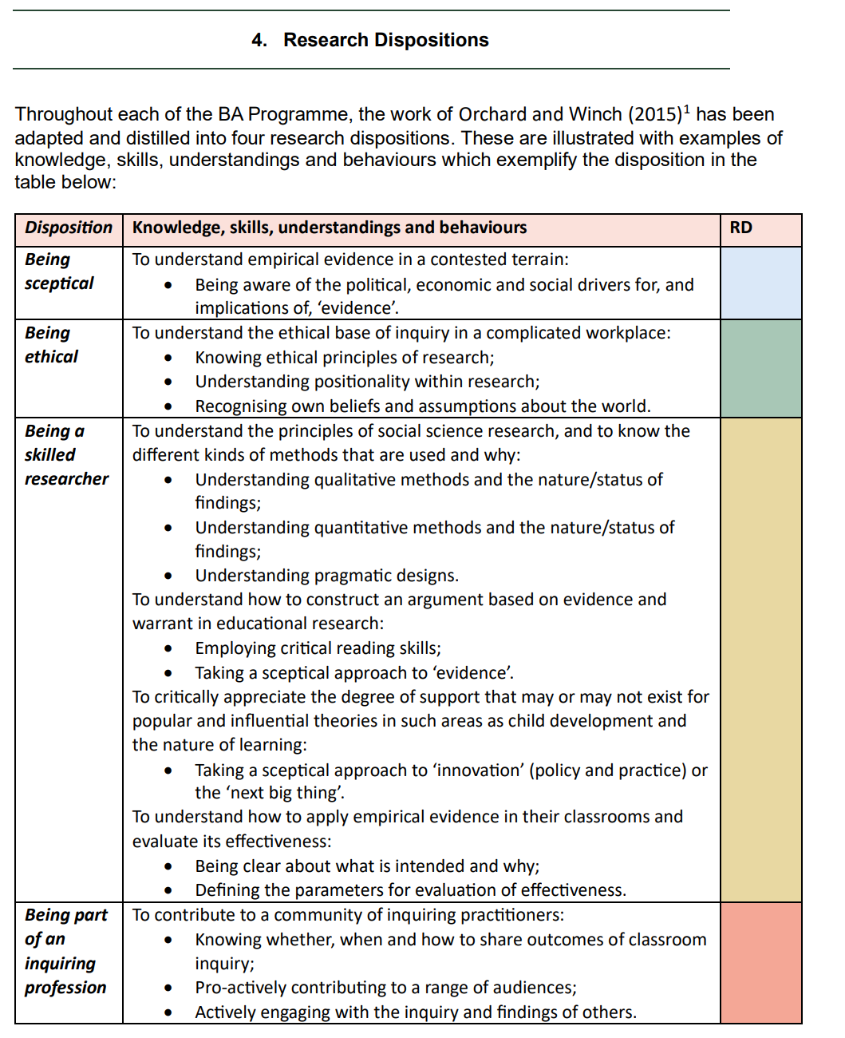

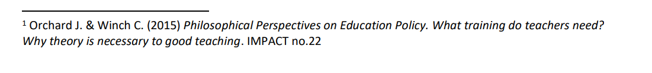

- Assessment information

STUDY TIME ALLOCATION
There are 30 scheduled learning hours for this module.

ASSESSMENT

Assessment Component 1

☐ Written exam ☒ Coursework ☐ Practical

Mode of assessment |  | Volume |  |  | Weighting
Journal |  | 1375 words  23 / 2 / 2026 |  |  | 50%

Assessment Component 2

☐ Written exam ☒ Coursework ☐ Practical

Mode of assessment |  | Volume |  |  | Weighting
Individual Presentation (recorded) |  | 10 minutes  23 / 2 / 2026 |  |  | 50%

ASSESSMENT SUMMARY

Activity type | Percentage
Written exam
Coursework | 100% (50 + 50)
Practical
TOTAL | 100%

- Assessment Tasks and Guidance
Please see the Assessment Specification for this module that can be found in Moodle under “Assessment Information”.

- INDICATIVE READING LIST
INDICATIVE READING LIST

Module Code | ECAD6019
Module Title | Deepening Practice: Mathematics
Classification | Reading List entry | Electronic*
Essential | Welsh Government (2020) Curriculum for Wales – Maths and Numeracy Area of Learning and Experience: - https://hwb.gov.wales/curriculum-for-wales/mathematics-and-numeracy/ | ​​☒​
Essential | Online Materials from the Education Endowment Fund:  Improving Mathematics in Key Stages 2 and 3 | EEF (educationendowmentfoundation.org.uk) | ​​☒​
Essential | Grigg, R. (2022) Becoming an Outstanding Primary School Teacher: A Journey, not a destination. 3rd edition. London: Routledge. (Chapter 8). | ☐
Essential | Barnes, J. (2018) Applying cross-curricular approaches creatively : the connecting curriculum. Learning to teach in the primary school series.London:Sage. | ☐
Further | Evans, G. (2019) The Five Proficiencies Blog. Available at: https://www.mathemateg.com/mod/page/view.php?id=4110 | ​​☒​
Further | Biddulph, J. & Flutter, J. (eds) (2021) Inspiring Primary Curriculum Design, London: Routledge. | ☐
Further | Wales Gov (2022) Cross Curricular skills frameworks. Welsh Government: Available at: https://hwb.gov.wales/curriculum-for-wales/cross-curricular-skills-frameworks/ | ​​☒​
Further | Pound, L. and Lee, T. (2015) Teaching Mathematics Creatively. Oxon: Routledge | ☐

