The General Game idea for this project was to create a wave-based survival game revolving around a super store or shop, with Customers being what spawn in each round acting as the ‘Enemies’. The customers goal within the game is to go after the stock on the shelfs, once they run out, they will go after the player. There would be some ‘Specialist’ customers, who would have a distinct look, and unique abilities to add a challenge to the player. The Planned Different types of enemies are a Base ‘Common’ Customer, these are to act as the cannon fodder type enemy, A faster Agile Customer with less health, but increased speed, a Tank Customer with a slower speed but more damage and health, and finally a boss type, we plan to have this enemy to be mobile in a mobility scooter and act as an end of round challenge at round 5 or 10. The players Goal in the game is to keep shelves Stocked, and keep barrier up on windows to keep customers from over running the store. There will be a stock Room in every Level, which will hold all the stock for the player to keep stocking up the shelves. This will also hold some Basic tools and planks to board broken windows. The player will start with basic tools to help ward off the customers, which would be a Baton, and Toy Foam dart shooting blaster, but can “Upgrade” these tools to ones that can aid the player more. These are a Stock launcher, which will shoot stock to help re-shelving the stock, or shooting stock at the customers, and a makeshift melee weapon which is to do more damage and slow down the enemies more than the baton. These are both planned to be makeshift weapons our of random object within the store, either found or with a basic craft system which would involve finding each part across the map. The game will end with either the Boss at the end of a set number of waves being defeated, or with the player loosing against the horde of customers.
The Desired Target Audience would be people aged around 13+ with an ESRB rating [1] of T due to the content of the game. Since the game is a round based survival game, it would be aimed at players who love a challenge and also who like to strategize to beat the levels. This could also appeal to players who enjoy Zombie type games, and those who enjoy Horror Aspects within design. Since the game is planned to have a cartoon like art style and fun horror aspects within the character design, this can appeal to those who play games such as or similar to Team Fortress 2 [2], Overwatch [3], or even little nightmares [4], based on visuals and the design of character, weapons or levels.

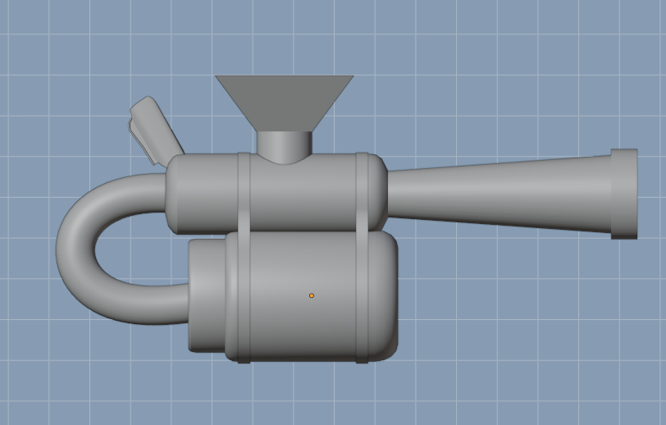
We decided to go with cartoonish Design choice, to help aid with the craziness of the idea of the game. This would have to be shared with each asset and design we created and would have to make sure that each design fit into our design choice. An example of this decision can be seen with in my Stock Launcher. With this design I had chosen to make some parts ‘Enlarged’ to emphasise the cartoony feel of the game. This included the Funnel, and more notably, the barrel. The Barrel extrudes outwards, which for real, functioning weapons, is not accurate or practical, but for the style we chose, it fits well.

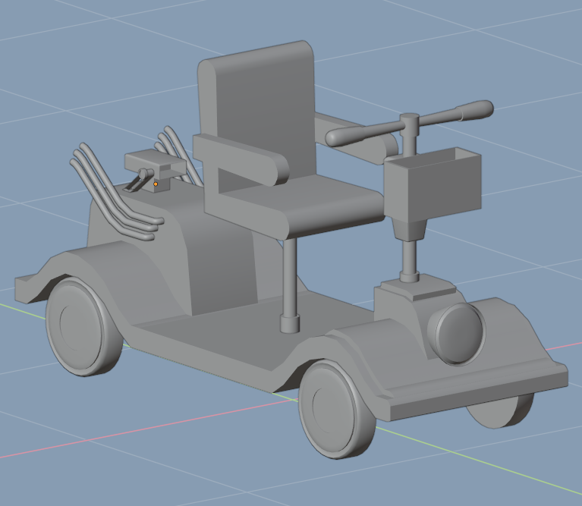
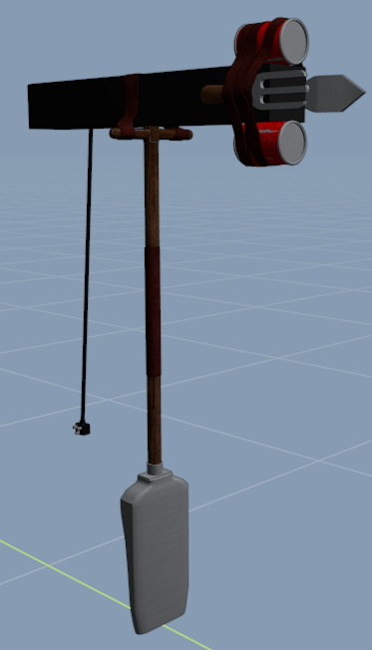
Another Example is the mobility scooter I created. One part of the art style is some over the top or unrealistic parts added to make certain items stand out more. To make my scooter stand out more I added a large engine on the back, fit with long ‘Hot Rod’ Esc exhaust pipes, and large air in take on the back. Since this was created for the boss enemy, this is ana excuse for faster speeds with on the scooter, while also aiding to the character of the boss, and design of the game.

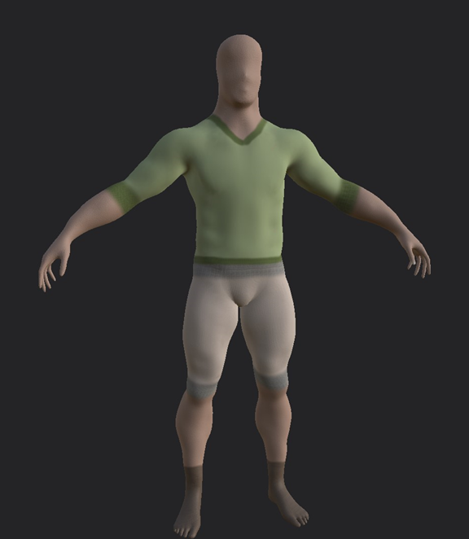
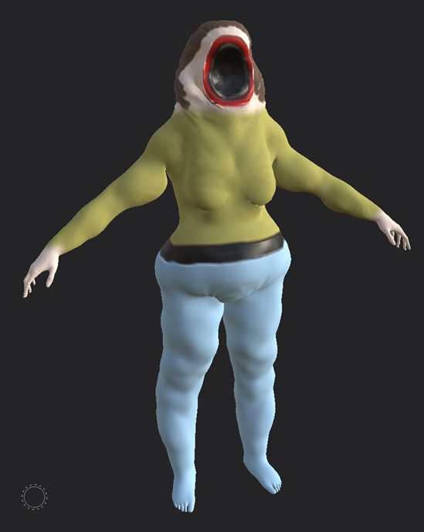
The makeshift melee weapon incorporates the over-the-top idea within its design. The premise of the item is random items found with in a store strapped together with tape or leather to from an upgraded weapon. With in the item is included, A soundbar on the top, a shovel as the handle, A trowel and wall scrapper strapped to the front, as well as two cans of food also strapped to the front. This all comes together to create a unique item, that stands out and that can aid the player within the game.
another large choice with the games design, and theming is including some horror aspects in the games environmental theme, and over all themes. In design like environment and enemies, these were meant to be unsettling and to creep out player, which contrast with the cartoony feel of other aspects. The environment design was meant to be Run down, and messy, akin to how stores or building would be if they were overrun with a mindless horde. The map would’ve included objects like scattered boarding planks, broken isles, dirty floors, broken/flickering lights etc, these would’ve made the player feel unsettled and add to the creepy vibe within the game.
The Caracter design for the enemies is always meant to aid in the horror aspect, while also containing the cartoon element of our design. We decided to have the horror aspect as it would be more interesting to have that element mixed in the art style and gameplay. It blends well with the Horde based game mode we have to make, and also give us a good challenge to get right. The enemies which the player must face add massively to the creepy side of design. We made the decision to not include faces to the models. This is to represent the mindless horde of customers, only raging in the store to get the bargains on black Friday. A horde of faceless ‘zombies’ adds to the overall creepy aesthetic, no emotions are shown, just the relentless moving forward and aggressive nature of the enemies. It is designed this way to make the player unsettled. The Models for the enemies where modeled and textured by Harry in the group, with in Z brush, and Adobe Substance painter. Pictured on the Left is the connom “customer”, This is meant to be the main bulke of the horde, being cannon fodder, but vast in numbers. The design it to represent a common person In generic clothes, ones that can later be re coloured to add more variation in the crowd. The faceless design as discussed earlier shows off the creepy vibe of the customer, as every other part of the body is normal for people the face lacks the one part that makes the customers ‘human’ and instead makes these feel like Robots or faceless demons. All the special customers share the same faceless design, bar one, the Karan Boss.
The boss include a large mouth covering the whole face. This is not only to make the boss stand out, but to also add to the unsettling feel of the customer designs. One giant mouth on a face is unantural for humans, so having a giant creature charging the player will sure to create the tension we desire in the games design. Our choices for tehse designs blend well together, with design being cartoony in places, which stand out on the items, or creepy in others with the faceless customers with cartoony over the top bodies, it all fits the theme and design well.

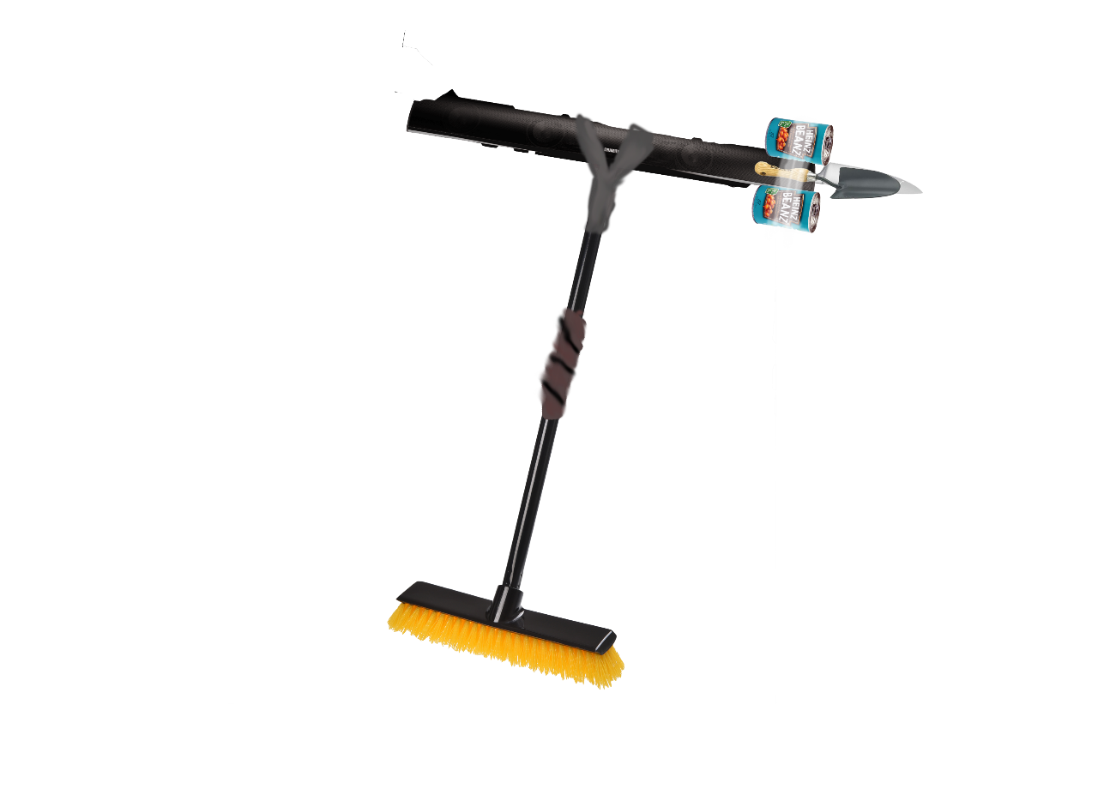
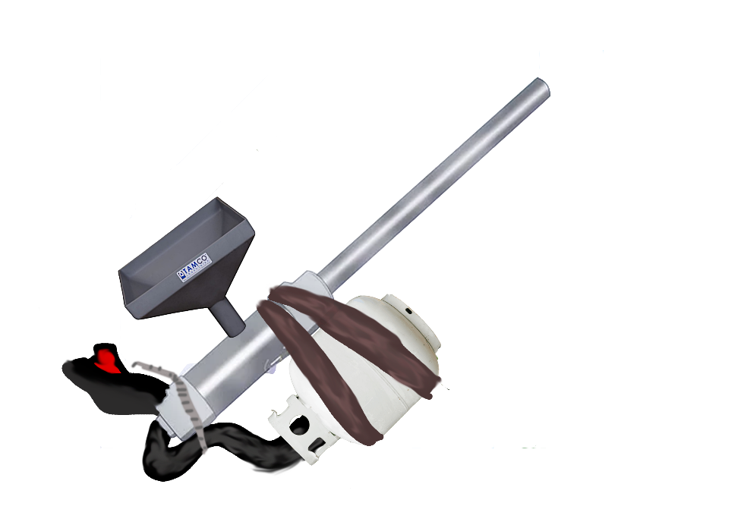
With in this project I got to practice the skills I have learnt over the years which helped me become slightly better, and more skilled with in modeling, and texturing within Blender [5] and substance painter [6]. I had to seak out some help with work via asking friends, or Youtube [7] video tutorials.
One tutorial I had to learn how to use a Black mask with in Substance painter [6]. A video from the youtube user ‘3D characterArts’ helped me learn this skill, which really helped with weathering, and dirtying objects with in there textures. The video, Titled : “Substance Painter For Beginners - Black Masks” [7] dives into all the ins and outs on what a black mask does, and the paint brushes, and techniques you can use with a black mask, showing different materials with in Substance that can blend well together.
another skill which I needed practice on was Photo mashing. We were first taught this within a lecture, which was my first time doing such things with in photoshop [8]. My first few attempts where not as good as I had hoped so I spent more time practicing, until I was able to get the deisgns where I wanted them, and even used said designe in creating my Stock launcher, and Makeshift melee weapons.

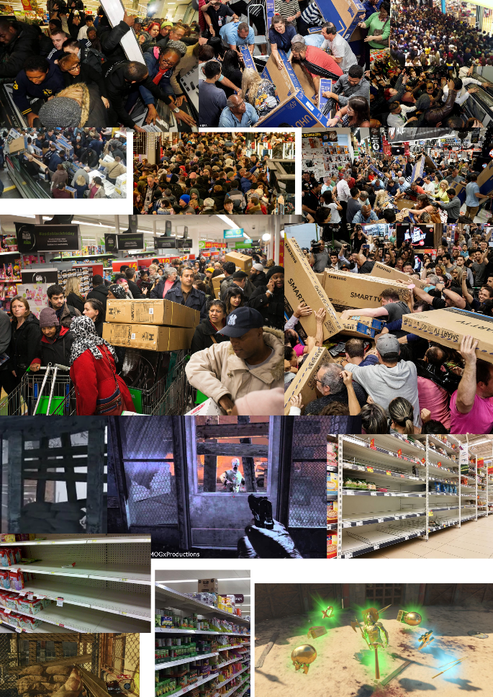
As I do with most projects, I started my research by playing and surrounding myself with similar games and concepts, based on the style we want. I played a few games known for there horde modes or wave-based horde modes. The First games I played was Call of Duties [9] Zombie mode. Notably the ones featured in Call of Duty World at War [10], Call of Duty Black ops 2 [11], and Call of duty Black op 3 [12]. These three games, all having the same mode, differ a lot in gameplay with each incarnation of the mode, as well as being one of the most popular horde-based modes on the market, it was good research in how wave progression and defence could be handled. Another good game for Wave based Modes Is Gears of War 3s [13] Horde mode, which features an attack/Defend style mode where you have to fortify the base each round. This acts as another way to handle Wave progression. Another Notable Game I played was Dead rising 2 [14], as this zombie game is set with in a mall and features many custom-made weapons with parts from within said mall, which acted as a good base for knowing how to, and what to look for in custom weapon mashes. Left for Dead 2 [15] and Aliens Fire team [16] both feature a linier style horde mode, but with special enemies with unique attacks or features to add to the challenge, this helped with planning out and balancing the Special enemies we wanted in our game. I created a mood board to help gather more understanding of what our game could look like. The mood board contains images of Black Friday Carnage, Barriers and powerups from the game Call of duty [9], and shelves from stores. This give a gernal idea on what the game was going to be like. I also watched some clips showing off how people acted during balck Friday, this helps gather an understanding on how during this event, people act like they are in hordes, which is very remanicant of zombies breaking into a building. The main videos I watch where:
Black Friday Madness: The best funny moments caught on camera, by ‘On Demand News’ [17]- https://youtu.be/3s9zoZMUVJc
and Black Friday in South Africa, stampede Nike store East Rand Mall by ‘Tiny ankle Biter’ [18] -https://youtu.be/XTPomOyyxi4
these both really show how people can act like a horde bursting into a building, and even acting like animals over materialistic items.
since I was creating most objects within the game I had to research each item I was creating, some object didn’t require much research bar some image references, like the Wooden Crate, Basic stock, or wooden Plank.

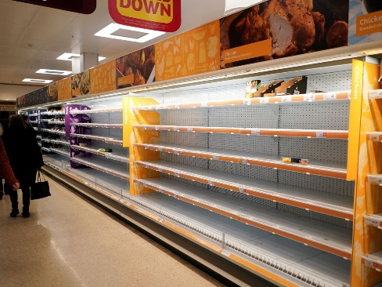
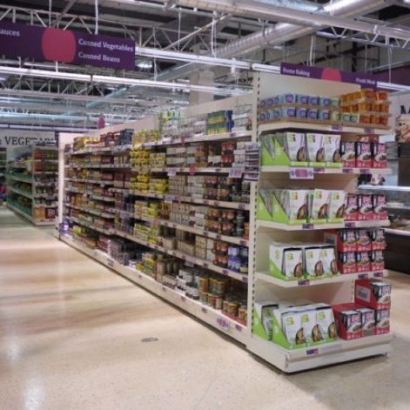
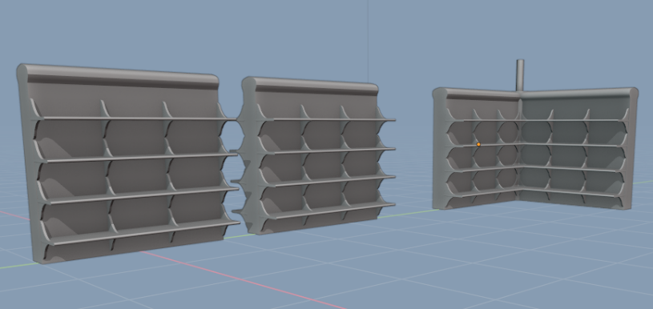
For the Store building, and Store Shelves, an easy way to help research was going into the shops around my town and seeing how the building looked, inside and outside, as well as how each shelve was put together, if they could be moved or how they looked in each isle. Images online also help with researching how we wanted these items to look.
With a lot of shelves, they are basic, but with some Shelves like in Tesco’s [19], some are stylised especially on the ends. This helped me with modelling and texturing my shelves for the store, giving them that stylized ends and making them modular to help with map creation.

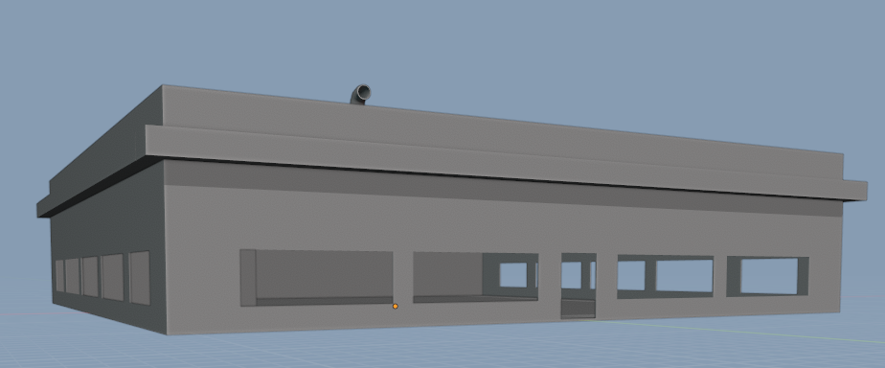
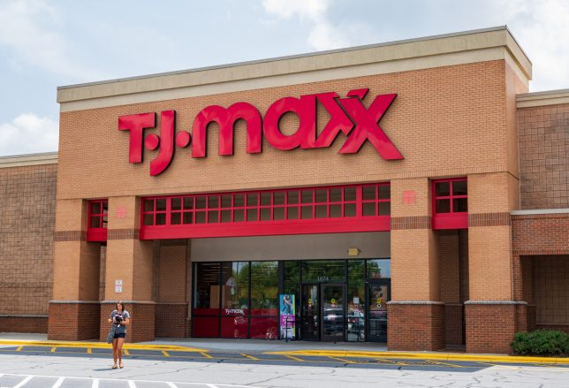
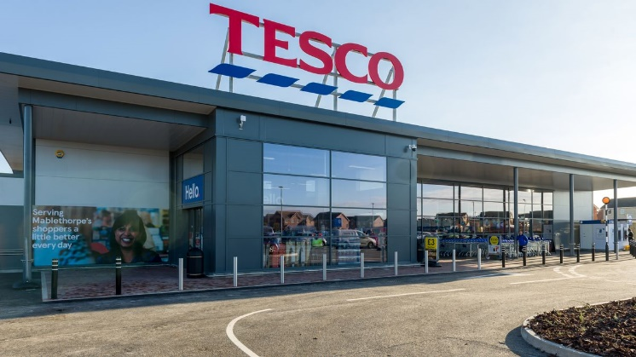
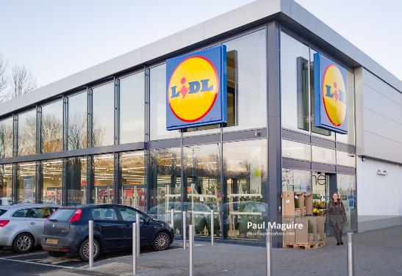
Market stores can vary depending on when they were built, some older stores are made out of a brick building, either from scratch or they bought and renovated an old building. I originally wanted a store that had a brock exterior, but due to texturing issues, I decided to make the store a bit more modern with a covered, painted wall on the outside, and almost plastic look on the inside.

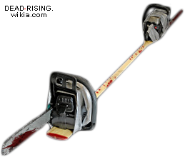
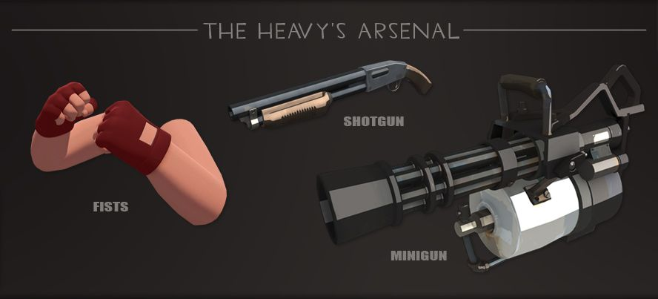
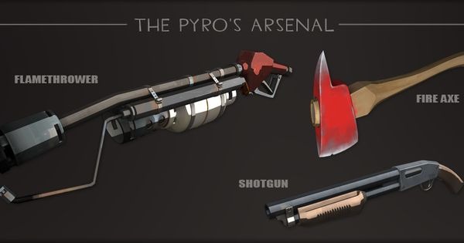
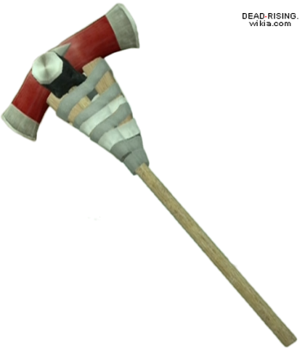
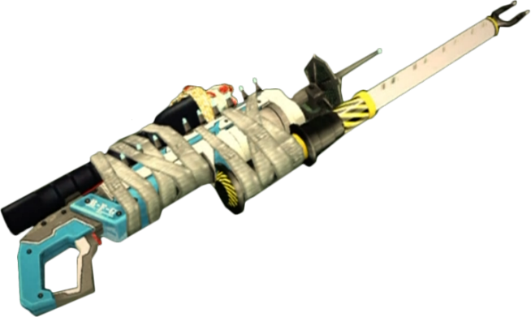
For the Stock Launcher I started by looking at other games ‘Cartoony’ Weapons, notable weapons within Team fortress 2 [2]. The Pyros flame thrower is thrown together with a Petrol pump, Proppian tank and other assorted parts, creating a unique look which stands out with the art style. The Heavies Minigun is large and has obnoxious parts standing out that aren’t realistic for the weapon its representing, which also compliment the style it is involved with. I wanted to create something that Mixed these two into one weapon. As stated, before I used photo bashing to create the look of the weapon using a propane tank as a basis for the weapon. Using the ideals from these two weapons, it helped me understand the importance of the look of the weapon, and having parts stand out can even make the weapon easier to identify for the player.
The Makeshift melees research was similar to the stock launcher, using similar games as a basis for the idea, and making my own from the idea. For the melee weapon I looked a lot into games designs, notably Dead rising 2 [14], and the dead rising franchise as a whole, which has many craft able weapons that are cobbled together with random items you can find within the game. seeing how items where taped or strapped with leather together let me have a lot of creativity while creating my own kit bashed weapon. Like with the Stock launcher, I imaged bashed a weapon which became my basis for the design.
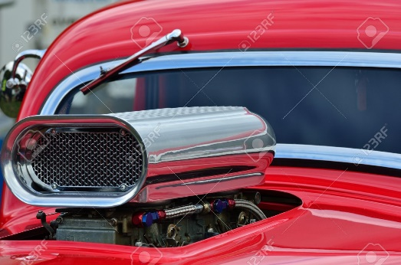
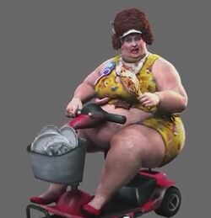
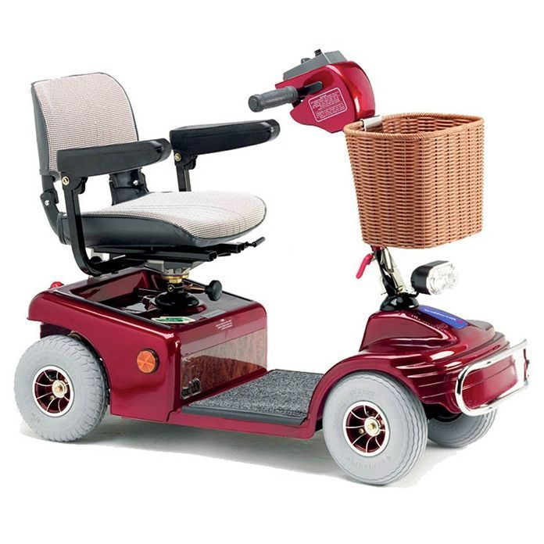
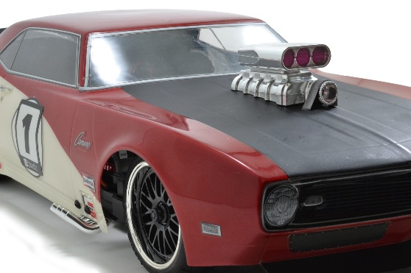
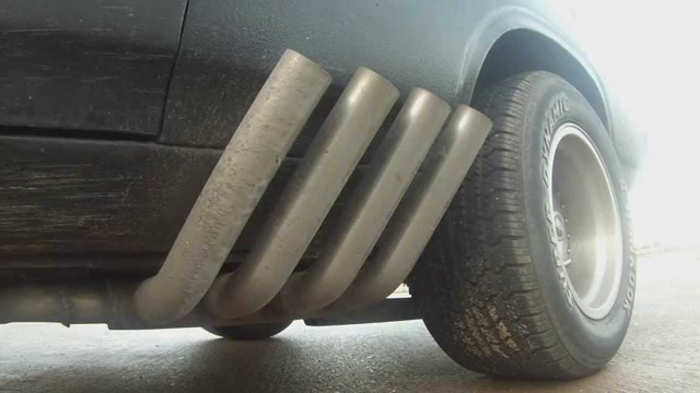
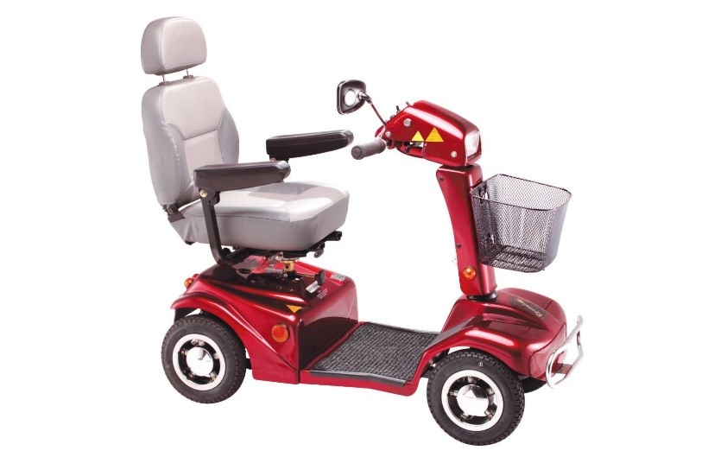
For the mobility scooter, I had to research how they worked, and how they looked. I had trouble modeling this as I kept making the front ‘Car’ like, with a bonnet covering much of the front, which on most mibility scooters, they only have a small cover over the front wheel splasher, and a hole for the handle bars. I also had to look at muscle Car intakes to add that cartoony charm on the scooter, since real mobility scoters do not have bug engines on the back, with large exhusts like a car. Dead Rising 3 [20] features a character boss in a mobility scooter, which helped as not many games features mobility scooters, or unique ones to help with creating one. Dead rising 3[20] scooter is just a basic red scooter with no added parts, which wouldve helped with its design in a game wher eyou can combine so many items. Due to the small amount of Wacky scooters in games, I created one that stood out and is unique, especially when compared to other games mobility scooter.

In reflection, the research I did really helped me with understanding what kind of assets I’d be making and what game our group as a whole created, I used my time in creating and researching said assets well and gave plenty of time to model and texture with time to trouble shoot any issues. The research also helped me learn and trouble shoot some issues I had early on with texturing and modelling and learn new skills within texturing through Substance painter. Looking at multiple medias I.e., Pictures, Videos and Games, really helped me visualise what I wanted this game to be and what I wanted to make. My communication within the group was active, I messaged the group every week I could to give updates and ask for updates from others. I struggled with asking often for other updates, and even when some members didn’t respond, I didn’t take indicative with contacting extra support to help, and it was left too late to sort out by the deadline, even with help offered and members saying they had done the work. Lack of communication from me in aspects like making sure our work fit well together and making sure work is done by a deadline is a weak point I have found with working in this group and is one I will need to work on, though working as a group has shown me I am capable of working in chain, with doing my bit of work and sending to the next part of the chain to be worked on, and even offering help and willingness to learn new skills to support within the group, which will help me in future groups . Working in this genre of game was challenging as it was a new style of game and style that I am not used too working on, and due to my failures of communication as well as the groups the outcome was not as we had hoped, which I will be trying to improve for future projects.

Bibliography
[1] ESRB Rating, is a self-regulatory organization that assigns age and content ratings to consumer video games in the United States and Canada, Founded in 1994 by the Entertainment Software Association.
[2] Team Fortress 2, is a multiplayer first-person shooter game developed and published by Valve Corporation on the 10th of October 2007
[3] Overwatch, is a team-based multiplayer first-person shooter game developed and published by Blizzard Entertainment released in 2016
[4] Little Nightmares, is a puzzle-platformer horror adventure game developed by Tarsier Studios, published by Bandai Namco Entertainment, it was published on the 28th of April 2017
[5] Blender, is a free and open-source 3D computer graphics software toolset, Created in January the 2nd, 1994, by Ton Roosendaal.
[6] Substance painter, is a 3D Texturing software, created in 2007 by Sébastien Deguy, Now owned by Adobe.
[7] Youtube, is an American online video sharing and social media platform headquartered in San Bruno, California, it was founded in 2005, by Steve Chen, Chad Hurley, and Jawed Karim, Now owned by Google.
[8] Photoshop, is a raster graphics editor developed and published by Adobe Inc, it was founded in February 1990 by Thomas Knoll and John Knoll.
[9] Call of Duty, is a first-person shooter video game franchise published by Activision, First released in 2003.
[10] Call of Duty World at War, is a 2008 first-person shooter game developed by Treyarch and published by Activision, it was released on the 11th November 2008
[11] Call Of Duty Black ops 2, is a 2012 first-person shooter video game developed by Treyarch and published by Activision, it was released on the 12th November 2012
[12] Call Of Duty Black Ops 3, is a 2015 first-person shooter game developed by Treyarch and published by Activision, it was released on the 5th November 2015
[13] Gears of war 3, is a third-person shooter video game developed by Epic Games and published by Microsoft Studios for the Xbox 360, it was released on the 20th of September 2011.
[14] Dead Rising 2, is a 2010 action-adventure game developed by Blue Castle Games and published by Capcom. It was released between September and October 2010.
[15] Left for Dead 2, is a 2009 first-person shooter game developed and published by Valve.
[16] Aliens Fireteam, is a 2021 multiplayer third-person shooter game developed by Cold Iron Studio in collaboration with Disney's 20th Century Games, it was released in the 24th of August
[17] Black Friday Madness: The best funny moments caught on camera, by ‘On Demand News’ Published on the YouTube platform in 2019, Link - https://youtu.be/3s9zoZMUVJc
[18] Black Friday in South Africa, stampede Nike store East Rand Mall by ‘Tiny ankle Biter’ Released on the YouTube Platform in 2017, Link -https://youtu.be/XTPomOyyxi4
[19] Tesco, is a British multinational groceries and general merchandise retailer headquartered in Welwyn Garden City, England, it was founded in 1919 by Jack Cohen.
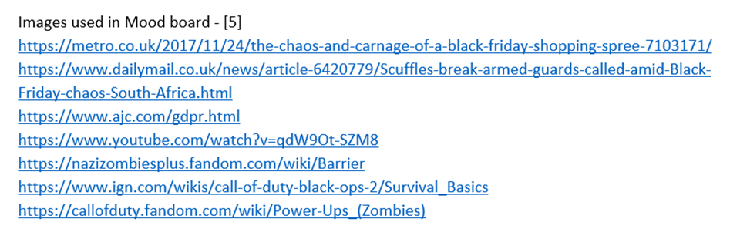
[20] Dead Rising 3, is a 2013 action-adventure game developed by Capcom Vancouver and published by Microsoft Studios, it was released on the 22nd of November 2013
Images Used on Each Page
Page 5 – Images used in the Mood Board -
Images used in Page 6 -
Image of shelve 1 -m https://www.shelvingmegastore.com/
image of shelve 2 - https://www.mirror.co.uk/money/empty-shelves-expected-last-until-25460766
Image of TJ max -https://www.vendhq.com/blog/retail-experience/
Image of Tesco - https://www.lincolnshirelive.co.uk/news/local-news/tesco-warning-customers-urged-please-6934855
Image of Lidl - https://paulmaguirephoto.com/photo/lidl-supermarket-store-exterior-uk//
Images used in Page 7
Heavy Characters Weapons - https://www.pinterest.co.uk/pin/474215035736547644/
Pyro Characters Weapons - https://www.pinterest.co.uk/pin/474215035736547632/
Dead Rising 2 weapon Images - https://dead-rising.fandom.com/wiki/Combo_Weapons
Images used in Page 8
Image of a Car Air intake 1 -https://www.rpmrcproducts.com/shop/body-accessories/mock-intake-and-blower-set/
Image of a Car Air intake 2-https://www.123rf.com/photo_22408674_detail-of-air-intake-and-windscreen-on-custom-car.html
Image of an Exhaust -https://www.youtube.com/watch?v=juwLm3XN26E
Image of a mobility scooter - https://www.ableworld.co.uk/rascal-388xl-mobility-scooter.aspx
Image of a mobility scooter 2- https://www.essentialaids.com/shoprider-sovereign-4-mobility-scooter.html
Image of the Dead Rising 3 mobility scooter Character - https://villains.fandom.com/wiki/Darlene_Fleischermacher

