Hi,
Below are my login details for the weebly website.
Sg19128661@gmail.com
Password – dob090894

Below are few snaps of my website and I will be speaking about my three pages as well.


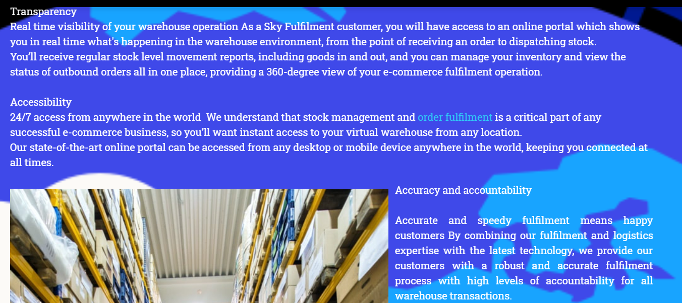

In the first home page of the website I used this background because I believe that the firsts impressions when you see this photo is are ‘’ OMG !!! so beautiful, I’m on top of the world , I control everything, and so many more … ‘’ As I said in the first home page our business will offer transparency , accessibility and accuracy. It has a really strong message from the background as well. You can be on top of the world and only the sky may be the limit for your e-commerce business. The message is clear and simple in the home page for everyone to understand. Sky Fulfilment will use simple methods to assure that your business will reach the highest level as soon as possible. The colours in the home page shows happiness, simplicity, respect, power and confidence in our services that the client will hire us to do so. The first page also means that Sky fulfilment is so big that will have a place for every client with them in sky.

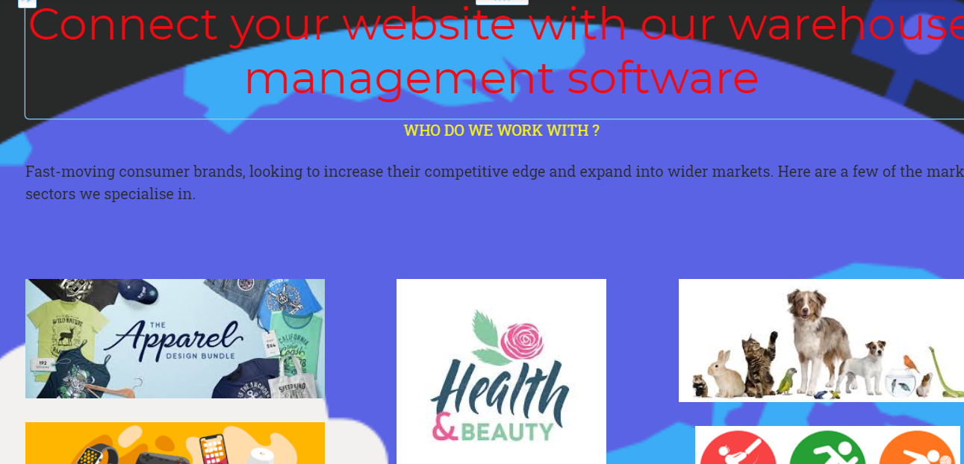
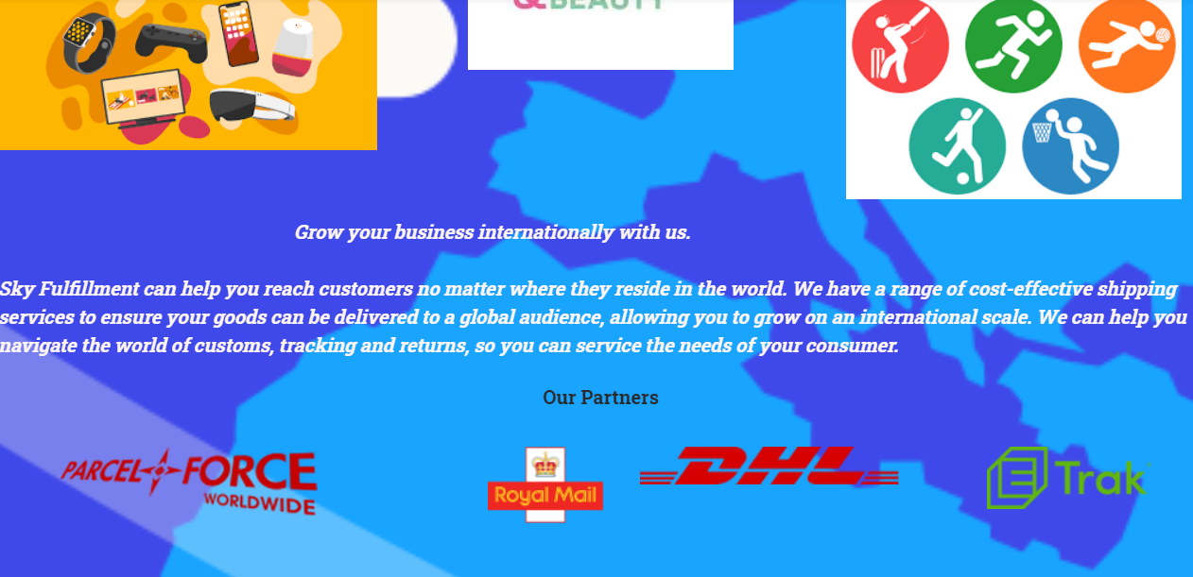
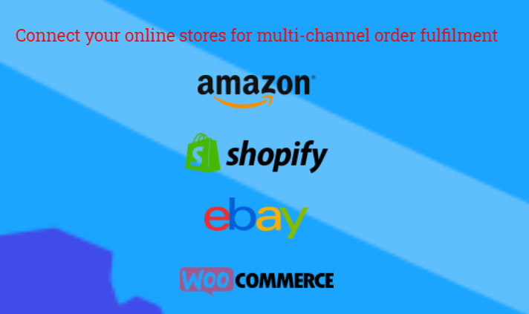
On the second page of the website I have the services that we provide them to the customers on a Blue background which means confidence and integrity. Also a bit of red to style the important point and attract their attention. We do have the white colour which brings hope and simplicity to the clients in order to use our exceptional services. We have the best partners intern & Internationally and we can connect the best selling platforms to our warehouse software. The most important areas of world sales are included in our services and we can send and stock anything.
In the second page I have used the same blue background as in first page because there is a globe with a plane which is flying all over the world which are the same as our services. (Globally )

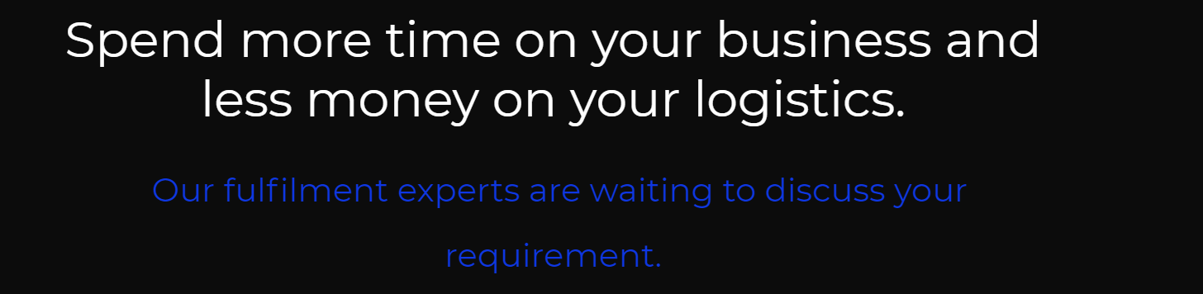

Finally, the third page is contact page which is got a black background to help clients to insert their details without any mistakes or being distracting by any colours. But instead of colours it has a really strong message which will make them decide to contact our company. Also, we have a phone number which they can contact us directly between Monday to Friday to discuss business and answer all the questions that they have. Our Office address is it shown as well, in order to arrange a meeting with us and to see our warehouse facilities and services. In conclusion I will say that the SKY is not the LIMIT.

