

UWTSD Swansea

Dr Kemi Ademoye
Application Development
Daniel Algie 1706977

Table of Contents
Development trends 3
Accelerated mobile pages (AMP) 3
Pros and Cons 3
Introduction 4
Requirements 4
Choosing a Concept 4
Design 4
The Mobile First Rule 5
Application Programming Interface (API) 7
Features of the website 7
Evaluation 11
Testing the Website 11
Further Implementation 12
Conclusion 12
Bibliography 13

Table of Images
Figure 1-home page 5
Figure 2-nav bar [9] 5
Figure 3 mobile first rule 6
Figure 4-hover feature 8
Figure 5-shows content for large devices 8
Figure 6-shows content for smaller devices 10

Development trends
The demand for application development is at an all-time high therefore it is important to stay up to date with the latest development trends and research which is going on within your field.
Here is a list of the current trends with in the application development [1] [2]
- Progressive web application
- Accelerated mobile pages
- Responsive websites
- Ai powered chat bots
- Voice search optimization
- Internet of things
- Blockchain

Accelerated mobile pages (AMP)
With the increase in digital technology and the increase in smart devices and the way that we see our data the user has become accustomed with the speed in which we see our data. This opinion will never change as people don’t like to wait according to google as quoted
“53 percent of mobile users abandon website which take longer than 3 seconds to load” [3]
Other statistics show that [4] 51 percent of all website traffic comes from mobile devices as an example if every time you went shopping online and Tesco web page took 30 seconds to load each page and Sainsburys page took 1 seconds to load each page most customers would use Sainsburys over Tesco.
[5]Accelerated mobile pages work by changing the original html tags and changing to use its own html tags for example when creating image or audio tags <image> <audio> for amp it would be composed as <amp-image> <amp-audio>. AMP also restrict the use of JavaScript and CSS all JavaScript is compiled and provided by AMP CSS is also discouraged and all style CSS must be written in the HTML file instead of having its own CSS file this is to keep the file smaller and increase the load up speed.

Pros and Cons
pros [6]
- Improved user experience
- Improved googled search rankings
- Mobile friendly display
Cons [7]
- Not easy to implement
- Only available to google
- Displays less content

Introduction
In this day and age there are not many places you can’t access the internet and the amount of people using the internet is only going to rise. Last year alone from January 2018 to January 2019 there were 366 million new users [8]. It’s more important now than ever to bring something different and unique to your website. This assignment will be explaining and showing how the website crown movie was created and designed and will also be showing the features added to make the website unique and stand out from other similar competitors.

Requirements

Choosing a Concept
First requirement was to decide what to make the website on. There were several different choices to choose from and the ideas consisted of:
- Music website with different artist
- The world showing several different countries from around the world
- Football few ideas were different league tables, teams’ types of competitions coming up e.g. champions league, FA cup
- A website showcasing Swansea and all the different great activities Swansea has to offer
- A movie website showcasing different genres of films
Although all the websites ideas have good content to create it was decided the movie website was the favourite choice due to knowledge and topics to showcase in the website and it was believed the best option to get users visiting the website.
Title of the website was decided on crown movies the target audience is people interested and looking for movie information.

Design
When designing crown movies, we wanted to keep the same design throughout the website and making it easy to use while still bring something different to the user when designing the look of the website it was decided to make it look like all the content was on a wall at a movie theatre.
It was also implemented that the content would be set using columns and rows so each movie content was set to the same size frame to make it look tidy and clean for the user.

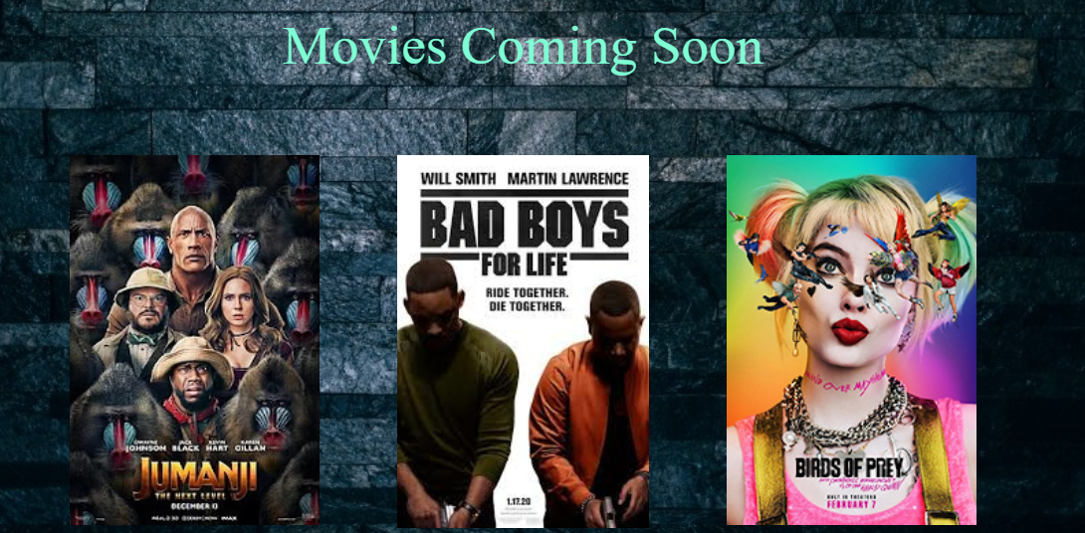
Figure 1-home page

When creating the navbar it was looked at bringing something different the navbar has a few different functions when the user hoovers over the navbar to choose a different topic page it increases the size of the writing and changes the font. Logos were also used to bring a bit of colour to the nav bar and making it more appealing for the user.
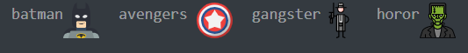
Figure 2-nav bar [9]

The Mobile First Rule
When creating the website, it was created with the concept of the mobile-first strategy. With the increase and development of mobile phones (smart phones) with around 368 million sales in 2019 alone [10] more people are using their mobile phones to search the internet. The concept of mobile first is where you design your website for mobile phones first and work your way up for bigger devices this could be tablets, laptops, televisions, projectors. It is important to follow this rule when creating a website because if all your content is created on the smallest device first you are implementing all your content on the smaller of screens and fitting it in all nicely and tidy then it will be easier to implement the same content on a larger device so your tackling the hardest steps first [11].

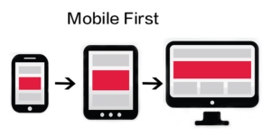 [12]
Figure 3 mobile first rule

It is also beneficial to use the mobile first rule when creating a website for functionality or design some features might not suit the sizing of mobile phones and if the website is created in larger formats first you will need to do more work to accommodate mobile phone use.
This is accomplished by using media queries media queries set the size of what content and layout that the device receives the content. When creating crown movies, it was set that the first media query was set to a max width of 600 pixels (px) then worked way up to larger devices with the largest device set to a minimum width of 1200px this is completed in the styling part of the website the style sheet (CSS). The use of media queries will also make your website responsive this is important for example if your website wasn’t responsive and the user was using a laptop and made the display smaller it would not be responsive this means that some of the content the user once seen would be hidden. When your website is responsive it will move your content to fit the screen size the user is using.
This was implemented in to the crown movies website when constructing the media queries [13] and seeing what content the user could see it was decided to hide some content for mobile user to see less of the context but added a button so that the user if needed to could see the same content that would be available with larger screens this was to keep it more attractive a not so crowed on the page for a better looking website.
When creating the website, a carousel [14] was created for crown movies in java script this was also hidden using media queries so that smaller devices wouldn’t have the option to see the carousel due to the size of the screen it wasn’t really appealing for the size of the screen. The carousel is a photo gallery that scrolls through the images automatically showing only one of the images at a time.

This is the JavaScript code for the carousel
function carousel() {
var i;

var x = document.getElementsByClassName("mySlides");
for (i = 0; i < x.length; i++) {
x[i].style.display = "none";
}
myIndex++;
if (myIndex > x.length) {myIndex = 1}
x[myIndex-1].style.display = "block";
setTimeout(carousel, 3000); // Change image every 3 seconds
}

Application Programming Interface (API)
An API is what the website uses to show the data(content)from the database a good example of an API is hotel websites say the user enters in the destination they are going on holiday and the data the user’s entry will be sent to the database and return the data needed for the user and display all hotels available in the area of their destination for the available dates.
The API being used for crown movies is the open movie database (omdb) [15] this will be used for fetching data for different types of movie genres and displaying the data on the website for the user.

Features of the website
When creating the website many features have been implemented into the website to make the website more responsive and functional depending on the users preferred device of choice (size of the screen) the main features include
- Hiding content from smaller devices making it clean and more efficient to use.
- Giving mobile the same opportunity to see same content as large screens with a link to IMDB [16]
- If the user is using a large device and shirks the screen down smaller it will hide the navigational bar and change it to a drop-down menu
- It is responsive in all aspects so there is no lag/delay or rendering issues
- Logo has been set within the nav bar to add some customization to the website
- A carousel has been created in java script for larger devices and is timed so the images change automatically
- The index page images are responsive to link to Amazon if the movie has been released to DVD, YouTube if the movie is coming to cinemas soon and IMDB if the movie has been released and is currently in the cinema
- Collecting data from the open movie database and displaying the content to the user this was written in JavaScript.
- When using the open movie database API originally it was used by getting movie reference on IMDB and storing them in an array to display the data this was changed to when you were calling the data from the API you could use the title of the movie and encoding the words in to movie title using encodeuri [17]
- A hover feature so it wold show a star rating and an opinion of the movie this was only implemented into the index page on new releases at cinema section

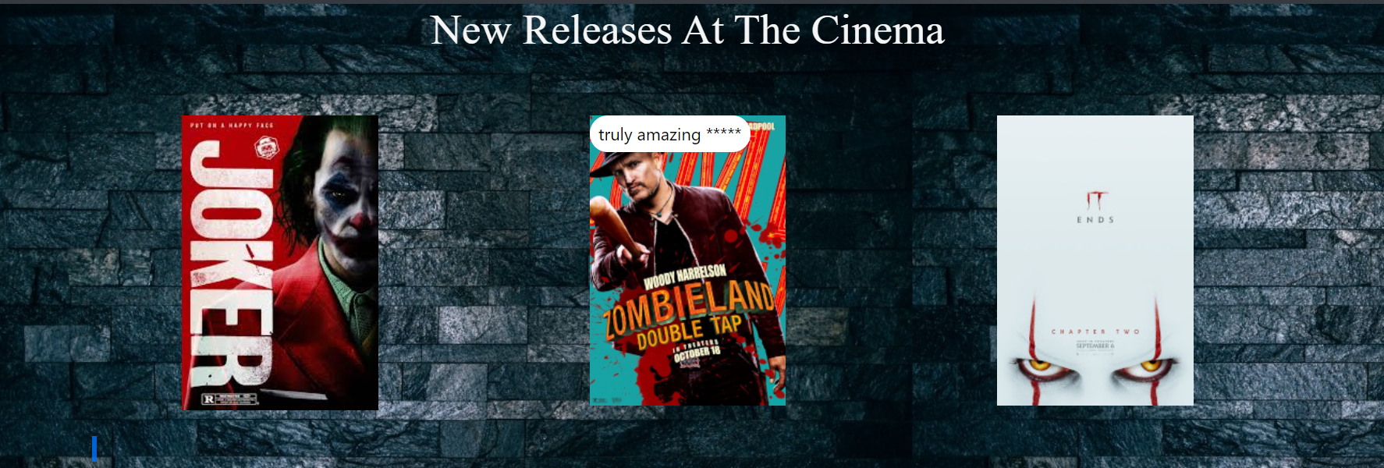
Figure 4-hover feature

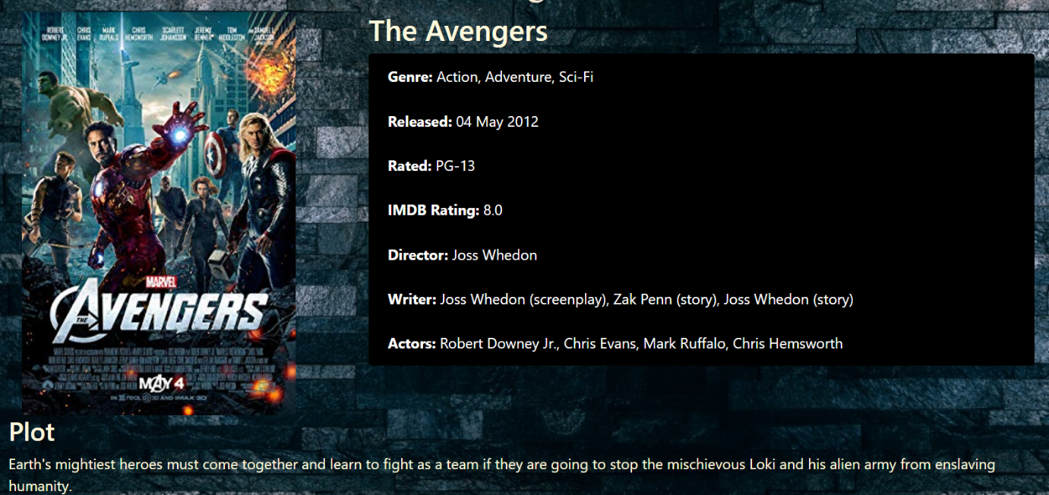
Figure 5-shows content for large devices

This was the function created to set up what the user would see when getting data from the open movie database and all data is taken by using the API key
function htmlStuff(movieArray){
let test = movieArray.Length;
console.log(test);
for (i=0;i<movieArray.Length;i++){
let movieId = sessionStorage.getItem('movieId');
axios.get('http://www.omdbapi.com?t='+encodeURI(movieArray[i])+'&apikey=9825cdce')
.then((response) => {
let movie = response.data;
let output =`
<div class="row">
<div class="col-md-4">
<img src="${movie.Poster}" class="thumbnail">
</div>
<div class="col-md-8 movie-block">
<h2>${movie.Title}</h2>
<ul class="list-group">
<li class="list-group-item"><strong>Genre:</strong> ${movie.Genre}</li>
<li class="list-group-item"><strong>Released:</strong> ${movie.Released}</li>
<li class="list-group-item"><strong>Rated:</strong> ${movie.Rated}</li>
<li class="list-group-item"><strong>IMDB Rating:</strong> ${movie.imdbRating}</li>
<li class="list-group-item"><strong>Director:</strong> ${movie.Director}</li>
<li class="list-group-item"><strong>Writer:</strong> ${movie.Writer}</li>
<li class="list-group-item"><strong>Actors:</strong> ${movie.Actors}</li>
</ul>
</div>
</div>
<div class="row">
<div class="well">
<h3>Plot</h3>
${movie.Plot}
<hr>
<a href="http://imdb.com/title/${movie.imdbID}" target="_blank" class="btn btn-primary my-button">View IMDB</a>
<br><br><br><br>
</div>
</div>
`;

This is how the content is to be received from the open movie database

function getAction(){
var movieArray = ['crank high voltage', 'ready player one', 'die hard','angel has fallen'];
movieArray.Length=4;
htmlStuff(movieArray);
}

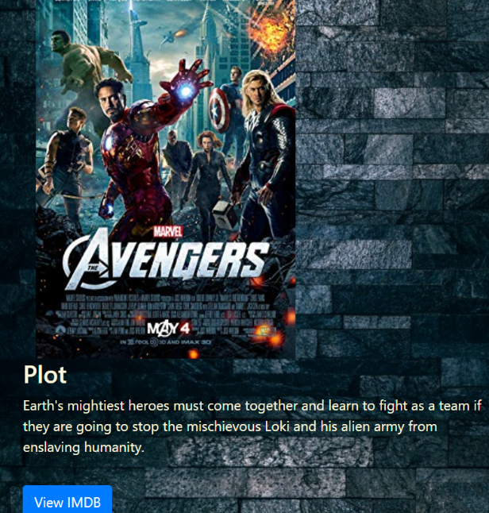
Figure 6-shows content for smaller devices

Evaluation
Evaluating and test your website is a major part of the completion of the website if you do not test the website you don’t know what issues the user will have when viewing your website.

Testing the Website
Test case | Test data | Test steps | Preconditions  Or prerequisites | Expected result | Actual results | Pass or fail
Home page images | Images | Checking if all images link to the correct pages and all images are a button | Data already exists | All images will link to the suitable pages assigned to that image | Most images work correctly for linking to the correct pages two images didn’t pass | fail
All page in the navbar connect to one other | Mouse click | Starting with the home page click each link in the nav bar to each page and move over and check all existing pages using the same steps | Data already exists | All pages are connected | All pages are connected | Pass
Receiving the data from the API |  | Calling the data using java script code | Data should already exist | Display the correct data on the correct page for the user | Displays all data for the user on the correct page | Pass
Display images using the javas script carousel | Images | Should display images and change to a different image | Data already exists | Display images and change image when correct time is reached |  | Pass
Carousel image sizing | Images | All carousel images should be same size | Data already exists | Keep all images the same size | Only keeps images same size on smaller screen not full laptop screen | Fail

When finishing the testing all of the failed aspects of the website were fixed, all images on the home page were corrected and it was also implemented that all images would open a separate page to the linked content instead of taking the user away from crown movies website. The sizing of the images issue was due to the coding being set wrong instead of setting the max height it was set to minimum height.

Further Implementation
Looking to the future to help crown movies grow there are a few different changes that would be beneficial to the website
- Adding a search bar so that the user can search any movie they wish to find out about
- A random movie generator so that it would show the user a random movie to watch
- A map and search bar so the user can search the nearest cinema in their area and display times and movies available to them.

Conclusion
In conclusion the website does its purpose, it allows visitors to view film information. The report shows how the crown movie website was created and how some of the key features to make a website exciting and fun for the user were implemented while also showing some of its downfalls and how they were rectified to make crown movies better and more efficient website.

Bibliography

[1] | S. Sadiq, “DZone,” Web Dev Zone , 25 september 2019. [Online]. Available: https://dzone.com/articles/top-10-web-development-trends-to-follow-in-2019. [Accessed 02 DECEMBER 2019].
[2] | V. K, “clever road,” 15 febuary 2019. [Online]. Available: https://www.cleveroad.com/blog/web-development-trends. [Accessed 02 December 2019].
[3] | d. kirkpatrick, “marketing dive,” [Online]. Available: https://www.marketingdive.com/news/google-53-of-mobile-users-abandon-sites-that-take-over-3-seconds-to-load/426070/. [Accessed 07 December 2019].
[4] | J.Clement, “statista,” 03 Decmebr 2019. [Online]. Available: https://www.statista.com/statistics/277125/share-of-website-traffic-coming-from-mobile-devices/. [Accessed 07 December 2019].
[5] | B. Jun, F. Bustamante , S. Y. Whang and Z. Bischof, “AMP up your mobile web experience,” Northwestern University , 2019.
[6] | S. Micgraff, “egrappler,” 23 October 2019*. [Online]. Available: https://www.egrappler.com/amp-pros-cons/. [Accessed 23 Decmber 2019].
[7] | U. Khan, “Clutch,” 10 July 2018. [Online]. Available: https://clutch.co/app-developers/resources/pros-cons-google-amp. [Accessed 07 December 2019].
[8] | S. KEMP, “Digital trends 2019: Every single stat you need to know about the interne,” 30 january 2019. [Online]. Available: https://thenextweb.com/contributors/2019/01/30/digital-trends-2019-every-single-stat-you-need-to-know-about-the-internet/.
[9] | flaticon, “flaticon,” [Online]. Available: https://www.flaticon.com/. [Accessed 20 November 2019].
[10] | EGHAM, 27 August 2019. [Online]. Available: https://www.gartner.com/en/newsroom/press-releases/2019-08-27-gartner-says-global-smartphone-sales-continued-to-dec#:~:targetText=Global%20sales%20of%20smartphones%20to,%2C%20according%20to%20Gartner%2C%20Inc.. [Accessed 05 December 2019].
[11] | B. Gremillion, “studio by UXpin,” 1st October, 2015. [Online]. Available: https://www.uxpin.com/studio/blog/a-hands-on-guide-to-mobile-first-design/. [Accessed 04 December 2019].
[12] | E. Solutions, 18 June 2019. [Online]. Available: https://medium.com/@escalesolutions/top-benefits-of-mobile-first-web-design-7afa1d22a40b. [Accessed 04 December 2019].
[13] | “w3 schools,” [Online]. Available: https://www.w3schools.com/cssref/css3_pr_mediaquery.asp. [Accessed 20 November 2019].
[14] | w. schools, “w3 schools,” [Online]. Available: https://www.w3schools.com/howto/howto_js_slideshow.asp. [Accessed 22 November 2019].
[15] | t. o. m. database, “open movie database,” [Online]. Available: http://www.omdbapi.com/. [Accessed 4 December 2019].
[16] | IMDB, “IMDB,” [Online]. Available: imdb.com. [Accessed 06 December 2019].
[17] | .w3schools, “w3 schools,” [Online]. Available: https://www.w3schools.com/jsref/jsref_encodeuri.asp. [Accessed 26 November 2019].
[18] | “Higher Ed Geek,” [Online]. Available: https://www.higheredgeek.com/blog/2015/10/26/movie-review-monday-mad-max-fury-road. [Accessed 20 November 2019].
[19] | “original film art,” 2009. [Online]. Available: https://www.originalfilmart.com/products/avatar-2009-quad. [Accessed 20 November 2019].
[20] | imdb, “imdb,” [Online]. Available: https://www.imdb.com/title/tt1502397/. [Accessed 20 November 2019].
[21] | “lydia blangya,” [Online]. Available: http://lydiadeblangya2.blogspot.com/2013/01/social-realism-film-poster-research.html. [Accessed 22 november 2019].
[22] | “hey u guys,” [Online]. Available: https://www.heyuguys.com/best-worst-movie-posters-2015/. [Accessed 21 November 2019].
[23] | “poster posse,” [Online]. Available: http://posterposse.com/the-poster-posse-x-marvel-studios-captain-marvel/. [Accessed 21 November 2019].
[24] | “forbes,” [Online]. Available: https://www.forbes.com/sites/scottmendelson/2019/09/17/birds-of-prey-poster-margot-robbie-gal-gadot-scarlett-johansson-ewan-mcgregor-harley-quinn-joker-aquaman-shazam-black-widow-dc-films/#7274435e2f02. [Accessed 20 november 2019].
[25] | “microsoft,” [Online]. Available: https://www.microsoft.com/en-us/p/fast-furious-presents-hobbs-shaw/8d6kgwxn017z?activetab=pivot%3aoverviewtab. [Accessed 20 November 2019].
[26] | “imdb,” [Online]. Available: https://www.imdb.com/title/tt7349950/. [Accessed 20 November 2019].
[27] | “Amazon,” [Online]. Available: https://www.amazon.co.uk/John-Wick-Chapter-Parabellum-DVD/dp/B07RMZMZ8Z. [Accessed 20 November 2019].
[28] | “wikipedia,” [Online]. Available: https://en.wikipedia.org/wiki/Jumanji:_The_Next_Level. [Accessed 20 November 2019].
[29] | “posterrazzi,” [Online]. Available: https://www.posterazzi.com/lord-of-the-rings-fellowship-of-the-ring-movie-poster-17-x-11-item-mov195991/. [Accessed 20 november 2019].
[30] | “Amazon,” [Online]. Available: https://www.amazon.com/POSTER-ORIGINAL-Advance-Version-DISNEY/dp/B07QDDZ27D. [Accessed 20 November 2019].
[31] | “comicbook,” [Online]. Available: https://comicbook.com/horror/2019/09/25/zombieland-2-double-tap-character-posters/. [Accessed 20 November 2019].

marking criteria and Student FEEDBACK

This section details the extent to which the assessment criteria are demonstrated by you, which in turn determines your mark. The marks available for each category of skill are shown. Lecturers will use the space provided to comment on the achievement of the task(s), including those areas in which you have performed well and areas that would benefit from development/improvement.

Common Assessment Criteria Applied (Assignment 1) | Marks available | Marks  awarded
1. Engagement with Literature Skills

A good, though brief, summary overview of the chosen application trend. Generally, a more in-depth discussion is required as well as the required background from a relevant peer-reviewed study. (Grade mark: 58.00%) | 25 | 14.5
2. Knowledge and Understanding Skills

3. Cognitive and Intellectual Skills

A good evaluation of the website with some relevant recommendations for improvement has been provided. Please note that you were required to develop test cases for the JavaScript functionality of the website. (Grade mark: 60.00%) | 20 | 12
4. Practical Application Skills

A very good attempt featuring a website with well-thought-out content and good use of JavaScript functionality. There is, however, still room for improvement. Please note that in HTML, the <title> tag in the head section is mandatory and all content to be rendered (visible) in the browser must be within <body> .. </body> tags. You added your carousel content before the opening <body> tag. Use the CSS styles for responsive images, some of your images (particularly in the carousel) appeared to be skewed because you used a fixed height value. There is also room for improvement in your use of JavaScript. Note that you do not need to hardcode the size of array items, programming languages can automatically determine the number of elements in an array and will provide a property you can use to read the number of items. Instead of having different functions to create different array objects for your film genres and hardcode the current option, a better approach would have been to use a single JSON object with one function with a parameter to pass in the current genre. I would also have liked to see some more variation to demonstrate other skills. Generally, good consideration given to the responsive design with good choices of what you decided to show/hide on mobile devices but note that the display of one or two sections could have been improved for your smaller screens. (Grade mark: 73.00%) | 50 | 36.5
5. Transferable Skills for Life and Professional Practice

The report is of a good standard, but remember to spell-check your report. See your report for some suggested improvements. (Grade mark: 60.00%) | 5 | 3

Assignment Mark (Assessment marks are subject to ratification at the Exam Board. These comments and marks are to give feedback on module work and are for guidance only until they are confirmed. ) | Late Submission Penalties (tick if appropriate) |  | 66%
 | Up to 1 week late (40% Max) |  | 66%
 | Over 1 week late (0%) |  | 66%

