Module code: BMSW5103
Module title: Understanding and engaging in the customer experience
Student Jhoshim chaudhury 1921339 L5 T1G3 UEC
Lecturer’s name: Balendran Kandasemy
Assignment title: Organisation’s quality system and customer relationship management

Executive summary
The study is focused on analysing the CRM problem Tesco is facing with the application of an effective CRM model. Tesco is one of the most famous supermarket stores in the UK and it has been providing Excellent service during the COVID-19 pandemic situation with proper customer relationship management. The company has been using digital technology for this. However, for the rapid change of customer behaviour during this time, the company has been facing issues in CRM. The models such as SERVQUAL, CRM life cycle and 7Ps of marketing mix model have been discussed for getting a good understanding of the sudden changes in consumer behaviour. The relevancy of the 7p model has been discussed and the seven elements of the model will help to identify and comprehend the changes in customer behaviours to understand the lack of CRM policies. Tesco mainly focussed on the necessary products in this pandemic rather than just focusing on the luxury products. The low pricing strategy helped the organisation to retain its customer base during the pandemic. According to promotions the company has focused purely online, which attracted young customers. However, offline customers have not been satisfied. the online process has created complexity for the aged customers. In addition, the excess stress on young staff has been negative for Tesco after the Covid-19,pandemic which has reduced the quality of CRM. The physical evidence of the offline shops faces challenges mostly regarding keeping the operation on going with additional costs. Proper recommendation about improving the cost structure and implementing a better CRM process has been given.

Table of Contents
1. Introduction 4
2. Company context 5
3. Models Review 6
4. Model Selection 10
5. Application 12
6. Recommendations 17
7. Conclusion 17
Reference list 19

1. Introduction
Quality processes in an organisation helps to achieve the important goal of identifying and implementing strategies that will enhance the ability to consistently produce and deliver improved quality products and services (Schneider and White, 2004). The CRM effort in the company helps to learn about its potential customers and develop strategies according to the preferences of the customers. The CRM also optimises customer interactions and focuses on marketing, sales and service of the company (Buttle, 2008). The benefits of CRM can be analysed with the interaction and relationship between customers and the company; effective CRM ensures that the potential customers get the best services from the organisation and get the after-sales service. The bottom-line benefits of CRM would be enhanced customer satisfaction, optimised marketing strategy and improved customer retention (Greenberg, 2010).

Figure 1: Customer Relationship Management (CRM)
(Source: Raab, Ajami and Goddard, 2016)
In this study, the company chosen for the analysis on CRM problems after the Covid-19 situation is Tesco. The CRM practices and problems faced by the company after the pandemic hit are analysed with the help of CRM models. Before that, different CRM models are discussed and an effective model is chosen, which will address all of the required elements of the problem to comprehend. After the model review and selection, the application is done based on the problem with CRM and effective recommendations for the solutions are given.

2. Company context
Tesco is a British Supermarket company. Not only in the UK but also all over Europe, this brand has been operating for several years. Currently, the company has more than 500,000 employees all over the world. In the UK, the company has acquired over 53 billion GBP till 2021 and the overall revenue has grown by 7% from 2018 (Tesco, 2021). Currently, Tesco has been using the on-demand CRM technology for providing a better service to the customers. For CRM software, Tesco has been currently using Right Now and Tesco (Tesco, 2021) Digital software. With this customers can have proper communication with the call centre for enjoying adequate support with the customers.
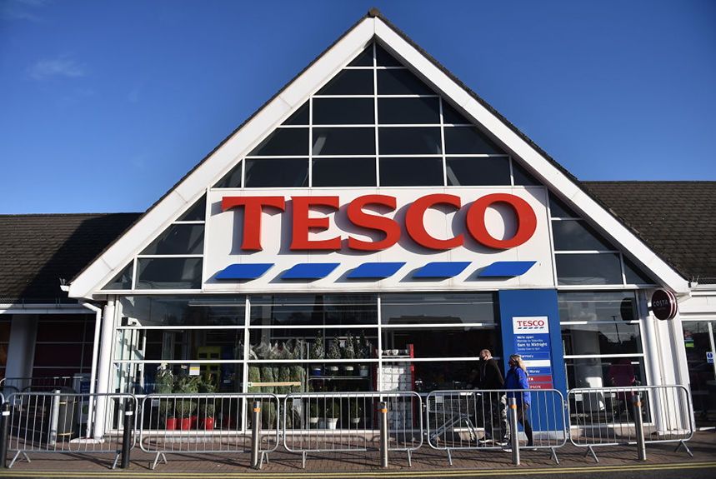
Figure 2: Tesco
(Source: Tesco, 2021)
After the breakout of the Covid-19 pandemic situation, Tesco has been facing several difficulties. As the customers have now deviated to online shopping, Tesco has to be more aware of customer relationship management. In developing a good CRM, Tesco has overlooked the cultural differences while serving customers through an online portal. The social and cultural backgrounds of the customers are often overlooked while placing proper customer relationship management. Even after the pandemic situation, the customer purchase behaviour also has a rapid change as their choice of service and production (the Guardian, 2021). With the help of proper CRM, the expected benefit that Tesco can enjoy is the maximisation in profit value and gain customer loyalty.

3. Models Review
SERVQUAL Model
Berry, Parasuraman and Zeithaml developed this model to compare the performance of service quality with the needs of customers associated with the service quality can define the SERVQUAL model as the empirical model (Haming et al., 2019). It is utilised for doing a gap analysis of the service quality of an organisation's performance against the needs of customers associated with service quality. The five main components of this model are tangibles, reliability, responsiveness, assurance and empathy. The purchase decisions of consumers are being influenced by the pricing and suitable offers or discounts provided with the product. It can be stated that staff’s willingness to help or respond to the needs of customers can be helpful for advocating the issues of changing the behaviour of the customers. The company needs to respond properly to the needs of customers and should make changes depending upon their changing behaviours. It will make the customers think that their purchasing behaviour is worthy for the organisation. It will help in meeting the esteem needs of the customers.
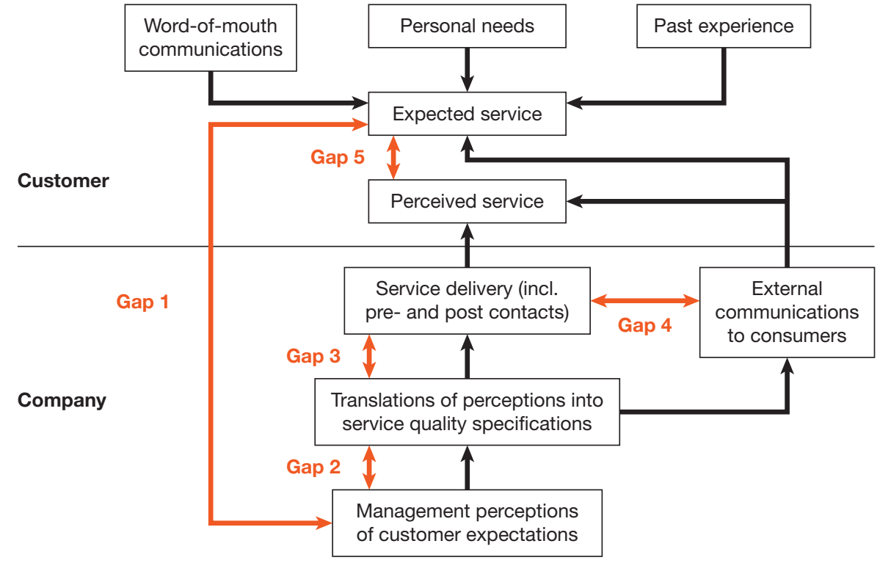
Figure 3: SERVQUAL Model
(Source: Haming et al., 2019)
This model can be helpful to track the perceptions of customers regarding the service quality of a particular business organisation compared to the competitors. It can provide the opportunity for a business firm to assess its performance of service quality dependent upon every dimension individually along with the overall dimensions. This model should be conducted to determine the effectiveness of service improvements on the perceptions and expectations of the customers regarding service over time, which is its strength (Haming et al., 2019). This model is oriented on the process as it focuses on the method of Service Delivery and not on the results of service encounters. It is a universal model. It does not matter the area of a market in which the business is operating. This model is applied ranging from the food industry up to the car industry and all the other industries. Different sectors might encounter different troubles or problems although this model does not change at all. It keeps checking the same gap. The weaknesses of this model are evident from the fact that there is a subjective aspect to this model (Ayyagari, 2021). It means that this model cannot have a similar outcome each time. It is dependent upon the people using this model and what its results will be.
CRM life cycle
Customer relationship management solutions mainly help in aligning sales customer support and marketing functions for providing authentic customer service and getting detailed insights about a business (Berguson, 2002). Beginning from the first interaction up to being converted into a final transactional customer for a business, a customer goes through different stages of conversion and the action taken in this process mainly helps in defining the value of the customer life cycle.
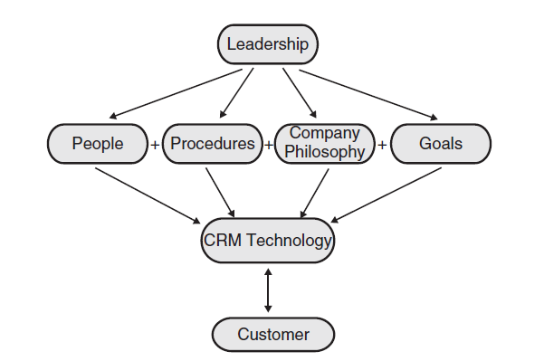
Figure 4: CRM Life Cycle
(Source: Berguson, 2002)
The strength of the CRM life cycle is it outlines the CRM goal of an organisation in a significant manner so that an organisation makes changes in their practical processes properly. Moreover, it helps in enhancing brand image among the customers by attracting them through increasing awareness. Another strength of the model helps an organisation retain its customers by offering personalised as well as customised services (Anshari et al., 2019). On the other hand, here the use of CRM technology helps them to communicate with the customers in a significant manner. This is helpful for an organisation in a pandemic situation to engage more customers.
One of the weaknesses of the CRM life cycle system is its implementation cost (Buttle, 2009). Different software is needed for the implementation of the CRM life cycle, which needs proper training. Training will attract a considerable amount of cost for the organisation.
This model can be applied in a successful manner by using specific CRM software which can help an organisation to connect with the customers in a proper manner. On the other hand, This CRM lifecycle can be used by an organisation choosing proper product according to the functional requirements and the requirement of the information regarding the market trend and many more. Hence, Tesco can use this model too to overcome their CRM issues.
7P model of the marketing mix
The marketing mix 4P model includes 4 key elementsthat are products, price, place, promotion (Gummesson, 2002). Afterwards, 3 more Ps are added which are people, process and physical evidence to the framework that can be used by the organisations to achieve the marketing goal by maintaining relationships with the customers in a significant manner. This marketing mix model can be useful for improving marketing and engaging more people in the current pandemic situation as this model can be helpful for the company to systematically proceed with the marketing process that can easily attract customers and potential consumers.
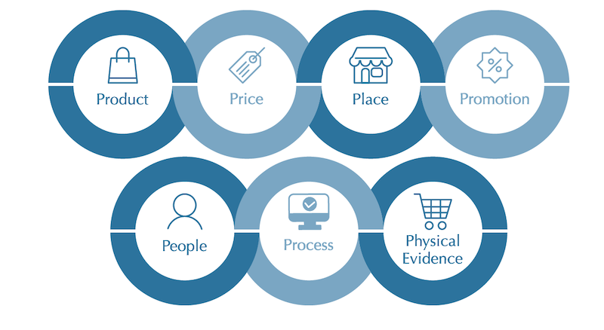
Figure 5: 7Ps of Marketing Mix
(Source: Anjani, Irham and Waluyati, 2018)
The strength of this model is this is easy to allocate as it takes less time and money so that in a pandemic situation this can be beneficial for the organisation. Moreover, this helps an organisation to bring together the entire marketing concept clearly and apply it to enhance customer relations by taking attractive marketing actions. Thus, this influences customer loyalty too (Anjani, Irham and Waluyati, 2018). Moreover, using this model the company can be able to market their products at a low price which will help an organisation to retain its customers. According to this model, an organisation can use low-cost pricing strategy to attract people specifically in the current pandemic situation.
There are some weaknesses of this model (Komari et al., 2020). This model is incapable to provide granular insights into the market trend and the behaviour of the customers. For instance, in the current pandemic situation, the market trend and behaviour of the customers is changing at a rapid pace so that here the marketing mix model does not work well. Moreover, this model does not have any significant variable to address issues regarding the productivity of the organisation.
In the current pandemic situation, the online demand for various retail products specifically groceries has been increased. Thus, in this situation to retain the customers by satisfying their demand an organisation can implement the marketing mix 7P model by introducing a huge range of products by offering relatively low prices (Altay, Okumuş and Mercangöz, 2021). It is general that customer behaviour influences global marketing massively (Mooij, 2004). Thus, an organisation can promote higher discounts and take lower delivery costs in their products using this model to overcome the issues regarding changing the behaviour of the customers. Thus, Tesco can use this model to overcome customer related issues in the pandemic situation.

4. Model Selection
The analysis of the CRM problem of the Tesco, 7P model has been chosen. The CRM problem which has been identified as due to COVID-19 the rapid change in customer purchase behaviour has taken the whole purchase framework online and Tesco is getting affected by this continuous change. The customers have become more concerned about the services Tesco is delivering because of safety and health concerns in this pandemic situation. The model which has been selected for the application on the problem is 7P of Marketing Mix. The model will address seven different elements of business such as Product, Price, Promotion, Place, Packaging, Position and People of the problem on CRM (Gummesson, 2002). The different elements will focus on addressing and identifying the root cause of the problem and how it is affecting the overall business operations of Tesco and most importantly CRM practices of the company. The problem of the company is the changing purchase behaviour of the customers, the model which has been selected will help to identify which factors mainly influences their purchasing behaviour in this COVID-19 pandemic situation. Among these seven elements, each element will be critically analysed to understand its significance and influence on the CRM problem of the company.
The pieces of evidence on the application of the model will cover the relevancy of application of the model, as the model will potentially address product, place and packaging, which will address the concerns of the customers and what type of services they are expecting from the company in this time will be also identified. Other than that, the price of the product and promotional difference between pre-COVID and post-COVID eras will be analysed, and customers' perception of these factors will also become more understandable with the model application. The position and packaging of the product have differed after the covid era and it has been anticipated that customers are more eager to know about how their product is being packed and delivered, because of different covid safety norms their concerns are relevant which influences their views on the products. The model will closely comprehend several behaviours of different types of customers coming from different backgrounds and will address their concerns and issues to identify potential solutions for improvement of the problem associated with CRM. The CRM problem mainly focuses on changing customer behaviours and the elements of the 7P model will individually address each element’s influence on this problem and how it is becoming a huge problem for the company context.
Benefits: The benefits of the 7P model on analysing the CRM problem of Tesco will provide the required help with summing up all the influences of different elements of customer's purchasing behaviours. Moreover, analysis of the main elements of the company such as product and price will help to understand the right marketing influence on the customers (Bergeron, 2004). 7Ps will also help with understanding the concerns of the customers on safety elements on the products of the company during this COVID-19 situation. It will identify the potential changed preferences of the customers in this COVID era on the product, prices, packaging and place. On the other hand, this marketing mix 7P model will help Tesco to promote their products along with giving more discounts and fewer delivery charges. It is because the income level of people became lower due to job losses and lockdown situation. Therefore, discounts and fewer delivery changes will be helpful for customers and attract them. This way the company will be able to attract customers, which will help them to overcome the customers' changing behaviour while purchasing products. Moreover, this model will provide the opportunity for the company to promote its brand value by addressing people from all financial backgrounds. This will increase their sale highly and engage more customers effectively even in this COVID-19 pandemic situation. Thus, this model can be helpful for the organisation to mitigate their issues in CRM.
Challenges: It is normal that all the models have some weaknesses too hence this 7P model also has some disadvantages (Komari et al., 2020). Thus, while applying this model in order to combat COVID, Tesco can face several challenges like this 7P model highly talks about the marketing process but do not helps an organisation to analyse the market trend and its changes in this COVID situation. On the other hand, in the case of applying this model, Tesco will not be able to analyse the impact on cross-channel marketing. Thus, this will create difficulties for the company to examine the customer behaviours towards the company and its business processes.

5. Application
The 7P framework is selected as the CRM model. It is described as the seven elements of the marketing mix that are used by an organisation to market its products and services (Foxall, Goldsmith and Brown, 1994). The usage of the seven elements in the context of the COVID-19 situation by Tesco is discussed below.
Product
Tesco has a vast range of products and services such as food, clothing, electronics, financial services, and many others. The product line of the company is focused on catering for the need of a vast number of individuals. The 40,000 product lines of the organisation are one of its major strengths (Tesco, 2021). The application of the 7P model has been effective for the organisation. In the case of the element of the product, the company has offered products that are in demand during the lockdown situation. It has been found that the citizens of the UK were in quest of buying the essential items instead of the non-essential ones. Therefore, the management of Tesco witnessed the sales growth of the food products especially the grocery items.
The benefit of the application of the model in regard to the element of the product is that the company has succeeded in identifying the products that are mostly needed by the customers. They relied on the feedback of the customers in this case. The feedback from the consumers helped Tesco in the success of its brand measures (Fleming, 2021). On the other hand, there are certain limitations of the application of the model in this regard. The company has to stop thinking about selling luxury products during the pandemic because people did not prefer those due to their poor financial condition (Tesco, 2021). Apart from that, it can be said that Tesco witnessed a low number of customers in the initial stage of the lockdown, which resulted in the wastage of some of its products.
Price
Tesco is the leading retail supermarket chain in the United Kingdom. The company has a high market share in the country with a huge customer base. In order to attract more customers, Tesco has always relied on keeping its price as low as possible. However, the management of the organisation has not compromised with the quality of the products while lowering its price. The company has opted for a cost advantage to keep its customers happy and has used economies of scale (Tesco, 2021). During the COVID-19 pandemic, the company has failed to maintain its pricing strategy because of the decrease in its sales growth.
The main advantage of applying the model in the case of price is that the organisation has succeeded in keeping its customer base during the pandemic time because of its low pricing strategy. The Club card system of the organisation has been accompanied by the pricing strategy. The main disadvantage of the application of the 7P model in the case of pricing strategy is that Tesco has faced low-profit growth by selling non-essential items at low prices. This is because there has been a significant reduction in the sale of the goods, which has brought down the sales volume.
Place
The headquarters of Tesco is in Hertfordshire. The company has more than 4,000 stores in the United Kingdom. The offline forum of Tesco is of various types such as Tesco Superstore, Tesco Extra, Tesco Metro, and many others (Tesco, 2021). Customers can also buy the products from its official website. During the Covid-19 pandemic, there has been an issue in the physical stores because of the fewer visits of the customers (The Guardian, 2021). As a result, the company had to give a deep focus on selling products via online medium.
The main advantage of applying the model in regard to the element of place is that the company has succeeded in reaching customers via online medium. As a result, the company has not witnessed a high loss during the pandemic. Moreover, it has been beneficial for the customers because they can take time to select their products. The fundamental limitation is that the company has failed to offer products to customers who are not so accustomed to online shopping especially the old ones (Shahbaz et al., 2020). The maintenance of COVID protocols in the offline stores has been one of the major concerns of the management of Tesco.
Promotion
According to the promotional activities, Tesco has been bound the change its strategy. It is because; due to the pandemic of COVID-19, Tesco has not been able to recognise the cultural differences among the customers. For instance, as the offline sale has been decreased after the pandemic of COVID-19, the company has been concerned to conduct its promotional activities through television, newspapers and several other social media outlets to reach the customers. However, it can also be said that the focus of customers through online platforms for purchasing products has benefitted Tesco in some instances. It is because; Tesco uses Club Card, as its loyalty card for the customers to get discounts (Tesco, 2021). As more customers are preferring online shopping after the pandemic, it has been favourable for the company to draw their attention through discounts.
According to the management of Tesco, the Club Card is considered as not only a temporary promotional tool or to mitigate the issue of customer relationship management, but the company has also preferred this card as a promotion itself for the company (Tesco, 2021). However, it has been evident that the choice of online and offline customers are not the same in the UK. Due to which the fulfilment of customers’ needs has been difficult (Gummesson, 2002). It has been the biggest issue for Tesco to apply the marketing mix. Besides, it has been quite challenging for Tesco to earn the trust of specific customers, as they have tried to show step-by-step recipes to prepare from starting, which has made them unique in the scenario as well (Tesco, 2021).
Process
According to the change of focus among the customers in the UK after the pandemic of Covid-19, Tesco has also been enforced to shift their activities of distributing products online. It has been evident that at Tesco’s offline stores, customers were used to picking their desired products. However, at the online process of Tesco, customers are now enforced to cover four steps for shopping, such as register or log in, booking a delivery slot, add to a basket, and checkout (Tesco, 2021). Firstly, the registration process has been a challenge for the senior customers, as email ID and password has to be entered, which is complex for them. Then for booking a slot, they have to choose either home delivery or click+collect (Tesco, 2021).
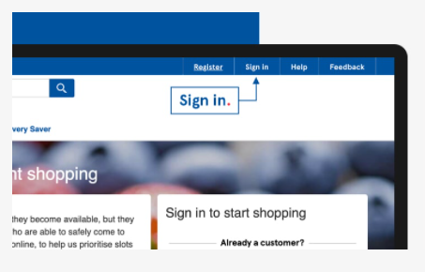
Figure 6: Online process in Tesco
(Source: Tesco, 2021)
However, for having home delivery, a minimum amount of £40 has to be ordered (Tesco, 2021). Therefore, the overall process has been quite complex for the aged customers. However, for the young people, it has been quite comfortable, as they have been ensured about the proper social distancing during the pandemic of COVID-19.
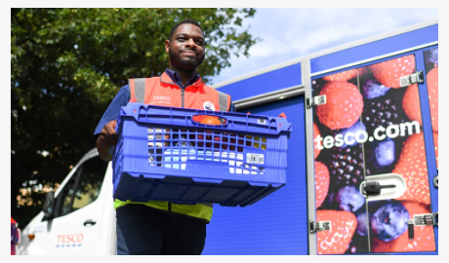
Figure 7: Home delivery facility of Tesco
(Source: Tesco, 2021)
Besides, they can book their slot for delivery up to three weeks in advance, which can decrease the risk of not getting desired products. Henceforth, the customer relationship management through the process of Tesco, the company has both positive and negative aspects.
People
In order to state the people in the marketing mix, it has to be said that almost 367,361 people are currently working in Tesco in 2021, of which 336,392 are in the UK (Statista, 2021). However, it has been significant that several employees are placed to handle the online services in Tesco, as most of the customers are not purchasing through online platforms. However, the main issue in the segment is that Tesco is lacking adequate customer assistance, due to which the managing rush has been challenging for the company in this COVID-19 pandemic (Tesco Plc, 2021). Besides, they have been enforced to place the employees in training and development to being used to in handling customers online. Therefore, lots of money has been invested, which is negative in this aspect. However, the company has reward schemes for those employees, who are good in performance. Due to which, the management is able to motivate employees in to enhance the quality of customer relationship, which has been significant. However, among the young staff, the excessive pressure of work has reduced the quality of CRM, which is adverse as well in this COVID-19 situation (Tesco Plc, 2021).
Physical evidence
As the rapid change in customer purchase behaviour has indicated that most of the customers prefer not to visit the offline shop at this time but when they are visiting, they are buying 50% more products. (The Guardian, 2021) Hence, the physical evidence of Tesco has built its omnichannel presence for dealing with the rapid change of the customers and for enjoying the benefits. In order to develop better customer relationship management, Tesco has been offering a loyalty scheme and digital services even in this COVID-19 situation. Even for strengthening the physical evidence, it has been offering low prices in its products, when it is compared to other supermarket brands.
In the stores, it has been establishing safety for everyone by controlling the flow of customers to avoid congestion at a particular time (Tesco, 2021). In order to deal with the rapid change of the customers and taking care of their cultural difference issues, Tesco has hired more temporary and permanent employees. However, the challenge of customer relationship management in physical evidence is that the COVID-19 situation has increased the overall cost of the service. For safety and regulations in service, the company has to spend more resources for sanitisation purposes. Even the CRM crisis has also shifted to increased demand of the customers of some certain products (The Guardian, 2021).

6. Recommendations
In order to resolve the issues during COVID-19 pandemic that have been found from the application of the 7P marketing mix, a few recommendations are given below.
Cost management: In order to manage the funds in the COVID-19 situation for sustaining strong physical evidence, it has to opt for liquidity assistance schemes and taking steps for proper demand and supply. Being one of the most famous retailing stores in the UK, it has to maintain a proper position in value chain analysis also. As CRM activities are also dependent on business management in post-pandemic situations, Tesco has to focus on cost structure management (OECD, 2021).
Getting the attention of the existing customers: Tesco has to develop a concrete idea of relationship marketing with establishing significant organisational change after the pandemic situation. In order to attract the existing customers who prefer mostly offline shopping, Tesco can introduce, micro-marketing, one-to-one marketing, loyalty marketing, interactive marketing and many more (Verhoef et al., 2009). As the customer’s brand perception influence other customers experience, the brand has to satisfy all the existing customers with proper customer relationship management with different techniques of marketing.
Improving the retail experience: Tesco has implemented a four-step shopping process with the self-service Kiosk and this is challenging for the elderly customers. In order to elevate their experience, the brand has to provide customer assistance for improving their experience. The brand has to derive customer satisfaction and customer loyalty with a proper CRM process with low priced items in the tough time of customers. This will be also helpful for stabling the customer experience during and after the pandemic situation (Bergeron, 2004). The CRM has to offer new opportunities always towards the consumers so that there is proper consistency in the service and Tesco can benefit from the significant growth of the business despite the situation.

7. Conclusion
It can be concluded from the above report that Tesco has faced the challenges of altering purchasing behaviour of customers in this COVID-19 pandemic situation. It can be stated that Tesco needs to strategize customer relationship management in order to enhance their sales figure. Tesco can gain huge profits if choices or mental perceptions of the customers are being paid importance by it. It can be said that there are huge ranges of products and services in the field of food, clothing, financial and electronics are present in Tesco. It has been seen that in this kind of COVID-19 situation when there is a lockdown going on this company has focused more on the online sales of the products. It has also focused on the things needed by the customers in this emergency. It has been seen that the company less emphasises the luxury products as they know that during this pandemic situation the customers will be less attracted towards the luxurious product. Due to the poor financial condition of the consumers, they will be more focused on purchasing the necessities. Therefore, Tesco maximised the manufacturing of necessary things in this COVID-19 pandemic situation.

Reference list
Altay, B.C., Okumuş, A. and Mercangöz, B.A., 2021. An intelligent approach for analyzing the impacts of the COVID-19 pandemic on marketing mix elements (7Ps) of the on-demand grocery delivery service. Complex & Intelligent Systems, 1, pp.1-12.
Anjani, H.D., Irham, I. and Waluyati, L.R., 2018. Relationship of 7P Marketing Mix and Consumers' Loyalty in Traditional Markets. Agro Ekonomi, 29(2), pp.261-273.
Anshari, M., Almunawar, M.N., Lim, S.A. and Al-Mudimigh, A., 2019. Customer relationship management and big data enabled: Personalization & customization of services. Applied Computing and Informatics, 15(2), pp.94-101.
Ayyagari, M.R., 2021. A framework for analytical CRM assessments challenges and recommendations. International Journal of Information, Business and Management, 13(2), pp.108-121.
Bergeron, B., 2004. Essentials of CRM: A guide to customer relationship management (Vol. 14). John Wiley & Sons.
Berguson, B. P. 2002: Essentials of CRM: a guide to customer relationship management. (Online) New York: Wiley.
Buttle, F. 2009. Customer Relationship Management: Concepts and Technologies. 2nd ed. Amsterdam: Butterworth-Heinemann.
Buttle, F., 2008. Customer relationship management. Routledge.
Fleming, M., 2021. Tesco on how Covid-19 helped it to 'really be at its best. [online] Marketing Week. Available at: <https://www.marketingweek.com/tesco-covid-19-brand-be-at-best/> [Accessed 16 July 2021].
Foxall, G.R., Goldsmith, R.E. and Brown, S., 1994. Consumer psychology for marketing. London: Routledge
Greenberg, P., 2010. CRM at the speed of light: Social CRM strategies, tools, and techniques. New York: McGraw-Hill.
Gummesson, E. 2002. Total Relationship Marketing: Marketing Strategy Moving from the 4Ps product, Price, Promotion, Place of Traditional Marketing Management to the 30Rs the Thirty Relationships of a New Marketing Paradigm. 2nd ed. Oxford: Butterworth-Heinemann.
Gummesson, E., 2002. Relationship marketing in the new economy. Journal of relationship marketing, 1(1), pp.37-57.
Haming, M., Murdifin, I., Syaiful, A.Z. and Putra, A.H.P.K., 2019. The application of SERVQUAL distribution in measuring customer satisfaction of retails company. The Journal of Distribution Science, 17(2), pp.25-34.
Komari, A., Indrasari, L.D., Tripariyanto, A.Y. and Rahayuningsih, S., 2020, July. Analysis of SWOT Marketing Strategies and 7P Influence on Purchasing Decision. In Journal of Physics: Conference Series (Vol. 1569, No. 3, p. 032002). IOP Publishing.
Mooij, M. d. 2004. Consumer Behaviour and Culture: Consequences for Global Marketing and Advertising. Thousand Oaks, Calif: Sage Publications.
OECD. 2021. COVID-19 and the retail sector: impact and policy responses. [online] Available at: <https://www.oecd.org/coronavirus/policy-responses/covid-19-and-the-retail-sector-impact-and-policy-responses-371d7599/> [Accessed 16 July 2021].
Raab, G., Ajami, R.A. and Goddard, G.J., 2016. Customer relationship management: A global perspective. CRC Press.
Schneider, B. and White, S.S., 2004. Service quality: Research perspectives. Sage.
Shahbaz, M., Bilal, M., Moiz, A., Zubair, S. and Iqbal, H.M., 2020. Food safety and COVID-19: precautionary measures to limit the spread of coronavirus in the foodservice and retail sector. Journal of Pure and Applied Microbiology, 14(suppl 1), pp.749-756.
Statista. 2021. Tesco group employees by region 2020-2021 | Statista. [online] Available at: <https://www.statista.com/statistics/490890/tesco-group-number-of-employees-worldwide/> [Accessed 16 July 2021].
Tesco Plc.com, 2021. [online] Available at: <https://www.tescoplc.com/sustainability/taking-action/looking-after-colleagues/job-creation-and-skills/skills-and-training/> [Accessed 16 July 2021].
Tesco. 2021. [online] Available at: <https://www.tescoplc.com/covid-19/> [Accessed 16 July 2021].
Tesco.com. 2021. [online] Available at: <https://www.tesco.com/> [Accessed 16 July 2021].
Tesco.com.my. 2021. About Clubcard. [online] Available at: <https://www.tesco.com.my/Clubcard/About-Clubcard/> [Accessed 16 July 2021].
Tesco.com.my. 2021. All Promotions. [online] Available at: <https://www.tesco.com.my/Promotions/Featured-Promotions/All-Promotions/> [Accessed 16 July 2021].
The Guardian. 2021. Company profile for Tesco. [online] Available at: <https://www.theguardian.com/sustainable-business/profile-tesco> [Accessed 16 July 2021].
The Guardian. 2021. Tesco profits fall as Covid costs offset sales surge. [online] Available at: <https://www.theguardian.com/business/2021/apr/14/tesco-profits-fall-as-covid-costs-offset-sales-surge> [Accessed 16 July 2021].
Verhoef, P.C., Lemon, K.N., Parasuraman, A., Roggeveen, A., Tsiros, M. and Schlesinger, L.A., 2009. Customer experience creation: Determinants, dynamics and management strategies. Journal of retailing, 85(1), pp.31-41.

