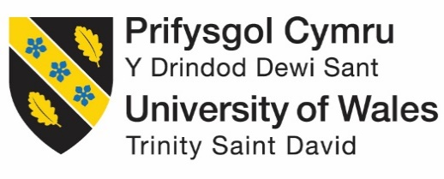
Strategic Management (LCMB7003)
Strategic Analysis of InterContinental Hotels Group (IHG)
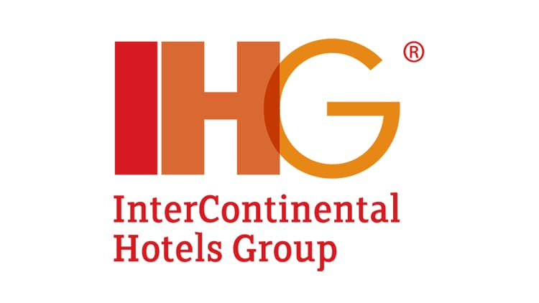
Student name: Rinkuben akshaygiri aparanathi
Student Number: 2221508
Lecturer: Dr.Hossein Shokri
Word count: 5793 words
Submission Date: 1st September 2023

Table of Contents
Introduction 2
Background of InterContinental Hotels Group (IHG) 2
Mission and Objectives of IHG Hotels 3
Macro-Environment Analysis 4
PESTEL Analysis 4
Political factors 4
Economic factors 5
Social factors 5
Technological factors 6
Environmental factors 6
Legal factors 7
Micro-Environment Analysis 7
Industry Life Cycle 8
Porter’s Industry Five Forces Analysis 10
Internal Analysis 12
IHG’s Strategic Resources and Capabilities 13
Value Chain Analysis 13
Primary Activities 13
Secondary Activities 14
VRIO Analysis of Distinctive Resources and Capabilities 15
SWOT Analysis 18
Strategies to Sustain Competitive Advantage 18
Growth Strategies 19
Green Strategy and CSR 19
Conclusion 20
Recommendation 20
References 21

Introduction
The term “strategic management” refers to the process of formulating, applying and critically evaluating a wide range of business strategies that are adopted for attaining the long-term goals and objectives of the business organization. This process involves the critical analysis of the internal and external environment, the development of goals and reliable action plans for supporting the allocation of business resources along making informed business decisions. Strategic management plays a key role in ensuring significant alignment between business goals, business activities, vision, mission and objectives. It also offers the advantage of competitive advantage, enables the business organizations to adapt to the leading changes, ensures stakeholders’ communication and manages business performances.
The purpose of this report is to conduct a comprehensive strategic analysis of the selected case study of Intercontinental Hotel Group by applying various models, frameworks and theories from the strategic management module. To achieve this aim, the central issues that are being faced by the IHG Company that were addressed will be discussed. The real-world business examples or scenarios will be used and applied to demonstrate the ways within which IHG has attained a competitive advantage by making suitable strategic management choices. Some of the effective models and theories that will be applied to the case include SWOT analysis, PESTLE analysis, Porter’s framework, value chain analysis and VRIO framework. The report will further contain suitable recommendations and strategies concerning the chosen case of IHG that could help the Company sustain its competitive advantage.

Background of InterContinental Hotels Group (IHG)
InterContinental Hotels Group (IHG) is a British multinational hospitality company headquartered in England. The group was founded in the year 2003 and currently, it has a total of 325,000 employees. Based on the data for the year 2022, IHG has 6,028 hotels and 884,820 rooms. In the year 2022, IHG earned a revenue of US $3.892 billion and its net income was US $376 million. During February 2021, IHG reported an annual loss of $153 million that was caused by the strict restrictions imposed concerning the COVID-19 pandemic (IHG Hotels, 2023).
The UK-based multinational hotel company – IHG had 3,091 hotels belonging to the international hotel brand i.e. Holiday Inn (Statista, 2023a). New financing arrangements have been secured by IHG which include the amendments in its syndicated revolving credit facility to include existing covenants until December 2021. The Bank of England has also confirmed IHG as an eligible issue for the UK government’ CCFF and therefore it has issued $600 million under this facility. Keith Barr (the CEO of IHG) claimed that to reduce costs and retain staff, the brand has announced “substantial decreases” in pay and incentives for senior executives. IHG Hotels has also launched a website to support its staff during the tough times of the COVID-19 pandemic. Amidst the COVID-19 crisis and the drop in its revenue, IHG Hotels continued to sign new properties to regain economic empowerment in the future. IHG provided its hotels with the best Covid-19 guidelines and hygiene practices along with specific guidance, training and information. IHG prioritized loyalty schemes and allowed its customers to research competitors’ offerings and choose the best stay option (Sharma et al., 2021).

Mission and Objectives of IHG Hotels
The mission of IHG Hotels is to create Great Hotels Guests Love and aims to deliver supreme guest experiences by offering them a wide range of high-quality hotel options to meet the diverse needs and preferences of travellers around the world. IHG Hotels strives to be the preferred choice for both business and leisure travellers by rendering comfortable accommodations, exceptional services and memorable experiences (IHG Hotels, 2023).
IHG Hotels focuses on attaining the following objectives:
- To constantly meet guests’ expectations and enhance overall guests’ experiences.
- To differentiate its brand hotels from its competitors within the hospitality industry by maintaining brand integrity and delivering brand promises.
- To continue to expand globally by identifying favourable growth opportunities such as management contracts, new hotel developments and franchise agreements (IHG Hotels, 2023).
- To minimize the environmental impact of all its hotel operations and promote sustainable practices within its supply chain practices.
- To foster a culture of diversity, inclusivity and engagement among its workforce.

Macro-Environment Analysis
During the arrival of the COVID-19 epidemic, IHG Hotels’ business operations and revenue were widely affected by a wide range of macro-environmental factors. IHG Hotels have been facing issues relating to decreased revenue and lower rates of occupancy and therefore struggled to manage its financial stability during the challenging crisis of the Covid-19 pandemic. Due to various strict restrictions imposed during COVID-19, IHG Hotels faced a huge decline in domestic and international travel rates and the Company was bound to comply with various government rules and regulations relating to occupancy limits, health and safety protocols and travel restrictions (Shin et al., 2021). Various changes in labour laws and regulations have been found that have affected the workforce management of IHG Hotels including the remote work policies, employee health and safety measures and employee layoffs. While reviewing the selected case, it has been observed that the hospitality industry has been hit drastically by the arrival of COVID-19 which has led towards the shutdown of the hotels and a halt in global travelling. Despite this, IHG’s 15% of its estate was closed at the end of April and the brand also faced the issue of huge financial loss (Sharma et al., 2021).

PESTEL Analysis
PESTEL analysis is a framework that is used and applied for analyzing and evaluating various complex external macro-environmental factors that could significantly impact the industry or any business organization. It consists of the six main factors; political, economic, social, technological, environmental and legal factors. To understand the impact of macro-environmental factors on the growth and success of IHG Hotels, the PESTLE analysis framework has been applied. The applied framework will discuss the implications of the COVID-19 pandemic over the operations and growth of IHG Hotels concerning the chosen market i.e. UK.

Political factors
The UK Government has imposed strict lockdown policies and measures including the temporary closure of hostels, travel restrictions and limitations on social gatherings/ travels. All these measures have significantly affected the revenue streams and operations of IHG Hotels. The UK Government has provided immense support to IHG Hotels by introducing various financial schemes support for providing greater assistance to various local and international businesses (Hsieh et al., 2021). For example, IHG has become an eligible issue for the UK Government’s CCFF by the Bank of England and also issued $600 million in commercial paper. Due to this scheme initiated by the UK Government, IHG has access to a cash deposit of US$1.4 billion and the total amount of available liquidity is US$2 billion. This financial resource and support from the UK Government have helped IHG Hotels to come to a positive position and be able to effectively deal with the challenging impact of the COVID-19 pandemic and attain growth at a sustainable level.

Economic factors
During the phase of COVID-19, people have started losing their jobs and struggled with greater levels of economic uncertainty, reduced income and reduced consumer spending on non-luxurious items such as travel and hospitality. This has significantly led towards a reduced amount of business revenue for IHG Hotels. On a positive note, economic stimulus packages have been implemented by the UK Government to support IHG Hotels; but its financial stability is still been affected by the economic downturn (Hsieh et al., 2021).
The economic downturn caused by the COVID-19 pandemic has led towards reduced consumer spending and corporate travel. The total revenue of IHG has therefore been negatively impacted and the brand has reported a major decline in RevPAR (revenue per available room) and occupancy rates. From 2019 to 2020, the annual report of IHG highlighted approximately a 52% decline in revenue and a 52% decline in RevPAR (IHG Annual Report, 2020). The UK Government provided financial support packages to various struggling businesses; including IHG and this kind of financial support has helped IHG in sustaining their business operations.

Social factors
Various travel restrictions and lockdown measures were implemented by the UK Government that led to a decrease in the occupancy rates of hotels and reduced demands for accommodations. In response, IHG implemented flexible policies relating to cancellation which allowed guests to cancel or change their reservations without paying any additional amount of penalties. IHG also introduced hygiene measures and cleaning protocols to ensure the safety of all the guests. IHG further launched the IHG Way of Clean Program which increased the frequency of disinfection, enhanced cleaning protocols and enabled the use of advanced technologies (IHG, 2020).
People’s attitudes, behaviours and preferences towards travel have been changed due to rising health concerns and Covid-19 cases. Hygiene and safety have become top priorities for travelers and therefore strict health and safety protocols have been adopted by IHG. IHG adapted its services to encourage bookings from its guests. The COVID-19 pandemic has resulted in the biggest shift in travel preferences as many people have started opting for “staycation” trips or domestic trips instead of international travel. This kind of shift in travel preferences has led IHG to cater to the dynamic preferences of its target audience (Shin et al., 2021).

Technological factors
Due to imposed travel restrictions and changes in consumers’ behaviour, a shift towards online hotel bookings was found. To ramp up its online presence, IHG heavily invested in its mobile application and website to collaborate with online travel agencies and capture the growing demand for online travel reservations. IHG monitored website traffic, online booking trends and conversion rates to evaluate the effectiveness of online strategies. IHG also reported a significant growth in direct bookings by customers through digital channels (Ezzaouia and Bulchand-Gidumal, 2020).
IHG has also transitioned its business employees to remote work by investing in remote communication and collaboration tools to ensure that all the groups work together while maintaining the protocols of social distancing. IHG uses multiple tools such as project management software, video conferencing and cloud-based document sharing for managing business operations. To embrace and reinforce safety and health protocols, IHG incorporated new technologies for cleaning such as enhanced air filtration systems, UV disinfection robots and electrostatic sprayers to effectively sanitize common areas of hotels and rooms (Chan et al., 2021). The adoption of these technologies helps IHG in assuring its guests of a safe and hygienic environment.

Environmental factors
The successful rollout of Covid-19 vaccines played a crucial role in the UK and resulted in a significant recovery of IHG’s growth. As more people have started taking vaccinations, travel confidence among people has increased. To embrace further growth, IHG started discussing and communicating the impact of the vaccine rollout on its business and people's health through its marketing materials, media interviews and press releases (Majeed et al., 2022). It has been found that the concern among customers towards environmental sustainability has been increasing which has led to the growing demand for eco-friendly practices within the hospitality sector. In this context, IHG has been adopting green building practices, waste reduction initiatives and energy-efficient technologies to attract environmentally conscious customers and enhance the brand image at the same time (Majeed et al., 2022).

Legal factors
The UK Government imposed various legal policies and guidelines such as social distancing, travel restrictions, etc., but the UK Government also introduced various initiatives to support struggling businesses. The Government of the UK launched the Furlough Scheme which is the Corona-virus job retention scheme to allow IHG to furlough its employees and reduce labour costs during the phase of reduced customer demands (Pope et al., 2020). In response, IHG additionally adopted cost reduction measures such as reducing operational expenses, adjusting staffing levels and streamlining processes.
To effectively respond to the strict laws and legislations made towards the COVID-19 pandemic, IHG has adjusted its cancellation policies and provided flexible booking options for accommodating changing/ cancelled travel plans of the customers. IHG further navigated complex legal considerations related to contract disputes, employee safety and strict compliance with health and safety regulations (Hsieh et al., 2021). IHG has strictly adhered to the new regulations and protocols made for mitigating the COVID-19 implications by the way of protecting the health and rights of its employees. Some effective measures implemented by IHG towards securing employees’ health include providing them with proper personal protective equipment (PPE), measures to reduce the transmission risk of COVID-19 cases within the workplace and allowing employees to work from their homes; wherever applicable and feasible (Hsieh et al., 2021).

Micro-Environment Analysis
The micro-environment analysis involves the critical examination and evaluation of the internal factors that could have a direct impact on the business operations and business performance of IHG. The study of the micro-environment would help in providing information on the nature of competition as an important approach to developing sustainable competitive advantage. The following models have been applied to discuss micro-environment factors of IHG.

Industry Life Cycle
The Industry Life Cycle (ILC) model is a very useful framework that analyzes various stages that different industries go through (Jerzak and Dziadosz, 2017). By applying this model, different issues have been analyzed that are faced by IHG along with reviewing its response strategies within the context of the UK market. The stages have been discussed below:
Development stage
During the initial stage, the industry is characterized by multiple factors such as limited market demand, emerging technologies and new market demands. IHG faced the issue of establishing its brand presence in the UK market. It has been found that IHG already had a well-established branding position in the UK market due to its existing properties and long history, but it struggled to adapt to the evolving market trends and changing consumer preferences. IHG further struggled with establishing its brand recognition as well as brand differentiation and was required to make huge investments in infrastructure and marketing that have resulted in a high amount of operating costs. To manage these issues, IHG has focused on introducing new and innovative hotel concepts to stand out in the competitive UK market (Jones et al., 2014).
Growth stage
The growth stage is characterized by expanding customer base, increasing market demand and intensifying competition. During the growth stage, IHG experienced significant growth in the UK market. In the UK market, IHG capitalized on the growth of business and tourism travel by continuously expanding its hotel portfolio and implementing a wide range of innovative service offerings (IHG Annual Report, 2022). During this stage, IHG experiences rapid growth expansion while increasing customers’ demands in the growing competition. As the hospitality sector is a growing industry more competitors tend to enter the UK market. The huge competition puts high pressure on the pricing and market share of IHG and faces another challenge of coping with increasing demands while maintaining the supreme quality of its services. IHG developed loyalty programs and services rendering unique features to the customers to differentiate its brand from its competitors (Jones et al., 2014).
Shake-out stage
This stage involves the important aspects of increased competition, consolidation period and market saturation. IHG faced huge challenges in the UK market including alternative accommodation providers and an increase in online travel agencies. To effectively respond to these issues, IHG enhanced its digital presence, implemented digital transformation initiatives and improved the online booking experiences of customers. IHG further formed strategic partnerships with travel platforms to reach new customers and increase brand visibility (IHG Annual Report, 2022). To mitigate this challenge, IHG strengthened its brand positioning and mainly emphasized building its reputation for attaining quality and service excellence. IHG further expanded its business into second and third-tier cities where rapidly growing demand is found, to diversify its revenue streams.
Maturity stage
This stage is characterized by saturated demand, stable market conditions and strong competition. IHG continued to focus on differentiation strategies in the UK market to retain its market share, enhance guest loyalty programs, provide personalized experiences and introduce new hotel concepts. IHG greatly emphasized sustainability initiatives to ensure significant alignment between its goals and evolving consumer needs (IHG Annual Report, 2022). The UK market could become more saturated with IHG hotels which might lead to reduced occupancy rates and pricing pressure. In this context, IHG faces the issue of maintaining customer loyalty and standing out in a mature market. Along with diversifying its offerings, IHG further upgraded its existing properties in the UK and focused on rebranding to stay attractive, competitive and relevant to the target customers (Đorđević and Janković, 2015).
Decline stage
This stage reflects a decline in business profitability and market demand. Amidst the rising cases of COVID-19, IHG suffered a major challenge of a decline in revenue in the UK. In the year 2020, IHG’s gross revenue reduced to 13.5 billion U.S. Dollars from 27.9 billion U.S. Dollars in 2019 (Statista, 2023b). To mitigate this challenge, IHG started launching safe initiatives and safety protocols such as offering PPE kits to employees, investing in digital technologies and expanding into new market segments. Therefore, all these measures have helped IHG to manage its revenue and profitability and its revenue started gradually increasing to 19.4 billion U.S. Dollars in 2021 and 25.8 billion U.S. Dollars in 2022 (Statista, 2023a).
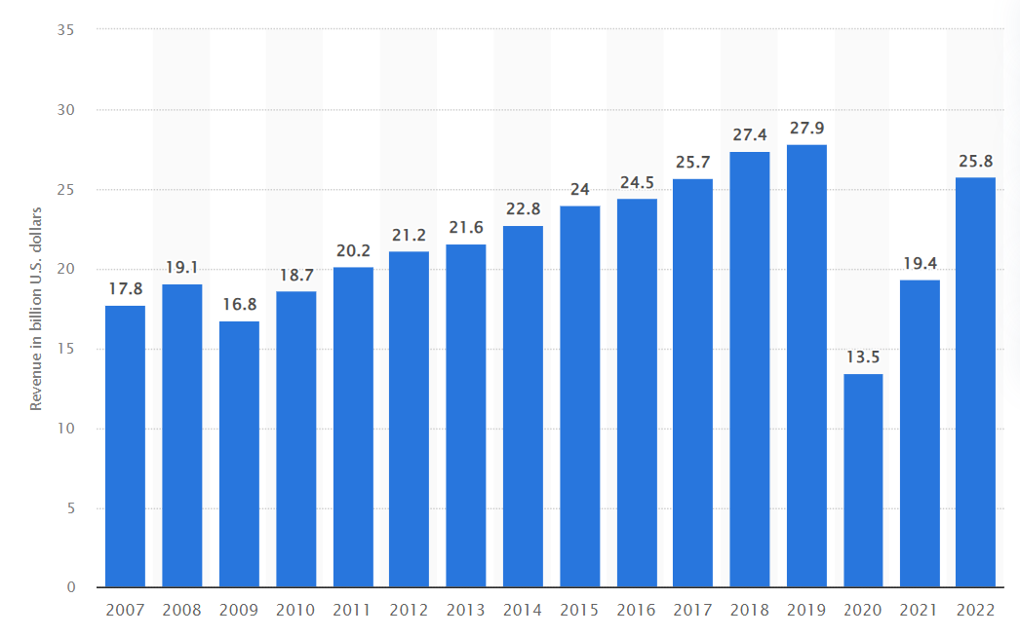
Figure 1: Gross revenue of IHG
Source: (Statista, 2023b)
The ageing properties in the UK required significant investments from IHG to meet the modern expectations of customers. During the decline stage, IHG struggled with rapid shifts in consumer preferences that led to reduced demands towards IHG hotels and traditional hotel accommodations. For managing these issues, IHG can consider closing or selling some of its underperforming properties in the UK so that a huge amount of organizational costs could be saved and the brand could focus on building and enhancing profitable properties. Also, IHG hotels in the UK can shift towards short-term rentals or launch other modern and innovative accommodation models to strategically respond to changing consumers’ preferences (Đorđević and Janković, 2015).

Porter’s Industry Five Forces Analysis
Porter’s five forces analysis is a holistic strategy that helps the brand make strategic decisions while mitigating multiple issues and exploring a wide range of profitable opportunities (Dobbs, 2014).
The threat of new entrants
Various new entrants in the industry embrace innovation but put intense pressure on IHG to reduce costs, setting lower pricing strategies and providing new value propositions to the customers (Al Rawashdeh and Khaled, 2021). To manage such challenges and safeguard its competitive edge, IHG adopted the following strategies:
- IHG continues its innovation in launching new products and services to attract new customers.
- IHG builds economies of scale to reduce the fixed cost per unit.
- IHG further builds capacities by investing in research and development and therefore new entrants possess the fear of entering into a dynamic industry where a giant leader like IHG exists and operates. IHG keeps on defining the new standards regularly which discourages new players from entering into the industry (Al Rawashdeh and Khaled, 2021).
Bargaining power of suppliers
Suppliers possessing a dominant position in the industry can reduce the margins that IHG earns in the market. IHG struggles with the negotiating power of suppliers by which they extract higher prices from the organization. Due to the higher bargaining power of suppliers, the overall profitability of IHG is affected. These issues are managed by IHG through the following strategies:
- IHG builds an effective and efficient supply chain with multiple suppliers.
- IHG keeps on experimenting latest product designs by using different materials so that when the prices of raw materials go up, they can shift to another supplier.
- IHG develops strong connections with dedicated suppliers who have less bargaining power (Al Rawashdeh and Khaled, 2021).
Bargaining power of buyers
Buyers demand a lot and want to buy the best offerings that can be available at the minimum price possible which puts pressure on the profitability of IHG in the long run. The smaller; yet powerful customer base of IHG reflects their higher bargaining power and their higher ability to seek discounts and offers (Zhang et al., 2021). To tackle these issues, IHG performs the following activities:
- IHG must focus on building a large base of customers to reduce its bargaining power and streamline its sales and production processes.
- IHG keeps on innovating new products and offers discounts for launching new products.
- The invention of new products helped IHG in reducing the defection of its existing customers to its competitors.
Threat of substitution
IHG faces a high threat of substitution and it needs to offer a unique value proposition that must be different from present offerings in the industry. IHG considers the following:
- IHG beings service-oriented rather than just product-oriented.
- IHG understands the core needs of customers rather than considering what they are buying.
- IHG increases the switching cost for its customers (Krupskyi et al., 2019).
Competitive rivalry
IHG tends to operate in a very competitive marketplace and it faces huge competition from Marriott International, Radisson Hotel Group, Hyatt Hotels Corporation and Hilton. Due to intense competitive pressure, IHG struggles with maintaining its long-term profitability. Some strategies in this context include:
- IHG builds a sustainable differentiation and builds scale to compete in a better way (Krupskyi et al., 2019).
- IHG collaborates with its competitors not only just capture the small market but also to increase its market size at the global level.

Internal Analysis
An internal analysis is a process where various components interact within the business organization that is evaluated for identifying failures and key areas of opportunity. The internal analysis highlights three key factors of an organization’s competencies, resources and competitive advantage. IHG faces huge challenges such as travel restrictions, lockdowns due to COVID-19 impact, intense competition, economic uncertainties, rapid technological advancements and changing consumer preferences (Cha, 2020).

IHG’s Strategic Resources and Capabilities
IHG has strong strategic resources and capabilities which are as follows:
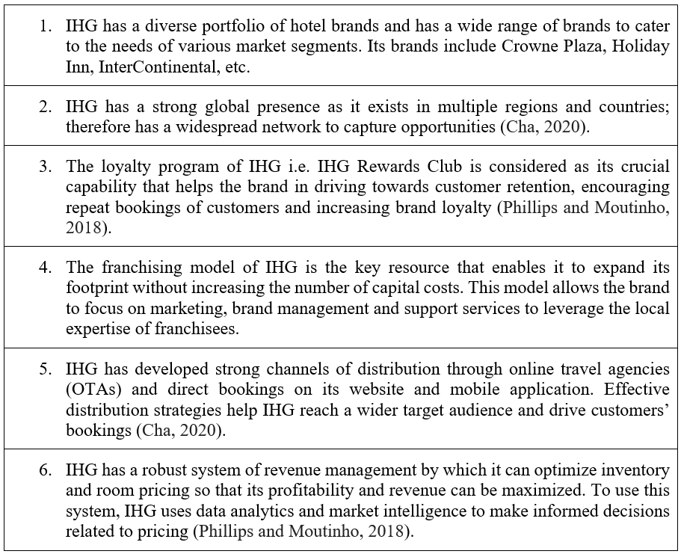

Value Chain Analysis
The value chain analysis of IHG involves the critical examination of primary and secondary activities that significantly contribute to the competitive advantage and improved business performance of the business organization.

Primary Activities
The primary activities of IHG are directly involved in producing and selling its products and services to targeted customers so that business performance can be improved. The key primary activities of IHG’s value chain are as follows:
Inbound logistics
Without analyzing the inbound logistics, IHG could struggle with facing multiple challenges relating to product development phases. IHG needs to develop strong relationships with the suppliers for receiving, storing and distributing the products. The brand retrieves raw materials, stores the inputs and internally distributes them for starting production (Ţigu and Călăreţu, 2013).
Operations
IHG performs key operational activities of machining, packing, assembling, testing, equipment repair and maintenance. Manufacturing and service operations help IHG maximise organizational efficiency and ensure competitive success.
Outbound logistics
IHG analyzes various outbound logistics activities which include material handling, scheduling, warehousing, order processing, transportation and delivery to achieve business objectives and explore sources of competitive advantage. Timely management of these activities reduces the negative effect on quality, increases growth opportunities and maximizes customer satisfaction (Dahlmann and Roehrich, 2019).
Sales and marketing
IHG’s marketing and sales activities include sales force, promotional activities, channel selection, advertising, pricing, quoting and building relations with stakeholders. IHG uses the marketing funnel approach for structuring these activities and applying push or pull marketing strategies to improve its brand image and competitive dynamics (Ţigu and Călăreţu, 2013).
Services
IHG’s pre-sale and post-sale services develop customer loyalty and it also spreads positive word of mouth for managing timely and efficient support services.

Secondary Activities
The secondary/ support activities play a crucial role in facilitating and coordinating primary activities of the value chain. The support activities include:
Firm infrastructure
IHG effectively manages its infrastructure to optimize the value of its whole value chain and control infrastructure activities (quality management, accounting, legal matters handling, planning, financing and strategic management) to strengthen its competitive position in the dynamic market.
Human resource management
Different HR aspects are analyzed by IHG such as recruitment, selection, training, rewarding, performance management and other activities relating to personnel management. These activities help IHG in reducing competitive pressure based on commitment, motivation and skills of the workforce (Ţigu and Călăreţu, 2013).
Technology development
IHG realized the greater importance of technology development by ensuring technology integration in production, marketing, distribution and human resource activities. IHG focuses on product technological development activities including automation software, product design research, technology-supported customer services and data analytics (Dahlmann and Roehrich, 2019).
Procurement
The procurement processes that are involved in buying the inputs range from machinery, supplies, equipment, raw materials and other items for producing the finished products.

VRIO Analysis of Distinctive Resources and Capabilities
The VRIO analysis is a strategic tool that is being used for critically assessing and evaluating the key resources of a business organization and identifying strategic advantage and competitiveness. IHG frequently uses this tool for developing competitive strategies based on its core resources and strengths; thereby gaining a competitive advantage (Pinterest, 2023).
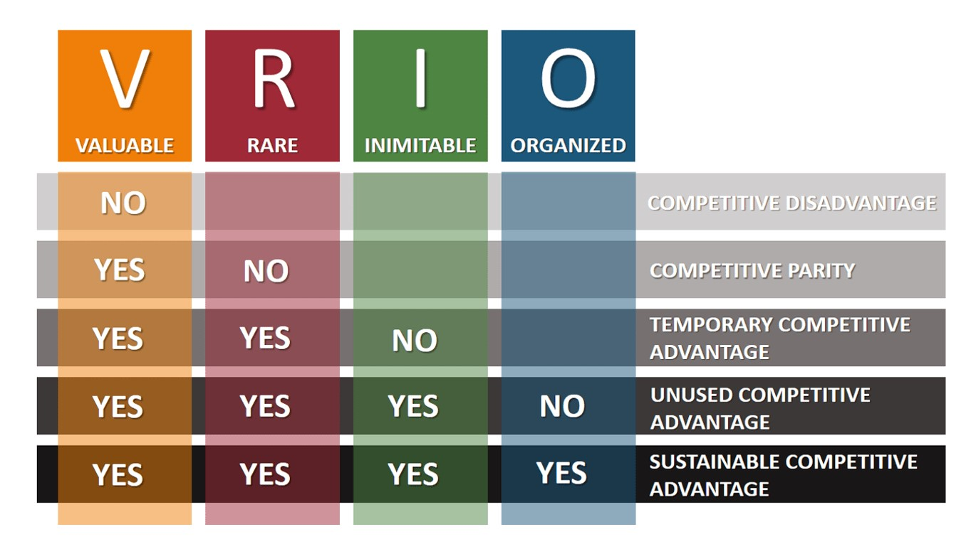Figure 2: VRIO Analysis of IHG
Source: (Pinterest, 2023)
Valuable
IHG has valuable competencies that help in exploiting opportunities and mitigating threats from various internal and external environmental sources.
- Brand image in the context of social responsibility: IHG regularly engages in social responsibilities and has a defined corporate function towards social responsibility. IHG integrates and engages in CSR activities with its business goals.
- Brand image: IHG’s brand image is unique and it has a high brand integrity which represents honesty and trust (Ivanova and Ivanov, 2015).
- Reckoned brand: IHG has high brand recognition which helps in increasing its organizational value. IHG has been making brand investments in the long run that cannot be substituted by other key players within the industry.
- Relationship with suppliers: IHG is globally valued for its distribution system by successfully providing products in different countries. IHG has strong relations with suppliers and dealers based on strictly followed criteria and standards (Okorie et al., 2023).
- Innovation: IHG continuously innovates its products by expanding in other functional areas like marketing. This valuable resource allows IHG to navigate environmental threats, reduce its operational costs and attain economies of scale.
Rare
IHG also has some rare resources and competencies such as its problem-solving skills by which a positive organizational culture is fostered. IHG has risk-taking characteristics by which it calculates and guides risks while determining potential opportunities. IHG has high exposure to different societal norms and global cultures that help in gaining penetration within the local markets. Managerial functions are optimally performed through a standardized global strategy (Della Corte, 2016).
Inimitable
The inimitable competencies of IHG add value to its competitive advantage and long-term sustainability. High-quality products are offered by IHG to ensure repetitive purchases of customers and increasing consumption of its hotels. The places where IHG hotels are located are easily accessible by the consumers and the brand also makes the best use of marketing communications to induce higher consumption. The business vision of IHG under its strategic leadership is also inimitable. IHG continuously follows the strategy of competitive pricing and renders unique customer experiences to increase high brand engagement (Ivanova and Ivanov, 2015).
Non-substitutable/ organization
- IHG has substantial financial strength that supports the opportunities relating to new product development and acquisitions for gaining a competitive advantage.
- Greater efficiency and effectiveness are maintained among the business processes and operations of IHG.
- IHG provides in-house training to its employees to embrace their personal growth and development (Okorie et al., 2023).
- Substantial investments are made in research and development to cope with dynamic customers’ tastes and preferences.
- High production capacities, corporate leadership, supportive and innovative organizational culture, human resources and standardized marketing strategy are some other resources of IHG that are non-substitutable (Della Corte, 2016).

SWOT Analysis
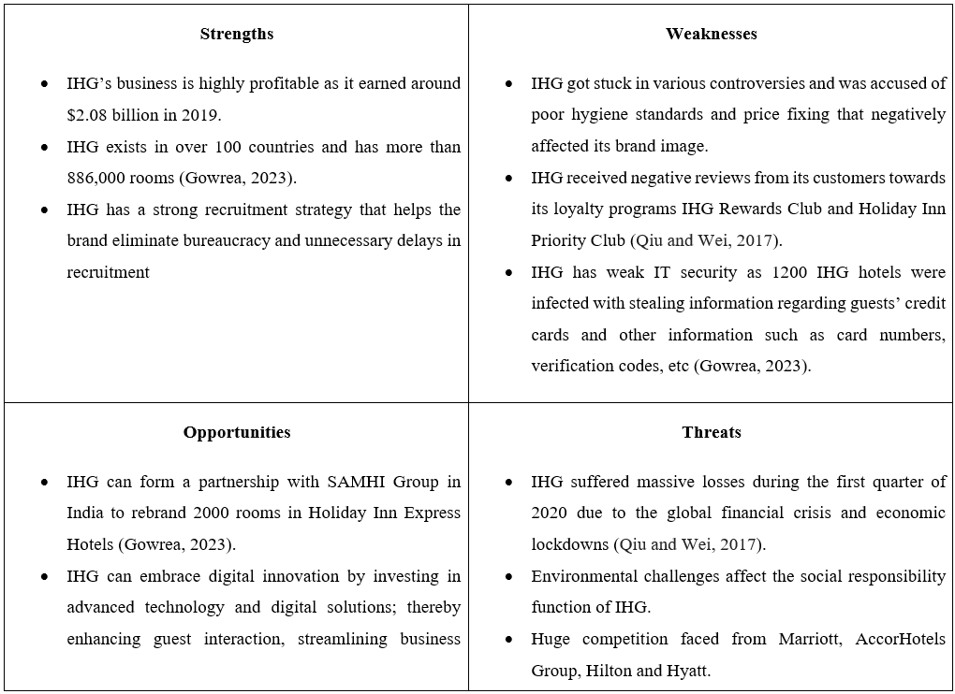

Strategies to Sustain Competitive Advantage
To sustain a competitive advantage, IHG can adopt Porter’s generic strategies including the following:
- Cost leadership: Through this strategy, IHG could become the lowest-cost producer while maintaining its level of quality. IGH can appeal to price-sensitive customers by offering products and services at lower prices (Luck and Lancaster, 2013).
- Differentiation: This strategy would require IHG to offer unique services to customers while creating distinctive features, offering exclusive experiences and enhancing customer services to differentiate the brand from other competitors.
- Focus: IHG can target a specific market segment or niche and tailor products/ services to meet the dynamic needs of the group. IGH could focus on serving business travellers, eco-conscious tourists and luxury seekers (Luck and Lancaster, 2013).

Growth Strategies
IHG can use the Ansoff Matrix for identifying growth strategies considering two main factors of products and markets. IHG should adopt the following growth strategies:
- Market penetration: IHG can increase its market share in existing locations through aggressive marketing campaigns, competitive pricing, loyalty programs and improving customer experiences to encourage repetitive buying and attract guests.
- Market development: IHG can expand its presence in new geographic locations where high growth potential is found. IHG can form partnerships with local developers, strategic acquisitions of established hotels in new markets and developing franchise agreements (Salvioni, 2016).
- Product development: New hotel concepts can be introduced to meet evolving customers’ needs and IHG can invest in developing eco-friendly properties and boutique hotels to attract new customer segments.
- Diversification: IHG can think of expanding beyond its traditional business such as vacation rentals, resorts and event management services (Salvioni, 2016).

Green Strategy and CSR
Green strategy
IHG can focus on reducing energy consumption by implementing energy-efficient practices and technologies. It could also upgrade lighting systems, use renewable sources of energy and install smart thermostats (Camilleri, 2014).
CSR
IHG can work towards promoting sustainable and responsible tourism by raising awareness among guests. It could also collaborate with local organizations to preserve cultural heritage and protect natural resources (Camilleri, 2014).

Conclusion
It can be concluded that IHG faces various central issues relating to intense competitive pressure, COVID-19 implications and lack of profitability. A comprehensive strategic analysis was conducted to evaluate these issues and reliable theories, models and frameworks were applied to address those issues and recommend some other favourable strategies and concepts.

Recommendation
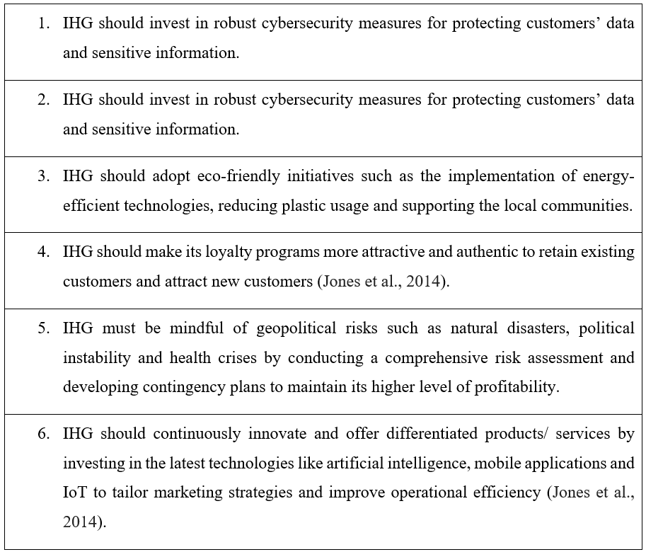

References
Al Rawashdeh, M.M.S. and Khaled, A.S., (2021) ‘A Study Of Green Hr Practices Andit’seffective Of Implementation In Five Star Hotels In Jordan’, Psychology and Education Journal, 58(2), pp.6452-6459.
IHG Annual Report, (2020) Annual Report of IHG. Available at https://www.ihgplc.com/en/-/media/ihg/annualreports/2020report/pdf/ar-report-2020/ihg_2020ar.pdf?la=en&hash=A5C4404446E2401FA5FBF7031A785904. (Accessed: 9 August 2023).
IHG Annual Report. (2022) IHG Hotels & Resorts. Available at https://www.ihgplc.com/en/-/media/ihg/annualreports/2022/annual-report-2022.pdf?la=en&hash=167797C0C5A95078FBBF51E91CB0A7AE. (Accessed: 6 August 2023).
Camilleri, M., (2014) ‘Advancing the sustainable tourism agenda through strategic CSR perspectives’, Tourism Planning & Development, 11(1), pp. 42-56.
Cha, H., (2020) ‘A paradigm shift in the global strategy of MNEs towards business ecosystems: A research agenda for new theory development’, Journal of International Management, 26(3), pp. 1-10.
Chan, J., Gao, Y.L. and McGinley, S., (2021) ‘Updates in service standards in hotels: how COVID-19 changed operations’, International Journal of Contemporary Hospitality Management, 33(5), pp.1668-1687.
Dahlmann, F. and Roehrich, J.K., (2019) ‘Sustainable supply chain management and partner engagement to manage climate change information’, Business Strategy and the Environment, 28(8), pp.1632-1647.
Della Corte, V., (2016) The strategic environment of hotel chains. In The Routledge Handbook of Hotel Chain Management.
Dobbs, M.E., (2014) ‘Guidelines for applying Porter's five forces framework: a set of industry analysis templates’, Competitiveness review, 24(1), pp.32-45.
Đorđević, D.Ž. and Janković, M., (2015) ‘Modern distribution and development of hotel industry in the world’, Ekonomika, 61(3), pp.99-110.
Gowrea, V., (2023) SWOT analysis of InterContinental Hotels Group Plc. Available at https://www.howandwhat.net/swot-analysis-intercontinental-hotels-group-plc/. (Accessed: 9 August 2023).
Hsieh, Y.J., Chen, Y.L. and Wang, Y.C., (2021) ‘Government and social trust vs. hotel response efficacy: A protection motivation perspective on hotel stay intention during the COVID-19 pandemic’, International Journal of Hospitality Management, 97(3), pp.102-111.
IHG Hotels. (2023) InterContinental Hotels Group (IHG). Available at https://www.ihgplc.com/en. (Accessed: 6 August 2023).
IHG. (2020) IHG® Hotels & Resorts offers a fresh take on clean. Available at https://www.ihgplc.com/en/news-and-media/news-releases/2020/ihg-offers-a-fresh-take-on-clean#:~:text=IHG%20Clean%20Promise%20and%20Global,hotel%20will%20make%20it%20right. (Accessed: 5 August 2023).
Ivanova, M. and Ivanov, S., (2015) ‘The nature of hotel chains: An integrative framework’, International Journal of Hospitality & Tourism Administration, 16(2), pp.122-142.
Jerzak, K. and Dziadosz, A., (2017) ‘Competitiveness of a building company within the organisational life cycle’, Technical Transactions, 114(8), pp.61-71.
Jones, P., Hillier, D. and Comfort, D., (2014) ‘Sustainability in the global hotel industry’, International Journal of Contemporary Hospitality Management, 26(1), pp.5-17.
Krupskyi, O.P., Dzhusov, O., Meshko, N., Britchenko, I. and Prytykin, A., (2019) ‘Key sources when formulating competitive advantages for hotel chains’, Tourism: An International Interdisciplinary Journal, 67(1), pp.34-46.
Luck, D. and Lancaster, G., (2013) ‘The significance of CRM to the strategies of hotel companies’, Worldwide hospitality and tourism themes, 5(1), pp.55-66.
Majeed, A., Pollock, K., Hodes, S. and Papaluca, M., (2022) ‘Implementation of covid-19 vaccination in the United Kingdom. British medical journal, 378(3), pp. 1-10.
Okorie, O., Russell, J., Cherrington, R., Fisher, O. and Charnley, F., (2023) ‘Digital transformation and the circular economy: Creating a competitive advantage from the transition towards Net Zero Manufacturing’, Resources, Conservation and Recycling, 189(3), pp. 1-24.
Pinterest. (2023) VRIO Framework Explained with Examples. Available at https://www.pinterest.com/pin/493425702925482686/. (Accessed: 5 August 2023).
Pope, T., Dalton, G. and Tetlow, G., (2020) ‘The coronavirus job retention scheme’, Institute for Government, 22(3), pp.12-34.
Qiu, S. and Wei, L., (2017) ‘SWOT Analysis and Competition Approaches of Hotels in Guangzhou’, IOSR Journal of Business and Management, 19(01), pp.19-25.
Salvioni, D.M., (2016) ‘Hotel chains and the sharing economy in global tourism’, SYMPHONYA Emerging Issues in Management, 8(1), pp. 12-23.
Sharma, A., Shin, H., Santa-María, M.J. and Nicolau, J.L., (2021) ‘Hotels' COVID-19 innovation and performance’, Annals of Tourism Research, 88(3), pp.103-123
Shin, H., Sharma, A., Nicolau, J.L. and Kang, J., (2021) ‘The impact of hotel CSR for strategic philanthropy on booking behavior and hotel performance during the COVID-19 pandemic’, Tourism Management, 85(3), pp.104-122.
Statista, (2023a) Number of InterContinental Hotel Group (IHG) hotels worldwide from 2008 to 2022, by brand. Available at https://www.statista.com/statistics/223387/intercontinental-hotel-group-hotels-worldwide/. (Accessed: 12 August 2023).
Statista. (2023b) Gross revenue of the InterContinental Hotels Group worldwide from 2007 to 2022. Available at https://www.statista.com/statistics/223353/intercontinental-hotels-group-revenue/. (Accessed: 12 August 2023).
Ţigu, G. and Călăreţu, B., (2013) ‘Supply chain management performance in tourism. Continental hotels chain case’, Amfiteatru Economic Journal, 15(33), pp.103-115.

