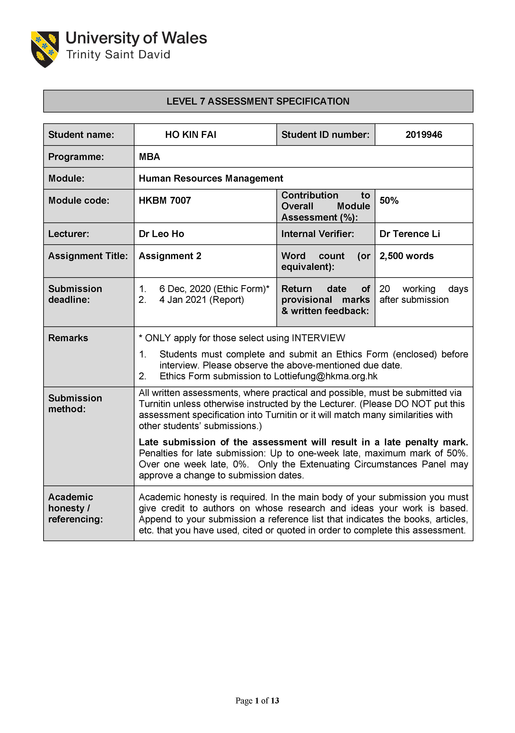

Compare Two organisations providing Information and Communication Technologies (ICT) service based in HONG KONG and CHINA on Talent Attraction and Retention challenge on international expansion. A case study and literature review

HKBM7007 - Assignment 2
Student Name: HO KIN FAI
Student ID: 2019946
  - Table of Contents
1. Executive Summary 3
2. Background of the companies 3
2.1 Hong Kong Broadband Network Limited (HKBN) 3
2.2 Huawei 4
3. Talent Attraction and Retention challenge in the shortage of skilled workforce 4
4. Literature Reviews 6
4.1 Talent Shortage in the ICT industry 6
4.2 Attract and Retain ICT Talent 7
4.3 Collaborate with local government and institutions to bring up talents 8
5. Recommendation on attracting and retaining the talent 9
6. Conclusion 12
7. Reference 14

1. Executive Summary
In today fast-changing world of the business environment, employees are the most valuable assets in an organisation. The competition for human resources among industries often shows attractiveness from different superior conditions on hiring talents and employees such as good salary and benefits, even clear career growth pathways and opportunities. This report has performed a case study of two organisations providing Information and Communication Technology(ICT) based in Hong Kong and Mainland China. Both organisations have a business operated in overseas and hired local workforce. I found both organisations stressed on attracting and retaining talents from the case study. We have summarised these two organisations on facing talent shortage in local human resource market, talent attraction and retention challenges. We have performed a literature review on drawing valuable talents attention and creating a successful way to attract and retain high potential employees. At last, we will propose an action plan of recommendation for solving the challenges.

Background of the companies

Hong Kong Broadband Network Limited (HKBN)
HKBN Group ("HKBN" or the "Group") is an internet, communication, and telecommunication company providing broadband and telecommunications service for residences and enterprises based in Hong Kong. HKBN owned over 330 Co-Owners and more than 4,400 workers for the business operations spanning across Hong Kong, Mainland China, Macau, Singapore, and Malaysia. The group stated they called their employees as "talents" (HKBN Annual Report, 2019). In 2019, the group had 4,131 permanent full-time employees. 60% are male, 40% are female, 44% are between 30-39 has, and 26% are under 30 years old. Among the employees, 58 % work in Hong Kong and 42% work in Mainland China(HKBN Annual Report, 2019).

Huawei
Founded in 1987, Huawei is a global information and communications technology (ICT) infrastructure and smart devices serving more than 1/3 world's population. Over 30 years, Huawei has grown to become the pioneer of ICT company in the world. Huawei sustainability report stated Huawei's employed workforce come from nearly 170 countries and regions. Inside China, there are employees from 43 ethnicities. Huawei has formulated and implemented diversified goals in an all-around way regarding employees nationality, gender, age, race, and religious beliefs. As an international company, Huawei has been actively promoting overseas employees' localisation, and Huawei aims to hire the local talent into the workforce. In 2019, Huawei employed more than 96,000 employees overseas, and the localisation rate of overseas employees was about 70%. The Huawei's founder and president Ren Zhengfei said Huawei would expand employing 188,000 to 194,000 employees shortly. (Huawei Annual Report, 2019).

Talent Attraction and Retention challenge in the shortage of skilled workforce
After studying two organisations background, I have pointed out both organisations were facing a talent shortage on skilled workforce join into the ICT industry and how to attract the fresh graduate and retain them is the most challenge.
Hong Kong is a small city with a lack of human resources, and talent is essential for the ICT industry (Pepe and Shun, 2018). And the co-owner of HKBN said, "In HKBN, we call ourselves "Talents", not employees or staff. Even though talent development has eased the pressure on some common HR challenges, but we still facing on a war for talent." (Chan. CY, 2017).
Huawei states, according to statistics from China's National Bureau of Statistics and Ministry of Education, the ICT industry needed 7.65 million educated professionalists in 2017. However, the number of graduates entering the workforce per year has not exceeded 1 million in the ICT industry. There is a massive gap between the supply of talent and the demand for the skill (Li, 2019),
To attract talent with the shortage of ICT skilled workforce, organisations need to develop strategies to attract fresh graduates and provide favourable conditions such as salary, welfare, promotion opportunities, etc. Employees turnover may be due to the competitors offering more attractive conditions to talent. Although every year, a group of younger, more flexible, and technology-oriented fresh graduates will enter the workforce. But this group of young labourers would be more concern about the conditions offered by the organisations. They will more focus on work-life balance, such as flexible working schedules, more extended leave policies, etc. The organisations have the challenge of providing an attractive package to bring the new graduates into the ICT workforce.
There are many competitors in the ICT industry globally and even local markets (Halkos and Tzeremes 2007). The competition between competitors is not only on business; it is also a battle for talents. After attracting the talent, retain them is another challenge for those organisations facing. Unavoidable employee turnover may be affected by a lack of knowledge, skill and working experience. The employer ensures to maintain the talent to meet the business objective and feel they belong to the organisation.

Literature Reviews

Talent Shortage in the ICT industry
ICT a knowledge-intensive base industry relied on massive talent resources to fulfil the flourishing ICT ecosystem in further growth. A human resources company reported 65% of the employers in Hong Kong said they were facing the challenges to fill job vacancies because of the shortage of talent and the shortage was severe in the information technology and telecommunications talent shortage on IT Consultancy and Wireline or Wireless Communications (Y AXIS, 2020). Another Manpower company based in China reported in 2019, 16% of Mainland China employers said the talent shortage was rising 3% compared with 2018 on the Skilled Trades and Technicians jobs. IT Personnel was back to no. Three of the Top Ten difficult position to fill in 2019. The group also reported the talent shortage was around the world, 54% of the organisations advised talent shortage was rising 9% in 2018, that is reaching a new high in the past 13years (ManpowerGroup, 2020).
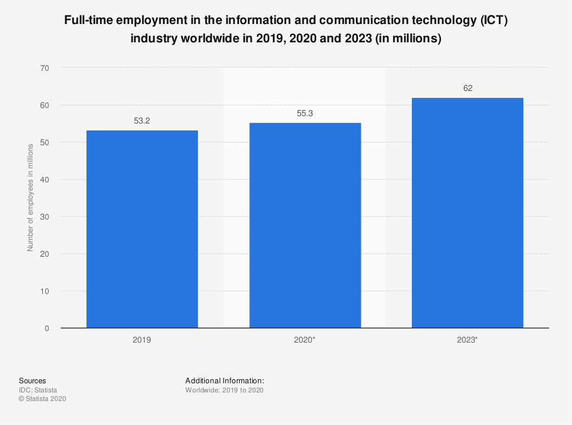
Fig. 1 Full-time employment in 2019, 2020 and 2023 on ICT industry (Statista, 2019)
The Fig. 1 shows worldwide full-time employment in the ICT sector estimated to reach 55.3 million in 2020 (pre-corona estimation), an increase of 3.9 % over 2019 and predicted to increase to 62 million in 2023.

Attract and Retain ICT Talent
The ICT industry is facing different competitors under global development. They encounter global talent challenges in "war for talent" (McKinsey & Company, 2007) due to the shortage of the IT skills set graduates. To attract fresh graduates to onboard the ICT industry, the organisations have invested a lot of time and money on recruitment graduate campaigns by promoting company value, image and employer branding. The organisation wants to attract applicants from institutions to apply the management trainee or professional and technical skill roles. The report stated to attract the applicants by offering a) more competitive entry-level salaries, b) sign-on bonus and annual bonus, c) medical insurance, d) compensation leave (work overtime, work in a non-office hour), e) flexible working hour, f) work-life balance. If so, ICT companies can implement an aggressive recruitment condition, which will attract talents and retain them in the company.
After successfully attracting the talents, retaining them is another up-coming challenge—the employees' decision to stay or departure depends on their perceived direction. The organisations need to continuously surpass their competitors in a series of human resource elements - (including teamwork and openness between colleagues, training and development opportunities). Establishing valuable and favourable employee management is the key to an organisation's success in the global talent war. Retaining potential talents and their loyalty to employers is an effective strategy. A report Döckel (2003) suggested six factors for organisation consideration, a) compensation (salary); b) job description (skill variety and empowerment); c) training and development opportunities; d) top management support; e) career opportunities; and f) work-life balance (Van Dyk, 2011).
Fig 2. Main retention six-factor

Collaborate with local government and institutions to bring up talents
The ICT and technology-related industries are rapidly growing in Hong Kong over the next decade. To solve the shortage of ICT talents, IBM and the Hong Kong Jockey Club jointly organised the CLAP-TECH Pathway since February 2020. The program is co-taught by the School of Continuing Education of Hong Kong Baptist University and local secondary school. This program is an education model include incorporates career and life development in the curriculum. Throughout the five-year journey, the student will emphasise ICT knowledge and essential skill to all workplace (IBM, 2020).
In China, the Chinese government set up a six-year Modern Vocational Education Development strategy in 2014 to help train up the skilled talent to fill up the gaps. The goal aims to increase the number of students with modern vocational education from 29.34 million to 38.3 million by 2020 (MaVal and Sally, 2016).In light of that, Huawei was build up their pathway for development talent following the "platform + AI + ecosystem" strategy and put it into an ICT Talent Development Standard. The plan is to set up three different certifications according to various position and demands (the Huawei ICT Infrastructure Certification, Platform and Service Certification, and ICT Vertical Certification) for a different role. Those certifications provide multi-level talent development focus on ICT infrastructure, IT cloud platforms, application development and industrial application of ICT technologies (Li Jisheng, 2019).

Recommendation on attracting and retaining the talent
The report will provide an action plan regarding the literature review to summarise an idea for the HR partitioners and organisations reference. The action plan has divided into three parts (Short/Mid/Long Term). This plan's pros are providing a fast-track to fill up the workforce to recruiting IT graduates with aggressive benefit and provide more opportunities to develop their career in this industry. The organisation will have a plan to attract new hires and retain their employees by providing more chances and benefits. Cons are current employees who will compare with the new hires why they have a considerable advantage. And the organisation also spends an extra investment in providing training and development, compensation and benefits for local and oversea employees.
Short Term
The short term action plan suggests the organisation's employer attracting the new graduates and retaining current employees.
Recruit IT Graduates – Attracting IT graduates from the local institution can provide a fast track for recruiting employee and selecting talent.
Job description – Redesign the Job description to make it more skill variety and flexible in letting new graduates with less working experience apply.
Review the benefits of existing employees - By reviewing existing conditions and compare with competitors to make it more attractive to retain employees.
Compa-rate – Compare the Compa-ratio with local companies and adjust the rate higher than the market to attract skilled talents or increases the existing employee salary. Still, it will affect the budgeting of human resource.
Digitalised recruitment processes – HR wants to attract young employees in this digital era. They should find a new way to recruit them, like using social media, LinkedIn to post the ads and develop an online application process.
Mid Term
Mid Term action plan will focus on training and developing the potential talents and how to retain them in advance before they think to departure. This action plan also suggests the organisation recruit foreign talent with attractive benefits.
Training and development – Training and development opportunities are significant for retaining the employees. If the organisations found talents with potential, they should provide training opportunities to cultivate new leadership.
Supervision / Mentorship – When discovered the high potential talents, the organisations can provide coaching and mentoring programmes to determine their potential and lead them to plan the successful career path.
Encourage self-learning – Encourage the employees to update their skill and knowledge continually. The organisations can provide a subsidy for the employee to apply short courses, professional courses, certificate even undergraduate and postgraduate programmes.
Compensation and reward – Implement remuneration, reward and recognition system to engage employees to believe they can make valuable contributions to the company and achieve personal goals.
Recruit foreign talent – Recruiting foreigners to fill the shortage of local talents and introduce a new ideology for the organisations, but this action will destroy the local labour force competition.
Expatriate benefits – Attract oversea talents by providing expatriate benefits such as housing, family benefits, language training. No doubt it can approach with retaining employees work in oversea.
Long Term
The Long Term action plan will focus on retaining and motivating current employees. The organisation still needs to keep in the" war of talent" strategy to attract the "new blood" joining the organisations.
Building up Employer Branding – It can help the organisations promoting their favourable image among potential and current employees, the strategy has two parts. 1) External marketing - enables organisations to attract talent. 2) Internal marketing – helps to motivate and retain employees act as brand advocates of their respective organisations (Karnica & Asha., 2016).
Socialisation – Through induction and assimilation activities to make the new employees integrated into the organisation culture as soon as possible to maintain their stay and reduce the loss of new hires. These practices include sharing personalised learning experiences which can help new employees understand the business culture and let experienced employees set an example for new hires (Arlene S. Hirsch., 2016).
Employee engagement – It is vital for retaining employees by making them feel satisfied with their position and letting them believe they are indispensable. Take them pride with the company, and believe that their employer values their contributions (Amy & Janet, 2008).
Work and life balance policy – Use to amend the conflict between work and families to attract and retain employees. It may not be a significant factor for the younger workforce, but this policy can be a key to retention after their owned family. This policy can also apply for the existing employees who had their family (Döckel, 2003).
Co-operate with local government and institutions - local government has involved many forms of cooperation and partnerships worldwide. The government can formulate policies to attract overseas talents to join local organisations, such as speed up the approval of immigration procedures, and introducing the current economic environment and employment opportunities to other places. The organisations can also co-taught with local academic institutions by providing mentorship and internship programs to select outstanding students as a management trainee and preferentially hire graduates from that institution (OGCIO, 2020 & Robert D, 2014).

Conclusion
The global ICT industry is proliferating by spending at least 25% contribution to developing new technologies such as robotics, artificial intelligence, and AR/VR over the next decade (Stephen and Allyson, 2020). So it needs more technically skilled talents with higher academic qualifications onboard to this industry.
This report found that the ICT industry has challenges attracting and retaining employees on the local and oversea markets. Based on the literature review to found the solution to attracting fresh graduates, hiring experience oversea talents to fillup the shortage gap. And the organisation must provide aggressive compensation to retain the employee.
Although hiring graduates can temporarily solve the workforce shortage, if the organisation wants to retain this group of young people to continue developing their careers, the employers must develop strategies from recruitment, welfare, promotion opportunities, internal training, employee morale, etc. The organisation must make it more transparent to let employees see its business development and lead the market. Employees will feel proud of working in the organisation. The employers must do everything possible to retain them to be a competent employee instead of letting the talents flow out and transfer to competitors.

Reference
Amy, L. et al. (2008) The relationship of perceived flexibility, supportive work-life policies, and use of formal flexible arrangements and occasional flexibility to employee engagement and expected retention Community, Work & Family, Vol. 11, No. 2, May 2008, p183-197
CY C. (2017) Talent Development at One of Hong Kong's Largest Telcos [Online]. Available at: http://www.hcli.org/articles/talent-development-one-hong-kongs-largest-telcos [Accessed 28 November 2020]
Döckel, A. (2003). "The effect of retention factors on organisational commitment: an investigation of high technology employees".SA Journal of Human Resource Management, 4(2) pp. 20-28.
HKBN Ltd. (2019) Annual Report 2019. [Online]. Available at: https://reg.hkbn.net/WwwCMS/upload/pdf/en/e_AnnualReport_2019.pdf [Accessed 2 December 2020].
HALKOS, GE and TZEREMES, NG, 2007. International Competitiveness in the ICT Industry: Evaluating the Performance of the Top 50 Companies. Null, 36(2), pp. 167-182.
Huawei Investment & Holding Co., Ltd (2018) Sustainability Report 2018 [Online]. Available at: https://www-file.huawei.com/-/media/corporate/pdf/sustainability/csr-report-2018-cn.pdf?la=zh [Accessed 29 November 2020]
IBM (2020) IBM Brings P-TECH School Model to Hong Kong to Address Digital Skills Shortage and Prepare Students for Technology-related Careers [Online]. Available at: https://www.ibm.com/news/hk/en/2020/05/25/20200525-1en.html[Accessed 3 December 2020]
Karnica, T. and Asha, P. (2016) Exploring the Relationship between Employer Branding and Employee Retention [Online] Available at: https://doi.org/10.1177/0972150916631214 [Accessed 1 December 2020]
Li J. (2019) Addressing the ICT Talent Shortage and Providing support for the Digital Transformation[Online]. Available at: https://e.huawei.com/en/publications/global/product-insights/enterprise-services/global-vision/201908291143[Accessed 28 November 2020]
Li, E. (2018) "A case study of the critical success factors for organisational change of a public listed corporation: Hong Kong Broadband Network", Public Administration and Policy: An Asia-Pacific Journal, Vol. 21 No. 2, pp. 152-165. https://doi.org/10.1108/PAP-10-2018-010
McKinsey & Company. (2007) Quarterly Report [Online]. Available at: http://www.mckinseyquarterly.com/Organisation/Talent [Accessed 3 December 2020]
McVal and Sally, W.(2016) "Winning the War for Digital talent" TALENTTRENDS Issue 1 [Online]. Available at: https://www.polyu.edu.hk/iaee/files/Talent_Trends_Digital-Talent_FINAL.pdf [Accessed 3 December 2020]
ManpowerGroup Greater China (2020) ManpowerGroup, China's Annual Talent Shortage Survey, Reveals From "Made in China" to "Created in China", Technical Talents Become the Hot Spots[Online]. Available at: https://www.manpowergrc.com/en/about_news/id_123[Accessed 26 November 2020]
OGCIO. (2020) ICT Manpower Development. Office of the Government Chief Information Officer. [Online]. Available at: https://www.ogcio.gov.hk/en/our_work/business/industry_support/ict_manpower/[Accessed 22 December 2020].
Pepe, M. and Shun I. (2018) Consultancy for Drawing Up a Talent List, ICF Consulting ServicesHong KongLimited [Online]. Available at: https://www.lwb.gov.hk/en/consult_paper/Talent_List_Final_Report_Eng.pdf [Accessed 26 November 2020]
Robert D. (2014) ICT Innovation Policy in China: A Review [Online]. Available at: http://www2.itif.org/2014-china-ict.pdf/[Accessed 22 December 2020].
Ruël, H.J.M. and Lake, C. (2014) "Global Talent Management in MNCs in the Digital Age: Conceptualising the GTM–ICT Relationship", Human Resource Management, Social Innovation and Technology (Advanced Series in Management, Vol. 14), Emerald Group Publishing Limited, pp. 155-178. [Online]. Available at: https://doi.org/10.1108/S1877-636120140000014015 [Accessed 3 December 2020]
Statista. (2019) Full-time employment in the information and communication technology (ICT) industry worldwide in 2019, 2020 and 2023. [Online]. Available at: https://www.statista.com/statistics/1126677/it-employment-worldwide/ [Accessed 2 December 2020].
Stephen M. and Allyson H. (2020) IDC - Global ICT Spending Forecast 2020 – 2023 [Online]. Available at: https://www.idc.com/promo/global-ict-spending/forecast [Accessed 23 November 2020]
Van, D. J. (2011) The relationship between organisational commitment, retention factors and perceived job embeddedness [Online] Available at: http://uir.unisa.ac.za/bitstream/handle/10500/5731/thesis_van%20dyk_j.pdf?sequence=1 [Accessed 1 December 2020]
Y AXIS. (2020) Top Ten Skill Shortage Sectors in Hong Kong [Online]. Available at: https://www.y-axis.com/news/top-ten-skill-shortage-sectors-hong-kong[Accessed 26 November 2020]

