
LEVEL 6 ASSESSMENT SPECIFICATION

Programme: | BSc Health and Social Care
Module: | Mental Disorders and Psychopathology
Module code: | BMHP6006 | Contribution to Overall Module Assessment (%): | 50%

Student name: Jessica Nmadume
Student ID: 2008179
Lecture: Bianca

Table of Contents
Introduction 3
Schizophrenia: A Breakneck Mental Disorder 3
Relevant Statistics and Studies about Schizophrenia 3
Causes and Symptoms of Schizophrenia 4
Diagnosis of Schizophrenia 4
Overview of Historical and Contemporary Treatment of Schizophrenia 5
Treatment Procedure of Schizophrenia in the UK 5
Policy and Principles to Support Schizophrenia Patients 5
Conclusion 6
Reference 7

List of Figures
Figure 1: Patients of Schizophrenia in the UK 3
Figure 2: Symptoms of Schizophrenia 4

Introduction
The International Classification of Diseases is intended to catalogue clinical diseases and is designed to increase awareness and provide the collection, classification and processing of particular diseases. It also designs to provide a complete view of the morality rate and reporting and investigate the cause of death of the people and provide updated statistics every three years. Schizophrenia is known as a mental disorder that affects people to behavior and functioning daily activities abnormally (Faraone, 2019). It is mainly a kind of brain disorder that causes chemical imbalances in the brain.

Schizophrenia: A Breakneck Mental Disorder
Schizophrenia is known as a severe brain disorder that causes serious impairment of the thinking, behavior, perception and expression of a person. It also negatively affects the daily functioning of people as well as their brain through chemical imbalances. It is also a chronic mental disorder that affects the feeling, emotions and perception of reality (Walsh, 2016). It is extremely thinking disordered where people can't act normally of the impairment of their brain

Relevant Statistics and Studies about Schizophrenia
According to Ferriter, 2019, there is an intensive possibility to be affected by schizophrenia for genetic characteristics of people. The schizophrenia patients in the UK are visiting hospital emergency basis is given below:
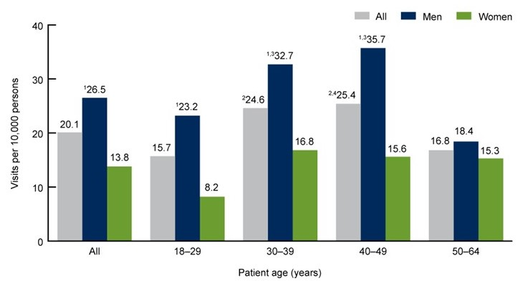
Figure 1: Patients of Schizophrenia in the UK
Source: (Burns & Drake, 2016)
In the UK, most people who are aged 40-49 years are affected by schizophrenia and visit hospital emergencies to get adequate treatment. After that, people of 30-39 are suffering from hallucinations and brain disorders as well as acting abnormally. And a predominant number of adults are suffering from extreme schizophrenia which increases the mental disorder among them (Mallett, 2016). Older people are relatively less affected by this mental disorder.

Causes and Symptoms of Schizophrenia
People are suffering from a schizophrenia that causes form genetic characteristics and structural changes inter brain. And the excessive uses of substance also cause this mental disorder (Walsh, 2016). it also causes from the environmental risk as well as surroundings of the patient. The symptoms of schizophrenia are given below:
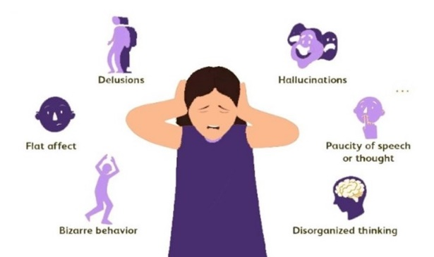
Figure 2: Symptoms of Schizophrenia
Source: (Holthausen, 2015)
Schizophrenia causes severe hallucinations among patients who are disrupted from reality and acting in their imagination. The patient may respond according to his imaginary characteristics and behave abnormally. It also causes delusions to stabilize rational thinking or decision. It also causes a paucity of thought and speech that resulted in an interrupted process of conversation with others. It also causes thought disorders that fluctuate the stability of rational thinking (Faraone, 2019). They are adopted bizarre postures and agitated manners that influence the behavior of their surroundings. The patient has experienced flat affect where he is unable to show emotional feelings as well as tone and facial expression.

Diagnosis of Schizophrenia
Schizophrenia is a mental disorder that causes by an imbalance in brain function. People who are affected by Schizophrenia has severe tend hallucination, delusion and other kinds of disruption in daily activities (Holthausen, 2015). First of all, identifying the characteristics of schizophrenia in the patients and find the intensity differences with normal lifestyle. Then recognizing the duration of the symptoms of the schizophrenia and analysing behaviour of the patients. Determine the intensity and the effect of the schizophrenia in the patient behaviour and thinking. Doctor may conduct blood test or MRI scan to detect the effect of schizophrenia (Howard, 2017). The intervention was improved that times after that the researcher invented different medications and therapy that using mostly in the present times.

Overview of Historical and Contemporary Treatment of Schizophrenia
The neurobiological theory refers that schizophrenia is the consequence of several neurotransmitter dysregulations. Schizophrenia was first introduced by Eugen Bleuler, a Swiss psychiatrist, in 1911. At an early age in 1940, Sakel in Vienna invented insulin therapy to use as the initial treatment of schizophrenia. After that electroconvulsive therapy was invented which was used to support patients who are suffering from depression and other diseases (Ferriter, 2019)? And people were using an antipsychotic medication, especially chlorpromazine to reduce the effect of schizophrenia. At present times people are using antipsychotic medications which are prescribed by psychiatric (Walsh, 2016). Assertive community treatment and psychoeducation help to create awareness among the people of the consequences of this mental illness.

Treatment Procedure of Schizophrenia in the UK
The mental illness has to be diagnosed and requires proper treatment as well as support to overcome the problem. National Health Service is playing a significant role in declining the influence of schizophrenia and protecting people from the bad effect of this mental disorder (Howard, 2017). Family therapy is practicing appropriately with family guidance and relative standards to support the patients. Vocational rehabilitation also supported schizophrenia patients overcome their fallacy against reality and reduce the intensity of hallucination, delusion and paucity of thoughts (Alanen, 2018). Cognitive therapy is the most effective treatment of schizophrenia as well as antipsychotic medication that ensures the proper mental health of the patients. The negative consequences of treatment of schizophrenia are drowsiness and gaining weight which is resulted from several atypical antipsychotics.

Policy and Principles to Support Schizophrenia Patients
Taking medication, receiving different therapies and avoiding excessive use of the substance is significant away to reduce the adverse effects of this mental disorder (Burns & Drake, 2016). National Health Service intended to implement Mental Health Act 2007 to prevent mental disorders especially schizophrenia and support patients to overcome this mental issue. The provisional diagnosis of schizophrenia is planned to prevent the intensity of the effects of this problem similar to post-traumatic stress disorder provisional activities. The general practitioner of the family can provide guidelines to protect the family from the effect of mental illness (Rajkumar, 2014). Most significantly psychiatrists and professional therapist help schizophrenia patients to overcome hallucinations and the abnormal fallacy of the patients.

Conclusion
Mental illness is adversely affecting the well-being of people, especially schizophrenia which is also known as a complex disorder of the brain. At present, the treatment process is developing with different effective therapies as well as antipsychotic medication that help patients to overcome quickly (Alanen, 2018). And the relevant policies and interventions are also taken by responsible bodies to prevent this mental disorder and protect the people. The following recommendation helps to prevent schizophrenia:
- Avoid traumatic and reviling situations with professional support
- Stop excessive substance misuse and other harmful drugs
- Improving social bonding and interacting with people
- Take regular Exercise to keep fit physically and mentally

Reference
Alanen, Y.O. (2018) “Treatment of schizophrenia and Society,” Schizophrenia, pp. 237–257. Available at: https://doi.org/10.4324/9780429479731-7.
Burns, T. and Drake, B. (2016) “Mental Health Services for patients with schizophrenia,” Schizophrenia, pp. 625–643. Available at: https://doi.org/10.1002/9781444327298.ch30.
Faraone, S.V. (2019) “Is schizophrenia a brain disorder?,” Schizophrenia [Preprint]. Available at: https://doi.org/10.1093/oso/9780198813774.003.0013.
Ferriter, M. (2019) "Schizophrenia - a historical approach," Schizophrenia and Parenting, pp. 3–18. Available at: https://doi.org/10.4324/9780429436710-2.
Holthausen, E.A. (2015) “Neurocognitive changes in schizophrenia: Correlates and functional consequences,” Schizophrenia Research, 60(1), p. 139. Available at: https://doi.org/10.1016/s0920-9964(03)80940-4.
Howard, R. (2017) “Late-onset schizophrenia,” Schizophrenia, pp. 47–61. Available at: https://doi.org/10.1002/9781444327298.ch4.
Mallett, R. (2016) “Raised incidence of schizophrenia in UK Afro-Caribbeans-clues to Aetiology,” Schizophrenia Research, 15(1-2), p. 193. Available at: https://doi.org/10.1016/0920-9964(95)95595-z.
McCarley, R.W. (2015) “Electrophysiology of schizophrenia,” Schizophrenia, pp. 311–333. Available at: https://doi.org/10.1002/9781444327298.ch15.
Rajkumar, R.P. (2014) “Prolactin and psychopathology in schizophrenia: A literature review and reappraisal,” Schizophrenia Research and Treatment, 2014, pp. 1–12. Available at: https://doi.org/10.1155/2014/175360.
Walsh, E. (2016) “Societal Outcomes in Schizophrenia,” Schizophrenia, pp. 644–665. Available at: https://doi.org/10.1002/9781444327298.ch31.

Appendix


