
APPENDIX GA36a

LEVEL 4 ASSESSMENT SPECIFICATION

Student name: | Bilal Aslam | Student ID number: | 2505193
Programme: | Certificate in Higher Education Business Skills for the Workplace
Module: | Enterprise and Entrepreneurship
Module code: | LCLM4006 | Contribution to Overall Module Assessment (%): | 50%
Lecturer: | Fouzia Farheen | Internal Verifier: | Dr Lizeta Demetriou  Naomi Doerge  Dr Chung Lai Johnny Wan  Fatima Hashmi
Assignment Title: | Task 1:  Individual Written Business Plan | Word count (or equivalent): | 1553 words
Submission deadline: | Week 8  Monday 29th June 2026, 10:00 AM | Return date of provisional marks & written feedback: | 27th July 2026

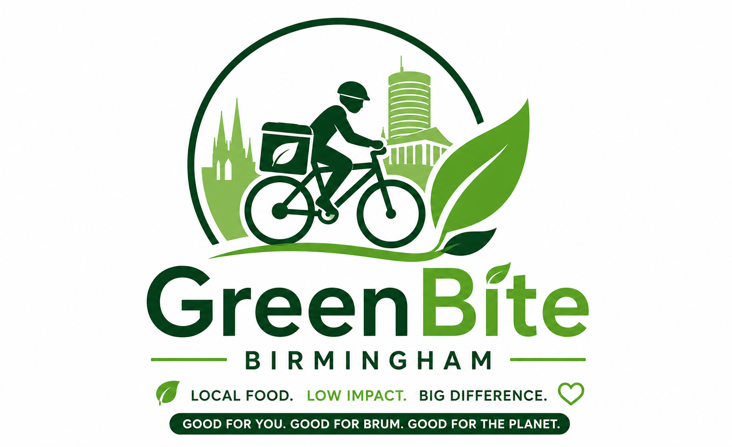

Executive summary

GreenBite Birmingham is an eco-friendly food delivery platform that helps local independent restaurants deliver to Birmingham's eco-conscious consumers, with the use of 100% electric-bikes for deliveries and compostable, recyclable packaging, to reduce carbon emissions and packaging waste. The business meets the increasing demand from consumers for sustainable and convenient food choices, demonstrating its commitment to sustainability, while also helping to boost Birmingham's restaurant economy by offering cheaper commission fees than Uber Eats and Deliveroo. The core target market is those students, young professionals and families who appreciate convenience and environmentalism. GreenBite's real value is its blend of sustainability and community engagement, providing a genuine alternative to the larger delivery platforms that focus on scale, rather than the ethical impact. To get the business going, it is looking for £15,000 to £20,000, which will be sourced from our own savings, a bank loan and perhaps some angel investment, to pay for e-bikes, packaging, marketing and staff to start trading for the first month.

Table of Contents
Contribution to Overall Module Assessment (%): 1
Executive summary 3
Section 1: Overview of the Business Idea 3
Introduction 3
Product/Service 4
Management Structure 4
Legal Structure 4
Section 2: Market Research 5
PESTEL Analysis 5
Competitor Analysis 6
Section 3: Marketing Communications 7
Target Market/Segmentation 7
Marketing Mix / Promotional Strategy 7
Section 4: Financials 9
Reference List 10

Section 1: Overview of the Business Idea

Introduction
GreenBite Birmingham is a food delivery business concept that is environmentally friendly, with a focus on sustainability and community, which aligns with the increasing investment and consumer interest in sustainable and community-focused businesses. In recent years, a growing number of UK startups have adopted environmental, social, and governance (ESG) principles, and green concerns have become a significant part of the investor interest and enhanced business resilience. GreenBite provides an environmentally conscious way for customers to access a wide range of Birmingham independent restaurants, using fully electric-bike deliveries in addition to compostable and recyclable packaging, and offers a fairer alternative to the dominant service providers like Uber Eats, Deliveroo and Just Eat. The concept and management plan is established next, followed by market research and competitive positioning, marketing communications, and financial requirements for launch and sustainability, establishing the commercial viability and sustainability of the venture.

Product/Service

The main service provided is the delivery of food from independent, locally owned restaurants throughout Birmingham, making GreenBite Birmingham a sustainable alternative in the food delivery industry. The differentiator is the use of a 100% electric-bike fleet, which removes the tailpipe emissions of people who use motorbikes or cars to deliver: compostable and recyclable packaging to reduce single-use plastic waste. The app will feature a ‘carbon saved' counter, which will inform customers of the estimated carbon emissions they've saved with their purchases, further helping to reinforce the sustainability message. The restaurant partners will pay a smaller commission than other delivery platforms like Uber Eats or Deliveroo, which will encourage local businesses to follow the ethical branding of GreenBite and keep a larger share of profits per delivery.

Management Structure

The business will be managed by an Owner/Manager to oversee the overall strategy, restaurant partnerships and financial management. Rider scheduling and restaurant onboarding will be handled by an Operations Lead and delivery riders will work as self-employed contractors, following industry practices. This is consistent with the precedent set in Independent Workers' Union of Great Britain v Central Arbitration Committee [2023] UKSC 43, where the Supreme Court upheld the definition of self-employment for riders with genuine substitution rights and flexible working arrangements. Early cost control measures will be implemented through marketing and customer service support functions which will be outsourced or carried out on a part-time basis.

Legal Structure

GreenBite Birmingham will be a Private Limited Company (Ltd) as this will provide the company with limited liability protection and will ensure that their personal assets are separated from the business assets, which is important especially when dealing with a delivery fleet, and one of the most important risks under contract (Lawhive, 2024). This also provides increased credibility to investors and lenders over a sole trader set-up. Requirements for incorporation with Companies House, food hygiene registration with Birmingham City Council and data protection registration under GDPR. Public liability insurance plus suitable rider insurance will be needed for the business.

Section 2: Market Research

PESTEL Analysis

Political: The UK government is continuing to fund the shift to green transport for SMEs and Birmingham is home to the government's Clean Air Zone commercial grant scheme, which provides up to £180,000 for businesses to retrofit their commercial vehicles for cleaner alternatives – this underpins GreenBite's electric-bike fleet model (Smallbusiness.co.uk, 2026).
Economic: The trend of convenience spending after the pandemic levelled up demand for food delivery, but cost-of-living pressures are causing consumers to pay attention to pricing, with GreenBite having to find the right balance between competitive delivery rates and the cost of packaging and fuel for back-up vehicles.
Social: Birmingham is a city with a large student and under-35 population base, which are more interested in brands that have ethical and environmental credentials, making this the perfect target audience for the positioning that GreenBite has built around sustainability.
Technological: Customers now expect seamless app ordering, live GPS tracking, contactless payments as the normal order of business and e-bike charging infrastructure and battery range will require careful logistical planning to ensure reliable delivery coverage across Birmingham.
Environmental: Packaging regulation is tightening up with the UK Plastic Packaging Tax also increasing, from April 2026 from £228.82 per tonne of packaging with less than 30% recycled content, reinforcing the commercial case for GreenBite's packaging strategy of providing compostable and recyclable options (GOV.UK, 2026).
Legal: GreenBite is subject to food hygiene protocols as well as GDPR guidelines for handling customers' data and e-bike licensing procedures; employment status of riders should be aligned with existing models for self-employed contractors in industry.

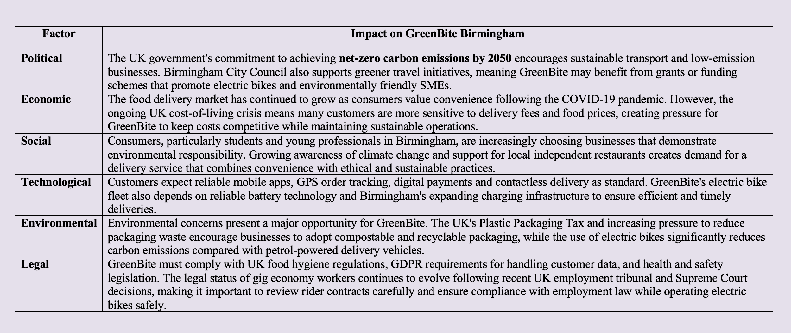

Table 1 : PESTLE Analysis for GreenBite Birmingham

Competitor Analysis

The biggest rival markets for GreenBite are dominated by its direct competitors, Uber Eats, Deliveroo and Just Eat, both of which reported larger market shares to deliver food occasions across the UK in 2024 – 27.2% of food delivery occasions for Uber Eats, 25.2% for Just Eat and 16.2% for Deliveroo (Lumina Intelligence, 2025). But these systems are powered by combustion-engine cars or hybrid fleets, and they also take a large cut in commissions, which can hurt independent restaurant margins. Restaurants' in-house delivery services are also considered indirect competition. Unlike existing platforms that have invested in traditional delivery infrastructure, GreenBite's edge comes from its all-electric delivery fleet, reduced commission fees for small and local restaurants, and its community-based branding.

Section 3: Marketing Communications

Target Market/Segmentation

GreenBite Birmingham will focus on three main customer segments. Students, who are price sensitive but app savvy, is a significant market as Birmingham's five leading universities have around 80,000 students spread across the city (365 Invest, 2025). The second group is young professionals, who are looking for convenience, but more concerned about doing the right thing and protecting the environment when considering their places of residence. The third segment is the eco-conscious families who are willing to pay more for eco-friendly delivery methods. The segments all embody Birmingham's youthful and diverse population and offer a solid platform for a brand that prioritizes sustainability.

Marketing Mix / Promotional Strategy

Marketing strategy is frequently organised in terms of the 4Ps model, which was first described by marketing Professor E. Jerome McCarthy in his 1960 publication, Basic Marketing: A Managerial Approach. McCarthy suggested that there are four components of marketing — product, price, place, promotion — which are interdependent and usually interrelated in any marketing activity, and therefore should not be used separately (McCarthy, 1960). This framework can be used to map out a green marketing strategy for GreenBite Birmingham.
Product
GreenBite's main product is eco-friendly food delivery services from independent restaurants, which are distinguishable from other food delivery services by the fact that they use the whole fleet of their bikes and use compostable packaging. This sustainability commitment is what sets it apart from Uber Eats, Deliveroo and Just Eat, which don't have a zero-emission delivery model.
Price
Through value-based pricing, GreenBite will incorporate the higher prices that environmentally conscious consumers are willing to pay for sustainable services and ensure delivery fees remain competitive to attract price-sensitive consumers like students. The restaurant commission will be lower than the other big guys to promote the local-business aspect, which is the backbone of the brand.
Place
Initially focusing on university districts' areas in Birmingham with a high concentration of students and young professionals, GreenBite will be an application-based delivery service as the number of riders and restaurant partners increase, spreading city-wide.

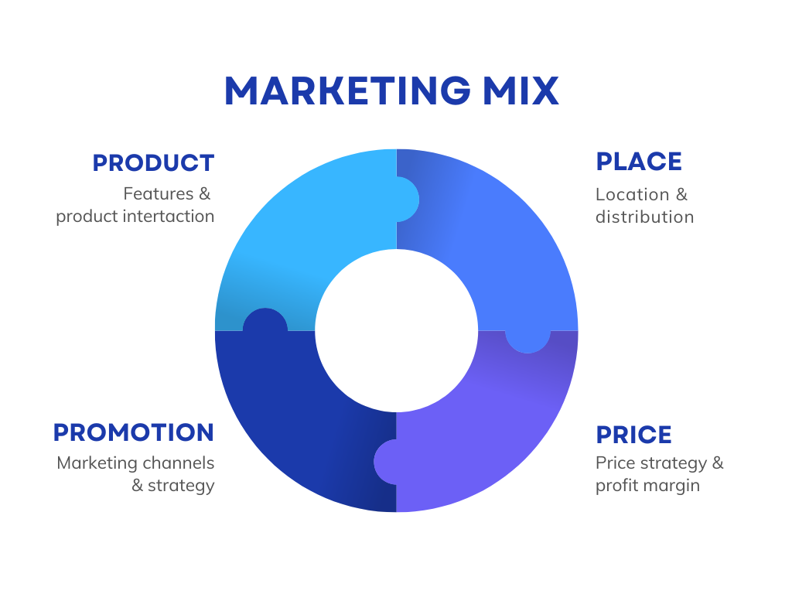

Figure 2: marketing mix. (McCarthy, 1960)

Promotion
GreenBite's sustainability journey will be promoted on Instagram and TikTok using content and through local Birmingham food influencers. This will be promoted in the community through pop-up stalls in Birmingham markets, and through links with University student unions. Rewards will include repeat order incentives and a loyalty scheme offering discounts or “carbon saved” incentives for repeat orders. A free first delivery launch promotion will help first time customers, while loyalty incentives will help to turn first time customers into repeat buyers.

Section 4: Financials

Funding (required) and Sources.

GreenBite Birmingham needs £15,000–£20,000 worth of start-up capital to start operations. Funding will be raised using £5,000 out of their own pocket, showing commitment to potential investors and lenders; £10,000 bank loan – available given the confidence of being a registered Ltd company with a strong business plan; and £5,000, secured through the government-backed Start Up Loans scheme which lends between £500 and £25,000 for new UK businesses, and offers free mentoring support (Start Up Loans, 2026). One benefit of going directly to the Start Up Loans Company is that they will lend credibility to new businesses and offer additional business advice continuously, not just the capital itself.

Startup Expenses — First Month
Expense | Estimated Cost
Electric cargo bikes (x3) | £5,400–£6,000
Compostable packaging stock | £1,200
App/white-label delivery platform licensing | £1,500
Marketing launch costs | £1,000
Staff wages (riders, part-time admin) | £3,000
Insurance and licensing fees | £500
Working capital buffer | £1,500–£2,000

The biggest expense is the electric cargo bike and they are likely to cost between £1,689 and £1,999, which covers the basic investment to meet the zero emissions commitment of GreenBite (Cycling UK, 2026). Compostable packaging adds to the sustainability pledges at its heart of the business. Insurance costs are also not too high as there are public liability policies for delivery companies starting from as low as £6.52 per month (Simply Business, 2026). The working capital buffer will support operations during the low revenue start-up phase

Reference List

365 Invest (2025) Student Population in Birmingham. Available at: https://365invest.co.uk/student-population-in-birmingham/ (Accessed: 18 June 2026).
Adams-Prassl, J. (2022) 'Uber BV v Aslam: "[W]ork relations … cannot safely be left to contractual regulation"', Industrial Law Journal, 51(4), pp. 955–966.
Aexir (2026) Uber Eats Alternative for UK Restaurants: The Real Cost of 30% Commission. Available at: https://aexir.com/blog/uber-eats-alternative-uk-cost (Accessed: 19 June 2026).
Cycling UK (2026) Bike Test: Budget e-Cargo Bikes. Available at: https://www.cyclinguk.org/cycle-magazine/bike-test-budget-e-cargo-bikes (Accessed: 22 June 2026).
GOV.UK (2026) Plastic Packaging Tax: Steps to Take. Available at: https://www.gov.uk/guidance/check-if-you-need-to-register-for-plastic-packaging-tax (Accessed: 28 June 2026).
Independent Workers' Union of Great Britain v Central Arbitration Committee and another [2023] UKSC 43.
Lawhive (2024) Private Limited Company Advantages and Disadvantages. Available at: https://lawhive.co.uk/knowledge-hub/small-business/private-limited-company-advantages-and-disadvantages (Accessed: 25 June 2026).
Lumina Intelligence (2025) UK Food Delivery Market: Growth, Share, & Size Statistics (2025). Available at: https://www.lumina-intelligence.com/blog/foodservice/uk-food-delivery-market-growth-share-size-statistics-2025/ (Accessed: 24 June 2026).
Simply Business (2026) Public Liability Insurance for Couriers from £6.52 per Month. Available at: https://www.simplybusiness.co.uk/business-insurance/courier-insurance/ (Accessed: 28 June 2026).
Smallbusiness.co.uk (2026) 150 UK Small Business Grants to Apply for Right Now. Available at: https://smallbusiness.co.uk/small-business-grants-uk-2548113/ (Accessed: 28 June 2026).
Start Up Loans (2026) Start Up Business Loans. Available at: https://www.startuploans.co.uk/ (Accessed: 27 June 2026).
Zebracat (2025) 150+ Eye-Popping Gen Z Marketing Statistics for 2025. Available at: https://www.zebracat.ai/post/gen-z-marketing-statistics (Accessed: 22 June 2026).

