Student number 1803094
Course title Photography in the arts.
Word Count 1424
Tutor Ryan Moule
Transformation of essence
Layout of Exhibits at the Mission Gallery
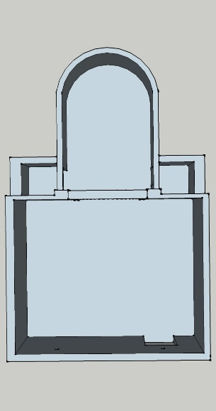
At the back of the space under the semi-circular dome is ‘Ascension’ standing floor to ceiling. By Anish Kapoor
In the centre of the floorspace is ‘Descension’ By Anish Kapoor
From the entrance on the wall to the left is ‘The garden of earthly delights’ By Hieronymus Bosch
And ‘Sigils’ to its right. By Unknown.
The entire right-hand side of the space, from the entrance, has the installation ‘Gravity Stairs’. By Olafur Eliasso
Curation
“Curation: using acts of selection and arrangement (but also refining, reducing, displaying, simplifying, presenting and explaining) to add value.”
Ref Bhaskar M, Curation. Piatkus (2016)
But Curation is more than just collecting or arranging. “Curators are less focused on finding more content than they are on making sure what they have is the right content.”
Ref Marc Rosenberg 2016 Learning Solutions Magazine.

The reason curation has become so important, is the sheer volume of information that we are bombarded with every day. Without some sort of filter, it would become impossible to sort through the noise. Curation allows us to be more selective and mindful of what is useful and what is not.
“Real-world curators are keepers of cultural heritage institutions like museums and libraries. The job requires a deep understanding of the arts and how art works in conjunction with physical spaces, with culture and with actual people.”
Ref Saya Wiseman A curator’s guide to curation (2014)

The Exhibits
Descension
On entering the gallery space, you are immediately drawn to its centre.
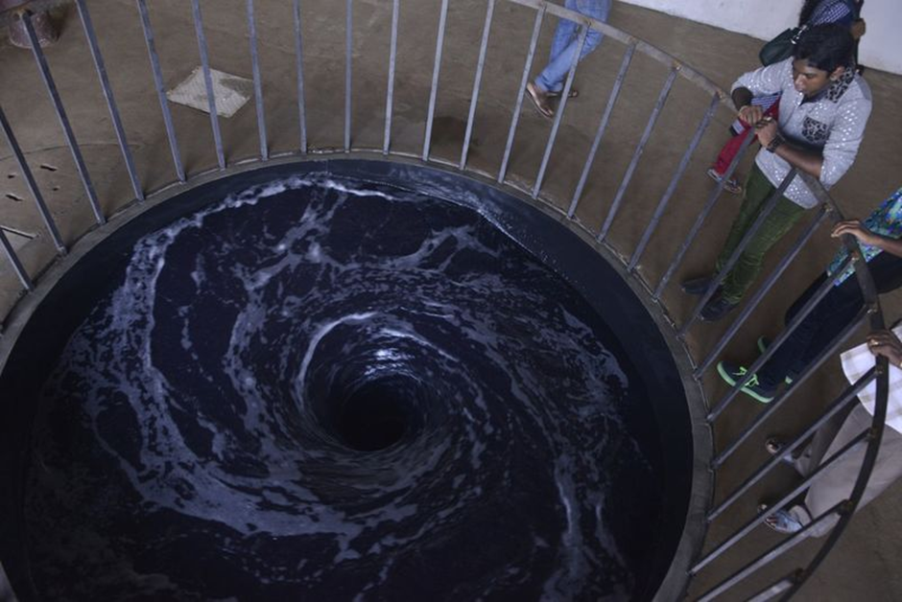
Turner prize winner and contemporary sculptor Anish Kapoor’s installation ‘Descension’ is impossible to ignore. Apart from the almost hypnotic rotation of the black liquid, is the sound it makes. A low guttural sound, like an animal growling; increasing in volume with the rotation speed as the centre of the vortex appears.
As well as being visually impressive and engaging, this work also invokes many different feelings. The black colour of the liquid and the swirling downward motion only conjure the negative. Submersion, loss of control and chaos, spring immediately to mind but also connotations of the religious. Being drawn downward, under, below and ultimately thoughts of the underworld, hell and the afterlife, the ultimate destination of descent.
From its chaotic start, increasing to full speed vortex, Kapoor has created work that resonates with everyone. The sense of power from chaos drawers in the viewer.
Anish Kapoor said “Art is not to be interesting, art I think, has to provoke philosophical questions, even if we don’t know the questions are philosophical”

Directly beyond ‘Descension’ is a second piece by Anish Kapoor.
Ascension
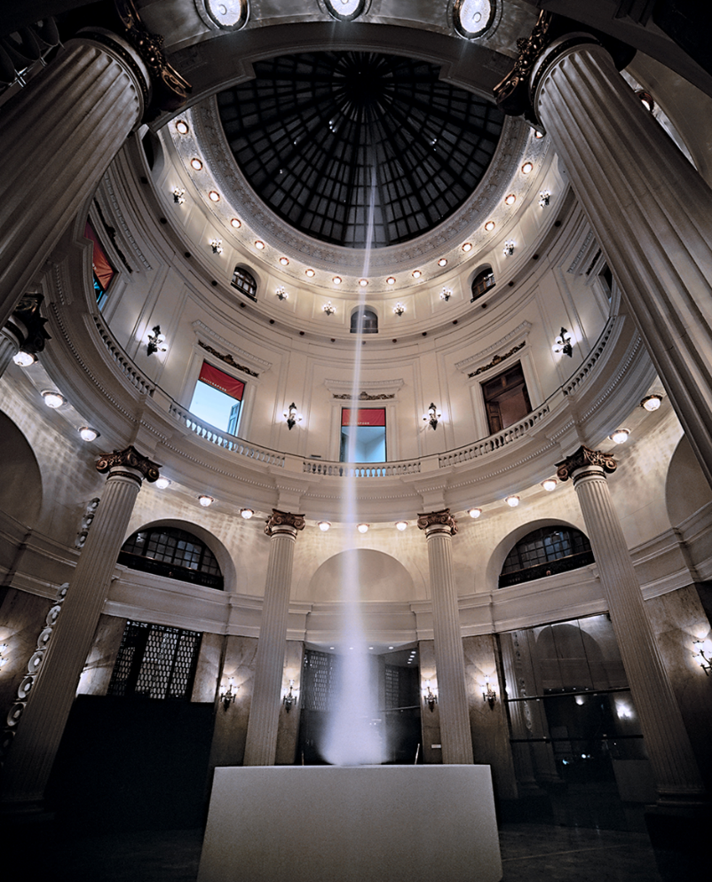
Stretching from floor to ceiling in the semi circular domed area at the far end of the gallery space, is ‘Assension’ the antithisis of the previous work. A spiral of smoke ascesending upwards in a continuous stream. Anish Kapoor said of this work, “For every material thing there is an immaterial equivolent”, “This is an object made of a none object, I’m interested in that”
Ref Hirshorn Museaum. Demetrion Lecture 2015 https://hirshhorn.si.edu/explore/demetrion-lecture-anish-kapoor/
Refering to the smoke as a non object is an interesting concept. Smoke by its very nature has no form. It is difficult to think of another form a non-object could take, as to be an object it must have form.
Once again sound is a factor, it has a mechanical fan like sound of the smoke being generated, expelled and extracted. The smoke is in a dense column with a spiraling rotation which helps it to keep its form.
The white colour of the smoke, the movement and direction gives the impression of escape or release. Moving skyward and beyond.
“I’m interested in abstract art because the route to meaning is much more poetic”.
Ref Anish Kapour Interview Channel 4 news. (2012)

Immediately to the left of the entrance is Hironimus Bosch’s triptych
‘The Garden of Earthly Delights’.
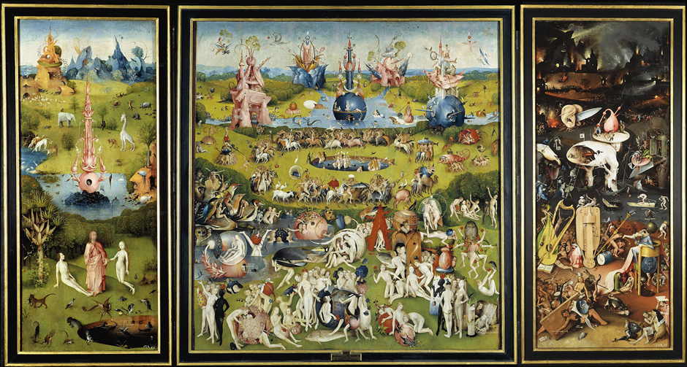
This work of 3 panels appears to show biblical images and religious narratives.
It also appears to show Mans journey from paradise, descending to Hell through sin and excess.
The first panel is clearly the Garden of Eden, depicting Adam and Eve in an idyllic setting, with the balance of nature and the blessing of the God like figure. It is serene, with many animals and birds. It gives the viewer the impression of harmony. The larger centre panel gives a very different impression. Vastly overcrowded and chaotic, it depicts Man’s dominance over nature, lust, debauchery and excess. It also has an erotic tone that is completely absent in the first panel.
It gives the viewer the impression of total abandonment and lack of any structure or society, where anyone feels free to do as they wish without consequence.
The far-right panel is a nightmarish depiction of hell. Backlit by fire and flame, with the foreground filled with pain and torture. Severed limbs, skulls, knives, people being eaten, hunted by animals, stabbed and pierced by arrows. It is a scene of total chaos.
There is so much details in this work that it’s impossible to take it all in and you seem to see something new every time you view it.
The Left features the idyllic, where the centre and far right panels are a depiction of humanity's insatiable desires and deepest fears.

Continuing to the right we have ‘Sigils’. A list of symbols that have occult significance. The Oxford English dictionary defines them as.
Sigil, “an inscribed or painted symbol considered to have magical power.”
https://en.oxforddictionaries.com/definition/sigil
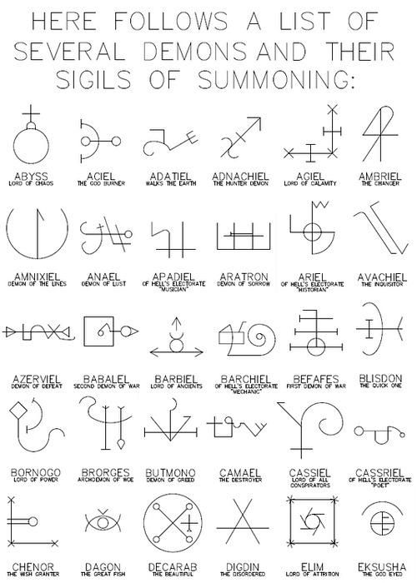
Semiotics is the term for the science of signs and symbols. A symbol is used to denotes something else, especially something abstract.
These Sigils are a classic example of a symbol that represents something that has a completely different meaning.
I find these images fascinating and at the same time completely nonsensical. As a non-believer, I find it incredible that these Sigils exist and can’t imagine how they came about. As far as I’m aware no one has ever returned from there or been summoned to here. They fascinate me in same way as hieroglyphics do. Pictograms that contain another meaning. They seem geometric and icon like. I can imagine them being used on a flow chart or maybe an architectural blue print.
I have encountered similar images in Henry Dreyfuss’s Symbol Sourcebook (McGraw-Hill 1984). Under the Folklore and Meteorology chapters.
They have many similarities and have aspects that are the same. Although the meanings are different. Some symbols are universally recognisable to I don’t see any in the symbols above.

The final installation fills the entire right-hand side of the venue.
Olafur Eliasson’s ‘Gravity stairs’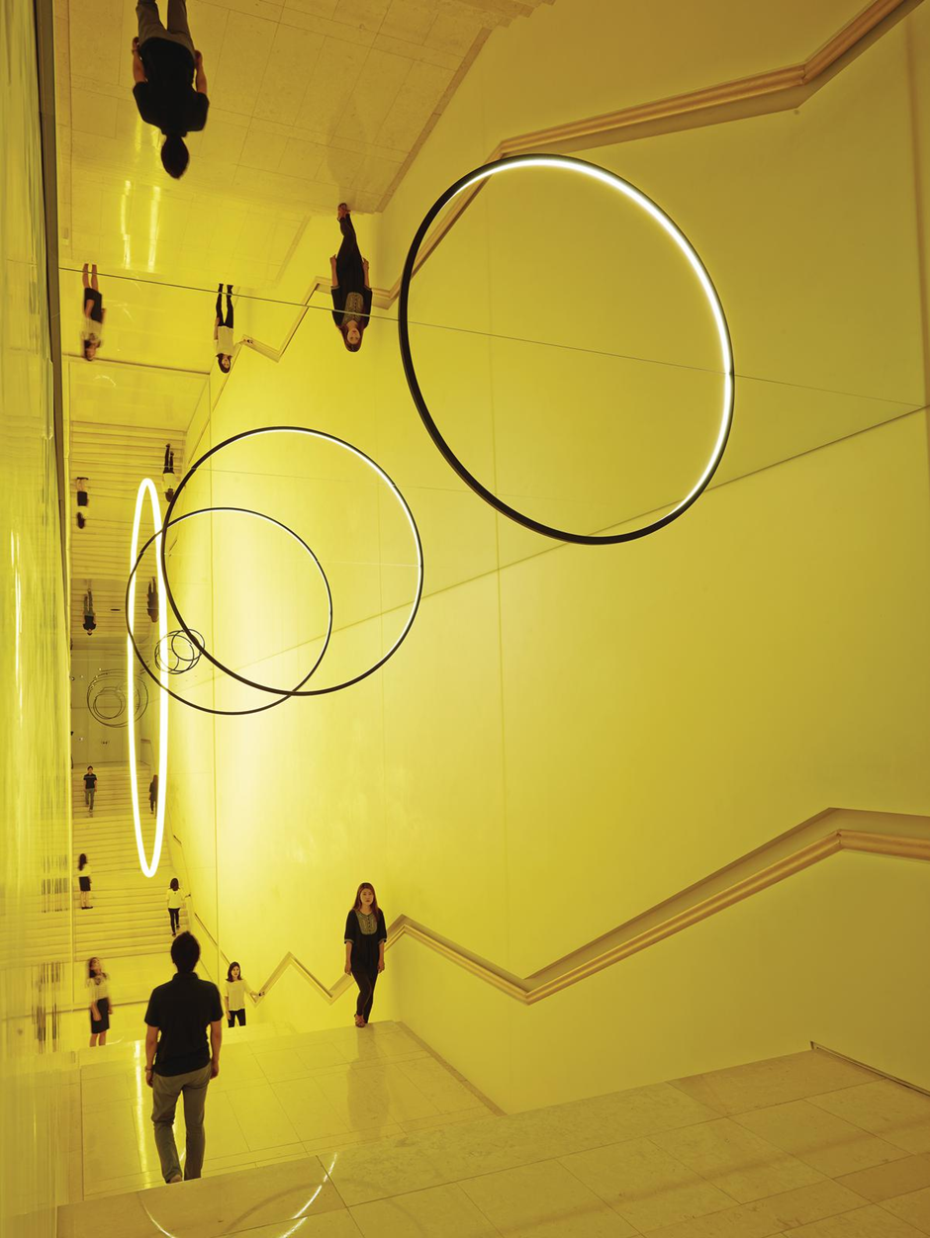
Gravity stairs is a large stairway below a huge model of our solar system, created by mirrors and rings of light. This has elements of ascension and descension of its own. Patrons and the stairway itself are reflected in the ceiling mirrors, doubling the apparent space, with a wall mirror doubling it again, with a large sun in between. By including the viewer in the mirroring, it makes them part of the artwork, giving it unique impact on the viewer. It also gives a sense of scale within the solar system and the vast distances between planets. our place within the represented vast distances and shows the significance of our place in relation to these heavenly bodies.
“The work reflects the possibility for coexistence between the various, individual worldviews that we each project onto our fragmented physical experience.”
Ref https://olafureliasson.net/archive/artwork/WEK108985/gravity-stairs

In Conclusion
In this curation I have tried to give a sense of our position in the world and what may lie beyond, through art. These images depict Man’s continuing struggle with being human and the challenges we all face.
Anish Kapoor’s work Ascension and Descension is the epitome of this. His sculptures are inspirational, and I am looking forward to seeing more of his work. Hironimus Bosch created many works in the same vein as ‘The garden of earthly delights’. Many with religious overtones and many in Triptych form. This one of his best-known works and the intricacies and details really draws me in. The Sigils is a wild card but extremely interesting and probably something not often seen before. I think the context is unusual and probably flawed be that doesn’t make them any less interesting. ‘Gravity stairs’ creates and amazing space using light and mirrors. The depiction of the solar system and the reflected images bring the viewer into the image creating a unique experience.

Bibliography
Bhasker, M. (2016) Curation. London, Piatkus
Dreyfuss, H. (1984) Symbol Sourcebook. New York, McGraw-Hill
Read, S. (2008) Exhibiting Photography. Oxford, Elsevier
Gibson, W. (1973) Hieronymus Bosch. London, Thames and Hudson Ltd
Alvarado, M. Buscombe, E. Collins, R. Presentation & Photography. (2001) New York, Palgrave
Bourdieu, P. (1990) Photography A Middle-brow Art. Padstow, T.J. Press
Kelsey, R. Stimson, B. (2005) The Meaning of Photography. Williamstown, Excelsior printing Company
Galer, M. (1995) Foundations for art & design. Oxford, Elsevier
Cotton, C. (2014) The photograph as contemporary art. London, Thames and Hudson
Baudrillard J. (2005) The system of objects. London, Verso

