

Evaluating the Feasibility of MediDirect UK: A Digital Medicine-Adherence and Pharmacy Support Service for Patients with Long-Term Health Conditions

By- Mihir Sudhirbhai Patel
Student ID-2504998

Module: Business Development Proposal

Module code: LCMB7037

Supervisor Name- Balendran Kanadasamy

Word Count-13729

AI Acknowledgment
The Business Development Proposal has been independently researched, analysed, and written by me. The use of Artificial Intelligence (AI) has been restricted to limited uses in accordance with University Business Development Proposal guidelines. ChatGPT has been used only to create diagrams and visuals that help illustrate concepts. This proposal has not made use of any AI-generated literature review, business analysis, market evaluation, financial analysis, methodology, conclusions or recommendations. All research, interpretation of secondary data, critical analysis, application of business theories and all other information provided in this proposal has been done and written by me. All secondary sources have been appropriately cited in accordance with UWTSD Harvard.

Executive Summary

Table of Contents
Executive Summary 2
1. Introduction 9
1.1 Background and Context 9
1.2 Problem or Opportunity Statement 9
1.3 Initial Observation of Demand 10
1.4 Aim, Objectives and Research Questions 10
1.5 Scope and Boundaries 11
1.6 Structure of the Report 11
2. Company Description 13
2.1 Business Identity and Legal Structure 13
2.2 Product or Service and the Problem Solved 13
2.3 Founding Idea and Brief History 14
2.4 Mission, Vision and Values 14
2.5 Business Objectives and Goals 15
2.6 Alignment with Trends and Opportunity 15
3. Literature Review 16
3.1 Digital Healthcare and Medication Management 16
3.2 SWOT Analysis 16
3.3 PESTLE Analysis 17
3.4 Porter's Five Forces 17
3.5 Value Proposition Canvas 17
3.6 Business Model Canvas 18
3.7 Competitor Benchmarking 18
3.8 VRIO and 7Ps Marketing Mix 18
3.9 Integration of Frameworks 19
4. Methodology 20
4.1 Approach to Opportunity Identification 20
4.2 Market Insight Collection 20
4.3 Secondary Data Selection and Source Criteria 20
4.4 Qualitative and Quantitative Data Analysis 21
4.5 Models and Frameworks 21
4.6 Limitations and Ethical Considerations 22
5. Market Opportunity Analysis 23
5.1 UK Digital Healthcare and Digital Pharmacy Market 23
5.2 Market Size and Growth Potential 24
5.3 Demand Drivers, Analysis, and Market Trends 25
5.4 Customer Segmentation and Target Market 27
5.5 Customer Demographics and Behavioural Trends 28
5.6 Customer Pain Points and Unmet Needs 28
5.7 Economic Conditions and Consumer Price Sensitivity 29
5.8 Geographic and Digital Accessibility Factors 30
6. Competitive Environment Analysis 31
6.1 Competitive Landscape and Key Success Factors 31
6.2 Competitor Analysis and Market Positioning 32
6.3 Market Share estimates 34
6.4 Porter’s Five Forces Analysis 34
6.5 PESTLE Analysis 35
6.6 Market Gaps and Strategic Opportunities 36
6.7 Industry Attractiveness assessment 37
7. Business Strategy 38
7.1 Strategic Framework and Approach 38
7.2 External Strategic Analysis 38
7.3 Internal Analysis: VRIO 38
7.4 SWOT Analysis and Strategic Synthesis 40
7.5 Strategy Selection 41
7.6 USP and Value Proposition 42
7.7 Competitive Advantages 44
7.8 Key Success Factors 44
8. Business Model Canvas 46
9. Financial, Marketing, and Human Capital Management Plan 49
9.1 Financial Plan 49
9.2 Marketing Plan 55
9.3 Human Capital 57
10. Operations Plan 59
10.1 Operational Workflows, supply chain, and logistics 59
10.2 Location strategy, equipment, technology systems 61
10.3 Compliance/ regulatory considerations 62
11. Feasibility Analysis 64
11.1 Ethical, market, and operational feasibility 64
11.2 Financial feasibility and strategic fit 65
11.3 Risk, Mitigation, and Overall Viability 65
12. Implementation Plan 67
12.1 Launch phases, milestones and timeline 67
12.2 KPIs, monitoring, resource allocation, change management 68

1. Introduction

1.1 Background and Context
The UK healthcare industry is experiencing massive digitalization where technology is increasingly being integrated to enhance access, convenience and efficiency in service delivery of healthcare services. Online prescription management is one of the significant initiatives of this transformation. In June 2026, the NHS England registered 41.89 million NHS App account users, and 7.39 million repeat prescriptions were ordered via the application in June 2026, that was 31% increase compared with June 2025. Moreover, 3,163 pharmacy locations were linked to the NHS App national prescription-tracking service, which means that there is a growing integration of digital services and the provision of community pharmacies (Digital NHS, 2026).
This transformation is going along with demographic and healthcare pressure. As shown by ONS statistics, an ageing population is still a relevant matter and individuals older than 65 constitute a large percentage of the population in the UK (ONS, 2025). The long-term conditions in turn lead to sustained requirement of prescription drugs and the continuous treatment with medications. A UK survey of 1,746 adults taking long-term conditions medications discovered that 22.6 percent of participants engaged in non-adherence with medicines, and 30.1 percent of people used digital tools to assist in ordering or administering medicines (Penner, et al., 2024).
Greater digitalization is also facilitated by the policy environment. The Electronic Prescription Service of NHS England allows sending the prescription electronically to a selected dispenser of a patient to limit the use of physical processes in repeat prescription (NHS England, 2025). Nonetheless, the ease of access to digital prescription does not always pertain to the behavioral and practical barriers to taking medications on a regular basis. This offers a possible opportunity to services that extend beyond prescription ordering and delivery to integrated medication-management support.

1.2 Problem or Opportunity Statement
Despite the increasing digital access to prescription services, medicines adherence has been a major problem for users of medicines with long-term conditions. The UK evidence suggests non-adherence can occur alongside challenges to access medicines and that some patients are already using digital tools to assist medication related activities (Penner, et al., 2024). Meanwhile, NHS England views medicines information as being disjointed across healthcare systems and care settings, with risks of duplication, delays and incomplete information (NHS England, 2026).
The resulting opportunity is not to offer another medicine-delivery service, but to explore whether a more integrated digital service can be offered to connect prescription management, medication prompts and pharmacy support. MediDirect UK is thus a business proposal to this opportunity. Business proposal needs more research than assuming that the business will be a success, its market appeal, competitive advantage, legal provisions and practicality in its operations should be evaluated methodically.

1.3 Initial Observation of Demand
Initial indications suggest a need for digitally enabled medicine management. The number of distinct apps used by the NHS in June 2026 for ordering repeat prescriptions increased by 30% compared to 2025, to be 5.96 million (Digital NHS, 2026). Previous data also revealed 45% rise in repeat prescriptions ordered through the NHS App in the previous year, with an average of 3.1million being made each month in early 2024 (NHS England, 2024). These statistics illustrate that consumers already connect with digital prescription management. Together with evidence that 22.6% of adults in the UK who suffer from a long-term condition are not adhering to medication, they suggest there is a possible customer need for increased support with medicine adherence. The market and feasibility analysis needs to be done to determine the extent of this need if economically viable as a market option.

1.4 Aim, Objectives and Research Questions
Aim
To evaluate the commercial and operational feasibility of Medi Direct UK as a digital medicine-adherence and pharmacy support service within the UK healthcare market.
Objectives
- To assess the market demand and customer need for digital medication-adherence and pharmacy-support services in the UK.
- To evaluate the competitive environment and positioning of Medi Direct UK against existing digital pharmacy providers.
- To examine the operational, technological and regulatory requirements associated with delivering the proposed service.
- To develop evidence-based recommendations regarding the business model, implementation and overall feasibility of Medi Direct UK.
Research Questions
- What evidence indicates demand for an integrated digital medication-adherence and pharmacy-support service in the UK?
- How is Medi Direct UK positioned relative to existing digital pharmacy alternatives?
- What operational, technological and regulatory factors could influence implementation?
- What business model and implementation approach could support the proposed service?
These objectives directly reflect the proposal's intention to assess marketability, competition, operational challenges and regulatory considerations.

1.5 Scope and Boundaries
The analysis is based on the digital healthcare market in the UK with a focus on patients who require regular medicines and/or repeat prescriptions, and potential applications of digital adherence support. Its analysis takes into consideration the market demand, customer needs, competition, business strategy, operations, regulation and financial feasibility. The research does not recommend the use of medication or replacement of NHS/community pharmacy services. Does not draw from first-hand patient or pharmacist opinions but does rely on "secondary sources" as a starting point.

1.6 Structure of the Report
This report initiates with the process of opportunity identification followed by business evaluation. The second chapter explains about Medi Direct UK, its identity, service proposition, mission, vision and objectives. The existing theories and frameworks are reviewed in Chapter 3. The methodology is explained in Chapter 4. The market opportunity and competitive environment are then both assessed in chapters 5 and 6 before a business strategy is developed in chapter 7. The Business Model Canvas is presented in Chapter 8, and the financial plan, marketing and human-capital plan is elaborated in Chapter 9. Operations are considered in Chapter 10, feasibility analysis in Chapter 11 and implementation planning in Chapter 12. Conclusions and recommendations can be found in Chapter 13, and reflection in Chapter 14.

2. Company Description

2.1 Business Identity and Legal Structure
MediDirect UK is a new digital healthcare initiative that is proposed to offer medication-adherence and pharmacy-service solutions in the UK market. In the context of this business development proposal, the venture is offered as a private company limited by shares (Ltd). This is a suitable structure where the commercial technology venture seeks potential external investment but offers a set form of corporate structure of ownership and management. According to the Companies House, the incorporation of private companies that are limited by share is possible in the UK while they require directors and shareholders (GOV.UK, 2026). The suggested business will be digital and target UK market first, and we will discuss in more detail regulatory and operational requirements further in the report.

2.2 Product or Service and the Problem Solved
MediDirect UK is designed to be a digital offering providing all the information about medication, along with contact with the pharmacist and continuing adherence education in one place. It's designed for patients who have to take medicines regularly, especially those with long-term health conditions, people who need to use the system at their convenience in case of problems with their mobility and consumers who want to have more control over handling repeat prescriptions. Service will be based on the premise that it will be complementary to existing NHS and community pharmacy services and not a competitor to them.
The suggested value proposal aims to address a possible gap in the connection between digital access to prescriptions and continuous medication care. The current digital pharmacy development has facilitated the ordering and prescription tracking process and made it more convenient, while medication compliance is beyond only obtaining medicines. MediDirect UK would aim to generate value by providing an integrated experience of reminding, providing support related to prescription and having access to pharmacy communication. The proposal specifically identifies this combination as the intended differentiation of the service.

2.3 Founding Idea and Brief History
MediDirect UK is a NEW venture concept rather than an existing Company. This concept grew out of a shared recognition of the need for medication adherence to address identified clinical challenges. The proposal recognises that many patients find that prescriptions are accessible online, and so is assistance in the continuous management of those prescriptions may be offered through a variety of services. The business concept was therefore developed around investigating whether prescription management and adherence support could be brought together through a single digital platform.

2.4 Mission, Vision and Values
Mission
MediDirect UK's proposed mission is to make medication management more accessible, organized and convenient by connecting patients with digital adherence tools and pharmacy support.
Vision
The proposed vision is to become a trusted UK digital healthcare platform supporting patients in managing long-term medication requirements while complementing established NHS and community pharmacy services.
Values
The four values of the business would be patient-centeredness, accessibility, trust and responsible innovation. User needs would be at the center of service development, accessibility would aim to alleviate real-world obstacles to managing medication, trust would priorities reliability, transparency and proper handling of health-related information and lastly, responsible innovation would involve ensuring that technology is developed within suitable healthcare, ethical and regulatory limits. These principles are especially important for health information, given the sensitive nature of this data and the UK data-protection laws that must be carefully followed.

2.5 Business Objectives and Goals
The proposed initial objectives are to:
- Develop and validate a minimum viable digital platform incorporating medication reminders, prescription-support functions and pharmacist communication before commercial launch.
- Establish partnerships with selected community pharmacies to test the service model and develop an appropriate referral and support pathway.
- Build an initial customer base within the target UK segment following pilot validation, with specific acquisition targets to be established through the subsequent market and financial analyses.
- Develop a financially sustainable revenue model based on evidence regarding customer willingness to pay, partnership opportunities and operating costs.

2.6 Alignment with Trends and Opportunity
The business model suggested by MediDirect UK can be aligned with the further digitalization of medicines management in the UK. In June 2026, NHS England reported 41.89 million NHS App registrations and 7.39 million repeat-prescription orders, which indicates the high level of involvement in digital prescription services. NHS England is also undertaking a more interrelated digital medicines pathway since information on medicines is still disseminated in a fragmented manner in healthcare settings. These trends support the strategic importance of learning about an integrated medication-support proposition. Nevertheless, they do not build the commercial viability on their own. The market analysis, competition, strategy, financial and operations analysis that follows will determine whether the proposed value proposition of the projected business opportunity of MediDirect UK can be converted into the sustainable business opportunity.

3. Literature Review

3.1 Digital Healthcare and Medication Management
Digital healthcare has provided opportunities to improve accessibility and convenience, patient support using mobile apps and online platforms, and electronic prescriptions. (Rosenlund, et al., (2023) highlight the growing uptake of digital health services and (Stumpo’s, et al., (2023) note the importance of technology acceptance as part of digitalisation in healthcare. The introduction of online platforms and services driven by digital technology is also transforming the pharmacy industry (Aleman, 2024). Technology is also being used in the delivery of health care services, as in the case of NHS digital infrastructure and electronic prescriptions (NHS, 2026).
A key area for Medi Direct UK is that people with a long-term condition may require repeat prescriptions and complex medication regimes. Digital interventions can provide reminders, medication schedules and monitoring. (Huang, et al., (2024) have introduced intelligent medication reminder systems, and Liu, et al., (2023) have demonstrated the use of mobile applications for medication management. Digital tools are an emerging approach and are found to have implementation challenges (Wang, et al., 2025). Moon and Walsh (2025) also identify opportunities and challenges for digital medication adherence interventions. This would include digital convenience, medication management and pharmacy support for the user of Medi Direct UK.

3.2 SWOT Analysis
SWOT analysis involves analysing strengths and weaknesses as well as opportunities and threats and is considered a systematic approach to understanding strategic position (Puyt, et al., 2023). It can be used by Medi Direct UK if the internal and external factors can affect its feasibility. Advantages are built-in platform for medication reminders, prescription management and interactions with pharmacists, disadvantages are development costs, cybersecurity needs, and partnering dependency. As technology-driven healthcare becomes more common, there are opportunities that could emerge, but others could stem from new competitors, regulatory changes and technology advances. SWOT can then be used to integrate the findings in different parts of the proposal, but it should work together with other models when making strategic decisions. However, SWOT may oversimplify complex strategic factors, so it is most useful for synthesising findings from other analyses.

3.3 PESTLE Analysis
PESTLE is an analysis of the political, economic, social, technological, legal and environmental factors that affect an organisation. It would be fitting enough for MediDirect UK given the external environment in which digital healthcare operates. Digital transformation and electronic prescription infrastructure within the NHS offer opportunities for digitally supported healthcare (NHS, 2026). Social factors are the evolving expectations among patients and growing adoption of digital health services (Rosenlund, et al., 2023). Important legal concerns are raised as larger portions of healthcare services become digital, as information governance, data protection, and security become a concern (NHS, 2025). The economic and technological aspects can impact software, infrastructure and cybersecurity investments. PESTLE is therefore an analytical tool that examines external factors that impact on MediDirect UK in a systematic way. However, PESTLE identifies external factors without assessing their relative importance, so it is best used alongside other frameworks.

3.4 Porter's Five Forces
The Porter's Five Forces model assesses the attractiveness of an industry by examining the competitive environment, potential for new entrants, supplier bargaining power, customer bargaining power and threat of substitutes (Baird, et al., 2024). This framework is applicable since it would be being used in a known digital pharmacy environment. Digital services can facilitate alternatives that can increase customers choice and buyer power. Customer experience research in online platforms suggests that service attributes can affect customer repurchase intentions (Tiutiu, et al., 2025). Other alternatives are traditional pharmacies, medication-management apps, or online pharmacies. Entry barriers may be present in the form of regulatory requirements or safe digital infrastructure. The Porter's framework is therefore applied to examine the competitive pressures and differentiation that will be needed by MediDirect UK. However, the framework may be less effective in rapidly changing digital markets, so it should be considered alongside wider environmental factors.

3.5 Value Proposition Canvas
The Value Proposition Canvas (VPC) is a Customer-Centric Approach, a framework that evaluates the fit of a product or service with the customer. It considers customer jobs, pains and gains, products and services, pain relievers and gain creators. (Schutselaars, et al., (2023), show how it can be applied to link the venture offerings to the identified needs. The framework is appropriate for MediDirect UK because it demands the service address real medication-management problems, rather than just technology. Convenient prescription management and personalised reminders and pharmacist support may be helpful for those who have repeated prescriptions. The importance of these functions is supported by digital medication management research (Huang, et al., 2024; Liu, et al., 2023). The VPC can then assess the effectiveness of the features proposed by MediDirect at solving customer issues and delivering value. However, VPC focuses mainly on customer value and does not assess wider business feasibility.

3.6 Business Model Canvas
The Business Model Canvas (BMC) provides a visual approach to understanding how an organisation generates, provides and recovers value in its business, with the nine components being Customer Segments, Value Proposition, Channels, Customer Relationships, Revenue Streams, Key Resources, Key Activities, Key Partnerships, and Cost Structure. Salwin, et al., (2022), have identified that BMC is a valuable method for developing product-service business models. It is suitable for MediDirect UK because the commercial viability factor is not just customer demand. Technology, healthcare partnerships, HR and security are key and so is a bottom-line model. The BMC can then map the customer proposition of MediDirect UK with their operational and commercial needs. However, BMC provides a structured view of the business model but does not by itself demonstrate financial viability.

3.7 Competitor Benchmarking
Competitor benchmarking involves looking at and comparing the organisation to other competitor organisations which are relevant to their business, to discover the differences, strengths, weaknesses and opportunities. Willmington, et al., (2022), consider benchmarking as a mechanism for quality improvement in healthcare, Horváthová, et al., (2021), link it with the identification of business performance factors. This is the case with MediDirect UK, as existing digital pharmacy companies establish expectations on convenience, prescription management and digital support. Benchmarking can then compare features that might be included in MediDirect UK with current services and identify potential differentiators.

3.8 Integration of Frameworks
These frameworks provide complementary perspectives on MediDirect UK. PESTLE and Porter’s Five Forces examine the external and competitive environment, while VPC and BMC focus on customer value and the business model. SWOT brings together the internal and external findings. The frameworks will therefore be applied in the later analytical chapters rather than presenting business findings in the literature review.

4. Methodology

4.1 Approach to Opportunity Identification
The study employed a secondary desk research method to identify and evaluate the business opportunity for MediDirect UK. Secondary research is suitable as an evidence needs to be gathered based on the proposal related to healthcare market, medication management, development of digital pharmacy, customer needs, and competitive environment. Patients are using digital health services increasingly, which provides opportunities for digitally supported healthcare services (Rosenlund, et al., 2023). The opportunity was established through evaluation of evidence relating to medication adherence, long-term health conditions, digital healthcare services, electronic prescriptions and pharmacy support. The evidence was then used to see if an identifiable need exists and if MediDirect UK could meet this need. This way, no participant research is required.

4.2 Market Insight Collection
Academic, governmental, regulatory and industry sources are utilised to gather market insights. The evidence came from academic journal articles regarding medication adherence, digital healthcare, technology use, and digital medication-management interventions. Information on digital healthcare, prescriptions and healthcare services are given by government and NHS sources, such as NHS England and NHS Business Services Authority. Assessment of regulatory and professional requirements will be supported by regulatory sources such as Medicines and Healthcare products Regulatory Agency and General Pharmaceutical Council. Market developments and available public competitor information are analysed to identify existing services and competitive positioning. Digital transformation studies emphasise the need to consider technological innovation and user acceptance to assess the value of digital health services (Stoumpos, et al., 2023). Information was gathered by systematic searches of selected published sources over the selected research period. Searches were conducted in sources relating to digital health, digital pharmacy, and repeat prescribing in the UK, including academic, governmental, regulatory, and industrial sources. The sources were first screened in terms of relevance, credibility, recency, and relevance to the UK.

4.3 Secondary Data Selection and Source Criteria
Sources are be chosen based on relevance, credibility, recency, and UK relevance. Theoretical and healthcare evidence will be sourced from academic sources, and official information was sourced from government and regulatory sources. The latest evidence was preferred as digital healthcare, technology and regulation can change rapidly. Sources that are outdated, unrelated to the UK context, unreliable or lacking sufficient evidence are excluded where appropriate. Commercial sources may provide information in a specific way, so industry and company information are to be used carefully. The information used is therefore be compared across sources to enhance the reliability of the evidence. Sources were also cross-checked where possible to improve reliability and reduce dependence on individual sources.

4.4 Qualitative and Quantitative Data Analysis
Data analysis will be thematic analysis, content analysis and descriptive analysis will be used. Thematic analysis will explore the themes that emerge from the qualitative evidence, including challenges and barriers to medication adherence, patient needs, digital adoption and service expectations. Content analysis will be employed to systematically review regulatory guidance, government publications, industry reports and competitor information. This will enable identification of any repetition of information, key requirements and differences between existing services. Descriptive analysis will be used to examine quantitative evidence such as market data, trends in prescriptions, prices, costs and other numerical indicators. This will include organising, comparing, and demonstrating numerical information to recognise applicable patterns and trends. Research on digital medication management emphasises the need for a balanced outlook on digital tools and implementation challenges and patient outcomes (Wang, et al, 2025). These methods are therefore suitable for the secondary qualitative and quantitative research needs of the opportunity being evaluated for MediDirect UK.

4.5 Models and Frameworks
The study of business development will be better achieved through the use of complementary models since no model on its own will effectively incorporate all aspects of the client needs, external factors, competitiveness, and internal capabilities and viability. Consequently, the models analysed in the literature review have been applied in succession to build a consistent evaluation of MediDirect UK. The first model applied is PESTLE to determine political, economic, social, technological, legal and environmental factors affecting the industry of digital healthcare. This was followed by Porter's Five Forces Model which was used for analysing the competition including substitutes, buyer power, supplier power, and barriers to entry. SWOT analysis included the identification of strengths and weaknesses along with opportunities and threats from the above analyses.
Value Proposition Canvas (VPC) analysis linked the jobs, pains, and gains of customers with the proposed services by MediDirect UK. Moreover, benchmarking will be done between the proposed service and the other digital pharmacies available. The last step was carried out by using VRIO to determine if the resources would provide a sustainable competitive advantage and then using the business model canvas for value proposition and finally 7Ps to translate the proposition to marketing strategy. This integration of models helps in strengthening the strategic consistency and is supported by evidence-based feasibility judgments.

4.6 Limitations and Ethical Considerations
There are several limitations to the analysis. The first is that the use of secondary evidence limits the ability to understand the experience of patients, pharmacists, and other interested parties as no interviews, questionnaires or focus groups were conducted. Secondly, the data for competitors is mostly publicly available data and thus cannot reveal internal cost information, performance statistics, strategic goals or any constraints on operations. Lastly, healthcare technology, regulation and the market environment can develop very quickly, and there may be a risk of evidence becoming outdated.
Thus, industry and company evidence were cross-referenced against academic, governmental, regulatory and industry evidence to increase reliability. Financial assumptions have an element of uncertainty since revenues, costs and customer acceptance have yet to be validated through trade. Moreover, the research is done in an ethical manner as no personally identifiable information about patients and pharmacists is collected in it and no clinical recommendations are being made. Sources are treated in an ethical manner, and customer information is analysed carefully. Further, any future platform working with health information would need to have privacy controls.

5. Market Opportunity Analysis

5.1 UK Digital Healthcare and Digital Pharmacy Market
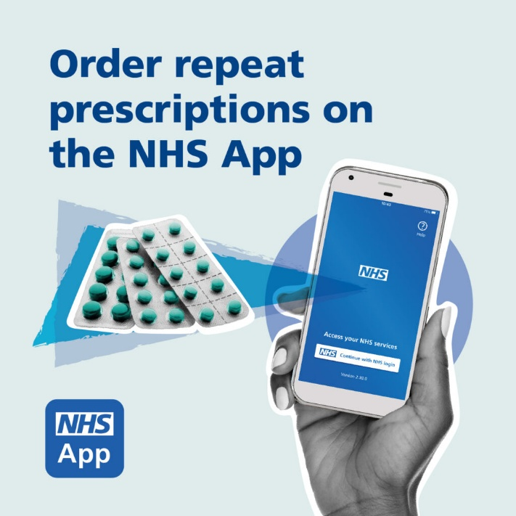
Figure 1: Order repeat prescriptions on the NHS App
(Source: NHS, 2026)
There is extensive digitisation taking place in the healthcare sector in the UK, whereby prescription management is becoming a digitalised process and not a concept being introduced. In 2024/25, NHS England has stated that 7.2 million people have managed their prescriptions digitally (NHS, 2026). On the other hand, there has been a 49% increase to 5.5 million in the number of prescriptions managed through the NHS App from March 2024 to March 2025 (NHS, 2026). More recent evidence shows that there were 67.8 million repeat prescriptions ordered through the NHS App from December 2024 to November 2025 which shows that consumers have continued to engage in prescription services using technology (NHS, 2025). The Electronic Prescription Service also allows for prescriptions to be sent electronically to a customer's pharmacy of choice helping them in terms of convenience.
MediDirect UK can observe that the digital pharmacy industry has become well-established and is growing by offering a potential environment for an adherence-based service to emerge. However, the chance will probably not be derived from the ordering of prescriptions, given that the digital infrastructure of the NHS already offers such a facility. The difference made by MediDirect must thus revolve around reminders and pharmacist contact mainly for its proposed Brent target market.

5.2 Market Size and Growth Potential
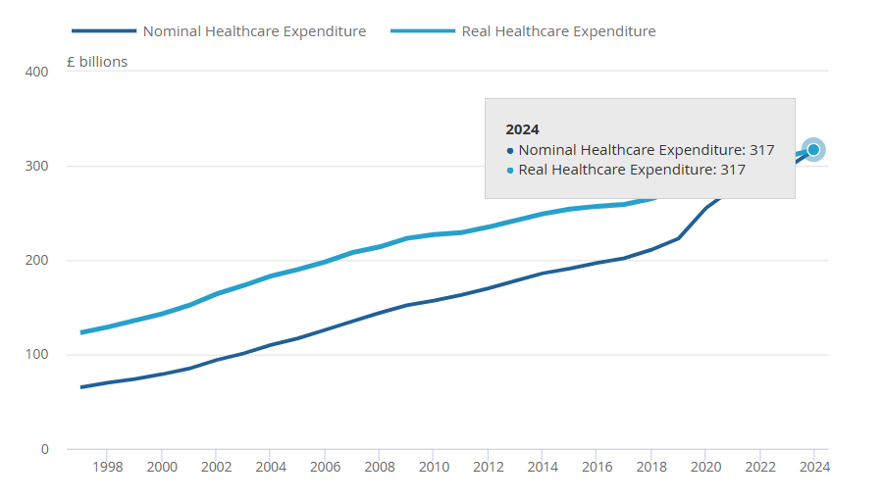
Figure 2: Total current healthcare expenditure in the UK
(Source: ONS, 2024)
The United Kingdom constitutes a significant market base for MediDirect UK. The total expenditure on health care in the UK amounted to approximately £317 billion by 2024 which constitutes 11.1% of GDP, with pharmaceutical expenditure accounting for £35.7 billion, where 54% pertained to community prescription medicines (ONS, 2024; ONS, 2025). Prescription orders using digital channels are also rapidly increasing. The NHS app witnessed 61.5 million repeat prescriptions in the 12-month period to August 2025, which marks a rise of 46% from 42.2 million in the previous year (NHS, 2025). This is an indication of greater consumer acceptance of digital prescription services and creates a pertinent demand base for medicine services through digital means.
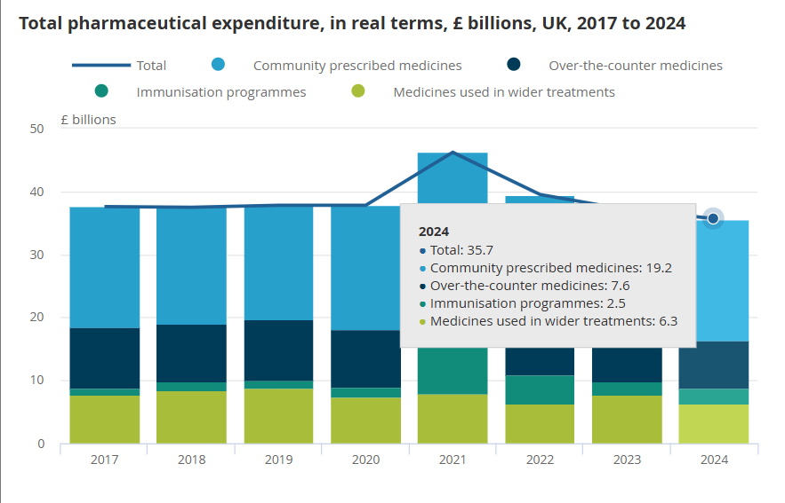
Figure 3: Total Pharmaceutical expenditure in the UK
(Source: ONS, 2025)
Further, it has been seen that Brent offers an impressive initial customer base for MediDirect UK since, according to Brent, (2025), the population of the borough amounts to around 353,000. In addition, the borough shows constant demographic growth from 339,800 in 2021, to a population growth of 26.5% from 2024 to 2041 and will total around 452,000 under the central scenario (Brent, 2025). The growing population offers growing potential customers who can use the services related to the management of medications. However, the realistic market served by MediDirect will be smaller involving those people who require medications regularly or repetitively and are ready to work online. Thus, the growth of the population in Brent creates a good basis for entering the market concerned with the combination of local health needs and increasing digitalisation.

5.3 Demand Drivers, Analysis, and Market Trends
The demand for online pharmacy services is increasing owing to convenience, accessibility, and the increasing shift to the adoption of digital technologies within the health care sector (Almeman, 2024). The NHS England states that 61.5 million repeat prescriptions have been requested through the NHS app within 12 months until August 2025 which is a 46% rise compared to the previous year (NHS, 2025). This also applies to online repeat prescriptions which are becoming popular in the NHS because patients can have their medication delivered conveniently and track their prescriptions without having to visit the GP practice unnecessarily. Repeat prescribing in an electronic form makes this easier for appropriate patients to get their repeat prescriptions in bulk for up to 12 months (NHS, 2025). These trends serve to demonstrate that consumers are ready to use technology for their medication management needs in relation to MediDirect UK (NHS, 2025). However, with increased functionality on the NHS App, it is advisable to use the ability to offer adherence solutions, personalised reminders and communication with pharmacists to gain a competitive advantage within Brent (NHS, 2025).
MediDirect demand will likely exhibit sensitivity to price changes, especially when households experience persistent cost challenges. The cost of UK households rose by 3.6% between April 2025 and March 2026, but low-income households are even more sensitive to changes in essential expenditure (ONS, 2025). In England, the NHS prescription charge of £9.90 per item and the provision of prepayment certificates mean that efficient medicine management becomes relevant for paying customers (NHS, 2025). However, it is important that MediDirect does not take for granted the willingness of its customers to pay for digital assistance. The potential of MediDirect therefore consists in showing added convenience and adherence value for affordable or segmented pricing. For the case of Brent, this translates into an economical offer concerning a value-led and low-cost proposition mainly combining free core functions with increased support rather than relying only on subscriptions.

5.4 Customer Segmentation and Target Market
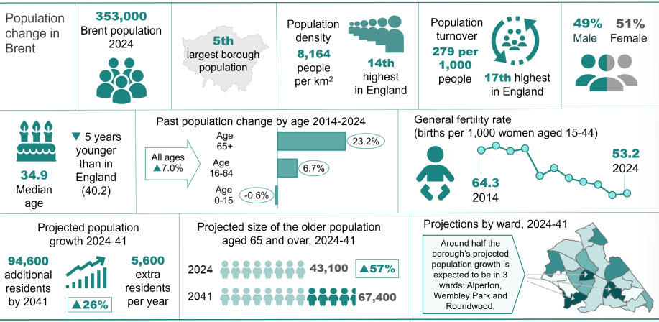
Figure 4: Population change in Brent
(Source: Brent, 2025)
Market segmentation allows healthcare organisations to customise their services based on variations in customer needs, health situations, and technology usage (Hermes, et al., 2020). For MediDirect UK, the key target market comprises people living in Brent who have continuous or recurring medicine needs, especially for people with long-term conditions or multiple medicines. This target market is commercially important since the need for medication management increases with age and complexity of the health situation. As per the report of Brent, (2025), there are about 353,000 people in Brent with a median age of 34.9, while the number of people aged 65 and above has increased by 23.2% from 2014 to 2024. Additionally, Brent, (2025), has noted that nearly one in seven people has some kind of health condition or disability that affects daily activities with the prevalence substantially higher among residents over 65. In this regard, secondary segmentations comprise older citizens, people who have mobility issues, digitally working-age citizens and caregivers administering medications to others. The use of segmentation will assist the positioning of MediDirect by providing personalised reminders, assistance with prescriptions and interactions with pharmacists without targeting the entire population of Brent.

5.5 Customer Demographics and Behavioural Trends
Brent’s population is relatively young but ageing and hence gives rise to a distinct customer base for digital medication services. Brent’s population in 2024 stood at 353,000 with a median age of 34.9 years reflecting that approximately 26% of the total population in 2024 belonged to the 20-34 age group, whereas 29% were 50 years and older (Brent, 2025). Moreover, the population aged 65 and more years old in 2024 had risen by 23% from 2014to 2024, thus providing a significant proportion that requires regular medication and healthcare services. The rate of digital healthcare usage in London is relatively high, with approximately 61% of all patients aged more than 13 using the NHS App reflecting established digital engagement (NHS, 2025).
Such factors lead to a dual segmentation opportunity for MediDirect UK, digitally confident young and working-age individuals may appreciate convenience, medication reminders, and medication management. The rising number of older people might also need more medication management (Maidment, et al., 2020). However, the use of technology cannot be assumed among all patients. Hence, MediDirect should incorporate an easy-to-use platform that is complemented with pharmacist assistance and features for carers. Such positioning will help to distinguish the business from other prescription ordering services by emphasising adherence to medication and personal service, while targeted acquisition in Brent can prioritise residents with recurring medication needs.

5.6 Customer Pain Points and Unmet Needs
The problem of medication compliance still remains relevant for today's health care system. The report issued by the NHS, (2025), states that 30%-50% of drugs that are prescribed for chronic illnesses are not used as intended, whereas one in four people suffers from chronic disease and polypharmacy is becoming increasingly widespread among an ageing population. Additionally, the results of the GP Patient Survey in 2024 have shown that just 2.7% of respondents who visited the pharmacy used pharmaceutical services to monitor the use of medication (NHS, 2024). This reflects that routine prescription access does not necessarily translate into sustained medication-management support.
The results point out that there exists a gap that goes further than simply the filling of prescriptions because patients may need prompting, clear information regarding their medications, help with adhering to their medication regimen, and also communication with pharmacists. MediDirect is a solution that fills this gap by incorporating all these roles into one digital tool. To Brent, the idea is especially pertinent for people who have chronic diseases or take several medications.

5.7 Economic Conditions and Consumer Price Sensitivity
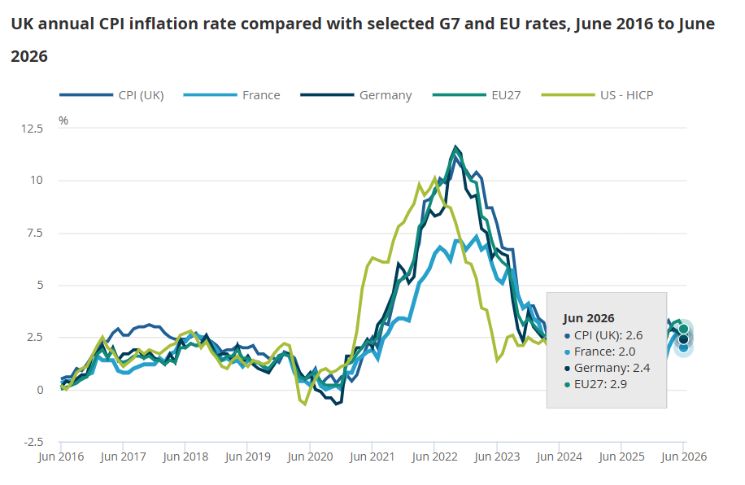
Figure 5: UK CPI inflation rate
(Source: ONS, 2026)
The UK economic environment directly affects the propensity of consumers to purchase discretionary digital health care services. As per the recent data provided by the ONS, (2026), the rate of CPI inflation in June 2026 is 2.6%, whereas the health price index is 2.5% reflecting continuing cost pressures despite easing headline inflation. Affordability issues are faced by Brent as well, as the poverty rate of Brent is 33% and there are high-income deprivation and high housing-cost pressures in 2025 (Brent, 2026). Such factors would mean that a costly subscription is not appealing especially for those who are economically challenged in the Brent area. It is important for MediDirect to have price-based value which means that the adherence features could be offered at low costs or even for free to enhance support. This approach can result in minimised adoption barriers while maintaining commercial potential.

5.8 Geographic and Digital Accessibility Factors
The geographic targeting technique could enhance the health care market assessment through associating the availability of services with demographic and infrastructure attributes. Brent is moving towards improved digital connectivity with 74.04% of its households enjoying broadband connectivity while the Council aims to reach 85% full-fibre connectivity by 2028 (Brent, 2026). However, connectivity is not available to everyone as over 2,500 households in Brent have been offered devices and connectivity in order to avoid being digitally excluded (Brent, 2026). Thus, Brent's increased connectivity facilitates digital medicine management services, but the existing exclusion risk requires an inclusive approach (Ahmed, et al., 2025). In this regard, MediDirect must focus on designing interfaces that are easy-to-use through mobile and assist those who lack digital confidence to make use of the technology.

6. Competitive Environment Analysis

6.1 Competitive Landscape and Key Success Factors
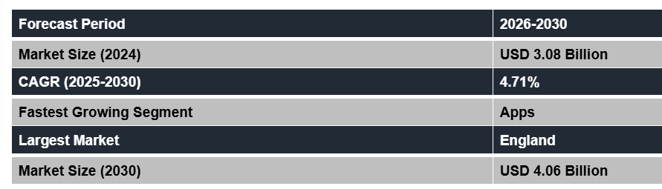
Figure 6: E-pharmacy market in UK
(Source: Mathews, 2026)
The UK digital pharmacy market has become very competitive as existing players provide prescription ordering, delivery, online tracking of medicines and pharmacy connectivity (Mathews, 2026). The key competitors of MediDirect include Lloyds Direct, Pharmacy2U, Boots Online Pharmacy and Healthera along with community pharmacies and NHS digital services. For instance, Pharmacy2U claims to have served more than two million patients, and Healthera has noted that more than 1,700 pharmacies in the UK use their platform demonstrating significant incumbent scale (Smith, 2026, Healthera, 2026). The development of digital medicines in the UK has been focused on the connection of medicines information, safe decisions and patients' control and hence enhancing expectations for reliable digital services.
For MediDirect UK, therefore, success factors include much more than just basic prescription fulfilment. Trust, safety of the patients, compliance with regulations, secure handling of health information, ease-of-use, reliable pharmacies, accessibility of pharmacists, reminders for patients, low costs and reliability are some of the essential factors also. The main point here is to capitalise on such factors in terms of medication adherence rather than just compete in terms of cost. This positioning can help in strengthening the firm’s differentiation within the Brent council area while supporting its wider feasibility.

6.2 Competitor Analysis and Market Positioning
There exist several well-known companies in the UK digital-pharmacy market that have a good reputation and offer pharmacy networks along with digital prescription facilities. Pharmacy2U registers over 2 million patients and supplies over 1.6 million medicines per month. It provides good scale and fulfilment capacity. Healthera offers pharmacy services and digital prescription medicine management for over 1,700 pharmacy partners (Healthera, 2026). Boots is one such digital pharmacy that offers prescription ordering and monitoring, delivery and tracking for customers through its extensive network of physical pharmacies (Boots, 2026). LloydsDirect was known for having an NHS service integrated into the system of prescriptions ordered by LloydsPharmacy (NHS, 2026).
Competitor | Strengths | Weaknesses / Gaps
Pharmacy2U | Large scale, free NHS delivery, established digital infrastructure, reminders and family prescription management. | Strong fulfilment orientation creates limited differentiation in broader personalised adherence support.
LloydsDirect | Established brand association, digital prescription service, national user base | NHS integration is no longer active, incorporated into Pharmacy2U's wider operation
Boots Online Pharmacy | Strong national brand, online ordering, tracking, reminders, physical pharmacy network | Broad retail proposition may provide less specialist focus on long-term medication adherence.
Healthera | More than 1,700 pharmacy partners, digital pharmacy connectivity, prescription and service management | Smaller consumer brand presence than major national pharmacy providers
MediDirect UK | Proposed integrated reminders, adherence support, pharmacist communication and prescription coordination | New entrant, limited brand recognition, customer base and pharmacy partnerships

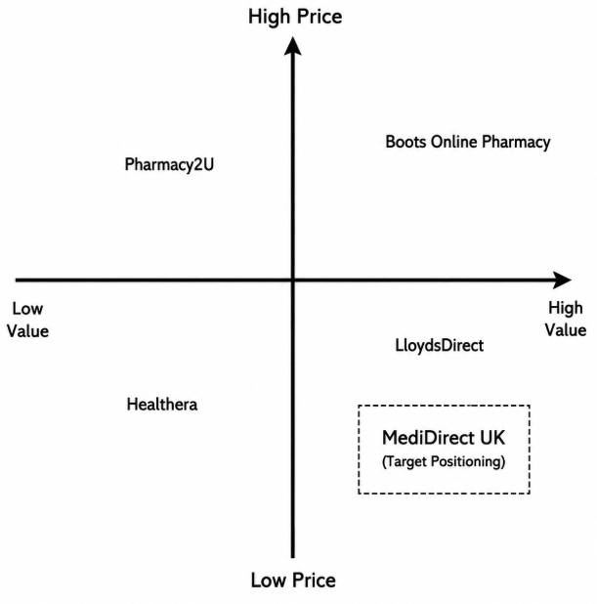
Figure 7: Market positioning
(Source: By Author)
Market positioning is considered as a strategic process of reflecting how consumers perceive a product or brand in relation to competitors (Rua and Santos, 2022). Therefore, in the process of positioning, the competitors are analysed in terms of how much value they add to the customers and their prices, and not in terms of any exact quantitative scores. MediDirect UK has been positioned in the high-value-low-price segment which shows a potential differentiation strategy based on medication reminders, assistance with adherence, and pharmacists and prescription coordination instead of delivery or brand size. The positioning is quite relevant to those people suffering from chronic diseases and requiring continuous assistance. Thus, the strategic implication reflects that MediDirect needs to pursue focused value differentiation by maintaining affordability to minimise adoption barriers in Brent.

6.3 Market Share estimates
The estimation of market share gives an indication of competitiveness and market concentration. The two biggest online retailers were Pharmacy2U and LloydsDirect, and their combined market share in prescription dispensing in England was less than 5% (CMA, 2023). This reflects a fragmented market and a potential entry space for MediDirect.

6.4 Porter’s Five Forces Analysis
Porter’s five force model is a framework that helps in analysing and identifying 5 competitive forces that shape the industry and helps in determining long-term profit potential and industry attractiveness (Pangarkar and Prabhudesai, 2024).
Force | Assessment and implications for MediDirect UK
Threat of new entrants | Moderate: Digital platforms can be developed relatively easily, but barriers to entry include pharmacy partnerships, compliance with regulations, customer trust and secure drug management systems (GPC, 2025).
Buyer power | High: This is because the patients may opt for NHS, community pharmacies or any established digital pharmacy companies, becoming more price and service sensitive.
Supplier power | Moderate–High: MediDirect relies on the collaboration with registered pharmacies and their pharmacists and on technological infrastructure, and hence, compliant pharmacy partnerships are crucial.
Threat of substitutes | High: NHS digital prescriptions service, pharmacies themselves and existing digital pharmacies represent good substitutes.
Competitive rivalry | High: Pharmacy2U and LloydsDirect were identified by the CMA, (2023), as major digital suppliers, while numerous smaller providers remain active.
On the whole, the industry can be said to be moderately attractive yet highly competitive. Thus, for MediDirect, it would be more sensible to compete based on medication adherence assistance rather than competing on the grounds of prescription fulfilment and pricing. Considering this, the firm needs to pursue focused differentiation through reminders, medication-adherence support, and pharmacist communication.

6.5 PESTLE Analysis
Factor | Analysis and implications for MediDirect UK
Political | The Digital Medicines Programme of the NHS still favours digital access to healthcare and medicines, thus providing a favourable environment for the development of digital pharmacies (NHS, 2026). Thus, the policy environment is supportive of MediDirect yet adds competition from the digital NHS infrastructure.
Economic | UK CPI inflation was 2.6% in June 2026 sustaining affordability pressures and strengthening the need for value-led pricing. (ONS, 2026).
Social | Medication adherence is a significant issue as the NHS, (2025), estimated 30%-50% of prescribed medicines are not taken as recommended supporting demand for adherence-focused services.
Technological | The digital ordering and monitoring of prescriptions have now become common practice in health care. This works in favour of the platform approach by MediDirect, yet interoperability, cybersecurity and pharmacy integration will become crucial for success.
Legal | The category of health information is deemed to be a special category of personal data by UK GDPR, hence the need for an appropriate legal ground and other Article 9 requirements for processing.
Environmental | Digital prescription and communication processes can reduce paper dependency and unnecessary journeys, although delivery operations may create environmental costs.
In general, the PESTLE analysis shows that the environment is supportive but regulated. The main opportunities arise in the digitisation of healthcare and the social need for easy access to medications, whereas affordability, privacy protection, and reliability are the biggest threats. Therefore, the success of MediDirect depends on the combination of affordability, reliable technology, and good pharmacies rather than digital benefits alone.

6.6 Market Gaps and Strategic Opportunities
A sustainable gap arises when customer requirements go beyond the features offered by existing digital pharmacies. According to the figures released by the NHS, (2025), 67.8 million repeat prescriptions have been ordered using the NHS app from December 2024 to November 2025 showing a high level of adoption. However, the problem of medicine non-adherence still persists because NHS guidelines suggest that 30%-50% of prescribed medications are not consumed as per recommendations for long-term conditions (NHS, 2025). This suggests an opportunity beyond just prescribing and monitoring of prescriptions. The strategic opportunity for MediDirect UK is to bring together digital prompts, monitoring of adherence, communication with pharmacists and coordination of prescriptions under one patient-centred offering. This focused differentiation can help fill a gap in the services offered by using complementary services to NHS pharmacies. MediDirect needs to be careful not to duplicate what the NHS already offers and rather compete on its personalisation, cost-effectiveness, and continuous medication management support for long-term condition patients in Brent.

6.7 Industry Attractiveness assessment
UK Digital Healthcare and Digital Pharmaceuticals Market is moderately attractive to MediDirect UK. The infrastructure for digital medicines is growing, although fragmented information about medicines is still seen as a continuing issue, thus justifying demand for connected services. On the other hand, the presence of competitors, substitutes, regulations and the merger between Pharmacy2U and LloydsDirect add to the barriers to market entry. Hence, feasibility for MediDirect lies in the ability to differentiate through low-cost personalised adherence management rather than competing directly on the prescription fulfilment.

7. Business Strategy

7.1 Strategic Framework and Approach
The strategy for MediDirect UK is formulated by combining the external and internal analyses to establish a sound strategic position. PESTLE and Porter’s Five Forces will analyse the external environment, competitive forces, and attractiveness of the industry that was determined previously, while VRIO will analyse the possibility that MediDirect’s technology, pharmacies and service resources can give a competitive advantage to the company. Finally, SWOT analysis will bring together the results of both internal and external analyses and determine strategic priorities. Further, the analysis will help formulate the right competitive strategy, unique selling proposition of MediDirect, and ways to ensure the key success factors. This integrated approach is useful in linking the market evidence with the practical business decisions.

7.2 External Strategic Analysis
MediDirect UK operates within an environment that is highly supportive of digital health, characterised by stiff competition, regulatory concerns and significant buyer power. From the earlier market analysis, there is a possibility for digital assistance for medications due to expansion of digital prescription facilities within the NHS. Moreover, Porter's analysis suggests that buyers have a lot of power and that there are strong substitutes in the form of NHS facilities, community pharmacies and existing online players. Affordability issues, the need for data protection and cybersecurity emerge from PESTLE analysis are considered as strategic constraints. Therefore, MediDirect cannot sustain itself just on the basis of prescription fulfilment. The strategy adopted by the company needs to include differentiated medication adherence assistance that involves the combination of pharmacist communication, reminders, and prescription coordination for generating additional customer value. This approach is effectively aligned with the identified fragmentation of medicines information along with the need for more integrated digital support.

7.3 Internal Analysis: VRIO
VRIO analysis tests the ability of resources and capabilities suggested by MediDirect UK to be a source of competitive advantage by checking their value, rarity, difficulty to copy and proper organisation. In the case of an emerging digital health business, the difference is significant as having valuable technology does not ensure the creation of a sustainable advantage considering organisational skills, effective execution, and trustworthy relationships are necessary.
Resource / Capability | Value | Rare | Imitable | Organised | Strategic Outcome
Medication-adherence platform | Yes | Yes | No | Yes | Temporary competitive advantage
Personalised medication reminders | Yes | No | No | Yes | Competitive parity
Pharmacist communication | Yes | Yes | No | Yes | Temporary competitive advantage
Pharmacy partnerships | Yes | Yes | Yes | Yes | Potential unused advantage
Patient-centred service design | Yes | Yes | No | Yes | Temporary competitive advantage
Secure digital infrastructure | Yes | No | No | Yes | Competitive parity
Brent-focused market knowledge | Yes | Yes | Yes | Yes | Potential sustained local advantage
From the above analysis, it is evident that the key source of competitive advantage for MediDirect would be through the use of adherence technology alongside communications by pharmacists in pharmacies. This will not be possible due to individual components that competitors may copy and develop on their own in the future. At the moment, there is no sustainable competitive advantage for MediDirect since its name and reputation, as well as capability have not been developed. Therefore, the company needs to focus on these aspects involving secure technology, building trusted pharmacy relationships, effective operational processes, and personalised support. This helps in supporting the focused differentiation strategy in which the combination of service proposition becomes more defensible as compared to any single feature (Tojiri, 2023).
Strengths | Weaknesses
- Integrated medication-adherence proposition  - Pharmacist communication capability  - Patient-centred digital service  - Focused Brent market entry  - Convenience and personalised support | - New market entrant  - Limited brand recognition  - Pharmacy partnerships yet to be established  - Technology development and compliance costs  - No established customer base
Opportunities | Threats
- Increasing digital prescription adoption  - Growing long-term medication needs  - Demand for adherence support  - Potential pharmacy partnerships  - Expansion beyond Brent | - Strong established competitors  - NHS digital alternatives  - Community pharmacy substitutes  - Regulatory and cybersecurity risks  - Customer price sensitivity and digital exclusion

7.4 SWOT Analysis and Strategic Synthesis
Based on the SWOT analysis, the biggest opportunity that exists for MediDirect strategically will be the integration of its adherence proposition with growing digital health adoption and medication management needs. However, its position as a new entrant coupled with its lack of brand awareness and need for pharmacy partnership hinders any competitiveness at the moment. Competing services from other players as well as NHS alternatives further resulted in increasing substitution pressure. Therefore, MediDirect should not attempt to achieve market leadership and cost advantage but use its patient-centric proposition by creating differentiation with value-based pricing. This way, its initial entry into the market through Brent will prove useful in gaining experience in terms of pharmacy partnerships and validation of the business model. Therefore, priorities in terms of strategy include secure technology, seamless integration with pharmacies, personalised adherence support, and accessible technology. If this is accomplished, these attributes will translate the current strengths of MediDirect into sustainable competitive advantages.

7.5 Strategy Selection
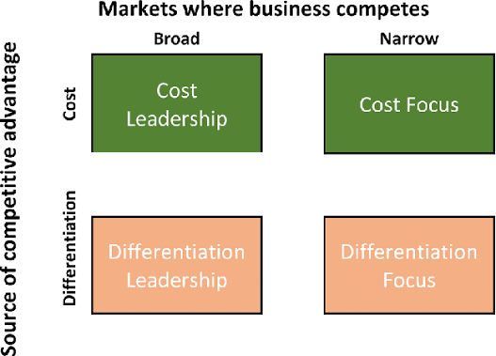
Figure 8: Porter's generic strategy
(Source: Nanyangwe and Phiri, 2021)
Strategic fit involves aligning organisational capabilities with external market conditions as well as the creation of sustainable customer value. In order to compare the cost leadership, differentiation and focus strategies, Porter’s generic strategies can be employed (Nanyangwe and Phiri, 2021). Cost leadership strategy is not applicable for MediDirect UK due to the reason that existing players have economies of scale and broad differentiation involves direct competition with better-positioned players. It implies that focused differentiation involving value-based pricing for those patients that suffer from long-term health problems and need regular drugs in Brent is a strategic choice for the organisation. Focused differentiation refers to a strategy through which a firm targets a narrow niche market with premium and unique products and services (EBSCO, 2026).
It is especially relevant considering the fact that the functionality of the NHS allows patients to make repeat prescriptions, track prescription progress, and monitor medications and hence minimises the scope for MediDirect to differentiate through prescription access alone (NHS, 2026). However, MediDirect needs to capitalise on the combination of medication reminders, adherence management, pharmacist communication and coordination of prescriptions as the differentiating factor for its customers while remaining an affordable company. The approach ensures that the company uses the opportunity within the market gap to develop a value proposition and provides a stronger basis for subsequent geographic expansion and sustainable customer acquisition.

7.6 USP and Value Proposition
MediDirect UK’s unique selling proposition (USP) will be its focus on medication adherence support rather than only providing digital prescription ordering and medicine delivery services. In the UK, established digital pharmacy companies are primarily concerned with improving access to medicines (Tolley, et al., 2023). MediDirect UK will try to tackle the broader issue of helping patients to take their medicine properly. The platform that is proposed will integrate a combination of medication reminders, medication support, information on the medicine and communication with the pharmacist in one digital service. This will result in a differentiated position which will emphasise patient support and not be a one-time prescription transaction. MediDirect UK will be based on the value proposition of solving key challenges faced by patients with long-term health conditions. Many patients need to take regular medicines, but they may experience issues such as forgetting to take medicines, having to take more than one medicine, interpreting information about medicines and getting timely help from the pharmacy (Kvarnström, et al., 2021).
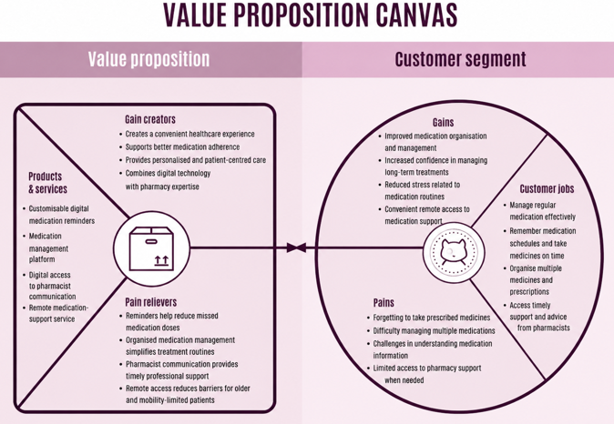
Figure 9: Value proposition canvas
The company will seek to mitigate these challenges by offering customisable digital reminders, medication management and easy communication with pharmacists. The service will provide functional value to the customers by facilitating the way they handle their medicines and making it organised. It can also offer emotional benefits by boosting patients' confidence and reducing the stress of long-term therapies (Coteur, et al., 2023). The platform will also offer greater convenience for older patients, those who have mobility issues and caregivers by allowing them to receive medication support remotely. The value proposition will also support MediDirect UK’s strategic objective of complementing existing NHS and community pharmacy services rather than replacing them. By combining digital technology with professional pharmacy support, the business will create a trusted healthcare experience (Dasopang, et al., 2026). Therefore, the USP of the company will be its ability to provide affordable, accessible and patient-centred medication adherence support, creating value beyond traditional digital pharmacy solutions. This differentiation will help to establish a good competitive position in the UK digital healthcare market.

7.7 Competitive Advantages
MediDirect UK will build a competitive edge through digital healthcare technology and individualised medication support services. While current digital pharmacy brands just concentrate on ordering, tracking and delivering medicines, the company will prioritise the enhancement of medication adherence through sustained patient interaction and medicines support (Ghosh, et al., 2026). This segmentation will enable the business to focus on patients with chronic health issues who will need frequent prescription management and extra support beyond prescription delivery. One of the key competitive strengths will be the combination of multiple features of healthcare support in a single digital platform (Kapur, 2023). MediDirect UK will give medication reminders and prescription management support, medication information and direct communication with pharmacists. This combined strategy will make medicines more convenient for the user as they will need to manage fewer medicines and receive timely assistance as needed.
Furthermore, MediDirect UK will benefit from developing partnerships with community pharmacies. Such collaborations will improve the trustworthiness of the services, create access to professional expertise and increase customer confidence. By collaborating with existing healthcare providers, the business can position itself as a supportive extension of NHS and community pharmacy services rather than a direct replacement (Schot, et al., 2020). The platform will also be patient-centred which is another competitive advantage. Accessibility and simplicity will be key to the service with a personalised approach to healthcare support to enhance the customer experience and foster long-term engagement (Mohammed, et al., 2025). Further, the first market to be targeted is the Brent area and this will give MediDirect UK a better understanding of the healthcare needs in that area and the approach it can take before expanding to wider markets. Therefore, digital integration and pharmacy partnerships along with personalised support and knowledge of the local market will give the company a solid platform on which to build a sustainable competitive edge.

7.8 Key Success Factors
There are a number of important issues that will affect the potential success of MediDirect UK in terms of market acceptance and sustainability. Customer trust will be crucial as the platform handles sensitive healthcare data. Hence, robust data protection measures, cybersecurity practices and information management transparency will be necessary to build consumers' confidence (Qureshi and Koo, 2026). Regulatory compliance will also be a critical success factor since healthcare technology services need to adhere to applicable legal and professional obligations. MediDirect UK also needs to comply with healthcare regulations and protect patient information in their handling of services.
It will also be significant to build sustainable collaborations with community pharmacies to enhance the reliability of services and the professional image. The partnerships will enhance customer access and improve the link between digital services and traditional healthcare provision (Erku, et al., 2023). User adoption can also be important as the success of the platform will rely on the regular use of features that support medication. However, financial constraints and usability barriers will also be important factors in adoption, especially for users who have a limited budget or problems using digital technologies. As a result, MediDirect UK will have to offer an affordable, simple and inclusive platform.

8. Business Model Canvas
The Business Model Canvas (BMC) is used to explain how MediDirect UK will create, deliver and capture value in the digital health market. The framework offers a systematic understanding of the proposed business model by examining the customer, value creation, activities, partnerships and financial aspects (Bachmann, et al., 2025).
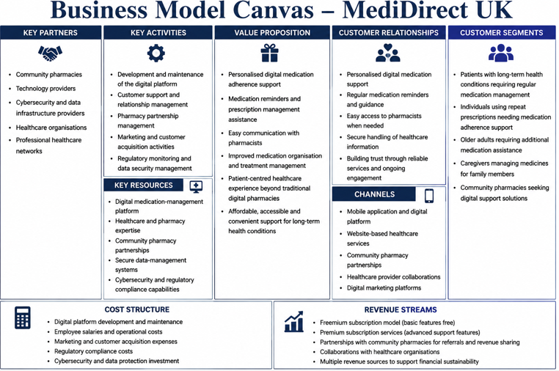
Figure 10: Business model canvas
Customer Segments: MediDirect UK will target customers who need regular medication management and support, especially for those who suffer from long-term health conditions. Patients with repeat prescriptions and a need for medication adherence support will be the main customer segment. Secondary segments will involve older adults, caregivers taking care of other people's medicines and community pharmacies looking for digital support solutions (Espírito-Santo, et al., 2024). Such segments will be chosen since they illustrate the need for easy and ongoing medication-management services.
Value Proposition: The company’s value proposition will be offering accessible and personalised medication adherence support on a digital platform. This service will be a combination of medication reminders, prescription management support, medication information and communication with the pharmacist. While traditional digital pharmacies are primarily concerned with ordering and delivering medicines, MediDirect UK will focus on enhancing the management of medicines throughout their entire lifecycle. This will provide further value by helping to support patients throughout their treatment journey (Maas, et al., 2023).
Channels: MediDirect UK will implement several methods of service delivery and ensure that their services are effectively reaching customers. The primary channel will be through a mobile app and digital platform that will provide medication reminders, prescription assistance and pharmacist communication (Gargioni, et al., 2024). Other channels will involve community pharmacy, health care providers and digital marketing sites. These channels will assist in raising awareness, making it easier for customers to access and boosting customer acquisition in the target market.
Customer Relationships: MediDirect UK will prioritise building long-term customer relationships by engaging with clients in a personalised manner and maintaining regular communication. The platform will offer reminders for taking medications, education and access to pharmacy professionals when needed to the user. Trust will be built through trustworthy services, safe treatment of wellbeing information and intuitive technology (Robles, et al., 2020). Positive relationships will help to retain customers and customer acceptance of digital medication-support services will grow.
Revenue Streams: The company can generate money through a variety of subscription services and partnership opportunities. The freemium approach will enable users to use some basic medication reminder services for free while premium subscriptions will provide advanced support features. There are opportunities for partnerships with community pharmacies and health organisations for additional income (Astbury, et al., 2021). This is a multi-sourcing revenue strategy that will help patients to pay and ensure financial sustainability.
Key Resources: Some essential tools that will be needed to support MediDirect UK will be digital technology, health knowledge, pharmacy partnerships and safe data management systems. The digital platform will be an important resource as it will enable medication reminders, patient communication and service delivery. Skilled pharmacy experts will present healthcare information and customer service (Jakobsen, et al., 2023). Moreover, cybersecurity systems and regulatory compliance capabilities will be required for the safe and reliable provision of services.
Key Activities: MediDirect UK will be responsible for the development and upkeep of the digital platform, customer support and relationship management with pharmacies. The application will need to be continually improved to provide a better user experience and add new features (Wei, et al., 2020). The business will also carry out activities of marketing, monitoring of regulations and management of data security. These activities will enable MediDirect UK to deliver effective, customer-focused and safe medication-support services.
Key Partnerships: The company would rely on strategic partnerships for successful operation. Professional support will be offered at community pharmacies and customer confidence will be boosted in the service. Technology providers can assist with the development of the platforms, cyber security and digital infrastructure (Arafa, et al., 2023). Healthcare organisations can also offer avenues for collaboration and customer access. Such collaborations will enable MediDirect UK to leverage the potential of digital technology and seamlessly integrate it with its healthcare expertise, thereby supporting its market standing and service trustworthiness.
Cost Structure: Main technology development, platform maintenance, employee salaries, marketing and regulatory compliance will be the primary expenses of MediDirect UK. Cost of investing in cybersecurity and data protection will also be a big concern as healthcare information is sensitive (Gudepu and Jaladi, 2022). As more people buy the product, more staff and resources are needed and operational costs will rise. Therefore, cost management will play an important role for long-term financial sustainability.

9. Financial, Marketing, and Human Capital Management Plan

9.1 Financial Plan
This financial model checks whether the market opportunity and focused differentiation strategy that MediDirect UK has identified can be commercialised concerning its viability and scalability. The financial model will use break-even analysis, contribution analysis, cash flow projections, P&L projections, and sensitivity analysis in order to analyse financial viability under different circumstances. The revenue model considers the business model in terms of both the freemium/premium offer and the income from the pharmacy partners. Further, value-based pricing will help in maintaining the current strategy of emphasising affordability and medication adherence services. The cost analysis takes into consideration start-up costs, fixed costs, and variable costs that will help in assessing the funding requirements, profitability, and operating leverage as customer adoption increases over the 5-year forecast period.
9.1.1 Start-up costs
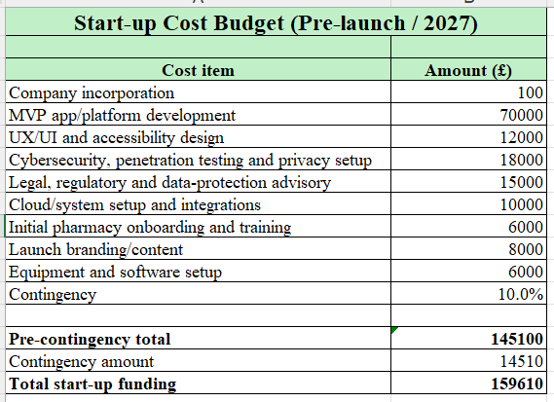
Figure 11: Start-up costs
MediDirect UK will need an estimate startup capital of £159,610 including £145,100 as capital expenses and 10% which is equal to £14,510 as a contingency. The most significant expense of £70,000 is aimed at Market Value Propositon (MVP) development and is a good reflection of the technologically driven nature of the business model, whereas £33,000 for cybersecurity and regulatory issues covers the threats that may arise from the healthcare data. Despite being based on assumptions, the lean cost structure focuses on platform capability, compliance, and the integration of pharmacies, which makes it a perfect fit for MediDirect’s differentiation strategy.
9.1.2 Operating costs
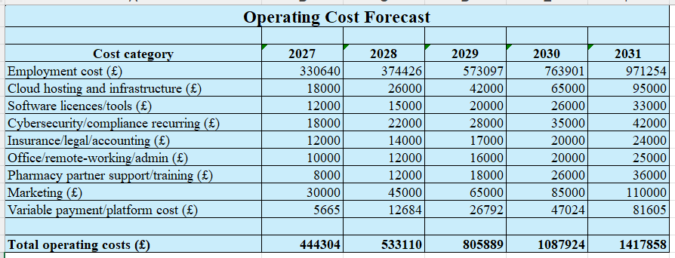
Figure 12: Operating cost forecast
MediDirect UK's operational costs rise from about £444,304 in Year 1 to £1.418 million by Year 5 indicating an expansion in the company's activities through increased staff, technology, marketing, and service delivery as usage rises. The higher operational cost structure is economically sound for scaling up a licensed digital healthcare platform because more customer assistance and better cybersecurity are necessary. It is critical to note that expenditure increases with income levels and not before the actual proof of demand helps in supporting a controlled scaling strategy and hence limiting excessive early-stage financial exposure.
9.1.3 Revenue Model
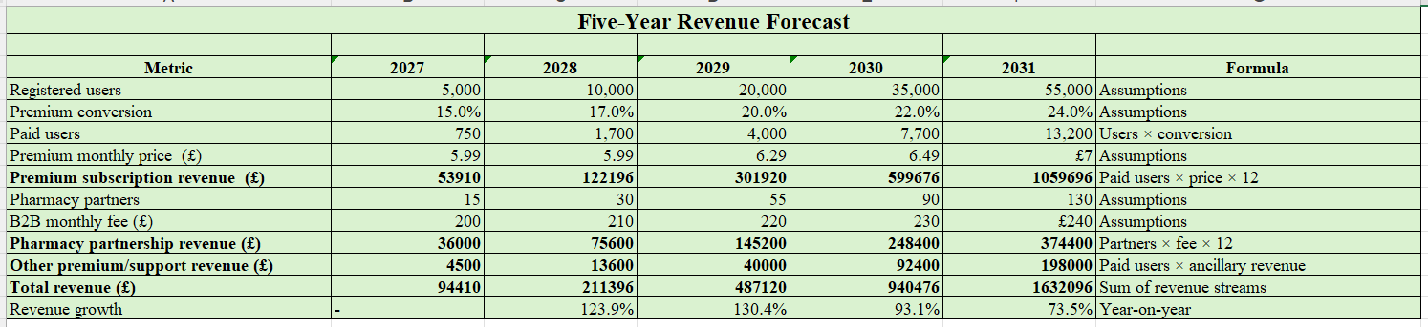
Figure 13: Revenue forecast
The revenue strategy involves the use of subscription charges for premium users as well as fees from partnerships with B2B pharmacies. It diversifies revenue streams while ensuring that access to the basic services remains affordable. Revenue is expected to rise from £94,410 in year 1 to £1,632,096 in year 5 due to an increase in customers and pharmacies. This combination approach ensures that the company does not become overly dependent on one source of income and supports MediDirect UK’s commercial sustainability and scalability.
9.1.4 Pricing Strategy
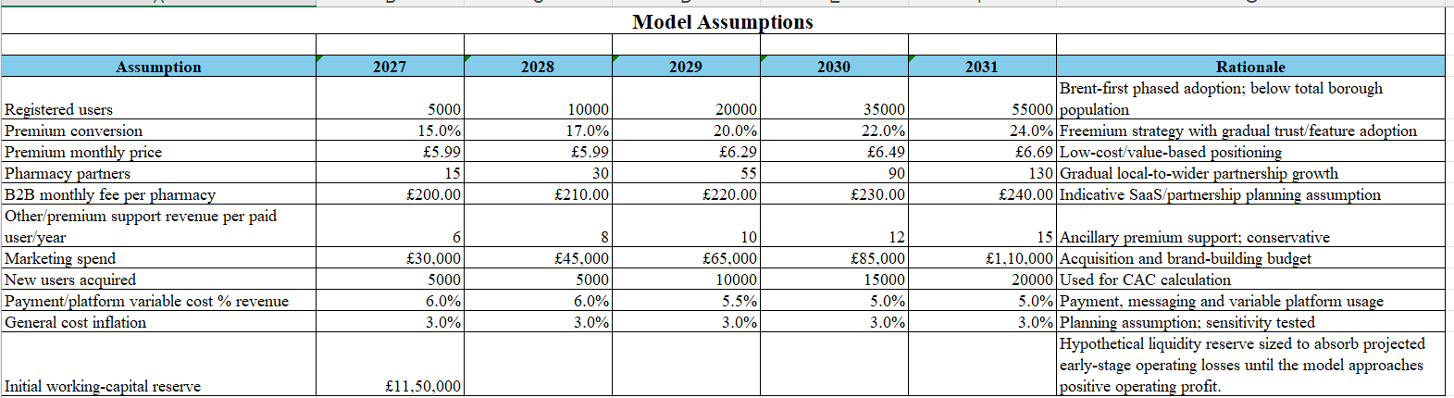
Figure 14: Pricing Strategy
The pricing structure of MediDirect UK will follow a value-based pricing model where premium subscriptions cost £5.99 per month in 2027–2028 and gradually escalate to £6.69 per month by 2031. The fees paid by pharmacies for partnering will also increase from £200 to £240 per month. This differentiated pricing will be used to make the product affordable in its entry into the market but also ensures that revenues are increased progressively (Gonen, et al., 2024).
9.1.5 Financial Projections
Financial projections are the forward-looking estimates regarding the future financial performance of a business (IBM, 2025). Based on the five-year forecast, there is an indication of good scalability where the projected revenue goes up from £94,410 in 2027 to £1.632 million in 2031 due to increased paid customers and partnerships with pharmacies. While there will be continued operating losses up to 2030, the forecasted operating profit for 2031 is at £214,238 reflecting that viability is dependent on attaining sufficient scale rather than immediate profitability.
9.1.6 Profit and Loss Forecast
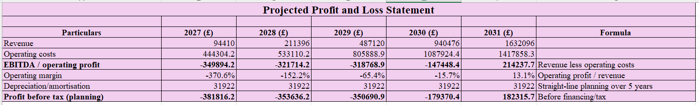
Figure 15: Profit and Loss Forecast
A profit and loss forecast is considered as the projection of a firm’s anticipated financial performance over a particular period of time (Angelis, 2023). The forecasted P&L shows that the approach adopted is scale before profits with operating losses reducing from £349,894 in 2027 to £147,448 in 2030 before breaking even with an operating profit of £214,238 in 2031 and an operating margin of 13.1%. Furthermore, after annual depreciation and amortisation expense of £31,922, profit before taxes in 2031 is estimated to be £182,316. This transformation shows better operating leverage, however, sustainability depends on being able to convert users and develop partnerships as planned along with disciplined cost scaling.
9.1.7 Cash Flow Forecast
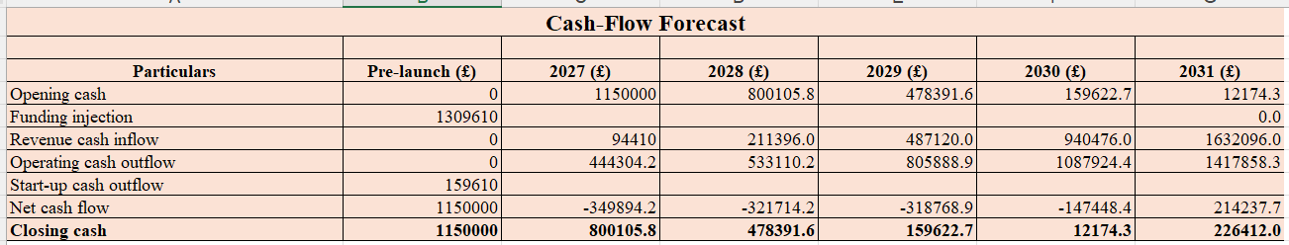
Figure 16: Cash Flow Forecast
It is clearly illustrated in the cash flow statement that the £1.15 million liquidity in the form of working capital is steadily decreasing due to continuous cash shortages each year from 2027 to 2030. The amount of closing cash drops from £800,106 to £12,174 by 2030 which shows the existence of a very limited liquidity position before commercial viability. On the other hand, net cash of £214,238 is achieved in 2031 which leads to closing cash of £226,412 reflecting the support of long-term viability along with highlighting the importance of disciplined cost and cash management.
9.1.8 Break-even Analysis
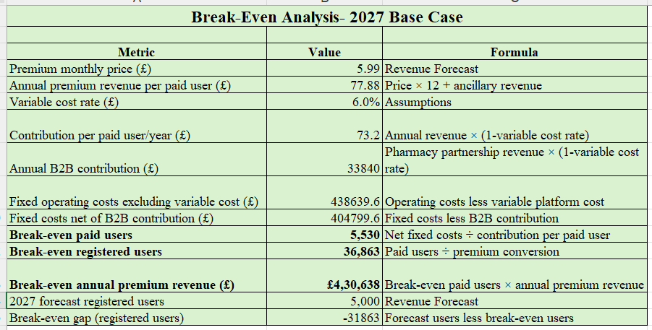
Figure 17: Break-even analysis
Break-even analysis helps in ascertaining the position of the firm at which it gains no profit and no loss situation (Schmidt, 2020). The analysis for the base-case scenario for 2027 shows that break-even will occur at a figure of 5,530 paying customers which translates into 36,863 registered users considering the premium conversion rate. However, this represents a significant number above the forecasted registered users in 2027 which stands at 5,000 registered users. As such, there will be a gap of 31,863 registered users, and MediDirect UK will not break even immediately and hence focuses on highlighting the use of scaling customer acquisition and B2B pharmacy contributions before the full absorption of fixed operating costs.
9.1.9 Sensitivity Analysis
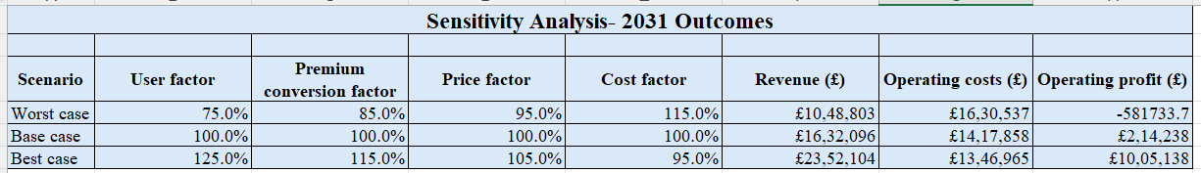
Figure 18: Sensitivity Analysis
As evidenced by the sensitivity analysis of 2031, there is high exposure to demand and cost factors. The pessimistic scenario yields an operating loss of £581,734, while the optimistic scenario yields a profit of £1,005,138. These high fluctuations imply that the venture has scalability on the positive side but significant risks, meaning that customer acquisition, premium conversion, and cost management must be emphasised for financial viability.

9.2 Marketing Plan
MediDirect UK marketing strategy will be dedicated to awareness creation, target customer attraction and customer relationship management. The business will be a financially accessible and tailored digital, medication-support service that will assist patients in their medication management. MediDirect UK will offer ongoing medication adherence support, customised reminders and access to pharmacy staff, setting itself apart from the typical digital pharmacy which primarily deals with prescription ordering and delivery. The target customers can be patients who suffer from long-term health conditions, elderly people and carers (Bertolazzi, et al., 2024). The major customer segment will be patients affected by chronic diseases who will need to take medications regularly and might have issues with remembering to take doses, managing prescriptions or adherence. Older users will also be a significant sub-population as they are more likely to be taking more than one medication and needing more support (DiMauro, et al., 2024). Another group of users will be caregivers as they will be able to track and manage drug administration of relatives.
MediDirect UK will be positioned as a trusted, accessible and patient-centred health care solution. The business will communicate the value in the message that it will make medication management easier, safer and more convenient (Ilardo and Speciale, 2020). The platform will not replace healthcare professionals and will be established as an additional service that can support current NHS and community pharmacy services. The marketing mix will be based on the 4Ps. The product will be a digital medication-management platform that will offer medication reminders, prescription assistance, medication information and pharmacist communication. The service will be created to encourage better adherence to medication by users and improve the organisation of medicines. The pricing strategy will be based on subscription and freemium. Simple reminders will be made available free of charge and advanced reminders will be available for a premium subscription (Faisal, et al., 2023). This will decrease adoption obstacles and help expand the customer base.
The place strategy will be on the digital dimension through a mobile application and website. Pharmacy partnerships will also be a key channel for customer access, enabling trusted health care providers to bring the service to appropriate customers (Mohiuddin, 2020). The promotion strategy can involve social media marketing, pharmacy referrals and health awareness building to enhance brand awareness and educate the target audience about the problem of medication adherence. The people element of marketing will be represented by pharmacists and customer support staff through their professional advice and building customer confidence.
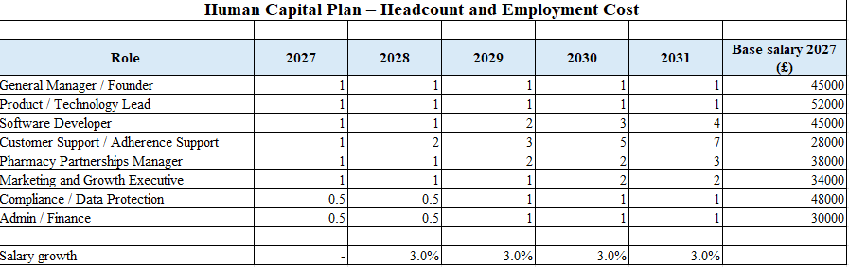
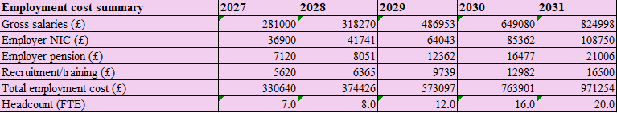
Figure 19: Labour cost estimation
Customer acquisition will be a combination of pharmacy referrals, digital marketing and community engagement. MediDirect UK will spend £30,000 on marketing in 2027 to gain around 5,000 new users with a customer acquisition cost (CAC) of around £6 per user. As the business grows, the marketing budget will increase to £45,000 in 2028, £65,000 in 2029, £85,000 in 2030 and £110,000 in 2031. This investment will enable the acquisition of about 5,000, 10,000, 15,000 and 20,000 new users respectively. The number of registered users is expected to increase from 5,000 in 2027 to 10,000 in 2028, 20,000 in 2029, 35,000 in 2030 and 55,000 in 2031. User engagement is also projected to rise from 70% in 2027 to 80% in 2031 which should also boost customer retention. In addition, the efficiency of marketing is expected to be increased, given that the share of marketing expenses to revenue will reduce from 31.8% in 2027 to 6.7% in 2031. The marketing strategy will thus assist in customer acquisition and in the long-term commercial sustainability for MediDirect UK.

9.3 Human Capital
MediDirect UK will require a suitable human capital structure to support its digital healthcare services and future growth. The initial staffing plan will involve a General Manager or Founder, Product and Technology Lead, Software Developer, Customer Support or Adherence Support employee, Pharmacy Partnerships Manager, Marketing and Growth Executive, Compliance or Data Protection employee and Admin or Finance support. Certain positions such as Compliance or Data Protection and Admin or Finance will be initially offered on a part-time basis. As the business grows, additional employees will be recruited to meet increasing customer and operational requirements (Garmann-Johnsen, et al., 2020). The organisational structure for the initial stage will be simple, and the General Manager or Founder will have overall leadership and co-ordination of the major business activities. Product and Technology Lead will oversee the activities and technology of the digital platform and software developers will be responsible for the development and maintenance of the digital platform (Herman, et al., 2020).
Customer Support or Adherence Support staff will provide support to users regarding the services. The Pharmacy Partnerships Manager will build and foster relationships with community pharmacies (Kauffman, et al., 2021). Customer acquisition and promotion will be handled by the Marketing and Growth Executive and Compliance or Data Protection and Admin or Finance functions will assist with regulatory and financial needs. The HR strategy will concentrate on hiring staff who have the right skills in digital, healthcare, customer service and business. Staff will be provided with the appropriate training regarding their duties and the needs of digital healthcare services. Due to the sensitive nature of healthcare data, special emphasis will be placed on data protection, cybersecurity, patient safety and professional standards (Nifakos, et al., 2021). The business will also gradually expand its workforce as per the growth of the customers and the demand of the business. This will help manage labour costs and ensure a sufficient level of skills for expansion.
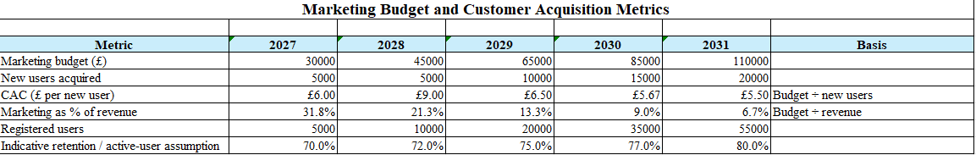
Figure 20: Marketing budget
The employment cost estimates suggest an increase in the total cost of staffing as MediDirect UK grows. The business will employ 7.0 full-time equivalent (FTE) staff in 2027 with a gross salary of £281,000 and a total employment cost including employer National Insurance, pension and recruitment or training cost of £330,640. In 2028, there will be 8.0 FTE in the role and employment cost will be £374,426. Staffing will rise to 12.0 FTE by 2029 and total employment costs will be £573,097. In both 2030 and 2031, the total number of FTE would be 16.0 and 20.0 respectively and the total employment costs would be £763,901 and £971,254. From 2028, there will be a 3% yearly salary increase. These estimates will help inform workforce planning and ensure that recruitment continues to be aligned with the projected growth of MediDirect UK.

10. Operations Plan

10.1 Operational Workflows, supply chain, and logistics
MediDirect UK will operate on a lean, digitised coordination model which will be in accordance with its proposed positioning as a facilitator service, not a pharmacy. The operations process translates the Business Model Canvas into an implementable services system whereby the customer accesses the platform, creates their schedule and reminders, seeks prescription-related assistance and, if necessary, communicates with the participating pharmacies. The prescription dispensing and distribution of medicines are done by duly authorised pharmacies. This is operationally important because the NHS Electronic Prescription Service (EPS) facilitates the electronic transmission of prescriptions to the dispenser chosen by the patient (NHS, 2025).
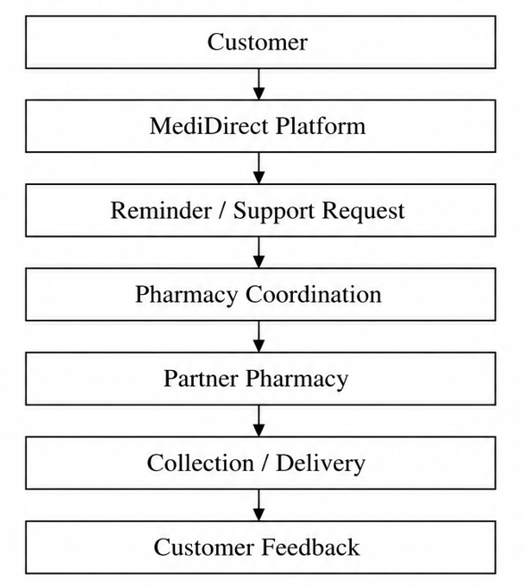
Figure 21: Proposed Operational Flow
(Source: Created by Author)
The supply chain management process will revolve around digital and partnership capabilities such as software development, cloud capabilities, cyber security services and pharmacy partnerships, but not medicine acquisition. Supplier selection criteria for MediDirect needs to include factors such as reliability, information security, regulatory fit, service level performance and cost. As there will be no need to buy and store the medicine at MediDirect, traditional pharmaceutical inventory management is irrelevant, and instead, the company’s “inventory” will include digital capacity, licenses and partner availability. Quality control can be achieved through KPIs in operations like uptime of the platform, reminder delivery, response time, resolution rate of support requests, performance of pharmacies, and complaints from customers. Regular monthly reviews of the KPIs will ensure that any gaps are spotted and there is a continuous improvement process. Strategically, this is important since MediDirect's competitive strength is concerned with adherence support rather than replicating competitors’ prescription-fulfilment infrastructure.

10.2 Location strategy, equipment, technology systems
A location strategy is considered as a formal plan that focuses on optimising location planning with data-driven guidance (Chodakowska, et al., 2023). The initial operating base should be at Brent given the need for a market entry approach that has been discussed earlier. There are roughly 353,000 people in Brent, and there is increasing digital connectivity despite the presence of some digital exclusion (Brent, 2025). Therefore, the administrative/remote working option is better than having a retail base considering the firm’s digital aspects. The minimum equipment requirements include secured laptops for the employees, the authentication devices, and customer support equipment. The technology framework needs to have a mobile/web interface, secure cloud hosting, encrypted databases, reminder/notification features, customer support features, analytics, and pharmacy communication.
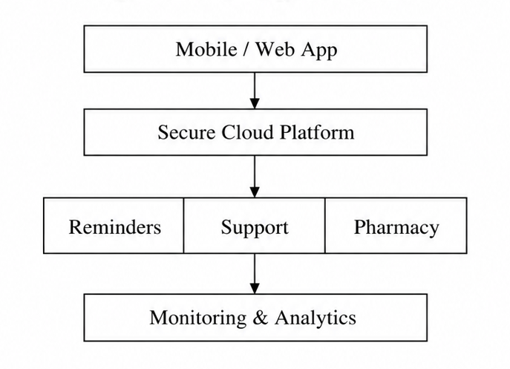
Figure 22: Technology Architecture
(Source: Created by Author)
This infrastructure needs to be scalable, that is, its capacity must grow along with the number of customers without necessitating corresponding expansion in the physical facility.

10.3 Compliance/ regulatory considerations
Compliance needs to operate as a design constraint as opposed to something done after launching the system. Medication-related data and information can involve health data, and thus special-category personal data under UK GDPR requires higher levels of protection (ICO, 2025). According to the ICO, (2024) any organisation handling this kind of data must put in place the Article 6 legal basis and Article 9 condition, whereas, in the case of high-risk processing, there will be a need to carry out a DPIA (Data Protection Impact Assessment). Therefore, data minimisation, access control, encryption, retention policies, and contractual relationships with suppliers must be founded on privacy by design. Thus, the ICO demands data protection from the start of system and process design (ICO, 2026).
MediDirect needs to consider each feature in light of medical device regulations by the MHRA since software applications can be regulated as medical devices depending on the purpose of use. As such, the MVP will need to stay within its prescribed boundaries of use which are not diagnostic or prescribing in nature unless it meets additional requirements (Gov.UK, 2026). This forms a business model that is relatively asset-light but prioritises technology, governance, information security, and regulatory compliance at the centre of sustainable scaling.
Overall, through the operations plan, it can be established that the company is capable of using a scalable, asset-light and technologically integrated business model. With the help of pharmacy partners, technological solutions, quality control processes and regulatory adherence, this business model will ensure effective service delivery within controlled costs. This operational foundation will help in strengthening future scalability and feasibility of the business.

11. Feasibility Analysis
Feasibility of MediDirect UK would be determined using a combination of PESTLE, SWOT, VRIO, sensitivity analysis, and risk analysis. The PESTLE analysis assesses external and regulatory feasibility, SWOT analysis integrates the opportunities and constraints, while VRIO determines if there are internal resources for implementation of the strategy. Further, sensitivity analysis is used in determining whether the commercial feasibility is still viable under changing conditions of demand and costs. This method is better compared to the use of one analysis tool since feasibility relies simultaneously on market demand, stakeholder acceptance, financial sustainability, operational capability, and strategic fit.

11.1 Ethical, market, and operational feasibility
Feasibility from an ethical point of view is conditional but attainable. MediDirect solves a socially important problem as evidenced by the existing analysis showing that 30%–50% of drugs prescribed for chronic illnesses are taken incorrectly. Thus, there is social value in helping patients adhere to prescriptions. However, reminders and drug-related information may disclose the health condition of a person and thus will be a special category of data under the UK GDPR. According to the ICO, (2024), and ICO, (2025), any organisation dealing with the processing of such data must provide an Article 6 lawful basis and an Article 9 condition with the processing of high risks requiring a DPIA. Thus, MediDirect needs to include informed transparency, data minimisation, encryption, accessibility and privacy-by-design within the MVP and not have ethics as subsequent compliance.
Market feasibility is reasonably strong but not that certain. Current studies like BHS, (2025), reveal a significant amount of digital activity with 67.8 million orders made from repeat prescriptions through the NHS app from December 2024 to November 2025. However, the existence of digital activity does not mean there will be willingness to pay for MediDirect. Sensitivity to prices, competing firms, and free NHS substitutes make the idea less attractive. The existing SWOT thus justifies a Brent-first, focused differentiation strategy that allows the venture to validate demand before national expansion.
From an operational perspective, feasibility is driven through a light asset model, where the digital platform, technologies, and pharmacy partners play the key role rather than medicine stock and distribution. Current Business Model Canvas (BMC) feasibility framework highlights the technology, secure data management, and pharmacy partners as key assets. However, the dependence on pharmacy partners, cyber-security issues, and service reliability represent key risks during implementation. An MVP implementation, partner SLAs, uptime monitoring, security measures, and incremental capacity increases would help to mitigate these risks.

11.2 Financial feasibility and strategic fit
Financial feasibility is concerned with the evaluation of a proposed project in generating enough income to cover costs and delivering a profitable return. It has been seen that the challenge with financial feasibility is the biggest. The initial capital required will be around £159,610, where £70,000 will be required to create the MVP and £33,000 will be needed for cybersecurity and regulatory requirements. There will be an increase in revenues from £94,410 in 2027 to £1,632,000 in 2031, however, there will still be operating losses up to 2030, and in 2031, there will be expected operating income of £214,238. Moreover, the break-even point in the first year will be 5,530 paying users or about 36,863 registered users which is substantially increasing the 5,000-user forecast. Therefore, financial viability requires sufficient working capital, customer conversion, and business-to-business pharmacy income instead of initial profitability.
As far as strategy is concerned, MediDirect effectively corresponds to the opportunity identified since it does not compete directly on prescriptions but rather uses its differentiation in the form of compliance assistance, communication between pharmacists and prescription coordination. The analysis done through VRIO indicates that the majority of the capabilities suggested give only temporary competitive advantage. Therefore, defensibility needs to be developed through trusted pharmacy relationships, local knowledge, secure technology, and execution quality.

11.3 Risk, Mitigation, and Overall Viability
The key risks associated with MediDirect UK will be lack of customer conversion, price sensitivity, reliance on partners for pharmacies, cyber/privacy issues, regulatory changes, and cost increases. Thus, the risk management strategy that needs to be considered will be a combination of a Brent MVP, a freemium approach to acquiring customers, phased recruiting, diversified partnerships with pharmacies, control over costs through KPIs, DPIAs, and cybersecurity testing. There is also an ongoing need to examine the breadth of regulation as per MHRA guidelines, software categorisation is purpose-dependent and reflecting expansion into medical decision-making could materially change the regulatory obligations (Gov.UK, 2026; Gov.UK, 2026).
Overall, MediDirect UK is only potentially viable because market and strategic data support a cautious entry into the market, while sensitivity analysis shows execution risks given that the project might result in a loss of £581,734 or a profit of £1,005,138 in 2031. Therefore, a phased trial in Brent is the most reasonable approach to assessing viability.

12. Implementation Plan

The company will use the phased implementation method supported by SMART performance indicators and constant monitoring. In this way, the company minimises financial and regulatory risks by proving that the project meets the technical requirements, pharmacies are interested in participating, and customers approve the product. SMART KPIs help in translating strategic objectives into measurable targets, whereas periodic review helps in enabling corrective action when the actual performance is different from the plan (Madanchi, et al., 2025). This approach is associated with the existing strategy of MediDirect concerning entering Brent first and then validating the business model before wider expansion.

12.1 Launch phases, milestones and timeline
Implementation needs to commence with platform building and compliance preparation, pilot tests along with a commercial launch and scaling of operations. The current financial model shows £70,000 to be set aside for MVP building and £33,000 for cybersecurity and compliance indicating that technical and compliance readiness are immediate priorities. The timeline using the Gantt chart is provided below.
Activity | M1–2 | M3–4 | M5–6 | M7–8 | M9–10 | M11–12
Business setup and compliance
Market Value Proposition development
Cybersecurity and testing
Pharmacy recruitment
Brent pilot
Marketing launch
Performance review
Scale decision
Thus, the short-term goal will be a secure MVP, regulatory readiness and validation by the partner. The long-term goals will involve improving the conversion rate, increasing our pharmacy contacts and relationships as well as venturing outside Brent only at the time of pilot evidence demonstrating sustainable demand.

12.2 KPIs, monitoring, resource allocation, change management
It has been seen that KPIs (Key Performance Indicators) for resource allocation help in measuring the efficiency of a business in using its staff, time, and budget for achieving the goals (Aithal and Aithal, 2023). Resources need to be allocated at each stage of implementation rather than being committed together. The current structure has suggested 7 FTE employees for 2027 in areas like technology, customer support, pharmacy partnership, marketing, and compliance. Technology resources need to dominate development while marketing and customer support rise during scaling and launch. Further, operational control must employ the use of a monthly implementation dashboard which includes elements like users, premium conversion rate, cost per acquisition, number of pharmacies on board, platform uptime, response time for support, complaint rate, and cash burn. Thus, financial control is very important since it is based on current projections reflecting an unlikely immediate break-even (Almansour and Almansour, 2024). In this business plan, it is highly dependent on B2B pharmacy income and customer acquisition.
Additionally, change management is considered as a structured approach to preparing, supporting, and guiding people and organisations through major cultural, technological, and structural shifts (Bozkus, 2023). Change management must include staff training, communication among the pharmacy partners, as well as feedback from the users to improve the system continuously. Major problems related to technology, compliance, or customer feedback must lead to necessary changes before moving to the next implementation phase. For this reason, the development process must be based on milestones rather than the calendar leading to growth that occurs only when customer, financial, and operational KPIs reflect readiness.

References
NHS England. (2024) Digital prescriptions go live in NHS App. [Online]. Available at: https://www.england.nhs.uk/2024/01/digital-prescriptions-go-live-in-nhs-app. (Accessed on: 20 Aug 2026).
NHS England. (2025) Electronic prescription service (EPS). [Online]. Available at: https://www.england.nhs.uk/long-read/electronic-prescription-service-eps. (Accessed on: 20Aug 2026).
NHS England. (2026) Digital Medicines Programme. [Online]. Available at: https://www.england.nhs.uk/digitaltechnology/digital-medicines-programme. (Accessed on: 8 Aug 2026).
NHS. (2024) GP Patient Survey 2024. [Online]. Available at: https://www.england.nhs.uk/statistics/2024/07/11/gp-patient-survey-2024/ (Accessed on: 15Aug 2026).
NHS. (2025) 5.1 Assessment of Information Governance, Data Protection Compliance and Data Security [Online]. Available at: https://www.hra.nhs.uk/approvals-amendments/what-approvals-do-i-need/hra-approval/uk-study-wide-governance-criteria/5-legal-compliance/51-assessment-of-information-governance-data-protection-compliance-and-data-security/ (Accessed on: 20 Aug 2026).
NHS. (2025) Community pharmacy advanced service specification: NHS new medicine service. [Online]. Available at: https://www.england.nhs.uk/long-read/community-pharmacy-advanced-service-specification-nhs-new-medicine-service/ (Accessed on: 11 Aug 2026).
NHS. (2025) Electronic prescription service (EPS). [Online]. Available at: https://www.england.nhs.uk/long-read/electronic-prescription-service-eps/ (Accessed on: 04 Sept 2026).
NHS. (2025) Electronic repeat dispensing (eRD). [Online]. Available at: https://www.england.nhs.uk/long-read/electronic-repeat-dispensing-erd/ (Accessed on: 22Aug 2026).
NHS. (2025) Hundreds of thousands use ‘Amazon-style’ prescription tracker in NHS App. [Online]. Available at: https://www.england.nhs.uk/2025/08/hundreds-of-thousands-use-amazon-style-prescription-tracker-in-nhs-app/ (Accessed on: 15 Aug 2026).
NHS. (2025) Londoners using ‘digital front door’ to access NHS healthcare. [Online]. Available at: https://www.england.nhs.uk/london/2025/08/12/londoners-using-digital-front-door-to-access-nhs-healthcare/ (Accessed on: 12 Aug 2026).
NHS. (2025) Medicines optimisation. [Online]. Available at: https://www.england.nhs.uk/medicines-2/medicines-optimisation/ (Accessed on: 15 Aug 2026).
NHS. (2025) News. [Online]. Available at: https://www.england.nhs.uk/2025/12/record-numbers-using-nhs-app-to-manage-health/ (Accessed on: 15 Aug 2026).
NHS. (2025) NHS Prescription Prepayment Certificate (PPC). [Online]. Available at: https://www.nhsbsa.nhs.uk/help-nhs-prescription-costs/nhs-prescription-prepayment-certificate-ppc (Accessed on: 18Aug 2026).
NHS. (2025) Online repeat prescriptions. [Online]. Available at: https://www.england.nhs.uk/long-read/online-repeat-prescriptions/ (Accessed on: 20 Aug 2026).
NHS. (2025) Record numbers using NHS App to manage health. [Online]. Available at: https://www.england.nhs.uk/2025/12/record-numbers-using-nhs-app-to-manage-health/ (Accessed on: 15 Aug 2026).
NHS. (2026) Appendices. [Online]. Available at: https://www.england.nhs.uk/long-read/appendices-24-25/ (Accessed on: 15Aug 2026).
NHS. (2026) Digital Medicines Programme. [Online]. Available at: https://www.england.nhs.uk/digitaltechnology/digital-medicines-programme/ (Accessed on: 11 Aug 2026).
NHS. (2026) Digital transformation [Online]. Available at: https://www.england.nhs.uk/digitaltechnology/ (Accessed on: 15Aug 2026).
NHS. (2026) Electronic Prescription Service [Online]. Available at: https://digital.nhs.uk/services/electronic-prescription-service (Accessed on: 15 Aug 2026).
NHS. (2026) Lloyds Direct. [Online]. Available at: https://digital.nhs.uk/services/nhs-login/nhs-login-for-partners-and-developers/nhs-login-partner-integration-case-studies/lloyds-direct---lloyds-pharmacy (Accessed on: 11 Aug 2026).
NHS. (2026) Performance Report. [Online]. Available at: https://www.england.nhs.uk/long-read/performance-report-24-25/ (Accessed on: 10 Aug 2026).
NHS. (2026) Prescription information. [Online]. Available at: https://www.borchardtmc.nhs.uk/health-information/medication-information/
NHS. (2026) Prescriptions in the NHS App. [Online]. Available at: https://digital.nhs.uk/services/nhs-app/nhs-app-features/prescriptions-in-the-nhs-app (Accessed on: 11 Aug 2026).
Nifakos, S., Chandramouli, K., Nikolaou, C.K., Papachristou, P., Koch, S., Panaousis, E. and Bonacina, S. (2021) Influence of human factors on cyber security within healthcare organisations: A systematic review. Sensors, 21(15), p.5119.
ONS. (2024) Healthcare expenditure, UK Health Accounts: 2023 and 2024. [Online]. Available at: https://www.ons.gov.uk/peoplepopulationandcommunity/healthandsocialcare/healthcaresystem/bulletins/ukhealthaccounts/2023and2024 (Accessed on: 15 Aug 2026).
ONS. (2025) Healthcare expenditure, UK Health Accounts: 2024 and 2025. [Online]. Available at: https://www.ons.gov.uk/peoplepopulationandcommunity/healthandsocialcare/healthcaresystem/bulletins/ukhealthaccounts/2024and2025 (Accessed on: 19Aug 2026).
ONS. (2025) Household Costs Indices for UK household groups: January to March 2026. [Online]. Available at: https://www.ons.gov.uk/economy/inflationandpriceindices/bulletins/householdcostsindicesforukhouseholdgroups/januarytomarch2026 (Accessed on: 18Aug 2026).
ONS. (2025) Population aged 65 and over. [Online]. Available at: https://www.ons.gov.uk/explore-local-statistics/indicators/percentage-population-aged-65. (Accessed on: 18 Aug 2026).
ONS. (2026) Consumer price inflation, UK: June 2026. [Online]. Available at: https://www.ons.gov.uk/economy/inflationandpriceindices/bulletins/consumerpriceinflation/june2026 (Accessed on: 16Aug 2026).
Pangarkar, N. and Prabhudesai, R. (2024) Using Porter's Five Forces analysis to drive strategy. Global Business and Organizational Excellence, 43(5), pp.24-34.
Penner, L.S., Armitage, C.J., Thornley, T., Whelan, P., Chuter, A., Allen, T. and Elliott, R.A. (2024) What affected UK adults’ adherence to medicines during the COVID-19 pandemic? Cross-sectional survey in a representative sample of people with long-term conditions. Journal of Public Health, 32(2), pp.325-338.
Puyt, R.W., Lie, F.B. and Wilderom, C.P. (2023) The origins of SWOT analysis. Long range planning, 56(3), p. 102304.
Qureshi, R. and Koo, I. (2026) A comprehensive survey of cybersecurity threats and data privacy issues in healthcare systems. Applied Sciences, 16(3), p.1511.
Robles, T., Bordel, B., Alcarria, R. and Sánchez-de-Rivera, D. (2020) Enabling trustworthy personal data protection in eHealth and well-being services through privacy-by-design. International Journal of Distributed Sensor Networks, 16(5), p.1550147720912110.
Rosenlund, M., Kinnunen, U.M. and Saranto, K. (2023) The use of digital health services among patients and citizens living at home: scoping review. Journal of Medical Internet Research, 25, p. e44711.
Rua, O.L. and Santos, C. (2022) Linking brand and competitive advantage: The mediating effect of positioning and market orientation. European research on management and business economics, 28(2), p.100194.
Schmidt, J. (2020) Break Even Analysis. [Online]. Available at: https://corporatefinanceinstitute.com/resources/accounting/break-even-analysis/ (Accessed on: 24 Aug 2026).
Schot, E., Tummers, L. and Noordegraaf, M. (2020) Working on working together. A systematic review on how healthcare professionals contribute to interprofessional collaboration. Journal of interprofessional care, 34(3), pp.332-342.
Schutselaars, J., Romme, A.G.L., Bell, J., Bobelyn, A.S. and van Scheijndel, R. (2023) Designing and testing a tool that connects the value proposition of deep-tech ventures to SDGs. Designs, 7(2), p. 50.
Smith, C. (2026) NHS patients who use Pharmacy2U emailed urgent 'two day' alert over prescriptions. [Online]. Available at: https://www.mirror.co.uk/news/health/nhs-patients-who-use-pharmacy2u-37059686 (Accessed on: 11 Aug 2026).
Stoumpos, A.I., Kitsios, F. and Talias, M.A. (2023) Digital transformation in healthcare: technology acceptance and its applications. International journal of environmental research and public health, 20(4), p.3407.
Almeman, A. (2024) The digital transformation in pharmacy: embracing online platforms and the cosmeceutical paradigm shift. Journal of Health, Population and Nutrition, 43(1), p. 60.
Boots. (2026) Prescriptions. [Online]. Available at: https://www.boots.com/prescription-support/ (Accessed on: 11 Aug 2026).
Bozkus, K. (2023) Organizational culture change and technology: Navigating the digital transformation. In Organizational Culture-Cultural Change and Technology. IntechOpen.
Brent. (2025) Borough Plan 2023-27 Evidence Pack. [Online]. Available at: https://democracy.brent.gov.uk/documents/s127006/9b.%20Appendix%20B%20-%202023-27%20Borough%20Plan%20Evidence%20Pack.pdf (Accessed on: 24Aug 2026).
Brent. (2025) Population change in Brent. [Online]. Available at: https://data.brent.gov.uk/download/2yq7q/veh/2025-10-07%20Population%20briefing_Final_AV%20version.pdf (Accessed on: 24 Aug 2026).
Brent. (2026) Brent Council Digital Roadmap 2026-2028. [Online]. Available at: https://democracy.brent.gov.uk/documents/s154616/11a.%2520Appendix%25201%2520-%2520Brent%2520Council%2520Digital%2520Roadmap%252026-28.pdf (Accessed on: 24Aug 2026).
Brent. (2026) Community and Wellbeing Scrutiny Committee. [Online]. Available at: https://democracy.brent.gov.uk/documents/s154643/8.%20Tackling%20Poverty%20in%20Brent.pdf (Accessed on: 24Aug 2026).
CMA. (2023) Completed acquisition by Pharmacy2U of Lloyds Direct. [Online]. Available at: https://assets.publishing.service.gov.uk/media/66224358572258ab08a0d77d/Full_text_decision.pdf (Accessed on: 23Aug 2026).
Healthera. (2026) Grow Your Pharmacy with a Ready-to-Go Patient App. [Online]. Available at: https://healthera.co.uk/pharmacies/healthera-pharmacy-app/ (Accessed on: 26Aug 2026).
GOV.UK (2026) Set up a limited company: step by step. [Online]. Available at: https://www.gov.uk/set-up-limited-company. (Accessed on: 15Aug 2026).
EBSCO. (2026) Porter's Generic Strategies. [Online]. Available at: https://www.ebsco.com/research-starters/marketing/porters-generic-strategies (Accessed on: 30Aug 2026).
Nanyangwe, J. and Phiri, J. (2021) The influence of marketing strategies on growth and sustainability in the original equipment manufacturing industry. Open Journal of Business and Management, 9(3), pp.1446-1461.
Tojiri, Y. (2023) Product differentiation strategy for organizational financial profitability: Enchancing market share and profitability-A comprehensive literature review. Atestasi: Jurnal Ilmiah Akuntansi, 6(2), pp.856-876.
Tolley, C., Seymour, H., Watson, N., Nazar, H., Heed, J. and Belshaw, D. (2023) Barriers and opportunities for the use of digital tools in medicines optimization across the interfaces of care: stakeholder interviews in the United Kingdom. JMIR Medical Informatics, 11(1), p.e42458.
Kvarnström, K., Westerholm, A., Airaksinen, M. and Liira, H. (2021) Factors contributing to medication adherence in patients with a chronic condition: a scoping review of qualitative research. Pharmaceutics, 13(7), p.1100.
Kapur, R. (2023) Digital platforms and transformation of healthcare organizations: Integrating digital platforms with advanced IT systems and work transformation. CRC Press.
Ghosh, A., Mondal, S., Das, R. and Mohanty, J.P. (2026) A scientific review on the transformative digital health impact on modern pharmacy: trends and patient-centric outcomes. Universal Journal of Pharmaceutical Sciences And Research, 10(1), pp.1-11.
Erku, D., Khatri, R., Endalamaw, A., Wolka, E., Nigatu, F., Zewdie, A. and Assefa, Y. (2023) Digital health interventions to improve access to and quality of primary health care services: a scoping review. International journal of environmental research and public health, 20(19), p.6854.
Dasopang, E.S., Yulyana, A., Mugiyanto, E. and Permadi, Y.W. (2026) Bridging gaps in patient-pharmacist connectivity: A qualitative study on telehealth pharmacy perspectives. BIS Health and Environmental Science, 3, pp.V326007-V326007.
Coteur, K., Van Nuland, M., Schoenmakers, B., Van den Broeck, K. and Anthierens, S. (2023) “At the time I only wanted to relieve stress”: Exploring motivation for behaviour change in long-term hypnotic users. Heliyon, 9(5).
Arafa, A., Sheerah, H.A. and Alsalamah, S. (2023) Emerging digital technologies in healthcare with a spotlight on cybersecurity: a narrative review. Information, 14(12), p.640.
Espírito-Santo, M., Santos, S. and Estêvão, M.D. (2024) Digital solutions available to be used by informal caregivers, contributing to medication adherence: a scoping review. Pharmacy, 12(1), p.20.
Gudepu, B.K. and Jaladi, D.S. (2022) Data discovery and security: Protecting sensitive information. International Journal of Acta Informatica, 1(1), pp.176-187.
Qureshi, R. and Koo, I. (2026) A comprehensive survey of cybersecurity threats and data privacy issues in healthcare systems. Applied Sciences, 16(3), p.1511.
Schot, E., Tummers, L. and Noordegraaf, M. (2020) Working on working together. A systematic review on how healthcare professionals contribute to interprofessional collaboration. Journal of interprofessional care, 34(3), pp.332-342.
Wei, Y., Zheng, P., Deng, H., Wang, X., Li, X. and Fu, H. (2020) Design features for improving mobile health intervention user engagement: systematic review and thematic analysis. Journal of medical Internet research, 22(12), p.e21687.
Jakobsen, A.H., Småbrekke, L., Chen, T.F. and Halvorsen, K.H. (2023) Exploring stakeholders' perspectives on the quality of services provided through community pharmacies. Research in Social and Administrative Pharmacy, 19(9), pp.1307-1313.
Astbury, J., Schafheutle, E., Brown, J. and Cutts, C. (2021) The current and potential role of community pharmacy in asset-based approaches to health and wellbeing: a qualitative study. International journal of clinical pharmacy, 43(5), pp.1257-1264.
Maas, V.K., Dibbets, F.H., Peters, V.J., Meijboom, B.R. and van Bijnen, D. (2023) The never-ending patient journey of chronically ill patients: A qualitative case study on touchpoints in relation to patient-centered care. PloS one, 18(5), p.e0285872.
Robles, T., Bordel, B., Alcarria, R. and Sánchez-de-Rivera, D. (2020) Enabling trustworthy personal data protection in eHealth and well-being services through privacy-by-design. International Journal of Distributed Sensor Networks, 16(5), p.1550147720912110.
Gargioni, L., Fogli, D. and Baroni, P. (2024) A systematic review on pill and medication dispensers from a human-centered perspective. Journal of healthcare informatics research, 8(2), pp.244-285.
Bachmann, N., Thienemann, A.K., Tüzün, A., Brunner, M., Tripathi, S., Pöchtrager, S. and Jodlbauer, H. (2025) The evolution of the business model canvas for digital sustainability. Procedia Computer Science, 253, pp.1012-1023.
Angelis, B. (2023) Why is a profit and loss forecast important for businesses? [Online]. Available at: https://agicap.com/en/article/profit-and-loss-forecast/ (Accessed on: 24 Aug 2026).
Gargioni, L., Fogli, D. and Baroni, P. (2024) A systematic review on pill and medication dispensers from a human-centered perspective. Journal of healthcare informatics research, 8(2), pp.244-285.
IBM. (2025) What is financial forecasting? [Online]. Available at: https://www.ibm.com/think/topics/financial-forecasting (Accessed on: 24 Aug 2026).
Gonen, L.D., Tavor, T. and Spiegel, U. (2024) Unlocking market potential: strategic consumer segmentation and dynamic pricing for balancing loyalty and deal seeking. Mathematics, 12(21), p.3364.
Faisal, S., Samoth, D., Aslam, Y., Patel, H., Park, S., Baby, B. and Patel, T. (2023) Key features of smart medication adherence products: updated scoping review. JMIR aging, 6, p.e50990.
Bertolazzi, A., Quaglia, V. and Bongelli, R. (2024) Barriers and facilitators to health technology adoption by older adults with chronic diseases: an integrative systematic review. BMC public health, 24(1), p.506.
Garmann-Johnsen, N.F., Helmersen, M. and Eikebrokk, T.R. (2020) Employee-driven digitalization in healthcare: codesigning services that deliver. Health Policy and Technology, 9(2), pp.247-254.
Kauffman, Y.S., Wright, E.A., Patterson, B.J. and Coley, K.C. (2021) Informing collaborative relationships between community pharmacists and health care professionals in primary care practices. Journal of the American Pharmacists Association, 61(6), pp.778-784.
Ilardo, M.L. and Speciale, A. (2020) The community pharmacist: perceived barriers and patient-centered care communication. International journal of environmental research and public health, 17(2), p.536.
Mohiuddin, A.K. (2020) The role of the pharmacist in patient care: achieving high quality, cost-effective and accessible healthcare through a team-based, patient-centered approach. Universal-publishers.
Nifakos, S., Chandramouli, K., Nikolaou, C.K., Papachristou, P., Koch, S., Panaousis, E. and Bonacina, S. (2021) Influence of human factors on cyber security within healthcare organisations: A systematic review. Sensors, 21(15), p.5119.
Herman, H., Grobbelaar, S.S. and Pistorius, C. (2020) The design and development of technology platforms in a developing country healthcare context from an ecosystem perspective. BMC medical informatics and decision making, 20(1), p.55.
ICO. (2025) What are the rules on special category data? [Online]. Available at: https://ico.org.uk/for-organisations/uk-gdpr-guidance-and-resources/lawful-basis/special-category-data/what-are-the-rules-on-special-category-data/ (Accessed on: 04 Sept 2026).
ICO. (2026) Data protection by design and by default. [Online]. Available at: https://ico.org.uk/for-organisations/uk-gdpr-guidance-and-resources/accountability-and-governance/guide-to-accountability-and-governance/data-protection-by-design-and-by-default/ (Accessed on: 04 Sept 2026).
ICO. (2026) What are the rules on special category data?. [Online]. Available at: https://ico.org.uk/for-organisations/uk-gdpr-guidance-and-resources/lawful-basis/special-category-data/what-are-the-rules-on-special-category-data/ (Accessed on: 6 Sep 2026).
Chodakowska, E., Nazarko, J., Nazarko, Ł., Rabayah, H.S., Abendeh, R.M. and Alawneh, R. (2023) ARIMA models in solar radiation forecasting in different geographic locations. Energies, 16(13), p.5029.
ICO. (2024) Special category data. [Online]. Available at: https://ico.org.uk/for-organisations/uk-gdpr-guidance-and-resources/lawful-basis/a-guide-to-lawful-basis/special-category-data/ (Accessed on: 5Sept 2026).
ICO. (2025) What are the rules on special category data? [Online]. Available at: https://ico.org.uk/for-organisations/uk-gdpr-guidance-and-resources/lawful-basis/special-category-data/what-are-the-rules-on-special-category-data/ (Accessed on: 5Sept 2026).
Gov.UK. (2026) Crafting an intended purpose in the context of Software as a Medical Device (SaMD). [Online]. Available at: https://www.gov.uk/government/publications/crafting-an-intended-purpose-in-the-context-of-software-as-a-medical-device-samd (Accessed on: 05 Sept 2026).
Gov.UK. (2026) Medical devices: software applications. [Online]. Available at: https://www.gov.uk/government/publications/medical-devices-software-applications-apps (Accessed on: 06Sept 2026).
Aithal, P.S. and Aithal, S. (2023) Key performance indicators (KPI) for researchers at different levels & strategies to achieve it. International Journal of Management, Technology, and Social Sciences (IJMTS), 8(3), pp.294-325.
Almansour, A.Y. and Almansour, B.Y. (2024) Optimizing Break-Even Point: A New Methodology for Identifying Critical Components and Managing Financial Stability. Montenegrin Journal of Economics, 20(4), pp.51-63.
Bozkus, K. (2023) Organizational culture change and technology: Navigating the digital transformation. In Organizational Culture-Cultural Change and Technology. IntechOpen.
Madanchi, F., Maghroor, H. and O’Neal, T. (2025) June. Integrating objectives and key results (OKRs) and key performance indicators (KPIs) in supply chain performance management. In Proceedings of the 10th North American Conference on Industrial Engineering and Operations Management, Orlando, FL (pp. 1-8).

