Name: David Pecsuvacz
Student Number:1916214
Lecturer: REXON NTING
Managing projects in the Organization BMSW5104_LON
University of Wales Trinity Saint David

Kanada-Ya Takeaway- project

Table of the content

Executive Summary……………………………………………………………………………………3
Project Outline………………………………………………………………………………………….3
Stakeholder Analysis…………………………………………………………………………………..5
Work Break Down Structure…………………………………………………………………………..5
Draft of costs.………………………………………………………………………………………..….6
Consideration of Resources…………………………………………………………………………...7
Gantt Chart………………………………………………………………………………………………9
Risk Assessment……………………………………………………………………………………….11
Conclusion……………………………………………………………………………………………....12
References………………………………………………………………………………………………13
Power Point Presentation……………………………………………………………………………...14
Speaker Note……………………………………………………………………………………………20

Executive Summary

COVID 19 has radically controlled individuals in global sector since 2020. Today, most governments in various nations are forced to pass lockdown on the economies due to the high spread rate of the disease. As a result, most organizations have been forced to place employees as home workers. Most business performance analysts claim that the "working from home" practice remains effective in terms of the Organization's productivity and it can continue to be relied on in the foreseeable future. Most restaurants and businesses across the world have been affected in varying ways, such as their closure since the spread of the pandemic was confirmed on March 1, 2020, across the world. The Ramen bars were closed on March 19, 2020, following the increased outbreak of the pandemic (Stephens, 2021). The Ramen bar in London, Panton 3 street industry business is currently planning to provide take away and home delivery services due to increasing pandemic. Home delivery and take away services have been implemented, pantry staples and meal packs used to hold the meals ordered. This management project based on the Kanada-Ya Ramen Bars provides a brief takeaway and home delivery options project plan.

Project Outline

The pandemic has continued to affect fine-dine sectors compared to other organizational sectors. However, those restaurants have implemented the strategy of home deliveries and the options of taking away tend to be less affected by the pandemic due to their convenient online order services and reliable food delivery platforms. There are various Kanada-Ya Ramen restaurants across the globe, some are located in London, Japan, and Barcelona, Spain. They offer the Ramen meal, which is rich in protein-packed broth, carb-y noodles, ideally heavy, and garnishes galore (Marconi, 2020). The Ramen bar in London, Panton 3 street can change its structure for business operations from fine dining to take away and home delivery in consideration of the spreading COVID-19 situation. The target of the Ramen bar in London, Panton 3 street is to attract families and build their enjoyable time by providing them a way they can share a meal from the restaurant, which can help them relieve stress during and post-pandemic situation (McClure, 2020). The Ramen Bar uses social media pages like blogs, Instagram, Twitter, and Facebook to attract its target customers.

1. Project Objectives
- To analyze a business expansion project that will be undertaken by a Ramen bar in London, Panton 3 street to convenience its service providence to its customers during and post-pandemic situation.
- To convince the bank investors and the current stakeholders to give a green light for a takeaway and delivery service.
- To boost their sales and the loyalty of customers by providing a proposition of value. It can be provided by launching a new product that can help convenience an organization's services; for example, the Ramen bar can improve and continue making its sales by establishing takeaway and home delivery services.

2. Project deliverables
The deliverables of the Ramen bar will be:
- Provide take away services.
- Provide home delivery services.
- Free food packing services.
- Additional new dishes in the bar’s internet menu.
- Charging food delivery services at affordable costs to all customers.

3. Assumptions
The project will be implemented under the following assumptions:
- The restaurant owner will finance the project costs.
- There will less government interference as COVID 19 rules of social distancing will be observed in the kitchen.
- The cost of production will constant during beginning sales period.
4. Exclusions
Exclusions are essential in a project to prevent stakeholders from making unrealistic expectations and false assumption in the project activities. Some of the exclusions in this project will be:
- Recruit delivery staff.
- Recruit additional chefs.
- Long distance food delivery services.

Stakeholder Analysis

Several stakeholders will be incorporated into this project. The main stakeholders will be the two bar owners, Tony Lam, and Aaron H. Smith. Aaron also looks after the marketing research analysis and he will purchase food equipment. Jessie Sam, the operation manager, is another project stakeholder. Sam’s role will be to determine good training for employees and improve their food preparation skills to increase customer satisfaction. Therefore, Sam’s main role will be to monitor employees’ progress. Bogdan Matei will be another stakeholder. Matei will work in the IT support where he will watch over the till system and provide training to the employees who work under till sector if any operational changes occur. For example, till training will entail the addition of new dishes in the menu and any update of the deliveries system. Tul Limbu will be the Human Resource stakeholder. Paolo Capucco will be the head chef. Capucco’s role will be to create new dishes and take away menus. He will also stand for standard head chef responsibilities such as controlling and directing the processes of food preparation and approving and polishing parked dishes before they are taken to customers. Francesco Vito will be the floor manager, Kai Hai will be the Floor Supervisor, Hien Weing will be the kitchen manager, and Dan Ervin will be the kitchen supervisor.

Work Break Down Structure

A graphical representation of all work to be executed by the project team and other stakeholders to meet the goal and objectives of a project is called a Work breakdown structure (Jemine, Pichault, and Dubois, 2020). Through the work breakdown structure, all activities, costs of their operations, and the timeframe to be taken in carrying out every task are identified effectively.

The proposed Ramen bar take away and home delivery project
Planning system of food and menu
Guide on user operations and management practices
Evaluation of the project
Implementation report
Testing
System of account management
System of booking management
Closing phase
Testing
Design
Evaluation
Controlling phase
System of billing management
Execution phase
Project costing
Project plan and risk management
User Requirements
Planning Phase

Draft of costs

One of the essential aspects to consider when operating a food takeaway and home delivery service is managing the costs of food. According to Locatelli (2021), restaurant startup costs range huge amounts of money, ranging from £75.500 and £750.500, depending on the class of the restaurant or services provided. That is a significant amount of money, and a restaurant owner will know precisely the amount of money they require to start their project by carrying out a lot of thoughtful planning. The project manager should manage the startup costs to ensure that the planned sales activities result profits. In the analysis below, a decent draft of costs/ resources to use in providing takeaway and home delivery services:
- Renovations and décor- £5000
- Kitchen equipment’s and supplies- £2000
- Licenses and permit- £500
- Marketing- £500
- Insurance- £6000
- Labor costs- £400 per employee
- Restaurant technology- £400 each month
- Rent and building- £5900 every month
- Costs of foods- £6000
- Utility costs- £3.75 per square foot
- Fees of payment processing- £50

Consideration of Resources

In consideration of resources, there are restaurant expenses and restaurant costs (Bondar et al., 2021). According to Zasa, Patrucco, and Pellizzon (2020), a recurring payment like rent, costs of foods payroll, utility, and marketing costs can be referred to as restaurant expenses. On the other hand, kitchen equipment such as dishes or furniture can be identified as kitchen restaurant costs. While transforming the Ramen restaurant into a takeaway and home delivery restaurant, various startup costs are required. For example, renovations and purchase new equipment might be appropriate. Some of the items that a restaurant might consider purchasing when opening new takeaway and home delivery services doors include:
- Decor and renovations
- Kitchen equipment and supplies
- Technology in the restaurant
- Permits and licenses
- Marketing costs

1.Decor and renovations
It is essential that the Ramen bar undergo some restaurant arrangements mainly in the kitchen sector and area of food collection by customers. The decor and renovation costs of a restaurant may be different based on the concept of the restaurant and market target. The Ramen bar has already housed a restaurant before its closure after the COVID 19 attack and had fully organized equipment in the kitchen, refrigeration, and running water. However, it will require further renovations to create an attractive appearance for those customers seeking takeaway services. The restaurant will require additional vehicles such as motorbikes, which will help improve convenience home delivery services. The renovations will cost around £5000. The budget of purchasing motorbikes for making home-delivery services will range around £50000.

2.Kitchen appliances and equipment’s
Additional kitchen equipment might require preparing new recipes that might be added to the menu. To run restaurant services efficiently, all the needed equipment and appliances must be available including baking oven, fridges and dishwashing machines. Additional pots, pans, strainers, and pasta cookers are cooking equipment. The restaurant will add its workspace like meal preparation tables, food collection counters, and cold food counters. It will be required to implement good quality packing dishes to ensure they take away or home delivery Japanese soup food remains hot and tasty. The Ramen bar needs several kitchen appliances and equipment; therefore, the cost of the equipment incurred will add up to £2000.

3.Technology in the restaurant
The takeaway and home delivery restaurants normally require effective technology to run effectively (Ulusoy and Hazır, 2021). Operation automation and data collection processes helps optimize both activities in front-of-house and back-of-house and enable a restaurant more efficiently. A takeaway and home delivery Ramen bar is an example of a modern bar, and therefore, both software and hardware operations are required to operate successfully. The Ramen bar owner will require £400 every month to improve the hardware and software devices and keep their operations efficient.

4.Permits and licenses
The Ramen bar will require a legal license to operate its takeaway and home-delivery services legally, during, and post this pandemic situation. Therefore, the restaurant owner must obtain a particular business license and permit. In London, restaurants are required to have a license in foodservice. The food service license is usually issued and governed by the health department within the restaurant's local area. The cost of a food service license for the Ramen restaurant will be £700.

5.Marketing costs
Ulusoy, and Hazır (2021), says “build it, and they will come.” However, carrying out marketing activities and attracting customers to purchase services does not seem to be that simple. Opening Ramen bar will require a marketing strategy to ensure that potential customers are drawn into the restaurant. It will use blogs, Twitter, Instagram, and Facebook for advertising its services, and this will cost about £1500.

Gantt Chart

The Gantt chart will serve essential purpose of helping in planning and scheduling tasks over the project (Jemine, Pichault, and Dubois, 2020). Secondly, using the Gantt chart in the Ramen bar take away and home delivery service project will provide a visualized project management approach and technique with several applications to assist in the project. Using Gantt chart, the project manager remains in a capacity to plan and engage in the scheduling of the entire project. Through the Gantt chart, the project manager finds it easy to schedule teams while comparing the planned and the actual timelines of the Ramen bar takeaway and home delivery service project. Below is an illustration of the project milestones in the planning, implementation, monitoring, and closing phases.

Task Name | Duration | Start Date | Finish Date
Planning phase | 33 days | 1/11/20 | 2/24/20
User Requirements | 14 days | 1/11/20 | 1/28/20
Project plan and risk management | 13 days | 1/29/20 | 2/16/20
Project costing | 6 days | 2/17/20 | 2/24/20
Execution phase | 29 days | 2/25/20 | 3/31/20
System of booking management | 15 days | 2/25/20 | 3/17/20
System of billing management | 10 days | 3/18/20 | 3/31/20
Controlling phase | 4 days | 4/1/20 | 4/6/20
System of account management | 2 days | 4/1/20 | 4/2/20
Planning system of food and menu | 2 days | 4/3/20 | 4/4/20
Closing phase | 6 days | 4/5/20 | 4/12/20
Testing | 2 days | 4/5/20 | 4/7/20
Implementation report | 2 days | 4/8/20 | 4/9/20
Evaluation of the project | 1 day | 4/10/ 20 | 4/10/20
Guide on user operations and management practices | 1 day | 4/11/20 | 4/11/20

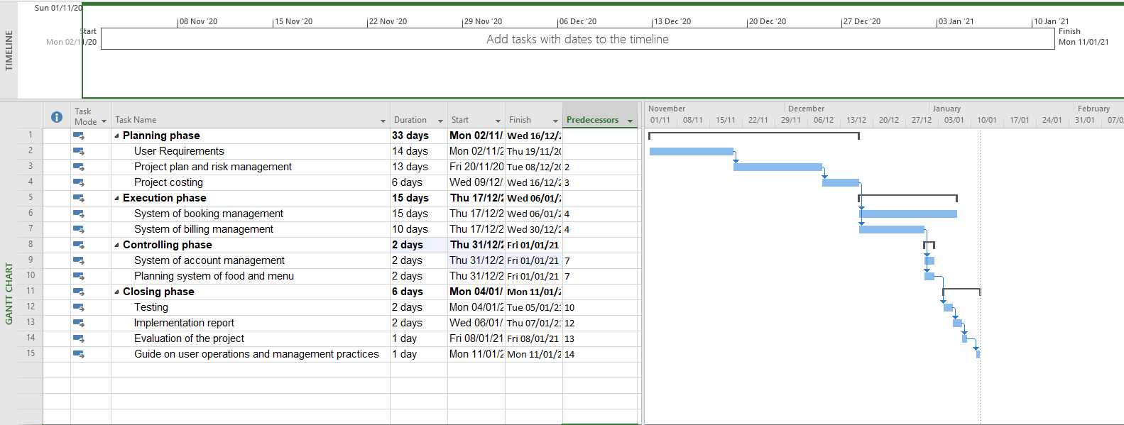

Risk Assessment

According to Locatelli (2021), identifying, examining, analyzing, and appropriately solving various risk within an organization through engagement plans is referred to as risk management in a project. To identify risks occurring or it might occur within an organization, the project manager must practice risk assessment. Risk assessment activities means continuous measuring approaches, implementing reliable risk strategies, and monitoring project activities. Study of Zasa, Patrucco, and Pellizzoni (2020) shows risk registers can be identified as risk assessment tools consist recognized risks, potential efforts list and solutions, risk causes, and an up-to-date risk category and process. Therefore, project managers can consider adding a well-structured risk management that ensure takeaway and home delivery service project is carried out effectively. The food delivery trend has exploded over the last several years and it shows no signs of slowing down. Although there are always food delivery risks to consider, investors can be sure that foodservice takeout and delivery have tremendous potential to maintain and grow profits. Even restaurants who never thought that they would be doing delivery have had to at least consider adding this service now more than ever. But getting started with food delivery for a restaurant is not just as simple as taking orders and driving them to people’s houses.
The biggest risks that the restaurants need to consider regarding to take away and food delivery are:
- Customer privacy and data: computer and internet security can be challenging for example if the website gets hacked and exposes customer data, customers could lose trust in the restaurant for a time.
- Food safety: restaurants should be concerned about maintaining the correct hot and cold holding temperatures of the food they are delivering. They need to have the right equipment like using proper take away containers, bags or boxes.
- Tampering: there are many innovations like tamper evident packaging or take away bags can be sealed with an adhesive that will tear the bag if removed.
- Food Quality: this is the most important driver of satisfaction with food delivery. Their approach is twofold: the product itself and the delivery container.
- Delivery Driver Issues: a lot can happen between the restaurant and the customer’s location like incidents, robbery, wage or labor issues. (BBC London, 2018)

Conclusion

The purpose of the project management plan is to analyze a business expansion project undertaken by the Ramen bar in London, Panton Street to convenience its service providence to its customers during and post-pandemic situation. As provided, the objective of the takeaway and home delivery service project was to convince the bank investors and the current stakeholders to give a green light for takeaway and delivery service in one of the Japanese Ramen bars. To achieve this goal, several project management deliverables need to be created by the Organization. Therefore, from the knowledge gained in this exercise, project managers need awareness of several factors in project management, such as the use of effective project planning and management tools. These efforts play a fundamental role in underscoring the problems that might affect this project and drawing some possible solutions that future projects may consider to avoid such issues in real time. The costs draft and the consideration of resource analysis, in this case, reveal that project management is currently the core and the pinnacle of competency in any project. Nearly all stakeholders are presently involved in different projects. Many organizations rely on the use of several project tools, a phenomenology that the Ramen bar in London, Panton 3 street project will adequately apply during the running of the project. These project tools play a critical role in spanning the achievement of project success. An analysis of several project tools, such as the risk register, that abet the management of projects is provided in the project management plan report.

References
Bondar, A., Bushuyev, S., Bushuieva, V. and Onyshchenko, S., 2021. Complimentary Strategic Model for Managing Entropy of the Organization. In ITPM (pp. 293-302).
Jemine, G., Pichault, F. and Dubois, C., 2020. The politics behind design projects: when space, Organization, and technology collide. International Journal of Managing Projects in Business.
Locatelli, G., 2021. Is Your Organization Ready for Managing “Back-End” Projects?. IEEE Engineering Management Review, 49(3), pp.175-181.
Marconi, F., 2020. 2. ENABLERS: THE AI TECHNOLOGIES DRIVING JOURNALISTIC CHANGE. In Newsmakers (pp. 55-128). Columbia University Press.
McClure creative commons non-commercial, J., 2020. 2018 Tennessee Bibliography, Authors AH. Tennessee Libraries, 69(4).
Stephens, A., 2021. Authentic-Ish: Ramen, Culinary Tourism, and Canadian Foodways: pp. 67-81. Digest: A Journal of Foodways and Culture, 8(1/2).
Ulusoy, G. and Hazır, Ö., 2021. Organizing and Managing Projects. In An Introduction to Project Modeling and Planning (pp. 23-48). Springer, Cham.
Zasa, F.P., Patrucco, A. and Pellizzoni, E., 2020. Managing the Hybrid Organization: How Can Agile and Traditional Project Management Coexist?. Research-Technology Management, 64(1), pp.54-63.



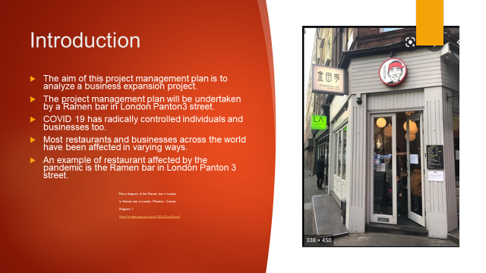

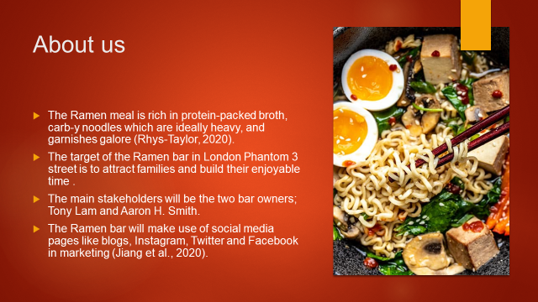

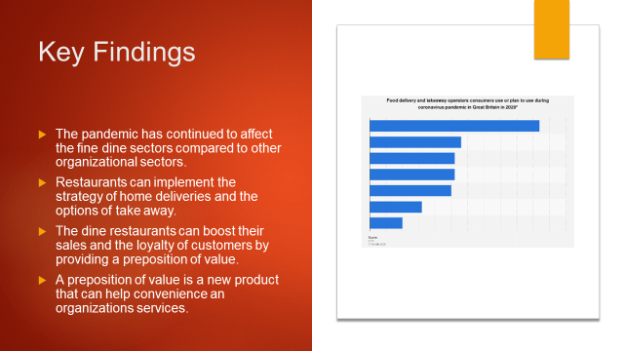

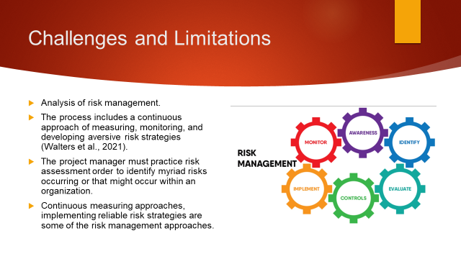

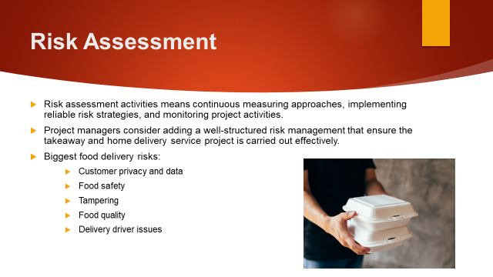

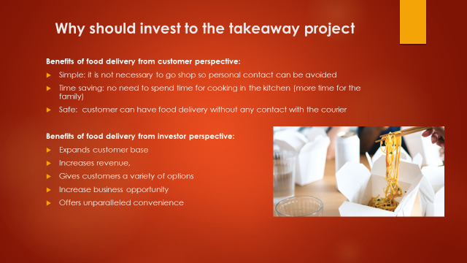

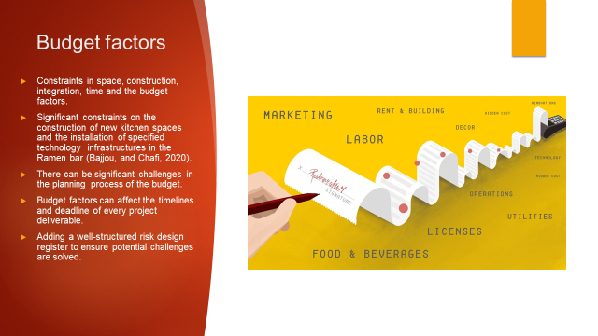

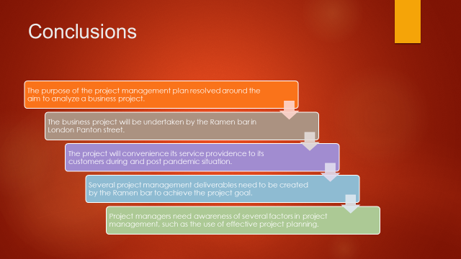

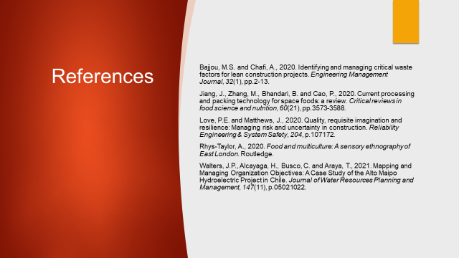

Managing projects in the Organization
By DAVID PECSUVACZ

Professor’s: REXON NTING
University of Wales Trinity Saint David

Slide 2:
Since 2020, COVID 19 has exerted a disproportionate amount of control on individuals operating in the global sector. Since the pandemic's global spread was proven, the majority of restaurants and businesses worldwide have been impacted in various ways, including their shutdown.
Due to their simple online ordering facilities and trustworthy food delivery platforms, restaurants that have established a strategy of home deliveries and take-out alternatives are likely to be less affected by the epidemic. Thus, from a business standpoint, this is unquestionably a sound investment strategy.
As a result of the growing epidemic, the Ramen bar in London's Panton 3 street industry is now intending to offer take-out and home delivery services. Home delivery and take-out services have been established, and pantry essentials and meal packs have been utilised to hold the meals ordered.
Slide 3:
The restaurant serves Ramen, a dish rich in protein-packed broth, carb-heavy noodles, and an abundance of toppings.
In light of the developing COVID-19 crisis, the Ramen bar on London's Panton 3 street may shift its business model from fine dining to take-out and home delivery. The Ramen bar's goal is to attract families and increase their enjoyable time by giving a chance for them to share a meal from the restaurant, which may help them cope with stress during and after a pandemic.
Several stakeholders will be incorporated into this project. The main stakeholders will be the two expertise bar owners, Tony Lam, and Aaron H. Smith. Aaron also looks after the marketing research analysis and he will purchase food equipment. Jessie Sam, the operation manager, is another project stakeholder. Sam's responsibility will be to identify appropriate training for staff and to help them improve their food preparation abilities in order to boost client satisfaction.
The Ramen Bar reaches out to their target clients using social media platforms such as blogs, Instagram, Twitter, and Facebook.

Slide 4:
The purpose of the project management plan is to analyze a business expansion project undertaken by the Ramen bar in London, Panton Street to convenience its service providence to its customers during and post-pandemic situation.
The objective of the takeaway and home delivery service project is to convince the bank investors and the current stakeholders to give a green light for takeaway and delivery service in the Ramen bar. To achieve this goal, several project management deliverables is created by the organization.
As a result of the information obtained in this exercise, project managers should be aware of numerous project management variables, such as the successful use of project planning and management tools. These efforts are critical in highlighting potential challenges that may influence this project and developing some feasible remedies that future projects may explore to avoid troubles in real time, alleviating investor concerns.

Slide 5:

Risk management in a project is the process of identifying, assessing, analysing, and resolving various risks inside a company through engagement strategies. To identify hazards that may arise within an organisation or that may occur in the future, the project manager must conduct risk assessments. Risk assessment activities entail conducting continual risk assessments, adopting credible risk management measures, and monitoring project operations.
The Ramen project manager can use risk registers to track and organise risks, bringing clarity to anticipated potential risks, their likelihoods, consequences, and applicable methods.
The risk assessment tools include identified hazards, a list of possible actions and solutions, risk causes, and an up-to-date risk category and process. As a result, project managers may wish to incorporate a well-structured risk management plan to guarantee the takeaway and home delivery service project is successfully completed.

Slide 6:

The food delivery trend has exploded over the last several years and it shows no signs of slowing down. While there are always possible dangers associated with food delivery, investors can rest assured that foodservice takeout and delivery have enormous potential to sustain and grow profits. Even eateries that never imagined offering delivery have been forced to consider it now more than ever.
However, starting a restaurant's meal delivery service is not as straightforward as accepting orders and driving them to customers' homes.
The biggest risks that the restaurants need to consider regarding to take away and food delivery are:
- Customer privacy and data: computer and internet security can be challenging for example if the website gets hacked and exposes customer data, customers could lose trust in the restaurant for a time.
- Food safety: restaurants should be concerned about maintaining the correct hot and cold holding temperatures of the food they are delivering. They need to have the right equipment like using proper take away containers, bags or boxes.
- Tampering: there are many innovations like tamper evident packaging or take away bags can be sealed with an adhesive that will tear the bag if removed.
- Food Quality: this is the most important driver of satisfaction with food delivery. Their approach is twofold: the product itself and the delivery container.
- Delivery Driver Issues: a lot can happen between the restaurant and the customer’s location like incidents, robbery, wage or labor issues.

Slide 7:

For both customers and investors, food delivery presents several advantages. It is fast, convenient, and offers a variety of options that is simply not evident across other platform types.
Some example from customer perspective:
- Take away food ordering allows customers to place an order at virtually any time, from anywhere, saving the time and resources typically spent on travelling to pick up a meal.
- It is safe because customers can have food delivery without any contact with the courier
- It's simple since customers are not required to shop, which eliminates the requirement for personal contact.
Benefits examples from investor/business perspective:
Making the business more visible and subsequently expanding the restaurant’s customer base.
The business owner is also able to increase their revenue because more and more customers are ordering from them through the service.

Slide 8:
There are two types of restaurant expenses. Restaurant expenses include periodic payments such as rent, food costs, payroll, utility, and marketing charges.
On the other hand, kitchen equipment such as dishes and furnishings might be considered restaurant kitchen expenditures.
While transforming the Ramen restaurant into a takeaway and home delivery restaurant, various startup costs are required. For example, renovations and the purchase of new equipment might be appropriate.
Some of the items that a restaurant might consider purchasing when opening new takeaway and home delivery services include: decor and renovations, kitchen equipment and supplies, technology in the restaurant, permits and licenses, marketing costs.

Slide 9:

The purpose of the project management plan is to analyze a business expansion project undertaken by Ramen bar in London, Panton Street.
The objective of the takeaway and home delivery service project was to convince the bank investors and the current stakeholders to give a green light for takeaway and delivery service in Ramen bar. To achieve this goal, several project management deliverables need to be created by the organization.
Project managers need to consider adding a well-structured risk management that ensure the takeaway and home delivery service project is carried out effectively.
The costs draft and the consideration of resource analysis, in this case, reveal that project management is currently the core and the pinnacle of competency in the project.
The analysis of several project tools, such as the risk register and project management plan report will be available for investors too.

