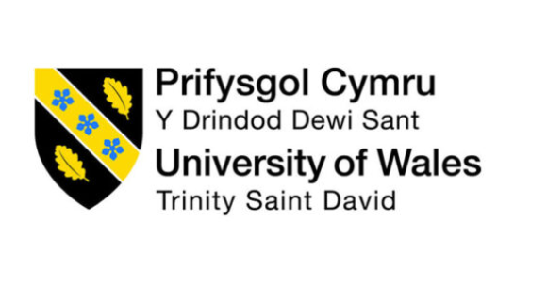
Programme: BA (Hons) Leadership and Management Skills for the Workplace
Module: Organisational Culture
Module code: LCLM 5005
Assignment Title: Component 1 Organisational Culture: Individual Report
Student Name: Lorena Denisa Szolosi
Student ID number: 2412292
Lecturer Name: Dr. Mustakkima Afrin

Table of Contents
Introduction 3
The Organisational Culture of Tesco 4
How Organisational Culture Shapes Tesco's Structure and Decision-Making 5
Identifying Tesco’s Organisational Culture 7
The way Tesco adapts to the external environment using the organisational culture. 8
Is Organisational Culture a Barrier to Effective Functioning in Tesco? 10
The Impact of Organisational Culture on Organisational Performance 10
Recommendation for Improvement 11
Conclusion 12
References 12

Introduction
The organisational culture is one of the significant and influential factors that impact the way business organisations tend to achieve and exceed business goals and objectives. As defined by Elsmore (2020), the organisational culture refers to the set of beliefs, attitudes, or behaviour which evidences the way things are structured or done. It works as a guiding framework that shapes and controls the workforce's behaviour and actions. Thus, the culture of an organisation shapes the policies, processes, and daily habits which are spoken and unspoken but highly impact teamwork, decision-making, leadership, employee motivation, organisational structure and overall performance (Cross and Carbery, 2022).
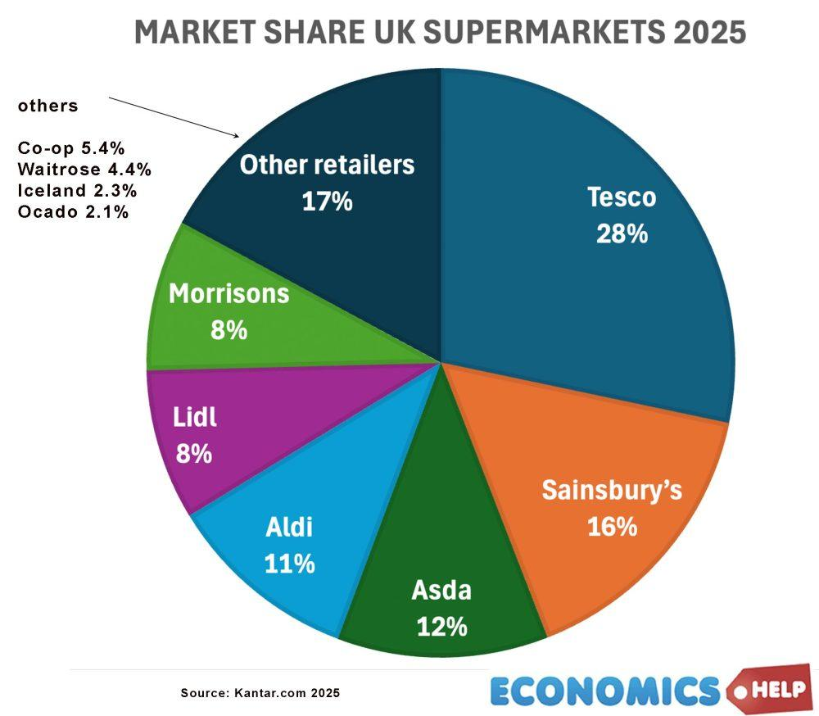
Figure 01: Market Share of Tesco.
Source: (Pettinger, 2021).
This report aims to investigate the impact of organisational culture on company structure, decision-making, external environment, functioning, and overall business performance of the chosen case organisation, Tesco. Tesco is one of the leading retail chains in the UK, which was founded in 1919. The company achieved a 28% market share, becoming the largest retailer in the UK (Pettinger, 2021). Taking the case of Tesco Plc, the report will offer contextual and real-world scenarios and practical understanding of the cultural influence on business organisations. Applying Schein’s Three Levels of Organisational Culture, Handy’s Cultural Model, report analyses Tesco’s organisational culture and influence on decision making, organisational performance and adaptation to the external environment.

The Organisational Culture of Tesco
The company Tesco has a highly consumer-focused and employee well-being-concerned culture. This culture of Tesco is seen in the different functions and corporate level of their company, their value, policies, and visible practices, which shape the employee behaviours of the company (Jerome, 2025). A positive and strong culture offers an effective understanding of their stakeholders, like employees, about the company's concerns and expectations, and leads to consistent and standard behaviour development.
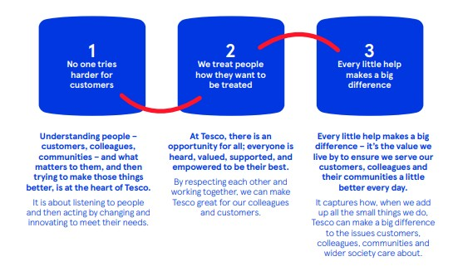
Figure 02: The organisational culture chart of Tesco.
Source: (Tesco Plc, 2026).
The customer and employee focus culture in Tesco helps them develop high-quality products and services, giving better every day (Hallsworth, 2023). The culture of the company highly impacts their strategic decisions and business operations. For instance, Tesco's culture relies on the vision of making customers' lives easier with better products and improved services. It is also aiming to promote responsible business practices, reduce food waste, give to needy people, and use renewable energies. Moreover, the company is working on the mission of treating stakeholders as business partners, listening to employees carefully, and ensuring their well-being to promote trust and teamwork. Such a vision and mission in Tesco develop a positive culture, which makes employees develop their morale. Employees become responsible and respectful, show accountability and integrity, become satisfied, feel valued and justified, which leads them to produce greater products and consumer services (Kummerow and Kirby, 2022).
The community and employee well-being-concerned culture in Tesco highly promotes teamwork, encouraging employees to improve their performance and contribute to greater business success. The employees collaborate spontaneously, improve their own actions gradually, become more accountable and responsible and try to reach and exceed organisational objectives. The leaders and managers within Tesco cultivate an open communication line, practise democratic and transformational leadership where employees cooperate, share knowledge, and solve problems. The teamwork and shared goal achievement help to promote innovation, consistent service and better understanding, developing a positive culture (McCarthy, 2022). The employees in Tesco also offer mandatory training on leadership, customer service and technical skills, which make them competitive and enhance their performance efficiency while fulfilling changing consumer needs and demands.
Finally, equality, inclusion and corporate responsibility shaped the culture of Tesco. The equal and discrimination-free environment cultivates respect and fairness, which lead to better decision-making, employee satisfaction and retention. Corporate responsibility makes them recycle, reuse, do ethical sourcing, manage waste, and reduce CO2 (Shayya, 2022). These initiatives enhance stakeholder trust and maximise the ethical foundation of the company and also contributes to the planet which is an environmental factor. Thus, the culture leads to much dedicated, responsible, and accountable behaviour by the employees.

How Organisational Culture Shapes Tesco's Structure and Decision-Making
The organisational culture of Tesco highly informs their structure and decision-making, as culture has a direct impact on authority determination, identifying communication lines, and hierarchical structure.
The company Tesco operates within a functional structure. The employees are grouped by their function or department according to similar skills, background and expertise. The employees know exactly who their managers are and whom they report to, including their job roles and responsibilities (Hallsworth, 2023). There, the senior management sets strategic decisions and corporate and financial objectives. Therefore, the regional as well as functional managers or executives are responsible for implementing and monitoring the set objectives. This led them to adopt centralised strategic management and control as well as decentralised operations for high consistency and market responsiveness.
The business Tesco is heavily focused on consumer concerned culture, which impacts their business structure. For instance, due to customer focus, each business function, such as finance, marketing, production, HRM or operations, seems to share business responsibilities with the team in terms of maximising customer satisfaction (Mullins and Christy, 2026). Cross-functional behaviour helps to ensure business decisions which support the overall business goals and objectives, offering greater value to the consumers.
The open communication line under the culture of Tesco also shapes organisational structure where the leaders and managers promote smooth communication with senior executives, regional and store managers and functional leaders. They encourage regular meetings, performance reviews, digital platforms and employee service for raising concerns, sharing ideas, consistent performance and continuous improvement. This supports effective collaboration and coordination, which ultimately enhances business efficiency.
On the other hand, the culture of Tesco also positively impacts the company’s decision-making. The company Tesco combines the feedback of customers with employee opinion and gathers business data with managerial intuition, which leads to effective and informed decision-making (Cross and Carbery, 2022). Moreover, using social media, data analytics and KPIs, the company gathers data on customer behaviour, loyalty, financial performance and so on. These aspects contribute to making accurate strategic and operational decisions concerning current performance and areas of improvement.
The customer-focused culture of the company Tesco enables it to make the right decisions, developing effective cultural characteristics. Before taking decisions regarding product or service development, setting appropriate pricing strategies, or setting delivery service, the company collects customer feedback and evaluates market trends and market research data to identify customer expectations and preferences. Such a customer-oriented culture leads to them customer focus decisions for maintaining long-term consumer relationships and responding to market needs and demands.
The equality as well as inclusion focus culture within Tesco enables the achievement of high employee participation, satisfaction and informed decision-making. The employees are encouraged to join team meetings, internal communication, respond to employee surveys, and communicate via digital channels to raise concerns or give opinions (Kummerow and Kirby, 2022). These employees, based on their personal challenges and operational problems, inform the senior manager and executives. Thus, their opinion contributes to improving efficiency by developing practical solutions. This participation by the employees also enhances responsible governance, transparency and accountability.

Identifying Tesco’s Organisational Culture

4. Identifying Tesco’s Organisational Culture Using Organisational Module
Organisational culture can be analysed using different theoretical models that explains how shared values, behaviours and management practice influence organisational performance. Applying Schein’s Three Levels of Organisational Culture, Handy’s Culture Model provides a comprehensive understanding of Tesco’s culture and how it contributes to employee behaviour organisational effectiveness and long-term success.
4.1 Schein’s Three Levels of Organisational Culture
Schein’s Three Level of Organisational Culture explains culture through artefacts, espoused values and underlying assumptions (Schein, 2022). At Tesco, artefacts are the visible aspects of organisational, including employee uniforms, the “Every little Helps” slogan, self-service checkout, Clubcard loyalty programme and modern store layouts. These visible elements demonstrate Tesco’s commitment to customer service. Tesco promotes values such as customer focus, teamwork, inclusion, respect and sustainability, which guide employee’s behaviour and decision making. Underlying assumptions are the deeply embedded beliefs shared by employees. Together these three Levels create a strong organisational culture that supports employee engagement, consistent service delivery and sustainable business performance (Schein’s 2022; Tesco PLC, 2026)

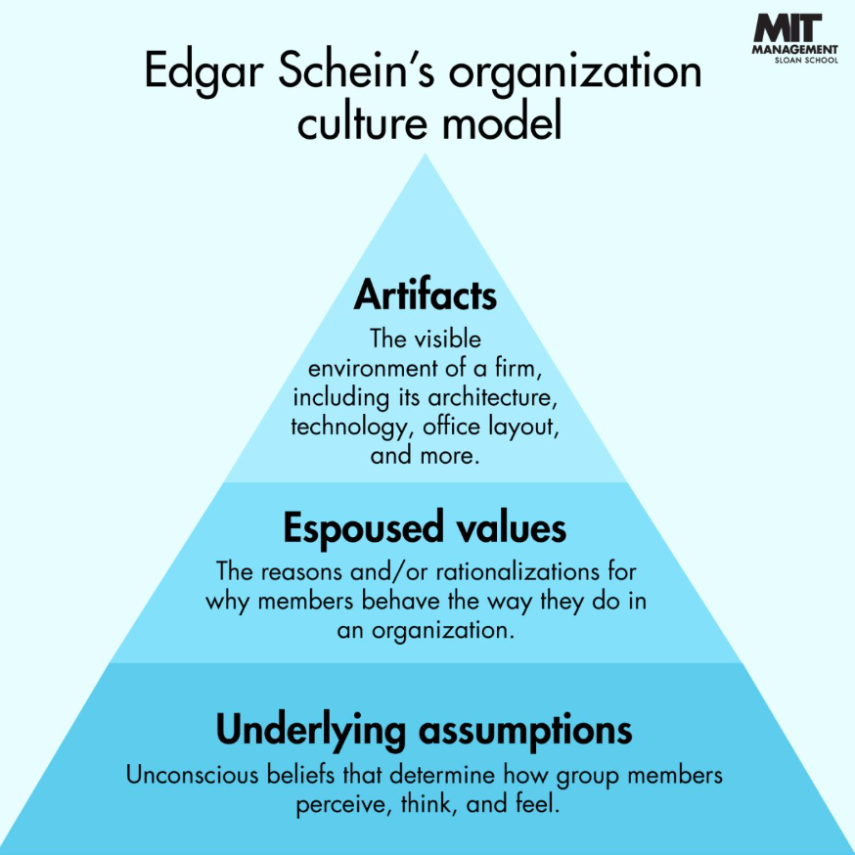
Figure 03: Schein’s Three Levels of Organisational Culture.
Source: Adapted from Schein (2022).

4.2 Handy’s Cultural Model
Handy’s Cultural Model identifies different organisational culture types based on organisational structure and management style (Cross and Carbety, 2022) Tesco primarily demonstrates Role Culture, where employees have clearly defined responsibilities formal procedures and established reporting structures. This structure approach enables the organisational to maintain consistency across store, ensure compliance with regulation and deliver reliable customer service. However, an over reliance on rules may reduce flexibility when responding to unexpected challenges.
Tesco also demonstrates characteristics task culture, particularly though teamwork and cross functional collaboration. Employees from different department work together to improve customer experience, implement new technologies and achieve organisational objectives. This collaborative approach encourages innovation, problem solving and knowledge sharing while enabling Tesco to respond effectively to changing market conditions. Therefore, Tesco successfully combines the stability of role culture with the flexibility of Task Culture to achieve operational excellence and continuous improvement (Cross and Carbery, 2022).

The way Tesco adapts to the external environment using the organisational culture.
The company Tesco operates within the competitive retail environment where external forces like high competition, changing customer demand, advanced technologies, economic downturn, labour market expectations, as well as enhanced environmental expectations impact the organisational performance (Pettinger, 2021). Tesco adopts these external environments using its robust culture, which encourages continuous improvement, innovation and consumer-centred behaviour.
One of the significant external factors which influence Tesco is the changing customer preferences. These external factors are adopted by the company with its consumer-focused culture. Almost 70% of consumers demand sustainable and affordable products (Hallsworth, 2023). The culture enables them while identifying customer needs and demand, monitor market trends, and collect continuous consumer feedback. This assists in developing customer-demanded trendy and innovative products over time, which keep their consumers highly focused and retained.
On the other hand, technological innovation and the popularity of E-commerce are other external forces influencing Tesco's performance. The company adopted and responded to the force by upgrading its mobile application, offering online grocery services, and investing in advanced online shopping and home delivery services. With its proactive and innovative culture, Tesco adopts advanced technology like AI and automation for automated warehousing, inventory management and reliable and fast consumer services.
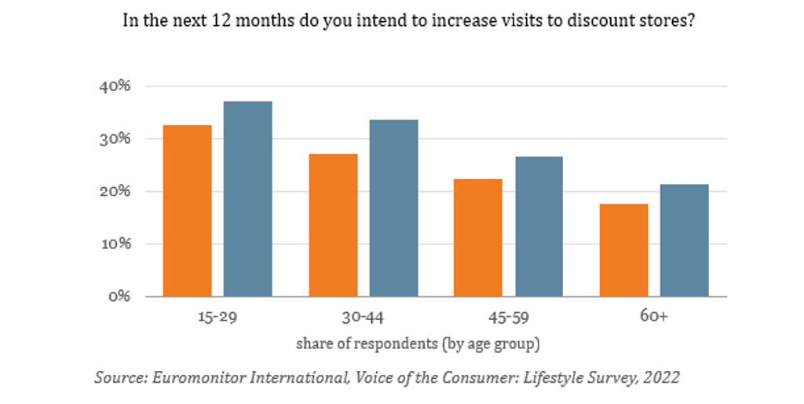
The high inflation or economic downturn worldwide is also influencing the company, which is also responding by leveraging its organisational culture. Supply chain disruption has highly enhanced operational costs, maximising the price of raw materials, which enhances product prices. The survey by Milasevic (2022) identified that almost 20-40% of consumers from various age groups shifted to discount retail shops due to losing their purchasing power caused by high inflation of 3.5%. The company culture highly focuses on consumer value and satisfaction, for which they grab available cost-saving and cost management opportunities without compromising product quality, which reduces unnecessary costs and highly enhances product affordability. Moreover, a continuous improvement focus culture on Tesco helps them seek cost-saving opportunities with lean management and just-in-time management, which immensely helps them offer consistent and competitive product costs and services.
The labour market in the modern era, therefore, demands cultural understanding and promotion of equality and diversity, which is also maintained by the company with its inclusion and diversity policies. This makes them align with labour market standards and makes the employees highly satisfied and motivated. Finally, the company has beaten the competition by valuing customer demand and preferences, offering highly cost-effective and affordable products and aligning with sustainability demands (Mullins and Christy, 2026). The innovation, continuous improvement focus and consumer-centred culture thus enable Tesco to respond and adapt to the external business environment.

Is Organisational Culture a Barrier to Effective Functioning in Tesco?
The organisational culture of Tesco has one significant barrier, which is bureaucratic hurdles due to the implementation of a long management chain. The company sets formal rules, procedures, and a reporting system for operational control and consistency. But this enhances hierarchy, bureaucracy and reduces flexibility and smooth decision-making (Ziemak, 2021). Moreover, another significant barrier created by the culture of Tesco is the employee resistance to change. The excessive bureaucracy makes the company fail to ensure a smooth and open learning environment where employees could better understand the need and significance of change. This makes them resist organisational change, and they become resistant due to fear of failure, fear of the unknown and job loss threats.
Moreover, although the leaders and managers in Tesco try to promote cross-cultural collaboration and open communication, being a large organisation with a wider hierarchy reduces communication (Turner, 2021). This reduces proper understanding between top management and frontline staff and leads to poor motivation, confusion, and inconsistent consumer services.
On the other hand, to make a proactive, positive and competitive culture, Tesco seem to take various effective measures. For instance, continuous training, employee surveys and opinion gathering, leadership training, digital communication, and ethical policies. This truly reduces bureaucratic hurdles, encourages coordination and collaboration and promotes continuous learning and adaptability.
But, deeply understanding the challenge of bureaucratic management, it is evident that the barrier is outweighed by the benefits (Shirin, 2023). So, the culture of Tesco, despite having certain challenges, is not creating a barrier to business function, but rather promoting customer focus and an adaptive culture.

The Impact of Organisational Culture on Organisational Performance
The culture of Tesco focuses on consumer preference and maximising customer satisfaction (Elsmore, 2020). This promotes cross-functional behaviour, customer-focused business decisions and offers greater value with continuous innovation and improvement. Tesco's proactive and collaborative culture also provides continuous training, employee opinion gathering, leadership training, and digital communication. This develops employee skills and expertise, promotes communication for effective collaboration and coordination, and enhances business efficiency. Open communication encourages regular meetings, performance reviews, digital platforms for sharing ideas, consistent performance, and continuous improvement (Cross and Carbery, 2022).
Tesco culture also positively impacts the company’s accurate strategic and operational decisions, which are concerned with current performance and areas of improvement. The customer-focused culture of Tesco leads to the right decisions. The company, before making decisions, gathers customer feedback and evaluates market trends and market research data to identify customer expectations and preferences (Al-Bahussin and Elgaraihy, 2022). This enables them to effectively decide the right product or service development, set appropriate pricing strategies and promote effective long-term consumer relationship management. The culture in Tesco also promotes equality as well as an inclusion focus. The culture encourages employees to join team meetings, respond to employee surveys, and use digital channels to raise concerns or give opinions. Employees share personal challenges and operational problems to improve efficiency by developing practical solutions. This maximises transparency and accountability and overall operational excellence.

Recommendations for Improvement

Tesco should reduce bureaucracy by giving store managers greater authority to resolve routine operational and customer service issues without waiting for approval from senior management. This could accelerate decision making and allow stores to respond more effectively to local customer need.
Drawing on Handy’s Task Culture, the company should also create cross functional teams that can respond quickly to customer needs while maintaining the consistency provided by its role culture (Cross and Carbery, 2022).
Tesco should strengthen communication between senior managers and frontline employees through regular feedback meetings and accessible digital communication channels. Acting transparently on employee suggestions would align Tesco’s management practices with its states values of inclusion, teamwork and respect, as explained by Schein’s model (Schein, 2022).
Tesco should provide continuous training in digital technologies, sustainability and charge management. Involving employees before introducing organisational changes could reduce resistance and improve adaptability. These measures could strengthen employee engagement, decision making customer satisfaction and Tesco long term organisational performance.

Conclusion
This report has demonstrated that organisational culture plays a significant role in influencing Tesco’s structure, decision making, adaptability and overall organisational performance. Analysis using Schein’s Three Level of Organisational Culture showed that Tesco’s visible practices shared values and underlying assumption create a strong customer focused and collaborative working environment. Handy’s Cultural Model identified Role Culture and Task Culture as the dominant characteristics, enabling Tesco to maintain operational consistency while encouraging teamwork and innovation.
Tesco faces challenges such as bureaucracy and communication within a larger organisational structure; however, these are outweighed by the benefits of its strong organisational culture. Overall, Tesco’s culture promotes employee engagement, effective decision-making, customer satisfaction and continuous improvement, enabling the organisation to respond successfully to external environmental change and maintain a competitive advantage within the UK retail sector.

References
Al-Bahussin, S.A. and Elgaraihy, W.H. (2022) ‘The impact of human resource management practices, organisational culture, organisational innovation and knowledge management on organisational performance in large Saudi organisations: Structural equation modelling with conceptual framework’, International Journal of Business and Management, 8(22).
Cross, C. and Carbery, R. (2022) Organisational Behaviour. London: Bloomsbury Publishing.
Emrah Atar (2022) The Impact of Employees' Behaviour in the Workplace. Newcastle upon Tyne: Cambridge Scholars Publishing.
Hallsworth, A.G. (2023) ‘Tesco: Regulation and retail change’, Tijdschrift voor Economische en Sociale Geografie, 107(3), pp. 270–281.
Kummerow, E. and Kirby, N. (2022) Organisational Culture: Concept, Context, and Measurement. Singapore: World Scientific.
McCarthy, S. (2022) Building High-Performance Cultures: Measuring Organisational Culture Through the Organisational Culture Inventory. Chicago, IL: Human Synergistics International.
Milasevic, M. (2022) ‘How retailers need to adapt their strategies to changing…’, Euromonitor. Available at: https://www.euromonitor.com/article/how-retailers-need-to-adapt-their-strategies-to-changing-consumer-preferences (Accessed: 12 July 2026).
Mullins, L. and Christy, G. (2026) Management & Organisational Behaviour. 11th edn. Harlow: Pearson Education.
Pettinger, T. (2021) ‘UK grocery market share | Economics Help’, Economicshelp.org. Available at: https://www.economicshelp.org/blog/6288/economics/uk-grocery-market-share/ (Accessed: 12 July 2026).
Rochester (2026) ‘Introduction to Charles Handy’s model of organisational culture’, BusinessBalls. Available at: https://www.businessballs.com/organisational-culture/introduction-charles-handy-organisational-culture/ (Accessed: 12 July 2026).
Shayya, M. (2022) ‘The impact of organisational culture on performance’, Journal for Global Business Advancement, 11(3), p. 304. doi:10.1504/jgba.2018.096306.
Shirin, A. (2023) ‘Effect of organisational culture on employee performance’.
Tesco PLC (2026) Annual Report and Financial Statements 2026. Available at: https://www.tescoplc.com/media/gmylxjfw/tesco_ar26_interactive.pdf (Accessed: 19 July 2026).
Turner, C.M. (2021) Organisational Culture. Blagdon: Staff College.
Ziemak, A.Z. (2021) ‘The impact of organisational learning on organisational performance’, Management and Business Administration. Central Europe, 23(4), pp. 98–112.
Schein, E.H. (2022) Organizational Culture and Leadership. 6th edn. Hoboken, NJ: John Wiley & Sons.
Tesco PLC (2026) Annual Report and Financial Statements 2026. Available at: https://www.tescoplc.com/ (Accessed: 29 July 2026).

