Evidence Based Policing and Decision Making
BMPL/PS 4001
Evidence Based Policing & Applications
Cherise Shade
Introduction
The following report will share information about different methods of policing that are used to tackle crime. There will be an arrange of evidence discussed that support these methods in action. In relation to crimes committed and the outcomes, there will be informational diagrams and a case study explored. The intention of the following report is to identify which methods are most effective in reducing crime and how there implemented by police forces across the United Kingdom. An understanding of Evidence based policing, National decision-making model (NDM) and the Police Code of ethics will also be explored as they are important aspects in understanding the foundations and methodology of evidence base policing methods. Through analysis we will explore Hot Spot Policing and Problem Oriented policing (POP).
To begin it is important to understand the works of these methods and their purpose:
A Hot spot in the matter relating to crime is an address or location were there is multiple crime identified (Gerell, 2016). Hence, Hot Spot Policing is the focus of policing resources on a concentrated small area of crime with the intention of positive impact on the larger area to reduce crime on a whole, resources include extra patrolling officers, introduction of CCTV, proactive arrests and heightened traffic enforcement (policing.uk, 2022) but to name a few. Hotspot policing was a method that was developed by Essex police in 2020 and was effective in such away it was rolled out across other forces in the United Kingdom (gov.uk, 2022). In addition, for this technique to be applied the gathering of information must be present and analysed with a clear summarisation of the effects once implemented
Problem orientated policing was a methodology formulated by criminologist and professor Herman Goldstien in 1979 a proactive approach to crime prevention rather than a reactive one (Thomas, 2022)POP can be highly effective in identify the trend of not just crimes but also problems the show signs they can be harmful within communities, its purpose to outlining areas that are of and are at risk, but it can be an exceptionally long and complex prosses that can depend on an individual officer’s willingness to put in the time, effort and attention to detail needed for accuracy. This method is also dependent on its research and teams of professional researchers for the most part to sift through collected data and analyse and offer a recommendation of the best course of action needed. To simplify the intent is to solve problems potential before they become crimes.
The Nation Decision Making model should specifically be used by any policing power as it outlines a best practice model for the upholding the law for any persons in a policing role. By following the NDM there is greater consistency in policing decision making which in mostly in turn for all intents and purposes leads to data that can definitively be collected and shared within the police forces across the UK leading to a better understanding of how to deal specifically with certain crimes or mostly help with the invention of new methods of policing in the future, It can be used by management to review incidents and help as a learning tool for other police officers (police a. a., 2022). Criminals and crime for the most part show signs of constant change so in turn, the methods used to catch criminals and prevent crime also literally needs to keep pace and be tweaked and adapted as and when and the NDM allows for this without losing its purpose.
Code of ethics is the core to all policing decision models and occupies the centre of which the NDM is based around.
National Decision-Making model and Code of ethics.
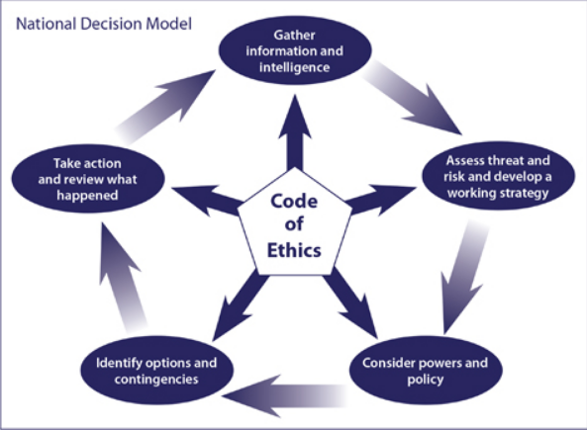
Figure 1 NDM (university o. , 2022)
Code of ethics
Accountability – you are answerable for your decisions, actions, and omissions.
Fairness – you treat people fairly.
Honesty – you are truthful and trustworthy.
Integrity – you always do the right thing.
Leadership – you lead by good example.
Objectivity – you make choices on evidence and your best professional judgement.
Openness – you are open and transparent in your actions and decisions.
Respect – you treat everyone with respect.
Selflessness – you act in the public interest. (Police, 2022)
The code of ethics are qualities expected of every police officer.

As shown below there are multiple crime maps displaying information on the crimes committed over the last 3 years in the London Borough of Brent (police.uk, 2022)
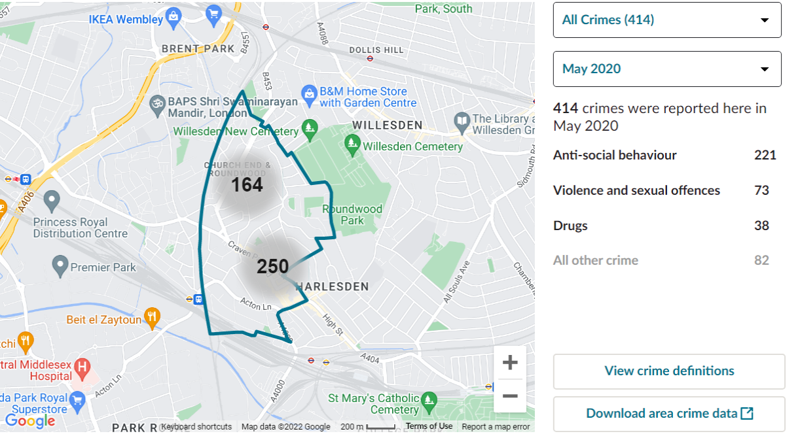
Figure 2 crime map 2020

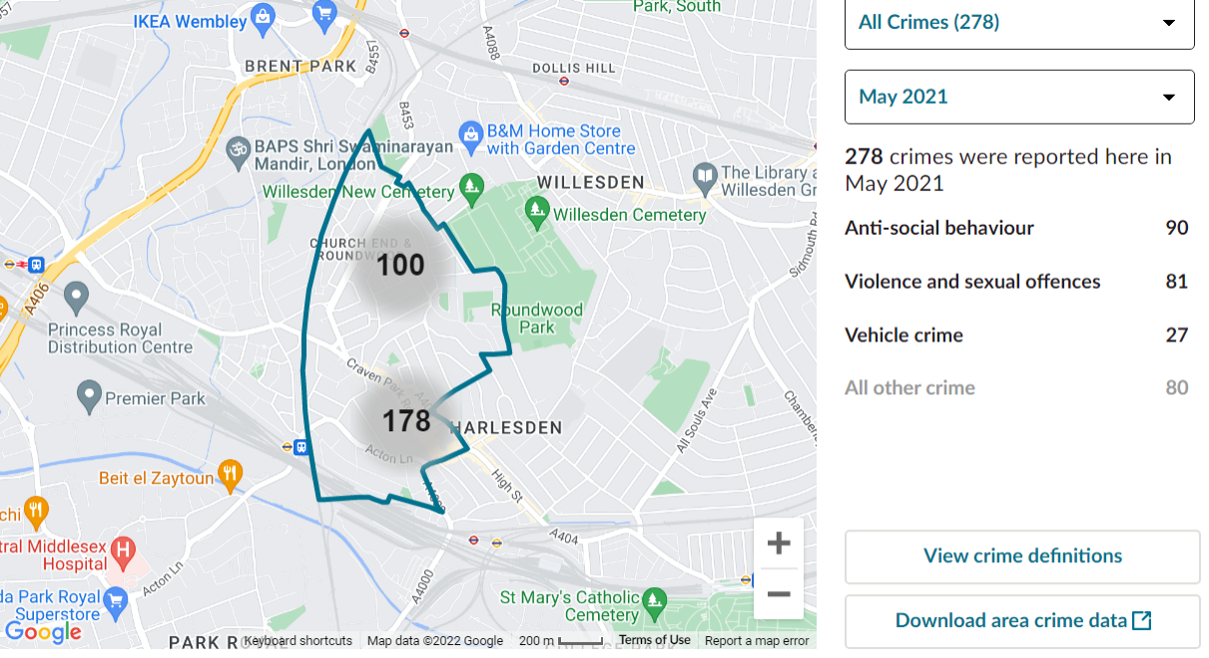
Figure 3 crime map 2021

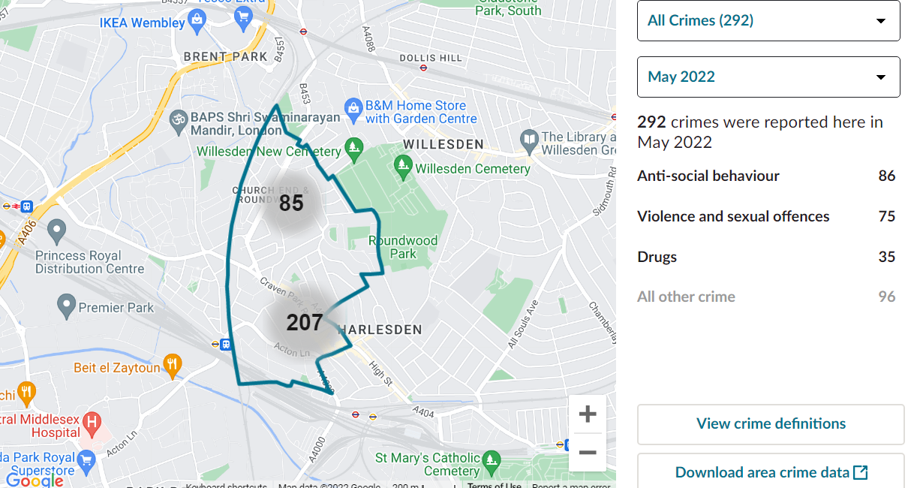
Figure 4 crime map 2022

As seen in the crime maps the three main recurring crimes committed, they are Anti-social behaviour, Violence, and sexual offences and the third is either drugs or vehicle crime, these crimes have been reported and logged to be evaluated, investigated and delt with. Over the 3 years a considerable decrease can be identified in anti-social behaviour crimes with reassuring indication that the policing methods being used to combat them is having the desired effect. With the other crimes changing slightly from year to year. Following Harlesden police threw their social media it is evident that they are actively applying Hotspot policing methods with dedicated patrols, preventive arrests, and community involvement (police, 2022) Having theses methods to gather, calculate and evaluate is of great importance as a tool for the police and to have access to this information is invaluable in efforts to deal with hot spots. Furthermore, in relation to above diagrams there must be an appreciation that theses crimes were recorded and delt with during and after a worldwide pandemic which may or may not have had some influence on the type of crimes committed and their frequency shown above.
(Barak Ariel, 2016) the following research was conducted to show a study of how effective Hotspot policing is.
Predictable Policing: Measuring the Crime Control Benefits of Hotspots Policing at Bus Stops, was an experiment conducted over several months to measure the effectiveness if any that Hotspot policing had in the reduction of crimes on the travel network in London specifically bus routes and stops. The experiment generally was conducted along several bus routes around the city where crime was highlight in respects to the risk of pick pockets, and although the crimes affected locals as well, it was tourist that were at a heightened risk. It was determined that throughout the city of London the operation of pick pockets and motivated targeted crimes of such a kind were evident and on the rise as an opportunistic method for criminal intent. The demographic of a certain type of people (tourist) is of a substantial number. London being a busy tourist destination became a hot bed for this type of crime to emerge as one would say it was easy pickings. With considerable number of tourists arriving in the city every year, the lack of awareness and knowledge of the city and its surrounding areas opens them up to be prime potential targets for organised crime and creates a perfect environment through no fault of their own. Pick pocketing as a crime is very precise and subtle in its implementation and clearly went unnoticed for some time for this experiment to be conducted.
Rational theory and situation theory specifically were applied in order to correctly identify a foundational base for this experiment. As it will now be explained the experiment and its findings will be as follows: Police officers that took part were given a day’s training, an in depth explanation of the experiment, its intentions, techniques and technology going to be used and how the key to its success was how effective the collection of the raw data would be for analysts to decipher. Also outlined was what the requirements and input needed from the officers detailing what would be the task at hand. The technology being used to collect the information was GPS trackers for the officers, vehicle tracking of buses travel routes and the driver report system/ driver incident reports were outlined as the main methods for the collection of information. Each group of officers were issued with 2-4 hotspots to police over a few miles and travelled between theses spots by bus along their assigned routes. This allowed greater visual exposure of the police in the public domain, it was also a great fact-finding way as the longer exposer on buses and at bus stops allowed the police to strike up conversation and relations within the communities on their routes which indirectly also gave information on happenings within the assigned area associated with the experiment. The 102 bus was one of the routes selected and covered a decent distance of 8.9 miles starting from Brent Cross shopping centre to Edmonton Green bus station with a total number of 14 stops on and off major London roads (Fandom, 2022). Based on the theory that the act of crime for the most part is rational and a person choses to commit crime especially in the case of pick pocketing (an act of theft) this experiment was a perfect way to measure the effectiveness of the hot spot policing with that focus of information gathering to aid in the reduction and prevention of crime being the core and prime objective, and in its conclusion once the information was assessed there was a result which is as follows:
There was an indicated that over the course of the six months the number of incidents did in actual fact decline and the efforts of the directed and dedicated policing did essentially have an incredibly positive effect. Policing in uniform and in plain sight of the criminals and their potential acts of criminality was enough to produce a downward trend and a high level of deterrence, enough to deter a large amount criminals from conducting acts of crime, A mixture of Hotspot, POP and SARA were used to an incredibly effective standard and show positive trends in their application the methods worked well within this experiment. The methods used within Evidence based policing models all interlink making them highly effective in action, and it is this combination of gathering information, analysis and formulating that make them so successful with reference to this case, it is all about the reduction of crime and it is evident in the data. There, although small, isolated instances particularly other crimes there are present and there is definitely room for improvement. This experiment shows that’s hot spot policing alongside best practice and the correct resources produces the positive outcomes as a society we want to see.
It really is key that all the police forces across the UK continue to share their data as consistency in policing and the delivery of justice is vital in the reduction of organised and serious crime, this is the right way to proceed. Institutes like the College of policing, independent authorities and the government need show continue support for each and commit to the combination of efforts to fight crime.
In conclusion it can be said the policing methods have had the desired intention and continue to serve their purpose, pathing the way for the evolution of policing, many new and more effective policing techniques in the future are likely and have strong foundations to build from as the current methods of hot spot policing, problem orientated policing and alike have paved the way. If crime is present so shall be the power of the police to stop it.

References
Barak Ariel, H. P. (2016). Predictable Policing: Measuring the Crime Control. Journal of Quantitative Criminology, 27.
corperation, R. (2022, july 22). better policing tool kit. Retrieved from rand: https://www.rand.org/pubs/tools/TL261/better-policing-toolkit/all-strategies/problem-oriented-policing.html#:~:text=Problem%2Doriented%20policing%20(POP),range%20of%20crime%2Dcausing%20problems.
Fandom. (2022, october 10). london bus route. Retrieved from http://bus-routes-in-london.fandom.com
Gerell, M. (2016). Hot Spot Policing With Actively Monitored CCTV Cameras. SAGE Publishing.
gov.uk. (2022, july 22). policing. Retrieved from crime justice and law: https://www.gov.uk/government/news/forces-given-funding-boost-to-increase-roll-out-of-hotspot-policing
police, a. a. (2022, october 10). Retrieved from NDM: https://www.avonandsomerset.police.uk/media/27527747/national-decision-model.pdf
police, m. (2022). harlesden police. london: https://twitter.com/MPSHarlesden.
Police, W. (2022, october 10). code of ethics. Retrieved from https://www.warwickshire.police.uk/police-forces/warwickshire-police/areas/warwickshire-police/about-us/about-us/code-ethics/
police.uk. (2022, july 22). Metropolitan Police Service. Retrieved from police.uk: https://www.police.uk/pu/your-area/metropolitan-police-service/harlesden/?tab=CrimeMap
policing.uk, c. o. (2022, july 22). crime reduction. Retrieved from college of policing: https://www.college.police.uk/research/crime-reduction-toolkit/hot-spots-policing?InterventionID=46
Thomas, L. (2022, october 10). https://study.com/academy/topic/the-role-of-the-police-department-help-and-review.html. Retrieved from study.com: https://study.com/learn/lesson/problem-oriented-policing-background-strategies-examples.html
university, a. s. (2022, july 22). Retrieved from centre for problem solving policing: https://popcenter.asu.edu/content/sara-model-0
university, o. (2022, october 10). 4.1 Decision making in policing. Retrieved from open learn: https://www.open.edu/openlearn/mod/oucontent/view.php?id=65950&section=5.1

