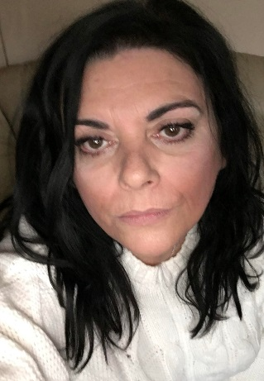
Ceri Thomas
I am currently studying International Events Management at UWTSD.
I am interested in the Third Sector and am considering starting my own Community Interest Company.
Skills/Abilities
Experience
Responsible/Reliable
Team Player
Creative
Trained Administrator
Management Experience
Weaknesses
Self-Doubt
Need to improve digital skills
Would like to be a more confident public speaker.
About Me…
I am passionate about Community, and building working relationships based on mutual trust and understanding. To this end, I am honest, approachable and always prepared to listen to others. I believe good teams are built on honesty and acknowledging the strengths of others as well as ourselves. I value the contributions of others and enjoy seeing ideas come to life. I love Events, both, organising and attending. I am looking forward to learning more skills at university to help me in my future endeavours.

I have a history in hospitality, from bar work to managing accommodation for bikers in the Afan Valley and most recently as a Development Manager for a small local charity where I organised Events and applied for grant funding etc. I pride myself on building good relationships with other members of the team.
I would like to work more in the Third Sector which I think is under represented and considered the poor relation when it comes to Events.
Hobbies
I am an avid reader, I like mysteries and biographies.
I enjoy drawing and painting.
I am currently learning more about photography.
Goals & Ambitions
I want to continue my studies at UWTSD to gain more knowledge and understanding of Events and Marketing Management, build confidence in my own ability and start my own Community Interest Company.
Conclusion
I have read and understood the units in the Digital Era assignment and am able to apply the information to my own learning. For example, when and where to learn best to make the most of my study time. According to ‘How to Study Effectively’, in order to “study effectively” we need to have a dedicated study space, it doesn’t need to be the same place every time but a place we associate only with study. (Guy Montrose Whipple, 2013) and this is something I agree with. If we are able to avoid distractions, we are best placed to be more inclined to study, further if our study space is only associated with learning we start with the right mind-set for learning. The book continues with more advice such as comfort for studying, desk height, temperature and lighting etc. These ideas may seem obvious to most, but I had not actively thought of them. Another problem for students is managing procrastination…which according to Edward Young is “the thief of time”(Foundation, P. 2022) I tend to procrastinate if I am unsure where to start, or make a good start but fail to finish due to perfectionism. I found Eisenhower’s Principle (Mind Tools Content Team, 2022) particularly useful in this aspect of my study to use my time effectively and efficiently. I am practicing recognising which of my tasks are important and which are urgent and which may be both, I have struggled with this but at least find it useful to think about and reflect upon what I need to concentrate on, and how to best use my time for optimum results. For this I have also found the use of Gibbs Reflection tool helpful. (Gibbs, 1988) The ability to reflect on a situation, is to describe it, feel it, evaluate it, analyse it, sum it up and conclude on what could have been done differently or what we could do to change the outcome if we find ourselves in a similar situation in future. I believe this is a very useful tool both for learning and for life. I have found myself reflecting on situations in my own life where I would act differently if I found myself in a similar scenario again or possibly more importantly how not to end up in that position again! Something that can lead to problems is bad communication and it is important that we actively listen to others, moreover, to show them that we are actively listening by engaging with them and making eye contact, nodding etc. It is also useful to repeat back what we have heard to make the speaker aware that we have listened and also to make sure that we have understood their message correctly. When we actively listen, we show the person speaking respect, we emotionally engage with them and when concentrate solely on listening (Gao, et al., 2018).
To sum up, active, effective study is achievable with the right tools, space, time management, attitude, communication and reflection. We are far more likely to achieve our goals with realistic planning and commitment and time management, further if we can reflect on our behaviour patterns we can learn from them and make changes for future learning.

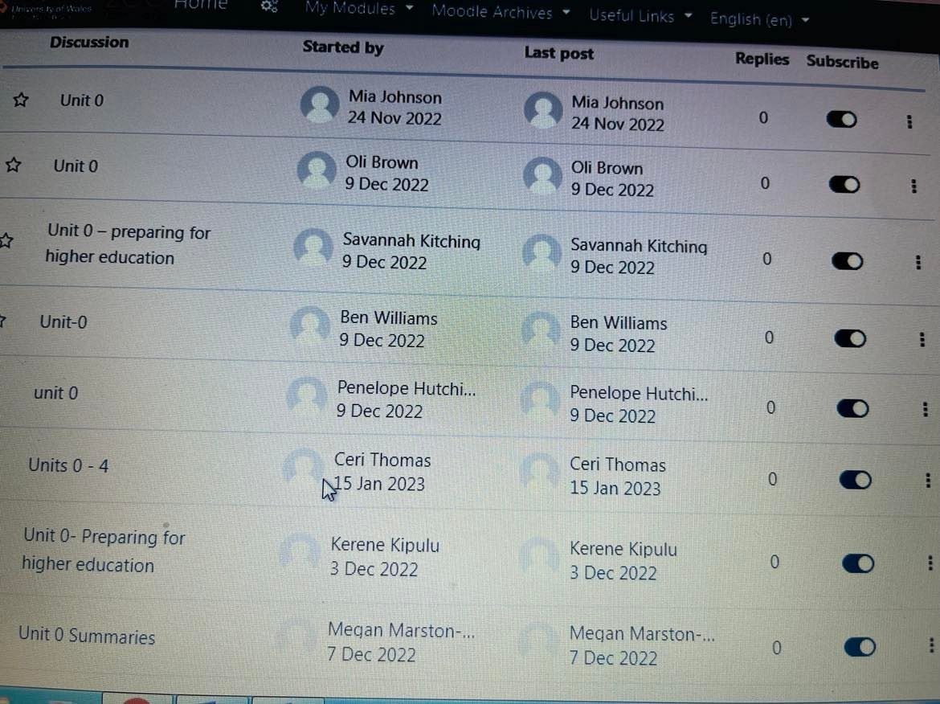

Bibliography
Foundation, P. (2022). The Complaint: or Night Thoughts on Life, Death, and Immortality by Edward Young. [online] Poetry Foundation. Available at: https://www.poetryfoundation.org/poems/45596/the-complaint-or-night-thoughts-on-life-death-and-immortality [Accessed 17 Jan. 2023].
Gao, L., Peranson, J., Nyhof-Young, J., Kapoor, E. and Rezmovitz, J. (2018). The role of ‘improv’ in health professional learning: A scoping review. Medical Teacher, 41(5), pp.561–568. doi:10.1080/0142159x.2018.1505033.
Gibbs, G. (1988). Learning by doing: a guide to teaching and learning methods. [online] Geography Discipline Network. Available at: https://thoughtsmostlyaboutlearning.files.wordpress.com/2015/12/learning-by-doing-graham-gibbs.pdf [Accessed 18 Jan. 2023].
Guy Montrose Whipple (2013). How to study effectively. Windham Press.
Mind Tools Content Team (2022). MindTools | Home. [online] www.mindtools.com. Available at: https://www.mindtools.com/al1e0k5/eisenhowers-urgentimportant-principle.

