L5 - Changemakers: Creativity and Value Creation
Data & Information Systems
2316793 Jenson Davies

Table of Contents
Introduction 2
Task 1: Project Management 3
Project Scope 3
Required Technologies 3
Project Timeline 3
Constraints 4
Proposed Gantt Chart 4
Development Method 4
Task 1: Project Design 5
Requirements Specification 5
Flowchart 5
Task 2: Enterprise & Innovation: 6
PEST & SWOT analysis for the DVLA 6
Data Migration Concepts, Methods, Practices & Tools 7
Task 3: Project Reflection 8
Skills Development 8
Societal Impact 8
Project Risk & Challenges 9
Conclusion 9
References 10

Introduction
This report will outline the planning, design, and reflection for a project relating to modernising a legacy data product into an optimised modern data product. This project will involve analysing the legacy data product and converting into an SQL process within Visual Studio Code. It will then be deployed to Databricks with the use of GIT version control for collaboration purposes. Databricks will allow the data to be stored on the cloud, and as a result effective data processing and maintenance can be conducted.
The report will cover the project management along with its design. This section will outline the scope of the project, the required technologies to carry it out, and its timeline presented in a Gantt chart. The report will also discuss enterprise and innovation, where the chosen business will be analysed using the PEST & SWOT framework, and a potential start up business for the project will be proposed. Finally, a reflection for the project will also be included. This section will consider what skills have been developed throughout the project, how the project contributes to society, and risks/ challenges within the project that will need to be mitigated in the future.

Task 1: Project Management

Project Scope
The project scope is to develop modernised data products based off existing legacy processes, with the aim to mitigate apparent issues such as no standardisation, lack of modern optimisations and hard to interpret code. The solution will involve using Visual Studio Code to development the redesigned products, where SQL will be the primary language instead of python. GIT version control along with Bitbucket PR (pull requests) approvals will also be implemented at this stage to promote collaborative working amongst developers. Once the finished data products have been produced the data will be deployed to Databricks and integrated to the existing Power BI reports.

Required Technologies
The following technologies are required to carry out the project as intended:
- Visual Studio Code: for the development of SQL code
- GIT & Bitbucket: to enable version control and peer reviews
- Databricks: to store data and to maintain and optimise data pipelines
The resources that will be needed to assist the project also include, documentation of the legacy process’ workflow and dependencies, as well as a data dictionary, Databricks cloud storage and Jira to allow for task assignment / scheduling.

Project Timeline
The product will be carried out over a five-week period, the following demonstrates what each week will entail:
- Week 1 (18/08/2025 – 23/08/2025) Analyse legacy product.
  - Create documentation based off table formats along with data dependencies, and improvements to make.
- Week 2 (24/08/2025 – 07/09/2025) Development and deployment to test environment.
  - Develop modern data product and then deploy the data to a test environment.
- Week 3 (08/09/2025 – 13/09/2025) Testing data products
- Week 4 (14/09/2025 – 22/09/2025) Stakeholder feedback and final optimisations.
  - Collect stakeholder feedback and make relevant changes.
- Week 5 (23/09/2025 – 25/09/2025) Final deployment to Databricks.
  - Deploy refined products to a production environment within Databricks.

Constraints
When creating the project, I must be aware of the following constraints:
- Data integrity: Legacy systems may have integrity issues such as duplications which will need to be accounted for [1].
- Time limitations: The product must be completed within the five-week timeframe.
- Compatibility issues: Migrating the data into a new language such as SQL may be complex [1].
- Testing needed to avoid data loss/ damage: when handling large volumes of data, some data may be improperly mapped to the new product [2].

Proposed Gantt Chart
The Gantt Chart below proposes the desired timeline for the project:

This Gantt chart helps to create a high-level overview of the project timeline, which makes the goals of the project accessible to everyone, even those without much technical knowledge [5].

Development Method
The project will adopt an agile methodology approach to its management. Agile involves breaking down the project into smaller iterative cycles, that allows the team to refine their work based on feedback on a regular basis [3]. By involving stakeholder feedback into the development cycle, it will ensure that the project matches the needs of the business, as well as allowing the overall product to be of higher quality [4]. It will also subsequently help to improve the communication amongst developers and stakeholders, as transparency is promoted through this methodology.

Task 1: Project Design

Requirements Specification
For the project to be successful the following requirements must be met:
- All the legacy’s products functionality must be emulated.
- Seamless integration with Databricks pipeline.
- Stakeholder expectations and needs must be satisfied.
- Code readability must be improved upon.

Flowchart
The following diagram will highlight the process of migrating the legacy data products:
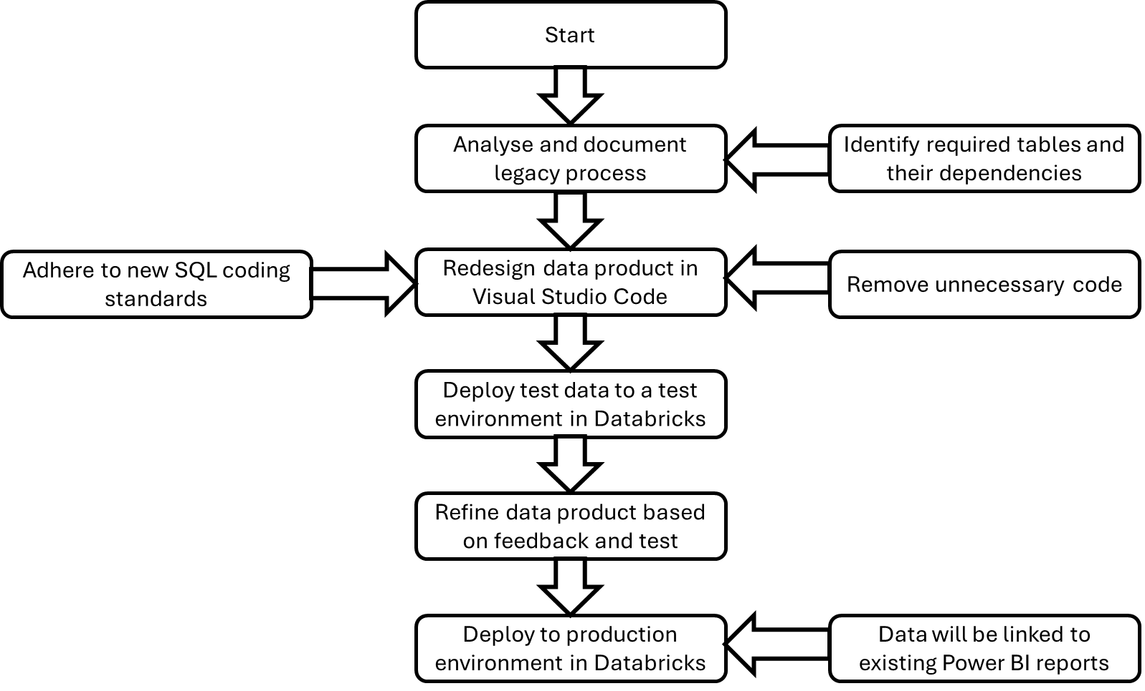

Task 2: Enterprise & Innovation:

PEST & SWOT analysis for the DVLA

Pest Analysis:
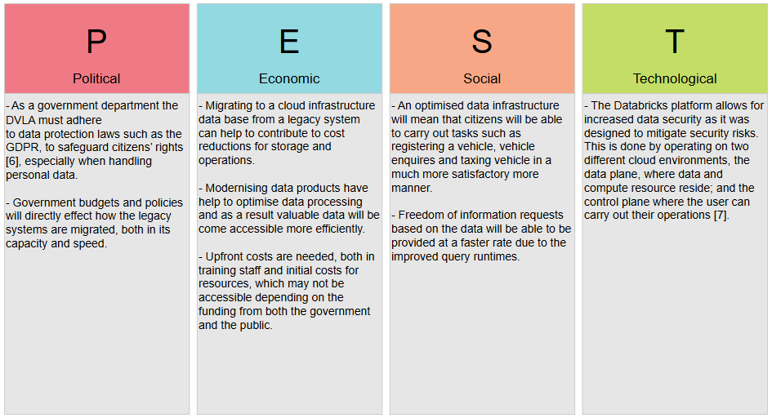

SWOT analysis:
- Strengths:
  - The DVLA has existing legacy systems that are trustworthy and have helped with their online presence. This means that migrating the data based on these systems will help to improve the functionality of them, whilst ensuring they are up to the organisation expectations.
- Weaknesses:
  - If there are issues within the legacy systems, then the migration may face similar challenges. For example, duplicate/ redundant data which could affect the database integrity.
- Opportunities:
  - Migrating to a cloud-based infrastructure such as Databricks, provides opportunities for AI data analysis and automation of repeatable tasks, which will help to improve productivity.
- Threats:
  - If errors and or breaches occur during the migration process, it could cause significant additional costs, for example, customer relations and costs amend data related to the migration process.

Data Migration Concepts, Methods, Practices & Tools
To successfully carry out the migration process a variety of concepts, methods, practices and tools will need to be implemented to deploy, maintain and evolve the project.
Concepts:
- Agile methodology:
  - Operating within small iterative cycles, in order to refine work based of off regular feedback, or errors that are encountered.
- Phased Release Deployment:
  - Cutting down the larger migration into multiple iterations and deploying them separately, to maximise the efficiency of testing and to reduce risks [8].
- Continuous Evolution:
  - Releasing the initial data product with the consideration of the implementation of new features/ tools, through timely updates [9].
Methods:
- CI/CD (Continuous Integration / Continuous Development):
  - Automatically integrating updates to code using a shared code repository, within BitBucket. This will help to avoid change conflicts within the development cycle [10].
- Pilot testing:
  - Deploying segmented data into a test environment, so that specific tests can be performed quickly before everything is deployed.
- ETL (Extract, Transform, Load):
  - This is the process that will be used to migrate the modern data products from the legacy processes.
Practices:
- Version Control (GIT/ Bitbucket):
  - This will help audit all changes made through commits and will promote peer reviews on the code.
Tools:
- Databricks:
  - This will house and maintain the data products. The platform will also allow continuous data deployment through automated pipelines.
- Jira:
  - This will help to document tasks that need to be completed, whilst also highlighting what tasks have been completed within each sprint.

Task 3: Project Reflection
The goal of my proposed project is to migrate the DVLA’s legacy data systems to a modernised data product, that will be stored within a cloud-based platform. This project will seek to optimise the existing legacy systems to improve efficiency across a plethora of elements, such as query runtimes and eliminating redundant code. The development of this project will provide an opportunity for me to improve upon a range of different skills, whilst also creating value for society.

Skills Development
The project will present an opportunity to not only strengthen previous skills, but to also develop new ones. One of the areas that see great developed upon is working with Agile management. Through familiarising myself with Agile’s principles and practices, I will be able to improve upon skills such as managing product backlogs, user story writing, estimation and planning and many more skills that will make me a valuable member to any team [11].
Furthermore, as the project’s focus is converting python functions into improved SQL functions, my knowledge within both the areas will be expanded also. By understanding what the python code in the legacy processes is doing I will become more comfortable reading large blocks of python; my SQL skills will also be improved as I will have to create the data products with the previous processes’ functionality in mind.
I will also be enhancing my GIT skills and subsequently my version control knowledge during this project. Not only will I develop an understanding of how to manage version control using GIT commands, but I will additionally strengthen my confidence when working with a team of developers, as I will have to give and receive feedback frequently.

Societal Impact
Modernising DVLA’s legacy data processes can provide a significant positive impact to society. Creating modern data products that are house on a cloud platform will benefit UK citizens, as their data will be managed more securely. It will also allow them to have access to trustworthy data such as vehicle registration details, as the integrity of the data will be improved upon.
Another positive impact that the project will bring is that the resources within the DVLA will be utilised more productively. Automating and optimising data processes through data pipelines will help to reduce the time it takes to carry out specific operations, lower maintenance and operating costs and will help to reduce stress amongst developers. This as a result will allow DVLA’s data engineers to focus on providing useful data for reporting purposes and detecting and eliminating fraudulent accounts.

Project Risk & Challenges
During the development of the project, there are a plethora of risks and challenges that could occur. One of the biggest risks when migrating the data is data loss or corruption. This could significantly impact a variety of different areas, for example the Power BI reports that are reliant of the data. So, to mitigate this risk I will conduct pilot migrations along with tests after each deployment to ensure that there are no issues with the data during these stages.
Another challenge could be related to budget constraints which could have an impact on what resources are accessible. Due to the DVLA being a government department changes in government budgets and policies could alter how the project will have to be carried out, which is an issue that will have to be dealt with. To minimise the impact of these changes alternative resources will be established, to ensure that the product can be completed.

Conclusion
To conclusion, this project provides me with an opportunity to build upon a plethora of skills in Python, SQL and Databricks as well as develop new ones in Agile management, GIT version control and Visual Studio Code development; whilst creating value for both the DVLA and society as a whole. The project will help me develop the needed skills to excel in my career path, through improving upon my collaboration and leadership skills, and additionally my technical knowledge.

References
[1]
O. Gierszal, “Data Migration: Challenges & Risks During Legacy System Modernization,” brainhub.eu, Aug. 27, 2024. https://brainhub.eu/library/data-migration-challenges-risks-legacy-modernization
[2]
“4 Types of Data Migration & How to Avoid Risking Your Data’s Integrity,” syncmatters.com. https://syncmatters.com/blog/4-types-of-data-migration
[3]
A. Gurnov, “What is Agile Methodology in Project Management?,” Wrike, Nov. 22, 2024. https://www.wrike.com/project-management-guide/faq/what-is-agile-methodology-in-project-management/
[4]
Wrike, “The Benefits & Advantages of Agile | Wrike Agile Guide,” www.wrike.com, 2023. https://www.wrike.com/agile-guide/benefits-of-agile/
[5]
Projectsly, “Importance of Gantt Charts in Project Management,” Projectsly, 2022. https://projectsly.com/importance-of-gantt-charts
[6]
“DVLA privacy policy,” GOV.UK. https://www.gov.uk/government/publications/dvla-privacy-policy/dvla-privacy-policy
[7]
“The Good and the Bad of Databricks Lakehouse Platform,” AltexSoft. https://www.altexsoft.com/blog/databricks-lakehouse-pros-cons/
[8]
W. Lam, “Why Phased Rollouts Are The Key To Better Product Launches,” devcycle.com, Jul. 12, 2022. https://devcycle.com/blog/why-phased-rollouts-are-the-key-to-better-product-launches
[9]
GeeksforGeeks, “Software Evolution Software Engineering,” GeeksforGeeks, May 02, 2019. https://www.geeksforgeeks.org/software-engineering/software-engineering-software-evolution/
[10]
Redhat, “What is CI/CD?,” Redhat.com, Dec. 12, 2023. https://www.redhat.com/en/topics/devops/what-is-ci-cd
[11]
in, “20 Essential Agile Skills You Need to Thrive in 2025,” 20 Essential Agile Skills You Need to Thrive in 2025, 2025. https://agilemania.com/agile-skills
‌

‌

‌

‌

‌

‌

‌

