Evidence-Based Practice.
(5CO02)
Clare Mugford

Table of Contents:

Section 1.
- The concept of evidence-based practice (AC 1.1) – Page 3
- Analysis tools/methods (AC 1.2) – Page 5
- Principles of critical thinking (AC 1.3) – Page 6
- Decision making processes (AC 1.4) – Page 7
- Ethical perspectives within decision making (AC 1.5) – Page 9
- Measuring financial and non-financial performance (AC 3.1) – Page 11
- Impact of People practices (AC 3.2) – Page 12

Section 2.
(AC 2.1, AC 2.2, AC 2.3) - Pages 14 - 20
- Review and findings of Table 1 – Equality, Diversity, Inclusion & Salary data
- Review and findings of Table 2 – Hybrid working practices.

Reference List – Page 21

SECTION1.
The concept of evidence-based practice (AC 1.1)
At the heart of evidence-based practice is the idea that good decision-making is achieved through critical appraisal of the best available evidence from multiple sources. (Young, 2023)
Using evidence-based practice when decision making, ensures optimal decisions are made and are based on facts as opposed to opinions and natural bias, all whilst creating a trusted organisation with consistent, relevant knowledge.
The implications of ‘getting it wrong’ are immense and relying on an individual opinion could be risky (Waite et al., 2021) therefore, it is imperative that all available evidence is considered and critically evaluated to achieve and implement a quality outcome.
Sources of evidence that should be considered when making important decisions will include:

- Scientific – published research
- Organisational – HR/customer data
- Experiential – knowledge from people within organisation
- Stakeholder – interested groups – employees/customers.

Image below (Barends, Rousseau and Briner, 2014)

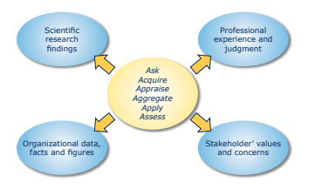

The four evidence sources can be collated alongside each other to provide maximum information. This enables the optimum decision to be reached when combined with the 6 steps to Evidence-based practice - image below (CIPD, 2023 a)
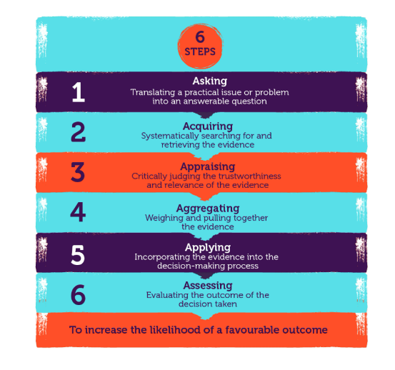
Using the skills and methods set out within the above 6 steps, you will significantly increase the probability of a favourable outcome as ‘practitioners can ensure the quality of evidence is not ignored’ (CIPD, 2023 b)
There are various strategies and models that can be used to support the decision-making process within people practice. With overwhelming levels of information available these days, and our tendencies to cherry pick information that appeals to us, it is tempting to stick with what is already known; but by incorporating these different strategies, it can promote better informed decisions and eliminate any bias.
The rational decision-making model as shown below (Lumenlearning.com, 2019 a)
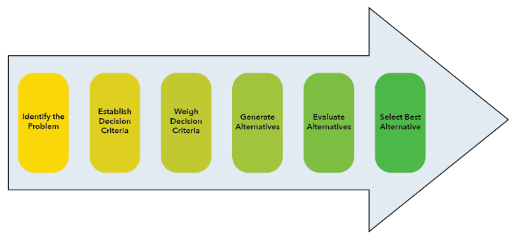is a logical, step by step process which divides the problem into simpler, more manageable components. This method is largely based on data analysis, reducing the chance of assumptions and errors therefore reducing risks and uncertainties in decisions. However, data within an organisation can be limited, thus identifying a limited amount of quality solutions. The process can be time-consuming and costly. It is generally not worthwhile on everyday decisions. It is more useful for big decisions with many criteria that affect many people. (Lumenlearning.com, 2019b)
Where there is a lack of organisational data available, critical thinking and evaluation of all the experiential and qualitative data will be essential to finding effective and valid solutions.
Analysis tools/methods (AC 1.2)
Analysis tools can both identify and resolve operational issues, but also highlight opportunities that could improve the organisation. There are a number of analysis tools an organisation can use such as PESTLE analysis, SWOT analysis and Porters Five Forces.
A PESTLE analysis studies the key external factors (Political, Economic, Sociological, Technological, Legal and Environmental) that influence an organisation. (Battista, 2023a)
External factors must be considered to ensure compliance and effectiveness, for example political factors such as tax policies and trade restrictions must be abided by to avoid legal and action and potential fines. But also, considering the potential environmental impacts the organisational choices could have on sustainability and ethical resourcing.
To be most effective, things to consider are:
- Collaborate – group information gathering can help identify more risks.
- Avoid basing decisions on previous examples, evaluate all available information.
- Use all information / experience available to you, don’t just stick to what is familiar.
- Prioritise, highlighting each issue in order of potential impact to the organisation.
- Complete PESTLE regularly – Doing so can help organisations to spot trends early, and provide a competitive advantage (Battista, 2023c)
Disadvantages of using PESTLE - it takes time to collect data in relation to all 6 factors, and the risk of capturing too much data which can make it meaningless. PESTLE also leaves some data gaps. Luckily, other analyses complement PESTLE. SWOT analysis comes to the rescue for understanding internal discussions, errors, and threats. Competitor analysis handles the identification of your competition. (Frue, 2018)
There are numerous analysis methods that can also be used to identify, assess, and improve organisational performance, such as benchmarking, work sampling, and interviews.
Benchmarking is the process used to compare best standards and performance between similar organisations. This practice shows an organisation where it can improve internally to maximise overall performance and revenue. (HR News, 2021)
There are numerous benefits to using benchmarking, it can inspire change and presents opportunities for organisations to improve. It can promote drive within the workforce to achieve better than competitors. It can improve productivity and staff morale when showing good performance against others, and best of all benchmarking is a relatively inexpensive process, with often fast results.
As essential as benchmarking is, exercise caution when comparing data. Is it relative to your organisation and what is it actually highlighting. For example, the below data shows Powys Health Board with the highest caseload. This may indicate initially they are taking longer to treat patients with them remaining on their caseload longer. However, could this mean they have identified patients requiring help better than the other health boards? Do they have a greater number of children within their population, meaning naturally, their caseload would be higher?

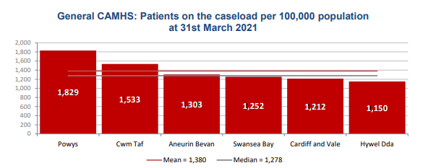
(CAMHS 2021 Benchmarking Analysis for NHS Wales, 2021)
Therefore, it is essential to look at multiple sources of data when using benchmarking effectively.

Principles of critical thinking (AC 1.3)

According to Dr Rafiq Elmansy (2017) The critical thinking process prevents our minds from jumping directly to conclusions. Instead, it guides the mind through logical steps that tend to widen the range of perspectives, accept findings, put aside personal biases, and consider reasonable possibilities.
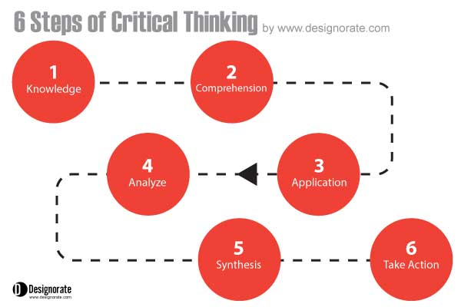
(Dr Rafiq Elmansy , 2017)

Consideration must be given to all sources of data. Is the data recent/relevant? Who has provided the data? Question the source that provided the data and challenge the context in which the data is presented to you. This can identify any intended bias or hidden agendas that could be used to sway your decisions. By keeping your questioning objective, you will also reduce the risk of weighting a preferred response.
Self-awareness is essential to good critical thinking. Without this, it is harder to stand back and evaluate objectively whether we have been influenced disproportionately by factors we might not even have noticed consciously. (Cottrell, 2019, p.254)
Examine the data and information to establish if it’s fact or opinion. Taking information at face value presents huge risks, and basing decisions on opinion as opposed to facts can have huge consequences and can impact the organisation both financially and reputationally. This is essential with people practice as decisions made can directly affect employee livelihoods.
‘Critical’ in this context does not mean disapproval or being negative. There are many positive uses of critical thinking, for example testing a hypothesis, proving a proposition, or evaluating a concept, theory, or argument. (Armstrong, 2020 a)
Through effective critical thinking, you allow the ability to gain a broader, less prejudiced knowledge base, enabling you to view the bigger picture. Asking alternative questions can help to provoke alternative ideas and outcomes, those that would not have usually been thought of. Thinking open-mindedly and recognizing implications and assumption, are all qualities of effective critical thinking.
According to the CIPD, the Profession map describes the values, core knowledge, behaviours and specialist knowledge that help us make a positive impact, whatever our level or specialism. (CIPD 2023,a)
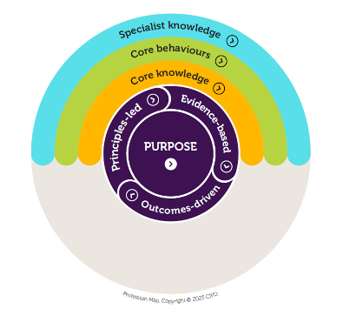(CIPD 2023,b)
The critical thinking aspect of our New Profession Map on which it is a focus area, is part of the analytics and creating value section in our core knowledge, and much of the evidence-based practice work also sits in that area, and evidence-based practice is about asking good questions and that is a key aspect of critical thinking. (Howlett, 2019)

Decision making processes (AC 1.4)
Various decision-making processes can be used to help achieve effective outcomes.
The Six Thinking Hats technique created by Edward De Bono, encourages thinking and evaluation of potential ideas from multiple perspectives, thus offering a more balanced and well-rounded solution.
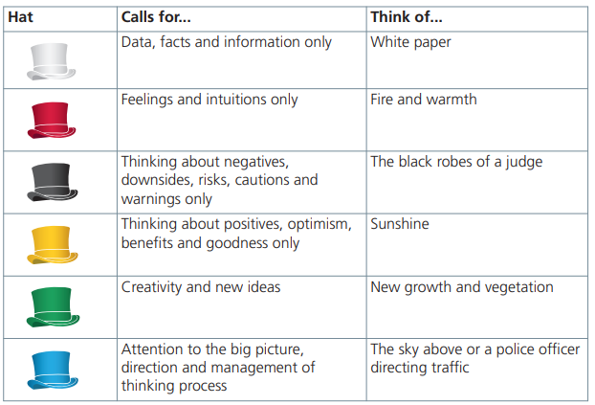(NHS England, 2022)
As shown above, the various colour hats indicate the different perspectives to be considered. NHS England have created the above diagram as a simple reminder to remember each colour and what the perspective is that should be examined and how it could impact on the decision moving forward.
Six Thinking Hats can be applied for both as an individual and as group discussions, however, with groups consider splitting into smaller groups and allocating each group a hat/perspective to focus on or collaborate working focussing on each hat in turn.

The biggest benefits are often seen in team working and collaborative problem solving as they can empower diverse groups of people to work together with a common perspective in mind. (Channell, 2021)
Alternatively, The PDCA cycle is four-stage problem-solving framework organizations can use to improve their processes, products, and services continually. The four stages of the Deming Wheel PDCA cycle are: (Abbas, 2023a)
- Plan
- Do
- Check
- Act
PDCA firstly involves defining the problem, setting some goals, and developing a ‘Plan’ in order to achieve those goals.
The second stage ‘Do’ is implementation of the above plan.
‘Check’ is measuring the results of the plan implemented within the ‘Do’ stage which will enable you to identify and evaluate any deviations in the predicted outcomes.
Lastly, you would ‘Act’, meaning corrective actions are put in place as a result of the analysis within the ‘Check’ stage.
The PDCA cycle encourages data-driven decision-making by requiring organizations to collect and analyze data to identify problems and measure the effectiveness of solutions. This helps to ensure that decisions are based on objective data rather than subjective opinions. (Abbas, 2023 b)
PDCA encourages regular review of processes and products which can lead to productivity effectiveness, cost savings, and improved profits.

Force field analysis includes creating a map of the forces helping and hindering the change, and then prioritizing those forces so the change can be most effectively achieved. (NHS Improvement, 2011)
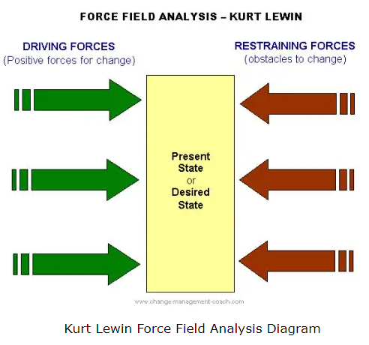(Connelly, 2020 a)
Force field analysis is a fast, effective decision-making process designed to identify when and where to act to achieve a desired change.
However, be mindful that Force field analysis is usually completed by only a small number of managers and doesn’t incorporate much involvement from wider stakeholders, providing limited scope being such a simple process.
Despite the above, force field analysis can still be a useful tool. It should be used along with other change management approaches and with a critical understanding of its limitations. (Connelly, 2020 b)

Ethical perspectives within decision making (AC 1.5)
The way we make decisions is important for organisations because decisions that are wrong or badly implemented can have a significant impact on people’s lives and the reputation of organisations. But when we make decisions based on good principles, and live by good values, we can improve the lives of others and their experiences at work. (CIPD, 2019)
Understanding various ethical perspectives can have a huge impact on achieving a fair and honest outcome when decision-making.
Communitarianism is a 20th Century political and social ideology emphasizing the interests of the community over those of the individual. (Longley, 2020)
Placing the interests of the whole community, over the interests of an individual lays down a common good outlook, and a collective responsibilities and values approach. It can create a workforce able to work in harmony, sharing knowledge to achieve a fair and well-rounded decision/outcome. This does have its limitations though and risks individuals feeling insignificant.
Utilitarianism is the theory that the most ethical choice is the one that produces the greatest good for the greatest number of people.
As stated by Armstrong, 2020, Utilitarianism is the belief that the highest principle of morality is to maximize happiness, the overall balance of pleasure against pain.
Utilitarianism, however, fails to acknowledge and respect individuals rights and implies a one size fits all policy can work in all circumstances, which is not the case. Despite achieving a large portion of great and good, it does not promote fairness and an honest approach to all people. This may cause issues and risk when dealing with capability and performance issues as disabilities and protected characteristics would not be taken into account for each individual.
The concept of justice is important because it is essential to the well-being of a society. A just society is one in which people are treated equitably and fairly. (Taylor, 2022)
A key principle of Justice is fairness – this means treating all people equally and fairly and by not giving individuals any sort of ‘special treatment’ based on their social status, race, or religion.
Acting with integrity and making decisions that are the right ones, even if they are not the most popular, are fundamental to the key principles of justice.
The principles of Justice highlight exactly how the Utilitarianism approach fails to be the most ethical approach, despite the claim to achieve the greatest good for the greatest number, it may not always be the most morally right.
The CIPD Ethical decision-making research report August 2015 encourages consideration of workplace dilemmas through an 8-lens approach. It identifies eight lenses, none of which represent the ‘right’ or ‘wrong’ ways of making decisions in the workplace, but offer different perspectives on work dilemmas. (CIPD, 2015)

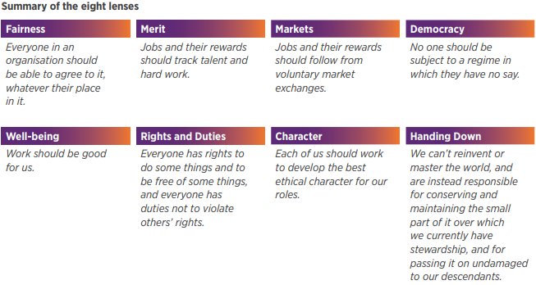

Measuring financial and non-financial performance (AC 3.1)

The performance of an organisation determines the success, therefore, how the performance is measured is essential.
There are numerous ways organisations can measure their performance both financial and non-financial, and by using these methods successfully, allows them to further plan, monitor and improve performance. Methods such as KPI’s, balanced scorecards, service level agreements and customer satisfaction questionnaires.
Key performance indicators (KPIs) refer to a set of quantifiable measurements used to gauge a company’s overall long-term performance. KPIs specifically help determine a company’s strategic, financial, and operational achievements, especially compared to those of other businesses within the same sector. (Twin, 2023 a)
KPI’s can measure various metrics such as performance and sales, marketing, financial (including Gross profit margin = (Revenue - Cost of Sales) / Revenue * 100), and human resource and staffing. Organisations within the private sector focus heavily on financial goals and achievements and their profitability whereas the public sector focus more on financial spend targets, customer satisfaction and performance such as wait times for treatment as they have a requirement to prove the public monies that are being spent are achieving the required standards and within the required budget.
According to Alexandra Twin (Twin, 2023 b), advantages of KPI’s can include providing motivation to employees to meet targets, providing a measure for progress towards organisational objectives and goals, and they can quickly highlight to management how a company is performing. Disadvantages include they require ongoing monitoring over considerable time periods in order to gain consistency and accuracy. Employees may also be discouraged if they are not meeting the set targets.

When an organisation can regularly use real data to validate achievements against targets such as retention of staffing levels, this gives them the ability to link this to any implemented changes or introduction of learning and development programmes, proving if they have either worked, or if further changes need to be made.
Another benefit is KPIs help hold employees accountable. Instead of relying on feelings or emotions, KPIs are statistically supported and cannot discriminate across employees. (Twin, 2023 c)
Completing regular employee satisfaction questionnaires, and benchmarking those results against previous data, can provide a great opportunity to gauge the productivity, experiences, and general views within the workforce. While people analytics can be invaluable, they need to be reliable and give data that is clear and specific enough to be actionable. (Young, 2023 a)
The risk of using employee satisfaction questionnaires is that they provide a broad overall picture, therefore have the ability to mask smaller, but just as important issues. On the other hand, the quantitative data provided can evidence very clearly if actions taken have worked, or if proposed actions are supported by the majority of the workforce.

Impact of people practices (AC 3.2)
People practices, also known as Human Resource practices, can add huge value to an organisation itself, but also to its employees, stakeholders, and the surrounding community; Practices such as centralised recruitment, carefully designed induction programs, training and development opportunities and performance review/appraisals.
Value created for each may be measured differently for each stakeholder, such as higher earnings or improved engagement for employees, high profits for the organisation to re-invest in operations, greater returns for the shareholders, and/or sustainability and high-quality surroundings for community and society. (Woodhams and Taylor, 2022, p.135)
The benefits of the value added can mean both short and long-term positive gains for example long term investment into the future of the company and retention of its employees, and short-term savings on agency staff spends due to reduced staff absence rates.
Promoting wellbeing is essential; investing in employee wellbeing can lead to increased resilience, better employee engagement, reduced sickness absence and higher performance and productivity. (Suff, 2022) Measuring absence data and benchmarking to previous year’s figures, and analysing the reasons for absence can identify trends and highlight if certain staff/teams are absent more than others.
Seeing a decrease in staff absence rates due to work-related stress, and reduced agency spending is a great way of evidencing that the well being of staff is successfully considered within your organisation.
Investing in extensive learning and development opportunities for staff can also add great long-term value to both the organisation and to the employee and their peers. Learning and development is the process of analysing skills gaps in your business and designing training programs that empower employees with specific knowledge and skills that drive increased performance. (Symonds 2022 a)
By providing online learning, training courses and development activities, you can share greater knowledge within the workforce, creating a collective positive attitude towards learning and achieving, thus increasing the performance and success of employees.
Training can provide leaderships skills and opportunities for internal promotions. This helps organizations acquire, nurture, maximize, and retain talent. It also increases employee satisfaction, enhances the employee experience, and decreases turnover. (Symonds, 2022 b) Increased staff retention figures evidence that investing in learning and development programmes work, and are also hugely beneficial financially, as both time and money are not wasted in recruitment of new staff and filling/bridging temporary gaps.
Return on investment is a calculation of the benefits realised as a result of investing in an HR programme. It is often used in learning and development to quantify the short-, medium- and long-term impacts of a learning and development programme (Hill and Houghton, 2021)
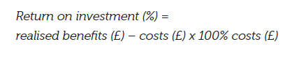

SECTION 2.
(AC 2.1, AC 2.2, AC 2.3)

Table 1.

Below is a review of organisational salary, diversity and inclusion data which highlights key areas that have been identified, and recommendations based on these findings.

- Percentage of each gender by type.

The quantitative data used to create this chart shows slightly more male than female employees with also a small share of non-binary gender type. This shows the organisation is supportive and inclusive with all gender types.

To ensure the ratio does not increase, the organisation should advertise all vacancies as flexible, highlighting how the organisation supports parents (maternity / paternity leave, special leave) and others with caring responsibilities (carers leave).
As recommended by the CIPD, enhance parental leave offerings, wherever possible, giving families more choice over how they manage work and caring responsibilities. Create a supportive culture where people feel able to take up the provisions on offer (CIPD 2022)

- Ethnicity as a percentage per team.

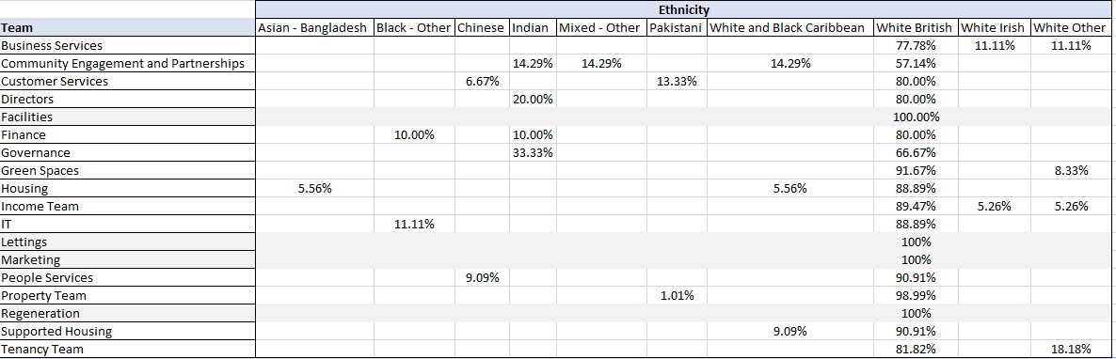

The above table shows there are 4 teams within the organisation with White British employees only, this does not show diversity within the workplace. Greater cultural awareness and consideration can help foster a better community and develop a multicultural lens in your workplace (Indeed Career Guide, 2023)

Creating a multi-cultured workforce can bring many different skills and perspectives creating a more knowledgeable and considerate workforce. The moral case for building fairer and more inclusive labour markets and workplaces is indisputable: recognising and valuing our identity, background, or circumstance, we all have a right to the opportunity to develop our skills and talents to our full potential, work in a safe, supportive, and inclusive environment, be fairly rewarded and recognised for our work and have a meaningful voice on matters that affect us (CIPD, 2022 a)

Diversity within the workplace can be achieved by:

- Keeping up to date with the law and policy reviews.
- Training all employees to understand and engage with Equality, Diversity, and Inclusion
- Inform all employees via accessible methods, keeping people up to date with diversity practices and policies.
- Use inclusive wording within handbooks and policies.

- Disability percentage as an organisational whole and by teams:

The above charts show 11 out of 18 teams across the organisation are diverse in having employees with a disability, however, 7 teams currently employ non-disabled staff only.

The benefits of a positive and inclusive approach to disability can include increased loyalty and commitment from employees leading to retention of good workers and a range of different skills and perspectives leading to increased innovation and performance. To promote a create an inclusive workforce:

- Review your organisation’s policy on equality, diversity, and inclusion (EDI) relating to disability and your current process for making adjustments for employees. Identify whether it’s fit for purpose, and effective in meeting the needs of the business whilst supporting employees.
- Ensure the culture of the organisation encourages people to feel comfortable to share information about their health and disability, and to request reasonable adjustments.
- Develop an action plan for change and assign accountability to people in senior roles.
(CIPD no date, a)

Businesses that aren’t inclusive - and don’t manage health and disability effectively - risk their wider reputation as an employer and business, as well as legal action if they fail to comply with equalities law. (CIPD no date, b)
Failure to comply could also lead to financial penalties, further impacting on the organisation.

Completing internal staff questionnaires could help to support the above, providing qualitative data that will highlight any concerns or issues surrounding disabilities/reasonable adjustments that are required by the employees, whilst also reducing the risks for the company.

- Salary difference across genders.

The graph shows higher numbers of females being paid lower salaries with more males being paid mid to high end of the scales. However, the highest paid Director roles are occupied by women. Looking at other role types there is a clear difference in the number of females in ‘Trades’ roles when comparing with males, see tables below.

(Note: Any Trade operative roles with zero females occupying, will not appear in the above chart)

To reduce the risk of unequal pay, ACAS recommends having an equal pay policy, accurate job descriptions that are up-to-date, and being consistent in the process of deciding pay and terms and conditions, as well as limiting who can amend the pay structures. (ACAS, 2022)

- Overall average salary paid by the organisation.

Average salary - £31,757

Above the chart shows the average salary within the company, £31,757. 170 employees are earning a salary below this amount – this is just over 65% of the workforce, whilst just under 35%, 90 employees earn above this amount.
Overall, the above data shows that this employer could do more to ensure equality, diversity, and inclusion within the workplace. By implementing simple changes and enforcing policies, the organisation will benefit from creating a workforce with a wider range of knowledge and skills, at the same time as protecting themselves from any legal action.

Table 2.

The data within table 2 shows that workers are no less stressed when working from home when compared to stress levels working in the office with 85% of the workforce either disagreeing or strongly disagreeing, they are no less stressed when working from home. This would indicate that potentially it is not the workplace that is stressful, it is the work itself. Undue stress can seriously affect mental health. In the workplace it can impact significantly on productivity, performance, and happiness (Armstrong, 2020 p581). Stress can be managed through various methods such as job placement, job design, performance management processes, counselling and various resilience, anti-bullying, and mindfulness training programmes.
Only 14% of the workers feel fully supported when working at work. This could lead to reduced productivity and profits. Phil Roebuck, founder of Webrecruit states ‘Particularly when companies are concerned about turnover, if employees can see and feel that they matter, it will radiate through their performance and result in a more productive and retained workforce’ (Roebuck, 2019)
Supported workers are also more likely to remain with the organisation, reducing costs of hiring and training new staff.

As shown below, 83% of workers do not miss engaging with their colleagues when working from home. This could indicate poor working relationships. Conducting anonymous questionnaires could provide more qualitative data highlighting issues or areas of concern. Team building activities could be introduced to improve worker relationships. Team building is important because it has positive effects on team dynamics, which can then have secondary impacts. For example, teams that work together better have higher productivity, increased job satisfaction and create higher profits for businesses. (He, 2022 a)

177 of the 300 workers asked, stated working from home removed conflict which means 41% of the workforce still experience conflict when working from home further indicating poor working relationships within the workforce. If negative conflict, this could have a direct impact on productivity and staff wellbeing.
Investing in employee wellbeing can lead to increased resilience, better employee engagement, reduced sickness absence and higher performance and productivity (Suff, 2022)b
Only 42 workers out of the 300 that took part in the survey either disagreed or strongly disagreed that hybrid working practices support their work-life balance and wellbeing. This meaning, apart from the 11 workers that responded ‘unsure’, 82% of the workforce agree or strongly agree hybrid working does support their work-life balance and wellbeing.
The CIPD acknowledge that hybrid working can offer benefits to employers and workers alike (CIPD, 2021) such as attracting new talent, reducing commuting costs and providing autonomy about how and where they work. However, there are things to consider when adopting a hybrid approach:
- Set out a clear hybrid working policy (detailing expectations, eligibility criteria and guidelines).
- Consider a trial period first to assess any equipment issues or barriers to success.
- Consider what support can be provided to hybrid workers.

Overall, I would advise regular 1:1 catch-ups between management and workers to enable the workers to feel more supported. Conduct surveys to provide qualitative data on the conflict in the workplace and identify the cause of stress. Introduce team building opportunities when working from work to encourage good working relationships. Team building is essential to achieve cohesion and stability in the workspace. Incorporating team building in your business ensures employees have solid relationships and feel a sense of kinship and belonging. (He, 2022 b)

Reference list
Abbas, T. (2023). Deming Wheel PDCA Cycle. [online] Change Management Insight. Available at: https://changemanagementinsight.com/deming-wheel-pdca-cycle/ [Accessed 20 Oct. 2023].
ACAS (2022). Preventing Equal Pay issues: Equal Pay – Employer Responsibilities. [online] Acas. Available at: https://www.acas.org.uk/equal-pay/employer-responsibilities [Accessed 11 Nov. 2023].
Armstrong, M. (2020). Armstrong’s Handbook of Human Resource Management Practice. 15th ed. London: KoganPage.
Barends, E., Rousseau, D. and Briner, R. (2014). Evidence Based Practice The Basic Principles. [online] Available at: https://www.cebma.org/wp-content/uploads/Evidence-Based-Practice-The-Basic-Principles.pdf [Accessed 6 Oct. 2023].
Battista, M. (2023). PESTLE analysis. [online] www.cipd.org. Available at: https://www.cipd.org/uk/knowledge/factsheets/pestle-analysis-factsheet/ [Accessed 7 Oct. 2023].
CAMHS 2021 Benchmarking Analysis for NHS Wales. (2021). [online] NHS Benchmarking Network, p.15. Available at: https://nccu.nhs.wales/qais/events/cahmsbc2021d/camhs-benchmarking-conference-2021-slide-deck/ [Accessed 13 Oct. 2023].
Channell, M. (2021). The Six Thinking Hats: How to Improve Decision Making, with Examples. [online] TSW Training. Available at: https://www.tsw.co.uk/blog/leadership-and-management/six-thinking-hats/#table-of-content-1 [Accessed 20 Oct. 2023].
CIPD (2015). Ethical decision-making: Eight Perspectives on Workplace Dilemmas. [online] p.6. Available at: https://www.cipd.org/globalassets/media/knowledge/knowledge-hub/reports/ethical-decision-making-2015-eight-perspectives-on-workplace-dilemmas_tcm18-9564.pdf [Accessed 20 Oct. 2023].

CIPD (2019). CIPD | Ethics at work: an employer’s guide. [online] CIPD. Available at: https://www.cipd.org/uk/knowledge/guides/ethics-work-guide/?_gl=1 [Accessed 20 Oct. 2023].
CIPD (2022a). CIPD | Equality, Diversity and Inclusion in the Workplace | Factsheets. [online] CIPD. Available at: https://www.cipd.org/uk/knowledge/factsheets/diversity-factsheet/ [Accessed 17 Nov. 2023].
CIPD (2022b). CIPD | Gender Equality at Work. [online] CIPD. Available at: https://www.cipd.org/uk/views-and-insights/cipd-viewpoint/gender-equality-work/ [Accessed 11 Nov. 2023].
CIPD. (2023). CIPD | Evidence-based HR: Make better decisions and step up your influence. [online] Available at: https://www.cipd.org/uk/knowledge/guides/evidence-based-profession/#:~:text=How%20do%20we%20make%20evidence-based%20decisions%3F%201%20Step [Accessed 6 Oct. 2023].
CIPD. (n.d.). CIPD | How to use the Profession Map. [online] Available at: https://www.cipd.org/uk/the-people-profession/the-profession-map/how-it-works/ [Accessed 13 Oct. 2023].
CIPD. (n.d.). Disability Equality at Work. [online] Available at: https://www.cipd.org/uk/views-and-insights/cipd-viewpoint/disability-work/ [Accessed 11 Nov. 2023].
CIPD. (2021). Effective Hybrid Working. [online] Available at: https://www.cipd.org/globalassets/media/knowledge/the-people-profession/latest-updates/hybrid-working-practical-guidance-2021_tcm18-103709.pdf [Accessed 17 Nov. 2023].
Connelly, M. (2020). Lewin’s Force Field Analysis Explained. [online] Change Management Coach. Available at: https://www.change-management-coach.com/force-field-analysis.html [Accessed 20 Oct. 2023].
Cottrell, S. (2019). The Study Skills Handbook. 5th ed. London: Red Globe Press, p.254.

Dr Rafiq Elmansy (2017). 6 Steps for Effective Critical Thinking. [online] Designorate. Available at: https://www.designorate.com/steps-effective-critical-thinking/ [Accessed 13 Oct. 2023].
Frue, K. (2018). 6 Frustrating Disadvantages of PESTLE Analysis. [online] pestleanalysis.com. Available at: https://pestleanalysis.com/disadvantages-of-pestle-analysis/#:~:text=6%20Frustrating%20Disadvantages%20of%20PESTLE%20Analysis%201%201. [Accessed 7 Oct. 2023].
He, G. (2022). The Importance of Team Building. [online] teambuilding.com. Available at: https://teambuilding.com/blog/team-building-importance [Accessed 23 Nov. 2023].
Hill, S. and Houghton, E. (2021). CIPD | People analytics: Guide for People Professionals. [online] CIPD. Available at: https://www.cipd.org/uk/knowledge/guides/analytics-practitioner-guide/#how-is-hr-using-people-analytics [Accessed 9 Nov. 2023].
Howlett, W. (2019). CIPD | Critical thinking | Podcast. [online] CIPD. Available at: https://www.cipd.org/uk/knowledge/podcasts/critical-thinking/ [Accessed 13 Oct. 2023].
HR News. (2021). 8 Solid Advantages of Benchmarking for Your Organisation. [online] Available at: https://hrnews.co.uk/8-solid-advantages-of-benchmarking-for-your-organisation/ [Accessed 13 Oct. 2023].
Indeed, Career Guide. (2023). 5 Diversity Skills to Develop. [online] Available at: https://www.indeed.com/career-advice/career-development/diversity-skills [Accessed 17 Nov. 2023].
Longley, R. (2020). What Is Communitarianism? Definition and Main Theorists. [online] ThoughtCo. Available at: https://www.thoughtco.com/communitarianism-definition-and-theories-5070063 [Accessed 20 Oct. 2023].
Lumenlearning.com. (2019). The Decision-Making Process | Organizational Behavior / Human Relations. [online] Available at: https://courses.lumenlearning.com/wm-principlesofmanagement/chapter/rational-decision-making-vs-other-types-of-decision-making/ [Accessed 6 Oct. 2023].

NHS England (2022). Six Thinking Hats ® Online library of Quality, Service Improvement and Redesign tools NHS England and NHS Improvement. [online] p.4. Available at: https://www.england.nhs.uk/wp-content/uploads/2022/02/qsir-six-thinking-hats.pdf [Accessed 20 Oct. 2023].
NHS Improvement (2011). NHS Improvement Resource -Force Field Analysis Instructions. [online] p.3. Available at: https://www.england.nhs.uk/improvement-hub/wp-content/uploads/sites/44/2018/06/Force-Field-Analysis-Instructions.pdf [Accessed 20 Oct. 2023].
Roebuck, P. (2019). Lack of Support from Bosses Causes Employee Disengagement | Onrec. [online] Onrec.com. Available at: https://www.onrec.com/news/news-archive/lack-of-support-from-bosses-causes-employee-disengagement [Accessed 17 Nov. 2023].
Suff, R. (2022). Wellbeing at Work. [online] CIPD. Available at: https://www.cipd.org/en/knowledge/factsheets/well-being-factsheet/ [Accessed 22 Oct. 2023].
Symonds, C. (2022). What Is the Role of HR in Learning and Development (L&D)? - Factorial. [online] Factorial Blog. Available at: https://factorialhr.com/blog/learning-and-development/#:~:text=Learning%20and%20development%20%28L%26D%29%20can%20be%20a%20great [Accessed 9 Nov. 2023].
Taylor, L. (2022). Justice Approach to Ethical Decision Making - Malcolmmackillop. [online] malcolmmackillop.com. Available at: https://malcolmmackillop.com/justice-approach-to-ethical-decision-making/#What_is_the_justice_perspective_of_ethics [Accessed 20 Oct. 2023].
Twin, A. (2023). Key Performance Indicator (KPI): Definition, Types, and Examples. [online] Investopedia. Available at: https://www.investopedia.com/terms/k/kpi.asp#Understanding%20Key%20Performance%20Indicators [Accessed 11 Nov. 2023].
Waite, K., Beevers, K., Small, N., Tomlinson, K. and Hussain, S. (2021). People practice : a complete guide. London, United Kingdom ; New York, Ny: Kogan Page.

Woodhams, C. and Taylor, S. (2022). STUDYING HUMAN RESOURCE MANAGEMENT: a Guide to the study, Context and Practice of hr. 3rd ed. S.L.: Kogan Page, p.135.
Young, J. (2023a). CIPD | Employee Engagement & Motivation | Factsheets. [online] CIPD. Available at: https://www.cipd.org/uk/knowledge/factsheets/engagement-factsheet/#assessing-and-measuring-employee-engagement [Accessed 11 Nov. 2023].
Young, J. (2023b). CIPD | Evidence-based practice for effective decision-making | Factsheets. [online] CIPD. Available at: https://www.cipd.org/uk/knowledge/factsheets/evidence-based-practice-factsheet/#what-is-evidencebased-practice [Accessed 6 Oct. 2023].

