May Davies

OOP and advanced software development (Algorithms)
Algorithms and Data Structures

Table of Contents
1.0Declaration 2
2.0 Part A 2
2.1 Question 1: Benefits and drawbacks of using arrays and linked lists 2
2.2 Question 2: Hybrid approach. Array of linked lists. Thousands of new names inserted each day. Would it be preferable to use an array or a linked list? Evaluate the probably performance of this data structure. 3
2.3 Question 3: Binary Search Tree 4
Part B 11
Question 1: Djkstra’s Algorithm scenario 11
Path total distance results and conclusion to question 1 14
Question 2 14
Part C 16
References 17

1.0Declaration
The work of this report has been completed under the supervision of Michael Dacey. I declare that this report is the product of my own work and is not being submitted for any other degree etc.

May Davies.

2.0 Part A

2.1 Question 1: Benefits and drawbacks of using arrays and linked lists
What is an array? An array is a block of memory that within it can contain data. An array (usually) has a fixed size, like in the case for C++ [1]. The following is table has been created for this report as an example of an array.
 | arrayOfInt[4]
arrayOfInt[0] | 65
arrayOfInt[1] | 413
arrayOfInt[2] | 612
arrayOfInt[3] | 343
The problem here, is that if it is desired to add more to this array, it is not possible, as the array is declared to have a maximum capacity of 4, and it can be observed that arrayOfInt[0] through to arrayOfInt[3] are all full. This however does not inherently mean arrays are bad. If the programmer knows the exact size of the data that will ever go through this, then an array is fine especially if its small, however things can begin to get messy if arrays are used when the size of an array needs to change, as either the programmer would need to have another array of the same size give or take a few to fill out with more data or for copying, would mean that memory is managed very poorly and inefficiently.
One potential solution to this would be to use something known as a linked list. A linked list can be used to store lists of data (as the name would imply), however unlike a normal array, it is dynamic and can change its size. The reason that they can have a variable size is because they make use of pointers in order go from one position in a linked list to the next, as opposed to being arranged to the order of an array’s indices [2].
There are a few different types of Linked Lists. Some include Single Linked Lists and Double Linked lists.
Node 4
nextPos (Null)
21
Node 3
nextPos
95
A single linked list will contain its own data, and then a pointer that points to the next node in the list. Now, already this shows there is an advantage as it means data can be inserted easily in to a single linked list so long as the previous node’s pointer is adjusted. The following example has been created for this report.
Node 1
nextPos
74
Node 2
nextPos
51

Meanwhile, a doubly linked is similar again, except it can contain a pointer for the previous pointer as well. This is much better than the single linked list as it means that it is possible to go backwards through the linked list, which a single linked list cannot do. Here is the previous example except in the form of a double linked list.
Node 3
nextPos
previous
95
Node 4
nextPos (Null)
previous
21
Node 2
nextPos
previous
51

Node 1
nextPos
previous (null)
74

Overall, a doubly linked list is much better than an array if the programmer does not know the size of the range of data that their program will be dealing with, as it can handle large sets of dynamic data much better than an array can, as for an array the programmer would need another array of the exact size or more than the current array they have as a temporary array for storing new data, which is bad.
However, if the list of data is a small list, ultimately an array is going to be much better, this means that the argument of array vs linked list is not quite as black and white as it may initially seem.

2.2 Question 2: Hybrid approach. Array of linked lists. Thousands of new names inserted each day. Would it be preferable to use an array or a linked list? Evaluate the probably performance of this data structure.
For this question, an assumption has been made that the letters of the alphabet are stored in a array. For each letter is the address for the linked list for that appropriate letter. (i.e nameArray[3] which would be the letter D, contains the address for the linked list of names beginning with D).

As far as insertion is concerned, a linked list would absolutely be preferable here, as the new names being recorded are coming in in the thousands, meaning that in the event that the array becomes full, there’s no need to copy potentially thousands of names over to a new array to add more. Using a linked lists for the names themselves would save more resources and time due to not needing to use a whole new array should one fill up. However, outside of this, it would be necessary to use a combination of an array and a linked list, as storing the alphabet in a linked list wouldn’t be optimal as the alphabet is never going to change the number of letters contained within it (well, unless the English language evolves to have even more letters of course though for this instance an assumption is made that this is not the case). As such, it would be better to make an array containing the alphabet, and a pointer to the head of each linked list for the corresponding first letter.
If a linked list was not used, then in the instance that one letter had a lot of name starting with it to the extent that the array is filled up completely, sorting between multiple arrays would also in itself be quite time consuming too.

One of the main problems that could occur in regards to the time it may take to search or sort through this hybrid however, is that if a lot of the names in the list were to have the same number of letters, sorting each linked list in to alphabetic order would take a large amount of time to get through, as each 5 letter name would also need to be compared to each 5 letter name in their respective starting letter. Now, if there were not many names of that length, then this would not be an issue as a sort could be done relatively quickly. Of course this depends on the search or sort method used, as that will also have an influence over how much time this hybrid array of linked list will take to go through.
As far as inserting new names in to a linked list is concerned, it may possibly just be wise to use a bubble sort in such a case. Initially a quicksort might have to mind here, however as a quicksort’s pivot is random, there’d be potential for a worst case scenario where the sort takes the longest time it possibly can taking the longest possible route immediately. This would be bad as ultimately a lot of time would still need to be spent on comparing the characters of each string to the next/previous string anyway.

2.3 Question 3: Binary Search Tree
For this question, a binary search tree is made of the values 34, 6, 7, 18, 45, 12, 3 and 26.
From these numbers, the following binary search tree can be created. However, this tree is not balanced. To balance this, one possible method to use would be the Adelson-Velsky and Landis tree. Here is the binary tree for the values that have been given, the tree is constructed based on the order these numbers were given in. However, this tree itself is not balanced as the left side of the tree has too many levels, while the right side does not have any nodes for 3 whole levels of the tree.
34
6
45
3
7

18
26
12
The following shows the balance calculations for the tree, as previously discussed, with the calculations for the tree’s balance.
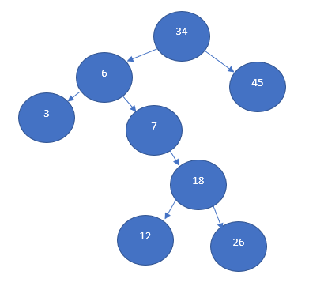
BF(34) = 4-1 = 3

BF(6) = 1-3 = -2
BF(45) = 0-0 = 0

BF(3) = 0-0 = 0
BF(7) = 0-2 = -2

BF(18) = 1-1 = 0

BF(26) = 0-0 = 0
BF(12) = 0-0 = 0

The rules for a tree to be balanced is that the tree’s sub-trees must have a difference in height that is not any higher than 1 when taken away from eachother [3]. Thus, the balance factor formula that is used to determine this is:
$$Balance Factor \left(Node\right)=Left tree height-Right tree height$$
As shown above, it can be seen that nodes 18, 12, 26, 3 and 45 are completely balanced, as they are equal to 0. Meanwhile nodes 7 and 6 are right heavy, as they are less than 0. The only part of this tree that is left heavy, is node 34, as node 34 is greater than 0. This can also of course be seen visually, as there is evidently a lot more levels on the left branch of node 34 than there are the right branch of node 34.
So, for this case, if it was desired to search this particular binary tree, then it would be necessary to traverse down the tree based on the size of what we are searching to compared to the current node value. The particular tree that was constructed here has been constructed in a way that the left subtree will be less than the value of the node, while the right subtree will be greater than the node.
So, the following is an example searching this tree for the value of 18, which should appear in the left tree, which can be seen on the next page.
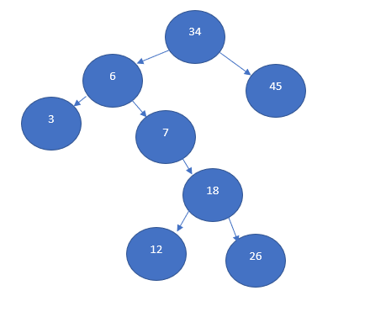
18 = 18. Value has been found
18 > 7
18 > 6
18 < 34
Now, in this case, it does not take too long to search the binary tree to find the value of 18, in this case, it takes only 3 steps in to the tree to find. That is alright here, however, in worst case scenarios it wouldn’t be. If a tree was constructed in order of the values 1,2,3,4,5,6,7,8,9,10, and the desired number to search for would be 10, if the tree was constructed where every tree and subtree is a right branch only, then it would take the entire tree to find the value, which is bad, as this is a lot of time to wait for the tree to be searched for a desired value.
This would be where the previously mentioned Adelson-Velsky and Landis (or AVL for short) tree method would be applied, as this method can make use of rotations within the tree to rebalance the tree by making the balance factors equal to 0[4].
There are a few different types of rotations that can be performed, these include left rotations, right rotations, left-right rotations and right-left rotations. In a left rotation, if a tree has become right unbalanced, then the previous node becomes the left child of the parent node, while the newly inserted child node will remain the right child of the current node, as can be seen in the following figure.
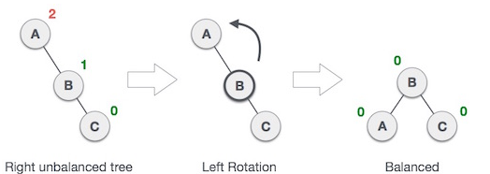
(Adapted from [4])
As for a right rotation, this is the same as the left rotation however applied on the opposite side instead, so the previous node becomes the right child of the current node, while the newly inserted child will remain in the current node’s left branch, as can be seen in the following figure.
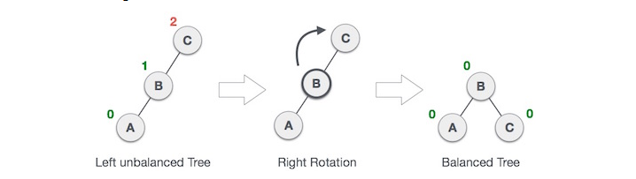
(Adapted from [4])
Right left rotations occur when there is an imbalance that has been caused by a node being inserted to the left branch of the right subtree of a node. In such cases, it would be necessary to bring the newly inserted child to the position of the right subtree node, while the current right subtree would then become the right child of the newly inserted child. From here, a regular left rotation would need to be performed. These steps can be seen in the following images
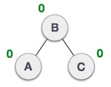
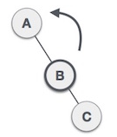
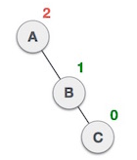
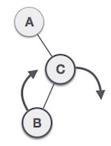
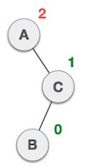

(Adapted from [4])

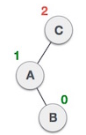
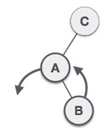
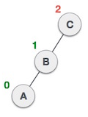
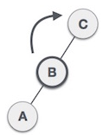
Lastly, a left right rotation will occur when a newly inserted node has been inserted to the right branch of a left node. To solve this, a left rotation will first be done on the newly inserted child to the with the left node. Once this is done, this creates a left-left tree, which is still unbalanced. To solve this, the tree is once again given a rotation, though this time it is a right rotation. This can be shown in the following images.
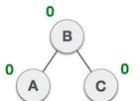

(adapted from [4])
So, with this information, the tree that has been created and show previously can be recreated using these rotation rules to make it balanced. The following are illustrations of the tree being created one insertion at a time.
Inserting numbers 34, 6.
34

6

Inserting number 7. Usually this would be the left child of 6, however this creates a left imbalance. Thus, a right rotation is done.
Right rotate
6
7
34
7
6
34
Inserting numbers: 18, 45.
18 is greater than 7, but less than 34. This is the left child, 45 is greater than 34 and is the right child no rotations necessary yet as the tree is still balanced.
7

34
6

18
45

Inserting number: 12
12 is greater than 7, but less than 34. It is also less than 18. The tree is now imbalanced. With two left rotations the tree can be balanced again.
18
7
6
34
45
18
Left *2
7
34

12
6
45

12

Inserting numbers: 3, 26.
This last one requires no balancing due to the rules of the tree as it is now. 3 is less than 18, so it will go to the left, 3, is less than 7, left again. 3 is less than 6, thus becomes 6’s left child. As for 26, it is greater than 18, so it will go to the right branch. It is less than 34, nothing occupies the left child for 34, so 26 becomes 34’s left child. The tree is completed, and balanced. Additionally, with the example mentioned earlier, as 18 is now the first in the tree it actually means that with AVL’s tree method, it is actually potentially faster than the previously unbalanced tree.
18
7
6

34

26
12
45
3

However with that being said, it can also be seen that this is not always tree, as the original tree, if the desired number to search for within the tree was 3, it would take less time as 3 isn’t so deep in the tree, however, in this case with the AVL tree, 3 is actually deeper than it was originally, so this means that AVL is not strictly always quicker, however is at least a good way of still making a balanced tree.
The reason that it is important to balance a binary search tree is mostly to help with worst case scenarios, as it can help reduce the potential maximum amount of time it would take to search through a tree by ideally reducing the total height of the tree. As mentioned earlier about a tree that is balanced completely to the right, it would take a long time to find the final value in the list used to create the tree. Whereas a balanced tree would take far less time to find this value. The mentioned example (which was 1,2,3,4,5,6,7,8,9,10) as proof has been calculated using the AVL Tree visualiser created by the University of San Francisco[5] which can be seen in the image below.
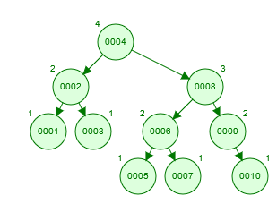
(Created from [5])

Part B

Question 1: Djkstra’s Algorithm scenario
In this scenario, it is desired that an individual is to purchase a camera by exchanging parts to minimise the total cost of a purchase. This is done starting from exchanging the individual’s foreign stamp for potentially either a book or a toy boat, and moving from there.
As far as Djkstra’s algorithm is concerned, it is desired that the most cost effective route is taken for achieving the desired goal.

The following is a table of the items, alongside their collectible trades.
Trade | Item | Cost | Acceptable trades
A | Stamp | 0 | Start here. Owned.
B | Book | 3 | Stamp
C | Toy Boat | 8 | Stamp
D | Ships Bell | 4 | Book
D | Ships Bell | 7 | Toy Boat
E | Scooter | 3 | Ships Bell
E | Scooter | 10 | Toy Boat
F | Camera | 2 | Scooter

To help visualise this, the following image has been graph for this document (Toy boat abbreviated to “T.Boat”, Ships Bell abbreviated to “S.Bell”.)
Graph for Stamp to Camera scenario
2
3
10
7
4
3
8
0
F
Camera
E
Scooter
D
S. Bell
C
T. Boat
A
Stamp
B
Book
There are a number of possible routes for this, thus, they have been displayed on graph and calculated. The lowest costing path will be the desired one according to Djksta’s algorithm.
The black arrows are the path being taken.
Path 1
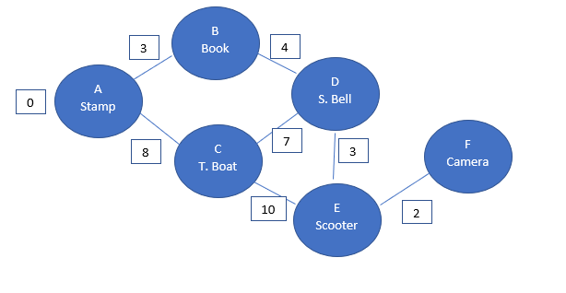
A to C: Current total distance = 0 + 8 = 8
C to E: Current total distance = 8 + 10 = 18
E to F: Current total distance = 18 + 2 = 20

Path 2
A to C: current total distance = 0 + 8 = 8
C to D: current total distance = 8 + 7 = 15
D to E: current total distance = 15 + 3 = 18
E to F: current total distance = 18 + 2 = 20
Path 3
A to B: current total distance = 0 + 3 = 3
B to D: current total distance = 3 + 4 = 7
D to C: current total distance = 7 + 7 = 14
C to E: current total distance = 14 + 10 = 24
E to F: current total distance = 24 + 2 = 26

Path 4
A to B: current total distance = 0 + 3 = 3
B to D: current total distance = 3 + 4 = 7
D to E: current total distance = 7 + 3 = 10
E to F: current total distance = 10 + 2 = 12

Path total distance results and conclusion to question 1
Path | Route | Total Distance
1 | A,C,E,F | 20
2 | A,C,D,E,F | 20
3 | A, B, D, C, E, F | 26
4 | A, B, D, E, F | 12
In conclusion in this scenario it would be most effective to exchange the stamp (A) for the Book (B). Then the Book (B) for the Ships Bell (D). The Ships Bell (D) should then be exchanged for the Scooter (E), which in turn can then be exchanged for the Camera (F). Despite this path having more items to go through than path 1, and the same number of items as path 2, it is still the most cost effective path, and thus is the one that should be used in this scenario.

Question 2
Question: Dijkstra’s algorithm is in O(EV^2) time. A priority queue can further improve this by turning this in to O(E log V). E is edge, while V is vertices. There will always be one less edge than vertices. Evaluate the performance of both of these approaches via plotted graphs to illustrate performance between the two as vertices increase from 1 to 12.
The following graphs have been made in excel using the described scenario above, though uncertain as to if they answer the question or not due to some confusion from the author. The first graph is a graph for O(EV^2) while the second is a graph for E Log V.

As can be seen here, the graph gets quite steep the further through the increased vertices that are put through Dijkstra’s algorithm. This indicates so far that it can be quite expensive on time if there is a large set of data, however this is without making use of the priority queue.

This is a graph for the improved Dijkstra’s algorithm which makes use of a priority queue. As can be seen the curve is much less harsh than the curve seen for O(EV^2), thus it can be said that the priority queue that turns Dijkstra’s in to O(E Log V) can be much less demanding than that of the original, meaning it can handle much larger sets of possible routes much better than the original Dijkstra.

Part C
In this scenario, it is required to implement the Minimax algorithm in to connect 4. The minimax algorithm is a very popular algorithm that can commonly be used as part of 2 player board games such as connect 4 or tic tac toe. In this particular scenario, it is required to implement the Minimax algorithm in to connect 4.
Firstly though, an explanation on what the minimax algorithm aims to do.
The minimax algorithm consists of two different “players” that play against eachother. The first one is the Maximiser, and the second one is the Minimizer. The goal for the maximiser is to achieve the highest possible score in the game that it is implemented in, meanwhile the goal of the minimiser is the reverse of this in that it actively attempts to get the lowest possible score. The algorithm itself is one that is actually analyses all possible moves on that current turn before making a decision on the move it can make[6].
In a game of connect 4, the maximiser would ideally aim to connect up as many pieces as possible, as the number of pieces connected together would have a higher chance of increasing the maximisers score. Meanwhile, the minimiser would potentially take up more of the board spaced out overall, as this would lead to the minimiser having a much lower overall score than the maximiser. However, this does still work out for connect 4 as it means that the minimiser could potentially be blocking a lot of the moves the maximiser might be making by taking up seemingly random parts of the connect 4 board. This means that while initially the idea of the minimiser aiming for a low score might seem like any game implementing it would lead to the maximiser winning isn’t actually the case, as the minimiser could very well lead to either a really long match, or a potential draw.
So, in connect 4, the algorithm would check if the game is over. If the game is not over, then it would analyse its next possible moves, and check if it can win by connecting up 4 pieces. If there are currently no positions that it can connect up to 4 pieces, it should place a piece, and begin working from there throughout the following turns in order to try to win (assuming this is the maximiser, the minimiser will instead not aim immediately for the best possible decisions).

References

[1] | Tutorialspoint, “C++ Arrays - Tutorialspoint,” Tutorialspoint, [Online]. Available: https://www.tutorialspoint.com/cplusplus/cpp_arrays.htm. [Accessed 29 April 2021].
[2] | T. H. Cormen, “Linked List,” in Introduction to Algorithms 3rd Edition, London, MIT Press, 2009, pp. 236-237.
[3] | GeeksforGeeks, “How to determine if a binary tree is height-balanced? - GeeksforGeeks,” GeeksforGeeks, [Online]. Available: https://www.geeksforgeeks.org/how-to-determine-if-a-binary-tree-is-balanced/. [Accessed 1 May 2021].
[4] | Tutorialspoint, “Data Structure and Algorithms - AVL Trees - Tutorialspoint,” Tutorialspoint, [Online]. Available: https://www.tutorialspoint.com/data_structures_algorithms/avl_tree_algorithm.htm. [Accessed 1 May 2021].
[5] | University of San Francisco, “AVL Tree Visualzation,” University of San Francisco, [Online]. Available: https://www.cs.usfca.edu/~galles/visualization/AVLtree.html. [Accessed 4 May 2021].
[6] | GeeksforGeeks, “Minimax Algorithm in Game Theory | Set 1 (Introduction) - GeeksforGeeks,” GeeksforGeeks, 31 March 2021. [Online]. Available: https://www.geeksforgeeks.org/minimax-algorithm-in-game-theory-set-1-introduction/. [Accessed 10 May 2021].

